**Screen shots for job seekers module**

1. This is the login page for the Job seeker if he/she is already a user on the page they can directly login and check out their details.

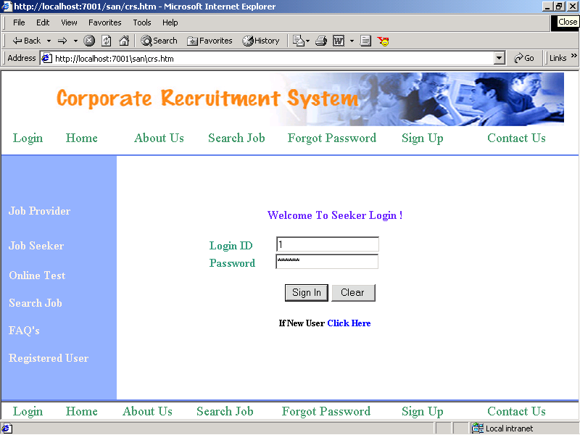

1. This is the In Box information provided by the job providers to the job seekers.

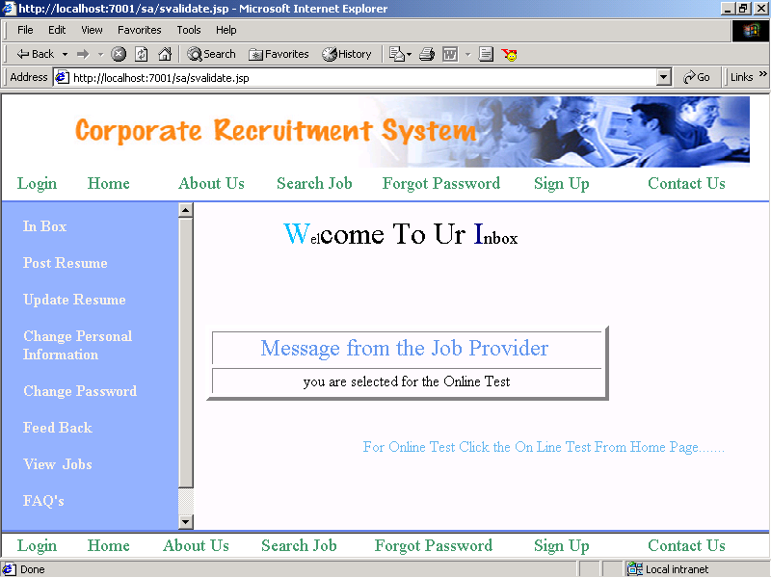

1. This is the screen shot for changing the personal information of job seekers.

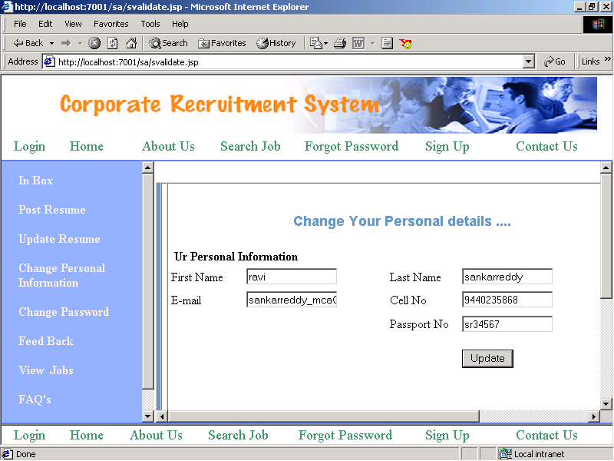

1. This is how the seekers can change their password by clicking on the change password label.

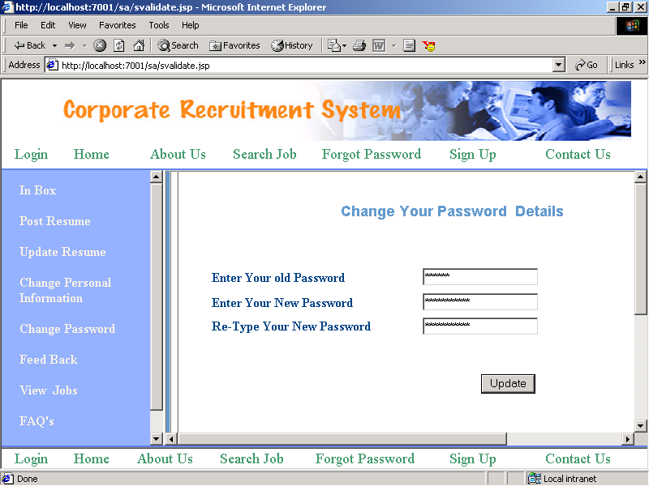

1. This is the feedback information provided by the job seekers

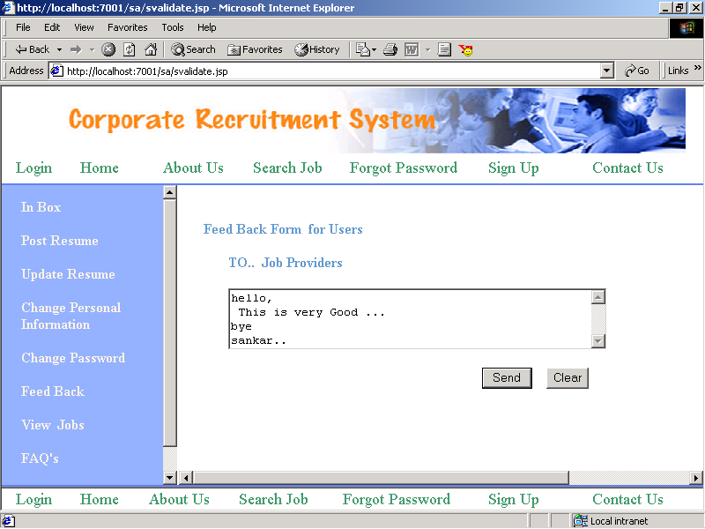

**Scrumdo story:**

