LAB-4 ASSIGNMENT

1. I have implemented a login web application using the asp.net. The following are the screen shots done in the process.

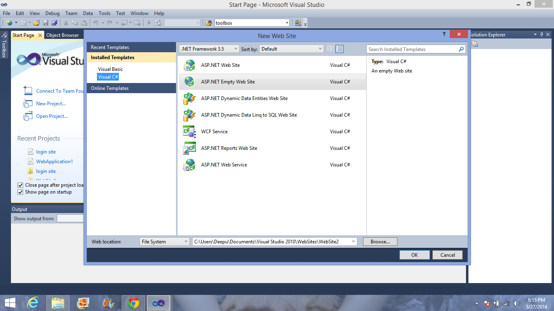

2. These is how I created the cells required for the login page

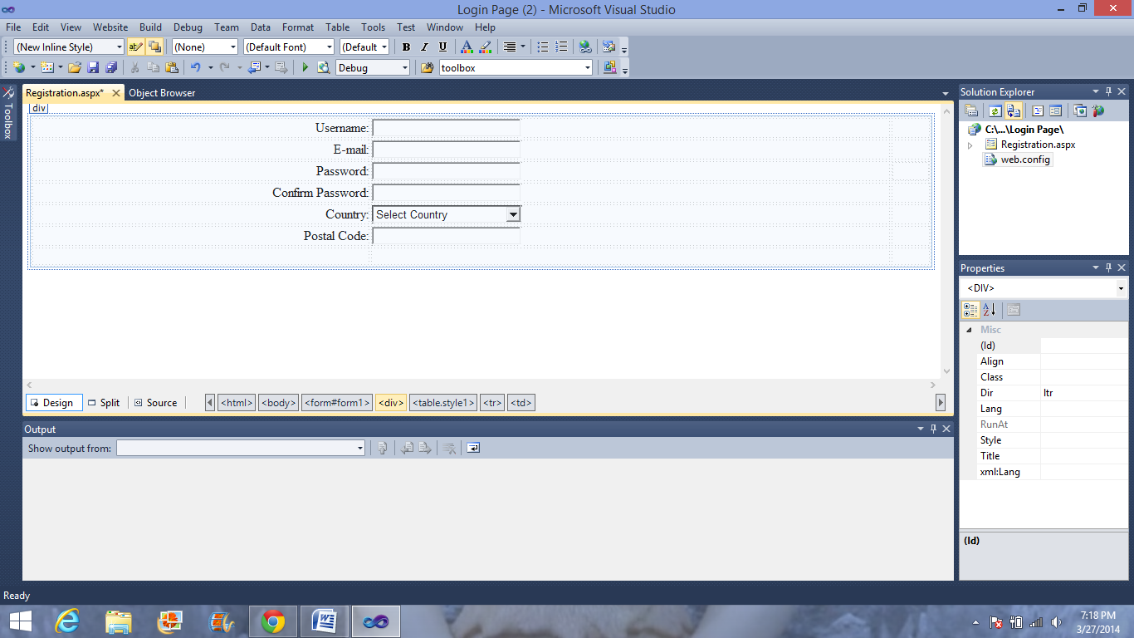

3.

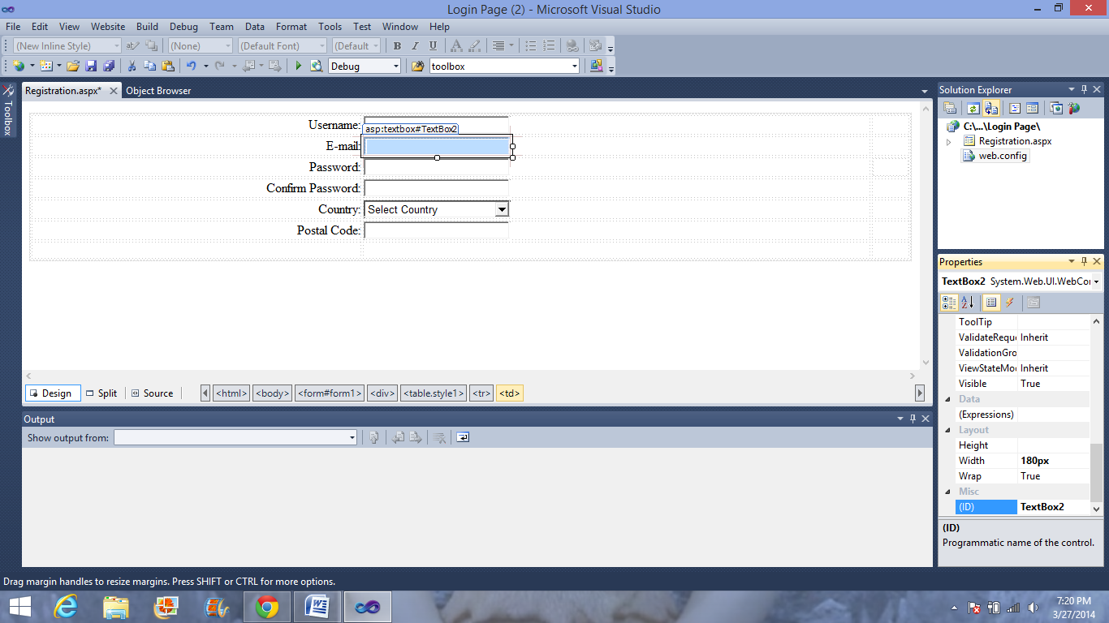

4. Edit the error message in the required field validator to the message you would like to display like "username is required", etc. and then change the color to red by selecting forecolor option. After this we need to set up a connection between 2nd column text boxes and 3rd column validators by clicking each validator seperately and using the option "ControltoValidate" in the properties.

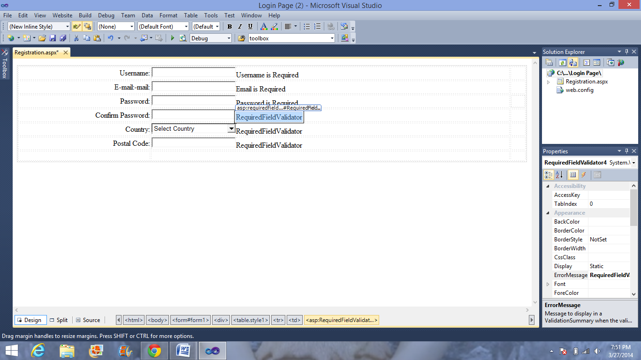

6.

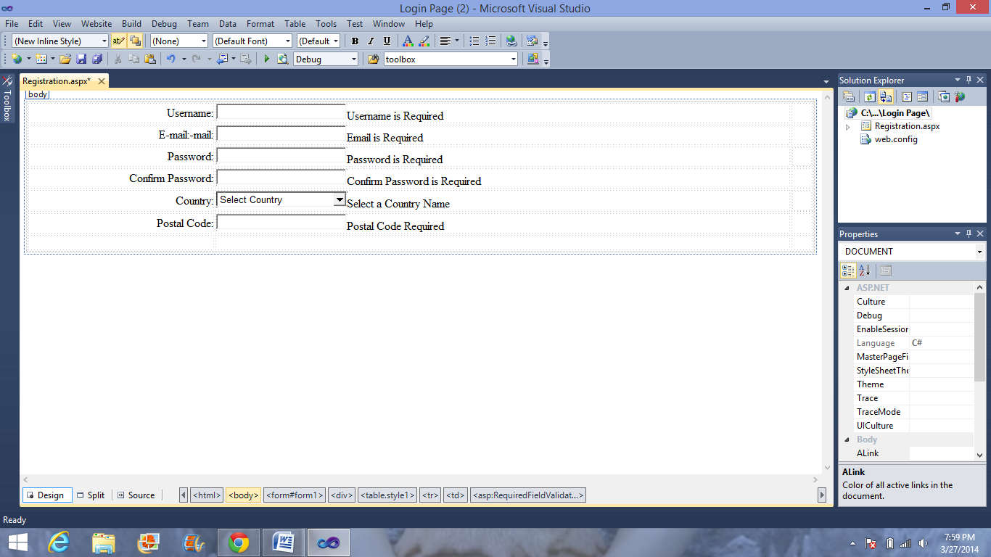

7. This is how they look after changing the color to red.

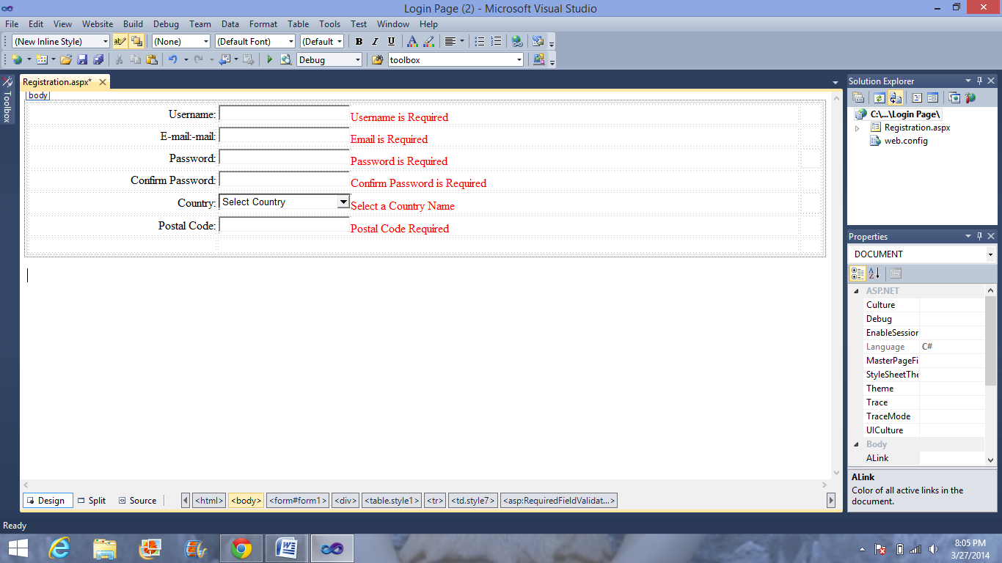

8. In the option "Select Country" i have inserted a dropdownlist and included various options of countries for the users to select.

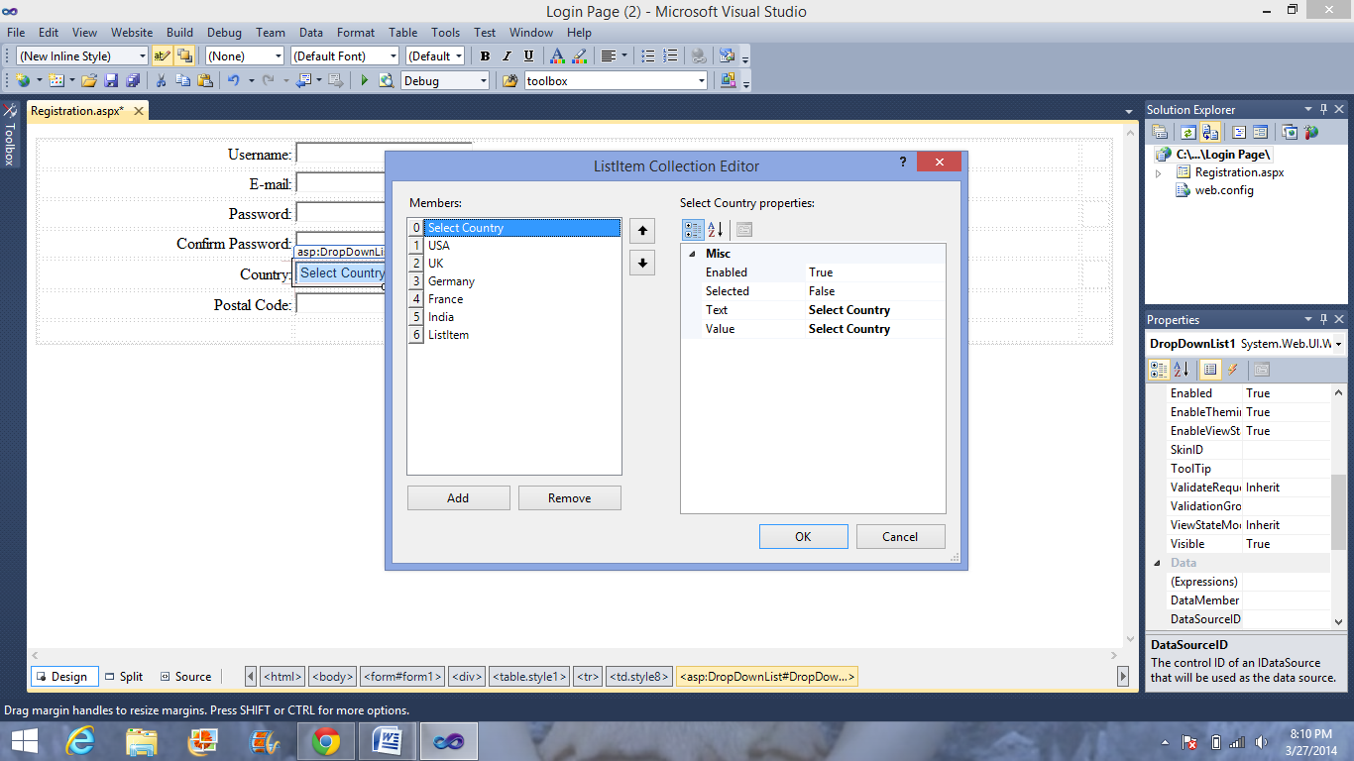

9.

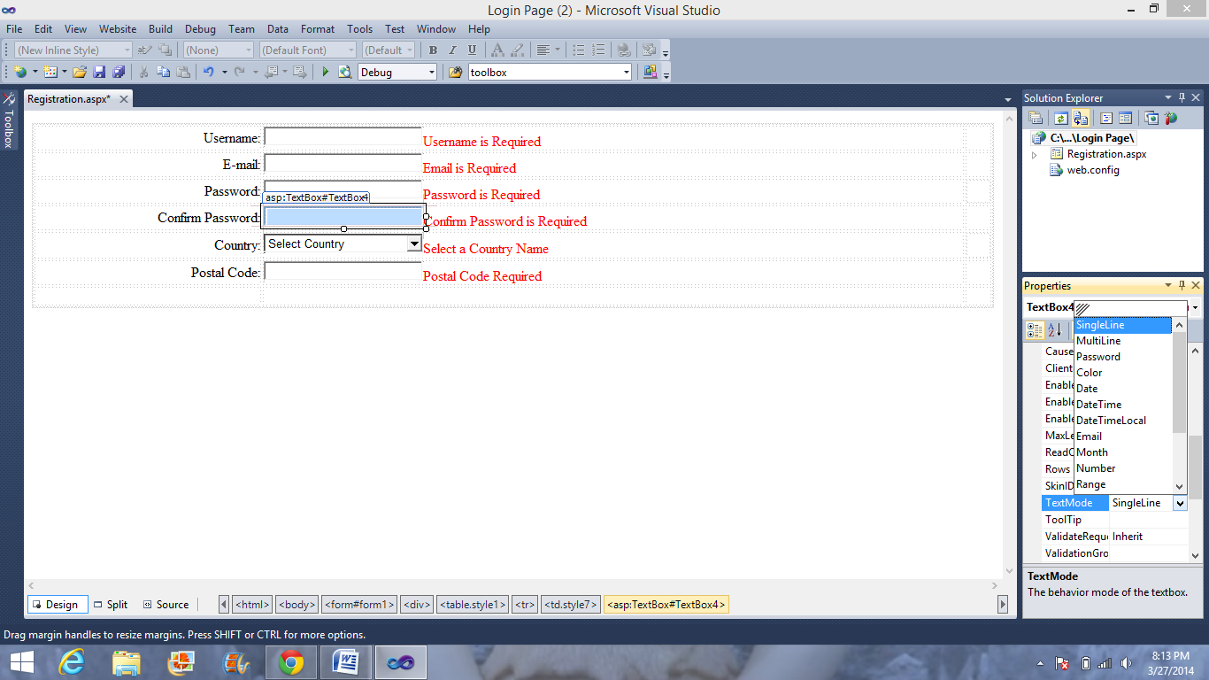

10. Now to check whether the user has entered the same passwords I have created another validator and set up connection between column 2 and 3 in the following way.. ControltoValidate - confirm password and ControltoCompare-Password

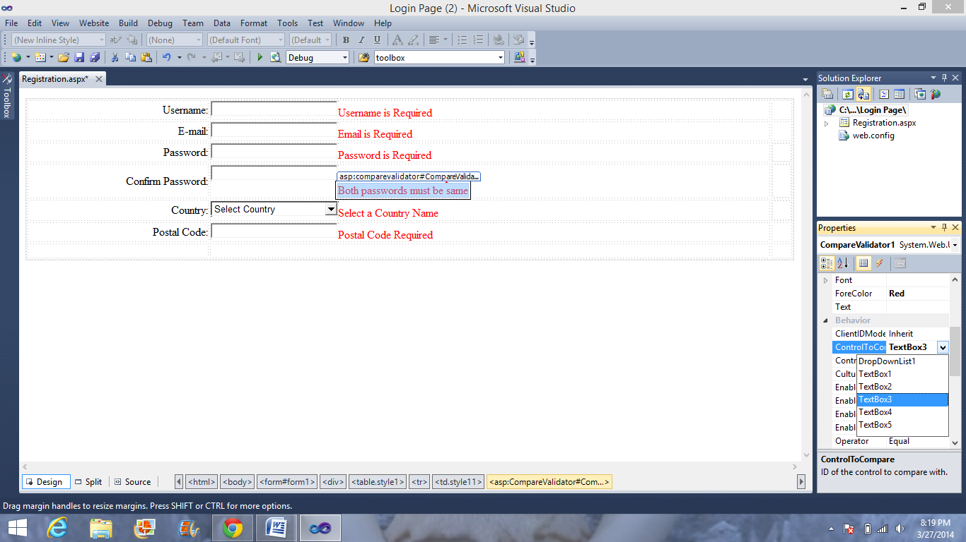

11. To check whether the user is entering the valid email id we use another validator and set its ValidationExpression to Internet e-mail address.

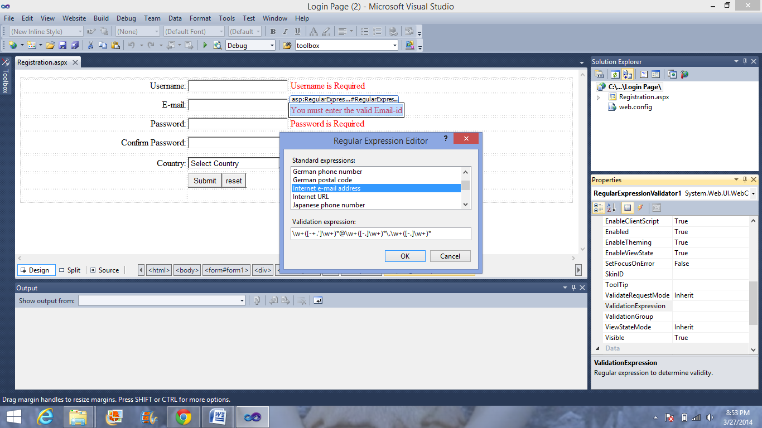

12. The following are the screen shots of the web page created we connect this to real time database and use it.

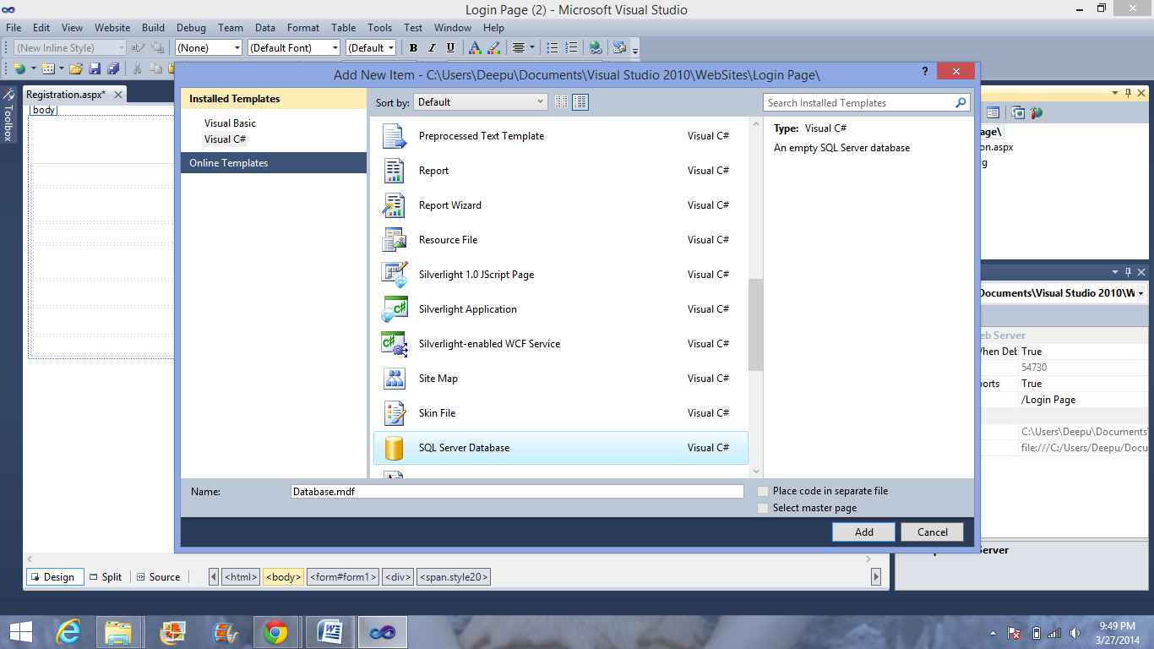

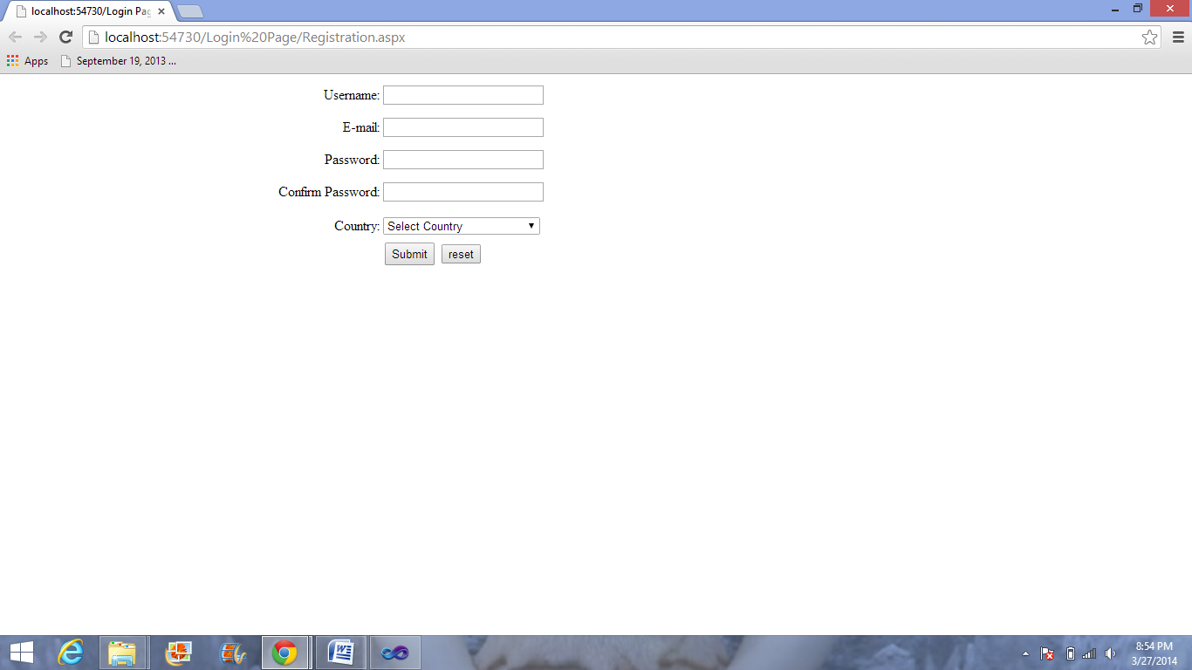

13.

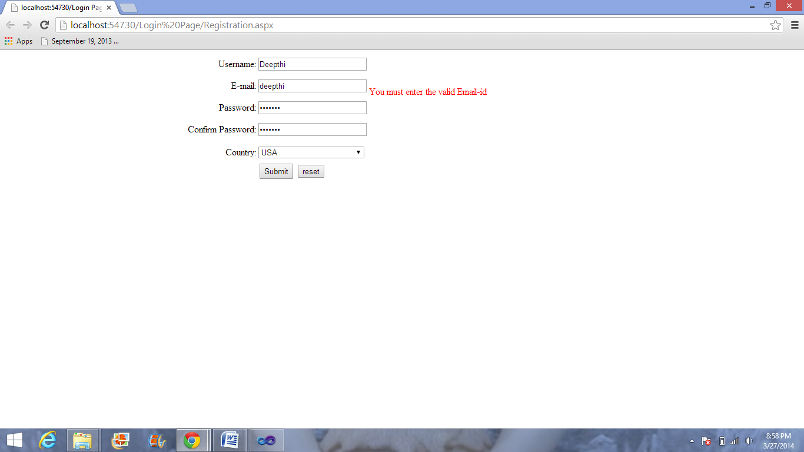

14.

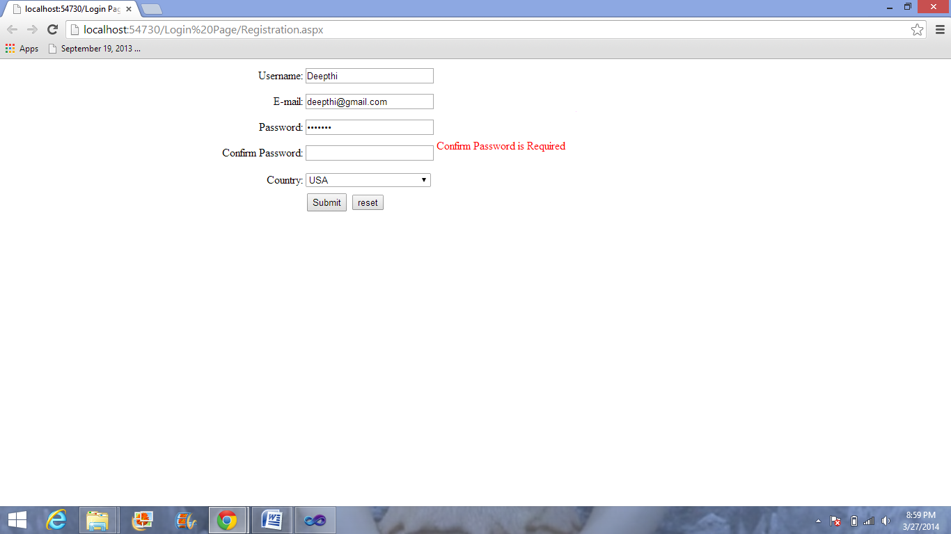

15.

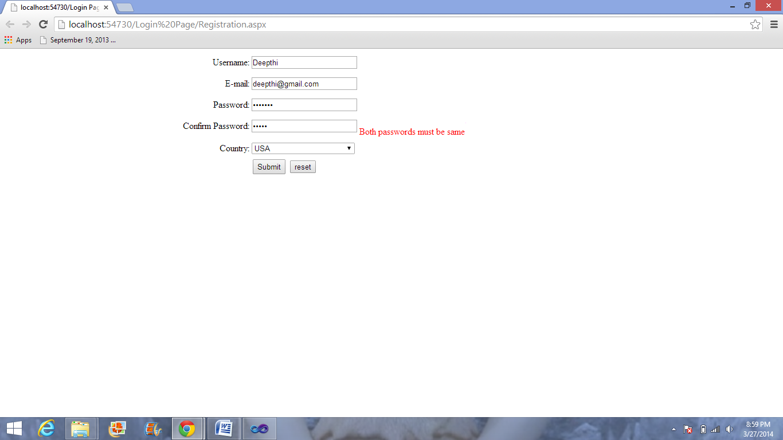

16.

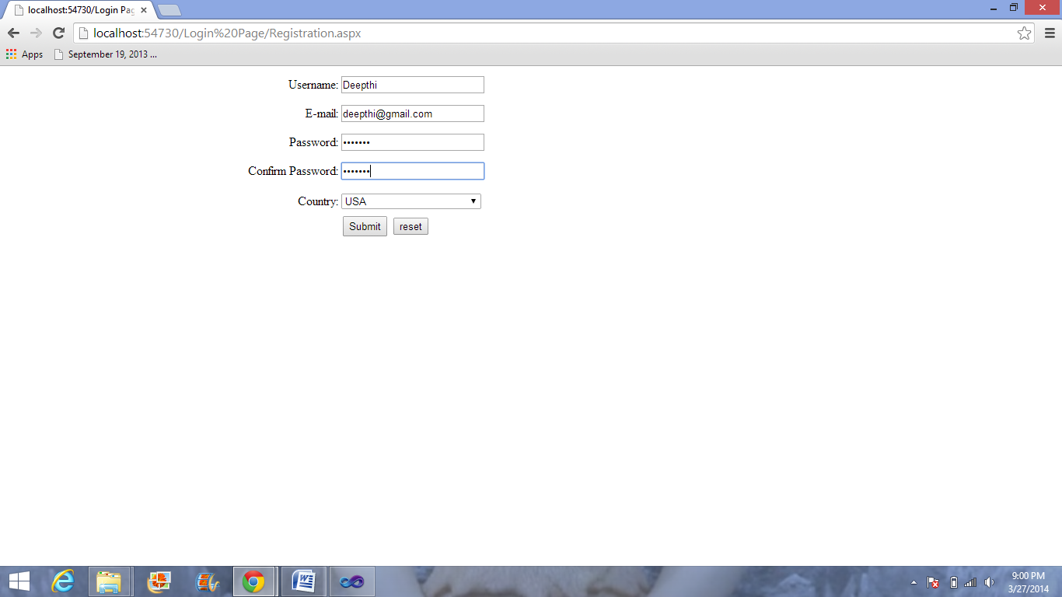

17.

