**WEEK 2: PL/SQL HandsOn**

**Exercise 1: Control Structures**

**Scenario 1:** The bank wants to apply a discount to loan interest rates for customers above 60 years old.

**Question:** Write a PL/SQL block that loops through all customers, checks their age, and if they are above 60, apply a 1% discount to their current loan interest rates.

**Query:**

BEGIN

FOR cust IN (

SELECT CustomerID

FROM Customers

WHERE MONTHS_BETWEEN(SYSDATE, DOB) / 12 > 60

) LOOP

UPDATE Loans

SET InterestRate = InterestRate - 1

WHERE CustomerID = cust.CustomerID;

END LOOP;

END;

/

**Output:**

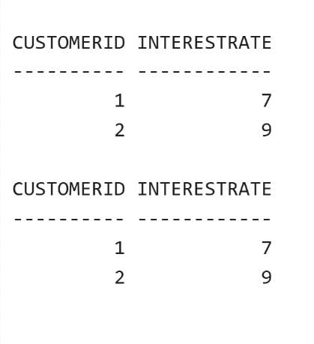

**Scenario 2:** A customer can be promoted to VIP status based on their balance.

**Question:** Write a PL/SQL block that iterates through all customers and sets a flag IsVIP to TRUE for those with a balance over $10,000.

**Query:**

BEGIN

FOR rec IN (

SELECT CustomerID, Balance FROM Customers

) LOOP

IF rec.Balance > 10000 THEN

UPDATE Customers

SET IsVIP = 'Y'

WHERE CustomerID = rec.CustomerID;

END IF;

END LOOP;

COMMIT;

END;

/

**Output:**

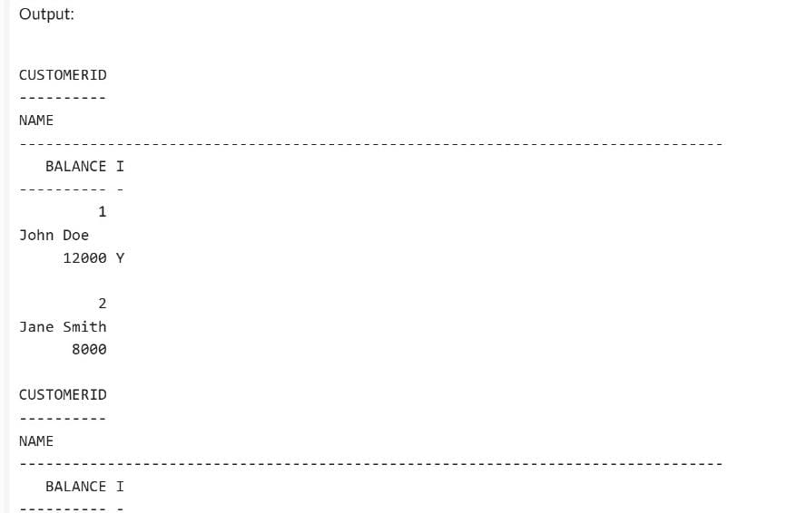

**Scenario 3:** The bank wants to send reminders to customers whose loans are due within the next 30 days.

**Question:** Write a PL/SQL block that fetches all loans due in the next 30 days and prints a reminder message for each customer.

**Query:**

BEGIN

FOR rec IN (

SELECT l.LoanID, c.Name, l.EndDate

FROM Loans l

JOIN Customers c ON c.CustomerID = l.CustomerID

WHERE l.EndDate BETWEEN SYSDATE AND SYSDATE + 30

) LOOP

DBMS_OUTPUT.PUT_LINE('Reminder: ' || rec.Name ||

', your loan (ID: ' || rec.LoanID ||

') is due on ' || TO_CHAR(rec.EndDate, 'YYYY-MM-DD'));

END LOOP;

END;

**Ouput:**

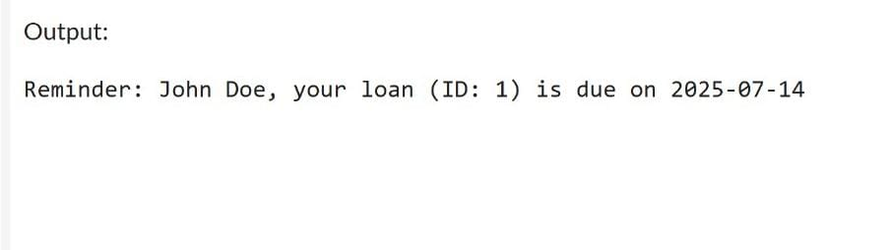

**Exercise 2: Error Handling**

**Scenario 1:** Handle exceptions during fund transfers between accounts.

**Question:** Write a stored procedure SafeTransferFunds that transfers funds between two accounts. Ensure that if any error occurs (e.g., insufficient funds), an appropriate error message is logged and the transaction is rolled back.

**Query:**

CREATE OR REPLACE PROCEDURE SafeTransferFunds (

p_from_account_id IN NUMBER,

p_to_account_id IN NUMBER,

p_amount IN NUMBER

) IS

v_balance NUMBER;

BEGIN

SELECT Balance INTO v_balance

FROM Accounts

WHERE AccountID = p_from_account_id;

IF v_balance < p_amount THEN

RAISE_APPLICATION_ERROR(-20001, 'Insufficient funds in source account.');

END IF;

UPDATE Accounts

SET Balance = Balance - p_amount

WHERE AccountID = p_from_account_id;

UPDATE Accounts

SET Balance = Balance + p_amount

WHERE AccountID = p_to_account_id;

COMMIT;

DBMS_OUTPUT.PUT_LINE('Transfer successful.');

EXCEPTION

WHEN OTHERS THEN

ROLLBACK;

DBMS_OUTPUT.PUT_LINE('Transfer failed: ' || SQLERRM);

END;

/

**Output:**

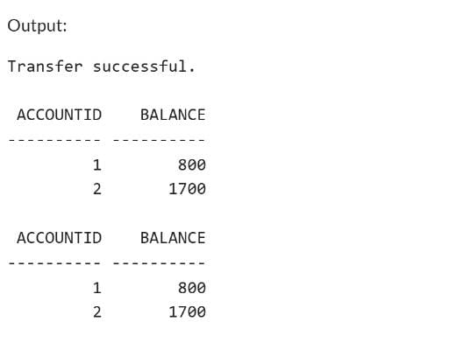

**Scenario 2:** Manage errors when updating employee salaries.

**Question:** Write a stored procedure UpdateSalary that increases the salary of an employee by a given percentage. If the employee ID does not exist, handle the exception and log an error message.

**Query:**

CREATE OR REPLACE PROCEDURE UpdateSalary (

p_emp_id IN NUMBER,

p_percent IN NUMBER

) IS

BEGIN

UPDATE Employees

SET Salary = Salary + (Salary * p_percent / 100)

WHERE EmployeeID = p_emp_id;

IF SQL%ROWCOUNT = 0 THEN

RAISE_APPLICATION_ERROR(-20002, 'Employee ID not found.');

ELSE

COMMIT;

DBMS_OUTPUT.PUT_LINE('Salary updated successfully.');

END IF;

EXCEPTION

WHEN OTHERS THEN

DBMS_OUTPUT.PUT_LINE('Error updating salary: ' || SQLERRM);

END;

/

BEGIN

UpdateSalary(1, 10);

END;

/

**Output:**

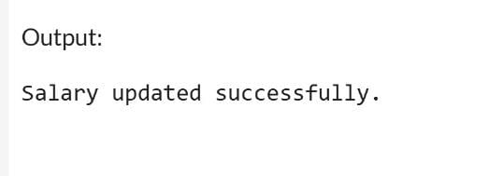

**Scenario 3:** Ensure data integrity when adding a new customer**.**

**Question:** Write a stored procedure AddNewCustomer that inserts a new customer into the Customers table. If a customer with the same ID already exists, handle the exception by logging an error and preventing the insertion.

**Query:**

CREATE OR REPLACE PROCEDURE AddNewCustomer (

p_customer_id IN NUMBER,

p_name IN VARCHAR2,

p_dob IN DATE,

p_balance IN NUMBER

) IS

BEGIN

INSERT INTO Customers (CustomerID, Name, DOB, Balance, LastModified)

VALUES (p_customer_id, p_name, p_dob, p_balance, SYSDATE);

COMMIT;

DBMS_OUTPUT.PUT_LINE('Customer added successfully.');

EXCEPTION

WHEN DUP_VAL_ON_INDEX THEN

DBMS_OUTPUT.PUT_LINE('Error: Customer with this ID already exists.');

WHEN OTHERS THEN

DBMS_OUTPUT.PUT_LINE('Unexpected error: ' || SQLERRM);

END;

/

BEGIN

AddNewCustomer(3, 'David Lee', TO_DATE('1992-09-10', 'YYYY-MM-DD'), 5000);

END;

/

**Output:**

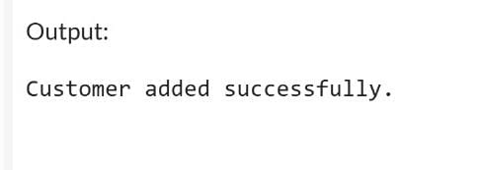

**Exercise 3: Stored Procedures**

**Scenario 1:** The bank needs to process monthly interest for all savings accounts.

**Question:** Write a stored procedure ProcessMonthlyInterest that calculates and updates the balance of all savings accounts by applying an interest rate of 1% to the current balance.

**Query:**

CREATE OR REPLACE PROCEDURE ProcessMonthlyInterest IS

BEGIN

UPDATE Accounts

SET Balance = Balance + (Balance * 0.01)

WHERE AccountType = 'Savings';

COMMIT;

DBMS_OUTPUT.PUT_LINE('Monthly interest applied to savings accounts.');

EXCEPTION

WHEN OTHERS THEN

DBMS_OUTPUT.PUT_LINE('Error applying interest: ' || SQLERRM);

ROLLBACK;

END;

/

BEGIN

ProcessMonthlyInterest;

END;

/

**Output:**

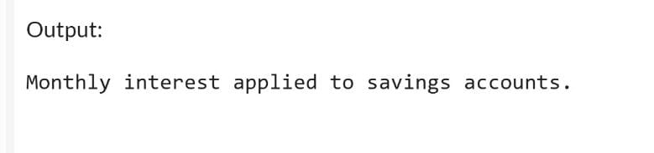

**Scenario 2:** The bank wants to implement a bonus scheme for employees based on their performance.

**Question:** Write a stored procedure **UpdateEmployeeBonus** that updates the salary of employees in a given department by adding a bonus percentage passed as a parameter.

**Query:**

CREATE OR REPLACE PROCEDURE UpdateEmployeeBonus (

p_department IN VARCHAR2,

p_bonus_pct IN NUMBER

) IS

BEGIN

UPDATE Employees

SET Salary = Salary + (Salary * p_bonus_pct / 100)

WHERE Department = p_department;

IF SQL%ROWCOUNT = 0 THEN

DBMS_OUTPUT.PUT_LINE('No employees found in department: ' || p_department);

ELSE

COMMIT;

DBMS_OUTPUT.PUT_LINE('Bonus applied to ' || SQL%ROWCOUNT || ' employee(s) in department ' || p_department);

END IF;

EXCEPTION

WHEN OTHERS THEN

DBMS_OUTPUT.PUT_LINE('Error updating bonus: ' || SQLERRM);

ROLLBACK;

END;

/

BEGIN

UpdateEmployeeBonus('IT', 5); -- Add 5% bonus to IT department

END;

/

**Output**:

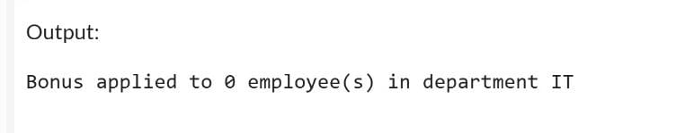

**Scenario 3:** **Customers should be able to transfer funds between their accounts.**

**Question:** Write a stored procedure TransferFunds that transfers a specified amount from one account to another, checking that the source account has sufficient balance before making the transfer.

**Query:**

CREATE OR REPLACE PROCEDURE TransferFunds (

p_from_account_id IN NUMBER,

p_to_account_id IN NUMBER,

p_amount IN NUMBER

) IS

v_balance NUMBER;

BEGIN

SELECT Balance INTO v_balance

FROM Accounts

WHERE AccountID = p_from_account_id;

IF v_balance < p_amount THEN

RAISE_APPLICATION_ERROR(-20001, 'Insufficient funds in source account.');

END IF;

UPDATE Accounts

SET Balance = Balance - p_amount

WHERE AccountID = p_from_account_id;

UPDATE Accounts

SET Balance = Balance + p_amount

WHERE AccountID = p_to_account_id;

COMMIT;

DBMS_OUTPUT.PUT_LINE('Transfer successful.');

EXCEPTION

WHEN OTHERS THEN

DBMS_OUTPUT.PUT_LINE('Transfer failed: ' || SQLERRM);

ROLLBACK;

END;

/

BEGIN

TransferFunds(1, 2, 300);

END;

/

**Output:**

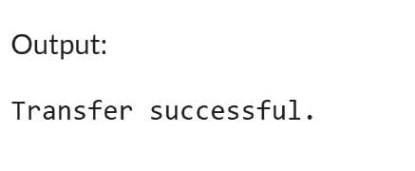

**Exercise 4: Functions**

**Scenario 1:** Calculate the age of customers for eligibility checks.

**Question:** Write a function CalculateAge that takes a customer's date of birth as input and returns their age in years.

**Query:**

CREATE OR REPLACE FUNCTION CalculateAge (

p_dob IN DATE

) RETURN NUMBER IS

v_age NUMBER;

BEGIN

v_age := TRUNC(MONTHS_BETWEEN(SYSDATE, p_dob) / 12);

RETURN v_age;

END;

/

**Output:**

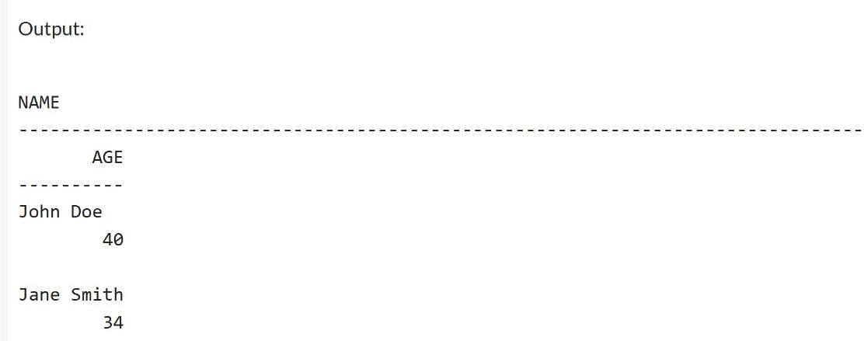

**Scenario 2:** The bank needs to compute the monthly installment for a loan.

**Question:** Write a function CalculateMonthlyInstallment that takes the loan amount, interest rate, and loan duration in years as input and returns the monthly installment amount.

**Query:**

CREATE OR REPLACE FUNCTION CalculateMonthlyInstallment (

p_loan_amount IN NUMBER,

p_annual_rate IN NUMBER,

p_years IN NUMBER

) RETURN NUMBER IS

v_monthly_rate NUMBER := p_annual_rate / 12 / 100;

v_months NUMBER := p_years * 12;

v_emi NUMBER;

BEGIN

IF v_monthly_rate = 0 THEN

v_emi := p_loan_amount / v_months;

ELSE

v_emi := (p_loan_amount * v_monthly_rate) /

(1 - POWER(1 + v_monthly_rate, -v_months));

END IF;

RETURN ROUND(v_emi, 2);

END;

/

**Output:**

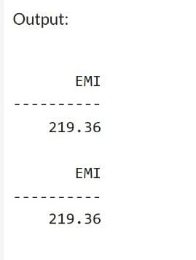

**Scenario 3:** Check if a customer has sufficient balance before making a transaction.

**Question:** Write a function **HasSufficientBalance** that takes an account ID and an amount as input and returns a boolean indicating whether the account has at least the specified amount.

**Query:**

CREATE OR REPLACE FUNCTION HasSufficientBalance (

p_account_id IN NUMBER,

p_amount IN NUMBER

) RETURN BOOLEAN IS

v_balance NUMBER;

BEGIN

SELECT Balance INTO v_balance

FROM Accounts

WHERE AccountID = p_account_id;

RETURN v_balance >= p_amount;

EXCEPTION

WHEN NO_DATA_FOUND THEN

RETURN FALSE;

WHEN OTHERS THEN

RETURN FALSE;

END;

/

DECLARE

v_result BOOLEAN;

BEGIN

v_result := HasSufficientBalance(1, 2000);

IF v_result THEN

DBMS_OUTPUT.PUT_LINE('Sufficient balance');

ELSE

DBMS_OUTPUT.PUT_LINE('Insufficient balance');

END IF;

END;

/

**Output:**

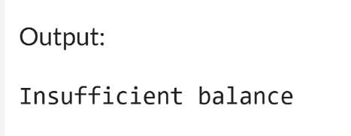

**Exercise 5: Triggers**

**Scenario 1:** Automatically update the last modified date when a customer's record is updated.

**Question:** Write a trigger UpdateCustomerLastModified that updates the LastModified column of the Customers table to the current date whenever a customer's record is updated.

**Query:**

CREATE OR REPLACE TRIGGER UpdateCustomerLastModified

BEFORE UPDATE ON Customers

FOR EACH ROW

BEGIN

:NEW.LastModified := SYSDATE;

END;

/

**Output:**

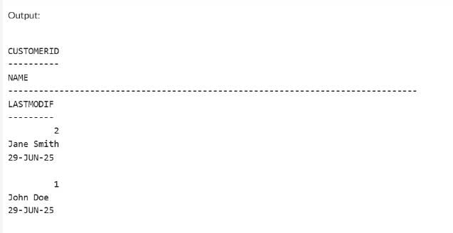

**Scenario 2:** Maintain an audit log for all transactions.

**Question:** Write a trigger **LogTransaction** that inserts a record into an AuditLog table whenever a transaction is inserted into the Transactions table.

**Query:**

CREATE TABLE AuditLog (

LogID NUMBER GENERATED ALWAYS AS IDENTITY PRIMARY KEY,

AccountID NUMBER,

TransactionDate DATE,

Amount NUMBER,

TransactionType VARCHAR2(10),

LoggedAt DATE

);

CREATE OR REPLACE TRIGGER LogTransaction

AFTER INSERT ON Transactions

FOR EACH ROW

BEGIN

INSERT INTO AuditLog (AccountID, TransactionDate, Amount, TransactionType, LoggedAt)

VALUES (:NEW.AccountID, :NEW.TransactionDate, :NEW.Amount, :NEW.TransactionType, SYSDATE);

END;

/

Output:

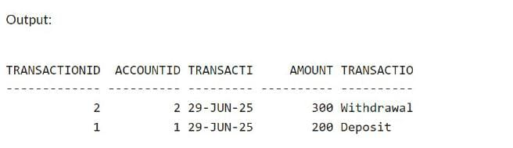

**Scenario 3:** Enforce business rules on deposits and withdrawals.

**Question:** Write a trigger CheckTransactionRules that ensures withdrawals do not exceed the balance and deposits are positive before inserting a record into the Transactions table.

**Query:**

CREATE OR REPLACE TRIGGER CheckTransactionRules

BEFORE INSERT ON Transactions

FOR EACH ROW

DECLARE

v_balance NUMBER;

BEGIN

-- Fetch current account balance

SELECT Balance INTO v_balance

FROM Accounts

WHERE AccountID = :NEW.AccountID;

IF :NEW.TransactionType = 'Deposit' AND :NEW.Amount <= 0 THEN

RAISE_APPLICATION_ERROR(-20001, 'Deposit amount must be greater than 0.');

END IF;

IF :NEW.TransactionType = 'Withdrawal' AND :NEW.Amount > v_balance THEN

RAISE_APPLICATION_ERROR(-20002, 'Withdrawal exceeds available balance.');

END IF;

END;

/

**Output:**

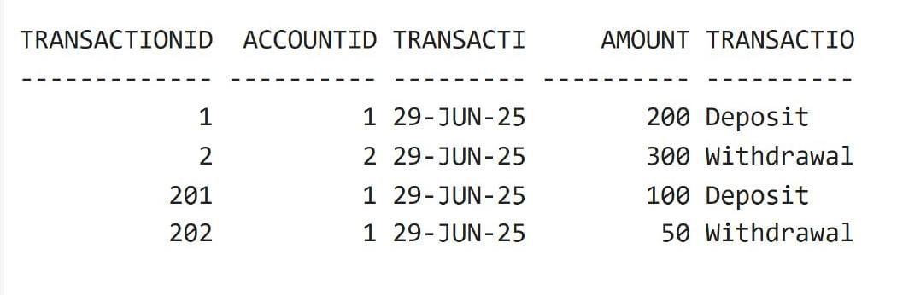

**Exercise 6: Cursors**

**Scenario 1:** Generate monthly statements for all customers.

**Question:** Write a PL/SQL block using an explicit cursor GenerateMonthlyStatements that retrieves all transactions for the current month and prints a statement for each customer.

**Query:**

BEGIN

DBMS_OUTPUT.PUT_LINE('--- Monthly Customer Transaction Statements ---');

OPEN cur_monthly_transactions;

LOOP

FETCH cur_monthly_transactions INTO v_transaction_id, v_customer_name, v_transaction_date, v_amount, v_type;

EXIT WHEN cur_monthly_transactions%NOTFOUND;

DBMS_OUTPUT.PUT_LINE('Customer: ' || v_customer_name ||

', Date: ' || TO_CHAR(v_transaction_date, 'YYYY-MM-DD') ||

', Type: ' || v_type ||

', Amount: ' || v_amount);

END LOOP;

CLOSE cur_monthly_transactions;

END;

/

**Output:**

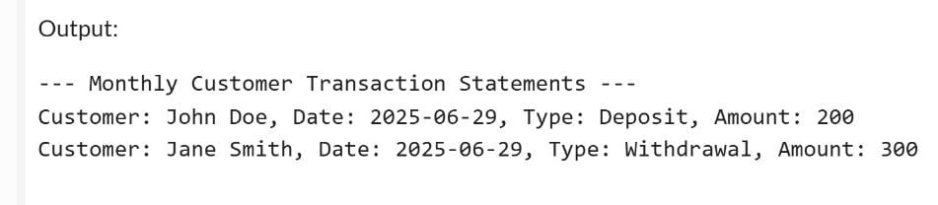

**Scenario 2:** Apply annual fee to all accounts.

**Question:** Write a PL/SQL block using an explicit cursor ApplyAnnualFee that deducts an annual maintenance fee from the balance of all accounts.

**Query:**

DECLARE

CURSOR cur_accounts IS

SELECT AccountID, Balance FROM Accounts;

v_account_id Accounts.AccountID%TYPE;

v_balance Accounts.Balance%TYPE;

v_fee CONSTANT NUMBER := 100; -- Annual fee amount

BEGIN

OPEN cur_accounts;

LOOP

FETCH cur_accounts INTO v_account_id, v_balance;

EXIT WHEN cur_accounts%NOTFOUND;

UPDATE Accounts

SET Balance = Balance - v_fee

WHERE AccountID = v_account_id;

DBMS_OUTPUT.PUT_LINE('Annual fee of ' || v_fee || ' applied to Account ID ' || v_account_id);

END LOOP;

CLOSE cur_accounts;

COMMIT;

END;

/

**Output:**

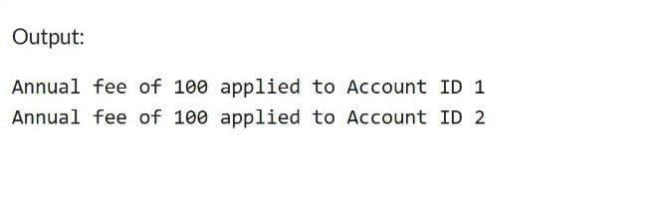

**Scenario 3:** Update the interest rate for all loans based on a new policy.

**Question:** Write a PL/SQL block using an explicit cursor UpdateLoanInterestRates that fetches all loans and updates their interest rates based on the new policy.

**Query:**

DECLARE

CURSOR cur_loans IS

SELECT LoanID, InterestRate FROM Loans;

v_loan_id Loans.LoanID%TYPE;

v_interest Loans.InterestRate%TYPE;

v_new_rate NUMBER;

BEGIN

OPEN cur_loans;

LOOP

FETCH cur_loans INTO v_loan_id, v_interest;

EXIT WHEN cur_loans%NOTFOUND;

v_new_rate := v_interest - 0.5;

UPDATE Loans

SET InterestRate = v_new_rate

WHERE LoanID = v_loan_id;

DBMS_OUTPUT.PUT_LINE('Loan ID ' || v_loan_id ||

' interest rate updated from ' || v_interest ||

' to ' || v_new_rate);

END LOOP;

CLOSE cur_loans;

COMMIT;

END;

/

**Output:**

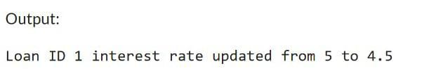

**Exercise 7: Packages**

**Scenario 1:** Group all customer-related procedures and functions into a package.

**Question:** Create a package CustomerManagement with procedures for adding a new customer, updating customer details, and a function to get customer balance.

**Query:**

CREATE OR REPLACE PACKAGE CustomerManagement AS

PROCEDURE AddCustomer(p_id NUMBER, p_name VARCHAR2, p_dob DATE, p_balance NUMBER);

PROCEDURE UpdateCustomer(p_id NUMBER, p_name VARCHAR2, p_balance NUMBER);

FUNCTION GetCustomerBalance(p_id NUMBER) RETURN NUMBER;

END CustomerManagement;

/

CREATE OR REPLACE PACKAGE BODY CustomerManagement AS

PROCEDURE AddCustomer(p_id NUMBER, p_name VARCHAR2, p_dob DATE, p_balance NUMBER) IS

BEGIN

INSERT INTO Customers VALUES (p_id, p_name, p_dob, p_balance, SYSDATE);

END;

PROCEDURE UpdateCustomer(p_id NUMBER, p_name VARCHAR2, p_balance NUMBER) IS

BEGIN

UPDATE Customers SET Name = p_name, Balance = p_balance, LastModified = SYSDATE WHERE CustomerID = p_id;

END;

FUNCTION GetCustomerBalance(p_id NUMBER) RETURN NUMBER IS

v_balance NUMBER;

BEGIN

SELECT Balance INTO v_balance FROM Customers WHERE CustomerID = p_id;

RETURN v_balance;

END;

END CustomerManagement;

/

BEGIN

DBMS_OUTPUT.PUT_LINE('CustomerBalance: CustomerManagement.GetCustomerBalance(1));

END;

/

**Output:**

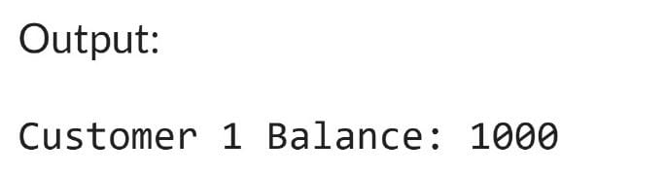

**Scenario 2:** Create a package to manage employee data.

**Question**: Write a package EmployeeManagement with procedures to hire new employees, update employee details, and a function to calculate annual salary.

**Query:**

CREATE OR REPLACE PACKAGE EmployeeManagement AS

PROCEDURE HireEmployee(p_id NUMBER, p_name VARCHAR2, p_position VARCHAR2, p_salary NUMBER, p_dept VARCHAR2);

PROCEDURE UpdateEmployee(p_id NUMBER, p_salary NUMBER);

FUNCTION GetAnnualSalary(p_id NUMBER) RETURN NUMBER;

END EmployeeManagement;

/

CREATE OR REPLACE PACKAGE BODY EmployeeManagement AS

PROCEDURE HireEmployee(p_id NUMBER, p_name VARCHAR2, p_position VARCHAR2, p_salary NUMBER, p_dept VARCHAR2) IS

BEGIN

INSERT INTO Employees VALUES (p_id, p_name, p_position, p_salary, p_dept, SYSDATE);

END;

PROCEDURE UpdateEmployee(p_id NUMBER, p_salary NUMBER) IS

BEGIN

UPDATE Employees SET Salary = p_salary WHERE EmployeeID = p_id;

END;

FUNCTION GetAnnualSalary(p_id NUMBER) RETURN NUMBER IS

v_salary NUMBER;

BEGIN

SELECT Salary INTO v_salary FROM Employees WHERE EmployeeID = p_id;

RETURN v_salary * 12;

END;

END EmployeeManagement;

/

BEGIN

DBMS_OUTPUT.PUT_LINE('Annual Salary of Employee 1: ' || EmployeeManagement.GetAnnualSalary(1));

END;

/

**Output:**

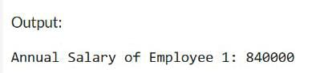

**Scenario 3:** Group all account-related operations into a package.

**Question:** Create a package AccountOperations with procedures for opening a new account, closing an account, and a function to get the total balance of a customer across all accounts.

**Query:**

CREATE OR REPLACE PACKAGE AccountOperations AS

PROCEDURE OpenAccount(p_account_id NUMBER, p_customer_id NUMBER, p_account_type VARCHAR2, p_balance NUMBER);

PROCEDURE CloseAccount(p_account_id NUMBER);

FUNCTION GetTotalBalance(p_customer_id NUMBER) RETURN NUMBER;

END AccountOperations;

/

CREATE OR REPLACE PACKAGE BODY AccountOperations AS

PROCEDURE OpenAccount(p_account_id NUMBER, p_customer_id NUMBER, p_account_type VARCHAR2, p_balance NUMBER) IS

BEGIN

INSERT INTO Accounts VALUES (p_account_id, p_customer_id, p_account_type, p_balance, SYSDATE);

END;

PROCEDURE CloseAccount(p_account_id NUMBER) IS

BEGIN

DELETE FROM Accounts WHERE AccountID = p_account_id;

END;

FUNCTION GetTotalBalance(p_customer_id NUMBER) RETURN NUMBER IS

v_total NUMBER;

BEGIN

SELECT NVL(SUM(Balance), 0) INTO v_total FROM Accounts WHERE CustomerID = p_customer_id;

RETURN v_total;

END;

END AccountOperations;

/

BEGIN

AccountOperations.OpenAccount(5, 1, 'Savings', 2000);

DBMS_OUTPUT.PUT_LINE('Total Balance: ' || AccountOperations.GetTotalBalance(1));

AccountOperations.CloseAccount(5);

END;

**/**

**Output:**

