GIT CONCEPTS :

1. GITHUB Repo create
2. Git clone, pull repo
3. Git add, commit, push changes to repo
4. Create empty repo and add readme files,…
5. Git branches
6. Merging branches

GIT – VCS (version control sys)

GITHUB - SCM (source code mgmt.)

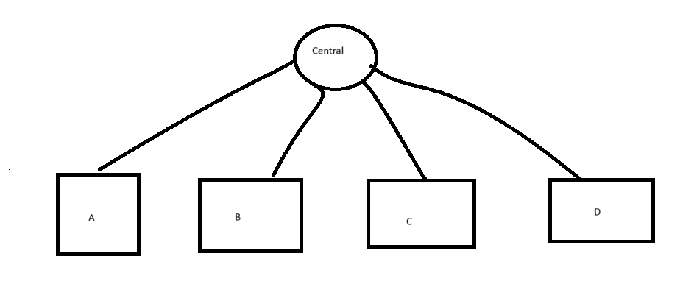

A, B, C, D are local repositories , central is remote repository

A, B, c, d can generate versions for every changes we have done , vesions can generate unique id for that repo

If a, b, c,d writes code and place them in central, so that any one can use their code that is (SCM)

**Create github account**

**Create first repository**

Git clone, pull, private and public repos:

Git clone is used only once to copy the remote repo to local machine

Git pull is used to get latest changes

Private – can be seen only restricted users

Public – can be seen by everyone but can’t modify the code

Git flow:

Git commit and push with complete git flow:

So create a two dev’s dev1, dev2 directories in ur local machine. inside that clone the “DeepthiRepo”repo from github

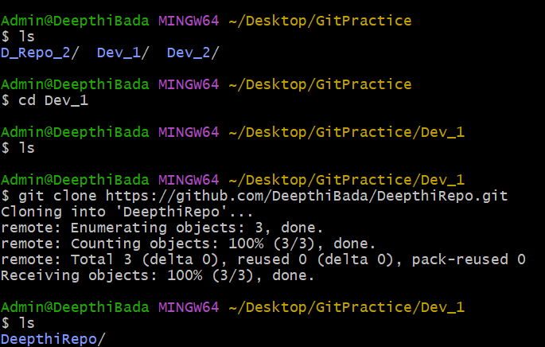

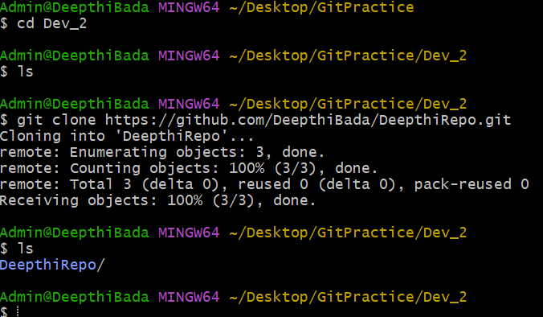

Add one file in dev2 workspace and push the changes into github repository.

The “demo” file is added by me in dev2 workspace

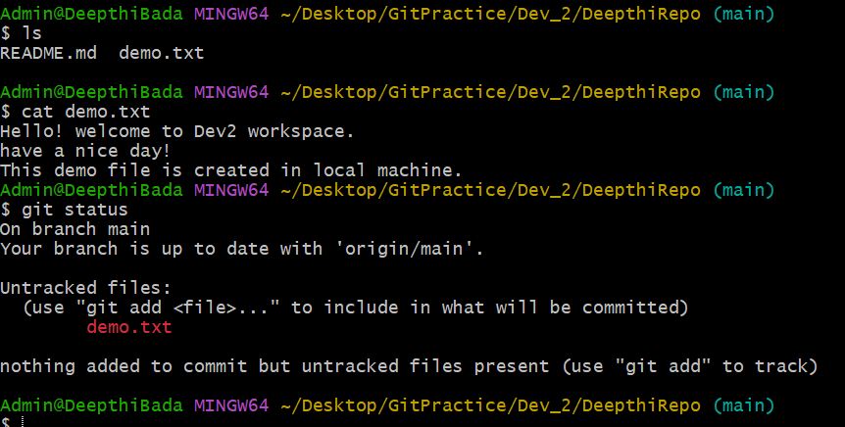

Here we can see the untracked files, we haven’t commit the changes 🡪 so it is there under untracked files (they are not ready to commit)

In ordre to be in commit they are need to be in staging area. So that they can be moved into the .git repository of local machine 🡪 which are in .git repo those can be pushed to github repository / remote repository

So those untracked filrs are not in staging area -> so to be in staging area we have to use “add” and move the files to staging area

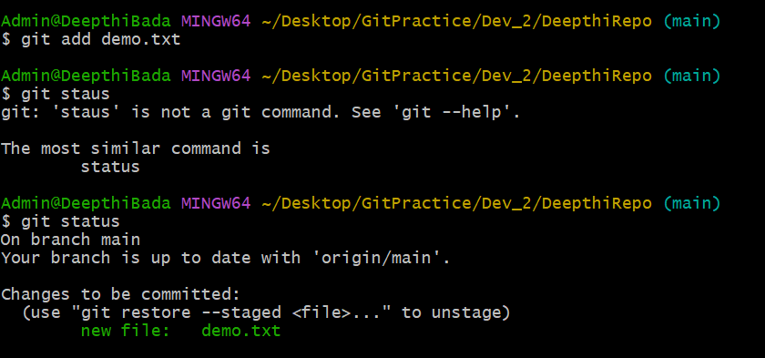

So files are in staging area -> which are ready to be committed

To commit them we have to use “commit”

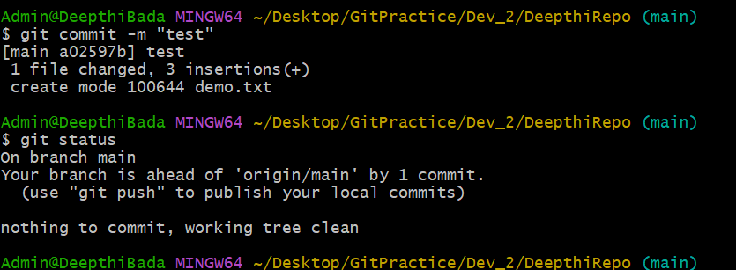

So to push the changes into github repo :

Use the push command

Initially I’m in main branch , so it may cause error (I have got error so I have made changes like this to change that into master branch)

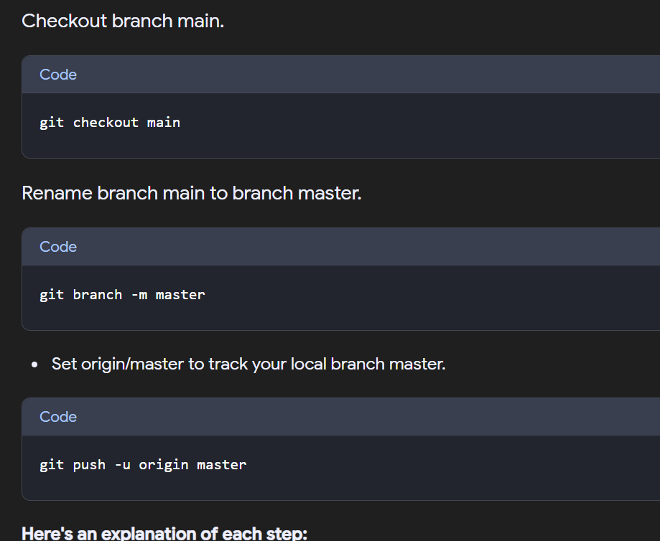

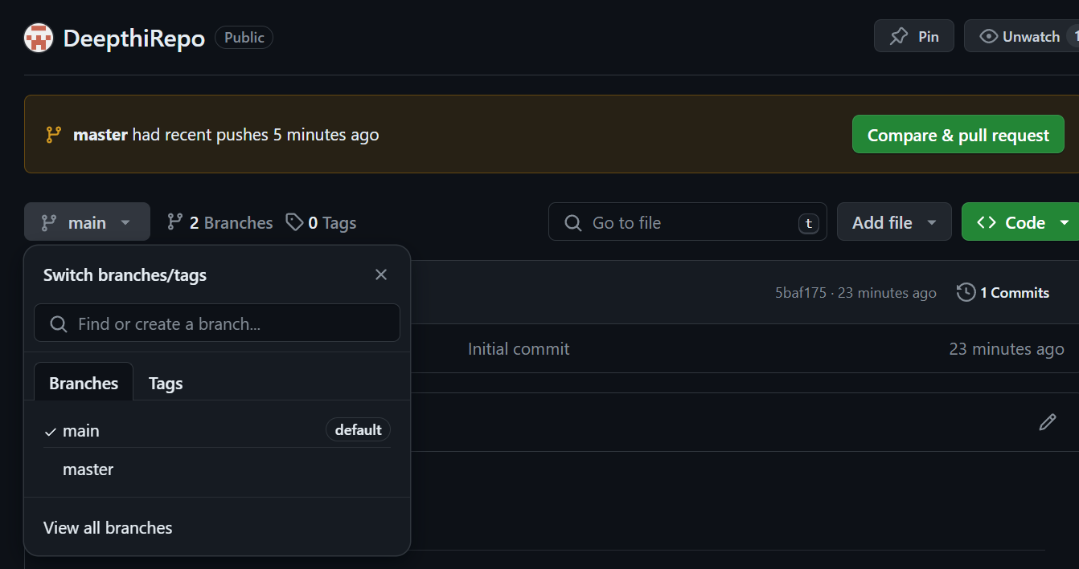

Switch to master and see the changes that we have made in out local machine and pushed into github repo

We can do the changes two ways:

1. Local to remote repos
2. Remote to local repos

Local to remote:

We have to follow the above steps

* Git clone
* Add any physical files in ur workspace
* And follow the git flow

Remote to local:

* Clone the repo
* Pull - to get the latest changes that we have made in github / remote repo

we have created Dev1 folder right, so to pull the same Repo which is in Dev2..we can do it by pull

Dev1 wants to create 3 more files and push into the same repo in Dev2 , and see the changes

Here I have created 3 more files , but I need to push only 2 files into the repo.

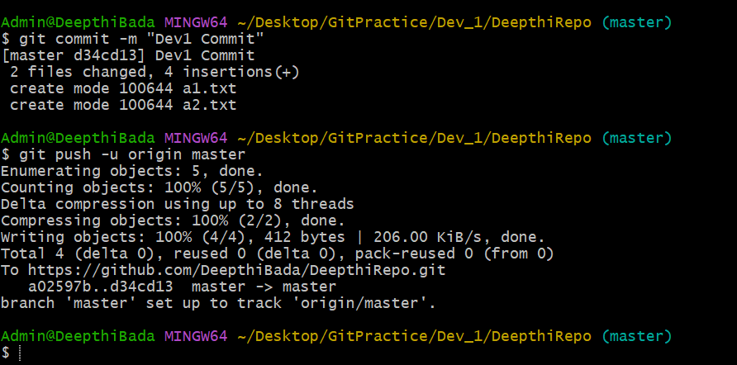

We can see the changes that we have made here in github repo..but not in Dev2 folder In our local machne(if we want we need to pull the changes).

Before pulling :

After pulling:

To know the which repository we are working : **git remote -v**

Git versioning:

We can see the changes, they have uniq id generated in local git repo

For every change it generates unique id which is known as git versioning

git add . -> it will add all the files of curr directory to staging area

git add a.txt b.txt c.txt -> it will add a,b,c files to staging area

git add –all -> used to add all files of entire repo to staging area

Git branch : copy of source code

For every repo there is default branch which is “MASTER”, we can change also in settings

Dev1, Dev2 is working on creating a website

They developed a “Sign -In” page and kept the code in master branch

The code which is kept in master branch is given to dev application server for checking the code -> testing -> production

At the same time, if we consider devops then in that case there is automation…they decided to release the feature by feature

dev1/dev2 needs not wait for 6 months to test the code and to release next functionality.

So in this case we can make use of creating branches, we can move the copy of that branch to new branch which is either (testing, pre-production or production, dev branches) by that we can work on the next functionality(Registartion) parallely irrespective of waiting for previous feature (SIGN IN).

If we do like this then there is no ambiguity and disturbance between them to test the code correctly.

**Create branch:**

We can create new branch from previous branch.

Any changes we do in prev branch or new branch doesn’t change the from branch , both are independent to each other.

**Creating and working with git branches:**

To list branches: git branch

Creating a new branch : git branch name

Switching to another branch : git checkout <branchname>

Creating and switching to new branch : git checkout -b <branchname>

Renaming a branch : git branch -m <oldname> <newname>

**Merging branches**:

Git merge <branch_name>

Learn more about merging branches (not understand perfectly)