Linux / unix os

1. Introduction to linux
2. Linux file system
3. Ls, date and cal commands
4. Working with directories
5. Working with files

**What is unix?**

What are the flavors of unix?

Components of unix

Unix : it is os, by using this user/applications communicate with h/w components

**Features of unix:**

* Free open source s/w
* Multi user os
* Multi tasking os
* Both GUI and CLI supports
* More secured

Flavors of unix: with lots of extensions and improvements several flavors of unix are formed Redhat linux, ubuntu, suse, centos, fedora, slackware etc.,

**Components**:

1. User / applications
2. Shell
3. Kernel
4. Hardware

**Linux File System**:

In linux everything is treated as a file.

Files are divided into 3 types:

1. Normal files – like text files, audio, video files
2. Directory files – folders, dire contains files and sub directories
3. Device files – these files r used to communicate with that device

File sys navigation commands:

1. . represents current directory

.. represents previous(parent) directory

1. cd . 🡪 curr dir
2. cd .. 🡪 parent dir
3. cd ~ -----> home dir
4. cd ------> home dir
5. cd - previous working dir

File system hierarchy(FSH) in LINUX:

Everything in linux is treated as file.

“/” is the topmost directory – parent directory

In which we have sub directories – home, bin, sbin, temp, proc, mount, media….etc

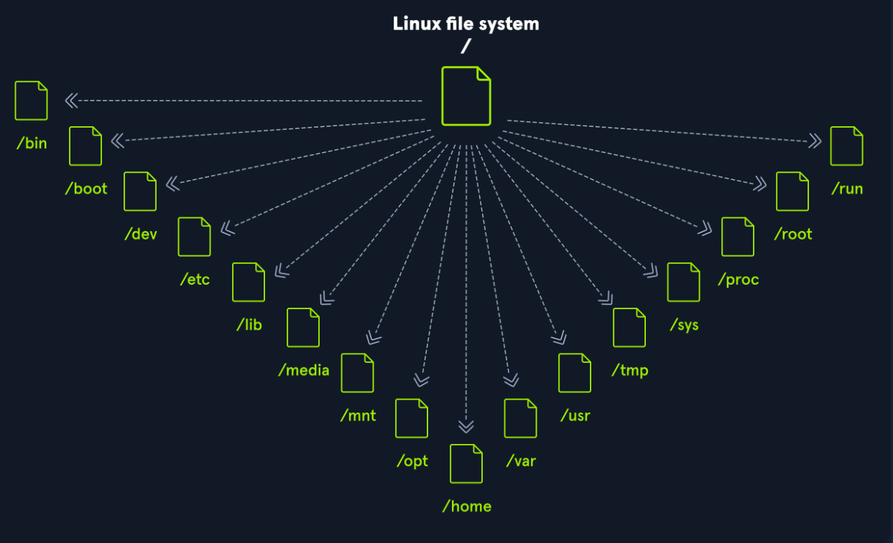

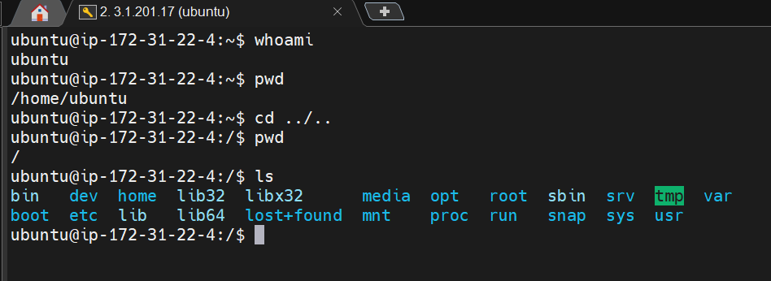

Here in sc we can see the files and directories that are present in “/” root directory

1. bin

here we can see all the executable commands

Cat : We can see those executable files by using the command : cat ls , cat truncate,…

Cp : We can also copy the executable file to some other file and make use the new file with same functionality of executable file.

While copying it won’t allow u to copy those files directly, so for that we can to use “sudo” along with that, then it allows us to copy.

rm : we can remove those executable files

1. sbin

here we can see super binaries executables

The directory contains executables used for system administration (binary sys files)

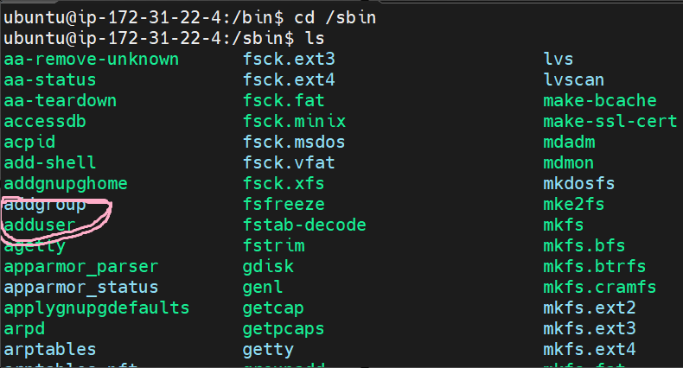

1. usr

contains executables, libraries, man files etc.,

/usr/bin = /bin

/usr/sbin = /sbin

1. home

here in this directory, users have separate directory to hold the specific info related to that specific user

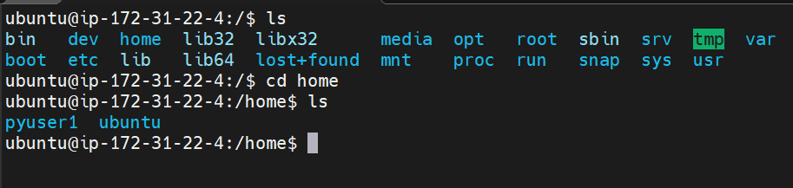

So here we have two users in the home directory

1. root

root is home directory of super user

/home/ubuntu -> ubuntu user home dire

/root -> super user home dir

1. dev

these are device files which files are used to communicate with devices

ex: tty, ram, fd, hd, stdin, stdout, stderr

1. etc

this directory contains all system config files. These config files can be used to customize the behaviour of linux os.

1. mnt

for suppose u have connected usb to system, so to get the files present in that usb drive we have to do it manually by doing some actions

1. media

if we mount the files automatically , then those comes under “media” directory

mnt – contains manual mounting files

media – contains automatic mounting files

1. var – this directory stores the files which are changing frequently (log files, cron jobs, web application related files etc..)
2. proc (processes) – the data related to curr running process will be stored in proc dir

doubt:

**Ls, date and cal commands:**

ls : used to lists all files and directories present in working directory

Various options of “ls” command:

ls -----#it displays all files and directories in alphabetical order

ls -r ------#displays in reverse order

ls | more ----#displays content line by line

ls | pg ------#displays content page by page

ls -l ------#long listing files

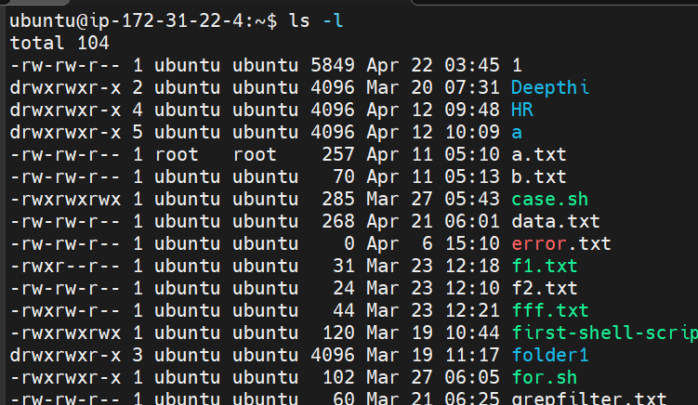

Type of file -> user, group, other permissions -> number of link files -> owner name -> group name -> file size in bytes -> last modified date and time or creation time -> file name or directory name

Here we can observe ‘d’ represents directory, ‘-’ represents ordinary or normal files

Next 3 are user permissions, 3-6 are group, 6-9 are other permissions

Next field represents number of links to that particular directory or file have

3rd column shows owner name

4th column represents group name

5th column shows size of file in bytes

6th column shows last modified date

7th column shows folder or file name

ls -t --------#display all files based on last modified date and time. Most recent are at top and old are at bottom.

ls -rt--------#display recent files at bottom and old are at top (opposite to “ls -t”)

ls -a--------#display all hidden files including . and ..

ls -A-------#almost all including hidden files except . and ..

ls -F -------#to display all files types

/ - represents directory

* - represents executable files

@ - link files

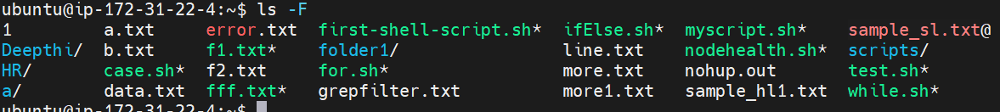

ls -f ------#to disable colours of files and directories

ls -i ------#to display all files with inode number

inode is the address of the location where the file attributes are stored

ls -R ----#recursive (it displays all files and directories including subdirectories contents also)

ls -s -----#number of blocks used by file is displayed

ls -h -----#human readable format

date +%D ---- date

+%T ----month, +%d -----day, m----month,y------year(yy), Y-----year (yyyy)

H----hours, M----minutes, S------seconds

Cal ----- can support only from 1 to 9999

**Working with directories**:

1. creation of directories

mkdir ----used to create directories

* mkdir dir1 -----creating a single directory
* mkdir dir1 dir2 dir3 ---- creating multiple directories
* mkdir dir1/dir2/dir3 ---- here creating dir3 within dir2, but dir1 and dir2 should be available…if not then it results error
* mkdir -p dir4/dir5/dir6 ------ if dir4 and dir5 is not available then it creates those directories in that specified path

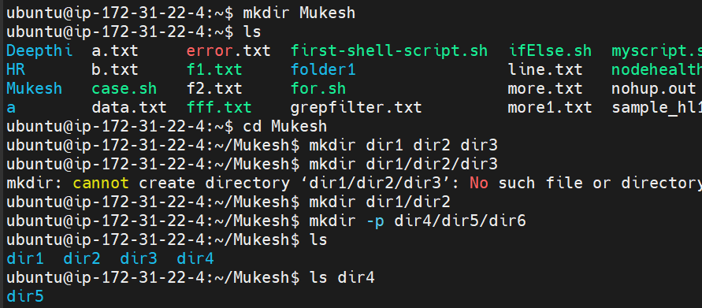

Case study -1:

Consider a “Friends” dir -> create any number of sub directories -> create subdirectories within the sub dir (same child sub dir for all the parent sub dir) -> create files

Here in Jashu folder we haven’t created jan,feb, mar folders to create files in that folder that’s why we are getting this error message.

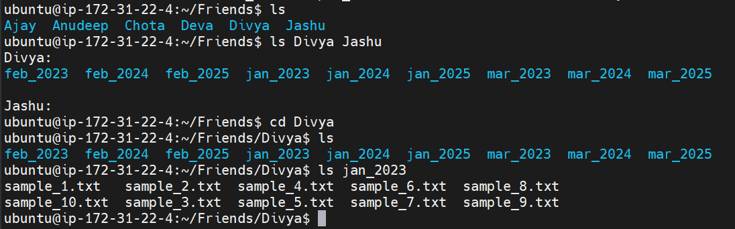

1. removing directories

* rmdir dir1 – to remove single empty directory
* rmdir dir1 dir2 dir3 – to remove multiple empty directories

rmdir is used to remove empty directories and it can’t be applied to files. So use “rm” to remove files and directories (empty or non-empty)

whenever we use rm for directories, use -r or -R option with “rm” case is not important.

In linux os, there is no way to undo operation, so we have to be careful while removing the files.

rm -r / ----- it removes entire linux file system (so be careful with this command)

various options with rm:

1. interactive option (-i)

rm -ir ---- interactive (which takes confirmation response from user whether we have to delete the file or not)

1. force removal (-f)

while removing files or dircetories, if we don’t want any error messages, then go woth this option

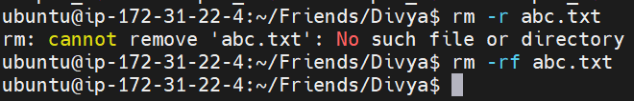

1. verbose option (-v)

if we want to know , what files we are removed we can go with this option

1. copy command(cp)
2. file to file

copying from one file to another file

cp file1 file2

if ifile2 is not available, then it creates new file2 and copies the data from file1

if file2 is already available, then it overwrites the data

1. copy file to directory

cp file1 file2 dir1

here we can copy any number of files into a directory, but dir should be already available.

1. Copy all files of one dir to another directory

cp dir1/* dir2

dir2 should be already available

1. Copy total directory to another directory (-r should be used compulsory)

cp -r dir1 dir2

1. Copy multiple directories into a single directory (r should be mandatory)

cp -r dir1 dir2 dir3 dir4 dir5 dir6

dir1,..dir5 is copied into dir6

1. Copying multiple files into a single file is not possible

cp fil1 file2 file3 file4 file5 ---- (not possible)

1. Moving and renaming (mv)
2. Renaming files
3. Renaming directories
4. Moving all files of one dire to another dir
5. Moving files to dir
6. Moving total dir to another dir