Linux Booting:

It is a process to initiate a laptop or desktop with os.

* When you press the power button then internally some process is going so, that is known as booting
* Booting process follows some steps internally, below are the steps :

1. BIOS – Basic input o/p sys

Post(power on self test)

Hw ram, rom, cd-rom

1. MBR(master boot record) – boot recorder
2. GRUB (grand unit boot loader)- handles multiple os
3. Kernal – take care of os into ram
4. INIT process

0 halt

1 Single usermode

2 multiuser

3 full multiuser mode

4 unused

5 graphical mode

6 reboot

1. Run level

BIOS / UEFI :

A low-level s/w that initializes our computer’s h/w to make sure everything is good to go

POST :

The BIOS runs a process called Power On Self Test

The POST performs the series of diagnostic tests to make sure that the computer is in proper working order

Boot device selection:

Next, the boot device will be selected. The device attached to the systems like hard-drive, USB drive, CD or DVD drive

Boot loader:

The comp will search for a bootloader. Bootloader is a small program that loads the operating system.

Kernel :

Once the bootloader loads operating sys, the kernel gets loaded. The kernel controls access to our computer resources. It also loads drivers(process mgmt., memory mgmt., file, i/o, disk mgmnt) for h/w attached to the computer

Next, essential sys processes and user space will be launched. Then the login process will allow th user to interact the computer sys.

Boot process steps:

Power on -> SMPS(switched mode power suplly) (AC – 230v to DC-12 or 9v)- it will supply power supply to all the motherboard components -> POST (Power On Self Test) -> BIOS (starts self test (POST) ) -> Bootdevice (detects hrd disk) -> MBR (master boot record) [Bootloader – Partitition table – Magic table]

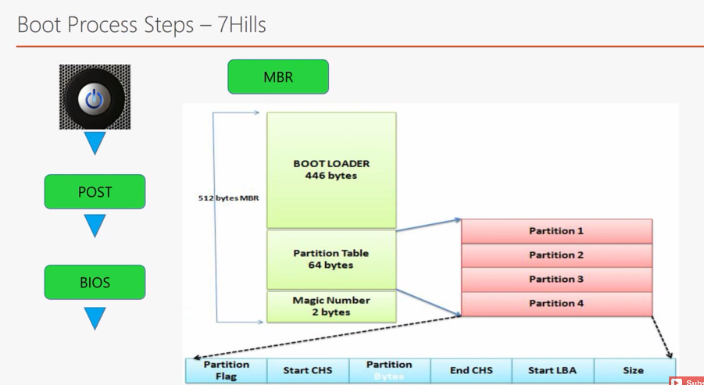

In whichever we have os, that we called as boot device …it may be hard disk, pen drive or cddrive etc.,

Bootloader – loads the os

Partition table – in windows we have c drive, e drive which are in Mware to store inf….similarly in linux we will store the inf in 64 bytes

Magic number – it helps when we have errors and help to detect them

GRUB – use to load the os …we have multiple os from that we can load the os by default

Kernel – communication btwn s/w and h/w… acts as a mediator btwn s/w and h/w

Kernel intiates the system process

Systemd – here we can initiate and run the mentioned services

Target – 0,1,2,3,4,5,6 run levels

We can check the current run level by running the command 🡪 $ who -r

Login - username and passwd

Load the sys

**The booting process in Linux involves several stages. Here's a simplified explanation:**

**BIOS/UEFI: When you start your computer, the Basic Input/Output System (BIOS) or the Unified Extensible Firmware Interface (UEFI) is the first program that runs. It performs a Power-On Self-Test (POST) to check hardware components like RAM, CPU, storage devices, etc.**

**Bootloader (GRUB): Once the BIOS/UEFI completes its tasks, it looks for a bootloader. Grand Unified Bootloader (GRUB) is one of the most common bootloaders used in Linux. The bootloader's main job is to locate the Linux kernel, load it into memory, and start it.**

**Linux Kernel: The kernel is loaded into memory by the bootloader. It initializes the hardware, mounts the root filesystem, and starts the first user-space process, which is Systemd (in most modern Linux distributions).**

**Init System (Systemd): Systemd is responsible for initializing the system and starting essential system services and daemons.**

**Userspace: Once systemd has started, it launches other system services and daemons required for the system to function properly. Finally, it starts a login prompt, and the system is ready for user interaction.**

Booting Process steps:

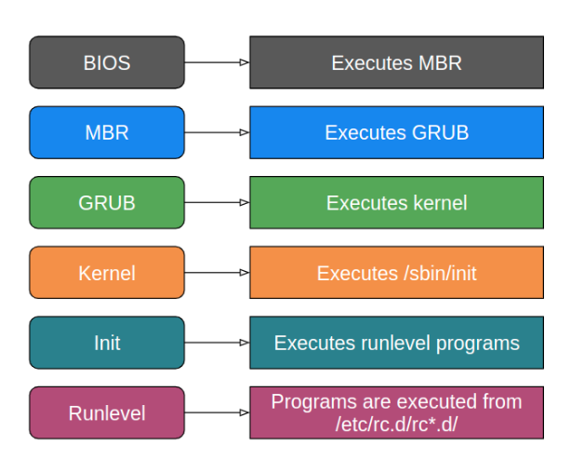

Power on -> BIOS (POST)->boot device -> boot loader-> MBR (GRUB + Partition table + magic table) -> kernel -> systemd -> run levels -> login