**Problem Statement @1:**

Let us assume we will be receiving list of user defined objects in JSON format from the server. Sample JSON Object data given in the Data.txt file.

Write a HTML Page [View Page] to display the objects in a table format by using AngularJS syntaxes. We want this action needs to be performed after user clicks an AngularJS HTML DOM Click Event.

Please see the screen shots for better understanding of the above problem statement.

**Note:**

Components Required Under JS folder:

1. *angular.min.js or CDN approach*
2. *MyController.js user defined controller*

**Data.txt File:**

[{"empNumber":7369,"empName":"SMITH","empJob":"CLERK","empBossCode":79 02,"empDoj":"Dec 30, 1980","empSalary":800.0,"empComm":0.0,"empDeptNumber":20

}, {"empNumber":7566,"empName":"JONES","empJob":"MANAGER","empBossCode":7839,"empDoj":"Mar 2, 1981","empSalary":2975.0,"empComm":0.0,"empDeptNumber":20

}, {"empNumber":7788,"empName":"SCOTT","empJob":"ANALYST","empBossCode":7566,"empDoj":"Dec 12, 1982","empSalary":3000.0,"empComm":0.0,"empDeptNumber":20

}, {"empNumber":7876,"empName":"ADAMS","empJob":"CLERK","empBossCode":7788,"empDoj":"Jan 3, 1983","empSalary":1100.0,"empComm":0.0,"empDeptNumber":20

}, {"empNumber":7902,"empName":"FORD","empJob":"ANALYST","empBossCode":7566,"empDoj":"Dec 3, 1981","empSalary":3000.0,"empComm":0.0,"empDeptNumber":20

}]

**Starting Page Output on the Browser:**

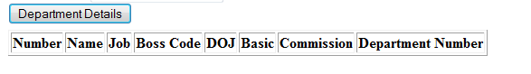

**After User Clicks The Department Details Button:**

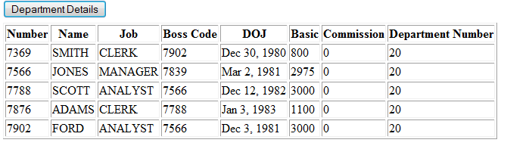

**Problem Statement @2:**

Write a HTML Page [View Page] to display the objects in a table format by using AngularJS syntaxes. We want this action needs to be performed after user clicks an AngularJS DOM Click Event.

Business Rule: Client wants the employee objects displayed based on salary / basic in sorted order. Use Order by and Date Filters.

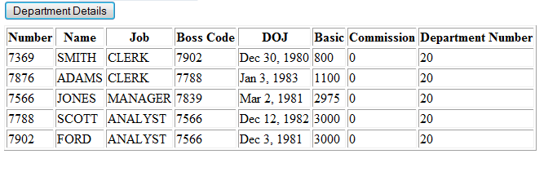

**Time Duration: 45 Mins**

**Pre Requisite: Java Script Knowledge, AngularJS Frame Work Knowledge**