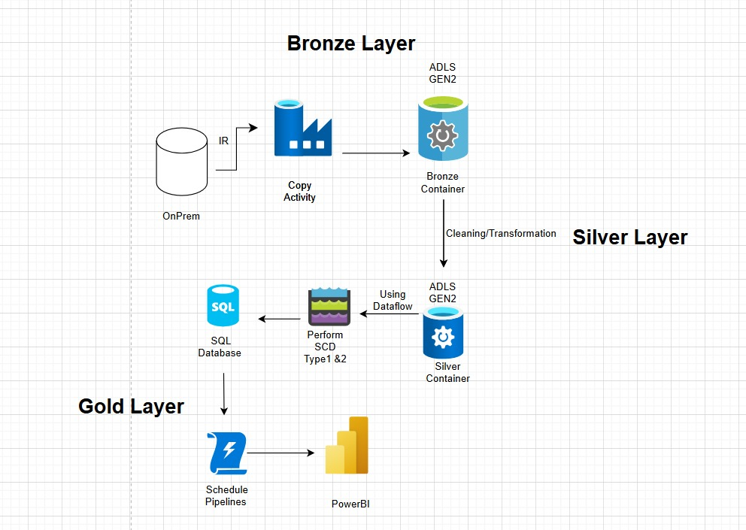**Boot Camp Project – 1 Data Pipeline for Customer Account Analysis**

Master Pipeline

**Step 1: Data Ingestion (Backend Storage to Raw/Bronze Container)**

* **ADF Copy Activity:**
  + Configured to transfer data from the backend team's storage account to the raw (bronze) container in the data lake.
  + **Source Files:**
    - accounts.csv
    - customers.csv
    - loan_payments.csv
    - loans.csv
    - transactions.csv
  + **Sink:** Raw (bronze) container in your ADLS account.

Fig 1 : Integration Run time and Linked Service

Fig 2: Bronze Layer Pipeline

Fig 1 – Meta Data

Fig 3: Contents inside the Copy Activity

**Results**:

Files Stores in the CSV Format.

**Step 2: Data Cleaning with ADF Dataflows**

* **Read Data:**
  + Dataflows read from all five sources in the raw (bronze) container.
* **Remove Null Values:**
  + Used aggregate transformation, window, or assert activities to identify and remove null Values.
* **Data Transformation:**
  + Applied schema enforcement (avoiding inferSchema), data type conversions, and handled missing values.
  + Output stored in CSV Files for optimized querying.

Fig 4: Silver Layer

Source of the File

Transformations to remove null values

Alter Row

**Step 3: Dataflows Using SCD Type Techniques (SCD 1 and SCD 2)**

* **Data Movement:**
  + Implemented Slowly Changing Dimension (SCD) Type 1 and Type 2 logic within Dataflows.
  + Data moved through the following layers:
    - Local → Bronze
    - Bronze → Silver
    - Silver → Gold
* **Upsert to SQL DB:**
  + Final cleaned and transformed data upserted into Azure SQL Database tables.
* **Scheduling:**
  + Pipelines scheduled for automated, repeatable data processing.

Fig 5: Gold Layer

Pipeline for Accounts, Customers under SCD Type1

Pipeline for Transactions, Loan payments, Loans

Transformations

Added Hash Key

Look Up Activity

Conditional Split

Audit the Columns

Alter Row

Sink

Union

Auditing the Columns

Sink for Insert

**Results**

Customers table output

Transaction Table data

**Step 4: Data Visualization with Power BI**

* **Data Source:**
  + Connected Power BI to Azure SQL Database tables.
* **Report Development:**
  + Built interactive visuals and dashboards based on processed data.
* **Publishing:**
  + Published the Power BI report to Fabric Workspace for sharing and collaboration.

We need to add the Server Name

Select the Required Tables from the server

Fig 6: Accounts Dashboard

Fig 7: Customers Dashboard

Fig 8: Loan Payments Dashboard

Fig 9: Loans Dashboard

**Triggers:**

* **Scheduled the Trigger at 9 AM every day.**

Fig 10: Scheduled Trigger

**Master Pipeline Structure**

* **Master Pipeline:**
  + Built using ADF's Execute Pipeline activity.
  + Sequentially calls child pipelines for each layer (Bronze, Silver, Gold) to ensure orderly data processing.

Fig 11: Master Pipeline

Git Hub – luckyaniketh08@gmail.com