3. Hands on practice

**Failure notification email**

Step 1: Login into Azure, search for logic apps

Step 2: Create resource, select multi-tenant as well as add resource group.

Step 3: Create Logic app name as lg-eail-madhu, select location as east US and create.

Step 4: Inside the logic app; select logic app designer , you can see add trigger activity, select request(http).

Step 5: Add request body JSON schema and select method as default at first

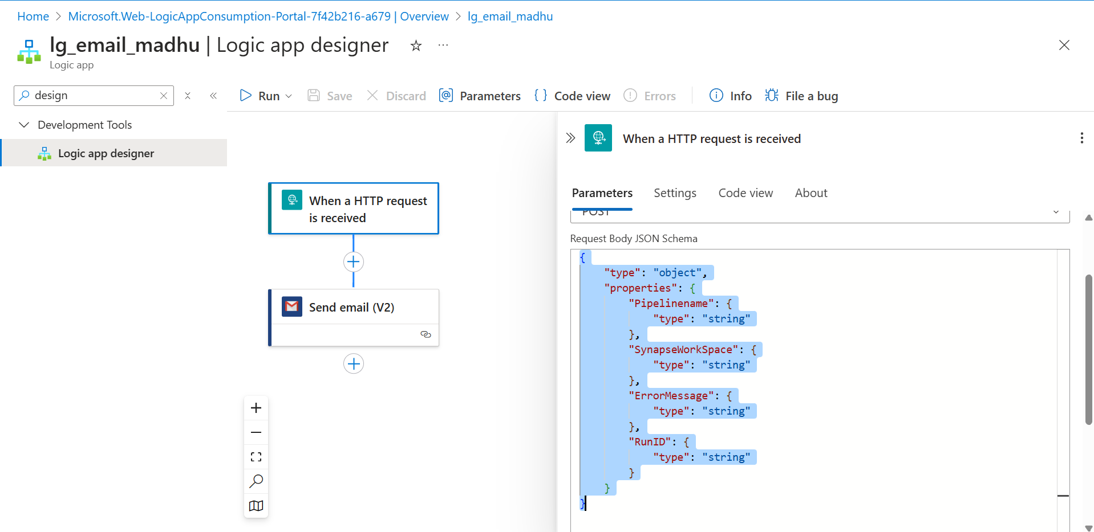

Step 6: After adding request body JSON scheme, http URL will be generated.

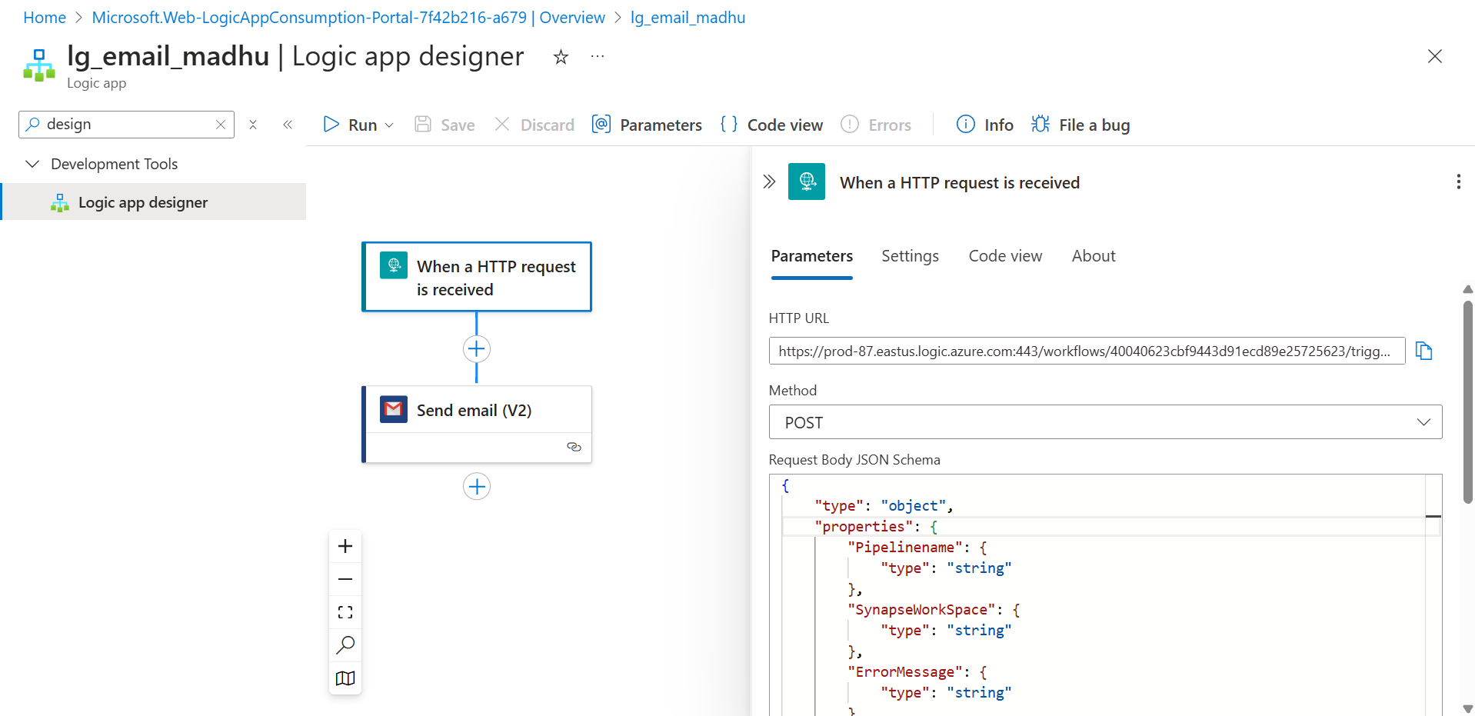

Step 7: Add the next trigger as send email V2(gmail)

Step 8: Signin the sender email id

Step 9:In parameter, give receiver email in To field.

Step 10: Give subject and body in the email chain

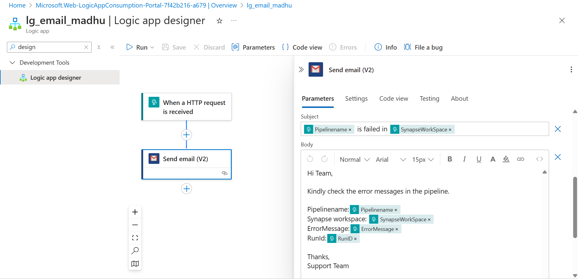

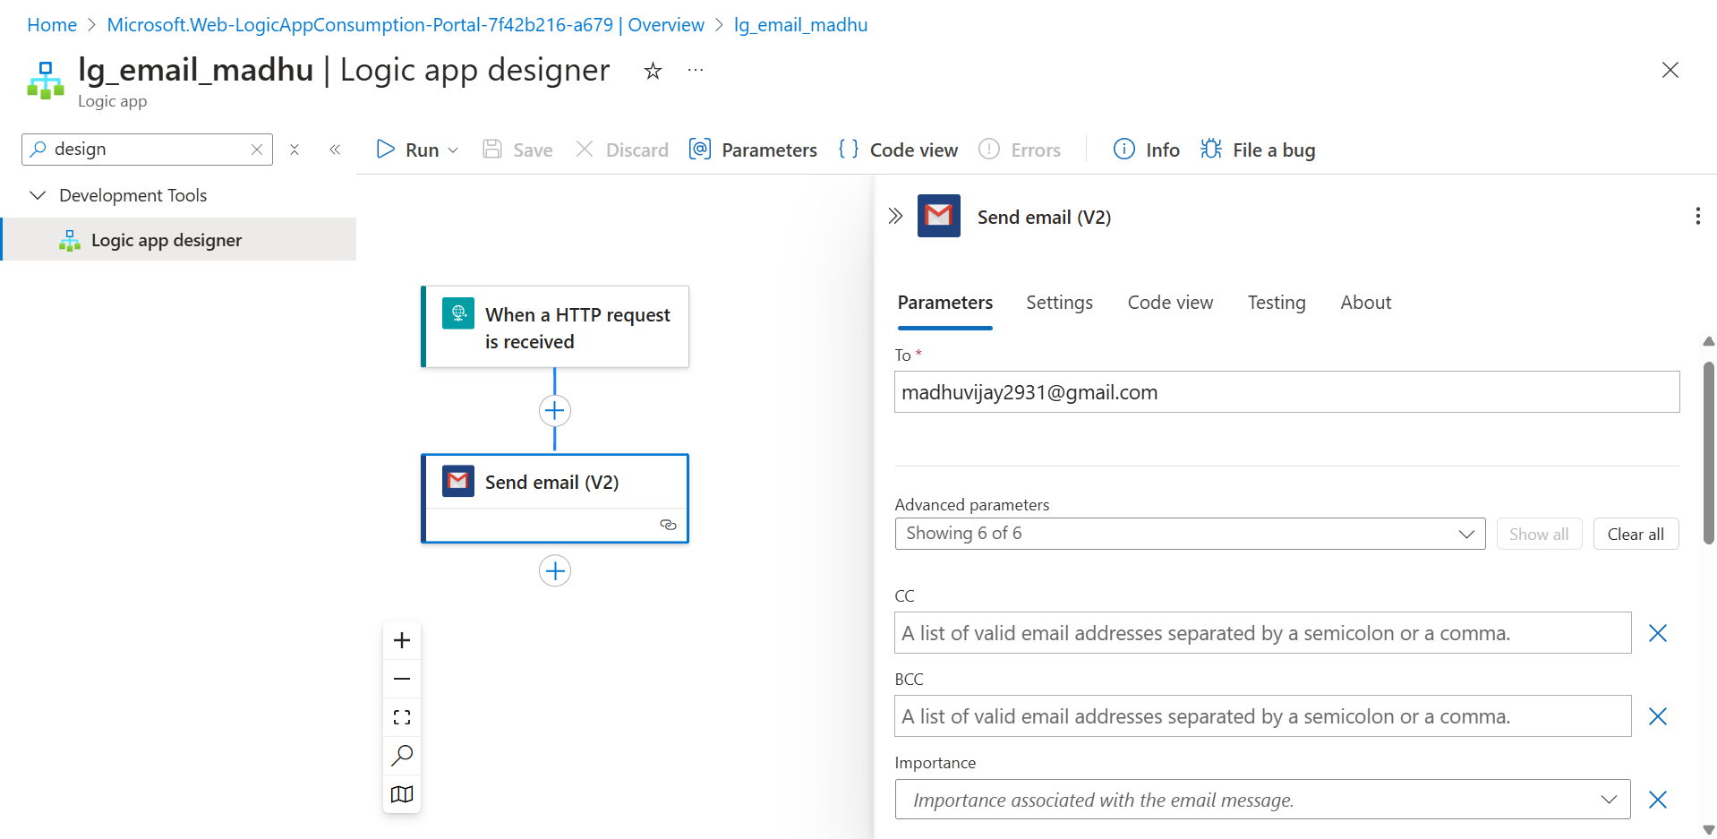

Step 11: Save and run.

Step 12: Open Azure synapse

Step 13: Create a pipeline and name it as pl_email_error

Step 14: Drag and drop the copy activity, In source dataset, select Azure Sql and give connection to it.

Step 15: Under query, give the table which is not exists in SQL

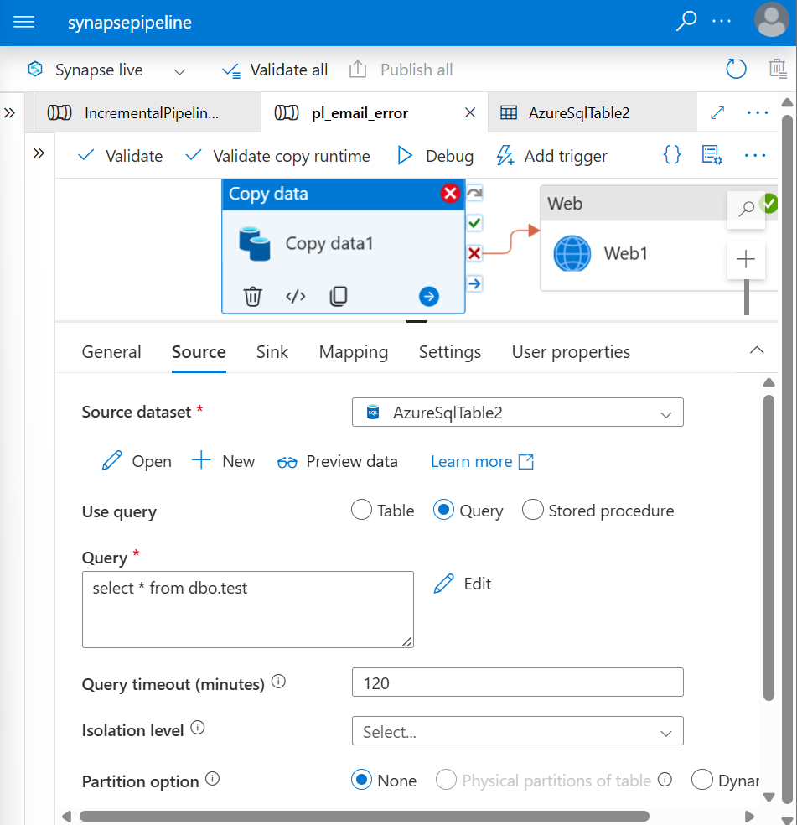

Step 16: In sink, select adlsgen2 and connect it, Give the file path as well.

Step 17: Drag and drop web activity and connect the copy with web activity in on fail

Step 18: Under settings, paste the url from request(http)

Step 19:Select the method as post and add pipeline expression builder

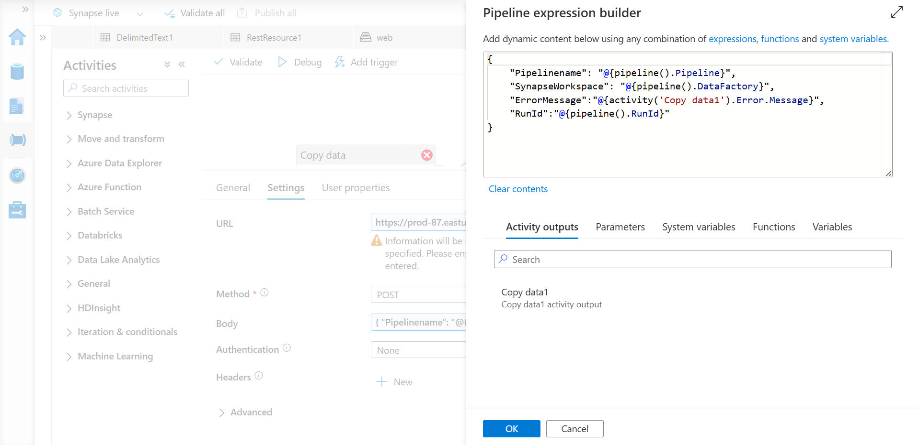

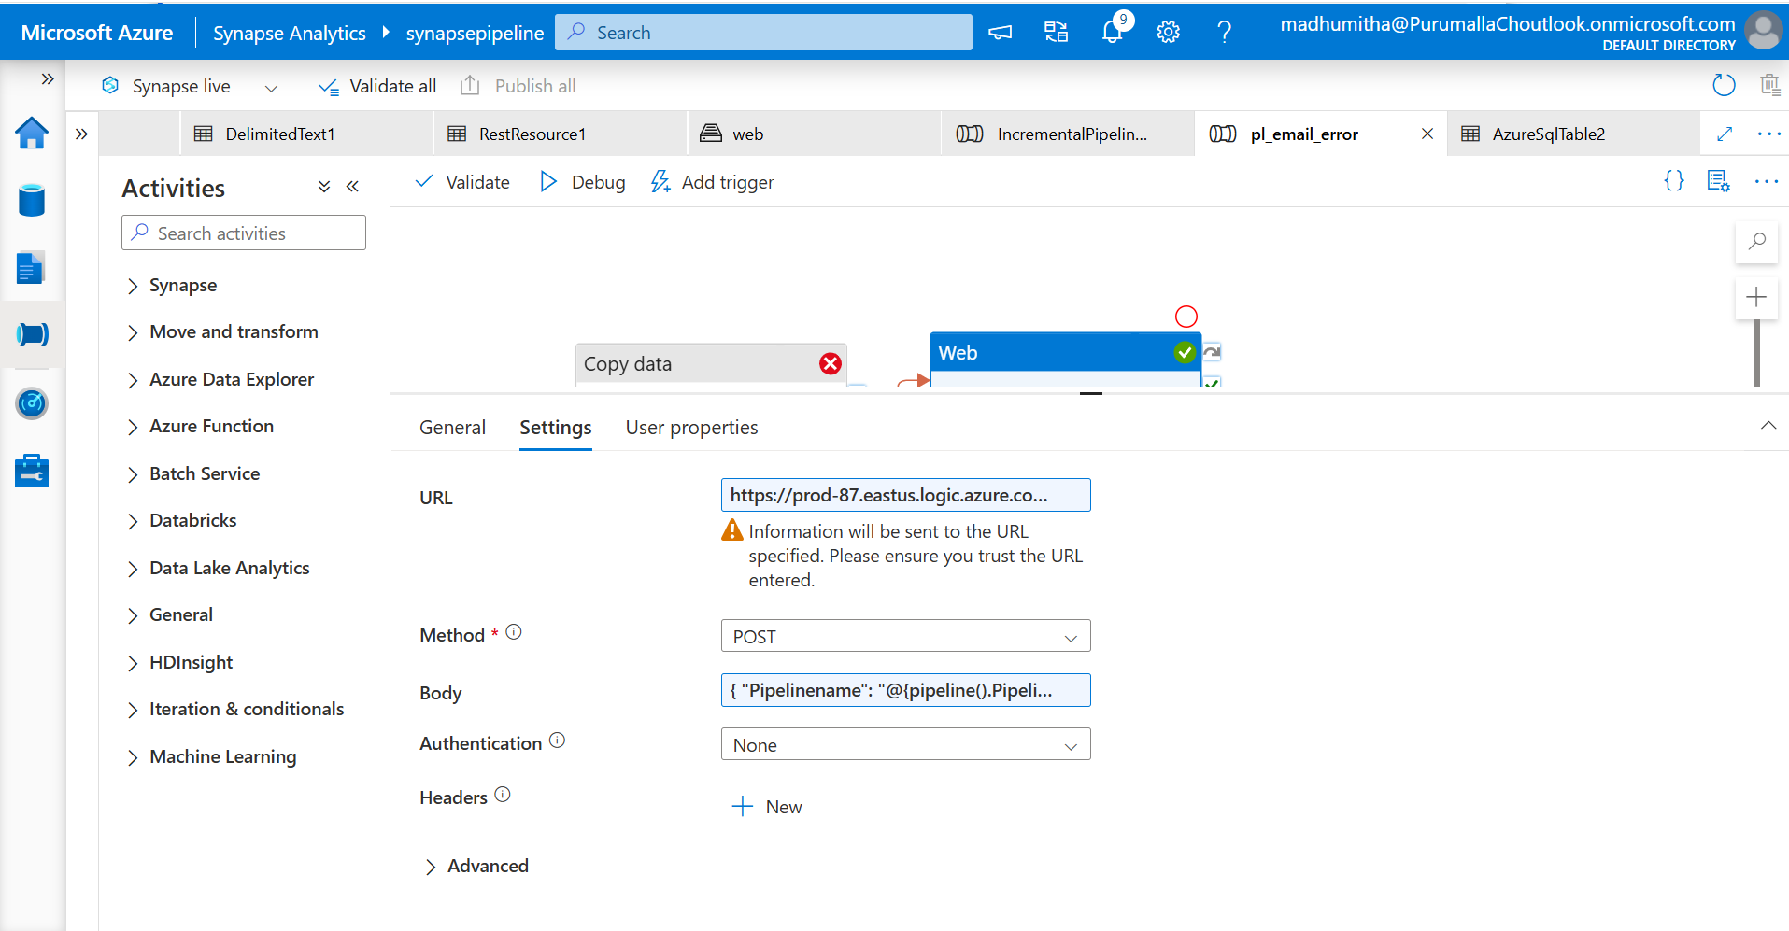

Pipeline -> Run the pipeline, copy activity will fail and web will trigger a email

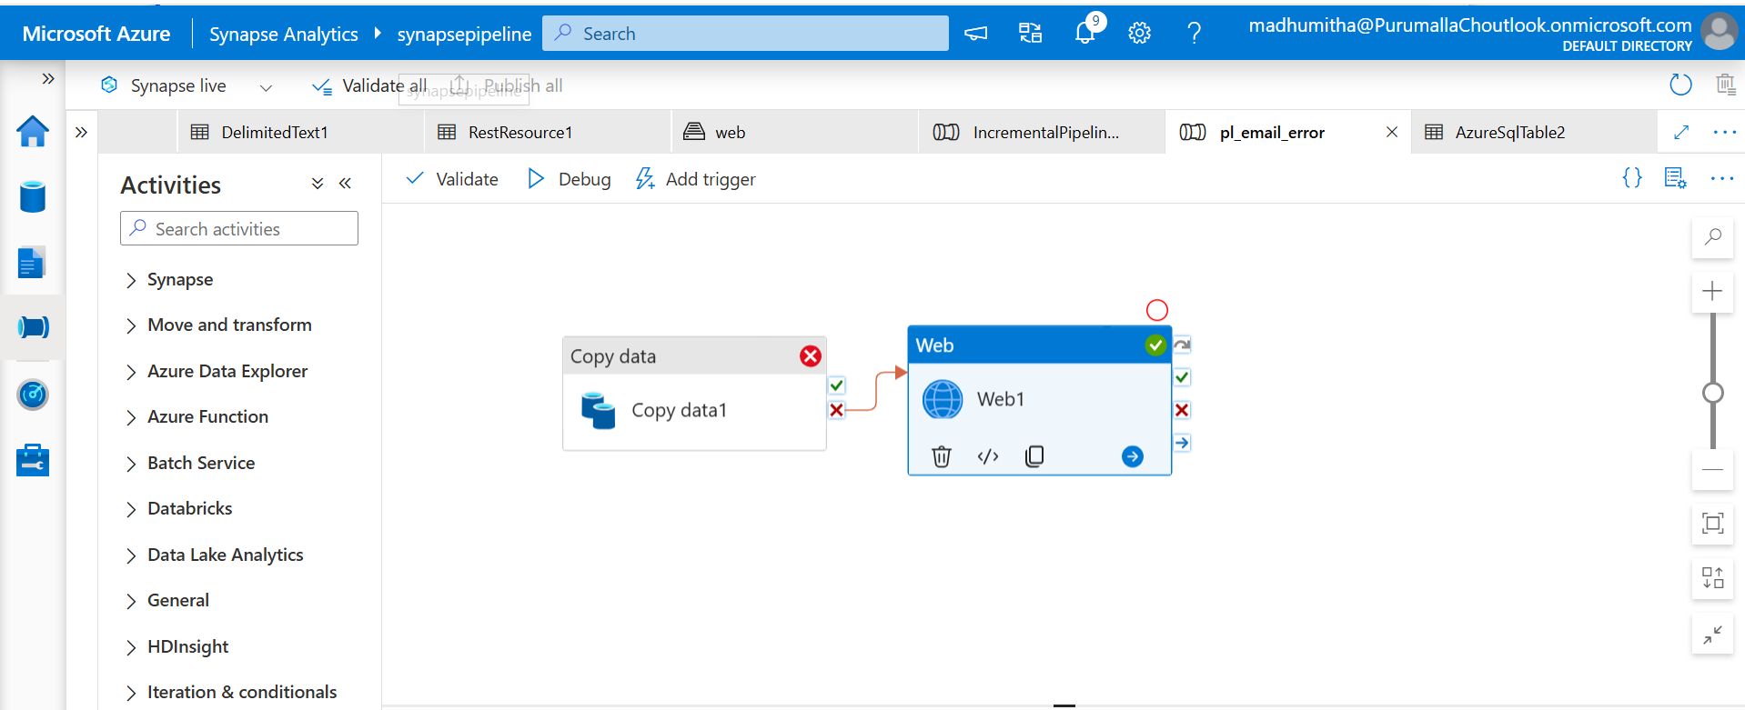

The output will be

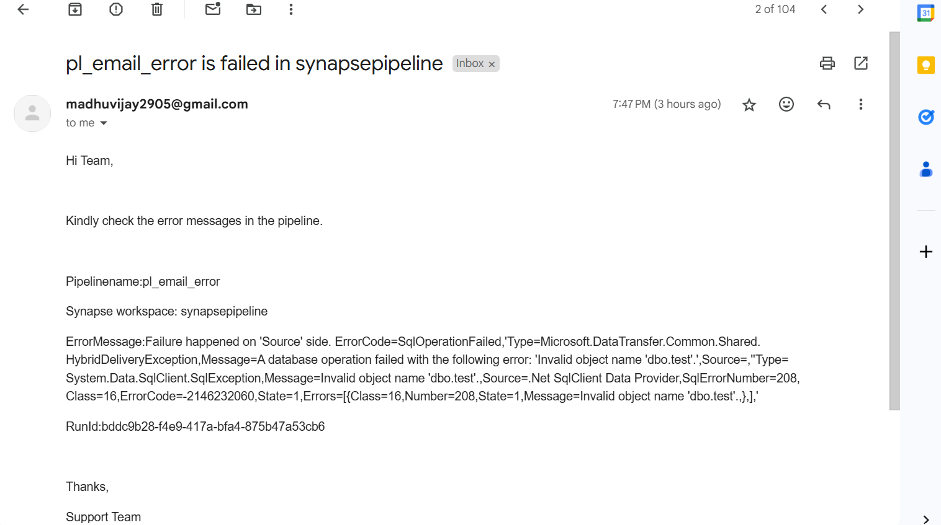

REST API scenarios

Step 1: Drag and drop the copy activity, Select the source set as Rest and connect linked service.

Step 2: Drag and drop the foreach loop, create an array in items

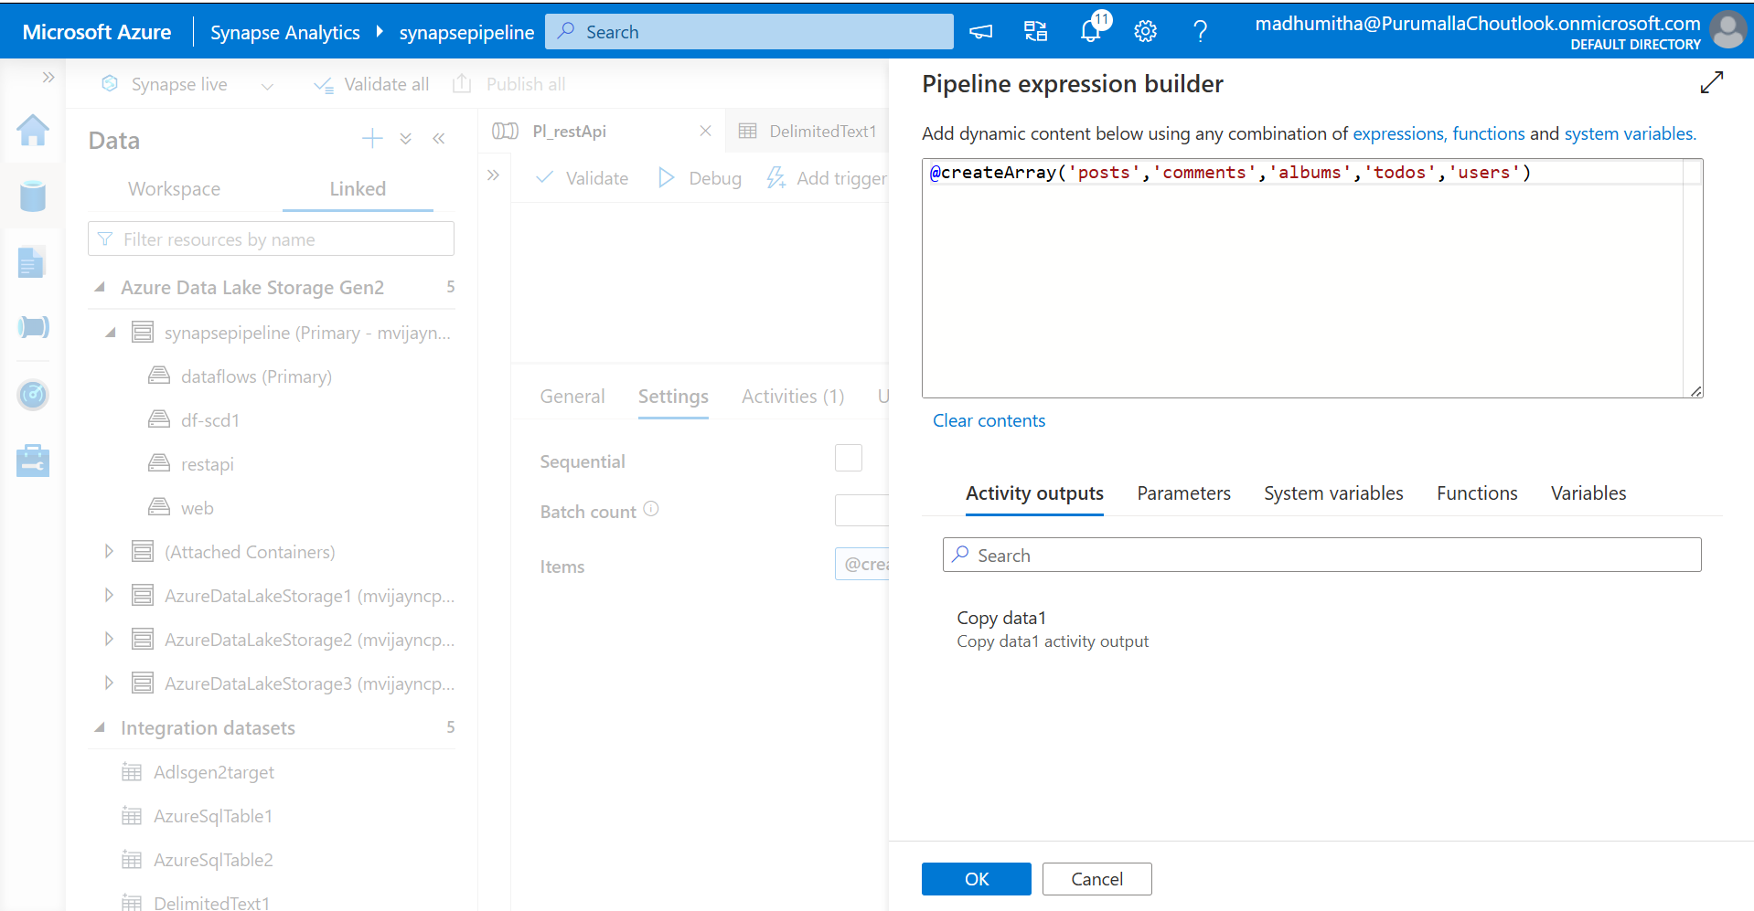

Step 2: In base Url , paste the <https://jsonplaceholder.typicode.com>

Step 3: Create a parameter as Table

Step 4: In relative path, add @dataset.Table

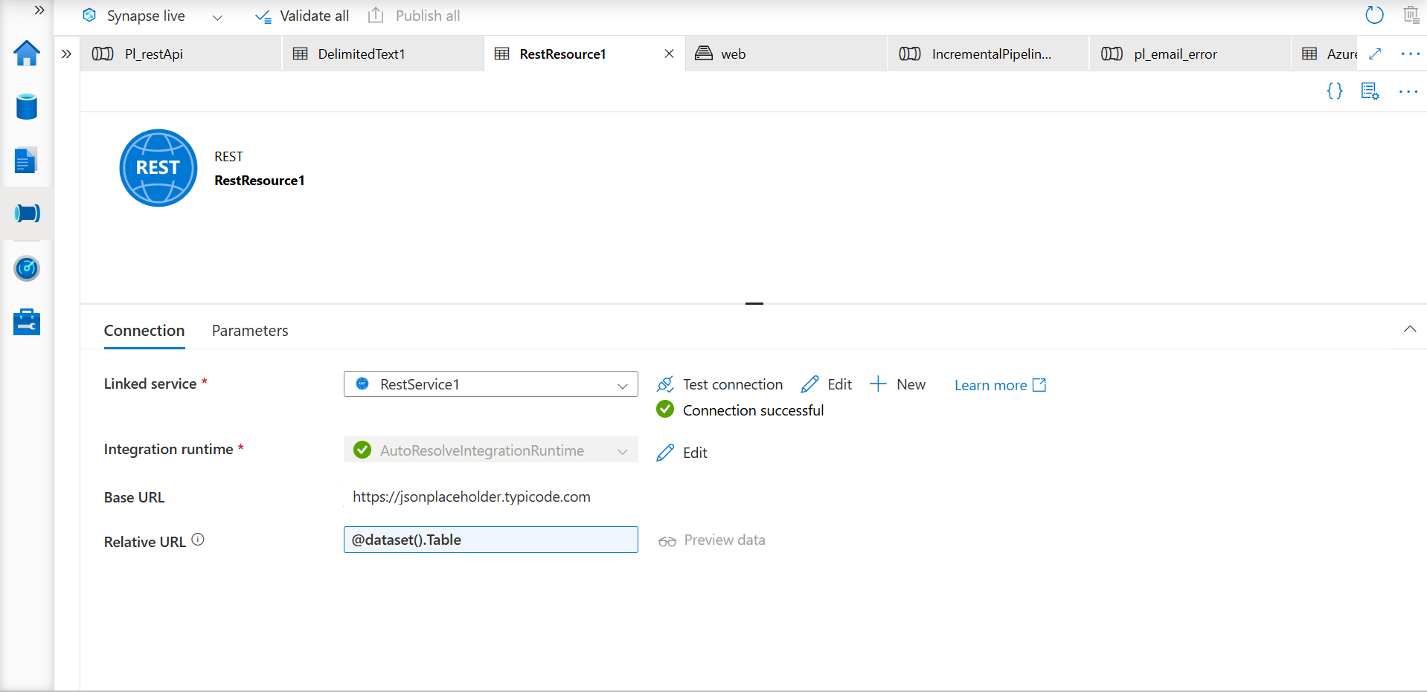

Step 5: Under dataset property, give value as @item in table

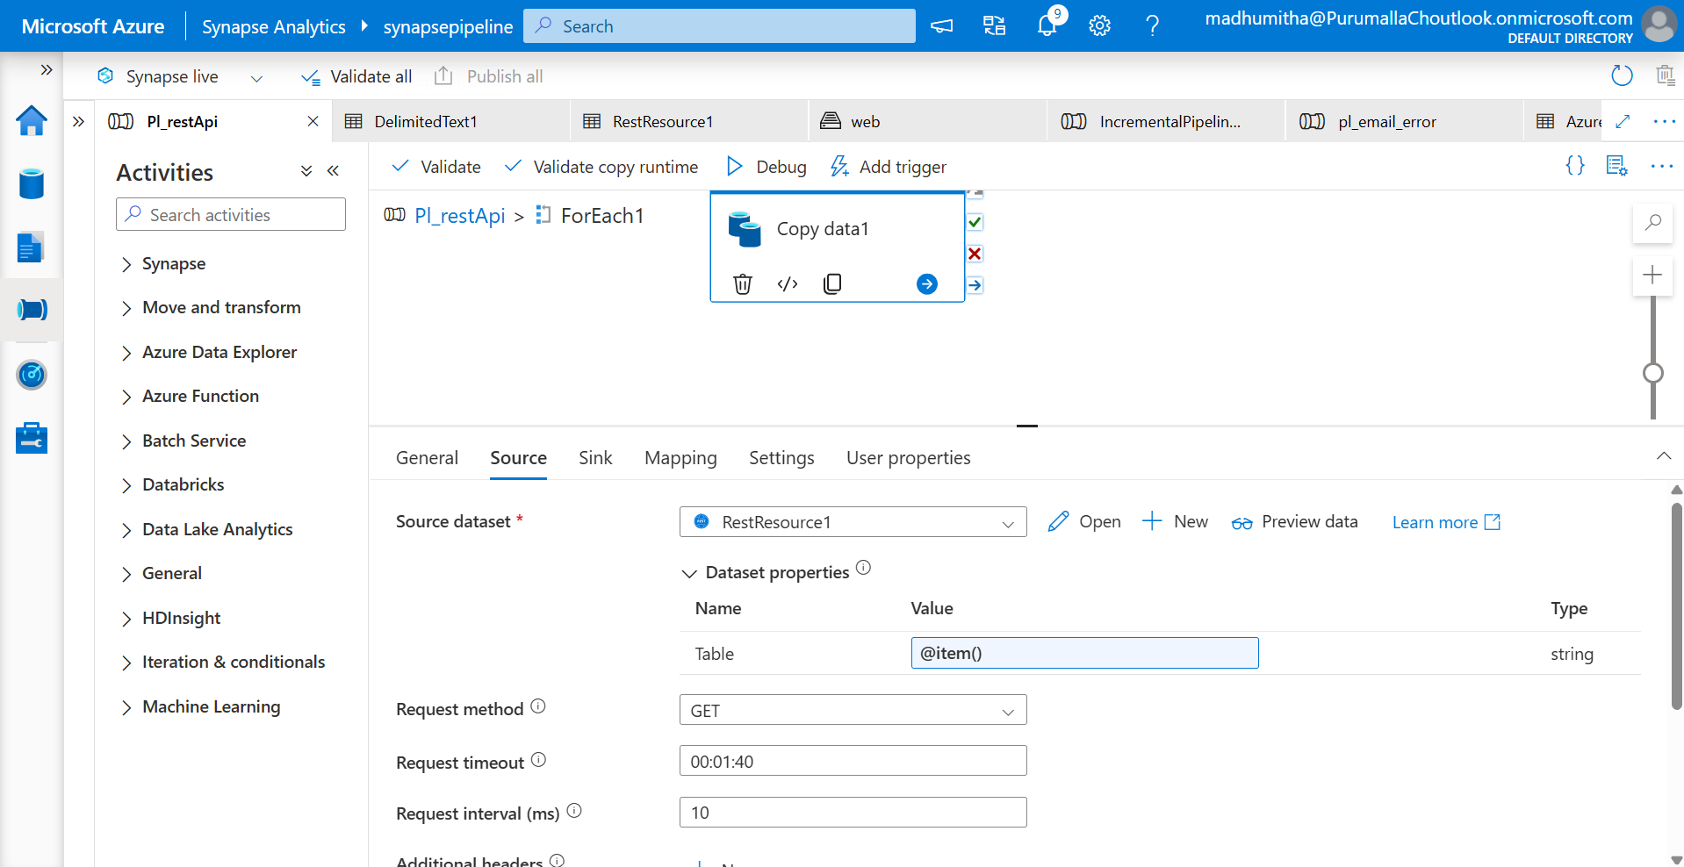

Step 6: Navigate to sink, select adlsgen2

Step 7: Select the file path

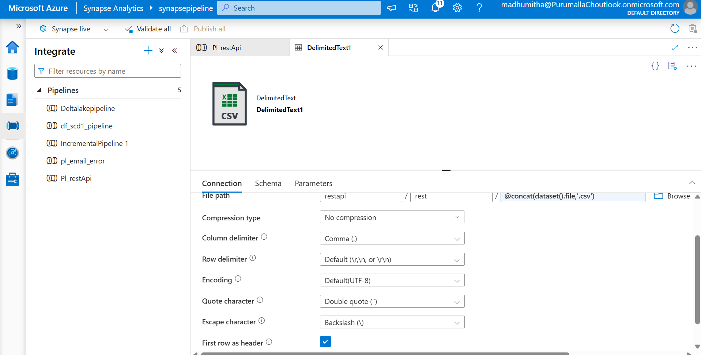

Step 8: Under dataset property, give value as @item in table

Step 9: Run the pipeline

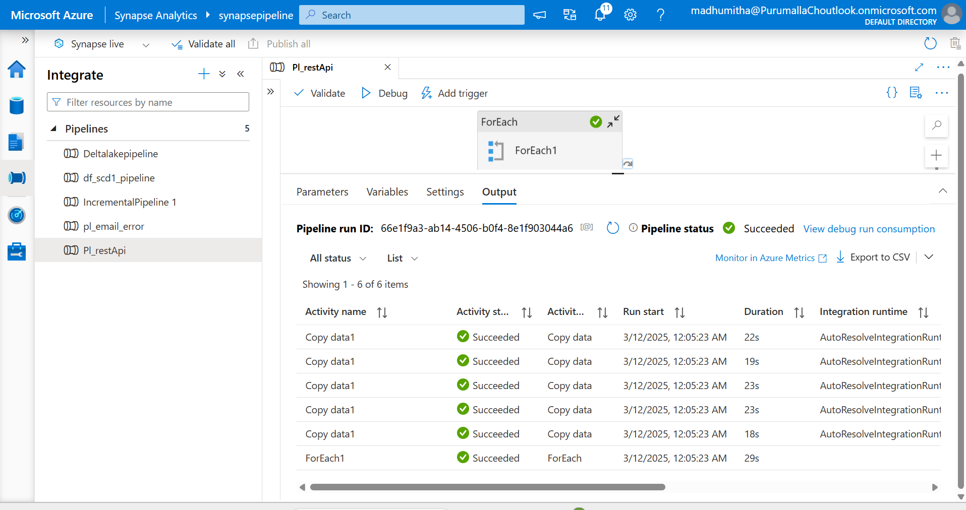

Files in ADLSGEN2

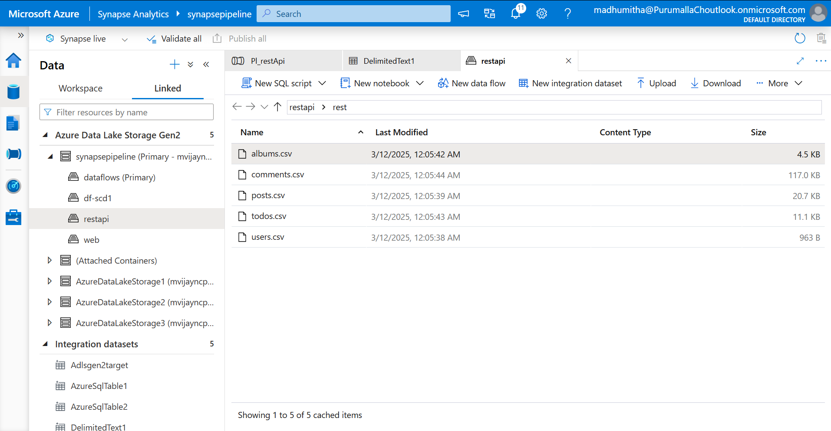

Pipeline flow

