Explore dbutil commands related to fs (file system)

Get data from blob storage account using mounting in Databricks and write data back

Mount an Azure blob storage container

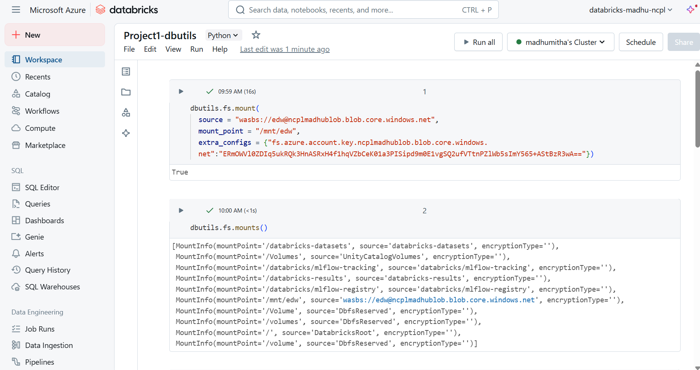

dbutils.fs.ls() command is used to list the contents.

dbutils.fs.head() command is used to read and display the data from the existing file.

Dbutils.fs.mkdirs() command is used to create a new directory

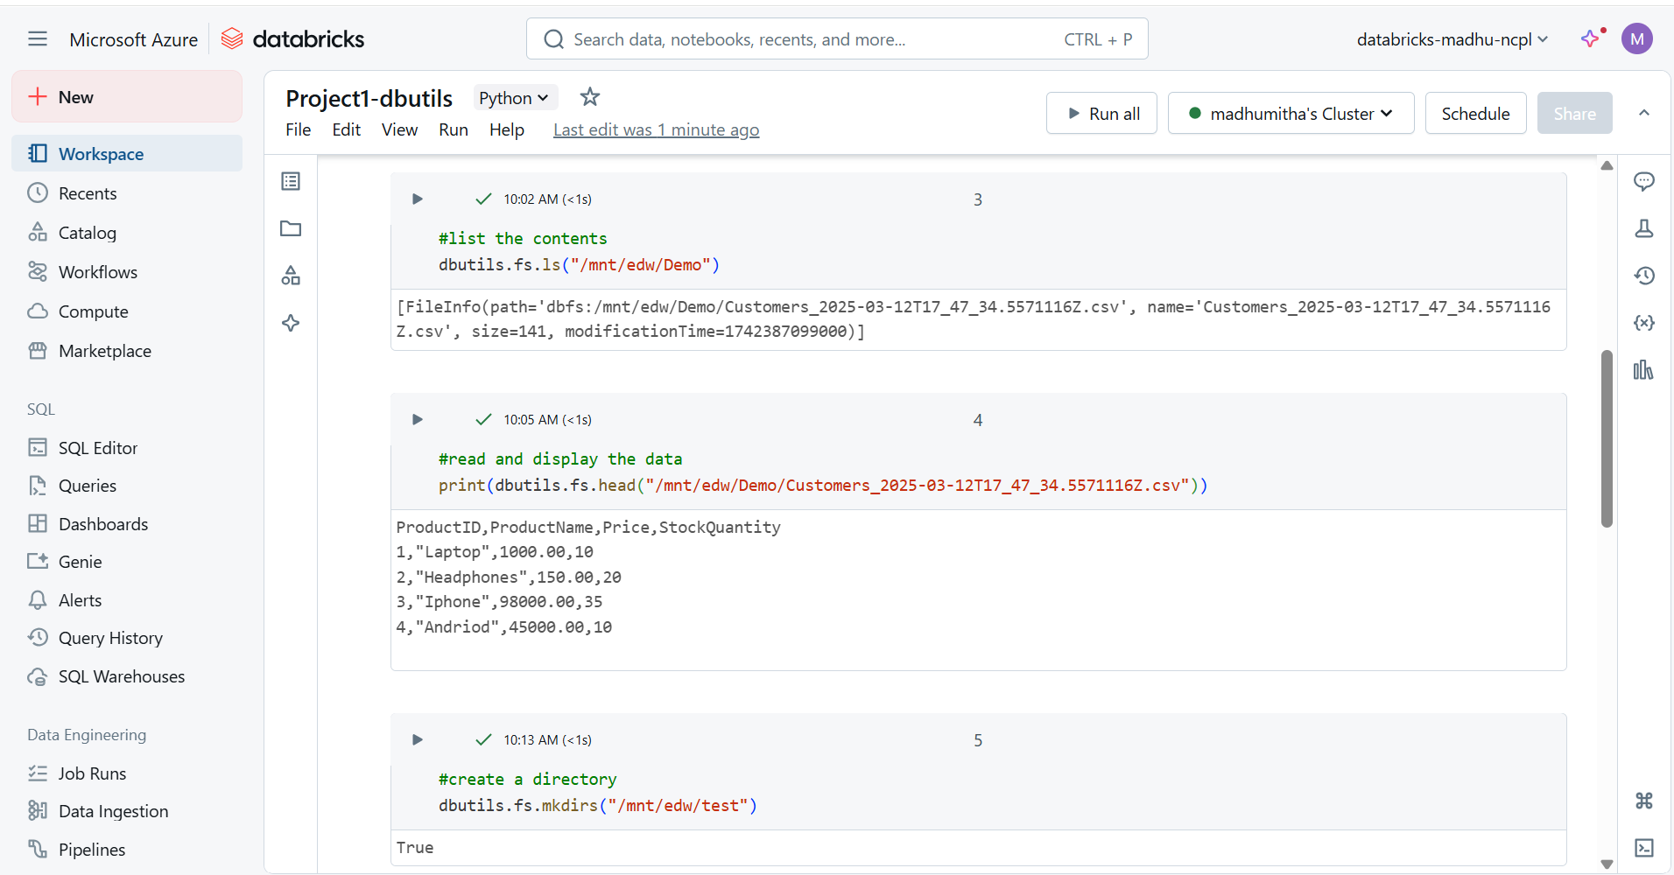

Demo and test directory is created

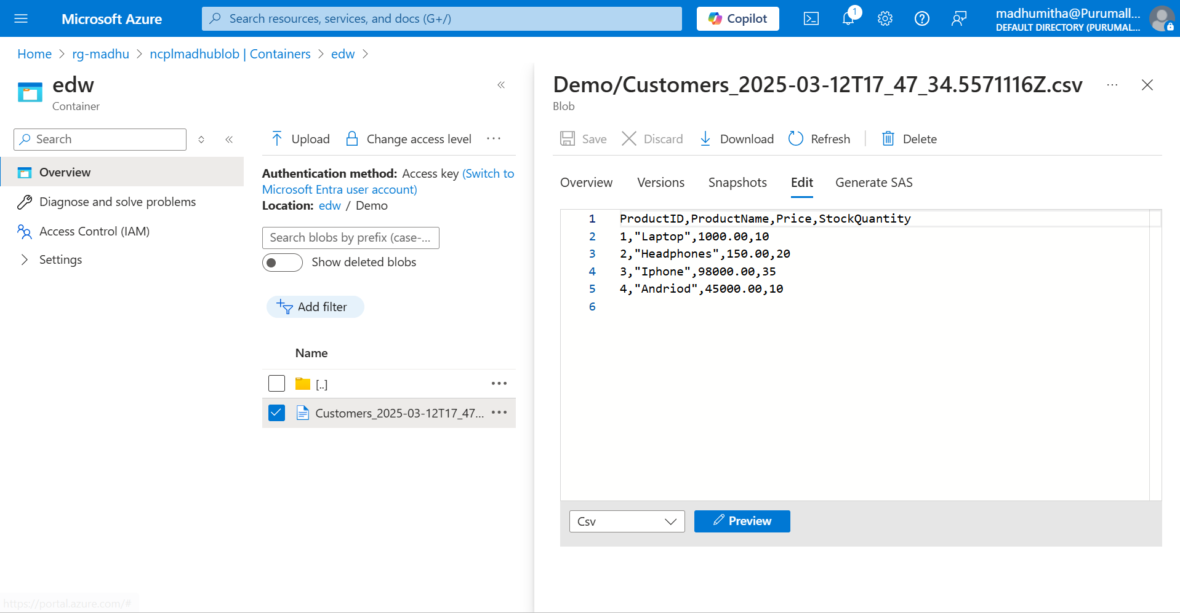

dbutils.fs.cp command will copy the data from one file to paste it in another file.

dbutils.fs.put command will insert a new data in a existing file

dbutils.fs.head command will display the data from the specified file

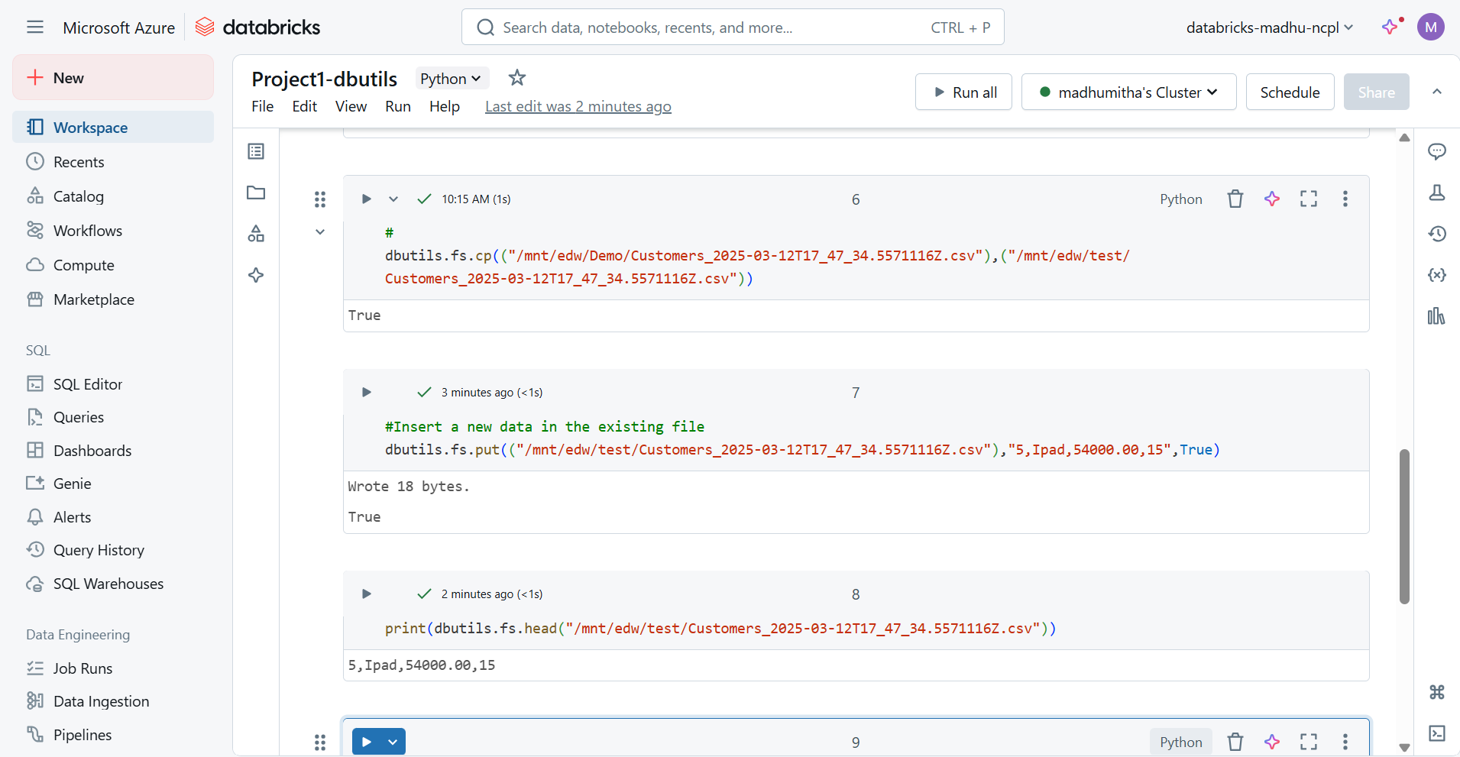

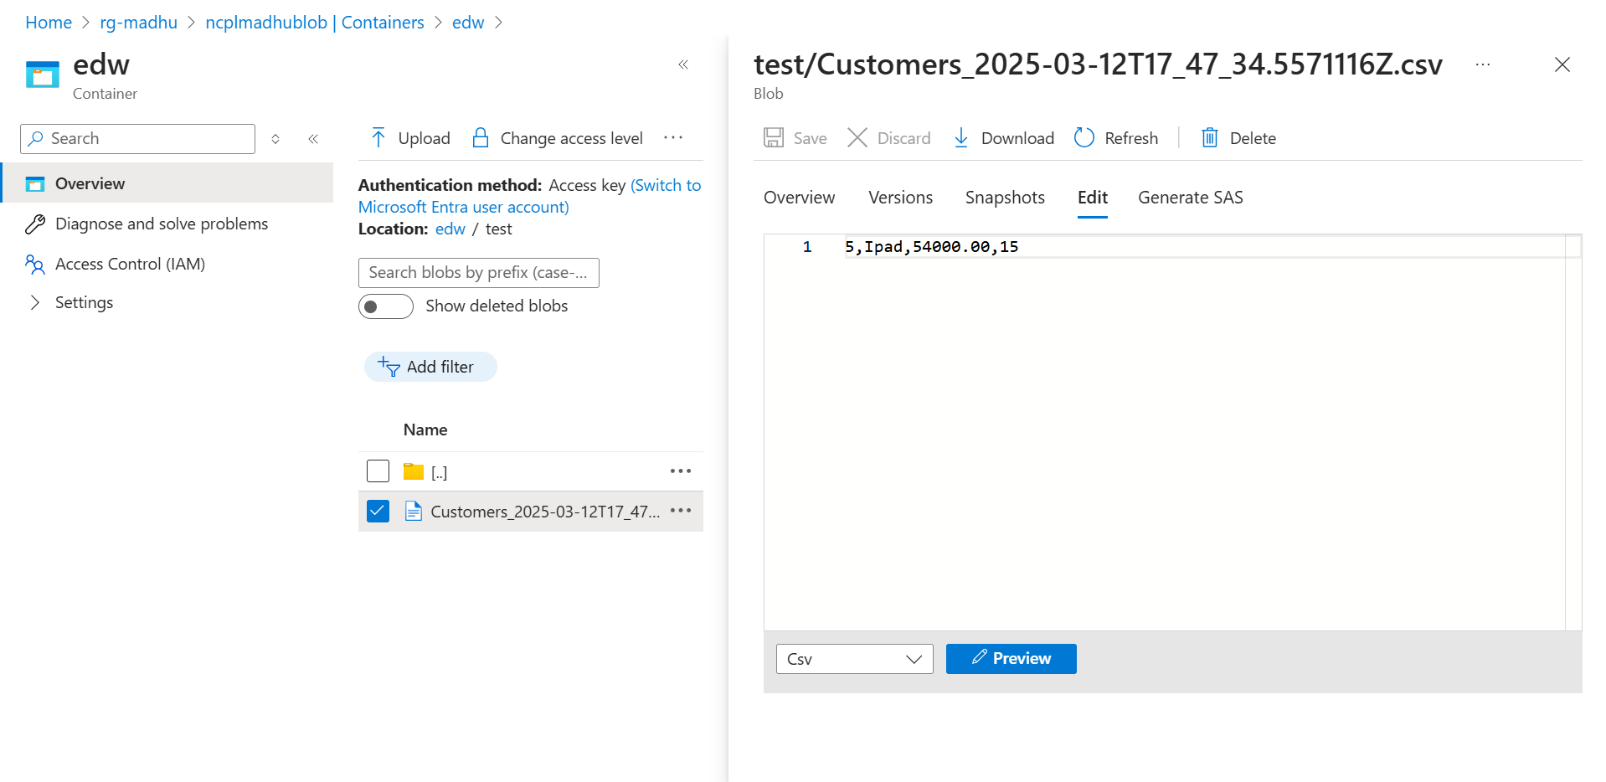

Using dbutils.fs.mkdirs command, create a new directory with file.

Since Blob Storage is being used as the storage account, if a specific file is not specified, the mkdir command will create the folder as a file.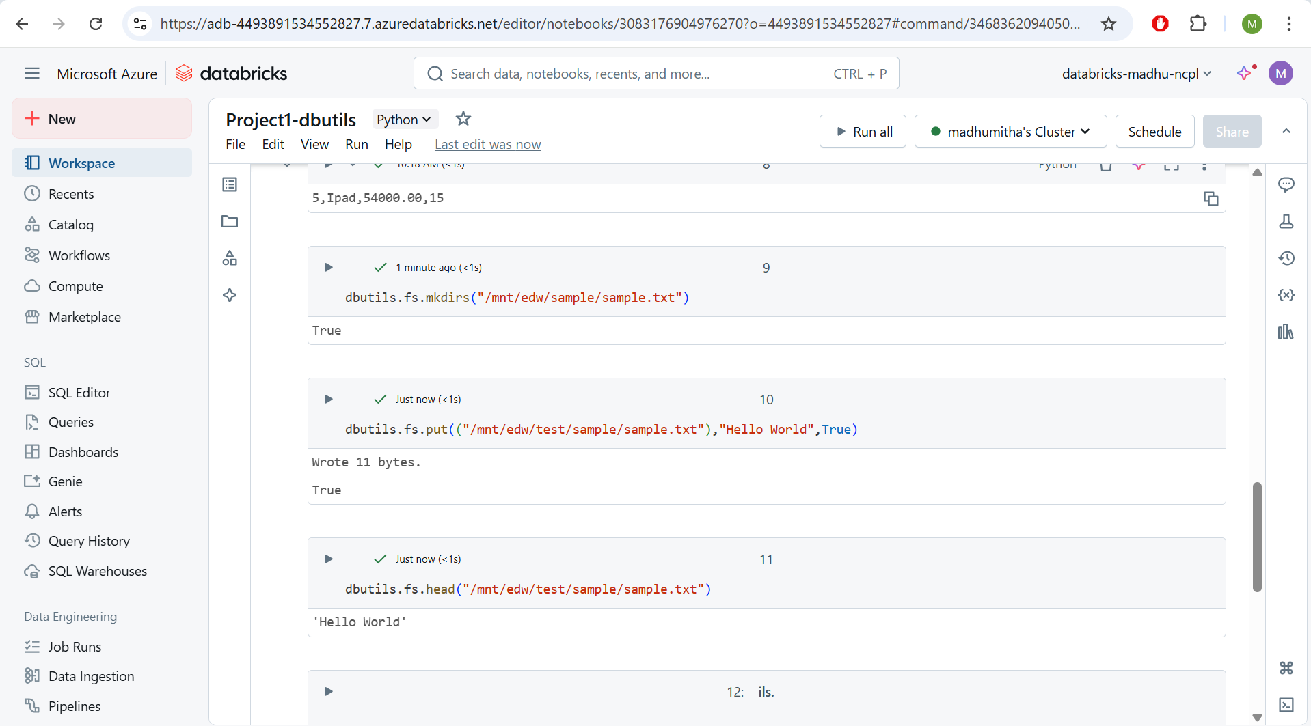

dbutils.fs.rm command is used to delete the folder and files from specified path

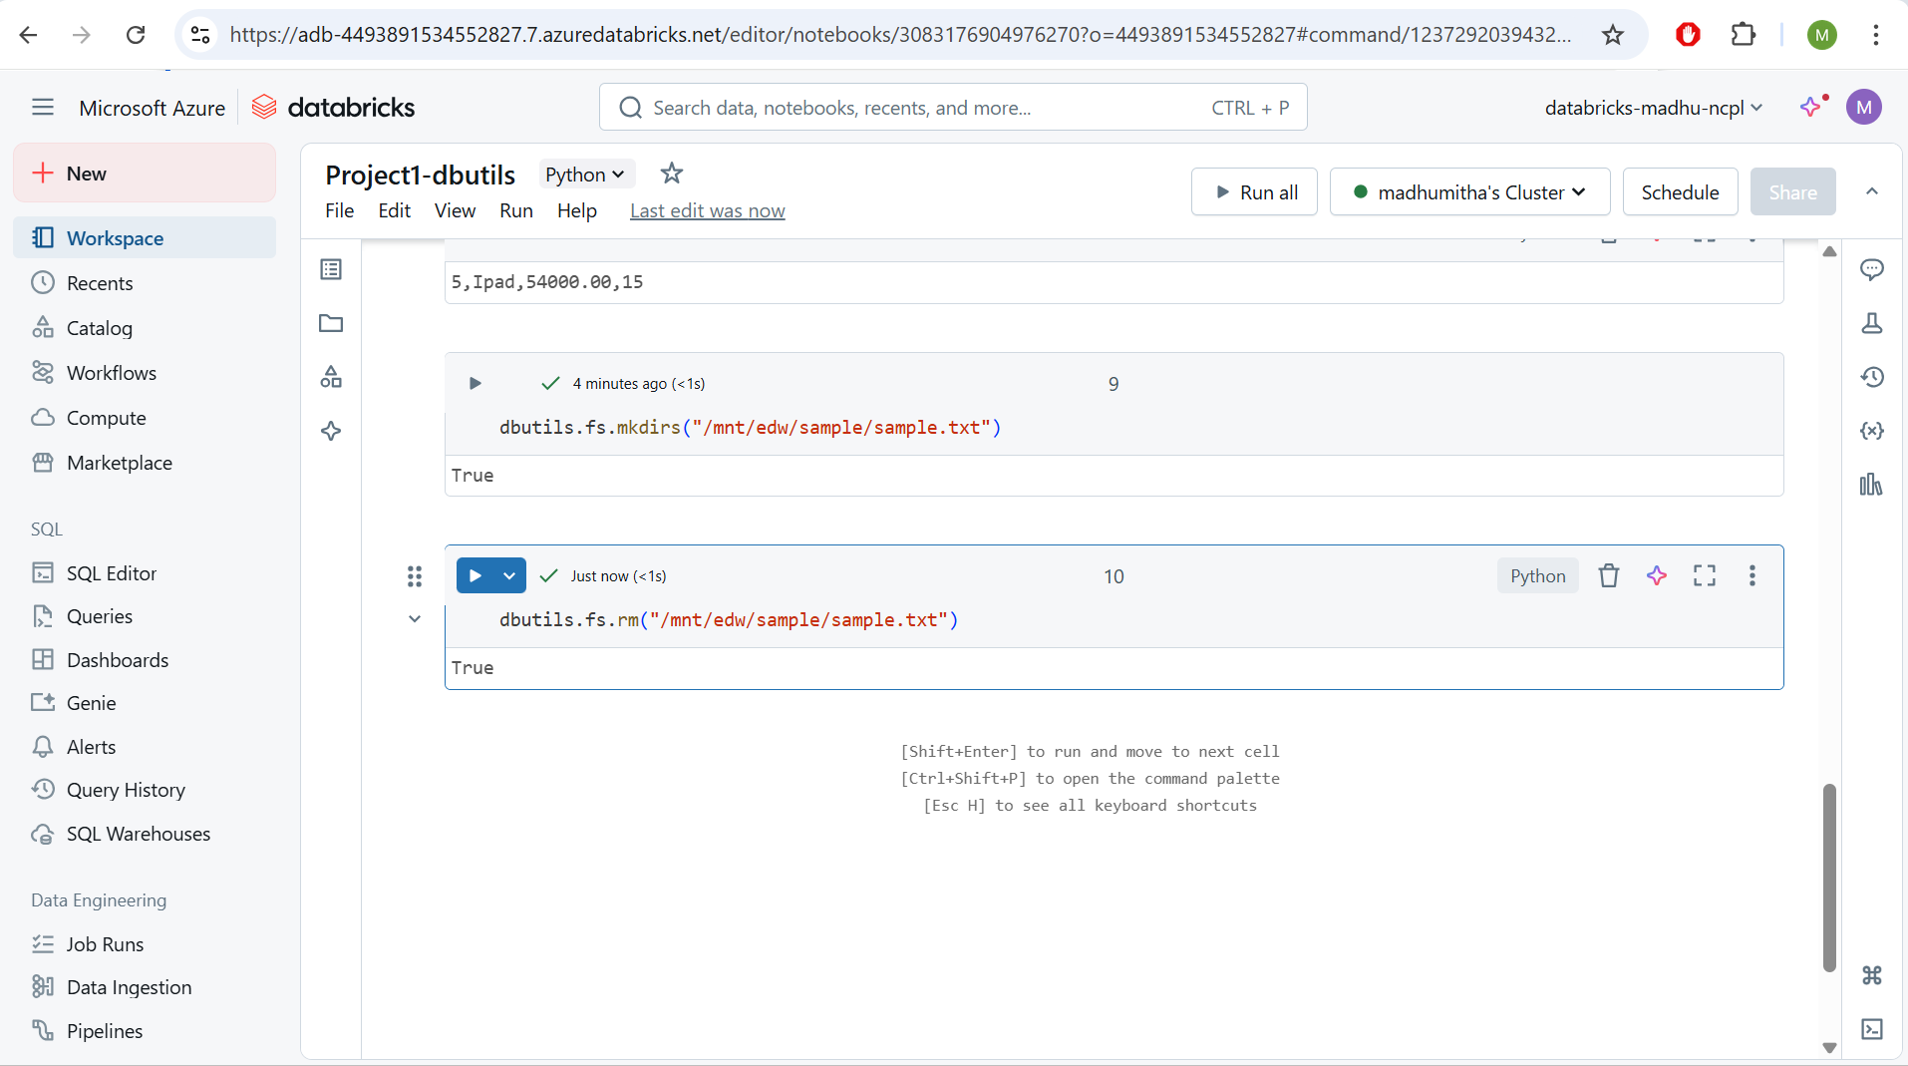

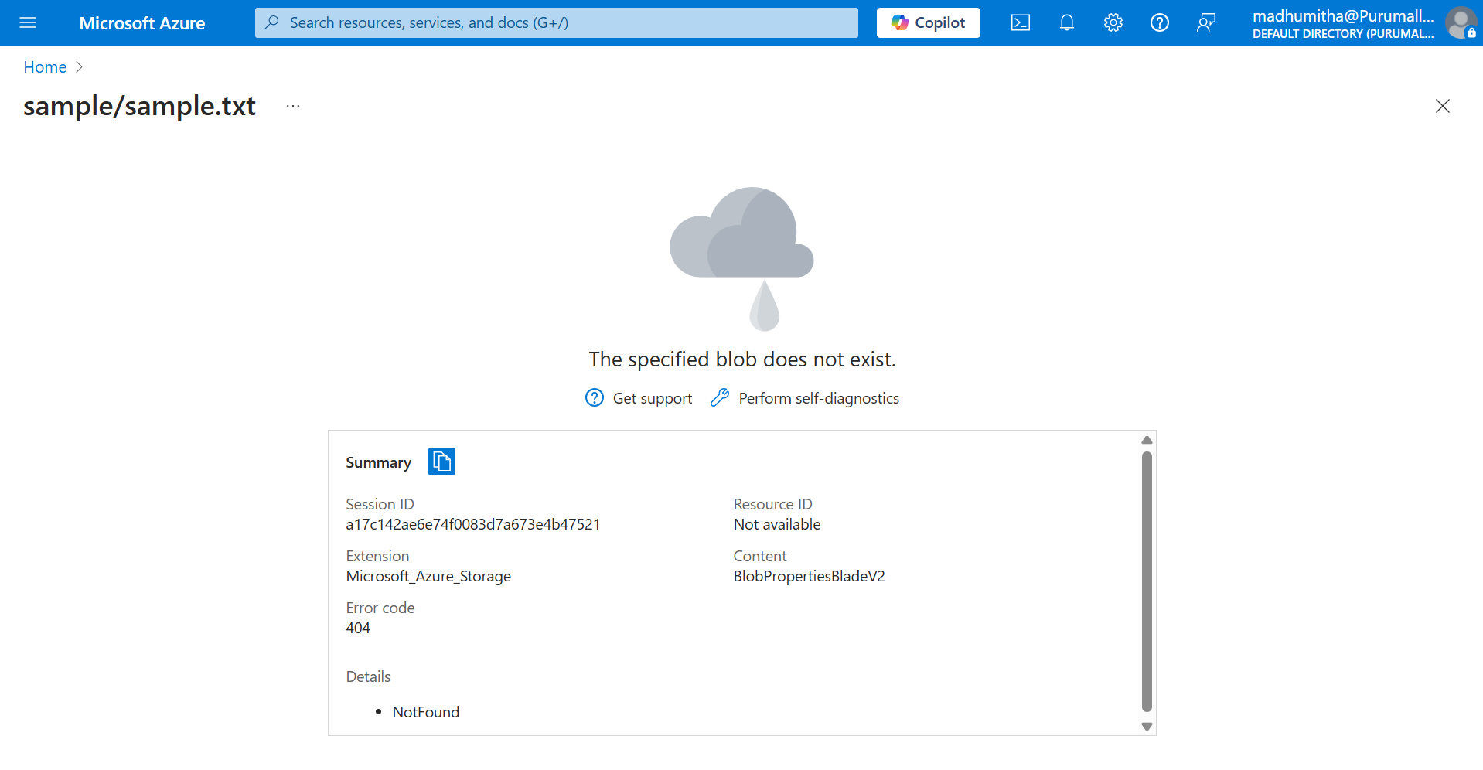

df=spark.read.format("csv").option("header", "true").option("inferSchema", "true").load("/mnt/edw/Demo/Customers_2025-03-12T17_47_34.5571116Z.csv")

display(df)

Command is used to read a CSV file into a Spark DataFrame and display its contents in Databricks.

