**Data Architecture**

**Tools & Technologies**

Azure Synapse

Azure SQL database

Azure Data Studio

Power BI

**Bronze Layer**

Loading the Data Manually in Bronze from the Kaggle link given in the document into the ADLS.

**Silver layer**

Before doing the transformations and loading the data into to Azure SQL database. Creating the tables in the SQL DB.

Creating data flows for storing data from ADLS to SQL database, where data transformations are applied, such as removing null and duplicate values.

Data Flow 1 – Parent Tables

Foreign Key DF – Dependent Tables

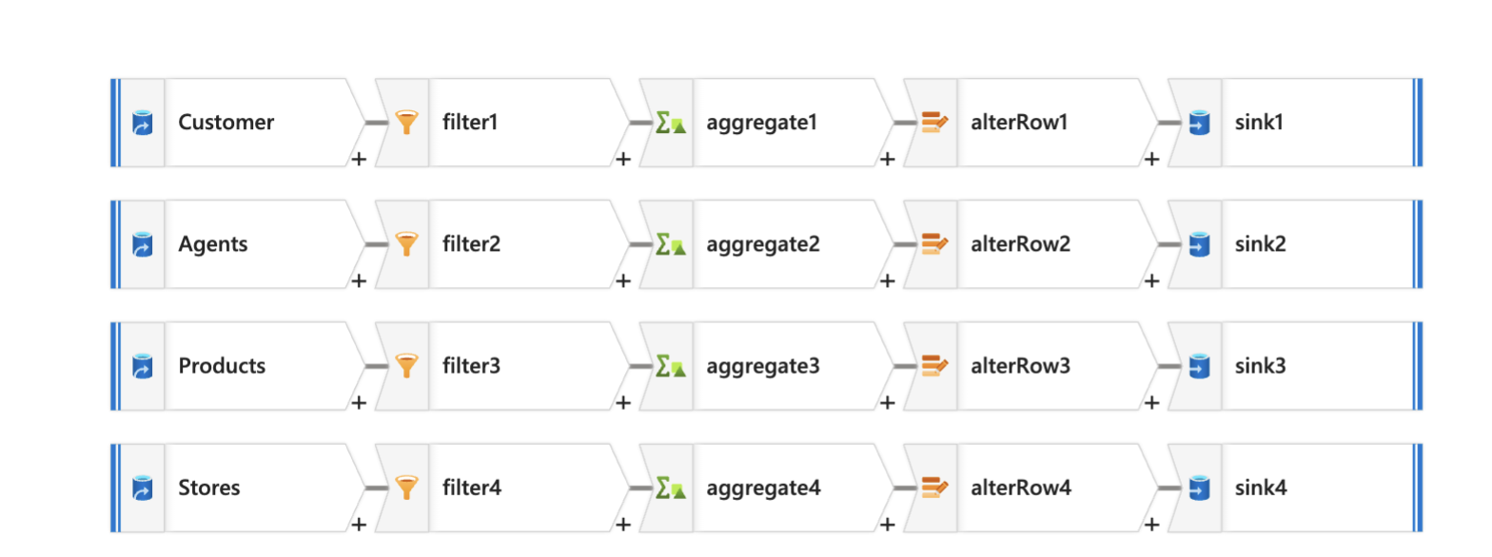

Step 1: Connecting to ADLS and Selecting the Source File.

* Selecting the Source, e.g., Customer.csv
* Importing the Schema

Step 2: Filter Transformation

* To remove null values

Step 3: Aggregate

* To remove the duplicate values
* Adding Group By and Aggregates using first()

Step 4: Atler Row

* Upsert if ( allows updating and insertion both for the new data )

Step 5: Sink

* Connecting to Azure SQL database
* 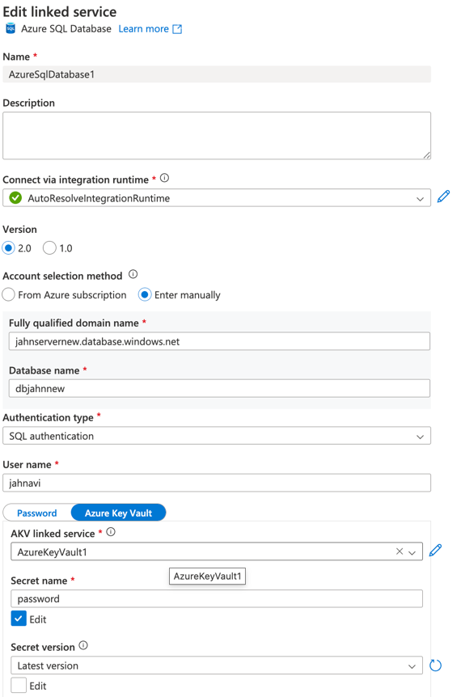While Creating the Linked Service used the Azure Key Vault.
* Adding the Schema name and the Table Name, and choosing Upsert if. And for the Key Columns, select the Primary Key.

Created the Same for the other tables.

Created the same for the dependent tables.

After the Data is Loaded in the SQL DB.

**Gold Layer**

Created Views in Azure Data Studio

**View 1:**

Calculates the Average Order Value for each product, category, and store location. It combines online transaction data with product and store details to show how much customers spend per order. This helps businesses understand which products perform well in different store locations and categories.

**View 2 –**

This view sorts customers into groups based on how much they spend, how often they shop, and their loyalty tier. It labels them as “High-Value Customers,” “One-Time Buyers,” or “Loyalty Champions.” This helps businesses understand which customers are most valuable. It uses a built-in function to find the top 10% of spenders.

**View 3 -**

**View_PeakTrafficAnalysis** helps identify the busiest days and hours for both online and in-store transactions. It groups data by day of the week and hour of the day, showing how many purchases happen during each time slot. This view combines both sales channels using Union ALL, making it easy to compare traffic patterns across online and physical stores.

**View 4 –**

**View_AgentInteractionStats** shows how well each customer service agent is performing. It includes their name, department, and shift, along with the total number of customer interactions they've handled. It also counts how many of those were successfully resolved and calculates a resolution rate as a percentage. This helps managers track agent efficiency and identify top performers or those needing support. The view uses a Left Join to include agents even if they haven’t handled any interactions yet.

Power BI

