Bootcamp Project 3

Customer 360 Data Integration

### **Overview Of the Project**

A retail business wants to build a unified Customer 360 view by integrating data from multiple sources, including online transactions, in-store purchases, customer service interactions, and loyalty programs. This project uses a mix of fact and dimension tables to ensure a clean, scalable structure.

### **Flow of Project :**

* We have given data of project in raw csv files.
* We are going to follow Medalen Architecture: storing data into 3 different containers: Bronze and Silver and Gold
* Raw CSV files are stored in Raw container.
* We have given 10 SQL table structures, which have relationships among them.
* We have to ingest the data from csv files into tables that will be created in Azure MS SQL Database. This ends up the raw layer.
* In Next phase, we are going to clean the data and transform into desired tabular structures.
* After finishing this, in next phase, we have given some insights or KPIs and we are going to create views on top of tables based on KPIs and then at last we are going to populate the processed data into Power BI dashboards.

# PHASE –1 (DATA INGESTION)

* In this phase, we are going to store raw csv files into ADLS G2 container.

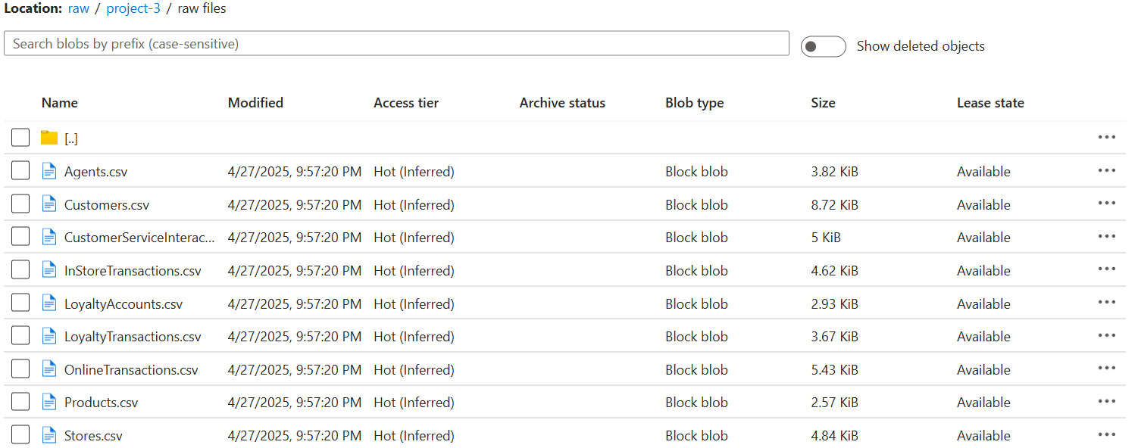

* Now, we are creating all 10 tables associated with files.
* Please note that tables have relations among them, we are going to create parent tables first, after that child tables.
* Tables’ Name:
  + Customers
  + Products
  + Stores
  + Agents
  + OnlineTransactions
  + InStoreTransactions
  + CustomerServiceInteractions
  + LoyaltyAccounts
  + LoyaltyTransactions

## Creation of Tables queries:

*-- Products SP*  
CREATE PROCEDURE project3.**Cleanproductstable**  
AS  
 BEGIN  
 *--removing duplicate records*  
 WITH cte  
 AS (SELECT *,  
 **Row_number**()  
 OVER (  
 partition BY productid  
 ORDER BY productid) AS RowNum  
 FROM project3.products)  
 DELETE FROM cte  
 WHERE rownum > 1;  
  
 *--trim the records*  
 UPDATE project3.products  
 SET NAME = **Trim**(NAME);  
  
 UPDATE project3.products  
 SET category = **Trim**(category);  
  
 *--default value*  
 UPDATE project3.products  
 SET price = *COALESCE*(price, 0.00)  
 WHERE price IS NULL;  
 END;  
  
*-- Stores SP*  
CREATE PROCEDURE project3.**Cleanstorestable**  
AS  
 BEGIN  
 *--removing duplicate records*  
 WITH cte  
 AS (SELECT *,  
 **Row_number**()  
 OVER (  
 partition BY storeid, manager  
 ORDER BY storeid) AS RowNum  
 FROM project3.stores)  
 DELETE FROM cte  
 WHERE rownum > 1;  
  
 *--trim the records*  
 UPDATE project3.stores  
 SET manager = **Trim**(manager);  
  
 UPDATE project3.stores  
 SET location = **Trim**(location);  
 END;  
  
*-- Agents SP*  
CREATE PROCEDURE project3.**Cleanagentstable**  
AS  
 BEGIN  
 *--removing duplicate records*  
 WITH cte  
 AS (SELECT *,  
 **Row_number**()  
 OVER (  
 partition BY agentid, NAME, department  
 ORDER BY agentid) AS RowNum  
 FROM project3.agents)  
 DELETE FROM cte  
 WHERE rownum > 1;  
  
 *--trim the records*  
 UPDATE project3.agents  
 SET NAME = **Trim**(NAME);  
 END;  
  
*-- Online Transactions SP*  
CREATE PROCEDURE project3.**Cleanonlinetransactionstable**  
AS  
 BEGIN  
 *--removing duplicate records*  
 WITH cte  
 AS (SELECT *,  
 **Row_number**()  
 OVER (  
 partition BY orderid  
 ORDER BY orderid) AS RowNum  
 FROM project3.onlinetransactions)  
 DELETE FROM cte  
 WHERE rownum > 1;  
  
 *--trim the records*  
 UPDATE project3.onlinetransactions  
 SET paymentmethod = **Trim**(paymentmethod);  
  
 *--default value*  
 UPDATE project3.onlinetransactions  
 SET amount = *COALESCE*(amount, 0.00)  
 WHERE amount IS NULL;  
 END;  
  
*-- InStoreTransactions SP*  
CREATE PROCEDURE project3.**Cleaninstoretransactionstable**  
AS  
 BEGIN  
 *--removing duplicate records*  
 WITH cte  
 AS (SELECT *,  
 **Row_number**()  
 OVER (  
 partition BY transactionid  
 ORDER BY transactionid) AS RowNum  
 FROM project3.instoretransactions)  
 DELETE FROM cte  
 WHERE rownum > 1;  
  
 *--trim the records*  
 UPDATE project3.instoretransactions  
 SET paymentmethod = **Trim**(paymentmethod);  
  
 *--default value*  
 UPDATE project3.instoretransactions  
 SET amount = *COALESCE*(amount, 0.00)  
 WHERE amount IS NULL;  
 END;  
  
*-- CustomerServiceInteractions SP*  
CREATE PROCEDURE project3.**Cleancustomerserviceinteractionstable**  
AS  
 BEGIN  
 *--removing duplicate records*  
 WITH cte  
 AS (SELECT *,  
 **Row_number**()  
 OVER (  
 partition BY interactionid  
 ORDER BY interactionid) AS RowNum  
 FROM project3.customerserviceinteractions)  
 DELETE FROM cte  
 WHERE rownum > 1;  
  
 *--trim the records*  
 UPDATE project3.customerserviceinteractions  
 SET issuetype = **Trim**(issuetype);  
  
 UPDATE project3.customerserviceinteractions  
 SET resolutionstatus = **Trim**(resolutionstatus);  
 END;  
  
*-- LoyaltyAccounts SP*  
CREATE PROCEDURE project3.**Cleanloyaltyaccountstable**  
AS  
 BEGIN  
 *--removing duplicate records*  
 WITH cte  
 AS (SELECT *,  
 **Row_number**()  
 OVER (  
 partition BY loyaltyid  
 ORDER BY loyaltyid) AS RowNum  
 FROM project3.loyaltyaccounts)  
 DELETE FROM cte  
 WHERE rownum > 1;  
  
 *--trim the records*  
 UPDATE project3.loyaltyaccounts  
 SET tierlevel = **Trim**(tierlevel);  
  
 *--default value*  
 UPDATE project3.loyaltyaccounts  
 SET pointsearned = *COALESCE*(pointsearned, 0)  
 WHERE pointsearned IS NULL;  
 END;  
  
*-- LoyaltyTransactions SP*  
CREATE PROCEDURE project3.**Cleanloyaltytransactionstable**  
AS  
 BEGIN  
 *--removing duplicate records*  
 WITH cte  
 AS (SELECT *,  
 **Row_number**()  
 OVER (  
 partition BY loyaltyid  
 ORDER BY loyaltyid) AS RowNum  
 FROM project3.loyaltytransactions)  
 DELETE FROM cte  
 WHERE rownum > 1;  
  
 *--trim the records*  
 UPDATE project3.loyaltytransactions  
 SET reason = **Trim**(reason);  
 END;

* Here are the tables created in Azure MS SQL database:

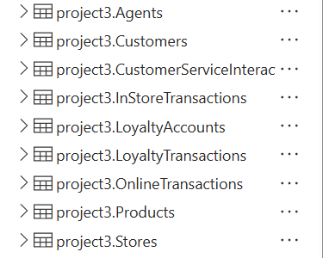

# Next Phase: Ingesting Data from ADLS G2 files into Azure SQL Tables

* To ingest the data from CSV files to Azure SQL tables, we are using Synapse pipeline.
* For that, I have created pipeline in Synapse named Project-3.
* In that, I’m using for-each activity to use parameterized values for copy data of each file.
* I’ve created pipeline parameter as string array that will be passed to for each activity and it is being run for each file sequentially.

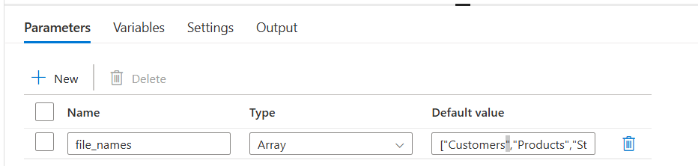Pipeline parameter

* Here is the array of string(please note that order of each file) ->

["Customers","Products","Stores","Agents","OnlineTransactions","InStoreTransactions","CustomerServiceInteractions","LoyaltyAccounts","LoyaltyTransactions"]

* Inside the for-each activity, I’m invoking copy activity which uses parameterized values to copy data from ADLS G2 csv files to Azure SQL table data.
* Source is : delimited file
* Sink : SQL Tables.

***Source :***

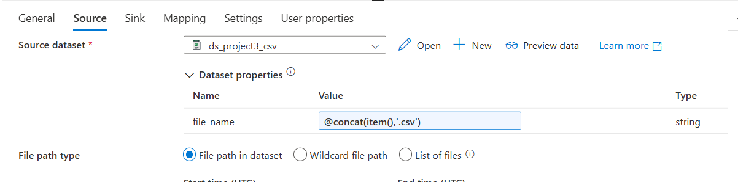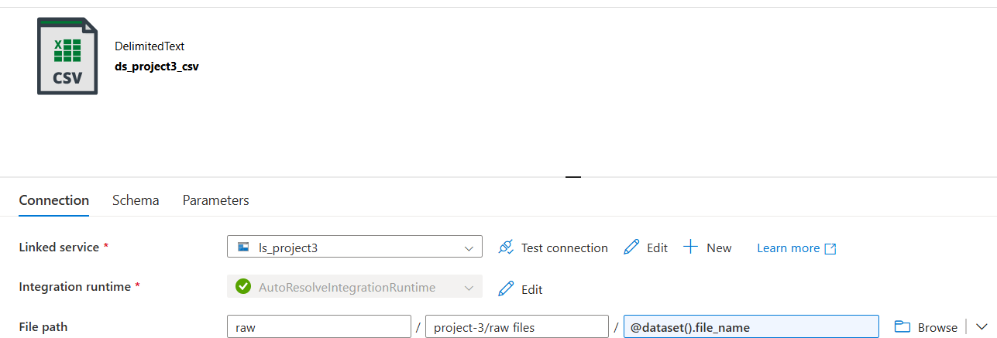

***Sink :***

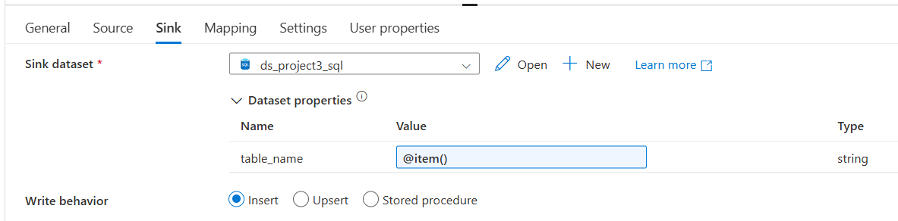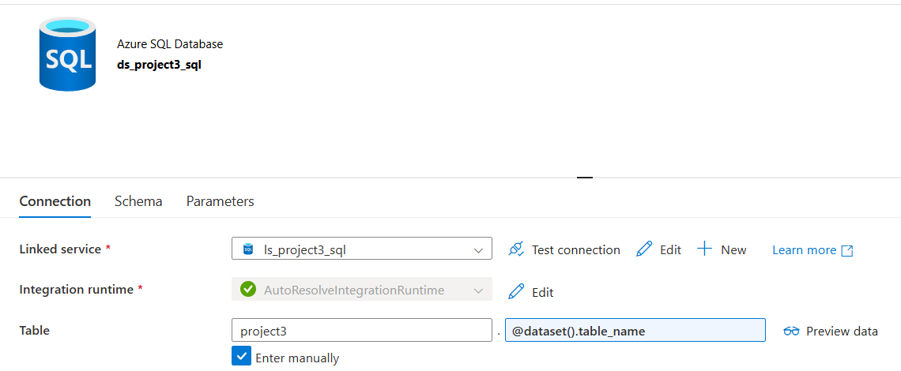

# Next Phase: Cleaning data of SQL Tables using Stored Procedures:

* Now it’s time to clean the data of these tables. I’m using different approach.
* Instead of using azure computational services, I’m using capabilities of Database only to clean the data.
* I’m creating stored procedures and cleaned the data by updating the tables.
* So I have created stored procedure in SQL database for each table and invoke each stored procedure sequentially using Pipeline created in Synapse.

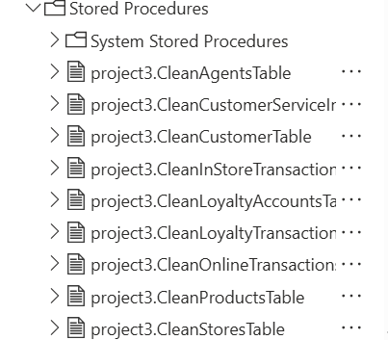

Stored Procedures created in SQL dB to clean data for each table

***What activities will be performed*** :

Duplicate records

Missing (NULL) values

Inconsistent formats (e.g., dates, strings)

Invalid or outlier values

Extra spaces or special characters

* Here are the queries of each stored Procedure :

*-- Products SP*  
CREATE PROCEDURE project3.**Cleanproductstable**  
AS  
 BEGIN  
 *--removing duplicate records*  
 WITH cte  
 AS (SELECT *,  
 **Row_number**()  
 OVER (  
 partition BY productid  
 ORDER BY productid) AS RowNum  
 FROM project3.products)  
 DELETE FROM cte  
 WHERE rownum > 1;  
  
 *--trim the records*  
 UPDATE project3.products  
 SET NAME = **Trim**(NAME);  
  
 UPDATE project3.products  
 SET category = **Trim**(category);  
  
 *--default value*  
 UPDATE project3.products  
 SET price = *COALESCE*(price, 0.00)  
 WHERE price IS NULL;  
 END;  
  
*-- Stores SP*  
CREATE PROCEDURE project3.**Cleanstorestable**  
AS  
 BEGIN  
 *--removing duplicate records*  
 WITH cte  
 AS (SELECT *,  
 **Row_number**()  
 OVER (  
 partition BY storeid, manager  
 ORDER BY storeid) AS RowNum  
 FROM project3.stores)  
 DELETE FROM cte  
 WHERE rownum > 1;  
  
 *--trim the records*  
 UPDATE project3.stores  
 SET manager = **Trim**(manager);  
  
 UPDATE project3.stores  
 SET location = **Trim**(location);  
 END;  
  
*-- Agents SP*  
CREATE PROCEDURE project3.**Cleanagentstable**  
AS  
 BEGIN  
 *--removing duplicate records*  
 WITH cte  
 AS (SELECT *,  
 **Row_number**()  
 OVER (  
 partition BY agentid, NAME, department  
 ORDER BY agentid) AS RowNum  
 FROM project3.agents)  
 DELETE FROM cte  
 WHERE rownum > 1;  
  
 *--trim the records*  
 UPDATE project3.agents  
 SET NAME = **Trim**(NAME);  
 END;  
  
*-- Online Transactions SP*  
CREATE PROCEDURE project3.**Cleanonlinetransactionstable**  
AS  
 BEGIN  
 *--removing duplicate records*  
 WITH cte  
 AS (SELECT *,  
 **Row_number**()  
 OVER (  
 partition BY orderid  
 ORDER BY orderid) AS RowNum  
 FROM project3.onlinetransactions)  
 DELETE FROM cte  
 WHERE rownum > 1;  
  
 *--trim the records*  
 UPDATE project3.onlinetransactions  
 SET paymentmethod = **Trim**(paymentmethod);  
  
 *--default value*  
 UPDATE project3.onlinetransactions  
 SET amount = *COALESCE*(amount, 0.00)  
 WHERE amount IS NULL;  
 END;  
  
*-- InStoreTransactions SP*  
CREATE PROCEDURE project3.**Cleaninstoretransactionstable**  
AS  
 BEGIN  
 *--removing duplicate records*  
 WITH cte  
 AS (SELECT *,  
 **Row_number**()  
 OVER (  
 partition BY transactionid  
 ORDER BY transactionid) AS RowNum  
 FROM project3.instoretransactions)  
 DELETE FROM cte  
 WHERE rownum > 1;  
  
 *--trim the records*  
 UPDATE project3.instoretransactions  
 SET paymentmethod = **Trim**(paymentmethod);  
  
 *--default value*  
 UPDATE project3.instoretransactions  
 SET amount = *COALESCE*(amount, 0.00)  
 WHERE amount IS NULL;  
 END;  
  
*-- CustomerServiceInteractions SP*  
CREATE PROCEDURE project3.**Cleancustomerserviceinteractionstable**  
AS  
 BEGIN  
 *--removing duplicate records*  
 WITH cte  
 AS (SELECT *,  
 **Row_number**()  
 OVER (  
 partition BY interactionid  
 ORDER BY interactionid) AS RowNum  
 FROM project3.customerserviceinteractions)  
 DELETE FROM cte  
 WHERE rownum > 1;  
  
 *--trim the records*  
 UPDATE project3.customerserviceinteractions  
 SET issuetype = **Trim**(issuetype);  
  
 UPDATE project3.customerserviceinteractions  
 SET resolutionstatus = **Trim**(resolutionstatus);  
 END;  
  
*-- LoyaltyAccounts SP*  
CREATE PROCEDURE project3.**Cleanloyaltyaccountstable**  
AS  
 BEGIN  
 *--removing duplicate records*  
 WITH cte  
 AS (SELECT *,  
 **Row_number**()  
 OVER (  
 partition BY loyaltyid  
 ORDER BY loyaltyid) AS RowNum  
 FROM project3.loyaltyaccounts)  
 DELETE FROM cte  
 WHERE rownum > 1;  
  
 *--trim the records*  
 UPDATE project3.loyaltyaccounts  
 SET tierlevel = **Trim**(tierlevel);  
  
 *--default value*  
 UPDATE project3.loyaltyaccounts  
 SET pointsearned = *COALESCE*(pointsearned, 0)  
 WHERE pointsearned IS NULL;  
 END;  
  
*-- LoyaltyTransactions SP*  
CREATE PROCEDURE project3.**Cleanloyaltytransactionstable**  
AS  
 BEGIN  
 *--removing duplicate records*  
 WITH cte  
 AS (SELECT *,  
 **Row_number**()  
 OVER (  
 partition BY loyaltyid  
 ORDER BY loyaltyid) AS RowNum  
 FROM project3.loyaltytransactions)  
 DELETE FROM cte  
 WHERE rownum > 1;  
  
 *--trim the records*  
 UPDATE project3.loyaltytransactions  
 SET reason = **Trim**(reason);  
 END;

* Then Through Synapse Pipeline, I’m invoking each stored procedure using Stored Procedure activity available in Synapse Pipeline:

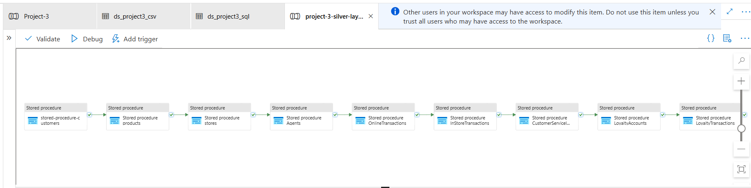

# Next Phase: Creating Views on top of tables for Insights:

* Few KPIs or Insights are :
  + **Average Order Value**
  + Segment customers based on total spend, purchase frequency, and loyalty tier
  + Analyze **DateTime** to find peak days and times in-store vs. Online
  + Number of interactions and resolution success rates per agent.

***Views created for each KPI:***

CREATE VIEW analytics.view_averageordervalue AS

SELECT p.productid,

p.NAME AS ProductName,

p.category,

s.storeid,

s.location,

Sum(t.amount) / Count(t.orderid) AS AverageOrderValue

FROM project3.onlinetransactions t

INNER JOIN project3.products p

ON t.productid = p.productid

LEFT JOIN project3.stores s

ON s.storeid IS NOT NULL -- since online might not have a store directly, kept flexible

GROUP BY p.productid,

p.NAME,

p.category,

s.storeid,

s.location;

----------------------------------CREATE VIEW analytics.view_customersegmentation AS

WITH customerspending AS

(

SELECT c.customerid,

c.NAME,

Sum(t.amount) AS totalspend,

Count(t.orderid) AS purchasefrequency,

l.tierlevel

FROM project3.customers c

LEFT JOIN project3.onlinetransactions t

ON c.customerid = t.customerid

LEFT JOIN project3.loyaltyaccounts l

ON c.customerid = l.customerid

GROUP BY c.customerid,

c.NAME,

l.tierlevel

)

SELECT customerid,

NAME,

totalspend,

purchasefrequency,

tierlevel,

CASE

WHEN totalspend >=

(

SELECT Percentile_cont(0.9) within GROUP (ORDER BY totalspend) OVER ()) THEN 'High-Value Customer'

WHEN purchasefrequency = 1 THEN 'One-Time Buyer'

WHEN tierlevel = 'Gold'

OR tierlevel = 'Platinum' THEN 'Loyalty Champion'

ELSE 'Regular Customer'

END AS customersegment

FROM customerspending;

* ***Views created for each KPI:***

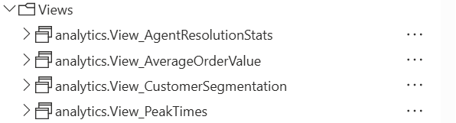

# Next Phase: Populating Dashboards on the data of Views:

