Project Name | Accessible MFA — Multi-Factor Authentication for Visually Impaired Users
Module | CS3053 — Computer Security — Group Project (Semester 5)
Assignment | Submission 1 — Individual Design Work
Group Name | CRYPTIX
Student ID | 230135A
Student Name (with initials) | DEWDUNIKA D.R.K.W.M.V.V
Group Slice Owned | Member 1 — Accounts & Factor 1 (knowledge factor: password/PIN)
Date | 15 September 2026

Individual Design Contribution
Accounts & Factor 1 — User Registration, Login, Sessions and Knowledge-Factor Authentication

1. Scope of my contribution
I own the Accounts & Factor 1 slice end to end: design, implementation, tests and this report. It covers:
Area | What I designed / will implement
Data | The User record (credential storage) and the Session record that other slices (Factor 2, Factor 3, orchestration) read and extend.
Endpoints | POST /register, POST /login, POST /logout, GET /me.
Factor 1 logic | Knowledge-factor authentication: password or PIN, chosen by the user at registration so that a numeric-keypad-only entry method is always available.
Security controls owned here | Argon2id password/PIN hashing, credential validation policy, and the account-side half of failed-attempt tracking that Member 5's rate-limit/lockout middleware consumes.

Everything else (TOTP/email OTP, WebAuthn, client accessibility, orchestration/lockout/audit) belongs to Members 2–5 and appears here only as necessary context.
2. Assumptions
None of the assumptions below removes a required security or accessibility property.
A1 — User population. Covers both blind users (audio-only) and low-vision users (high contrast/large text). The knowledge factor is audio-first, not audio-only.

A2 — Assistive technology. Standard keyboard + screen reader (NVDA, JAWS, VoiceOver or TalkBack) — the four readers used by 1,539 respondents in the WebAIM Screen Reader Survey #10 [6]. No unusual assistive hardware assumed.

A3 — Delivery platform. Browser-based web app, not a native mobile app, so browser-native accessibility APIs and TLS can be relied on.

A4 — TLS is provided by deployment, not my code. HTTPS termination is assumed to sit in the deployment environment (e.g. a reverse proxy); my design marks cookies Secure but does not implement TLS itself.

A5 — Single relational database. One database (e.g. PostgreSQL/SQLite), no horizontal scaling — appropriate for an academic prototype, not a production service.

A6 — Recovery email is not an MFA factor. It exists only for account recovery (Member 5), because NIST 800-63B says email SHALL NOT be used for out-of-band authentication [1, Section 3.1.3.1]. Flagged further in Section 12, since Member 2's slice lists email OTP as an option.

A7 — Threat model boundary. Local device/OS compromise and malicious AT extensions are out of scope, per the group threat model. This slice defends remote credential-guessing and database-leak scenarios (T1, T8, T9, T12).

3. Requirements
3.1 Functional requirements (FR)
ID | Requirement
FR1 | A new user can register with a username and either a password or a numeric PIN.
FR2 | A registered user can authenticate Factor 1 with the same credential type they registered with.
FR3 | On successful Factor 1 verification, the system starts a session and reports which factor is required next.
FR4 | A user can log out, invalidating their session server-side.
FR5 | An authenticated user can retrieve their own account summary (/me), including which factors they have enrolled.

3.2 Accessibility requirements (AR)
ID | Requirement | Standard
AR1 | No step in Factor 1 may require solving a puzzle, transcribing a CAPTCHA, or otherwise recalling/manipulating information beyond the credential itself, unless an alternative or assistive mechanism is offered. | WCAG 2.2 SC 3.3.8 [3]
AR2 | Password/PIN fields must accept paste and must not block password-manager autofill. | NIST 800-63B Section 3.1.1.2 [1]; WCAG 2.2 Understanding 3.3.8 [4]
AR3 | Every error response's message must be a complete, standalone sentence that makes sense read aloud with no visual context (no reliance on colour or icon alone). | WCAG 2.2 SC 1.4.1, SC 3.3.1 [3]
AR4 | No fixed short time limit on completing registration/login; if any timeout exists it must be extendable. | WCAG 2.2 SC 2.2.1 [3]

3.3 Security requirements (SR)
ID | Requirement | Standard
SR1 | Passwords used alongside a second factor must be at least 8 characters; a password used alone must never be accepted as sufficient for login (MFA is mandatory). | NIST 800-63B Section 3.1.1.2 [1]
SR2 | No composition rules (mixed case/digit/symbol) and no periodic forced expiry. | NIST 800-63B Section 3.1.1.2 [1]
SR3 | Credentials are checked against a breached/common-credential blocklist at registration. | NIST 800-63B Section 3.1.1.2 [1]
SR4 | Credentials are stored using Argon2id, never reversible encryption or a fast general-purpose hash. | OWASP Password Storage Cheat Sheet [2]
SR5 | Failed Factor-1 attempts on one account are capped, feeding Member 5's lockout middleware. | NIST 800-63B Section 3.2.2 [1]
SR6 | Session identifiers have ≥64 bits of entropy and are rotated on privilege change (each factor completed). | OWASP Session Management Cheat Sheet [7]

4. System context (design artifact 1)
Figure 1 shows where my slice (highlighted) sits in the system, including the trust boundaries from the group threat model.
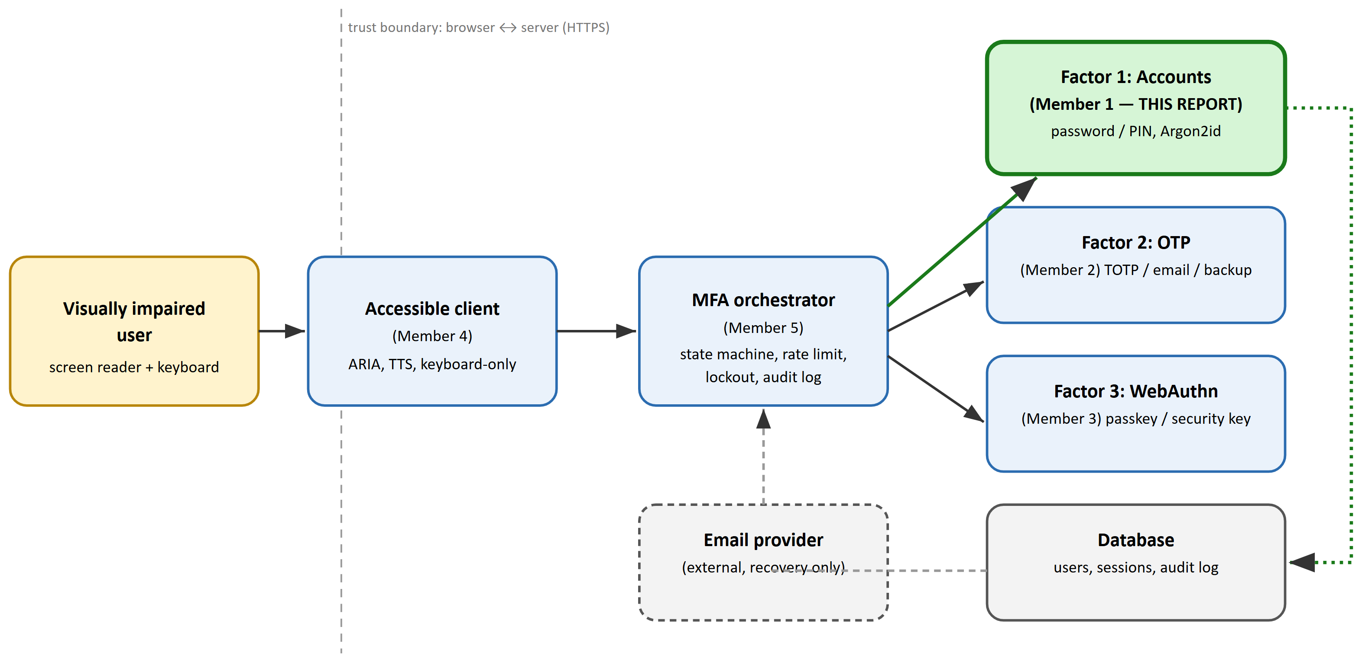
Figure 1. System context diagram (green = component covered by this report). Dashed line marks the browser↔server trust boundary from the group threat model. The dashed arrow from Factor 1 to Database represents credential read/write; the solid line from client to orchestrator represents every screen making its request through the orchestration layer's requireFactor(n) middleware.
5. Data design — entity-relationship model (design artifact 2)
Figure 2 shows the two entities I own (USER, SESSION), crow's-foot notation, plus Member 5's AUDIT_LOG for context.
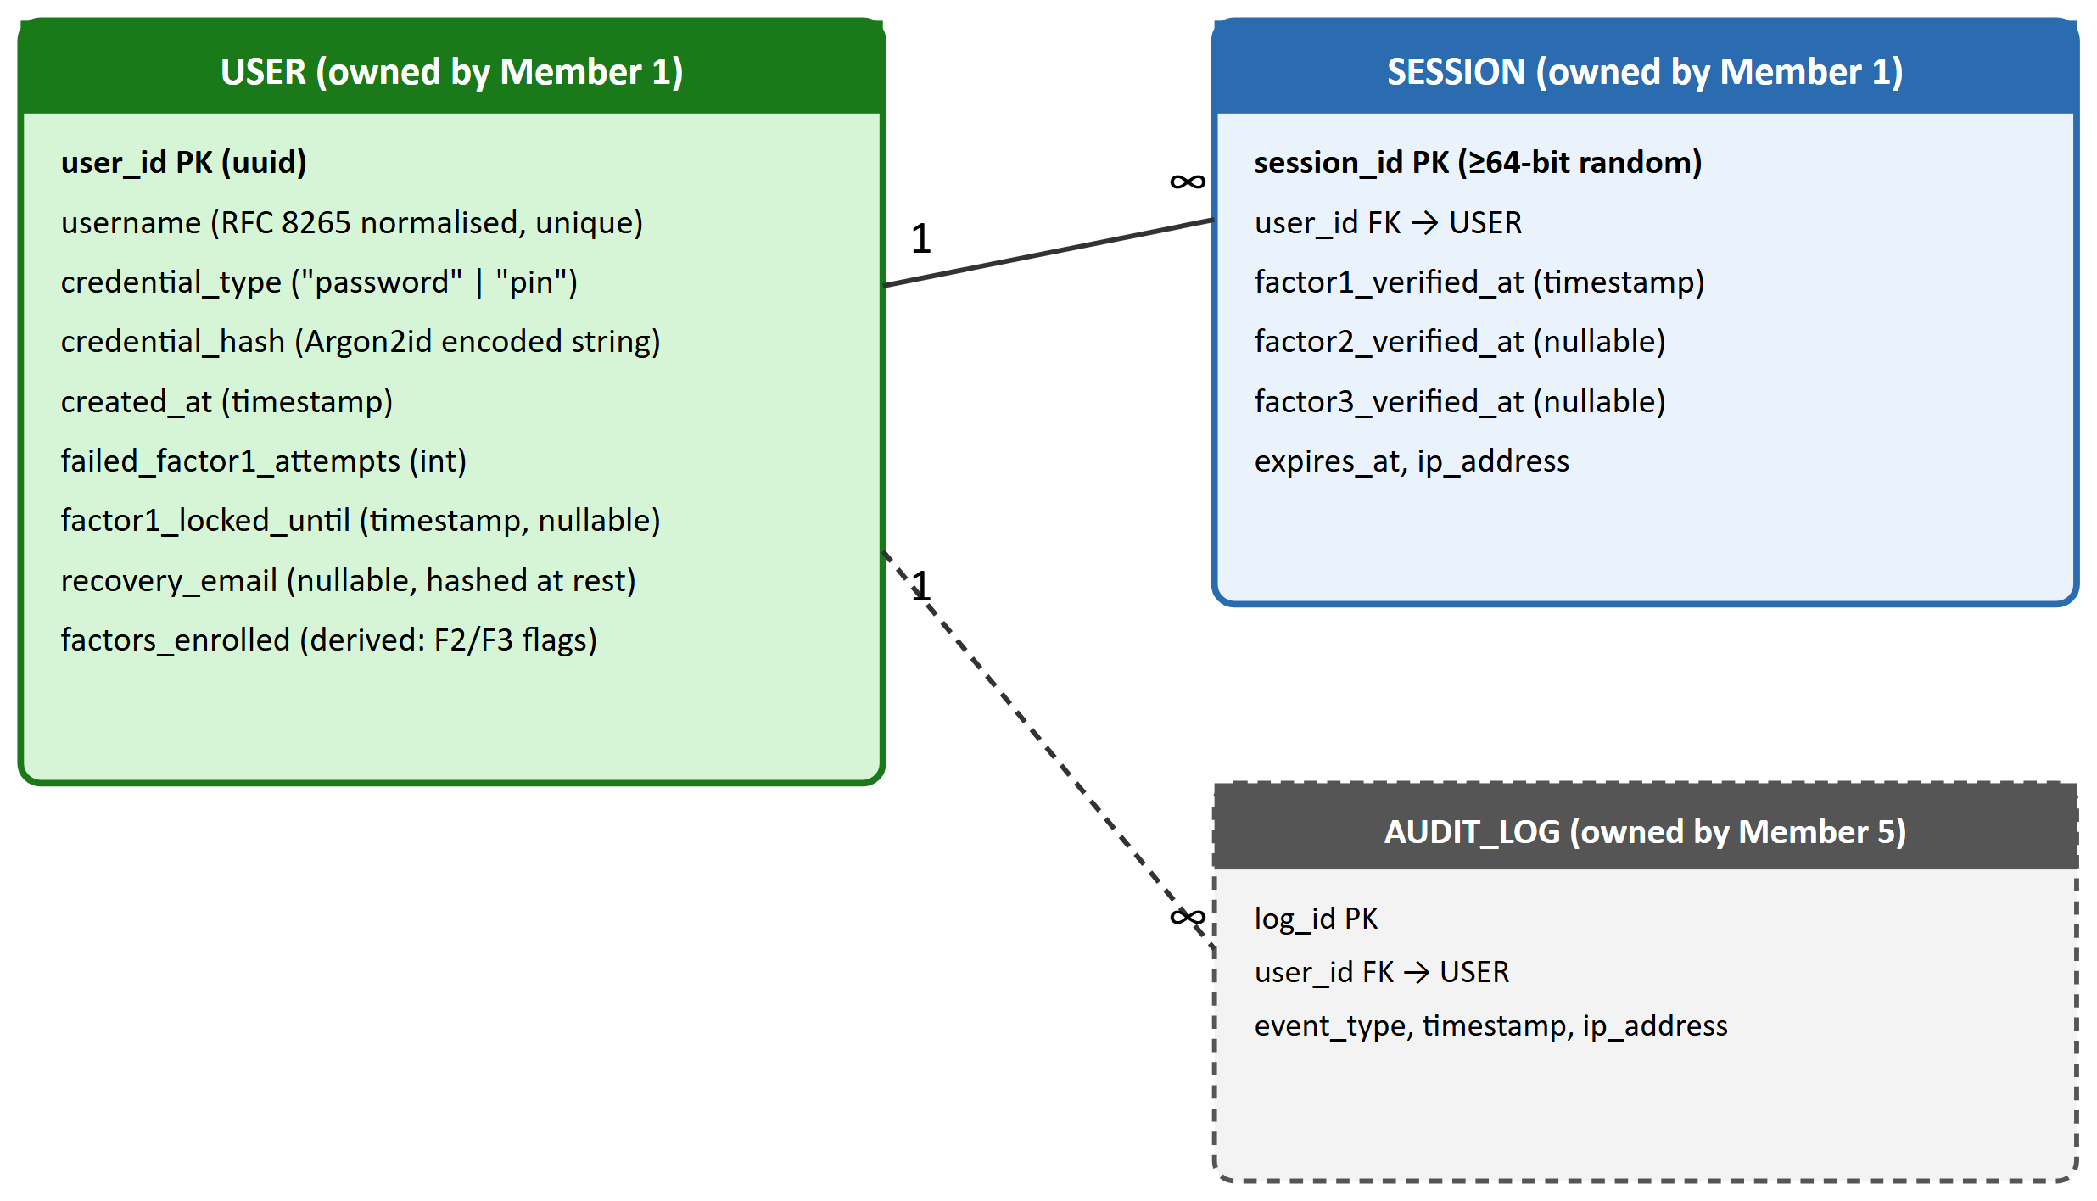
Figure 2. Entity-relationship diagram, crow's-foot cardinality (1 : ∞). Solid entities/edges are owned by this slice; the dashed AUDIT_LOG box is Member 5's, shown only to make the user_id foreign-key relationship explicit. credential_hash stores either the password or PIN hash — never both — because a user chooses one Factor-1 method at registration (design decision D5, Section 9).
6. Behavioural design — sequence diagrams (design artifacts 3 & 4)
6.1 Registration
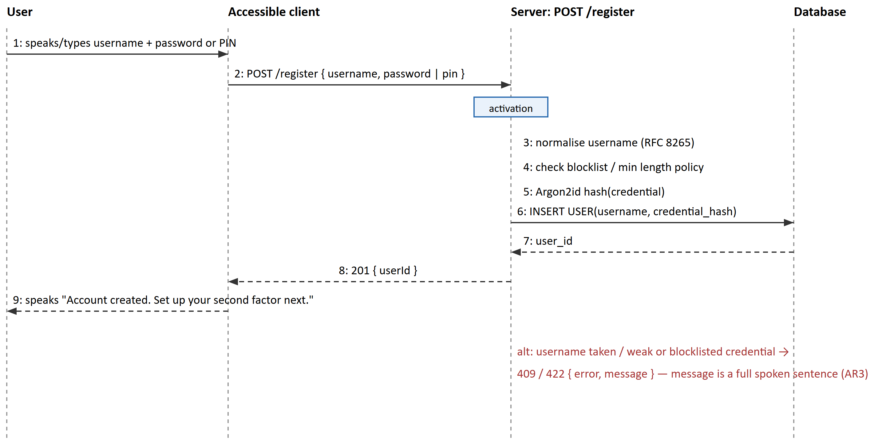
Figure 3. UML sequence diagram — registration (happy path + error alternative). Step 3–5 are the parts I implement inside the /register handler.
6.2 Login (Factor 1) and hand-off to Factor 2/3
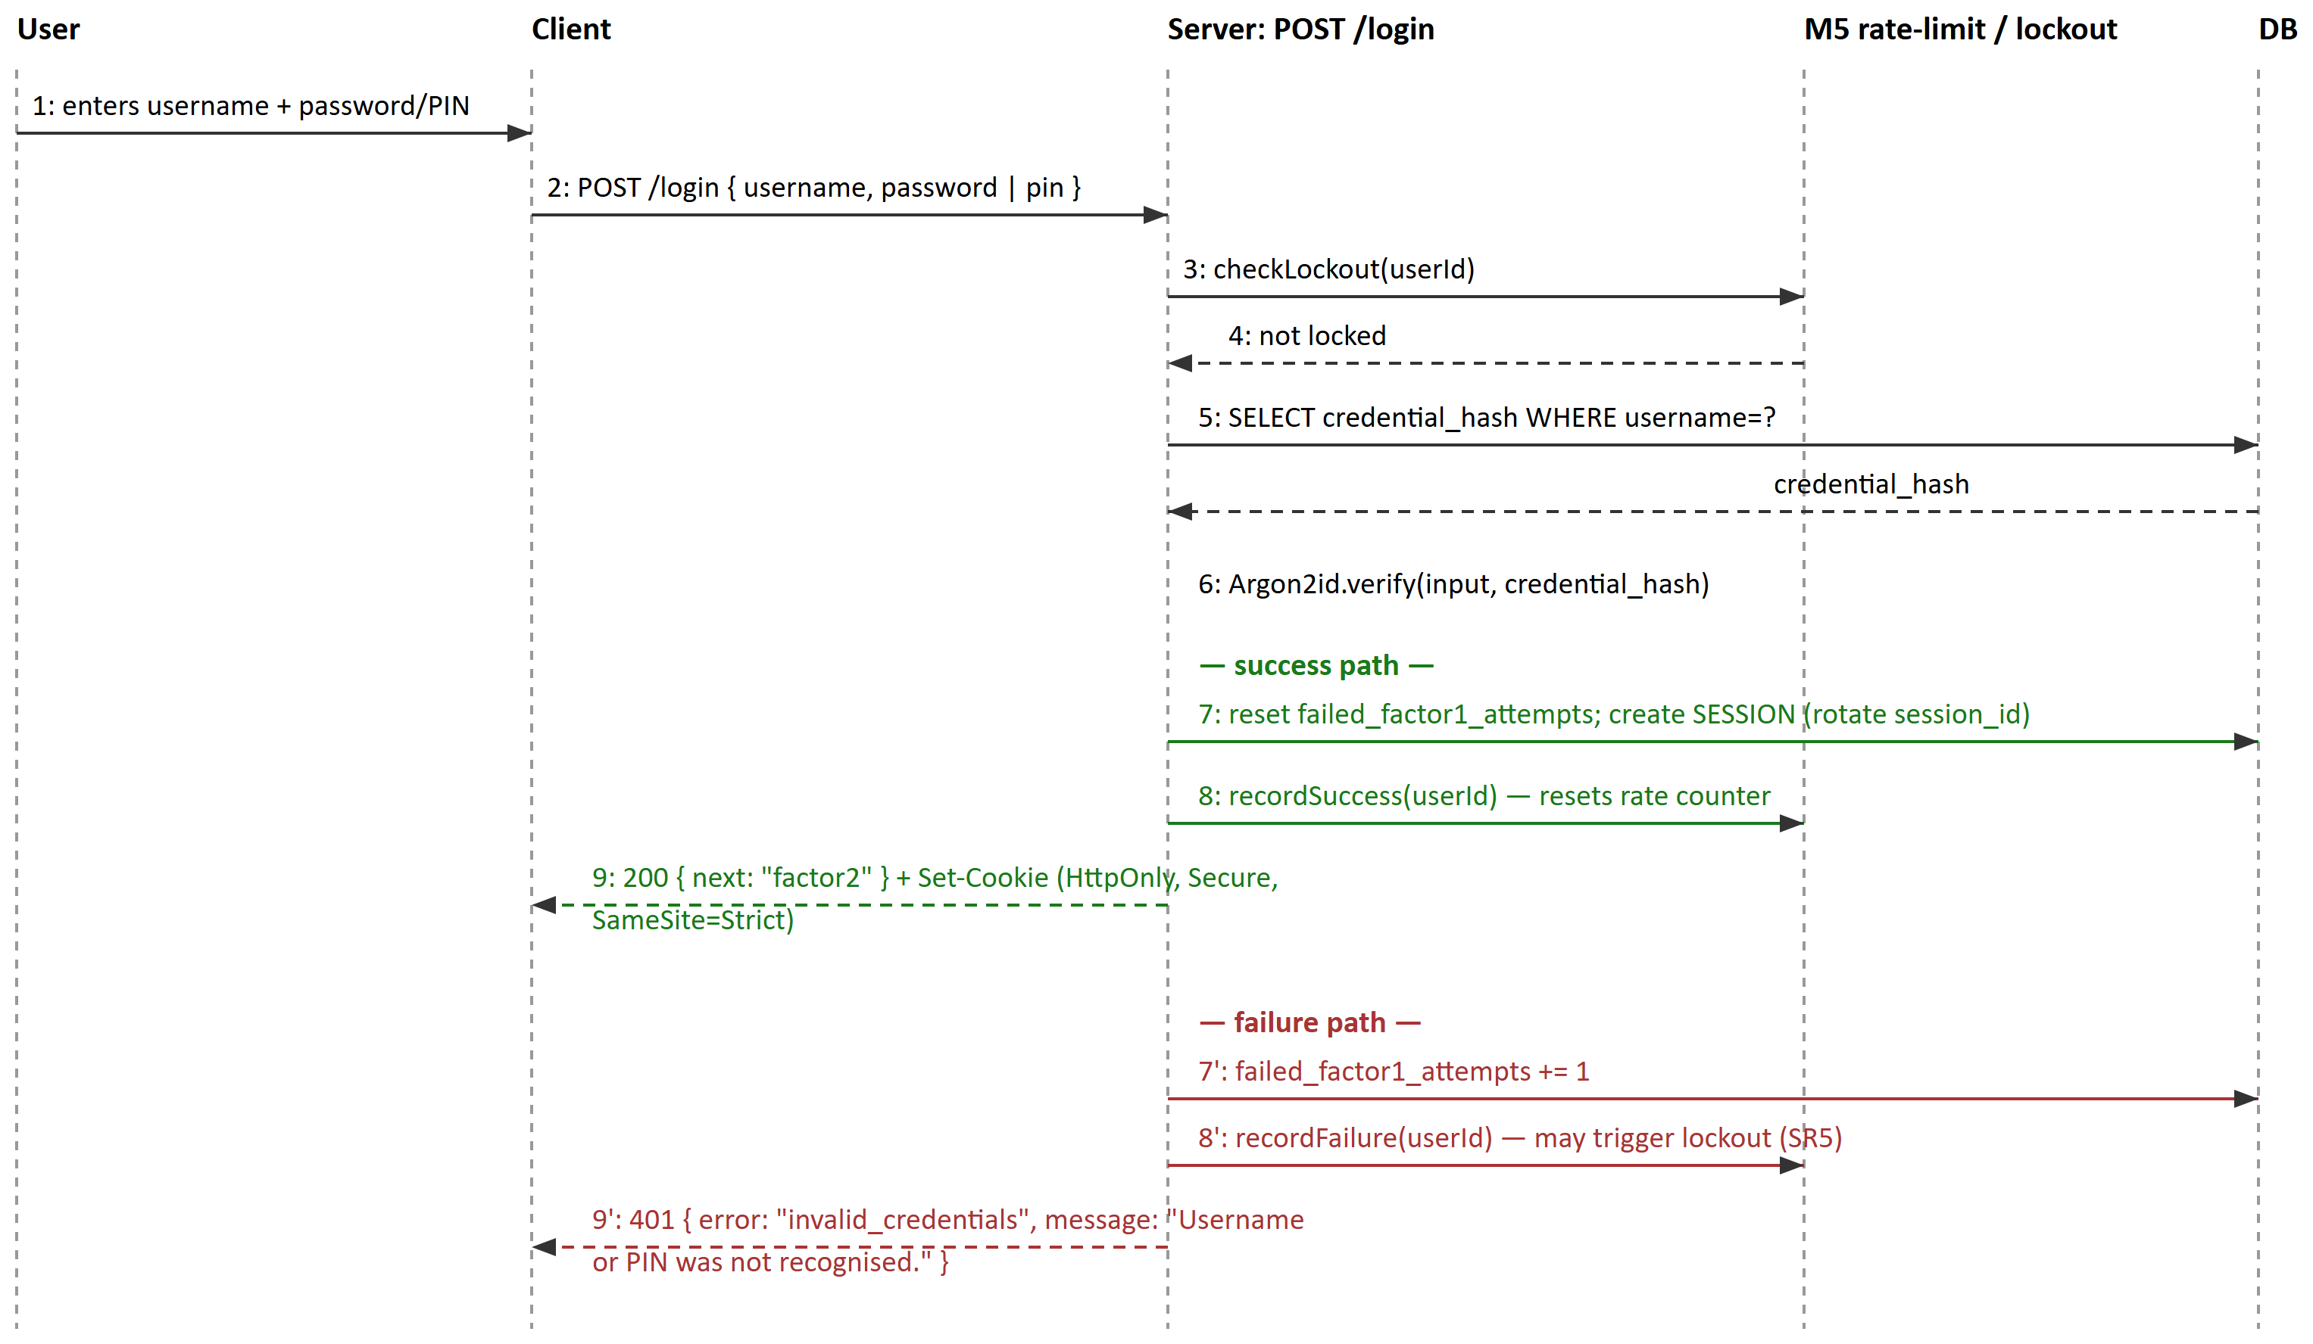
Figure 4. UML sequence diagram — Factor 1 login, showing both outcomes and the exact hand-off point (step 8/9) into Member 5's shared middleware and state machine. Note the error message at 9′ never reveals which of username/credential was wrong (mitigates account enumeration, contributes to T1 mitigation).
7. Behavioural design — session/auth state machine (design artifact 5)
Figure 5 shows the part of the shared state machine my slice drives; the full multi-factor machine is owned by Member 5.
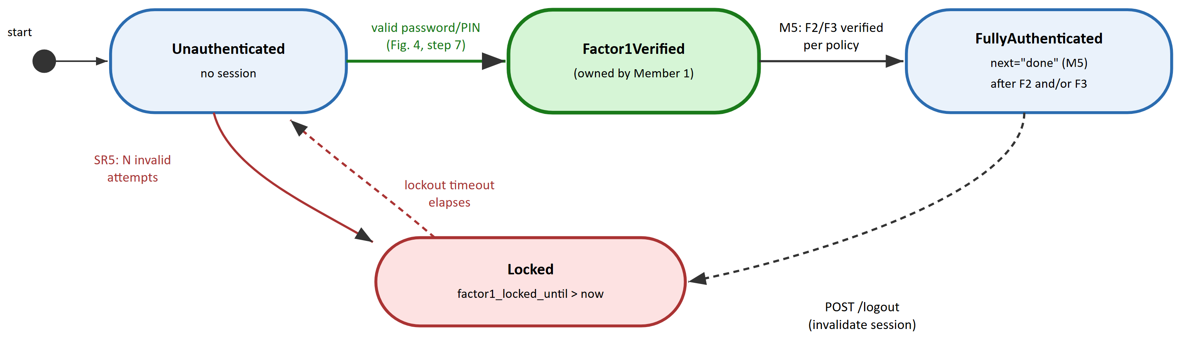
Figure 5. UML state diagram (excerpt). Unauthenticated → Factor1Verified and Locked transitions are implemented by my /login handler; Factor1Verified → FullyAuthenticated is driven by Member 5's requireFactor(n) once Factor 2/3 succeed, shown for context only.
8. API design
These four endpoints are the contract I implement, agreed in the group's shared docs/api-contract.md before coding began (a deliberate process decision so Member 4 could build the client against a stable contract while my backend was still in progress).
Method | Path | Request | Response | Notes
POST | /register | { username, password | pin } | 201 { userId } | Argon2id hash; policy enforced per Section 9 D1–D4
POST | /login | { username, password | pin } | 200 { next } | Calls M5 rate limiter (Fig. 4)
POST | /logout | – | 204 | Server-side session invalidation
GET | /me | – | 200 { userId, username, factorsEnrolled } | Requires full auth (all required factors)

Error shape is shared across the whole group API: { "error": "<machine_code>", "message": "<spoken sentence>" }, satisfying AR3.
9. Design decisions and justification
D1 — Argon2id, not bcrypt/PBKDF2/scrypt. Winner of the Password Hashing Competition; OWASP recommends it for its "balanced approach to resisting both side-channel and GPU-based attacks" [2]. Baseline parameters follow OWASP's documented minimum (m=19 MiB, t=2, p=1), tunable to hardware, per NIST's requirement to keep cost "as high as practical" [1, Section 3.1.1.2].

D2 — 8-character minimum, not 15, because MFA is mandatory. NIST 800-63B requires 15 characters only for single-factor use, but permits 8 "for passwords... used as part of multi-factor authentication" [1]. Since Factor 1 alone never grants login (SR1), the shorter, more screen-reader-practical floor applies.

D3 — No composition rules or forced expiry; a compromised-credential blocklist instead. NIST 800-63B forbids both [1, Section 3.1.1.2]. This also serves accessibility: composition rules force error-prone transcription, exactly the "cognitive function test" WCAG SC 3.3.8 asks us to avoid [3, 4].

D4 — Paste and password-manager autofill are allowed on both fields. Required by NIST 800-63B [1]. A 2025 interview study of 33 blind/low-vision users found all of them relied on password managers, and that accessibility gaps in generator/autofill flows pushed some toward reused or predictable passwords instead [9] — blocking paste would make credentials weaker, not stronger.

D5 — A numeric PIN is offered as an alternative to a password (not a replacement), on a standard 12-key layout. ITU-T E.161 standardises a tactile raised dot on the "5" key "to make it easier to use the keypad... by the visually impaired" [5]; reusing that layout lets tactile/muscle memory transfer. This satisfies WCAG 3.3.8's "Alternative" exception, not just its "Mechanism" exception [4].

D6 — PIN minimum is 6 digits plus a blocklist, not a bare 4-digit default. The largest published PIN study (n=1,220) found 6-digit PINs give no security benefit over 4-digit ones against a throttled attacker (10–100 guesses, matching SR5) unless paired with a blocklist covering roughly "10% of the PIN space" [8]. I require both digit count and a common-PIN blocklist, not digits alone.

D7 — Usernames are normalised with RFC 8265 (PRECIS UsernameCaseMapped). NFC normalisation and case-folding keep a username recognisable across different Unicode representations (a real risk from speech-to-text or autocorrect input) and block look-alike-character spoofing [10].

D8 — Failed-attempt counting is reported to Member 5's shared lockout middleware, not enforced locally. NIST 800-63B caps consecutive failures at 100 [1, Section 3.2.2]; the group threat model (T1, T10) requires lockout keyed on user and IP so it can't be weaponised against a victim. One shared policy avoids two competing lockout implementations.

D9 — Session cookie is HttpOnly, Secure, SameSite=Strict; ≥64-bit-entropy ID rotated on every factor transition. Follows the OWASP Session Management Cheat Sheet directly, which also warns that localStorage/sessionStorage tokens are lost to a single XSS bug [7]. Rotating the ID once Factor 1 succeeds also mitigates session fixation (T12).

D10 — Generic, non-enumerating error messages that are still full spoken sentences. The failure response never reveals whether the username or credential was wrong (mitigates account enumeration), while remaining a complete sentence rather than a code or icon, per WCAG's requirement that errors be identified "in text" [3].

10. Accessibility rationale specific to this slice
The WHO estimates at least 2.2 billion people globally have a near or distance vision impairment [11] — not a small edge case. A contextual inquiry of visually impaired users performing real authentication tasks found login forms measurably slower and more error-prone with a screen reader, largely due to unlabelled fields, unpredictable focus order and inaccessible CAPTCHAs [12] — exactly what WCAG SC 1.3.1, 2.4.3 and 3.3.8 exist to prevent. My Factor-1 forms therefore use: explicit label/ARIA associations (SC 1.3.1), a focus order matching reading order (SC 2.4.3), no CAPTCHA anywhere (rated the single most problematic barrier by screen-reader users in the WebAIM survey [6]), and no short fixed timeout (SC 2.2.1). Manual testing targets JAWS/NVDA on Chrome/Edge first, matching that survey's most common setup [6], then spot-checks VoiceOver.
11. Security evaluation against the threat model
The following rows from the group's shared STRIDE threat model (docs/threat-model.md) are wholly or partly mitigated by this slice:
ID | Threat | My mitigation
T1 | Credential stuffing / password guessing | Argon2id (D1) makes offline guessing expensive; failed-attempt reporting feeds shared lockout (D8, SR5); non-enumerating errors (D10) stop username discovery.
T8 | Database leak exposes credentials | Only the Argon2id hash is stored, never the plaintext password/PIN (D1); PIN blocklist (D6) reduces value of a leaked hash even after offline cracking.
T9 | Session token theft via XSS | HttpOnly cookie (D9) — the token is never reachable from JavaScript even if an XSS bug exists elsewhere in the app.
T12 | Session fixation | Session ID is freshly generated and rotated the moment Factor 1 succeeds (D9, Fig. 4 step 7), so a pre-authentication session ID an attacker planted cannot become an authenticated one.

Column "Tested?" for these rows will be completed in Phase 3 with unit tests for D1–D10 and a manual lockout/enumeration test, per the group's testing plan.
12. Known limitations and interaction with other slices
- Email OTP (Member 2's slice) conflicts with NIST guidance that email "SHALL NOT be used for out-of-band authentication" [1, Section 3.1.3.1]. My design keeps email out of Factor 1 (A6) and recommends the group treat email OTP as a fallback only, with TOTP/WebAuthn as the default second factor.
- Factor 1 alone is not phishing-resistant — NIST 800-63B excludes manually entered authenticator outputs from that category [1, Section 3.2.5]. Phishing resistance in this system comes from Member 3's WebAuthn factor, which must remain genuinely enrollable.

13. References
[1] National Institute of Standards and Technology (2025) SP 800-63B: Digital Identity Guidelines — Authentication and Authenticator Management, 26 August 2025. Available at: https://pages.nist.gov/800-63-4/sp800-63b.html (Accessed: 15 September 2026).
[2] OWASP Foundation (n.d.) Password Storage Cheat Sheet. Available at: https://cheatsheetseries.owasp.org/cheatsheets/Password_Storage_Cheat_Sheet.html (Accessed: 15 September 2026).
[3] World Wide Web Consortium (2024) Web Content Accessibility Guidelines (WCAG) 2.2, W3C Recommendation, 12 December 2024. Available at: https://www.w3.org/TR/WCAG22/ (Accessed: 15 September 2026).
[4] World Wide Web Consortium (n.d.) Understanding SC 3.3.8: Accessible Authentication (Minimum). Available at: https://www.w3.org/WAI/WCAG22/Understanding/accessible-authentication-minimum.html (Accessed: 15 September 2026).
[5] International Telecommunication Union (2001) ITU-T Recommendation E.161: Arrangement of digits, letters and symbols on telephones and other devices that can be used for gaining access to a telephone network, 02/2001. Summarised via: Wikipedia contributors, "E.161," Wikipedia, The Free Encyclopedia. Available at: https://en.wikipedia.org/wiki/E.161 (Accessed: 15 September 2026).
[6] WebAIM (2024) Screen Reader User Survey #10 Results, December 2023 – January 2024, n=1,539. Available at: https://webaim.org/projects/screenreadersurvey10/ (Accessed: 15 September 2026).
[7] OWASP Foundation (n.d.) Session Management Cheat Sheet. Available at: https://cheatsheetseries.owasp.org/cheatsheets/Session_Management_Cheat_Sheet.html (Accessed: 15 September 2026).
[8] Markert, P., Bailey, D.V., Golla, M., Dürmuth, M. and Aviv, A.J. (2020) 'This PIN Can Be Easily Guessed: Analyzing the Security of Smartphone Unlock PINs', 2020 IEEE Symposium on Security and Privacy (S&P), San Francisco, CA, 18–21 May, pp. 286–303. Preprint: https://arxiv.org/abs/2003.04868 (Accessed: 15 September 2026).
[9] Ponticello, A., Sharevski, F., Anell, S. and Krombholz, K. (2025) How Blind and Low-Vision Users Manage Their Passwords, arXiv:2510.13538, 15 October 2025. Available at: https://arxiv.org/abs/2510.13538 (Accessed: 15 September 2026).
[10] Saint-Andre, P. and Blanchet, M. (2017) RFC 8265: Preparation, Enforcement, and Comparison of Internationalized Strings Representing Usernames and Passwords, IETF, October 2017. Available at: https://www.rfc-editor.org/rfc/rfc8265.html (Accessed: 15 September 2026).
[11] World Health Organization (2026) Blindness and Vision Impairment, fact sheet, 10 February 2026. Available at: https://www.who.int/news-room/fact-sheets/detail/blindness-and-visual-impairment (Accessed: 15 September 2026).
[12] Dosono, B., Hayes, J. and Wang, Y. (2015) '"I'm Stuck!": A Contextual Inquiry of People with Visual Impairments in Authentication', Proceedings of the Eleventh Symposium on Usable Privacy and Security (SOUPS 2015), Ottawa, Canada, 22–24 July, pp. 151–168. Available at: https://www.usenix.org/conference/soups2015/proceedings/presentation/dosono (Accessed: 15 September 2026).
Individual Design Contribution — Member 1 (Accounts & Factor 1) — Group: CRYPTIX — 230135A — DEWDUNIKA D.R.K.W.M.V.V — CS3053

