**Face Detection and Classification System Report**

This report summarizes the functionality and observed performance of a face detection and classification system:

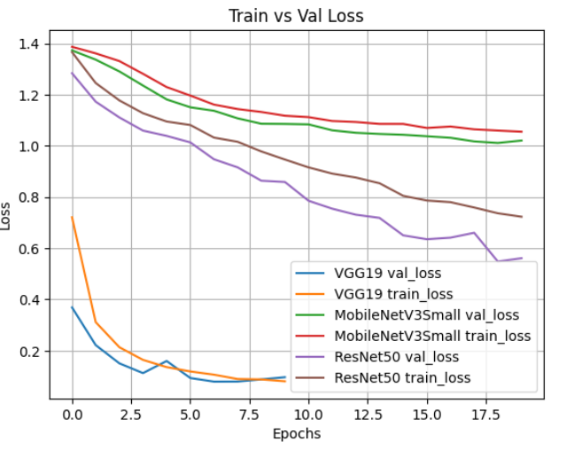

Since the train loss for VGG16 was less compare to other models this model was used for inference.

Below is the confusion matrix for the same:

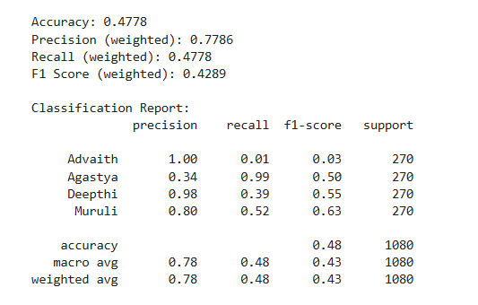

**Misclassifications**: A significant observation is that images from folders intended for "Advaith" and "Deepthi" are frequently misclassified as "Agastya" or "Muruli". For example, many images with a true label of "Advaith" are predicted as "Agastya" or "Muruli", and similarly, images truly of "Deepthi" are predicted as "Agastya" or "Muruli".

**Inference**

1. **System Capability**: The system demonstrates a functional pipeline for real-time face detection using Haar Cascades and subsequent face classification using a pre-trained deep learning model (MobileNetV3Small or ResNet50). This suggests a foundational capability for identifying and categorizing individuals in visual data.
2. **Model Performance Concerns**: The observed misclassifications in the inference.ipynb output, where individuals like "Advaith" and "Deepthi" are consistently misidentified as "Agastya" or "Muruli," indicate potential limitations or issues with the trained face classification model.