**WEEK-1**

**About this project**:

In this project, all business supply chain tables are to be created. This include data on product types, SKUs, Prices, availability, sales, revenue, customer demographics, stock levels, lead times, shipping detailes, supplier information, production volumes, defect rates, and trasportation modes.

**Objectives**:

* By the end of this project we will able to learn
* Basics of data analytics, power bi and related concepts.
* Data analytics case study on sustainable supply chain performance.

**Data Analysis**:

The job of data analysis is to keep the information and facts in much more understanding way via dashboards.

**How to Build the Dashboard:**

To build the dashboard we are using BI(Business Intelligence) tools.

For creating of visuals there is no need to write any codes by using BI tools we can easily create multiple vistualizations in the minimum time . And that’s the reason we called it as intelligent.

**How to download power BI**:

* Go to google
* Search the power BI for free
* Click on the first website
* Then click on install on windows
* The power BI will be downloaded

**ETL(extract transform load):**

Extract – pull data from data sources that is excel, csv, text, database file.

Transform – removing all the unnecessary data and it is also called as data processing and data cleaning.

Load – load the data on BI tool

**Creating a project on the power bi:**

Step-1: open the power bi desktop

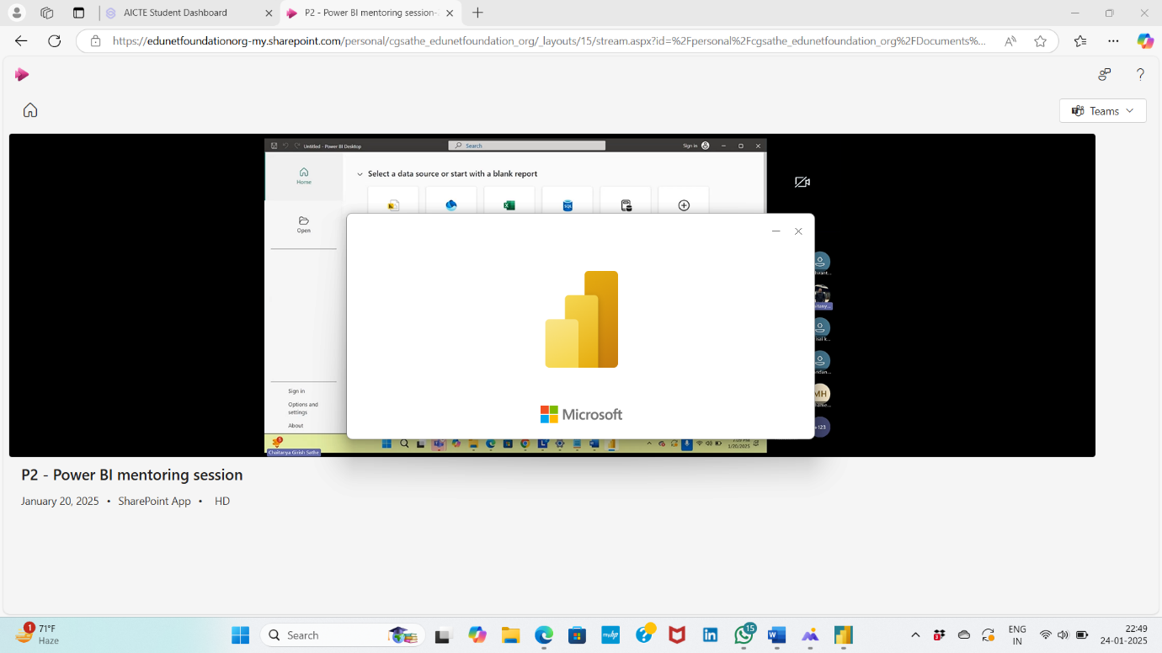

Step-2: click on the blank report

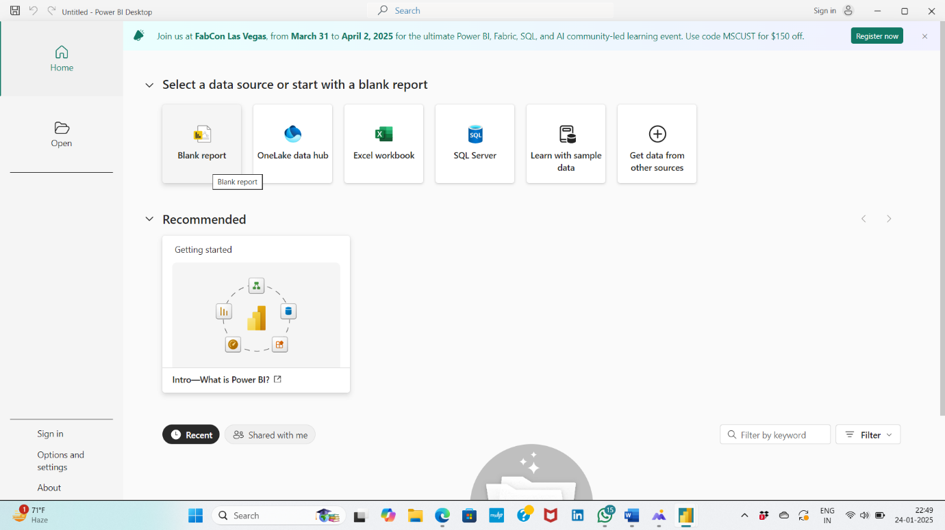

Step-3: The power bi window will opens on the desktop

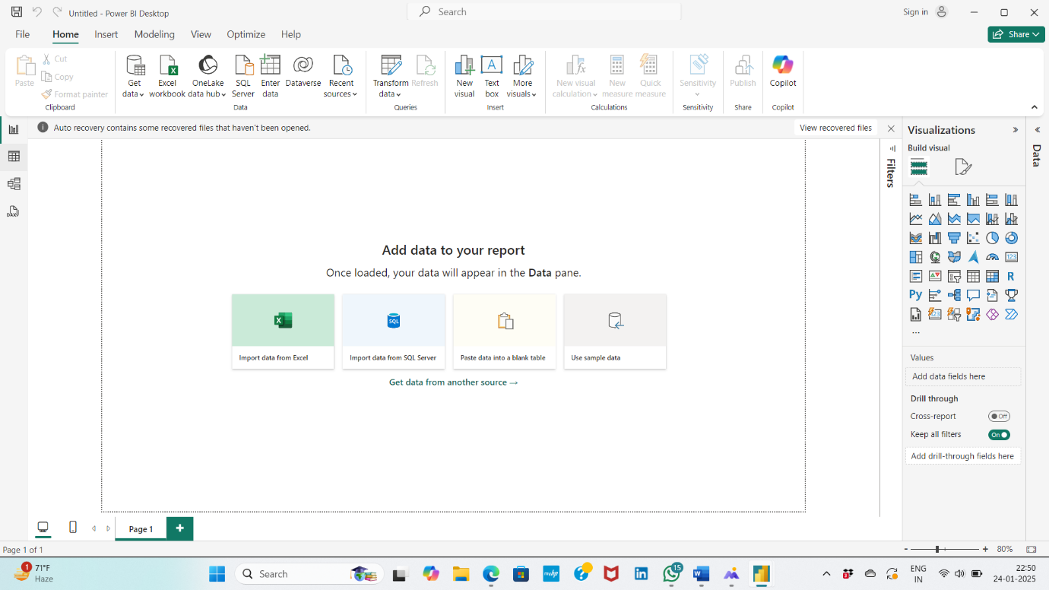

Step-4: In the power bi window where the cursor is moving that window is called as canvas. In the canvas we can draw all the charts/visualizations. There atre so many vistualiczations on the right side.

Step-5: For getting of data click on the get data in the top, multiple data sources will appears. Click on the csv.

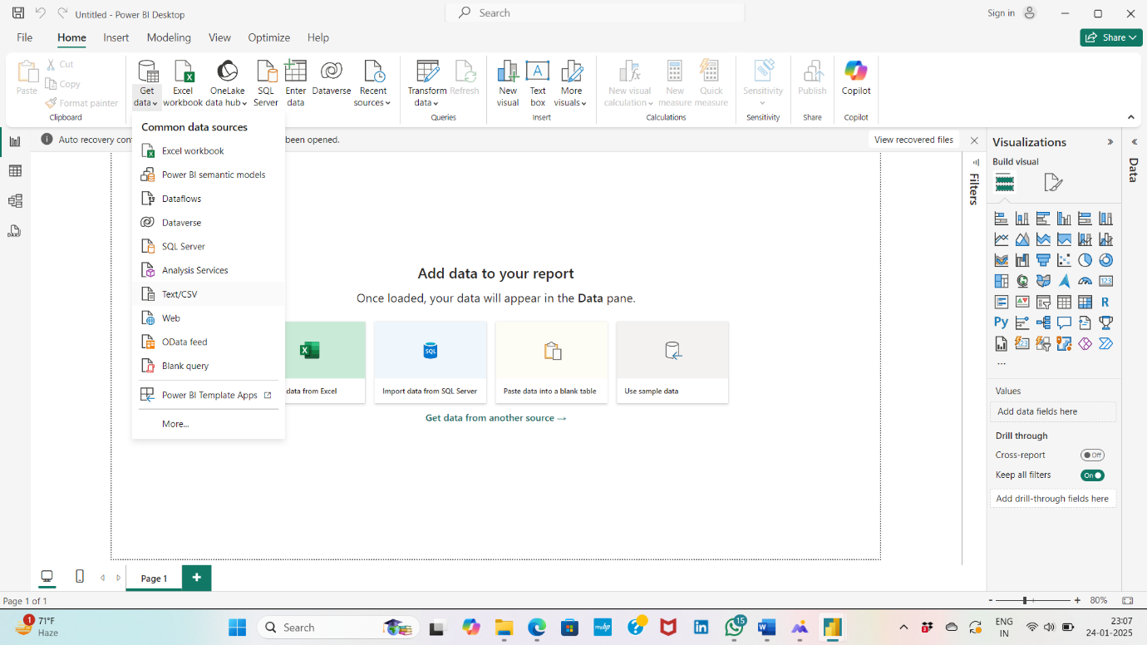

Step-6: click on the sustainable supply chain performance the open, then one window will appear that is the overview of the data on the bottom we can see 3 buttons that are load, transform data and cancel.

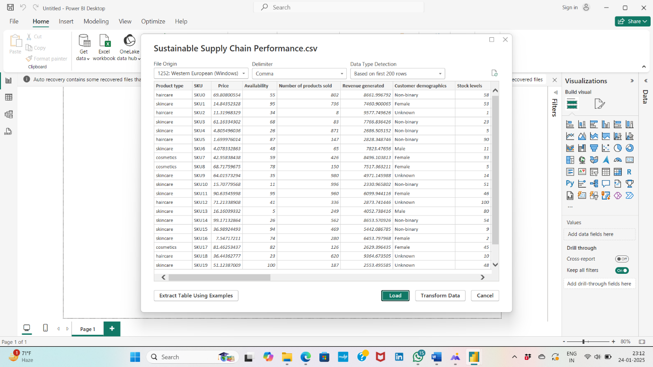

Load: when there is unnecessary data then click on load.

Transform data: if there is any unnecessary data occours or to process data click on transform data.

Step-7:once you load the data at the right side the data will appears

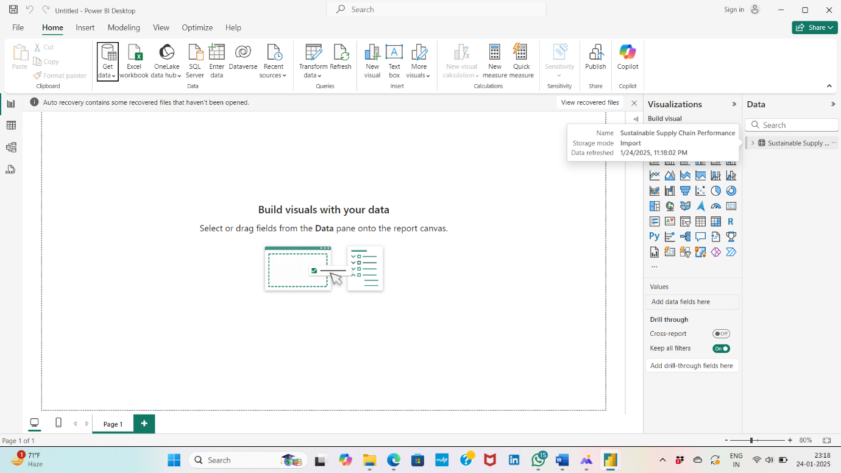

Step-8: click on the table view it on the left side to see the data.

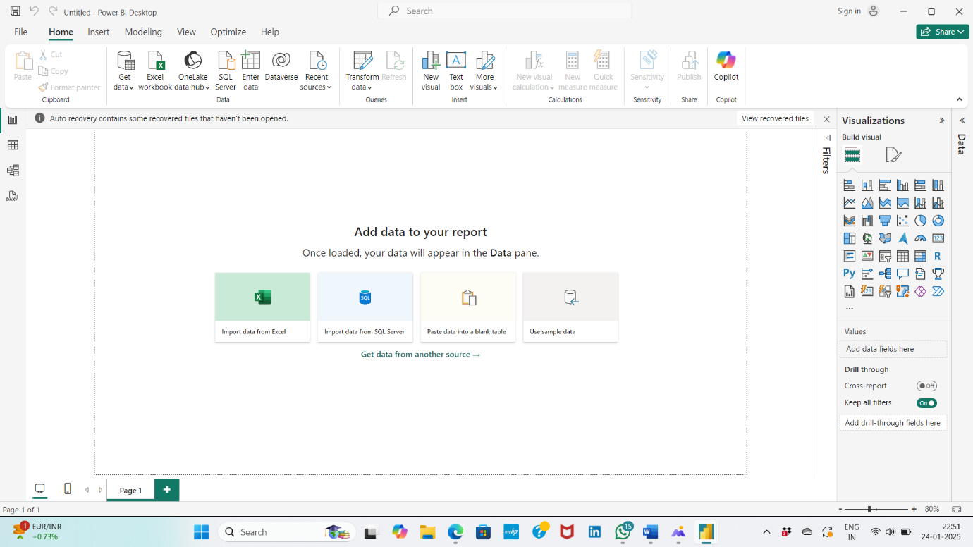

Step-9: now click on the transform data then a window will appears that window is called as power queary editor. It is to transform all the data.

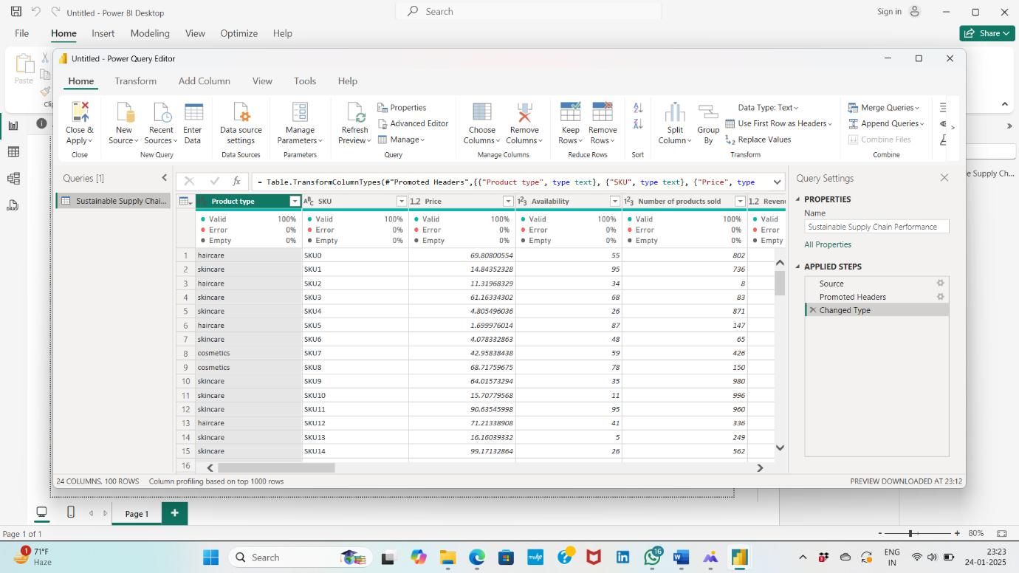

Step-10: After transforming the data save it.