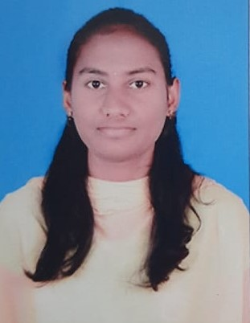
Mamillapalli Sravani
GitHub: https://github.com/Sravani9014
LinkedIn: www.linkedin.com/in/sravani-mamillapalli-6b2545316
Contact No: +919014965288
Email: sravanimamillapalli532@gmail.com
1/14,
Naravakatipalli(V),
Vontimitta(M),
Vontimitta-516213,
Y.S.R District, Andhra Pradesh.
CAREER OBJECTIVE:

Seeking a full-time opportunity with an established organization to have a growth oriented and challenging career, where I can contribute my knowledge and skills for the betterment of the company and gain experience through continuous learning and teamwork.
ACADEMIC PROFILE:

B-TECH: ANNAMACHARYA INSTITUTE OF TECHNOLOGY & SCIENCES
- Dept: Computer Science and Engineering
- CGPA: 8.88 , Y.O.P:2025
DIPLOMA: GLOBAL COLLEGE OF ENGINEERING AND TECHNOLOGY, KADAPA
Dept: Electrical and Electronics Engineering
- CGPA: 8.87 , Y.O.P: 2022
X: ZPHS SCHOOL, MADHAVARAM
- CGPA: 9.0 Y.O.P:2019
PROJECT:

Internship: Data Science , Programming Languages & Machine Learning ,
Cyber Security.

Projects: Portfolio Website , Simple Project on micro Service using RabbitMq.
An Ecommerce Project: Restaurant Web Page Using React Js.

Final year Project: Scalable CNN Model For Early pneumonia detection.

TECHNICAL SKILLS:

○ Languages: Java , JavaScript,Springboot,Express Js,Scrum Calls,CI/CD pipelenes.
○ Web Tech: HTML, CSS ,BootStrap
○ DB Language: SQL

○ Development Tools: Eclipse IDE, Visual Studio Code ,postman,swagger.
O MERN STACK DEVELOPER : Express Js , MangoDB.

SOFT SKILLS:

Quick learner
Can work in both groups or as an individual
Time management
Communication skills.

PERSONAL DETAILS:
☑ Name | : Mamillaplli Sravani
- Date of Birth  - Father’s Name  - Languages known | : 14-02-2004  : Ramakrishna Reddy  : English, Telugu
☑ Hobbies | :Listening Music , Cooking, Travelling.
DECLARATION:

I do hereby declare above particulars of information and facts stated are true, correct complete to the best of my knowledge and belief.

