**Publicis Sapient PJPAssignment_1**

**GIT**

**by**

Deepthi Shanmugasundaram

1.a.i. Local repository:

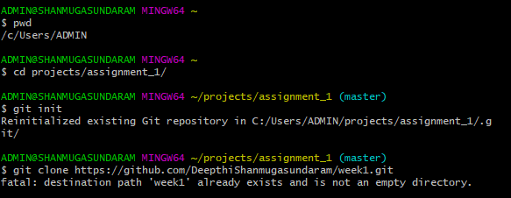ii.Remote Repository:

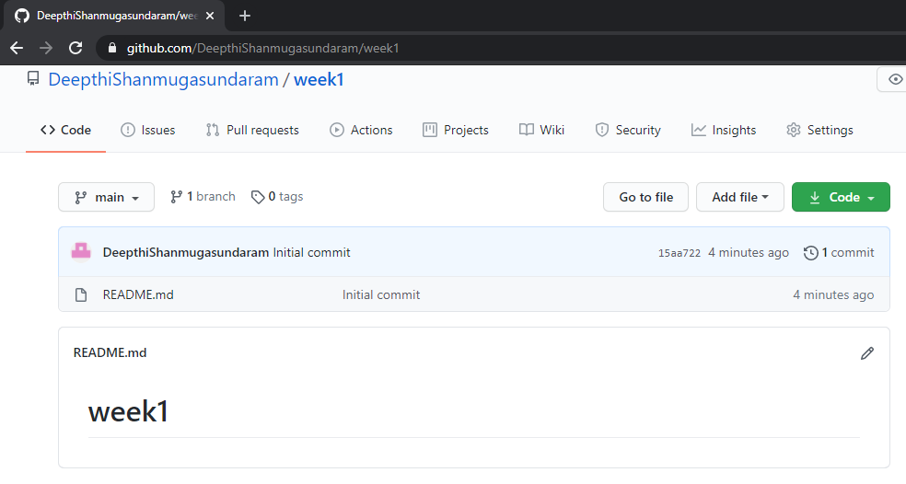

iii.local branches:

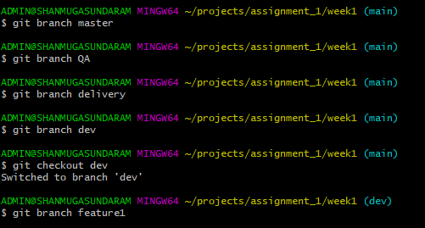

iv.remote branches:

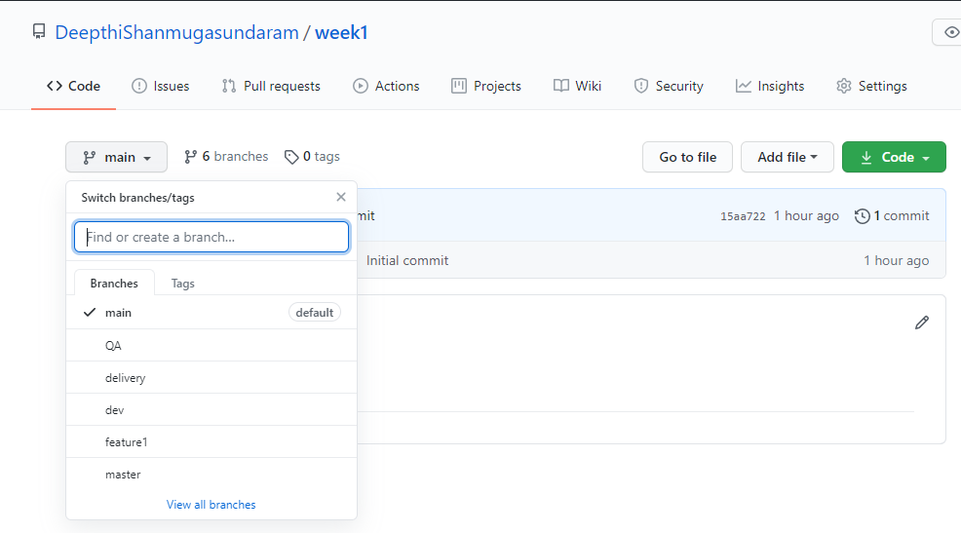

v.Add files and folders:

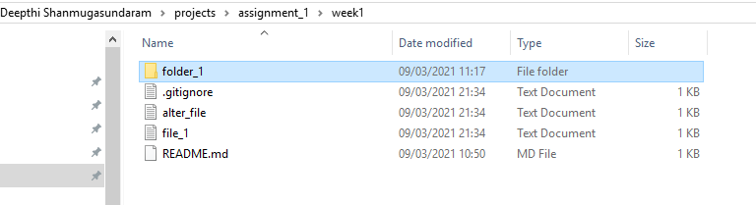

vi.Check-in ,Stage, Commit,Push into feature1:

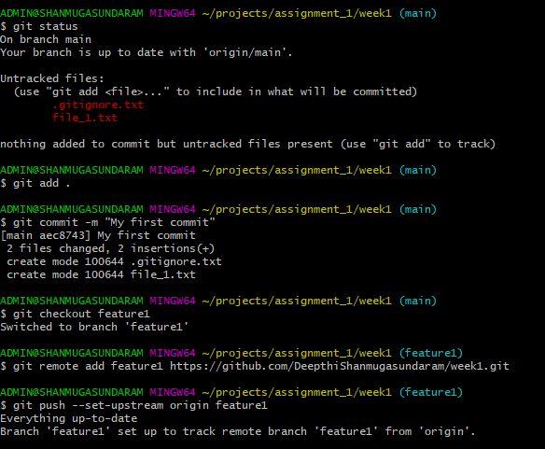

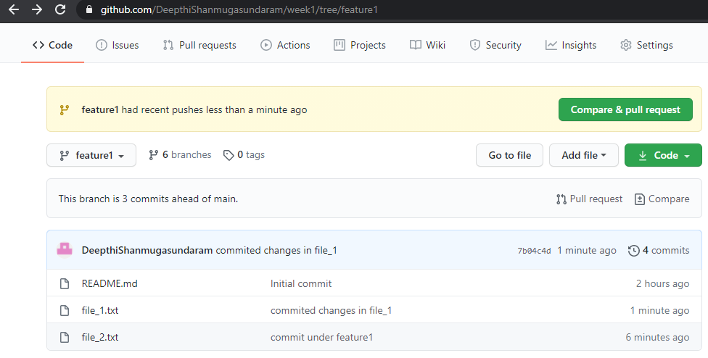

vii.Promote code from feature1 to dev:

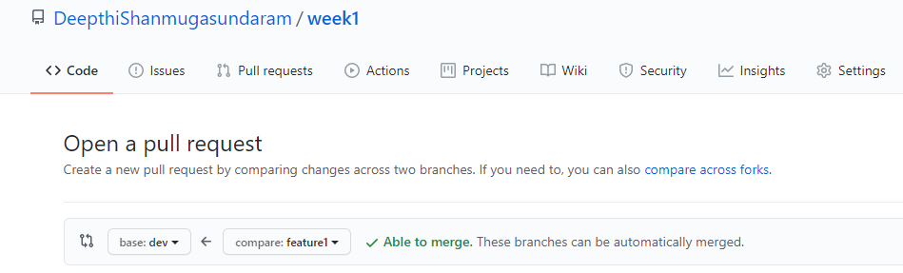

viii.Latest code from remote to local:

Pull updated local dev branch from remote repository.

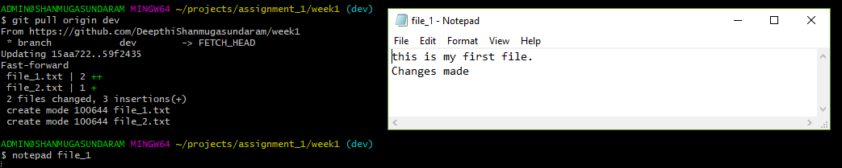

ix.Checkout: **Fetches the** latest changes into already downloaded repository. It wont merge those new changes but makes your working directory reflect them.

 Pull:Fetches and merges in local branch.

x.Handle Merge Conflict:

Same file(alter_file) is modified at two different branches and pushed into remote repository.When we try to pull them into main branch using cli,merge conflicts occurs. Resolve this merge conflict with a new commit after changing the text under the branch in which conflict occured.

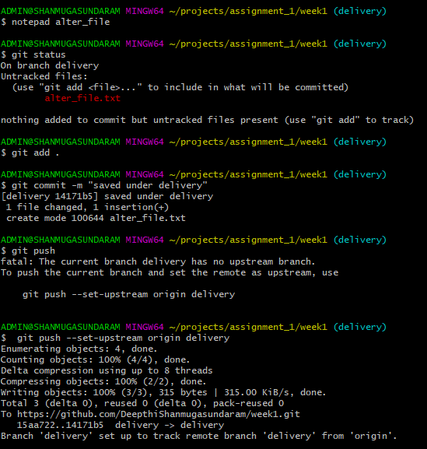

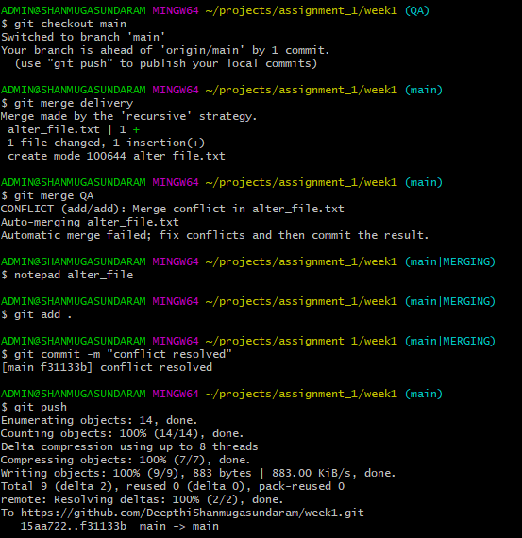

xi.Ensure the code is in sync .with latest changes across all branches:

Recent changes made under local branches are pushed into remote branch and pulled to other branches.

GUI

1.b i.Local repository:

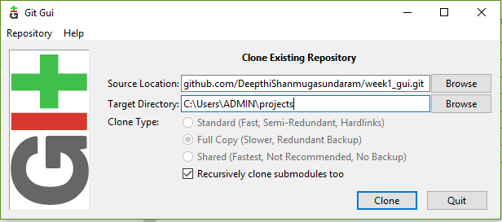

ii.Remote Repository:

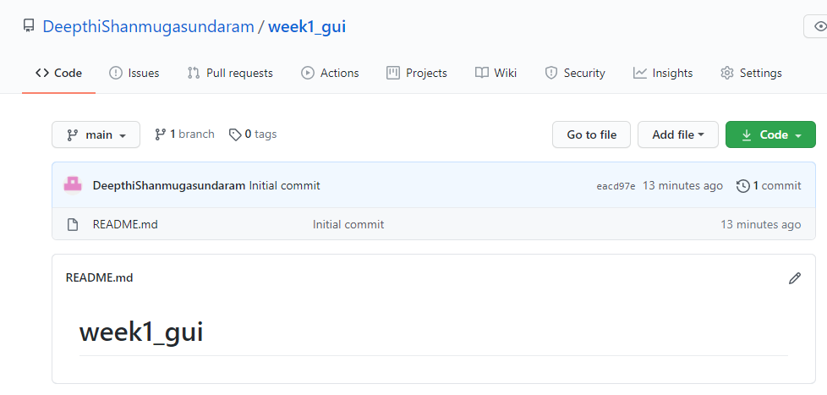

iii.local branches:

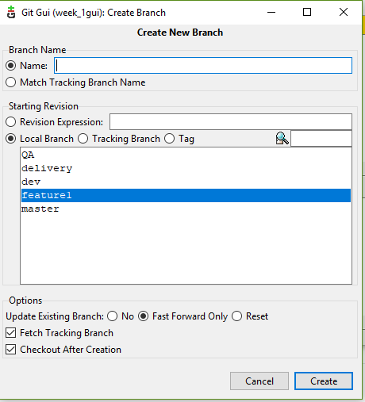

iv.remote branches:

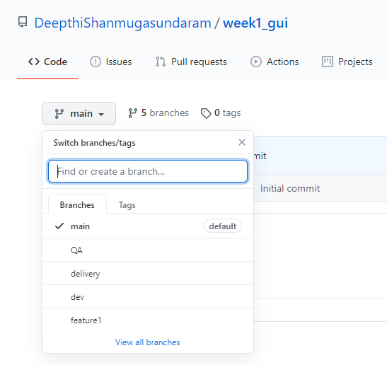

v.add files and folders:

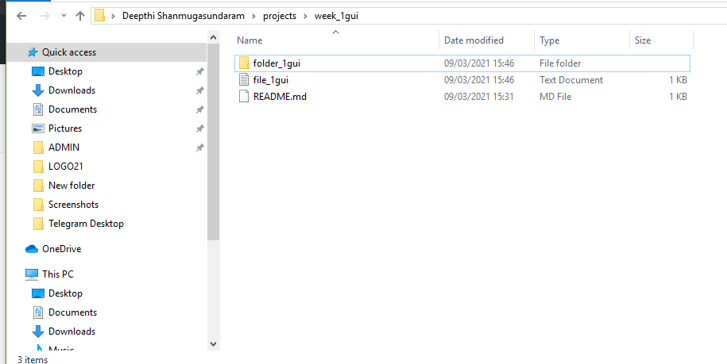

vi.Check-in ,Stage, Commit,Push into feature:

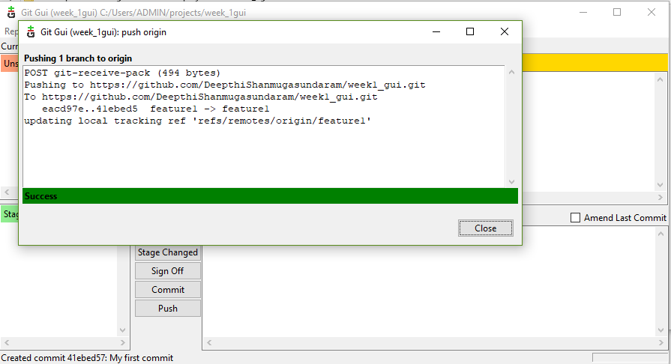

vii.Promote code from feature1 to dev:

Pull request from feature1 to dev is done.

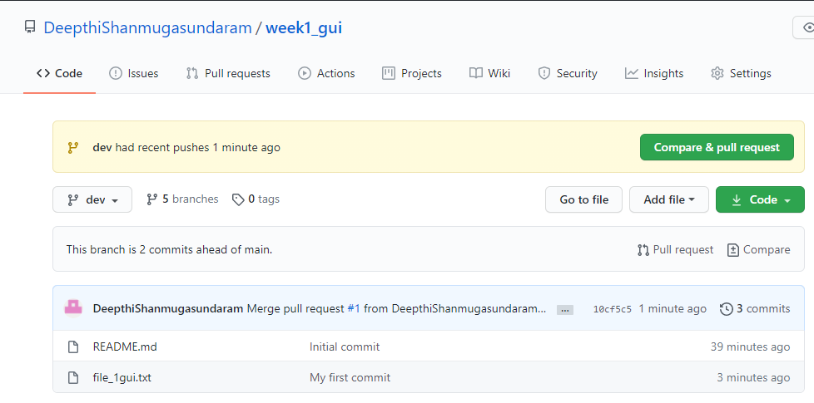

viii.Latest code from remote to local:

Fetch and merge into local repository

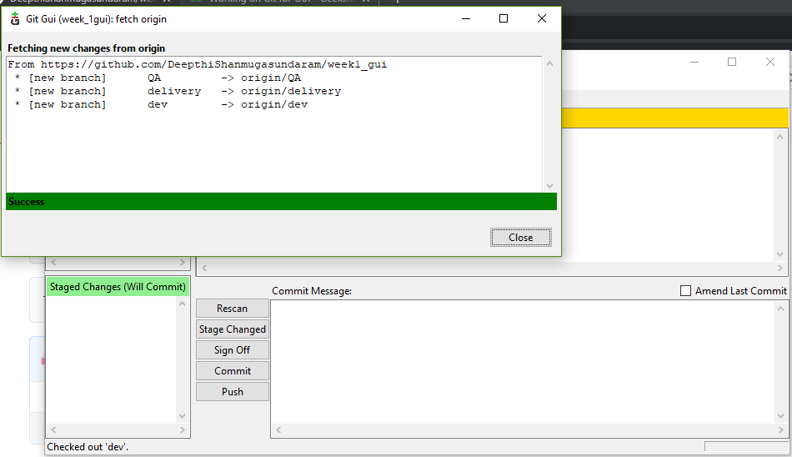

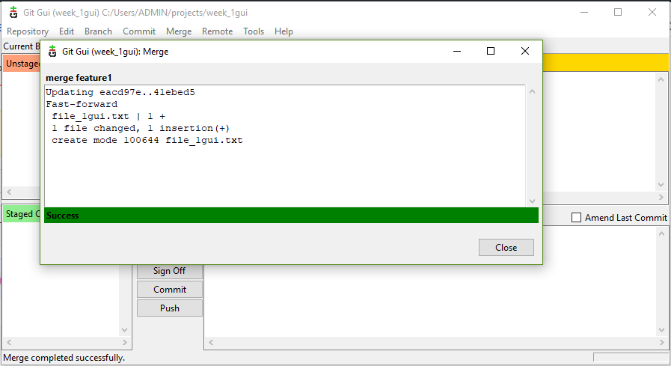

x.Handle Merge Conflict:

Merge conflict occurs when alter_filegui is merged into main branch as they have been changed under delivery and QA branches .

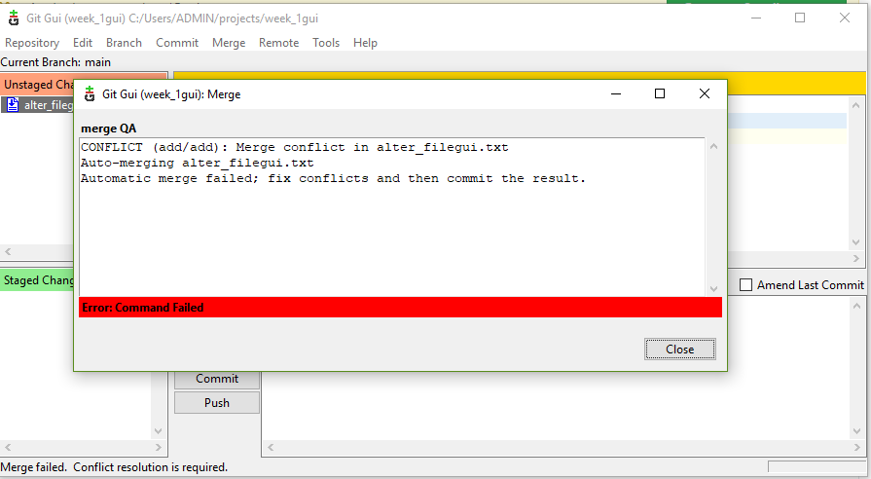

This is resolved by doing a new commit with required changes being done in the conflict file.

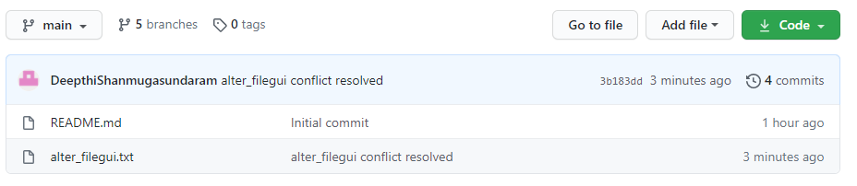

xi.Ensure the code is in sync with latest changes across all branches:

Recent changes are pushed into remote branch and pulled to other branches from there.

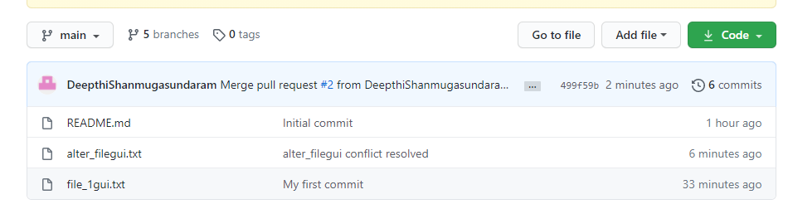

c.i.Reset or reverting the changes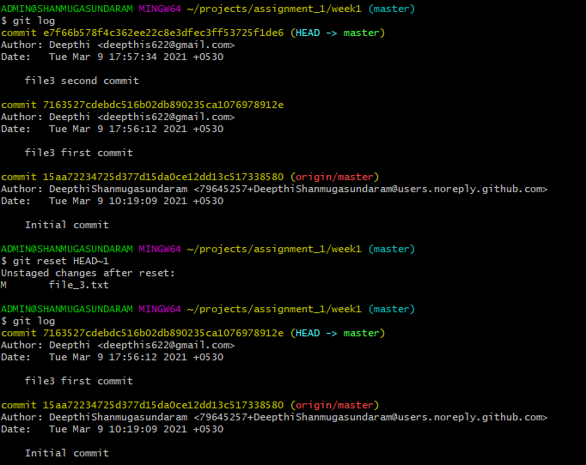

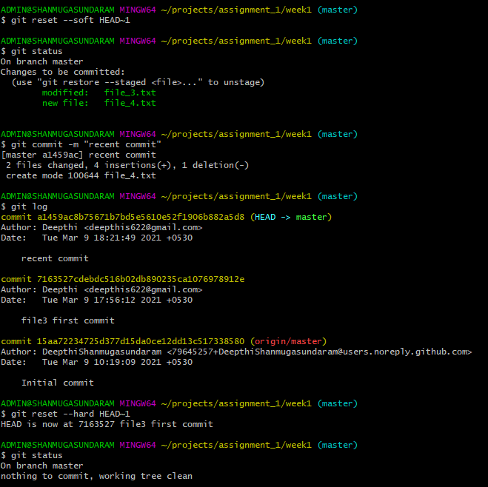

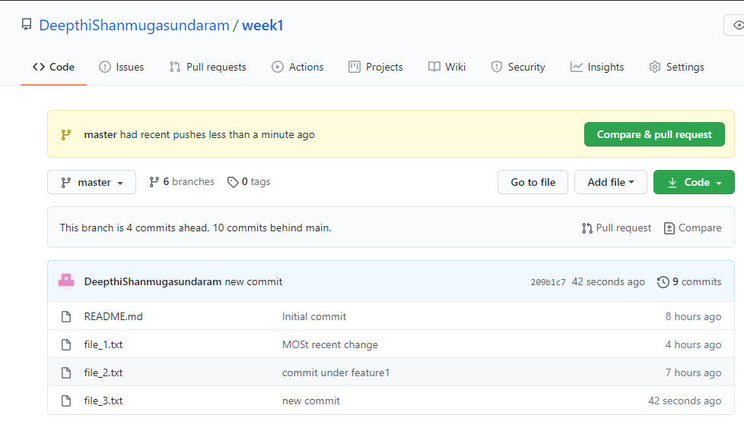

After reverting,file_3

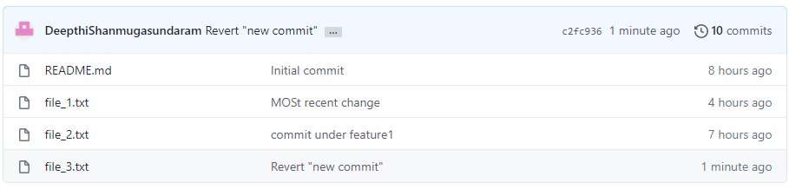

ii.Stash local changes

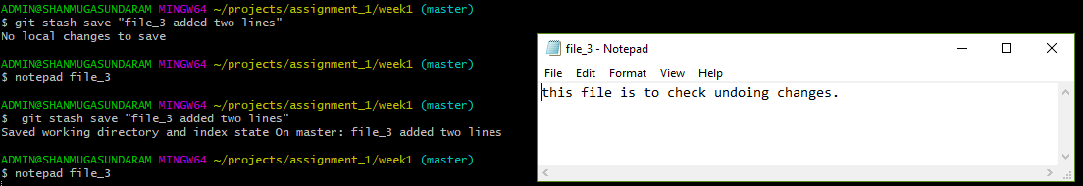

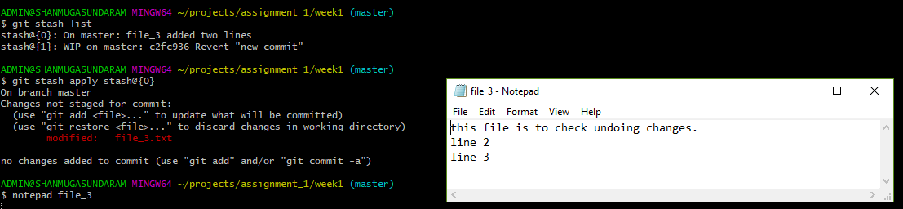

iii.Rebasing

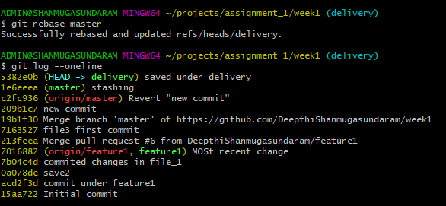

iv.git log,status & reflog:

