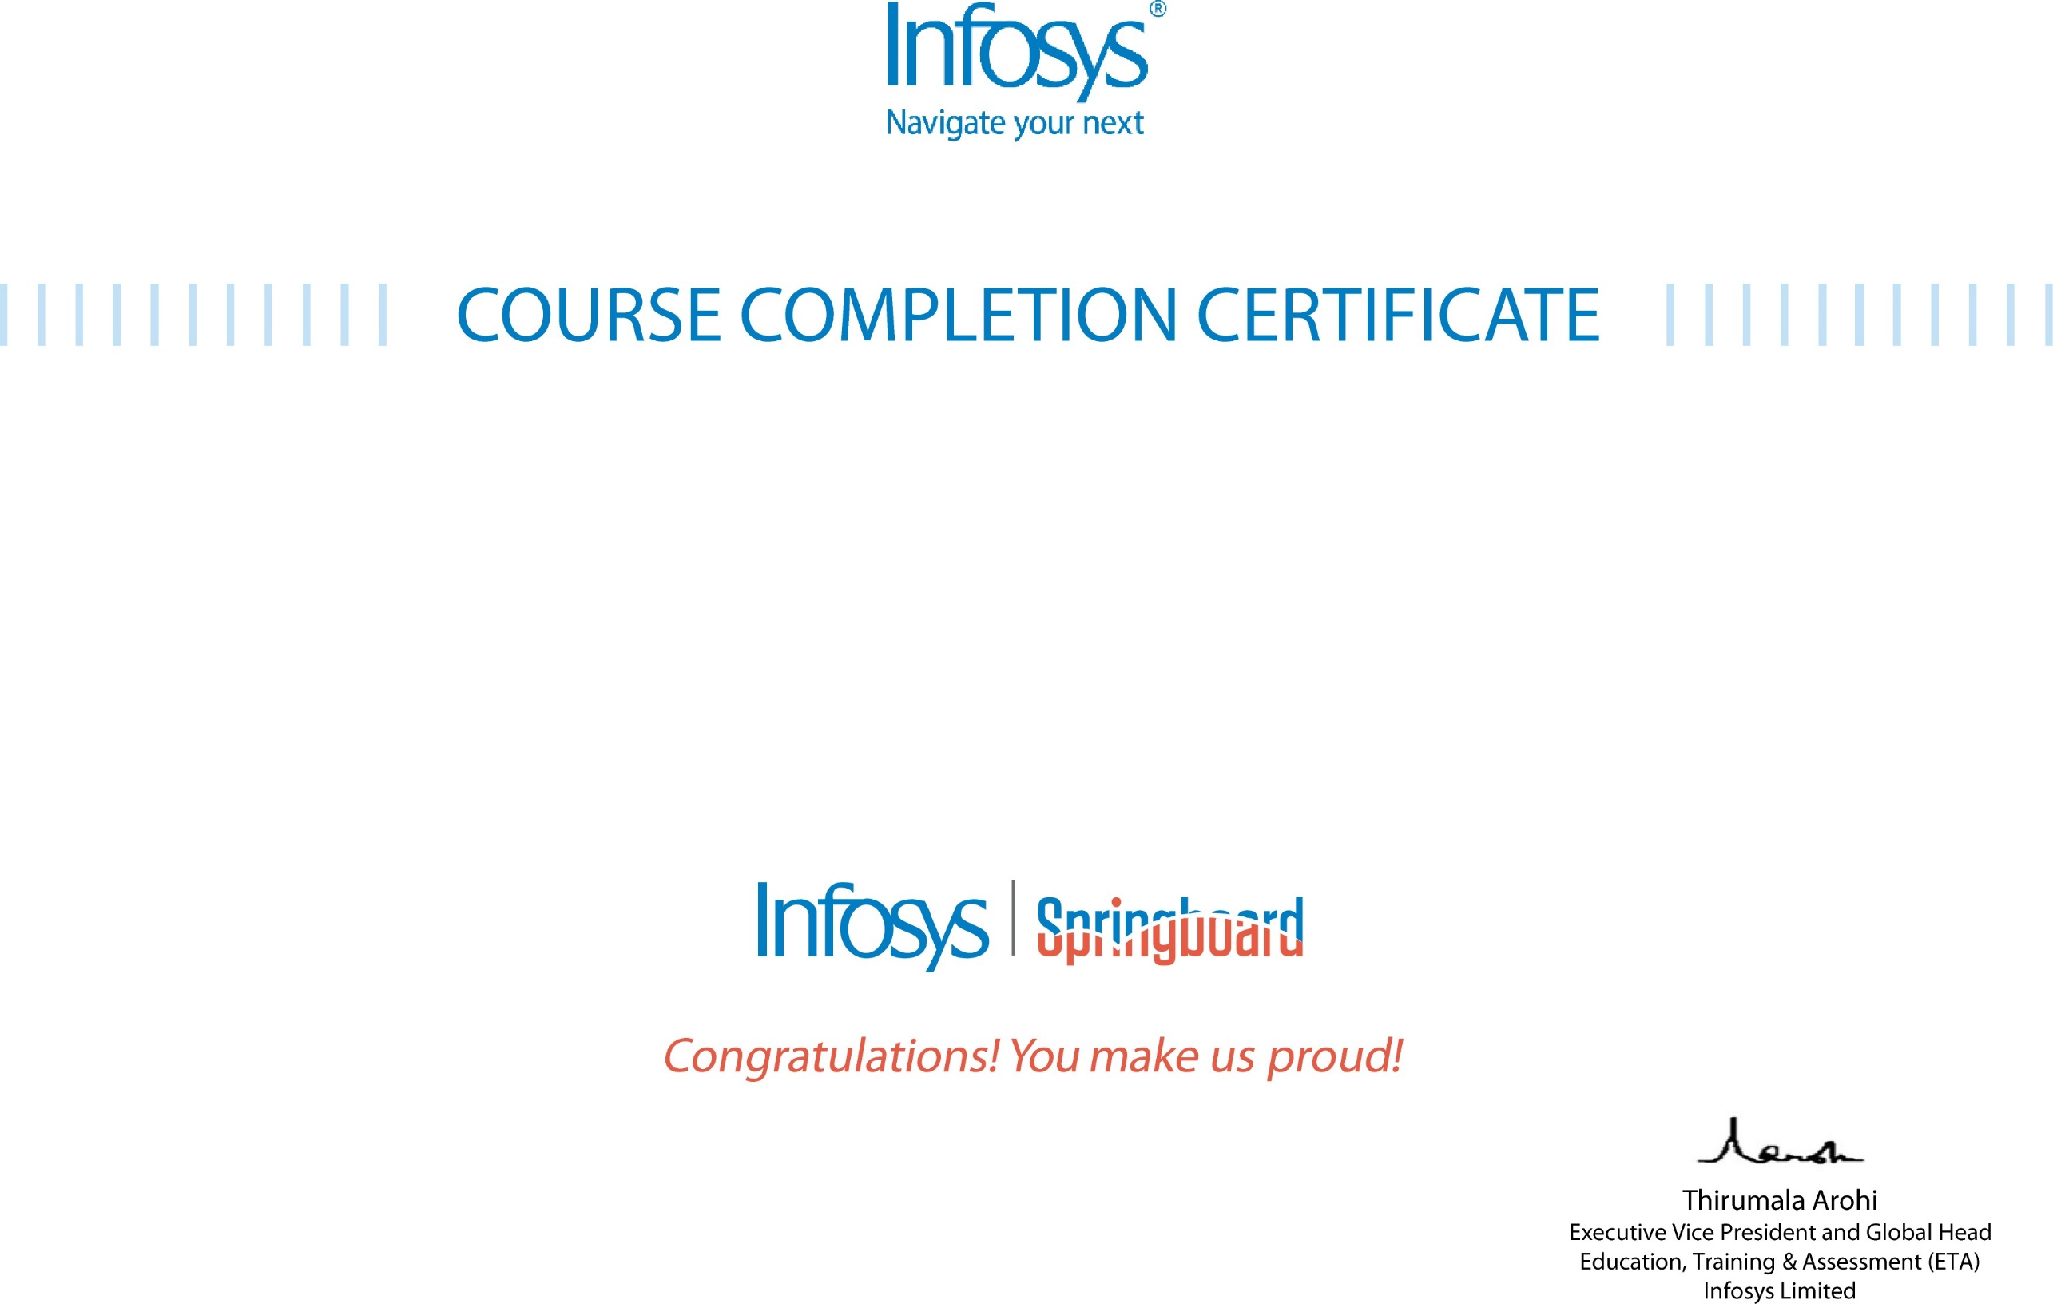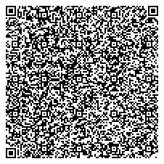

# The certificate is awarded to

Dasharadhi Deepthi Sri

# for successfully completing the course

**Programming Fundamentals using Python - Science Graduates - Foundation Program**

# on November 20, 2024

Issued on: Wednesday, November 20, 2024

To verify, scan the QR code at [https://verify.onwingspan.com](https://verify.onwingspan.com/)