CB.EN.U4AIE19022 DEEPTHI SUDHARSAN

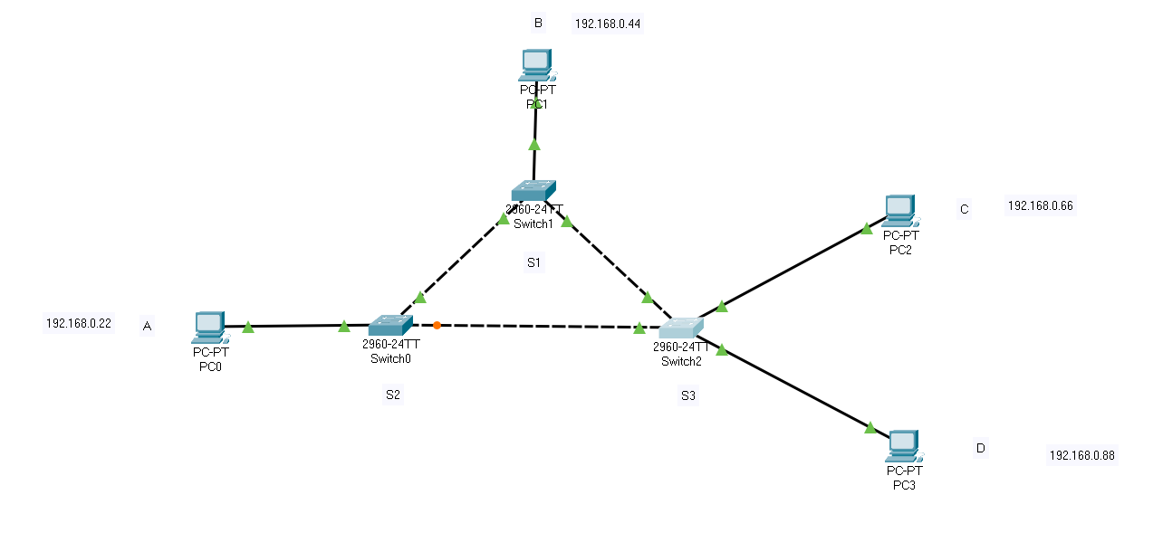

1. What are the protocols involved when message is sent from A to B

The protocols involved when message is sent from A to B are ICMP and ARP protocols.

1. Explain the role of each protocol

Address Resolution Protocol (ARP) is a protocol or procedure that connects an Internet Protocol (IP) address to a fixed physical machine address, also known as a media access control (MAC) address, in a local-area network (LAN)

Internet Control Message Protocol (ICMP) is used for reporting errors and performing network diagnostics. In the error reporting process, ICMP sends messages from the receiver to the sender when data does not come though as it should. Within the diagnostic process, ICMP is used to send messages that are used by ping and traceroute to provide information regarding how data is transmitted

1. Give the output of ping command when A, B and send messages to one another

A to B and C

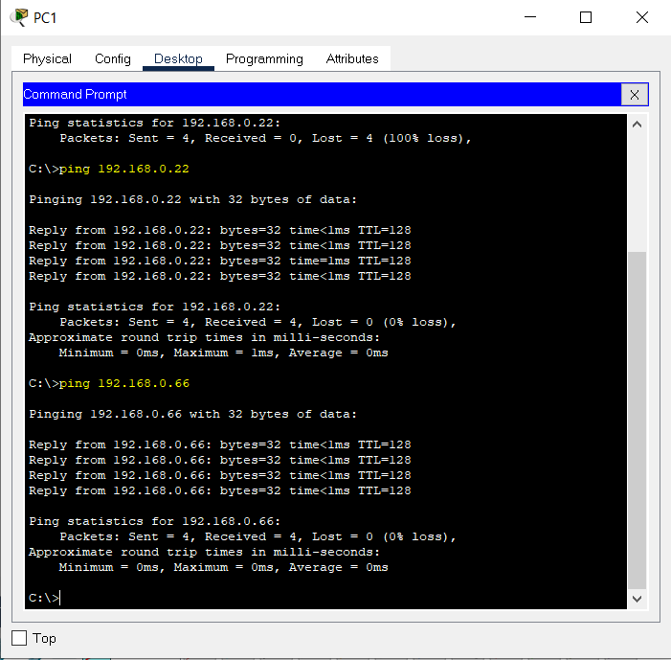

B to A and C

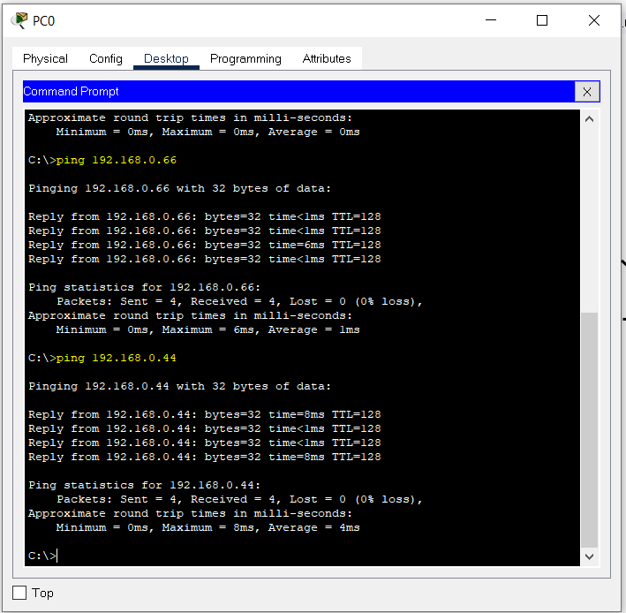

1. Give the output of ping from B to D and C to D

B to D

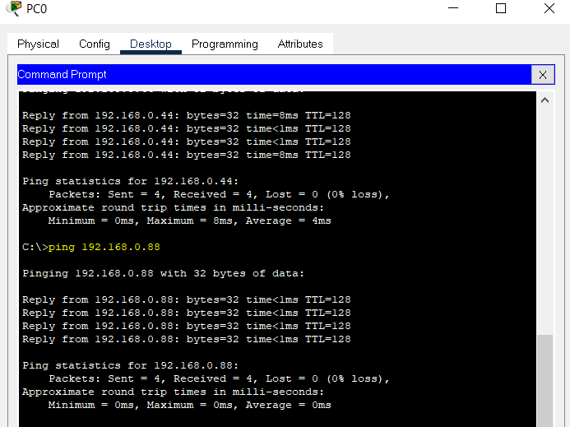

C to D

