Plant Monitoring using Image Processing Tools and using NDVI to analyse data from Servers [linking with IOT]

**Introduction:**

A system for monitoring the growth of plant can be done by simply taking photograph of a plant and analysing the Vegetative Index using RGB values of the corresponding image. Such kind of information can be useful for farmers, botanists and food processing companies to increase yield and their profits respectively. This work combines Image Processing implemented by coding . With the help of the image Processing, the yield of crop and use of insecticides and other growth inhibiting agents can be monitored. The code used in this project features extraction techniques of the images RGB colour and compares the information from this image with the ones in the database in order to recognise health of the plant. Hence, here we can potentially combine IoT with our image and do the analysis for all possible plants growing in the region to get best results for vegetation. In addition, our system is user friendly, reliable and cost effective.

India is an agrarian country. Many people in villages rely on agriculture directly or indirectly. It is the main source of bread and butter for the nation thus making it the basic foundation of nation building economic development. It provides highest contribution to GDP growth of our country. Agriculture also provides employment opportunities to very large percentage of population. Despite good climatic conditions, we are not been able to utilize agricultural resources to the utmost. The reason behind this is usually attributed to illiteracy and brain drain, but the actual reason is inefficiency and ignorance towards the bare necessities. Another cause may be attributed to unplanned usage of water and other resources due to which a remarkable amount of produce goes in vain. At the present era, the farmers have been using various insecticides and pesticides for crop at regular intervals. Illicit usage of these surplus but hazardous quantity affects the rate of crop growth and development. As a consequence, there will be a decrease in nourishment in young children and crop related disease in fellow humans and other herbivore animals and subsequently face an increase in poverty and a deterioration in welfare of all beings in the ecology.

The current system relies on visual observation which is a time-consuming process. If we monitor the growth and automate the analysation process, the problem can be solved if we use automatic to harness the growth of the crop. With the advancement in image processing, we can monitor plant health in an effective and efficient manner easily.

Image processing is processing of images using mathematical operations for which the input is an image or a series of images; the output of image processing may be either an image or a set of characteristics of parameters related to the image. Digital image processing makes use of various computer algorithms to perform image processing on digital images. It is widely used for classification (identifies to which class does a newly found observation belong), pattern recognition (recognize known and discover unknown patterns), feature extraction (initial information which is used to make further derivations), multiscale signal analysis (signal processing) and projection (three-dimensional object is converted into a planar surface).

In addition to the environmental factors, the plant with a diseased leaf can also be identified using Image processing as we have done win this project. Based on the output and constraints the farmers and botanists will be informed about the development of the plant and resources to use on the where the action has to be taken. Early diagnosis will thus help in taking the necessary actions to increase the produce and reduce failure of crops.

**Objective Of the Project:**

The main objective of this project is to scale the health of the plant leaf from 0 to 1 using Vegetative Index tool obtained by Image processing and thus identify the diseases of the plant. An image processing algorithm was developed to identify the diseases. This will help the farmers to identify and rectify the diseases in the initial stage itself and will improve the cultivation with healthy plants.

**Requirements:**

Live Plant leaves to analyse, A camera, MATLAB Version R2017a or higher

**NDVI: A Brief Theory**

The normalized difference vegetation index (**NDVI**) is a simple graphical indicator that can be used to Analyse the healthy regions of a plant using ratio of infrared to red colour index of a plant.

We are using NDVI as a part of our project because of the basic reason that healthy plants are the ones which perform photosynthesis at a good rate. So, if we are analysing the amount of green light which is exiting the plant { technically should be maximum because chlorophyll present in the chloroplast absorbs lights from red and blue region of the Visible spectrum}, we can accurately determine the health of the plant.

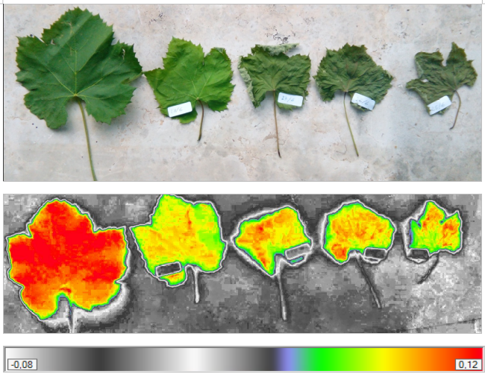

Live green plants absorb solar radiation in the [photosynthetically active radiation](https://en.wikipedia.org/wiki/Photosynthetically_active_radiation) (PAR) spectral region, which they use as a source of energy in the process of [photosynthesis](https://en.wikipedia.org/wiki/Photosynthesis). A strong absorption at these wavelengths would only result in overheating the plant and possibly damaging the tissues. Hence, live green plants appear relatively dark in the PAR and relatively bright in the near-infrared.

The NDVI is calculated from these individual measurements as follows: {\displaystyle {\mbox{NDVI}}={\frac {({\mbox{NIR}}-{\mbox{Red}})}{({\mbox{NIR}}+{\mbox{Red}})}}}

But since we want the analysis to be cost effective and easier to analyse, we’ll make a slight modification in the formula to make it:

{\displaystyle {\mbox{NDVI}}={\frac {({\mbox{NIR}}-{\mbox{Red}})}{({\mbox{NIR}}+{\mbox{Red}})}}}

**Colour Detection Algorithm:**

The algorithm to progress is as follows:

1) Start

2) Read the input jpg or jpeg image using imread() imbuilt function in MATLAB.

3) Convert Pixel values to double using img2double() function. This makes calculating NDVI accurately between 0 and 1.

4) Read the input pixel of colour image in three different planes (RGB) and store it into three variable channels RedChannel, GreenChannel, and BlueChannel.

5) Calculate NDVI using the above-mentioned formula.

6) Do this thrice day for a given plant and get three different ratios of NDVI.

7) Analyse health of the Plant using Data from Servers. This will tell us more information on plant health.

**MATLAB Code:**

clc;

clear all;

close all;

rgbImage = imread('Image.jpg');

rgbImage=im2double(rgbImage);

redChannel = rgbImage(:, :, 1);

greenChannel = rgbImage(:, :, 2);

blueChannel = rgbImage(:, :, 3);

z = zeros(size(rgbImage), class(rgbImage));

redImage = z; redImage(:,:,1) = redChannel;

greenImage = z; greenImage(:,:,2) = greenChannel;

blueImage = z; blueImage(:,:,3) = blueChannel;

figure

subplot(2,2,1); image(rgbImage);

subplot(2,2,2); image(redImage);

subplot(2,2,3); image(greenImage);

subplot(2,2,4); image(blueImage);

NDVI=(redChannel-blueChannel)./(redChannel+blueChannel);

figure

imshow(VI)

title("Vegetative Index");

**Result Images:**

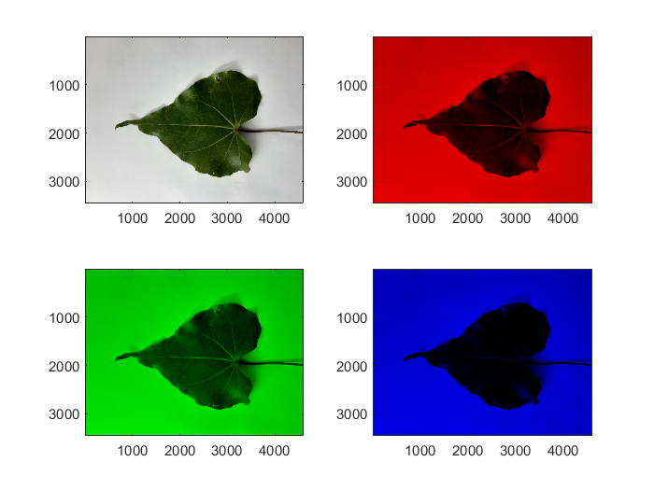

**Plant Name:** *Thespesia populnea* (Indian Tulip Tree)

**RGB Format:**

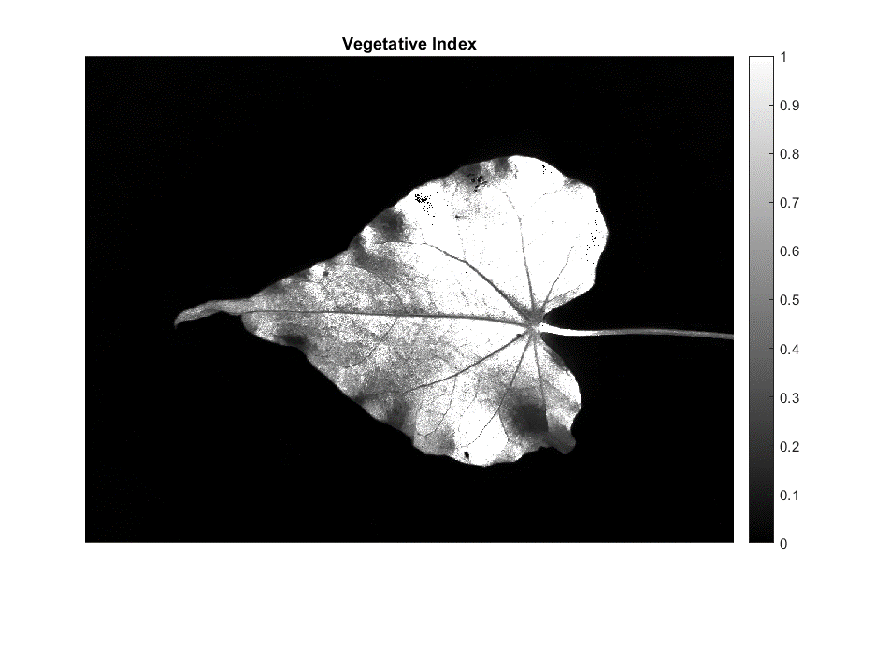**Vegetative Index:**

Here **white color** indicates the healthy part of the leaves

And **Black color** indicates the unhealthy part of the leaf

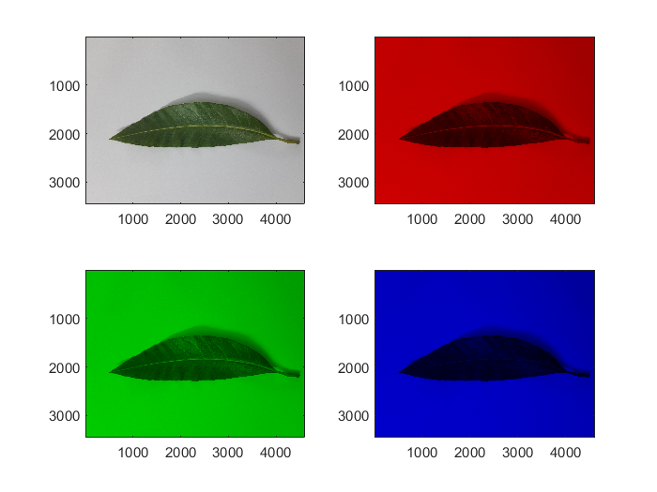**Image 2**

**Plant Name:** *Mangifera indica* (Mango Tree)

**RGB Format:**

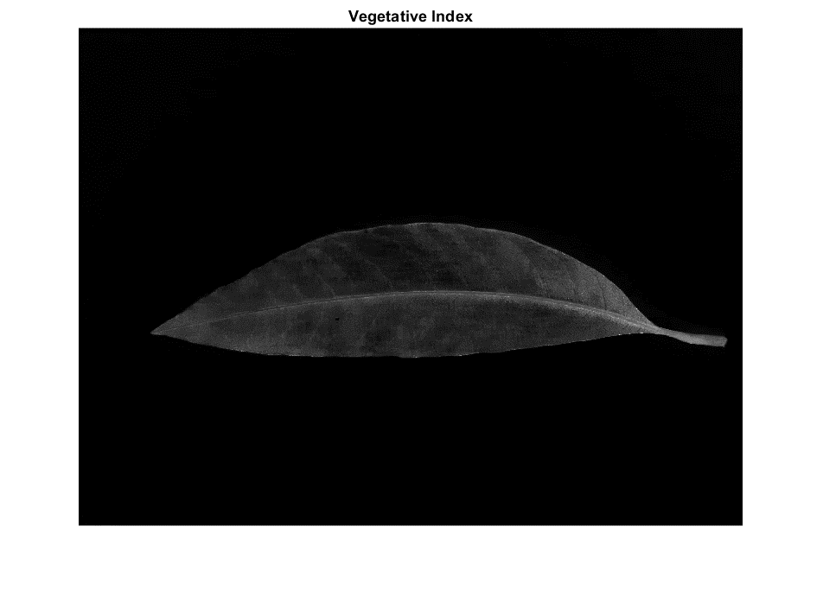**Vegetative Index:**

Here **white color** indicates the healthy part of the leaves

And **Black color** indicates the unhealthy part of the leaf

**Conclusion:**

The accurate detection and classification of the plant disease is very important for the successful cultivation of the crops, this can be done using digital image processing as seen in our project.

The proposed project has minimal errors, so for a large-scale production the number of cameras and length of conveyor system can be increased and modified. Capturing an accurate image at the correct angle with the fixed camera and varying lighting conditions from time to time is a big challenge as there is a chance of high uncertainty due to which analysis can give a mismatch with actual results. Due to factors like luminance and chrominance which will influence the results, we are taking the advantage of grey scale image which is less effected to the external environment changes as well as beneficial for finding size of a leaf. However, if possible we should always use IR camera to get best results.