sGame Design Document

Fill up the Following document

1. Write the title of your project.

Shooting Game

1. What is the goal of the game?

To destroy the monsters using guns and to gain points

1. Write a brief story of your game?

Monsters have attacked your city and your goal is to destroy them and save the citizens captured by the monsters and earn points to win.

1. Which are the playing characters of this game?

* Playing characters are the ones which respond to the user based on the input from the user
* Cars, monkeys, dinos, wizards etc, are the playing characters in the game.

|  |  |  |
| --- | --- | --- |
| Number | Character Name | What can this character do? |
| 1 | Mark | Shooting skills |
| 2 |  |  |
| 3 |  |  |
| 4 |  |  |
| 5 |  |  |
| 6 |  |  |
| 7 |  |  |
| 8 |  |  |

1. Which are the Non Playing Characters of this game?

* Non Playing characters are the ones which don't have an action or a behaviour when the user interacts with the game.
* Hurdles, stones, bananas, coins, etc are non playing characters in the game.

|  |  |  |
| --- | --- | --- |
| Number | Character Name | What can this character do? |
| 1 | Monsters | Bite people and turn them into zombies |
| 2 |  |  |
| 3 |  |  |
| 4 |  |  |
| 5 |  |  |
| 6 |  |  |
| 7 |  |  |
| 8 |  |  |

Draw your imagination of this game. What does this game look like?

* Draw the game either on your computer or on paper,
* Add images of scenes of the game to show each of the playing and non-playing characters at least once. 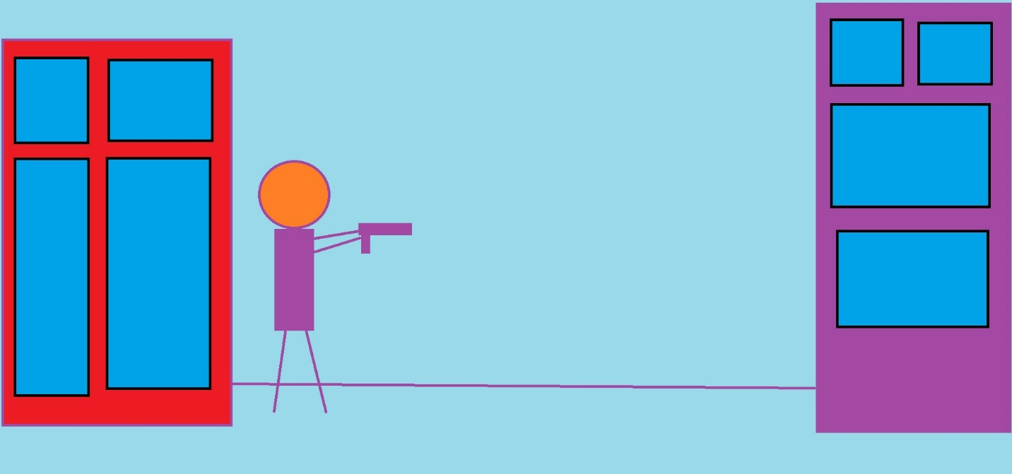

How do you plan to make your game engaging?

By adding points, obstacles, monsters, sounds