Harris Hawk Optimization-Based Distributed Denial of Service Attack Detection in IoT Networks

Shilpa S Chaudhari
Department of Computer Science and Engineering
Ramaiah Institute of Technology
Bangalore, India
shilpasc29@msrit.edu

D A Deepthi Yamini
Department of Computer Science and Engineering
Ramaiah Institute of Technology
Bangalore, India
deepthiyaminida@gmail.com

Abstract: As Internet of Things (IoT) grows in popularity, cyber risks and distributed denial of service (DDoS) attacks have increased. DDoS attacks shut down genuine users by flooding a targeted network or service with a large volume of traffic from several hacked computers. DDoS attack can cause significant harm to a network and its users. By gathering benchmark network traffic statistics that come within the Bigdata category, the proposed method assesses and categories these attacks to detect DDoS network activities. DDoS Insights and trends that might not be immediately visible from the table are discovered and understood using an exploratory data analysis technique named Harris Hawk Optimization (HHO). The minimum fitness value based optimal fitness function helps to achieve optimal detection result is effectively. Using benchmark/NS3 DDoS data, the proposed technique is assessed and found to be successful in detecting attack features and offering defense-related knowledge. By providing more accurate and consistent detection and prevention of DDoS attacks, this technology will play a significant role in enhancing security for IoT networks.
Keywords: DoS Attack, IoT, Distributed Denial of Service, Harris Hawk Optimization, Machine Learning, Detection.

Introduction
The strength of Harris Hawks to hunt in groups and cooperate to bring down prey is well documented. In comparison to other raptors, they are also great hunters with a high success rate. They are perfect for a variety of jobs, including surveillance, pest management, and search and rescue, because to their intelligence, agility, and rapid learning. IoT networks are at risk from distributed denial of service (DDoS) attacks, and it can be challenging to identify these attacks. Conventional approaches that might be resource-intensive, time-consuming, and prone to error are frequently used to identify DDoS attacks in IoT networks. Moreover, attacks that employ cryptic protocols or unconventional communication routes may be undetected by detection techniques that only depend on network traffic analysis. Harris Hawk Optimization (HHO) is a current method for detecting DDoS attacks in Internet of Things networks that makes use of the special talents and behaviour of Harris Hawks. This strategy uses less resources, is faster, more precise, and more suited to counteracting enemies' increasingly complex tactics than conventional ones.
We concentrate on Distributed Denial of Service attacks in IoTs in this paper. Section 2 presents our Literature review, whereas Section 3 presents Comparison table with parameters.Conclusion is found in Section 4. The study's findings are summarised in the paper's conclusion, along with an overview of potential future research topics.

Literature Review

Introduction
The literature survey of the papers reveals that DoS attacks are a common threat to IoT networks, and various methods such as machine learning, deep learning, data mining, graph-based approaches, adaboost algorithms, RSS, IP traceback, and energy-efficient approaches have been proposed to detect and mitigate them. However, more research is needed to develop robust and effective methods.

Comparison Table
A comparison table as shown in Table I-V may be used to quickly compare various security parameters for IoT networks. It is possible to compare several characteristics, including the target of the attack, the kind of solution, the subclass of IoT, the number of attackers, the tested assault, cryptography-based solutions, detection approach, mitigation/security mechanisms, and DoS attack scenarios. The finest security precautions for safeguarding an IoT network may be found using the comparison table. The optimum solution type, cryptography-based solutions, detection method, and mitigation/security mechanisms that should be used to guard the IoT network from prospective attackers may all be found.

Methodology
The methodology for the project can be divided into three main phases: collecting and pre-processing data, feature selection and data analysis, and modeling.
1). Collecting and Pre-processing Data: This phase involves collecting and pre-processing the network traffic data. The data has to be pre-processed by cleaning and filtering it to remove any unnecessary information, such as noise, and to extract relevant features.
2). Feature Selection: The next phase involves feature selection which is the process of selecting a subset of relevant features from the data. This can be achieved by using HHO algorithm.
3). Data Analysis and Modeling: The third phase involves data analysis which is the process of analyzing the pre-processed and feature-selected data to identify patterns, trends, and anomalies. Finally, the identified anomalies are modeled using various machine learning algorithms such as decision trees, support vector machines (SVM), and neural networks. These algorithms are used to classify the

- Comparison table
Component of study |  |  | Papers
 |  |  | [1] | [2] | [3] | [4] | [5]
Target of the attack |  | Resource-Constrained IoT Devices |  | √ |  |  | √
 |  | RPL based IoT network |  |  | √
 |  | IoT system | √ |  |  | √
 |  | Availability of a service or resource
Solution type |  | Prevention |  |  |  | √ | √
 |  | Detection | √ | √ | √ | √ | √
 |  | Mitigation |  | √ | √
 |  | Prediction | √
 |  | Evaluation
Iot network | Subclass of IoT/Analysis studies/ application | low power |  |  |  | √
Iot network | Subclass of IoT/Analysis studies/ application | RPL network |  |  | √
Iot network | Subclass of IoT/Analysis studies/ application | SDN
Iot network | Subclass of IoT/Analysis studies/ application | zigbee |  |  |  |  | √
Iot network | Subclass of IoT/Analysis studies/ application | rasbery pi/smart device |  | √
Iot network | Subclass of IoT/Analysis studies/ application | Healthcare
Iot network | Processing Layer | Cloud/fog Services | √ | √
Iot network | Processing Layer | Machine learning based |  |  | √
Iot network | Processing Layer | Centralized Database
Iot network | Processing Layer | standard IoT |  |  |  | √ | √
Iot network | Internet Connection Layer | IoT system-wireless | √ |  | √ | √
Iot network | Internet Connection Layer | RFID based |  |  |  |  | √
Iot network | Internet Connection Layer | Internet |  | √
Iot network | Internet Connection Layer | Wired
Iot network | Access Network Layer | 6LoWPAN/IoT |  |  |  |  | √
Iot network | Access Network Layer | Cellular (NB-IoT, LTE-M) | √ | √
Iot network | Access Network Layer | BLE |  |  |  |  | √
Iot network | Access Network Layer | LoRa | √ | √
Iot network | Access Network Layer | Thread
Iot network | Access Network Layer | ethernet |  |  |  | √ | √
Iot network | Access Network Layer | Wifi |  | √
Iot network | Access Network Layer | zigbee |  |  | √
Iot network | Access Network Layer | RF |  |  |  |  | √
Iot network | Access Network Layer | VPN/Dedicated networks |  |  | √ | √
Iot network | Access Network Layer | Power Line
Iot network | IoT devices | Static |  |  | √
Iot network | IoT devices | Smart | √ | √ |  |  | √
Iot network | IoT devices | Mobile |  |  |  | √
Iot network | Make use of the vulnerabilities or attack target | in the protocols
Iot network | Make use of the vulnerabilities or attack target | applications
Iot network | Make use of the vulnerabilities or attack target | operating systems |  |  | √
Iot network | Make use of the vulnerabilities or attack target | actual physical security of the target system |  | √ |  | √ | √
Number of attackers |  | Single-source DoS | √ |  | √ |  | √
 |  | Multiple-source DoS (DDoS) |  | √ |  | √
Tested attack |  | TCP SYN flood | √ | √
 |  | UDP flood |  |  | √
 |  | ICMP flood |  |  |  | √ | √
Cryptography-based solutions |  |  |  |  |  | √ | √
Detection Technique |  | Anomaly-based | √ | √ |  |  | √
 |  | Specification/Rule-based |  |  | √ | √
 |  | Signature-based
 |  | Hybrid
Mitigation/Security Mechanism |  |  |  |  | √
DoS attack environment |  | Simulation |  |  |  |  | √
 |  | Test-bed | √ |  |  | √
 |  | real-time |  | √ | √
Comparison of different parameters from paper 1-5
- Comparison table
Component of study |  |  | Papers
 |  |  | [6] | [7] | [8] | [9] | [10]
Target of the attack |  | Resource-Constrained IoT Devices | √
 |  | RPL based IoT network
 |  | IoT system |  | √ | √
 |  | Availability of a service or resource
Solution type |  | Prevention | √ |  |  | √ | √
 |  | Detection |  | √ | √
 |  | Mitigation
 |  | Prediction
 |  | Evaluation
Iot network | Subclass of IoT/Analysis studies/ application | low power | √ | √ |  | √ | √
Iot network | Subclass of IoT/Analysis studies/ application | RPL network
Iot network | Subclass of IoT/Analysis studies/ application | SDN
Iot network | Subclass of IoT/Analysis studies/ application | zigbee
Iot network | Subclass of IoT/Analysis studies/ application | rasbery pi/smart device |  |  |  | √
Iot network | Subclass of IoT/Analysis studies/ application | Healthcare |  |  | √
Iot network | Processing Layer | Cloud/fog Services
Iot network | Processing Layer | Machine learning based
Iot network | Processing Layer | Centralized Database |  |  |  | √
Iot network | Processing Layer | standard IoT | √ | √ | √ |  | √
Iot network | Internet Connection Layer | IoT system-wireless |  | √ | √ | √ | √
Iot network | Internet Connection Layer | RFID based
Iot network | Internet Connection Layer | Internet | √
Iot network | Internet Connection Layer | Wired
Iot network | Access Network Layer | 6LoWPAN/IoT
Iot network | Access Network Layer | Cellular (NB-IoT, LTE-M) |  |  |  |  | √
Iot network | Access Network Layer | BLE |  | √
Iot network | Access Network Layer | LoRa |  |  |  |  | √
Iot network | Access Network Layer | Thread |  |  | √
Iot network | Access Network Layer | ethernet
Iot network | Access Network Layer | Wifi |  | √
Iot network | Access Network Layer | zigbee
Iot network | Access Network Layer | RF |  |  |  | √
Iot network | Access Network Layer | VPN/Dedicated networks |  |  |  |  | √
Iot network | Access Network Layer | Power Line |  |  | √
Iot network | IoT devices | Static
Iot network | IoT devices | Smart |  | √ | √ | √ | √
Iot network | IoT devices | Mobile | √
Iot network | Make use of the vulnerabilities or attack target | in the protocols |  |  | √
Iot network | Make use of the vulnerabilities or attack target | applications |  |  |  | √
Iot network | Make use of the vulnerabilities or attack target | operating systems |  |  |  |  | √
Iot network | Make use of the vulnerabilities or attack target | actual physical security of the target system | √ | √
Number of attackers |  | Single-source DoS |  |  | √
 |  | Multiple-source DoS (DDoS) | √ | √ |  | √
Tested attack |  | TCP SYN flood |  |  | √ | √
 |  | UDP flood |  | √
 |  | ICMP flood | √
Cryptography-based solutions |  |  |  |  | √
Detection Technique |  | Anomaly-based |  |  | √ |  | √
 |  | Specification/Rule-based
 |  | Signature-based |  | √ |  | √
 |  | Hybrid | √
Mitigation/Security Mechanism
DoS attack environment |  | Simulation | √ |  | √ | √ | √
 |  | Test-bed
 |  | real-time |  | √
Comparison of different parameters from paper 6-10
- Comparison table
Component of study |  |  | Papers
 |  |  | [11] | [12] | [13] | [14] | [15]
Target of the attack |  | Resource-Constrained IoT Devices
 |  | RPL based IoT network
 |  | IoT system | √ | √ | √ | √ | √
 |  | Availability of a service or resource
Solution type |  | Prevention | √
 |  | Detection |  | √ | √ | √ | √
 |  | Mitigation
 |  | Prediction
 |  | Evaluation
Iot network | Subclass of IoT/Analysis studies/ application | low power | √ | √ | √ | √
Iot network | Subclass of IoT/Analysis studies/ application | RPL network
Iot network | Subclass of IoT/Analysis studies/ application | SDN |  |  |  |  | √
Iot network | Subclass of IoT/Analysis studies/ application | zigbee
Iot network | Subclass of IoT/Analysis studies/ application | rasbery pi/smart device
Iot network | Subclass of IoT/Analysis studies/ application | Healthcare
Iot network | Processing Layer | Cloud/fog Services | √
Iot network | Processing Layer | Machine learning based |  | √ | √ | √ | √
Iot network | Processing Layer | Centralized Database
Iot network | Processing Layer | standard IoT
Iot network | Internet Connection Layer | IoT system-wireless | √ |  |  |  | √
Iot network | Internet Connection Layer | RFID based
Iot network | Internet Connection Layer | Internet
Iot network | Internet Connection Layer | Wired |  | √ | √ | √
Iot network | Access Network Layer | 6LoWPAN/IoT | √
Iot network | Access Network Layer | Cellular (NB-IoT, LTE-M) |  |  |  |  | √
Iot network | Access Network Layer | BLE |  | √
Iot network | Access Network Layer | LoRa
Iot network | Access Network Layer | Thread |  |  |  | √
Iot network | Access Network Layer | ethernet | √ |  |  | √
Iot network | Access Network Layer | Wifi |  |  |  | √ | √
Iot network | Access Network Layer | zigbee | √
Iot network | Access Network Layer | RF |  |  |  |  | √
Iot network | Access Network Layer | VPN/Dedicated networks |  |  |  |  | √
Iot network | Access Network Layer | Power Line
Iot network | IoT devices | Static | √
Iot network | IoT devices | Smart |  | √ | √ | √ | √
Iot network | IoT devices | Mobile
Iot network | Make use of the vulnerabilities or attack target | in the protocols | √
Iot network | Make use of the vulnerabilities or attack target | applications |  |  |  | √ | √
Iot network | Make use of the vulnerabilities or attack target | operating systems
Iot network | Make use of the vulnerabilities or attack target | actual physical security of the target system |  | √ | √
Number of attackers |  | Single-source DoS | √ |  | √
 |  | Multiple-source DoS (DDoS) |  | √ |  | √ | √
Tested attack |  | TCP SYN flood | √ |  |  | √ | √
 |  | UDP flood |  | √
 |  | ICMP flood |  |  | √
Cryptography-based solutions |  |  | √
Detection Technique |  | Anomaly-based |  |  | √ |  | √
 |  | Specification/Rule-based
 |  | Signature-based | √ |  |  | √
 |  | Hybrid |  | √
Mitigation/Security Mechanism |  |  | √
DoS attack environment |  | Simulation | √ | √ | √ | √ | √
 |  | Test-bed
 |  | real-time
Comparison of different parameters from paper 11-15
- Comparison table
Component of study |  |  | Papers
 |  |  | [11] | [12] | [13] | [14] | [15]
Target of the attack |  | Resource-Constrained IoT Devices |  |  |  | √ | √
 |  | RPL based IoT network |  |  | √
 |  | IoT system | √ | √
 |  | Availability of a service or resource
Solution type |  | Prevention | √ |  |  |  | √
 |  | Detection |  | √
 |  | Mitigation |  |  | √
 |  | Prediction
 |  | Evaluation |  |  |  | √
Iot network | Subclass of IoT/Analysis studies/ application | low power | √ | √ | √ | √ | √
Iot network | Subclass of IoT/Analysis studies/ application | RPL network
Iot network | Subclass of IoT/Analysis studies/ application | SDN
Iot network | Subclass of IoT/Analysis studies/ application | zigbee
Iot network | Subclass of IoT/Analysis studies/ application | rasbery pi/smart device
Iot network | Subclass of IoT/Analysis studies/ application | Healthcare
Iot network | Processing Layer | Cloud/fog Services
Iot network | Processing Layer | Machine learning based | √ | √ | √ | √ | √
Iot network | Processing Layer | Centralized Database
Iot network | Processing Layer | standard IoT
Iot network | Internet Connection Layer | IoT system-wireless |  |  |  | √
Iot network | Internet Connection Layer | RFID based
Iot network | Internet Connection Layer | Internet
Iot network | Internet Connection Layer | Wired | √ | √ | √ |  | √
Iot network | Access Network Layer | 6LoWPAN/IoT |  |  | √
Iot network | Access Network Layer | Cellular (NB-IoT, LTE-M)
Iot network | Access Network Layer | BLE |  |  |  |  | √
Iot network | Access Network Layer | LoRa
Iot network | Access Network Layer | Thread |  |  |  | √
Iot network | Access Network Layer | ethernet
Iot network | Access Network Layer | Wifi |  |  | √
Iot network | Access Network Layer | zigbee |  |  | √
Iot network | Access Network Layer | RF
Iot network | Access Network Layer | VPN/Dedicated networks
Iot network | Access Network Layer | Power Line |  |  |  | √
Iot network | IoT devices | Static |  |  | √ | √
Iot network | IoT devices | Smart | √ | √
Iot network | IoT devices | Mobile
Iot network | Make use of the vulnerabilities or attack target | in the protocols
Iot network | Make use of the vulnerabilities or attack target | applications | √ | √ |  |  | √
Iot network | Make use of the vulnerabilities or attack target | operating systems |  | √ | √
Iot network | Make use of the vulnerabilities or attack target | actual physical security of the target system
Number of attackers |  | Single-source DoS |  | √
 |  | Multiple-source DoS (DDoS) | √ |  | √ | √ | √
Tested attack |  | TCP SYN flood |  | √ |  | √
 |  | UDP flood | √ |  | √ |  | √
 |  | ICMP flood
Cryptography-based solutions |  |  |  | √
Detection Technique |  | Anomaly-based |  | √ |  |  | √
 |  | Specification/Rule-based
 |  | Signature-based |  |  | √
 |  | Hybrid | √ |  |  |  | √
Mitigation/Security Mechanism |  |  |  |  | √ |  | √
DoS attack environment |  | Simulation | √ | √ | √ | √ | √
 |  | Test-bed
 |  | real-time
Comparison of different parameters from paper 16-20
- Comparison table
Component of study |  |  | Papers
 |  |  | [11] | [12] | [13] | [14] | [15]
Target of the attack |  | Resource-Constrained IoT Devices |  |  |  |  | √
 |  | RPL based IoT network
 |  | IoT system | √ | √ | √ | √ | √
 |  | Availability of a service or resource
Solution type |  | Prevention | √ |  |  | √
 |  | Detection |  | √ | √ |  | √
 |  | Mitigation
 |  | Prediction
 |  | Evaluation |  |  |  |  | √
Iot network | Subclass of IoT/Analysis studies/ application | low power | √ | √ | √ | √ | √
Iot network | Subclass of IoT/Analysis studies/ application | RPL network
Iot network | Subclass of IoT/Analysis studies/ application | SDN
Iot network | Subclass of IoT/Analysis studies/ application | zigbee
Iot network | Subclass of IoT/Analysis studies/ application | rasbery pi/smart device
Iot network | Subclass of IoT/Analysis studies/ application | Healthcare
Iot network | Processing Layer | Cloud/fog Services
Iot network | Processing Layer | Machine learning based | √ | √ | √ | √ | √
Iot network | Processing Layer | Centralized Database
Iot network | Processing Layer | standard IoT
Iot network | Internet Connection Layer | IoT system-wireless |  | √ | √ | √ | √
Iot network | Internet Connection Layer | RFID based
Iot network | Internet Connection Layer | Internet
Iot network | Internet Connection Layer | Wired | √
Iot network | Access Network Layer | 6LoWPAN/IoT
Iot network | Access Network Layer | Cellular (NB-IoT, LTE-M) |  |  |  | √
Iot network | Access Network Layer | BLE
Iot network | Access Network Layer | LoRa | √
Iot network | Access Network Layer | Thread
Iot network | Access Network Layer | ethernet |  | √ |  | √ | √
Iot network | Access Network Layer | Wifi | √ |  |  | √
Iot network | Access Network Layer | zigbee | √ |  |  |  | √
Iot network | Access Network Layer | RF
Iot network | Access Network Layer | VPN/Dedicated networks
Iot network | Access Network Layer | Power Line |  |  |  | √
Iot network | IoT devices | Static |  | √ | √ | √ | √
Iot network | IoT devices | Smart | √
Iot network | IoT devices | Mobile
Iot network | Make use of the vulnerabilities or attack target | in the protocols |  | √ | √ | √ | √
Iot network | Make use of the vulnerabilities or attack target | applications | √
Iot network | Make use of the vulnerabilities or attack target | operating systems
Iot network | Make use of the vulnerabilities or attack target | actual physical security of the target system
Number of attackers |  | Single-source DoS |  |  | √ |  | √
 |  | Multiple-source DoS (DDoS) | √ | √ |  | √
Tested attack |  | TCP SYN flood | √ | √ | √ | √ | √
 |  | UDP flood
 |  | ICMP flood
Cryptography-based solutions |  |  |  |  |  | √ | √
Detection Technique |  | Anomaly-based |  |  | √
 |  | Specification/Rule-based
 |  | Signature-based | √ | √
 |  | Hybrid |  |  |  | √ | √
Mitigation/Security Mechanism |  |  |  |  | √ | √ | √
DoS attack environment |  | Simulation | √ | √ | √ | √ | √
 |  | Test-bed
 |  | real-time |  |  |  |  | √
Comparison of different parameters from paper 21-25

anomalies as either normal or malicious according to the pre-processed and feature-selected data.
Overall, this methodology provides a structured approach to identify DDoS attacks in the network using machine learning and big data analytics.

Principles of Harris Hawk Optimization
Harris Hawk Optimization (HHO) is a probabilistic optimization algorithm that combines both exploration and exploitation strategies, similar to the behavior of Harris Hawks in nature. One of the key principles of HHO is its ability to balance exploration and exploitation, allowing it to find the global minimum of the objective function.
In the context of feature selection, HHO can be used to explore the high-dimensional feature space by selecting different combinations of features and evaluating their performance on a downstream machine learning model. This helps in finding the optimal feature set that maximizes the performance of the model.

Equation
The equation for Harris Hawk Optimization (HHO) for feature selection can be expressed as follows:
1). Evaluation of fitness function F(X), where X represents a potential subset of features.
2). Generation of the population of the Harris hawks, represented by their position vector X, velocity vector V, and number of searches NS.
3). During the search process, each Harris hawk adapts its position and velocity vector using the following equations:
V_ij(t+1)=wV_ij(t)+rand*(X_bestj(t)-X_ij(t)) +rand*(X_bestg(t) – X_ij(t)) (1)
X_ij(t+1) = X_ij(t) + V_ij(t+1) (2)
Where V_ij(t+1) is the updated velocity at time t+1 for the j-th feature of the i-th hawk, w is the inertia weight, rand is a random number between [0,1], X_bestj(t) and X_bestg(t) are the best positions found by hawks in their individual and global searches, respectively.
4). Update the number of searches of each hawk based on its performance.
5). Repeat steps 2 to 4 until the stopping criterion is met.
6). Return the best subset of features based on the fitness value.
Here, the aim is to use HHO to select the subset of features that maximizes the performance of a particular algorithm or model. The fitness function is evaluated for each potential subset of features in the population, and the HHO algorithm searches for the subset that maximizes the fitness function.

Algorithm for the Harris Hawk Optimization
1). Define an objective function called `objective_function_topass` that receives the input parameters `model`, `X_train`, `y_train`, `X_valid`, and `y_valid`.
2). Import the `HarrisHawkOptimization` algorithm from the `zoofs` module.
3). Create an object of the `HarrisHawkOptimization` algorithm with the `objective_function_topass`, `n_iteration`, `population_size`, and `minimize` parameters specified.
4). Import LightGBM classifier from the `lightgbm` module.
5). Create an object of `LGBMClassifier`.
6). Fit the algorithm by calling the `fit` method on the `algo_object` with the `lgb_model`, `X_train`, `y_train`, `X_train`, `y_train`, and `verbose` as parameters.
7). Plot optimization performance
This algorithm uses HHO to search for the best feature subset for a given objective function. The algorithm evaluates the fitness of each subset based on the objective function, and the HHO algorithm searches for the subset that maximizes the fitness function. The `LGBMClassifier` is used as a model for evaluation. The output is a plot of the optimization performance, and the best subset of features is printed to the console.

Principle of ML model
1). Decision tree: A decision tree is a tree-like model where internal nodes represent feature tests, branches represent the outcomes of those tests, and leaf nodes represent class labels or a probability distribution over classes. The goal of the decision tree algorithm is to find the best split points for the features that provide the most information gain for the classification task.
2). K-nearest neighbor algorithm (KNN): KNN is a lazy learning algorithm that classifies new samples based on the class labels of the k nearest training samples in feature space. The algorithm does not create a model, but instead stores all of the training samples and performs the classification task at runtime.
3). Random forest: A random forest is an ensemble method that aggregates decision trees by training multiple trees on random subsets of the training data and features, and then combining their predictions. The goal of the random forest algorithm is to create trees that are diverse, yet accurate on the training data, thereby reducing overfitting.
4). Support Vector Machine (SVM): SVM is a widely used algorithm for classification, regression and outlier detection. In classification problems, the algorithm finds a hyperplane that maximally separates the samples into different classes. In regression problems, it finds a hyperplane that is the closest possible fit to a set of data points.
5). Neural network (MLPClassifier): A neural network is a set of neurons (activation functions) in layers that process input data and learns to predict the output variable. MLPClassifier is a specific type of neural network known as a multilayer perceptron, which has an input layer, one or more hidden layers, and an output layer. The goal of training an MLPClassifier is to find a set of weights that minimize the error between the predicted and actual outputs on the training data.
6). Gradient Boosting Tree (XGBoost): Gradient boosting is an ensemble method that builds the model in a stage-wise fashion, similar to random forests. However, instead of combining many trees in parallel, gradient boosting adds trees one at a time, gradually correcting the errors made by the previous trees. XGBoost is a popular implementation of gradient boosting that uses a more advanced algorithm to combine the boosting process and tree building process into a single optimization process.
In summary, each listed model has its own unique principles and algorithms that contribute to their effectiveness in solving different machine learning problems.

Equation
The Decision Tree, KNeighborsClassifier, RandomForest, Support Vector Machine (SVM), MLPClassifier, and Gradient Boosting algorithms are all used for classification problems. The general equation for classification models is to learn a function f that maps input features X=(x1, x2, ..., xn) to target labels Y.
1) Decision Tree:
The Decision Tree algorithm can be represented by the following equation:
Y = f(X) + e (1)
where Y is the predicted class label, X is the feature vector, e is the error term, and f is a piecewise constant function that recursively partitions the feature space into subsets based on the features' values.
2) KneighborsClassifier:
The KNeighborsClassifier algorithm can be represented by the following equation:
Y = majority_vote(N_n(X)) (1)
where Y is the predicted class label, N_n(X) is the set of the n nearest neighbors of X in the training set based on some distance metric, and the majority vote is the most frequent class label among the n neighbors.
3) RandomForest:
The RandomForest algorithm can be represented by the following equation:
Y = f_T (X) (1)
where Y is the predicted class label, X is the feature vector, and f_T is the ensemble of decision trees (T) trained on different sub-samples of the training set.
4) Support Vector Machine:
The Support Vector Machine (SVM) algorithm can be represented by the following equation:
Y = sign(w*X+b) (1)
where Y is the predicted class label, X is the feature vector, w is the weight vector, b is the bias term, and sign is the sign function that returns +1 or -1 depending on whether w*X+b is positive or negative.
5) MLPClassifier:
The Multi-Layer Perceptron (MLPClassifier) algorithm can be represented by the following equation:
Y = f(W2 * f(W1 * X + b1) + b2) (1)
where Y is the predicted class label, X is the feature vector, W1 and W2 are the weight matrices, b1 and b2 are the bias terms, and f is the activation function that applies a non-linear transformation to the input.
6) Gradient Boosting:
The Gradient Boosting algorithm can be represented by the following equation:
Y = sum_i(f_i(X)) (1)
where Y is the predicted class label, X is the feature vector, and f_i is the i-th decision tree model in the ensemble.
Algorithm for the ML model
1). Define the machine learning models to be evaluated with their respective parameters.
2). Loop over the models, fit them to the training data, and make predictions on the test data.
3). Define a function `detection_rate_score` to calculate the detection rate score based on the confusion matrix.
4). Loop over the predictions made by each model, calculate the model evaluation metrics such as accuracy, precision, and detection rate, and append the results to `master_model_result`.
5). Finally, display the evaluation results as a dataframe.
6). Calculate the feature importances for each model and display the feature scores.

Flowchart
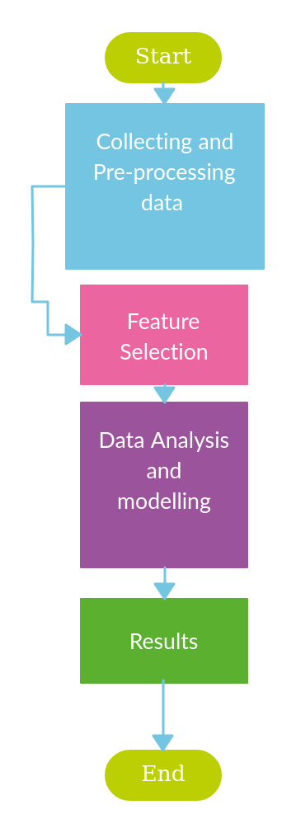
- Represents the methodology
The flowchart is represented in Fig.1. as follows:
1). Collect and pre-process network data.
2). Select relevant features using HHO.
3). Analyze features to identify anomalies.
4). Model the anomalies using machine learning algorithms.

Results and Conclusion
The dataset has many features in it, they are represented in the following Fig.2. The figure represents the correlation heatmap as correlation matrix colourfully. 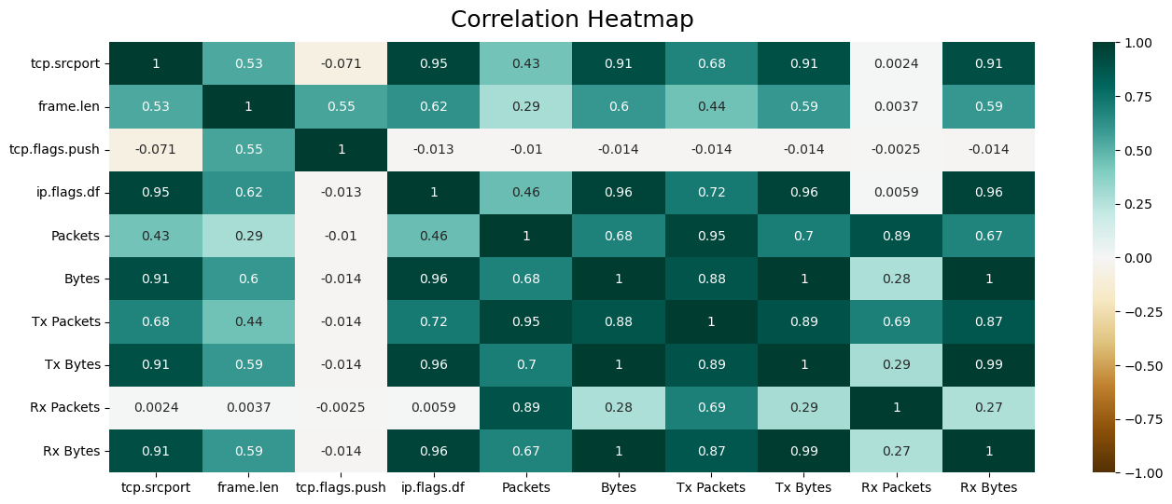
- Correlation Matrix
In conclusion, this research evaluated the use of Harris Hawk Optimisation (HHO) in Internet of Things (IoT) networks for feature selection with the optimization history plot as shown in the Fig.2. and Fig .3. used monitoring and analysing distributed denial-of-service (DDoS) attacks.

- Features selected using Harris Hawk optimization
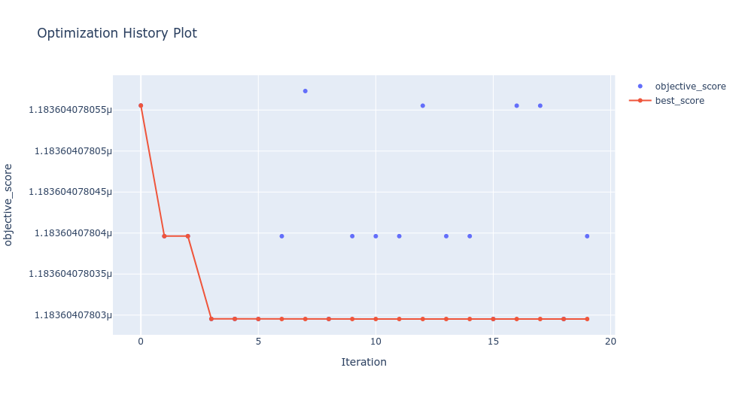
- Optimization history plots
This study has been able to test and evaluate the effectiveness of the recommended method in identifying various DDoS attack aspects using benchmark/NS3 DDoS data which is shown in the Fig .5. graph Packet vs Bytes. Here the green represents benign packets, orange and red represents attack packets DdoS-PSH-ACK and DdoS-ACK respectively.
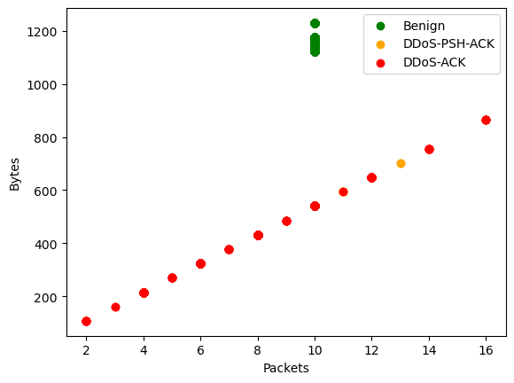
- Bytes vs Packets
HHO has demonstrated to be a successful optimisation strategy for achieving the best DDoS attack detection. The contribution of the suggested methodology has been recognised through this study, and prospective paths for more research have also been provided and shown in Fig .6. as ML model name, accuracy, precision and detection rate. Support vector machine, Gradient Boosting, Decision Tree, Kneighbors, Random forest has accuracy, precision and detection rate as 1 except Neural Network as 0.9 for accuracy, 1 for precision and 0.84 for detection rate.
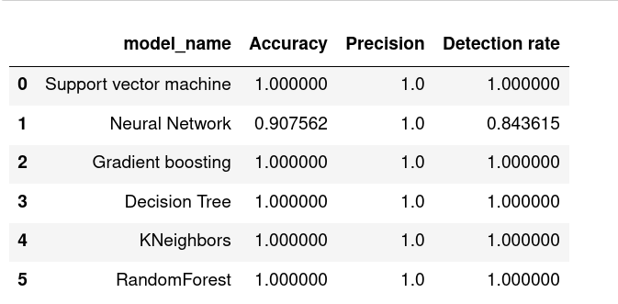
- ML Model with accuracy, precision and detection rate.
IoT networks might benefit from this research's ability to advance and improve their security, making them less vulnerable to online threats like DDoS attacks. Along with above results the feature which contribute more for the DDoS attack is identified. as shown in Fig.7. The feature 6 shows the score as 1which has more contribution for DDoS attack and all other features shows less contibution as the score was 0.

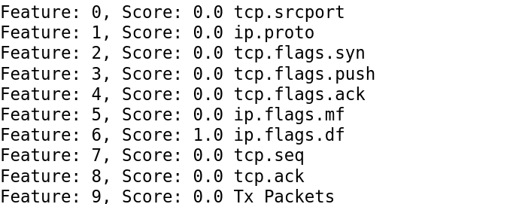
- Features and score
Future research can examine how well HHO detects and analyses various network activities, including malware, zero-day attacks, and other cyberthreats. To improve the effectiveness of the suggested method, more study can concentrate on the integration of more sophisticated machine learning methods including deep learning, reinforcement learning, and neural networks.

References
- Anthi, Eirini, Lowri Williams, Amir Javed, and Pete Burnap. "Hardening machine learning denial of service (DoS) defences against adversarial attacks in IoT smart home networks." computers & security 108 (2021): 102352.
- Tushir, Bhagyashri, Hetesh Sehgal, Rohan Nair, Behnam Dezfouli, and Yuhong Liu. "The impact of dos attacks onresource-constrained iot devices: A study on the mirai attack." arXiv preprint arXiv:2104.09041 (2021).
- Arış, Ahmet. "New lightweight DoS attack mitigation techniques for RPL based IoT networks." (2019).
- Jazzar, Mahmoud, and Mousab Hamad. "An Analysis Study of IoT and DoS Attack Perspective." In Proceedings of International Conference on Intelligent Cyber-Physical Systems, pp. 127-142. Springer, Singapore, 2022.
- Kumar, S. Santhosh, and K. Kulothungan. "An Anomaly Behavior based Detection and Prevention of DoS Attack in IoT Environment." In 2017 Ninth International Conference on Advanced Computing (ICoAC), pp. 287-292. IEEE, 2017.
- Garg, Umang, Shalini Singh, Shivashish Dhondiyal, and Neha Gupta. "An Approach to IoT Framework and Implementation of DoS Attack." In Green Internet of Things for Smart Cities, pp. 233-247. CRC Press, 2021.
- Baig, Zubair A., Surasak Sanguanpong, Syed Naeem Firdous, Tri Gia Nguyen, and Chakchai So-In. "Averaged dependence estimators for DoS attack detection in IoT networks." Future Generation Computer Systems 102 (2020): 198-209.
- Ambarkar, Smita Sanjay, and Narendra Shekokar. "Critical and Comparative Analysis of DoS and Version Number Attack in Healthcare IoT System." In Proceeding of First Doctoral Symposium on Natural Computing Research, pp. 301-312. Springer, Singapore, 2021.
- Paudel, Ramesh, Timothy Muncy, and William Eberle. "Detecting DoS attack in smart home IoT devices using a graph-based approach." In 2019 IEEE International Conference on Big Data (Big Data), pp. 5249-5258. IEEE, 2019.
- Rachmadi, Salman, Satria Mandala, and Dita Oktaria. "Detection of DoS Attack using AdaBoost Algorithm on IoT System." In 2021 International Conference on Data Science and Its Applications (ICoDSA), pp. 28-33. IEEE, 2021.
- Rim, Kwangcheol, and Dongho Lim. "DoS attack control design of IoT system for 5G era." Journal of information and communication convergence engineering 16, no. 2 (2018): 93-98.
- Sinha, Somnath. "Impact of DoS attack in IoT system and identifying the attacker location for interference attacks." In 2021 6th International Conference on Communication and Electronics Systems (ICCES), pp. 657-662. IEEE, 2021.
- Hussain, Faisal, Syed Ghazanfar Abbas, Muhammad Husnain, Ubaid U. Fayyaz, Farrukh Shahzad, and Ghalib A. Shah. "IoT DoS and DDoS attack detection using ResNet." In 2020 IEEE 23rd International Multitopic Conference (INMIC), pp. 1-6. IEEE, 2020.
- Huraj, Ladislav, Marek Simon, and Tibor Horák. "IoT measuring of UDP-based distributed reflective DoS attack." In 2018 IEEE 16th International Symposium on Intelligent Systems and Informatics (SISY), pp. 000209-000214. IEEE, 2018.
- Ilango, Harun Surej, Maode Ma, and Rong Su. "Low Rate DoS Attack Detection in IoT-SDN using Deep Learning." In 2021 IEEE International Conferences on Internet of Things (iThings) and IEEE Green Computing & Communications (GreenCom) and IEEE Cyber, Physical & Social Computing (CPSCom) and IEEE Smart Data (SmartData) and IEEE Congress on Cybermatics (Cybermatics), pp. 115-120. IEEE, 2021.
- Iqbal, Zahid, Azhar Imran, Amanullah Yasin, and Adnan Alvi. "Denial of Service (DoS) Defences against Adversarial Attacks in IoT Smart Home Networks using Machine Learning Methods." NUST Journal of Engineering Sciences 15, no. 1 (2022): 18-25.
- Sinha, Somnath. "Network layer DoS Attack on IoT System and location identification of the attacker." In 2021 Third International Conference on Inventive Research in Computing Applications (ICIRCA), pp. 22-27. IEEE, 2021.
- Arış, Ahmet. "New lightweight DoS attack mitigation techniques for RPL based IoT networks." (2019).
- Amudha, G., P. Prem Priya, V. Dinesh, A. Akash, and A. Akash. "Node MCU based DoS attack evaluation in IoT device." In AIP Conference Proceedings, vol. 2519, no. 1, p. 030084. AIP Publishing LLC, 2022.
- Galchynsky, Leonid, Mykola Graivoronskyi, and Oleh Dmytrenko. "Evaluation of Machine Learning Methods to Detect DoS/DDoS Attacks on IoT." (2021).
- Asad, Belal, and Neetesh Saxena. "On the feasibility of DoS attack on smart door lock IoT network." In International Symposium on Security in Computing and Communication, pp. 123-138. Springer, Singapore, 2021.
- Ahmad, Kassem, E. Abdullah, H. Ramadan, M. El-Hajj, and J. Hamieh. "Performance analysis and comparison of detecting Dos attacks in Iot using machine learning, deep learning and data mining: a Survey." Proceedings of internet technology and secured transactions (2018): 84-92.
- Alahari, Hanumat Prasad, and Suresh Babu Yelavarthi. "Performance analysis of denial of service dos and distributed dos attack of application and network layer of iot." In 2019 Third International Conference on Inventive Systems and Control (ICISC), pp. 72-81. IEEE, 2019.
- Ghahramani, Meysam, Reza Javidan, Mohammad Shojafar, Rahim Taheri, Mamoun Alazab, and Rahim Tafazolli. "RSS: An energy-efficient approach for securing IoT service protocols against the DoS attack." IEEE Internet of Things Journal 8, no. 5 (2020): 3619-3635.
- Cusack, Brian, Zhuang Tian, and Ar Kar Kyaw. "Identifying DOS and DDOS attack origin: IP traceback methods comparison and evaluation for IoT." In International Conference on Safety and Security in IoT, International Conference on Interoperability in IoT, pp. 127-138. Springer, Cham, 2017.

