AVANTHI PG COLLEGE

Dilsukhnagar , Hyderabad

**Department of Computer Science**

**CERTIFICATE**

This is to certify that Mr./Ms. MANCHI DEEPTHI

Has satisfactory completed the lab work in …………………………

Practical prescribed by Osmaniya University for computer Science course in the Laboratory for the year……………………………..

Inetrnal Examiner

Head Of the Department

External Examiner

Name : M.DEEPTHI

Ht.No :130521862099

Class :……………………….

CONTENT

**AIM:** To develop the “ATM Application” using Rational Rase Software and to implement the software in visuval base……….

LIBRARY MANAGEMENT SYSTEM

**INTRODUCTION :**

The project titled “Library Management System” is a Library management software for monitoring and controlling the transactions in a library.

The project “Library Management System” is developed in java, which mainly focuses on basic operations in a library like adding new member, new books, and updating new information, searching books and members to borrow and return books.

“Library Management System” is a windows application written for 32/64-bit Windows operating systems, designed to help users maintain and organize library. Our software is easy to use for both beginners and advanced users. It features a familiar and well thought-out, an attractive user interface.

The software Library Management System has four main modules.

1. Insertion to Database Module - User friendly input screen

2. Extracting from Database module – Attractive Output Screen

3. Report Generation module – borrowed book list & Available book list

4. Search Facility system – search for books and members

**SYSTEM ANALYSIS**

**EXISTING SYSTEM:**

System Analysis is a detailed study of the various operations performed by a system and their relationships within and outside of the system. Here the key question is:

What all problems exist in the present system?

What must be done to solve the problem? Analysis begins when a user or manager begins a study of the program using existing system.

In our existing system all the transaction of books are done manually. So taking more time for a transaction like borrowing a book or returning a book and also for searching of members and books. Another major disadvantage is that to preparing the list of books borrowed and the available books in the library will take more time, currently it is doing as a one day process for verifying all records. So we can say, Fast report generation is not possible Tracing a book is difficult Information about issue/return of the books is not properly maintained No central database can be created as information is not available in database So after conducting the feasibility study we decided to make the manual Library management system to be computerized.

**PROPOSED SYSTEM :**

Proposed system is an automated Library Management System. Through our software user can add members, add books, search members, search books, update information, edit information, borrow and return books in quick time. Our proposed system has the following advantages.

* User friendly interface
* Fast access to database
* Less error
* More Storage Capacity
* Search facility
* Look and Feel Environment
* Quick transaction

All the manual difficulties in managing the Library have been rectified by implementing computerization.

**LITERATURE REVIEW** :

A review of literature reveals that a computerized library management system will:

* Help to improve the library services.
* Help the Liberians with management information.
* Help the librarian in reporting on the various operations of the library.
* Increase the rate at which Tasks are completed accurately.

**FEASIBILITY ANALYSIS**

**Technical Feasibility:**

We can strongly say that it is technically feasible, since there will not be much difficulty in getting required resources for the development and maintaining the system as well. All the resources needed for the development of the software.

**Economic Feasibility:**

Development of this application is highly economically feasible .The organization needed not spend much money for the development of the system already available. The only thing is to be done is making an environment for the development.

**HARDWARE CONFIGURATION**

* At least a PC with Pentium III microprocessor.
* Hard Disk.
* Monitor.
* Key Board.
* Mouse

**SOFTWARE CONFIGURATION**

* Operating System: Windows XP, Windows Vista, Windows 8

Windows 8.1, Windows 10.

* Language: Java.
* IDE: NetBeans IDE.
* Database Management System: MySQL.

**Activities:**

* Search for a book.
* Add/Delete books.
* Maintain the database.
* View user details.
* Issue books.
* Return books.
* Maintain user details.

Use Case Diagram

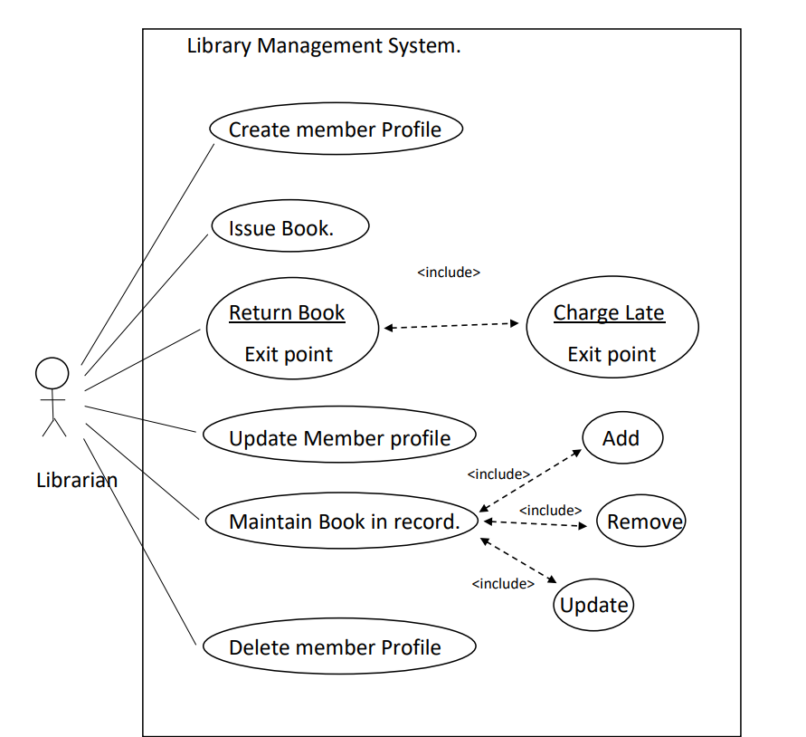

Activity Diagram

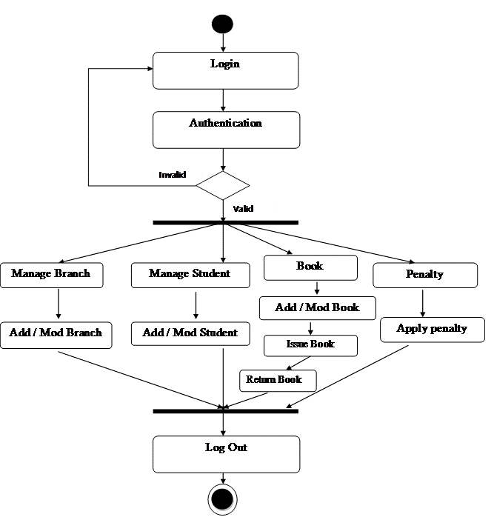

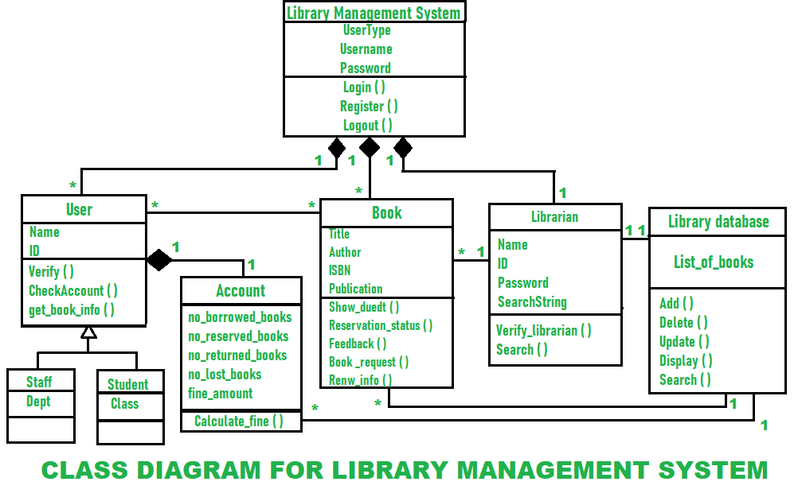

Class Diagram

Collabration Diagram

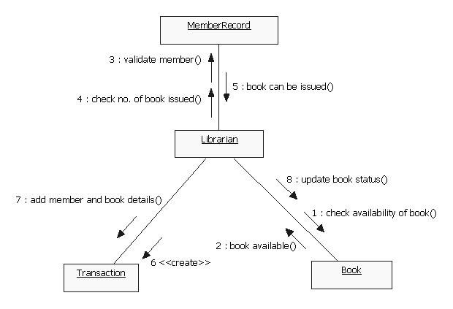

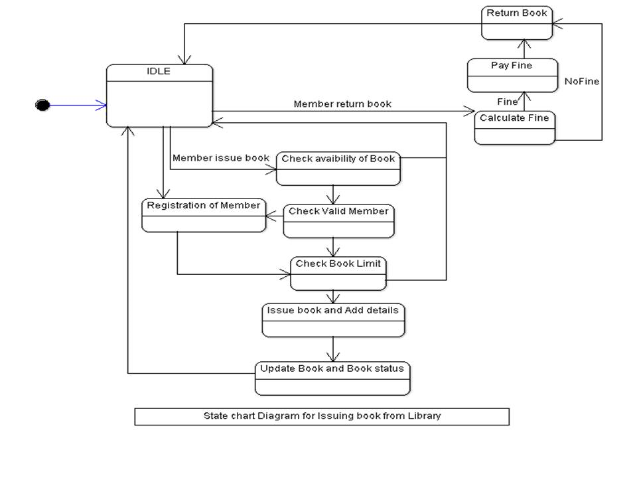

State Chart Diagram

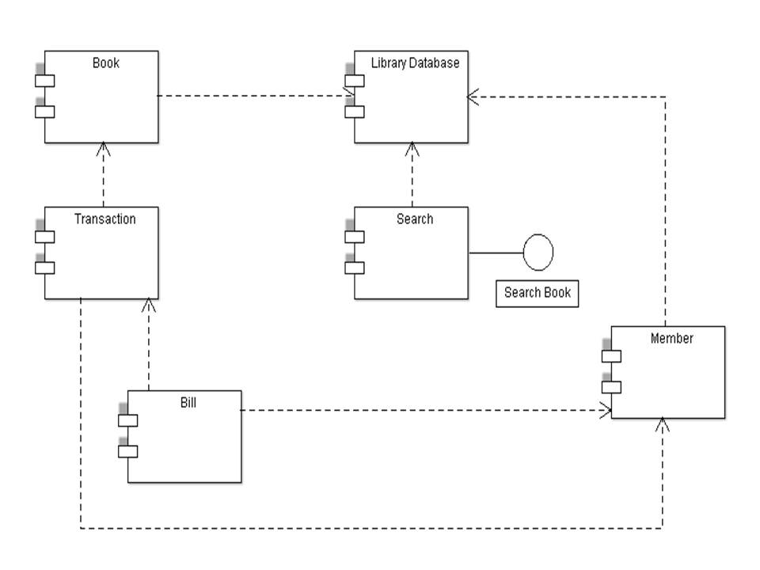

Component Diagram

Sequence Diagram

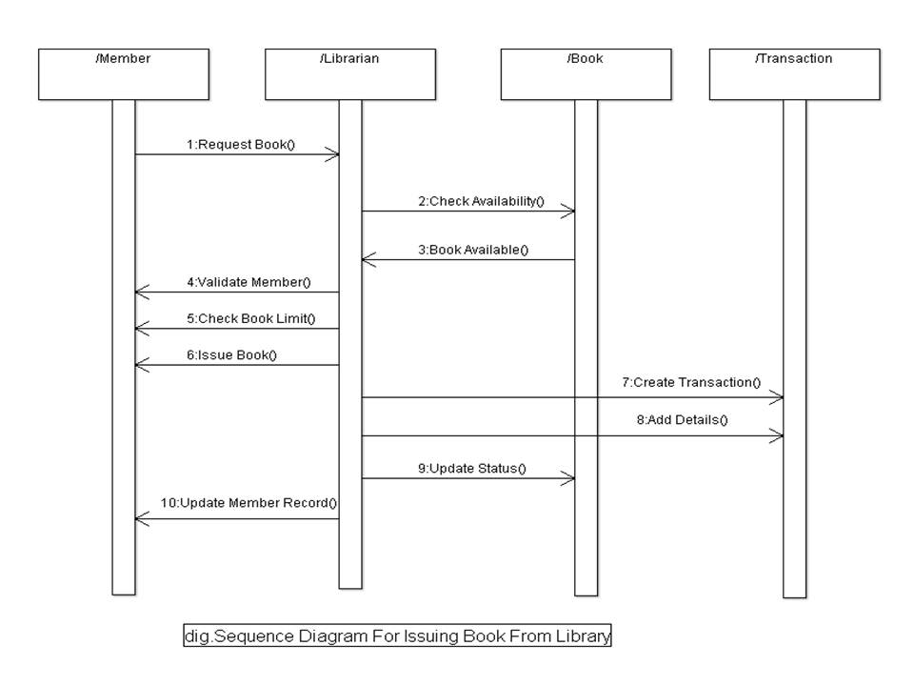

Deployment Diagram

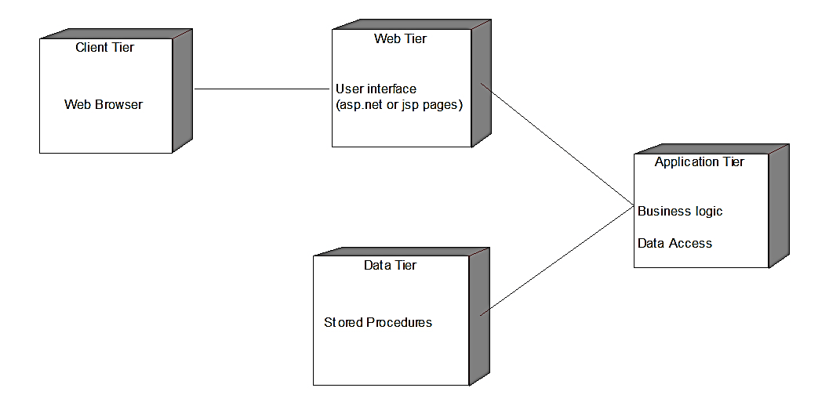

Package Diagram

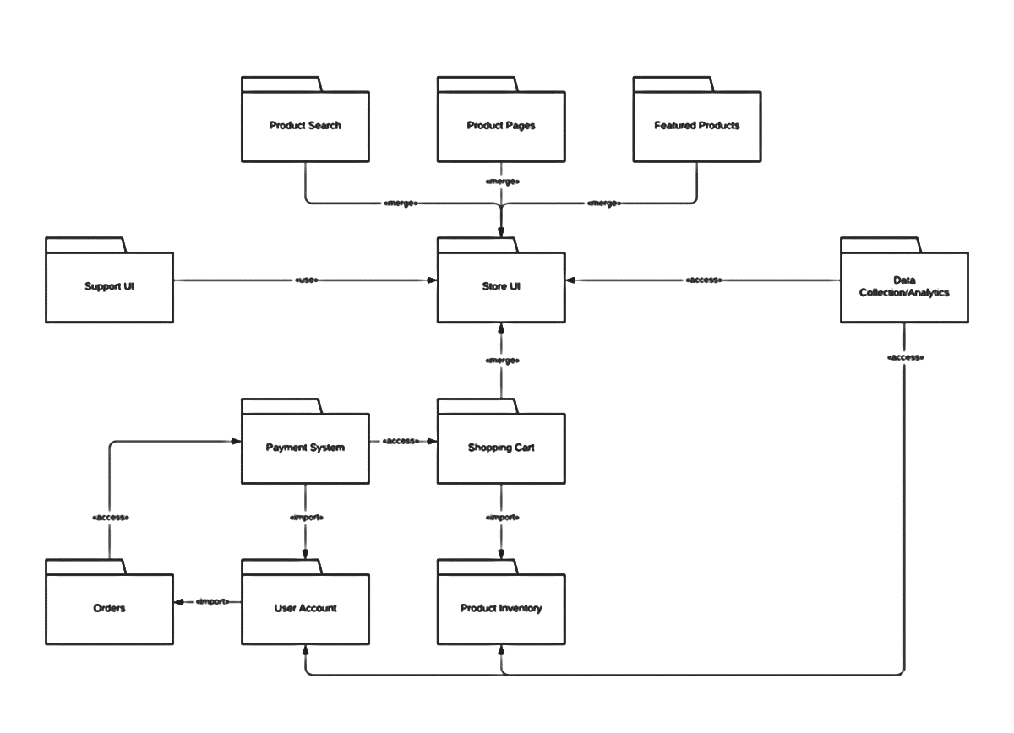

**Software Testing :**

**UNIT TESTING:**

Unit testing involves the design of test cases that validate that the internal program logic. It is the testing of individual software units of the application.

**INTEGRATION TESTING:**

Integration tests are designed to test integrated software components to determine if they are actually run as one.

**FUNCTIONAL TESTING:**

Functional testing provide the systematic demonstration of the functions

that perform in this process.

**WHITE BOX TESTING:**

It is the testing in which the software has the knowledge of the inner

workings, structure and language of the software.

**BLACK BOX TESTING:**

Black box testing is the testing software without any knowledge of the inner workings, structure or language of the module being tested.

**RESULT :**

Thus the project to develop library management system using Rational Rose Software and to implement the project in Visual Basic is done successfully