AUTOMATIC TRANSMISSION CONTROLLER

Name : Deepthy Shajan

Emp.ID : 214883

Contents

Introduction 3

Final Model Diagram 3

Modelling 4

• Engine 4

• Transmission 5

➢ Torque converter 5

➢ Transmission Gear Ratio 6

• Shift Logic 7

➢ MATLAB function code- SpeedCheck(): 8

• Vehicle 9

Solver selection strategy 10

Model Explorer – Callbacks 11

Model Explorer – Model Workspace 12

Sample input from signal builder 12

Results 13

List of figures

Figure 1 : Generic block diagram for a drivetrain system 3

Figure 2: Automatic Transmission Controller 3

Figure 3: Engine subsystem 4

Figure 4: Torque converter system 5

Figure 5: Example of a used lookup table 6

Figure 6: Transmission gear ratio subsystem 7

Figure 7: Transmission subsystem 7

Figure 8: Stateflow diagram of the transmission shift logic 8

Figure 9: MATLAB function 8

Figure 10: Simulink function-ComputeThreshold() 9

Figure 11: Vehicle subsystem 10

Figure 12: Solver Selection 11

Figure 13:Data Initializations using Callbacks 11

Figure 14:Data Initializations in Model Workspace 12

Figure 15: Signal builder input 12

Figure 16: Result 1 13

Figure 17: Result 2 13

Figure 18: Result 3 14

Figure 19: Result 4 14

List of Tables

Table 1: Transmission gear ratios 6

# Introduction

An automatic transmission is multi-speed transmission that does not require any driver input to change gears under normal driving conditions. This report shows how to model an automatic transmission with Simulink. Stateflow enhances the Simulink model with its representation of the transmission control logic. Simulink provides a powerful environment for the modelling and simulation of dynamic systems and processes.

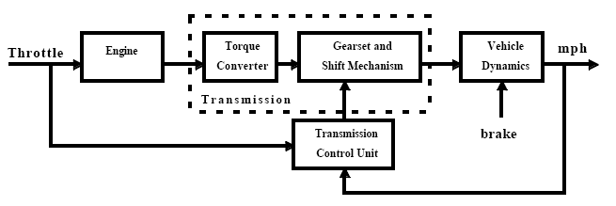

Figure 1 : Generic block diagram for a drivetrain system

Figure 1 shows the power flow in a typical automotive drivetrain. The throttle opening is one of the inputs to the engine. The engine is connected to the impeller of the torque converter which couples it to the transmission.

# Final Model Diagram

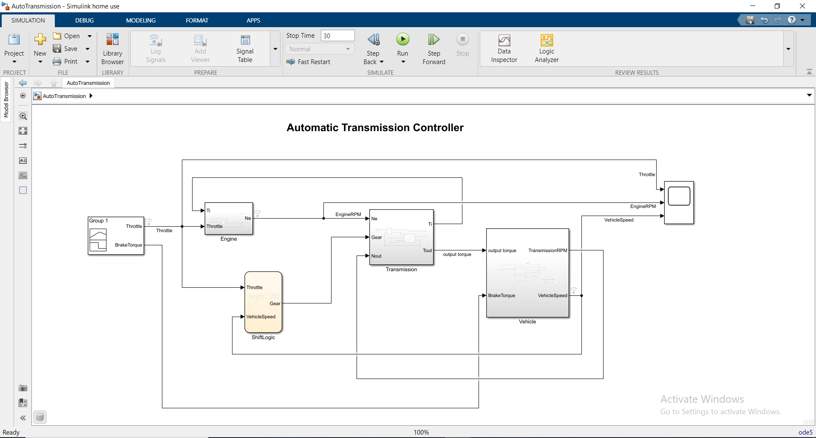

Figure 2: Automatic Transmission Controller

# Modelling

## Engine

Equation:

The Engine subsystem consists of a two-dimensional lookup table that interpolates engine torque versus throttle and engine speed.

Data initialized using postload function in callbacks:

NE_VEC = [799.9999999999999 1200 1600 2000 2400 2800 3200 3600 4000 4400 4800];

TH_VEC = [0;20;30;40;50;60;70;80;90;100];

EMAP = [-40 -44 -49 -53 -57 -61 -65 -70 -74 -78 -82;215 117 85 66 44 29 10 -2 -13 -22 -32;245 208 178 148 122 104 85 66 48 33 18;264 260 241 219 193 167 152 133 119 96 85;264 279 282 275 260 238 223 208 189 171 152;267 290 293 297 290 275 260 256 234 212 193;267 297 305 305 305 301 293 282 267 249 226;267 301 308 312 319 323 319 316 297 279 253;267 301 312 319 327 327 327 327 312 293 267;267 301 312 319 327 334 334 334 319 305 275];

Iei = 0.0219914882835559;

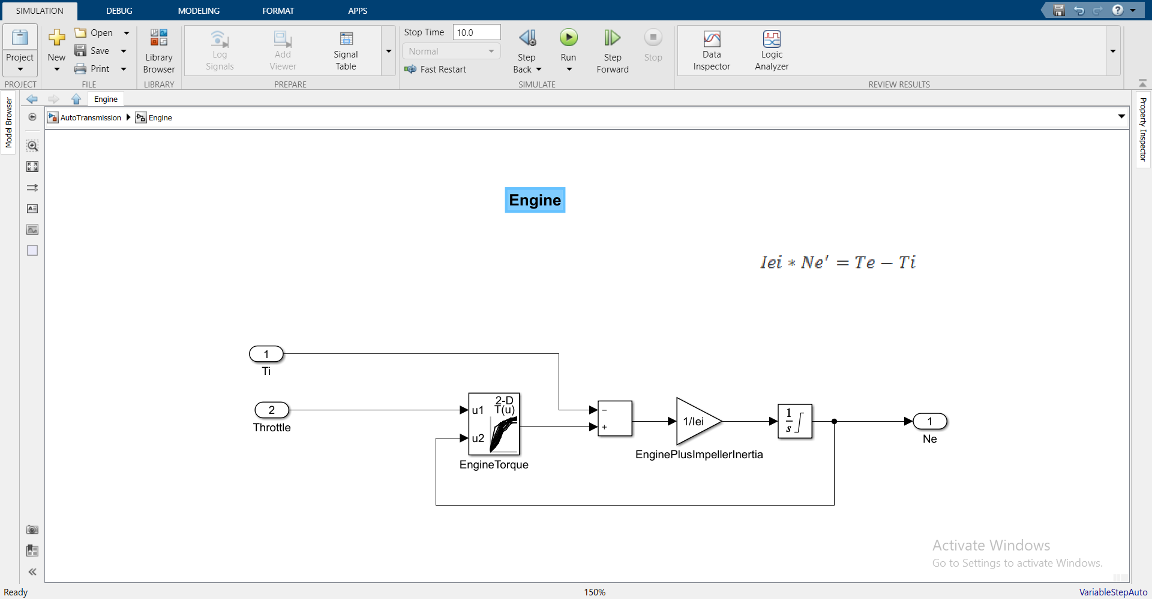

Figure 3: Engine subsystem

## Transmission

### Torque converter

Equations:

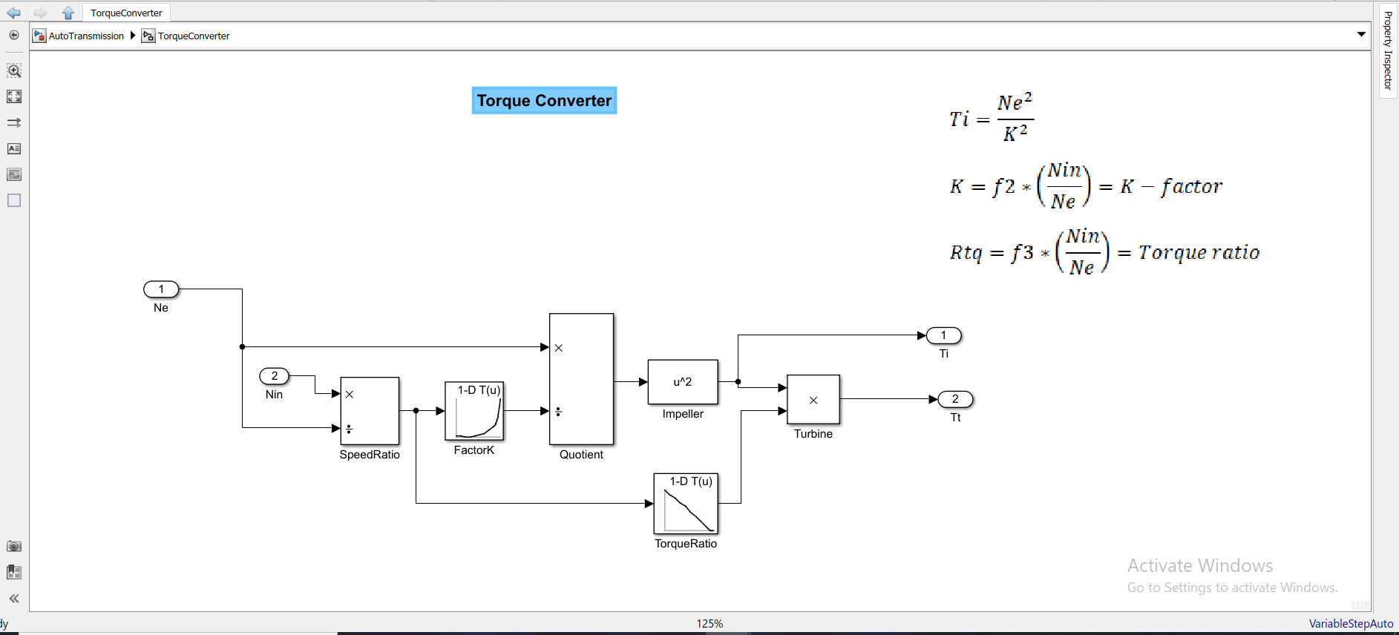

Figure 4: Torque converter system

Initialized the data in lookup tables (Kfactor, speedratio and Torkratio) from the matrix CONVERTER_DATA in model workspace.

speedratio = CONVERTER_DATA(:,1)

Kfactor = CONVERTER_DATA(:,2)

Torkratio = CONVERTER_DATA(:,3)

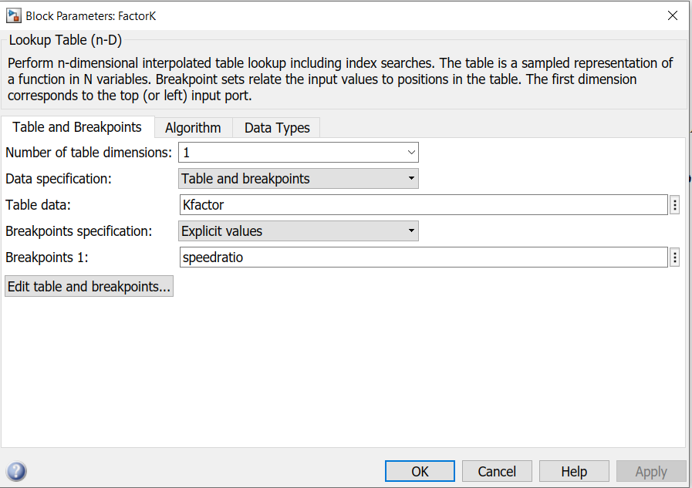

Figure 5: Example of a used lookup table

### Transmission Gear Ratio

The transmission ratio block determines the ratio shown in Table 1 and computes the transmission output torque and input speed, as indicated in Equation. Figure 5 shows the block diagram for the subsystem that realizes this ratio in torque and speed.

Equations:

|  |  |
| --- | --- |
| Gear | Rtr=Nin/Nout |
| 1 | 2.393 |
| 2 | 1.450 |
| 3 | 1.000 |
| 4 | 0.677 |

Table : Transmission gear ratios

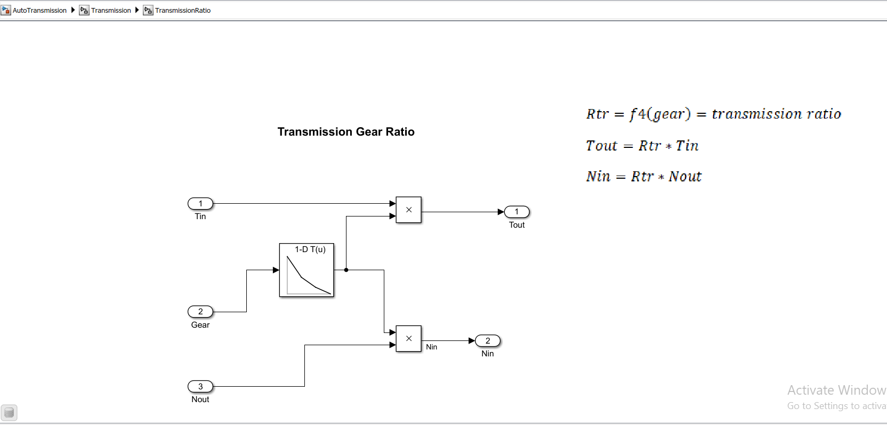

Figure 6: Transmission gear ratio subsystem

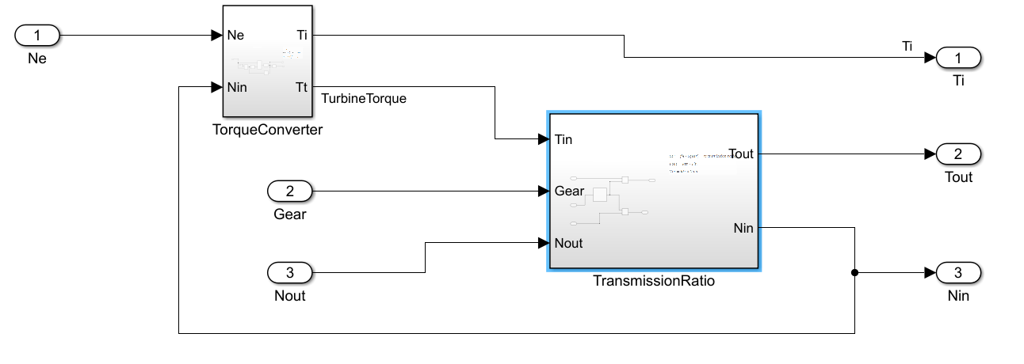

Figure 7: Transmission subsystem

## Shift Logic

The Stateflow block labeled ShiftLogic implements gear selection for the transmission.  Two dashed AND states keep track of the gear state and the state of the gear selection process. The Stateflow diagram shown in Figure 7 illustrates the functionality of the block.The overall chart is executed as a discrete-time system, sampled every 40 milliseconds.

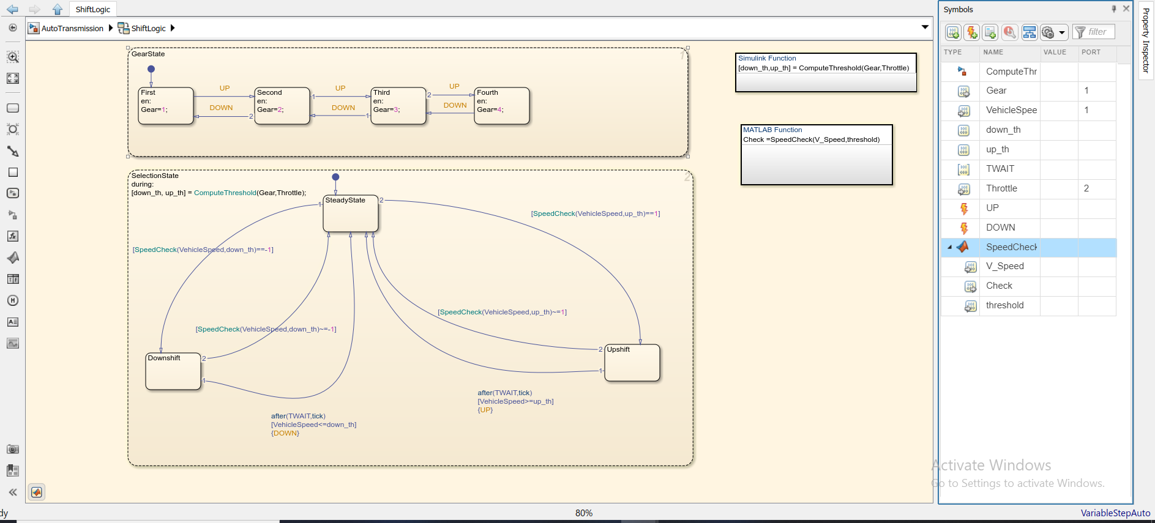

Figure 8: Stateflow diagram of the transmission shift logic

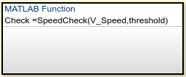

Figure 9: MATLAB function

### MATLAB function code- SpeedCheck():

function check = SpeedCheck(V_Speed,threshold)

if(V_Speed<threshold)

check=-1;

else if(V_Speed>threshold)

check=1;

else

check=0;

end

end

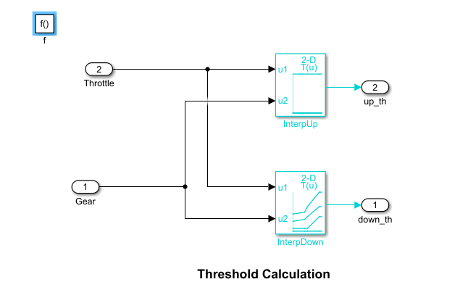

Figure 10: Simulink function-ComputeThreshold()

## Vehicle

The Vehicle subsystem (Figure 10) uses the net torque to compute the acceleration and integrate it to compute the vehicle speed.

Equations:

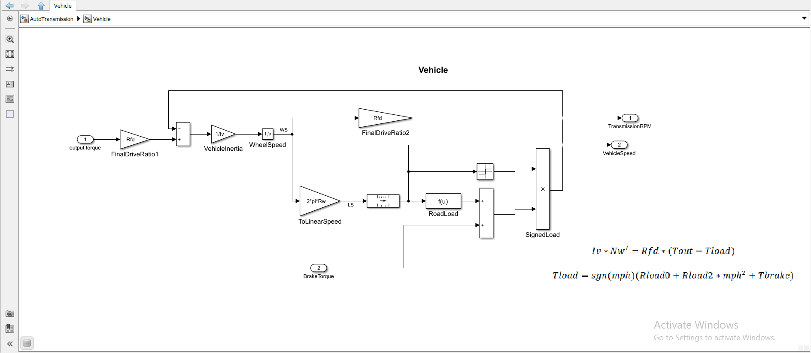

Figure 11: Vehicle subsystem

Parameters used:

VEHICLE_DATA=[3.23;40;0.02;1;12.09414785731247;0];

Rfd=VEHICLE_DATA(1);

rload0=VEHICLE_DATA(2);

rload2=VEHICLE_DATA(3);

Rw=VEHICLE_DATA(4);

Iv=VEHICLE_DATA(5);

N20=VEHICLE_DATA(6)/VEHICLE_DATA(4)*VEHICLE_DATA(1);

# Solver selection strategy

Fixed step solver type and ode5(Dormand-Prince) solver is used.

Reason to use a fixed-step solver is that ,a code should be generated from the model and run the code on a real-time system. Variable step sizes cannot be mapped to the real-time clock of a target system.

ode5 is a Fixed-Step Continuous Explicit solver. Explicit solvers use past information in the equations to compute next step. This is computationally simple. The system have continuous states. Thus ode5 is used.

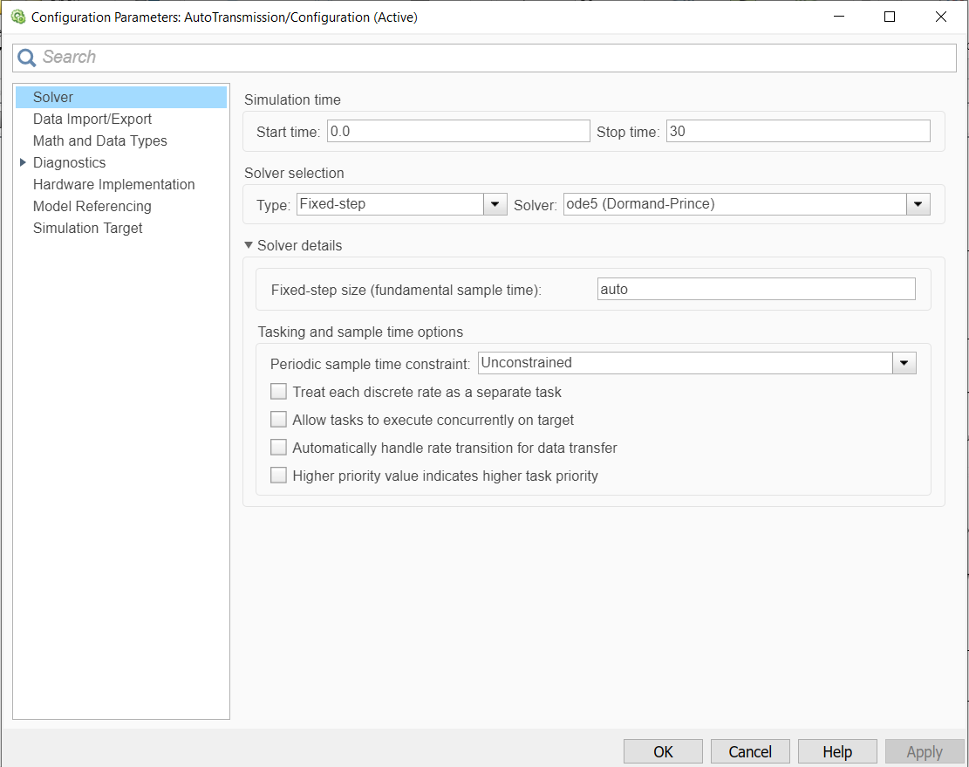

Figure 12: Solver Selection

# Model Explorer – Callbacks

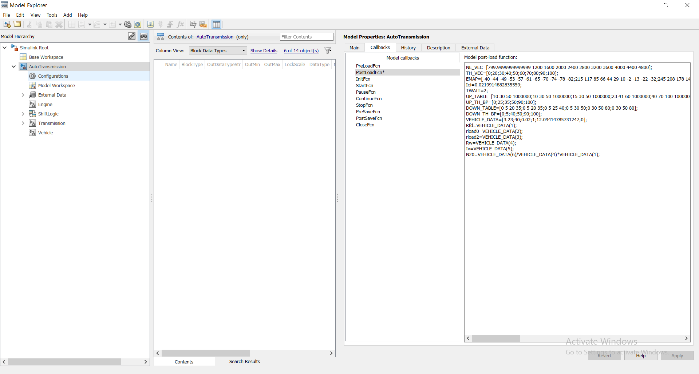

Figure 13:Data Initializations using Callbacks

# Model Explorer – Model Workspace

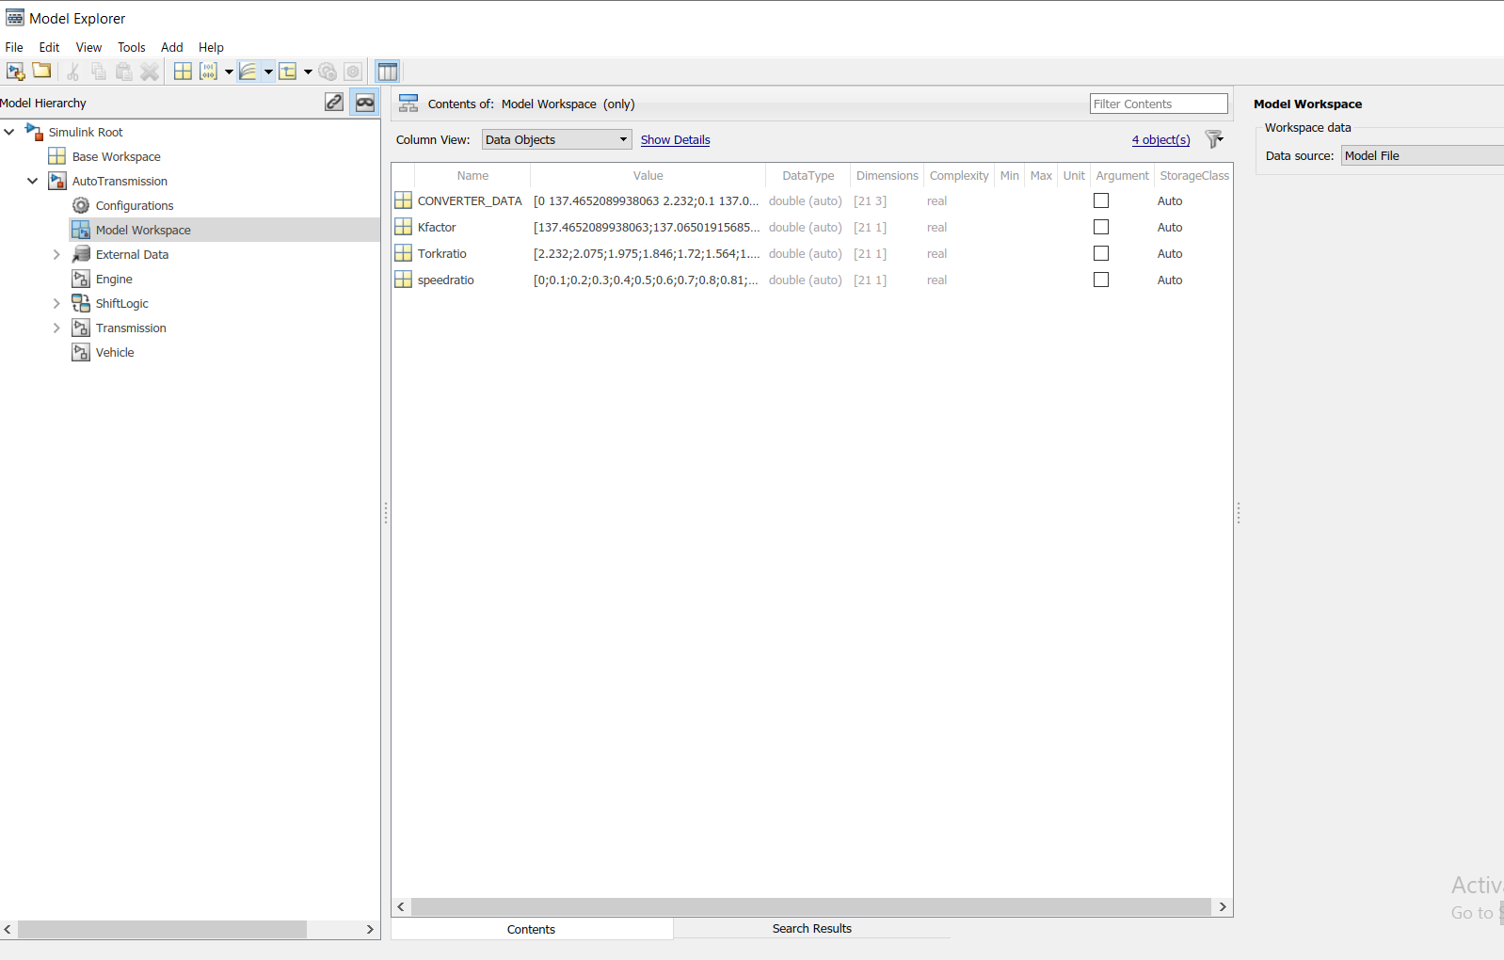

Figure 14:Data Initializations in Model Workspace

Sample input from signal builder

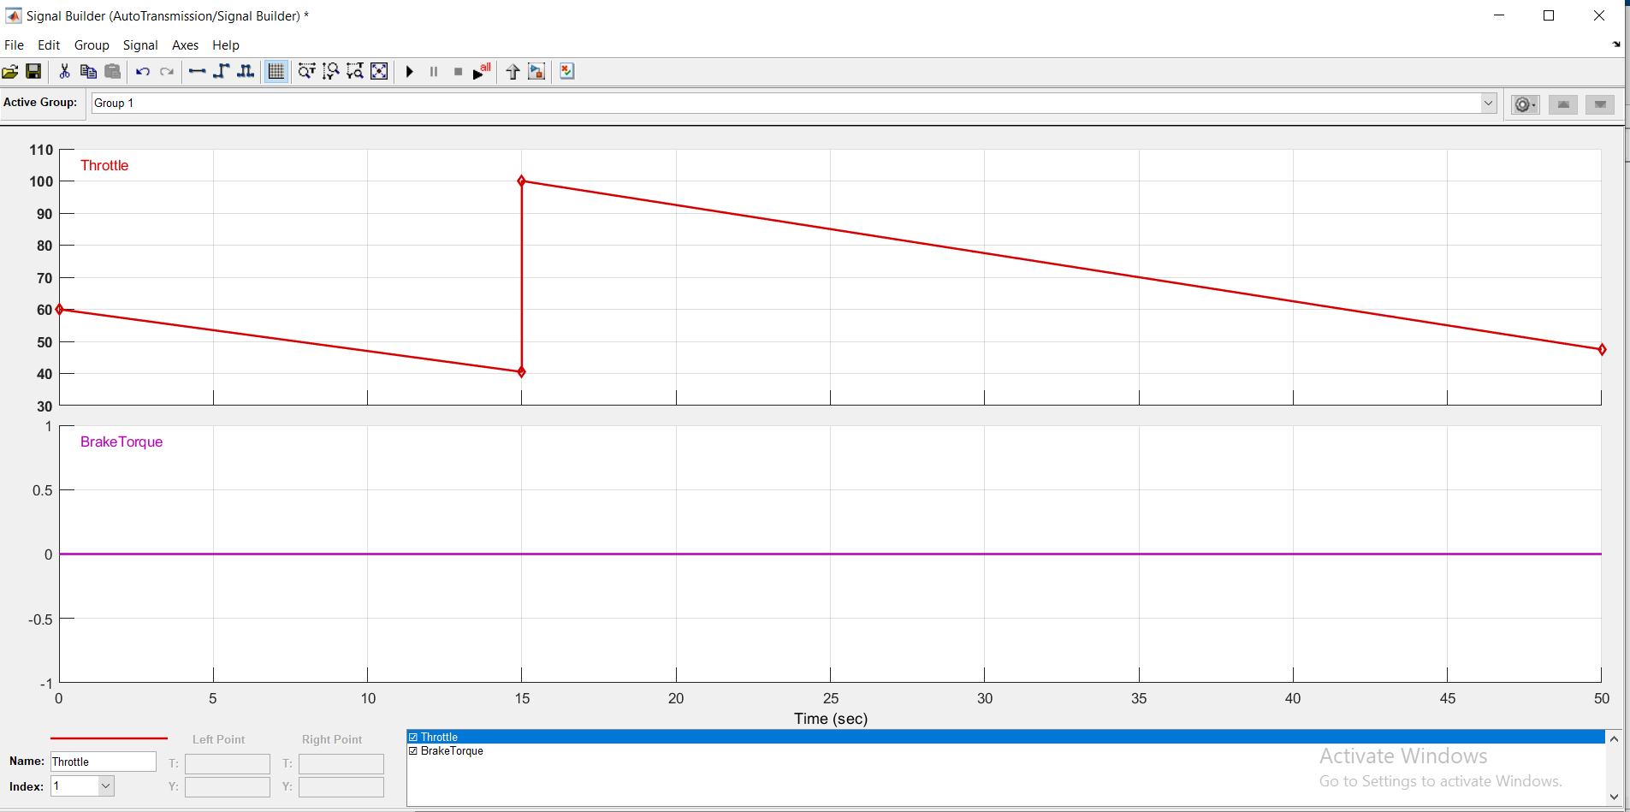

Figure 15: Signal builder input

# Results

**Test Result 1**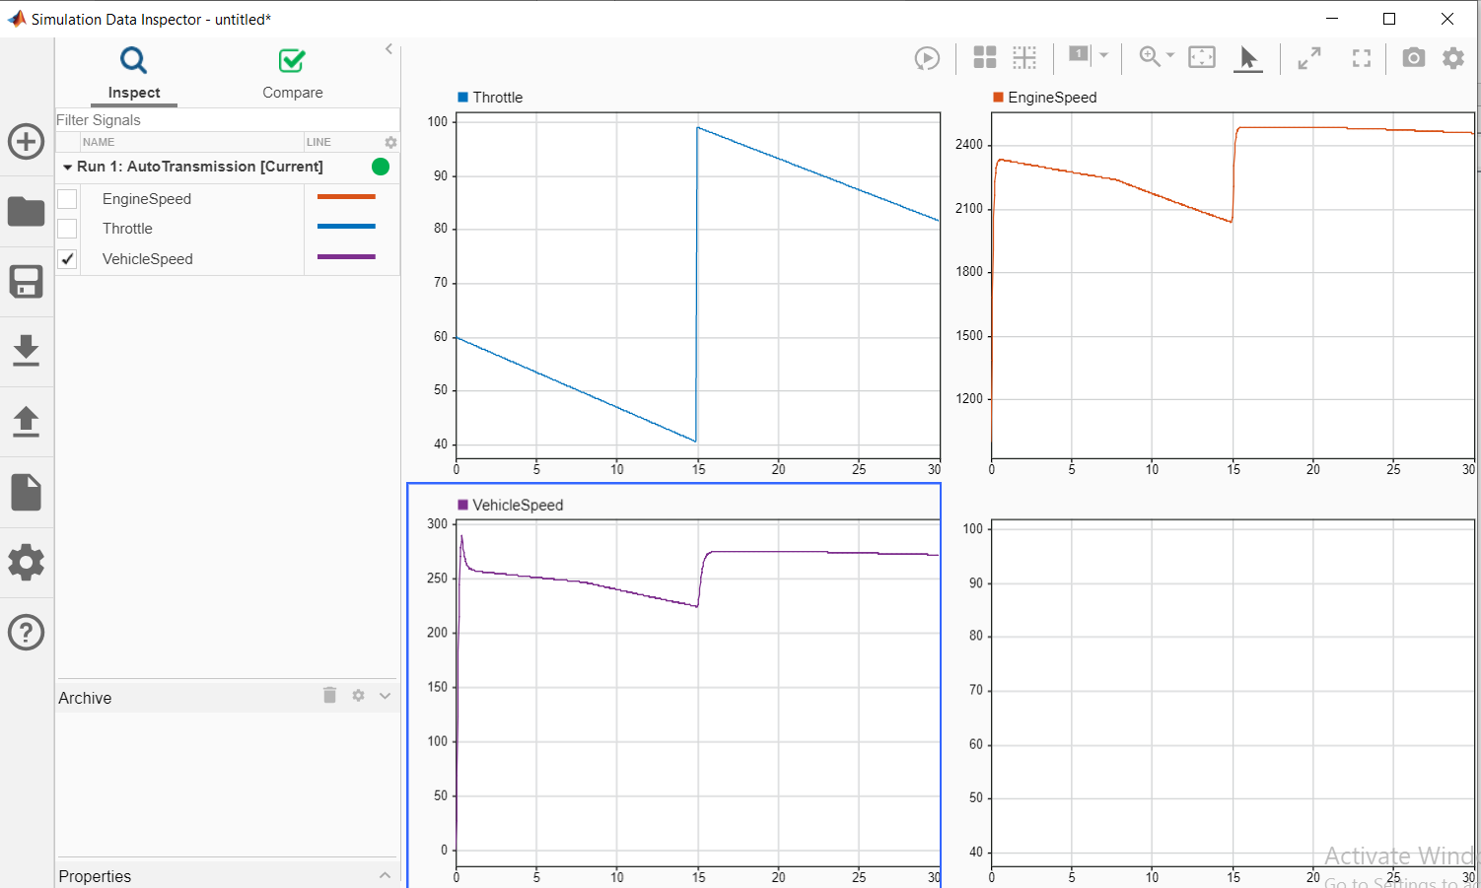

Figure 16: Result 1

**Test Result 2**

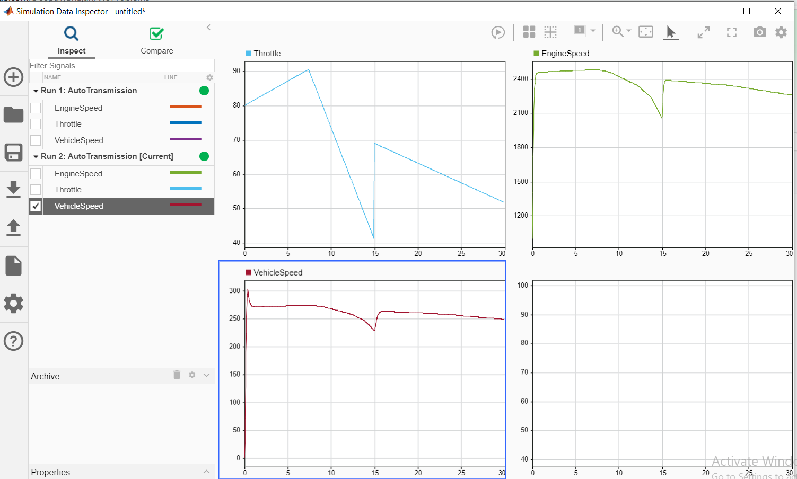

Figure 17: Result 2

**Test Result 3**

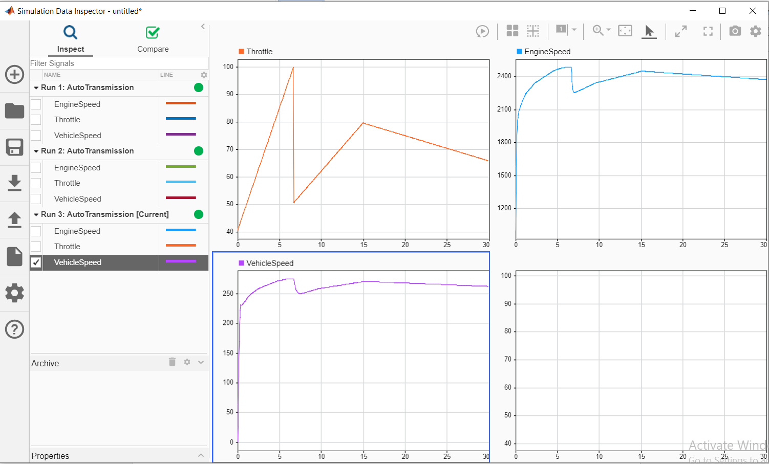

Figure 18: Result 3

**Test Result 4**

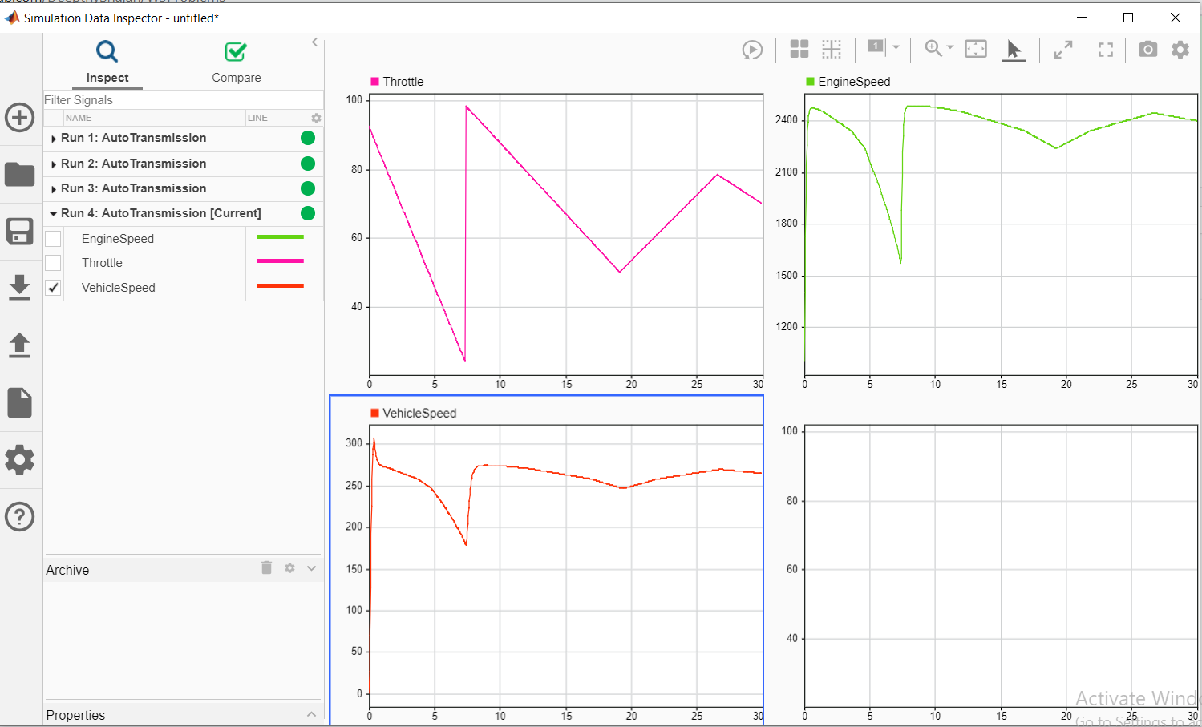

Figure 19: Result 4