**Problem Statement**-

**Integral Spiral**: To print the given integer in spiral form based on the given input direction i.e. left or right.

Ex: Input Number: 7, Direction: Left

Output:

7 6

1 0 5

2 3 4

**Approach Used**-

I have used Angular Js 1.4 to do the problem statement. The steps are as follows:

1.We get the input number(positive integers) and direction from the UI.

2.For ex. We get the input as 7 and left.

3. Then we take a variable ‘spin’ which will tell us that the direction is left or right. If the direction is left

the spin will be true else it will be false. Hence spin=true.

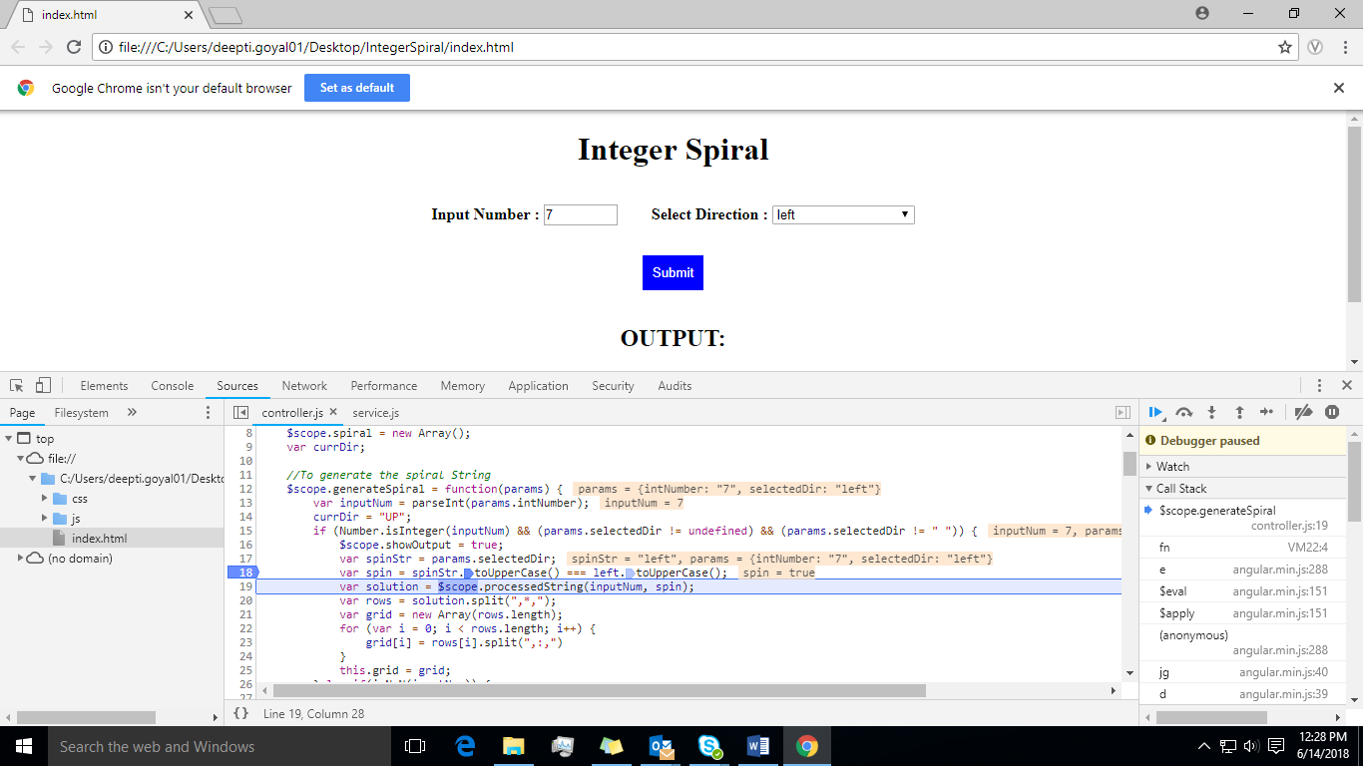

4.Then using the input number we find the maximum matrix size using which the spiral would be made.

In our case the matrix size would be 3*3 matrix.

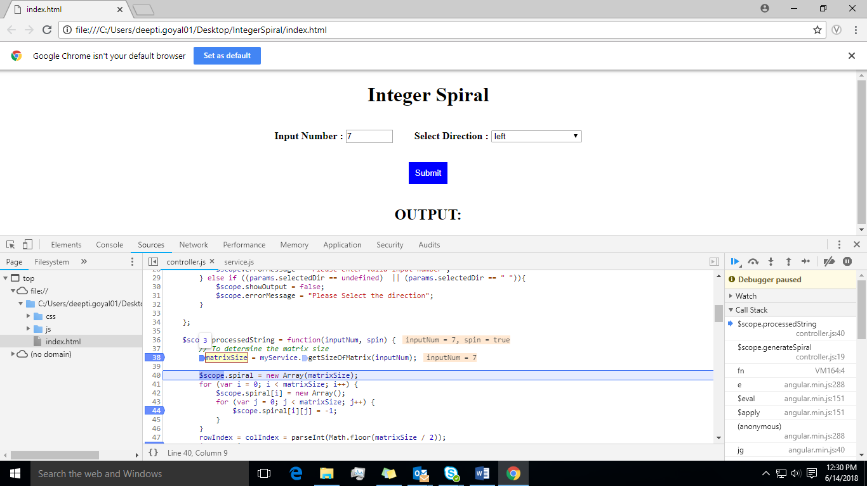

5.Then we fill the 3*3 matrix with the value -1.

Spiral [3][3] = -1 -1 -1

-1 -1 -1

-1 -1 -1

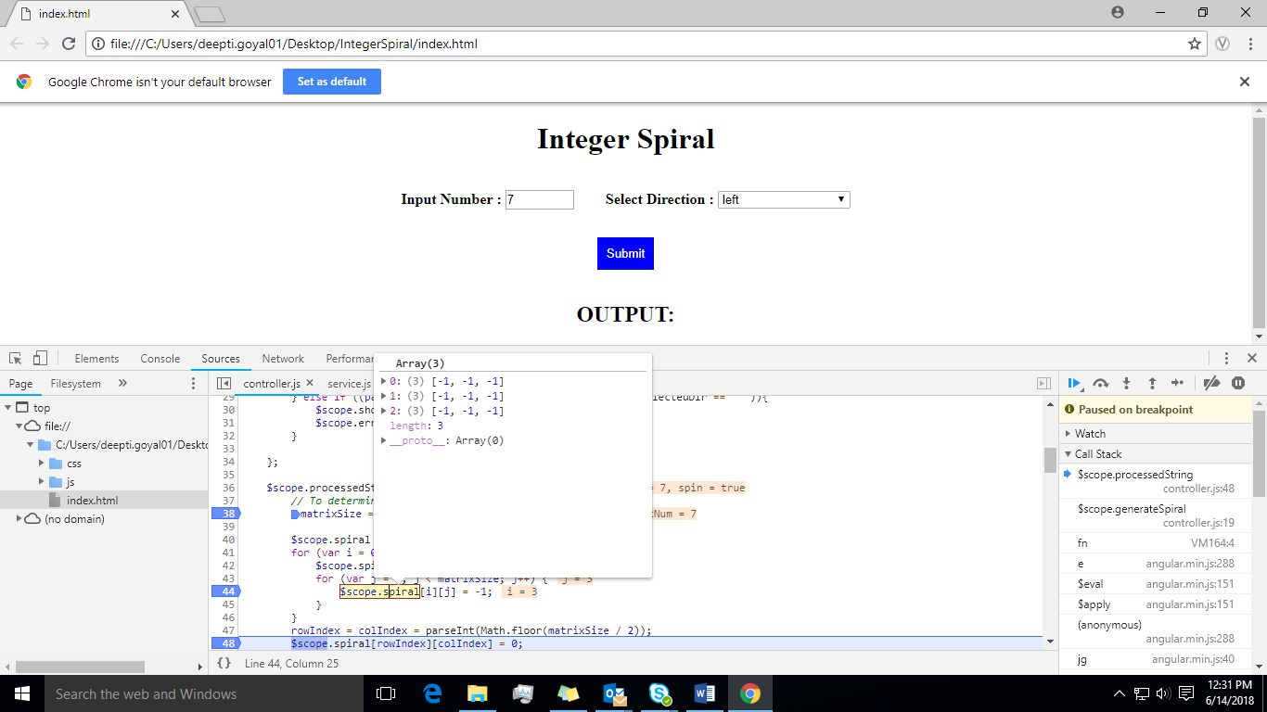

6. We find the central position of the matrix and assign it as 0.

In our case central position will be (1,1). Hence,

Spiral [3][3] = -1 -1 -1

-1 0 -1

-1 -1 -1

Currently position i.e. rowIndex and colIndex of the matrix is (1,1).

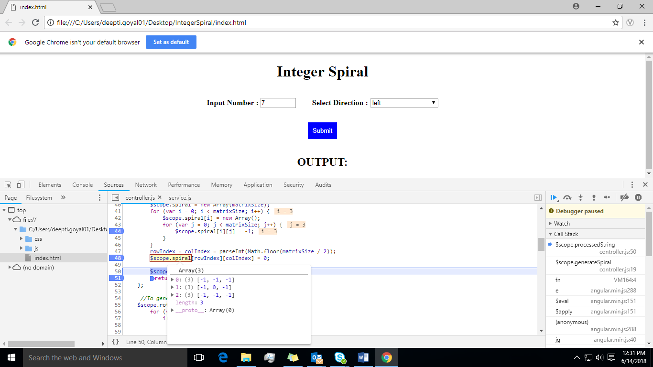

7.Then using the spin value we have to move the numbers around in the matrix.

Like in our case spin = true. So we run a loop from 0 to 7(input number) and we declare a variable as ‘currDir’ which will tell us the direction in which the number has to be printed and its value will be by default “UP”. If the currDir is “UP” then colIndex of the matrix will decrease by 1 and the currDir will change to “Left” based on spin value and the current value of the loop will get assigned to the current position of the matrix.

Hence,

CurrDir = “Left” and rowIndex= 1, colIndex= 0 and 1 will be assigned to position (0,1)

So spiral matrix will be -1 -1 -1

1 0 -1

-1 -1 -1

Similarly from 0 to 7 the loop will run based on the currDir the matrix will be formed.

The final matrix would be -1 7 6

1 0 5

2 3 4

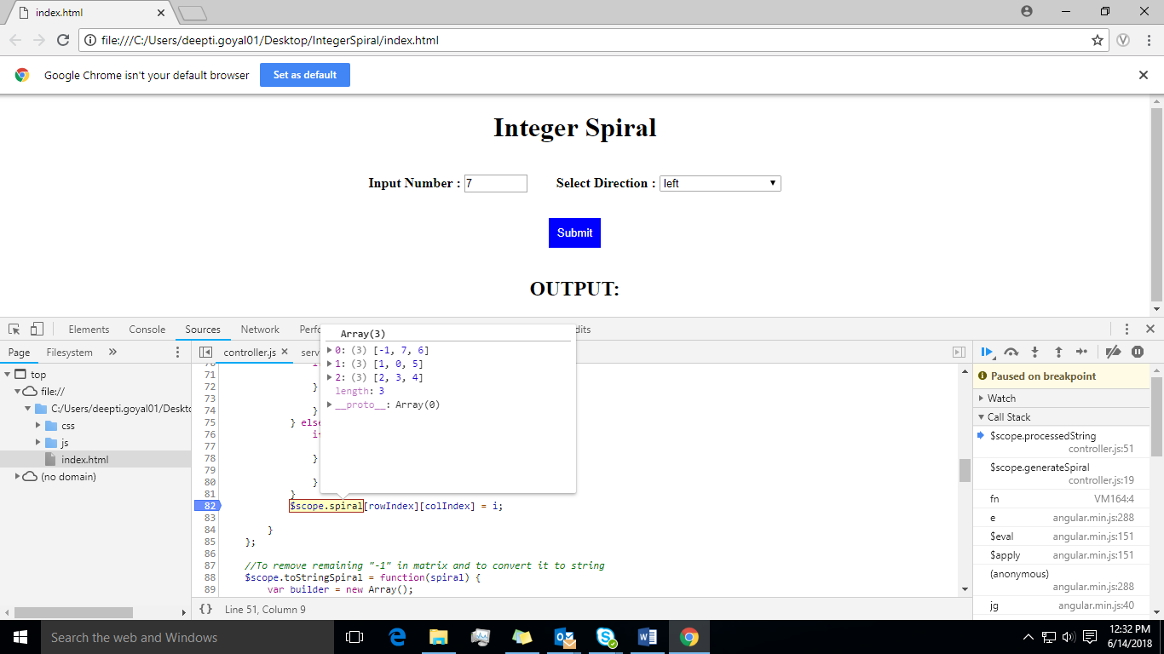

8.Then we make a string of the matrix by replacing ‘-1’ with space and any other number with the space

added in front of it.

Hence we get the processed string as

" ,:, 7,:, 6,*, 1,:, 0,:, 5,*, 2,:, 3,:, 4"

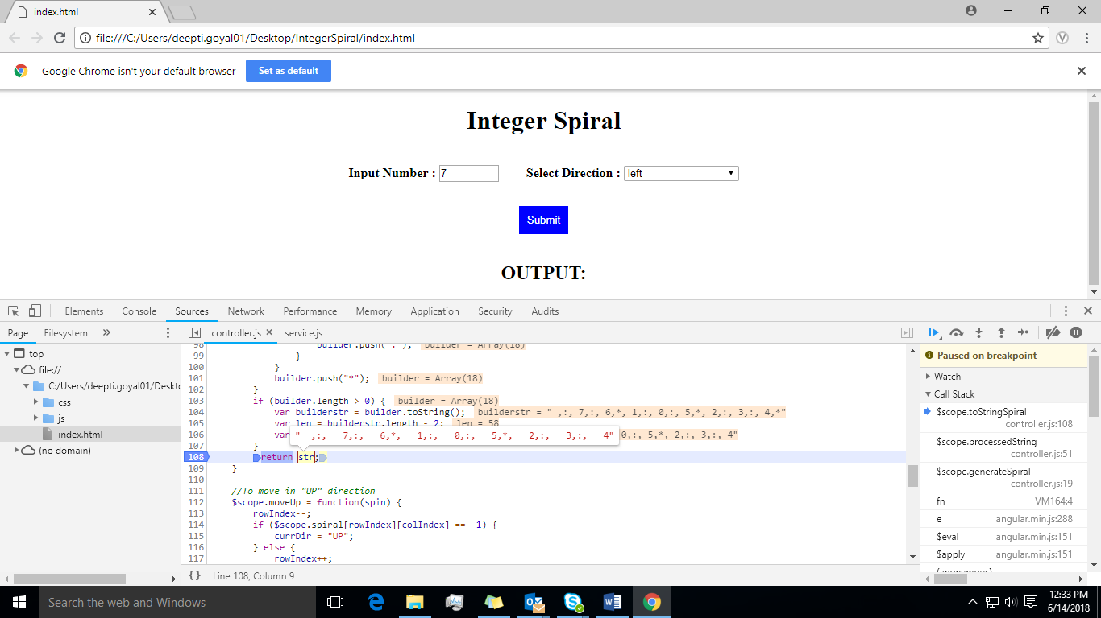

9.Then we make divide into different arrays by splitting it based on “,*,”.

Hence we get three array i.e.

[ , 7, 6] , [ 1, 0, 5] , [ 2, 3, 4]

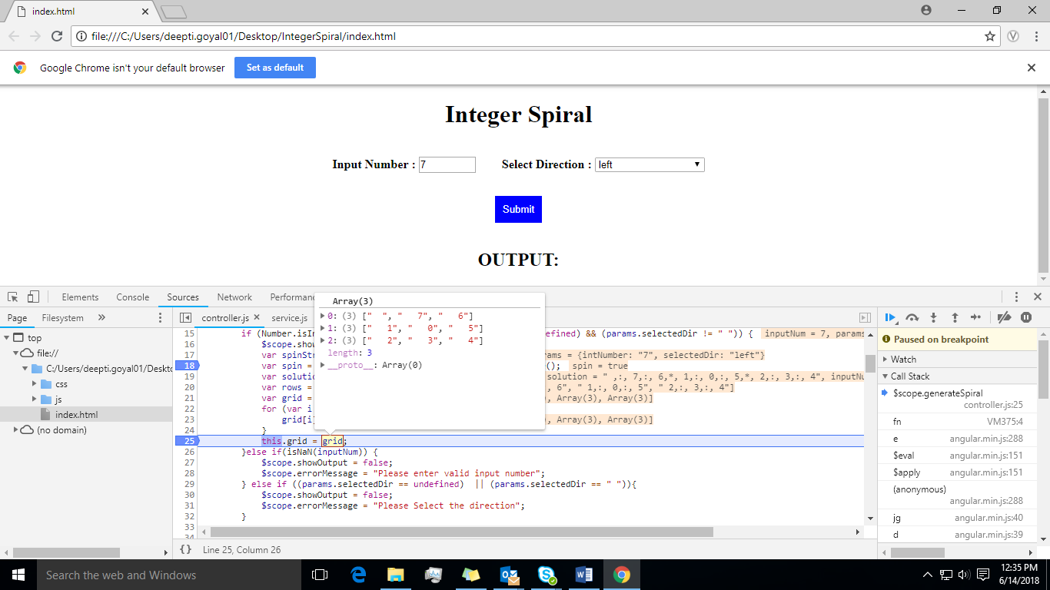

10. Then using ng-repeat we print the array in table. Hence we get the final spiral matrix as output.

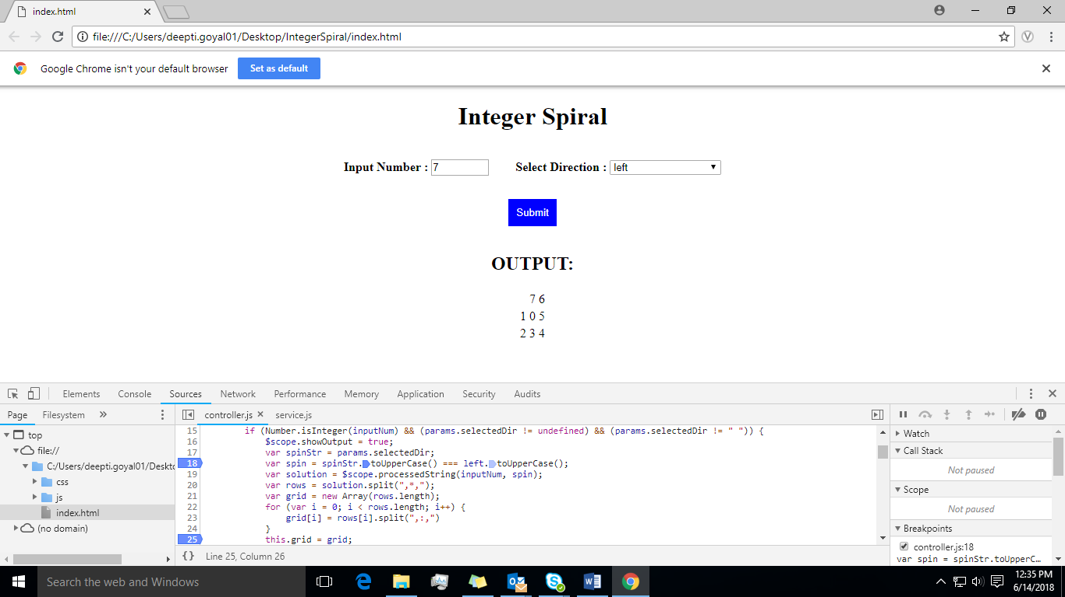

11.When we give a float input it will take the number before the point and make the spiral matrix.

12. If we give any input other than a integer it will throw error message as “Please enter valid input

Number” and if we do not select the direction then it will throw the error as “Please Select

the direction”

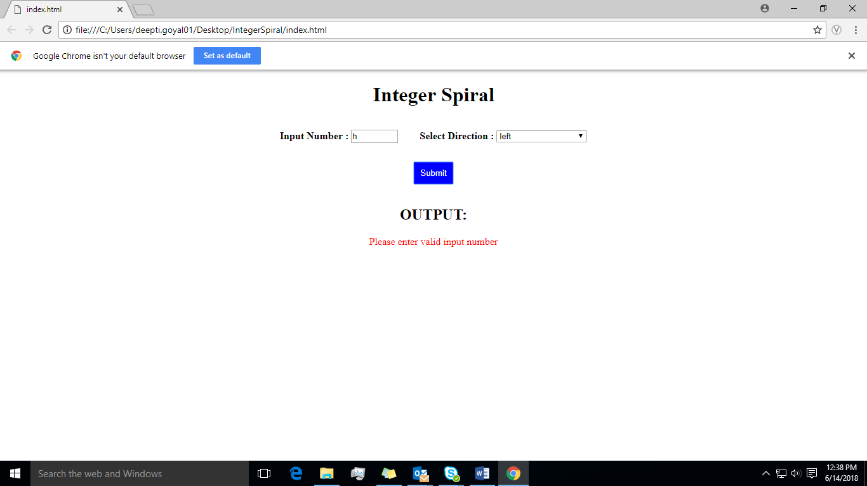

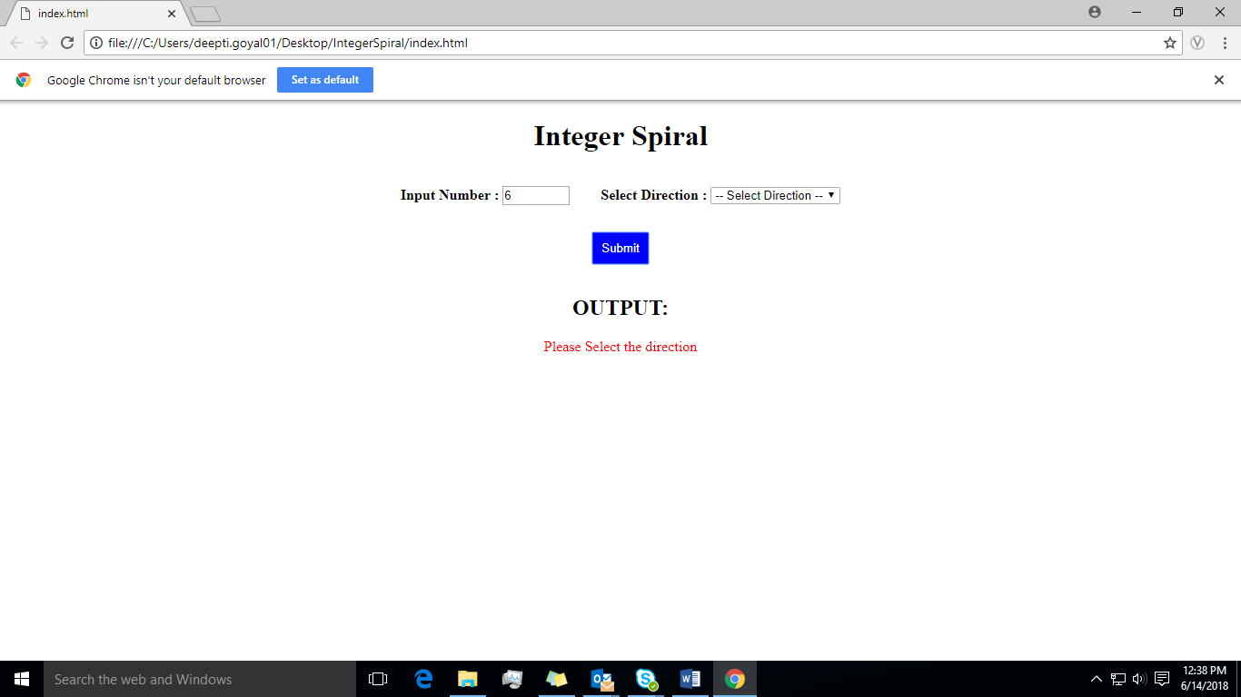

**Test Scenarios Tested:**

1.Tested whether the output is displayed or not based on the variable “showOutput” for input number:

20 and direction as left.

2.Tested the value of matrix at position (1,4) for input number: 20 and direction as left is coming as

expected or not.

3.Tested the output for a non- integer for input number as ‘a’ and direction as left.

4.Tested whether the output array is coming as expected or not for input number 6 and direction as left.

5.Tested for the scenario when the direction was not selected whether the error to select the

direction is coming or not.

All the test scenarios are passed and the test cases were written in Jasmine.

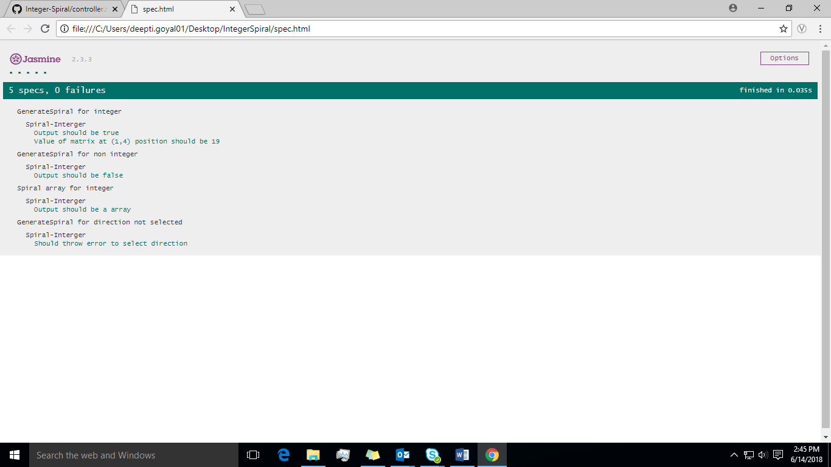

**Reason to use this approach**: I have written the code in Angular Js 1.4 as I think there is more reusability of code written and the concept of two-way data binding is great in angular js which reduces the code and testing is also easy in angular js.

**Flow Diagram**

Start

Enter Input Number & Direction

Display error

**YES**

Check if the Input Number is empty & is not a negative number

Rotate the numbers from 0 to input number within the matrix

**n * n**

Update the matrix elements with ‘-1’ and Replace the central position of matrix with ‘0’.

Calculate the matrix size.

Check if the Direction is empty.

**NO**

**YES**

**NO**

Replace the remaining ‘-1’ with space and add space in front of other numbers

I have used this approach as I found it is very easy to understand and any positive integer number can be displayed in spiral form. Also the functions can be reused.

END

Display the arrays using ng-repeat.

Convert it into string and split the string into arrays.