How to Test SCD2 (Do This in Order)
This is non-negotiable before moving forward.

🔬 Test 1 — Fresh Load (Baseline) - Worked
Step
- TRUNCATE dimension tables:
TRUNCATE customers, products;
- Put customers.csv and products.csv in data/incoming
- Run:
python run_pipeline.py
Expected DB result
SELECT customer_id, is_current, effective_to
FROM customers;
✔ One row per customer
✔ is_current = true
✔ effective_to IS NULL
Manually verify:
SELECT
customer_id,
customer_sk,
effective_from,
effective_to,
is_current
FROM customers
ORDER BY customer_id, effective_from;

🔁 Test 2 — Re-run Same Files (Idempotency Check) - Worked
Step
Run the pipeline again with the same files.
Expected result
SELECT customer_id, COUNT(*)
FROM customers
GROUP BY customer_id
order by customer_id
✔ Count = 1 per customer
✔ No duplicates
✔ No expired rows
👉 Confirms hash-based no-change detection works

🔄 Test 3 — Change a Dimension Attribute (Core SCD2 Test)
Phone_No- 8404784484, CUST_001
Color: Green, PROD_00001 SKU-FAS-0001
Step
Edit customers.csv:
- Change phone_no or city for one customer
- Keep customer_id same
Run pipeline again.
Expected result
SELECT customer_id, phone_no, is_current, effective_from, effective_to
FROM customers
ORDER BY customer_id, effective_from;
✔ Two rows for that customer
✔ Old row:
- is_current = false
- effective_to NOT NULL
✔ New row:
- is_current = true
- effective_to IS NULL
👉 This proves SCD2 works
1st Time Run – Unit Test Case
ISSUE-1: Unique Key violation constraint via code and pgAdmin
Via code:
Solved as it was still calling SCD1 type where unique key was customer id where as after SCD2 , the uniqueness should be checked on customer_id and is_current flag = true
if rules.get("unique", False):
if not (is_scd2 and col_l in SCD2_CONFIG[table]["business_key"]):
constraints.append(f"UNIQUE ({col_l})")
SELECT conname, pg_get_constraintdef(oid)
FROM pg_constraint
WHERE conrelid = 'customers'::regclass;

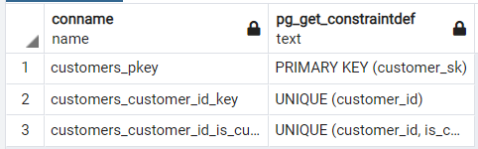

ALTER TABLE customers
DROP CONSTRAINT customers_customer_id_key;
Run above command
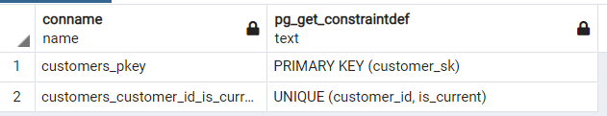

select customer_sk,customer_id,phone_no,effective_from,effective_to,is_current from customers
where customer_id='CUST_001'
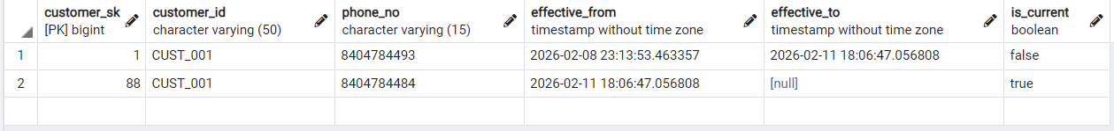

SELECT conname, pg_get_constraintdef(oid)
FROM pg_constraint
WHERE conrelid = 'products'::regclass;
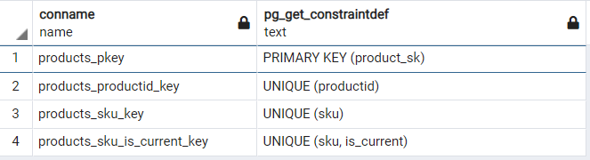
Better to keep constraint of uniqueness on sku as ideally this will be different in most cases. Productid can also be added to this and including both will be higher performance cost, join cost,generally not sure if this can be unique.
ALTER TABLE products DROP CONSTRAINT products_productid_key;
ALTER TABLE products DROP CONSTRAINT products_sku_key;
SELECT conname, pg_get_constraintdef(oid)
FROM pg_constraint
WHERE conrelid = 'products'::regclass;
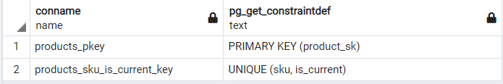
select product_sk,productid,sku,color,effective_from,effective_to,is_current from products
where productid='PROD_00001'
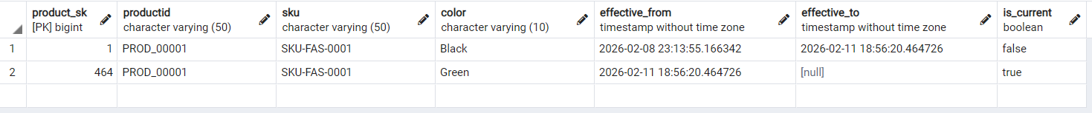

2nd Time Run - Unit test Case,
CUST_005: leena_kant_7812@gmail.com
CUST_021 : First Name: Jackie

select customer_sk,customer_id,email_id,effective_from,effective_to,is_current from customers
where customer_id='CUST_005'

select customer_sk,customer_id,first_name,effective_from,effective_to,is_current from customers
where customer_id='CUST_021'

SKU-FAS-0087, PROD_00087: 25, discount
Failed

3rd Time Run - Unit Test Case
Fresh load
select * from etl_audit
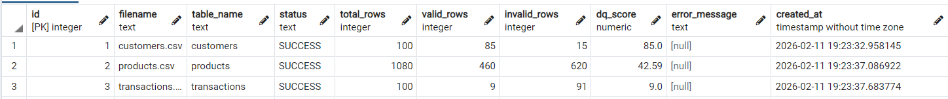
Change data
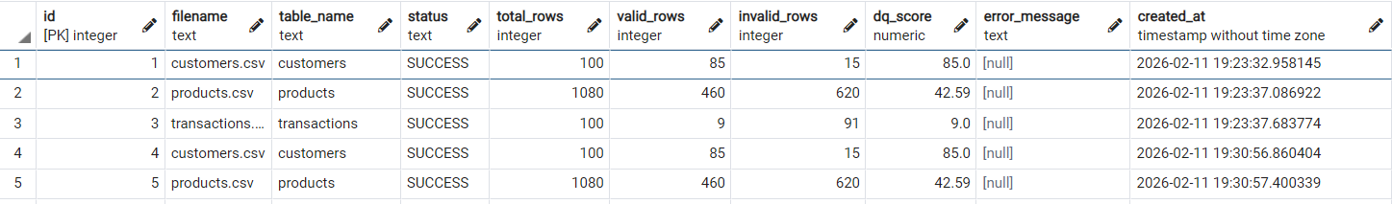
CUST_012 : Age: 35, Income: 10 - 15L
CUST_098: Address_Line1 : Hennur, Bagalur Road – Business rule validation failed
Products
SKU-FAS-0087, PROD_00087: Discount: 25
select product_sk,productid,sku,discount,effective_from,effective_to,is_current from products
where productid='PROD_00087'

Re-run Same Files (Idempotency Check) - Not adding more rows of the same files

select * from etl_audit
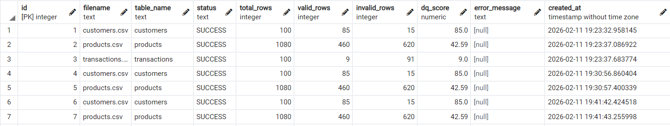
SELECT customer_id, COUNT(*)
FROM customers
GROUP BY customer_id
order by customer_id
Only showing more than 1 count where the data is changed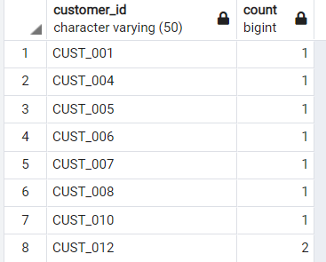

Test 4 — Non-tracked Column Change (Important) – Worked fine, no inserts on non tracked cols

Change a column not in tracked_columns.

Expected

✔ No new row inserted
✔ No expiration
✔ Still one row

👉 Confirms tracked vs non-tracked logic

CUST_006: Customer_Type: Existing to New

Re-runs /Idempotent – Unit Test cases
1st – Fresh Load : Passed
Customers, products, transactions
2nd – Re run all csvs: Passed
No duplicates found in tables and no transaction id errors
3rd – Change a value in a row in customer and Products table
CUST_050: Employment_Status: Self-Employed
select customer_id,customer_sk,employment_status,effective_from,effective_to,is_current from customers where customer_id='CUST_050'
PROD_00200 , SKU-FAS-0200: Product_Description: Very comfortable
select productid,sku,product_description,effective_from,effective_to,is_current
from products
where productid='PROD_00200'

4th – Add 1 row in Customers csv: Passed
select * from etl_file_metadata
