## horizontal line



SCORE Project: DRisk  
A Dynamically Configurable Risk Game  
- Requirement Document -

10.17.2015

**M**eng-Jung Lin  
**A**nant Srivastava  
**S**hujian Ke  
**C**haoyi Fu  
**S**atyam Jaiswal

**Table of Content**

Executive Summary

Project Requirements

Functionality Requirements

Usability Requirements

Reliability Requirements

Performance Requirements

Supportability

Constraints

Project Schedule

Gantt Chart

Tasks & Milestones

# Executive Summary

*SCORE Project: DRisk - A Dynamically Configurable Risk Game -* (DRisk) is a project built by Team MASCS, a group of students from Arizona State University. DRisk is one of the project topics of the 2016 SCORE Contest, which is a student contest on software engineering held every year. The DRisk project is sponsored by Nazareno Aguirre.

Risk is a popular strategy board game designed and created in the late 1950s. Risk is a turn-based board game that allows two to six players to fight over conquering forty two territories. Because of its popularity, and with the technology growing at a rapid pace in the recents years, there have been several PC version of Risk game release to the public, including web versions.

Risk is a strategy game. There are many rules set in stone in the manual. With the current official set up, the playing time of the Risk game can be very lengthy, and can be challenging for some first-time players. There are a couple of simple versions of the risk game, but the rules and game play are still immutable.

The ultimate goal of this project is to create a dynamic Risk game (D stands for Dynamic in DRisk). Team MASCS has created a web-based dynamic Risk game that allows the users to configure some variables within the game. With this setting, we are giving the user more control on how the games is setup and on the playing time of the game, we also think that this can help the first-time players learn the game in a simpler version before going on to a complex full version of the game.

# Project Requirements

Since DRisk is a contest project topic, there are some set requirements that the team has to follow when building the project.

Original project description and requirements can be found on the official SCORE project website (<http://score-contest.org/2016/projects/drisk.php>)

Note that ID is subject to change as the lists grow

## Functionality Requirements

|  |  |  |  |
| --- | --- | --- | --- |
| **CATEGORY** | **ID** | **PRIORITY** | **DESCRIPTION** |
| **FEATURE SET** | F01 | 1 | The project implements all core functionalities of the standard version of Risk game. |
| F02 | 1 | The project is a Risk game to be played through a web site. |
| F03 | 1 | The game allows 2-6 player to play. |
| F04 | 1 | The game has a preloaded, 42-territory map. |
| F05 | 1 | The game allows user to define and upload map configuration: image (aesthetic aspects) |
| F06 | 1 | The game allows user to define and upload map configuration: number of territories |
| F07 | 1 | The game allows user to define and upload map configuration: grouping into continents |
| F08 | 1 | The game allows user to define and upload map configuration: neighbor relations |
| F09 | 3 | The game allows user to define and upload map configuration: number of players |
| F10 | 1 | The game allows for maps to automatically adjust granularity by collapsing neighboring territories according to number of players |
| F11 | 1 | The game allows the user to select complexity of the game (easy, medium, hard) |
| **Security** | F12 | 1 | User will not be able to access the server |

## Usability Requirements

|  |  |  |  |
| --- | --- | --- | --- |
| **CATEGORY** | **ID** | **PRIORITY** | **DESCRIPTION** |
| **HUMAN FACTORS** | U01 | 1 | The game runs on Internet Explorer. |
| U02 | 1 | The game runs on Chrome. |
| U03 | 1 | The game runs on Firefox. |
| U04 | 5 | User can access the mobile version of the webpage through mobile devices. |
| **AESTHETIC** | U05 | 3 | The game contains an elegant interface to make it easy for user to navigate around. |
| **CONSIS- TENCY** | U06 | 3 | Information of each new game will be stored in the database in the same format |
| U07 | 3 | All code follows the same coding standards for easy understanding and maintenance. |

## Reliability Requirements

|  |  |  |  |
| --- | --- | --- | --- |
| **CATEGORY** | **ID** | **PRIORITY** | **DESCRIPTION** |
| **PREDICTA-BILITY** | R01 | 2 | Server will restart itself if it crashes. |
| R02 | 1 | Entering a URl will take the user to the correct page and load the correct game instance. |
| R03 | 2 | The web site work the same way in IE8, Chrome 46, and Firefox 41 |
| **ACCU- RACY** | R04 | 4 | HTTPS will be supported for users who wish to use it. |
| R05 | 1 | Information for each game is accurate. |
| **RECOVER-ABILITY** | R06 | 2 | When user enters a wrong URL or click on a broken link, a 404 page is displayed. |

## Performance Requirements

|  |  |  |  |
| --- | --- | --- | --- |
| **CATEGORY** | **ID** | **PRIORITY** | **DESCRIPTION** |
| **RESOURCE CONSUMPTION** | P01 | 2 | Database storage does not exceed 30 GB. |
| P02 | 2 | Website handles 1,000 games at the same time. |
| P03 | 4 | Server downtime does not exceed an hour per week. |
| **RESPONSE TIME** | P04 | 4 | Game page loaded within 5 seconds after starting new game or join existing game. |
| P05 | 1 | Web pages loaded under 10 seconds even under slow connection |

## Supportability

|  |  |  |  |
| --- | --- | --- | --- |
| **CATEGORY** | **ID** | **PRIORITY** | **DESCRIPTION** |
| **TESTA- BILITY** | S01 | 2 | Controllability: Possible to control the state of component under test as required for testing. |
| S02 | 2 | Observability: Testers are able to observe intermediate and final result. |
| S03 | 4 | Understandability: Component under test are documented or self-explaining. |
| **EXTENCI- BILITY** | S04 | 3 | New features are easily implemented without breaking or changing other parts of the program |
| **MAINTAIN-ABILITY** | S05 | 3 | Future maintenance is easy. |
| **EASE OF INSTAL** | S06 | 2 | User is able to access the website using any browser |

## Constraints

|  |  |  |  |
| --- | --- | --- | --- |
| **CATEGORY** | **ID** | **PRIORITY** | **DESCRIPTION** |
| **DESIGN** | C01 | 2 | Object-oriented design/language is used. |
| C02 | 3 | Information displayed on the website is handled by OO database model. |
| C03 | 4 | Development period is one semester |
| **IMPLEMENTATION** | C04 | 1 | Use PHP and Java as web programming languages |
| C05 | 1 | Use Amazon AWS as the server |
| C06 | 2 | The database is MySQL |
| **INTER- FACE** | C07 | 3 | The website is fully functional using IE, Chrome, and Firefox. |
| **PHYSICAL** | C08 | 2 | The website is accessible using PCs, smartphones, and tablets. |

# Project Schedule

## Gantt Chart

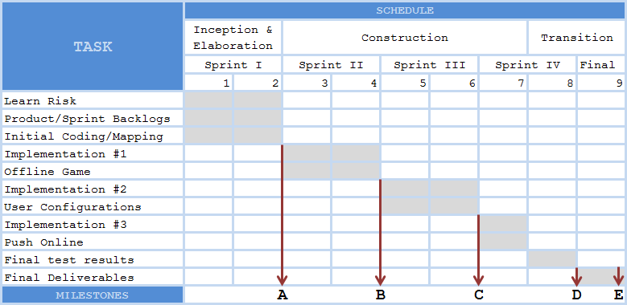

## Tasks & Milestones

