**Finance 501**

**Problem set 5**

1. You manage a company with 8.5 million shares of common stock outstanding, 250,000 shares of preferred stock outstanding, and 135,000 bonds outstanding. The preferred stock has a 5 percent dividend yield, while the bonds offer a 7.5 percent coupon, semiannual payments, and a $1000 face value. The common stock currently sells for $34 per share and has a beta of 1.25, the preferred stock currently sells for $91 per share, and the bonds have 15 years to maturity and sell for 114 percent of par value. The market risk premium is 7.5 percent, T-bills are yielding 4 percent, and the company tax rate is 35 percent.

Given,

Number of Common stocks = 8500000

Number of Preferred Stocks = 250000

Number of Bonds = 135000

Stocks dividend yield = 5%

Bonds coupon rate = 7.5%

Bonds face value = 1000$

Present Value of Common Stocks = 34$

Present Value of Preferred Stocks = 91$

Present Value of Bonds = 1140$

Beta = 1.25

Market risk premium = 7.5%

Company tax rate = 35%

a.What are capital structure weights for the debt (D), equity (E), and preferred stock (P) in the company?

Debt (D) = Number of outstanding bonds * Present Value of Bonds

Therefore, debt = 135000 * 1140

D = 153,900,000$

Equity (E) = Number of Common Stocks * Present Value of Common Stocks

Therefore, Equity = 8500000 * 34

E = 289,000,000$

Preferred Stock (P) = Number of Preferred Stocks * Present Value of Preferred Stocks

Therefore, Preferred Stock = 250000 * 91

P = $22,750,000

V= D+E+P

= $ 465650000

**Weights**

**D/V = 0.330505745**

**P/V = 0.048856437**

**E/V = 0.620637818**

b.If you are evaluating a new investment project that has the same risk as the firm’s typical project, what rate should you use to discount the project’s projected cash flows?

Computing, Cost of Equity:

We know, Cost of Equity (Re) = Rf + β (Rm)

Therefore, Cost of Equity = 0.04 + 1.25 ( 1.25 * 0.075)

CoE = 0.13375

Computing Cost of Debt:

We know Future Value = 1000$

PMT = ( Future Value * Coupon rate ) / 2

Therefore, PMT = 37.5$

Since Semi- Annually, Time = 15 *2 = 30

By using Calculator, I/Y = 3.0327

We know rD =3.0327 (2) = 6.0654

After tax Cost of Debt = rD ( 1 – Tc )

Therefore, After tax CoD = (1 - 0.35) * (0.060654)

= 0.0394251

Finally WACC = (E/v)*(CoE) +(D/V)*(After tax CoD)+(p/v)*(DY)

= (0.620637818 * 0.13375 ) + ( 0.330505745 * 0.0394251 ) + (0.048856437 * 0.05)

= **9.85%**

c.If you are evaluating a new investment project that has the same risk as a portfolio of financial assets equally divided between a stock market index fund and T-bills, what rate should you use to discount the project’s projected cash flows?

Effective β = [ 0.5 (1.25) + 0.5 (0) ]

Therefore, β = 0.625

We know, E(r) = Rf + β (Rm – Rf)

= 0.086875

= **8.6875%**

d.If you are evaluating a new investment project that has twice as much systematic risk as a portfolio of financial assets invested entirely in a stock market index fund, what rate should you use to discount the project’s projected cash flows?

Since systematic risk is twice. β = 2*1.25

We know, E(r) = Rf + β (Rm – Rf)

= 0.04 + ( 1.25 * 0.075 )

Therefore, E(r) = **22.75%**

2. You are hired as a consultant for Ginka Technology Corp (GTC), a start-up company trying to decide whether to produce a new line of semiconductors. The company plans to produce the semiconductors on some land it bought three years ago at a cost of $1.4 million in anticipation of using it to build a storage facility. The company believes it can sell the land right now for $1.5 million after taxes, or for $1.6 million after taxes if it sells the land in four years. The company also just hired Agarwal Marketing to study the semiconductor market, at a cost of $125,000. The study arrived at the following main conclusions:

• The semiconductor market will grow rapidly over the next four years, but then market conditions will deteriorate considerably.

• If GTC prices the semiconductors aggressively, at $650 each, they should be able to sell 3,800, 4,700, 5,300, and 4,200 units each of the next four years, respectively.

• Given expected market conditions, GTC should abandon the semiconductor market at the end of the four year period.

GTC estimates that fixed costs for the project will be $425,000 per year, while variable costs will be 15 percent of total sales. The equipment necessary before GTC can begin production will cost $3.5 million and will be depreciated according to a 3-yr MACRS schedule, where the applicable deprecation percentages on the 3-year schedule are: 33.33% (year 1), 44.45% (year 2), 14.81% (year 3), 7.41% (year 4). At the end of the project, the equipment can be scrapped for $400,000. Net working capital of $125,000 will be required immediately, but is recoverable at the conclusion of the project. GTC has a 38 percent tax rate, and the required return on the project is 13 percent.

Given,

Cost before 3 years = 1,400,000$

Present Selling price = 1,500,000$

Selling price in 4 years = 1,600,000$

Cost of Study = 125,000$

Therefore, Land = 1,500,000$

Cost for Study ( CS ) = 125,000$

Equipment Cost ( EC ) = 3,500,000$

1. Find the (exact) payback period for the project.

For calculating Actual payback

Step 1 : Calculating investments

Actual land cost =$1.4Million

Equipment Cost =$3.5Million

Market Study = $125000

Net Working Capital ( recoverable) =$125000

Total Investment = $5150000

Step 2 : Finding Cashflows

Cash flow = Sales – variable cost – Fixed cost – tax

Year 1 Cash flow =1481479

Year 2 Cash flow =1937670

Year 3 Cash flow = 1748988

Year 4 Cash flow = (Sales – variable cost – Fixed cost – tax) +NWC+ land Value = 3246763



Therefore, Exact payback period = **2.989 Years**

1. Find the (exact) discounted payback period for the project.

For calculating Actual payback

Step 1 : Calculating investments

Actual land cost + Equipment Cost+ Market Study+ Net Working Capital

Actual land cost =$1.5 Million (Present value of land)

Equipment Cost =$3.5Million

Market Study = $125000

Net Working Capital ( recoverable) =$125000

Total Investment = $5250000

Step 2 : Finding Cashflows

Cash flow = Present Value Actual cashflow = PV(Sales – variable cost – Fixed cost – tax)

Year 1 Cash flow =PV(1481479)

Year 2 Cash flow =PV(1937670)

Year 3 Cash flow = PV(1748988)

Year 4 Cash flow =PV( (Sales – variable cost – Fixed cost – tax) +NWC+ land Value) = PV(3246763)



Therefore, Exact Discounted Payback period = **3.607 Years**

c, d. Find the NPV & IRR for the project.

Step 1 Depreciation Calculation

Depreciation = Equipment cost * MACRS%

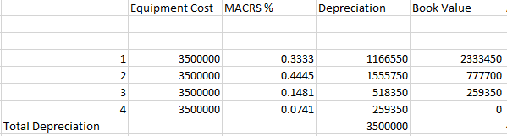

Where Book Value = Total Depreciation – Depreciation of that year

After Tax Salvage = Scrap value of Equipment – Tax%( Scrap value of Equipment-Book Value of year 4)

= 400000-0.38*(400000-0)

= $ 248000

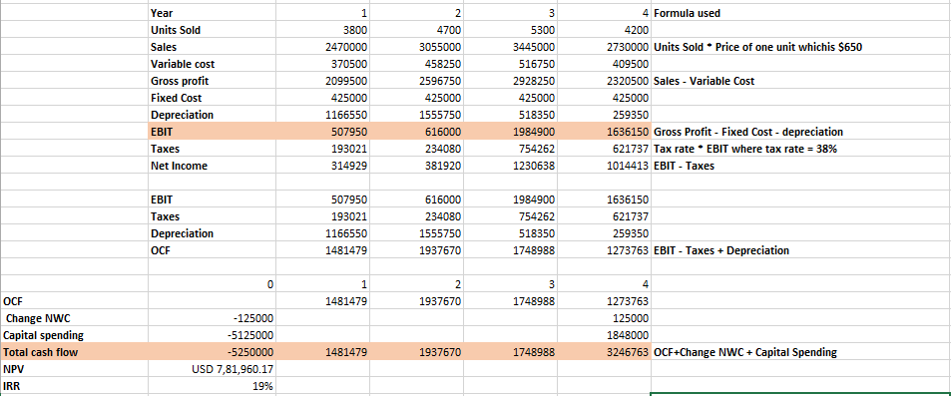

Where capital spending in Year 0 = Actual land cost + Equipment Cost+ Market Study = 1.5M + 3.5M+125000= $5125000

Capital Spending in Year 4 = After Tax Salvage + Land Value = 248000+1.6M= 1848000

Using Excel functions to compute IRR and NPV,

We get **IRR = 19% and NPV =$781960.17**

e. Explain to GTC why they should or should not produce the new line of semiconductors.

Thus, **they should invest** in this project as the IRR (19%) crosses the hurdle rate of 13% and NPV ($781960.17) is positive. Also the discounted payback period is within 4 years i.e 3.607 years.