**Matrices Sum Map Reducer**

Matrix sum is the operation of adding matrices by adding corresponding entries together.

**Entrywise sum**

The sum of two m × n matrices A and B, denoted by A + B, is again an m × n matrix computed by adding corresponding elements

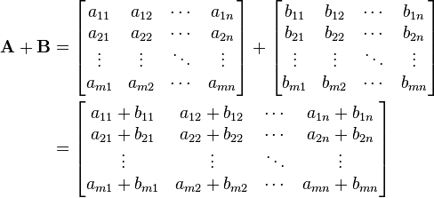

1. Mapper emits the row index as key and entire row as a value. If you have different types of matrices then create separate mappers to process/ filters the matrix.

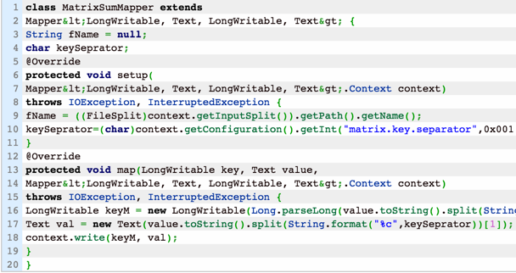

1. Reducer gets the row key as (m). Next split each value to generate (n) then add the values index and position wise.

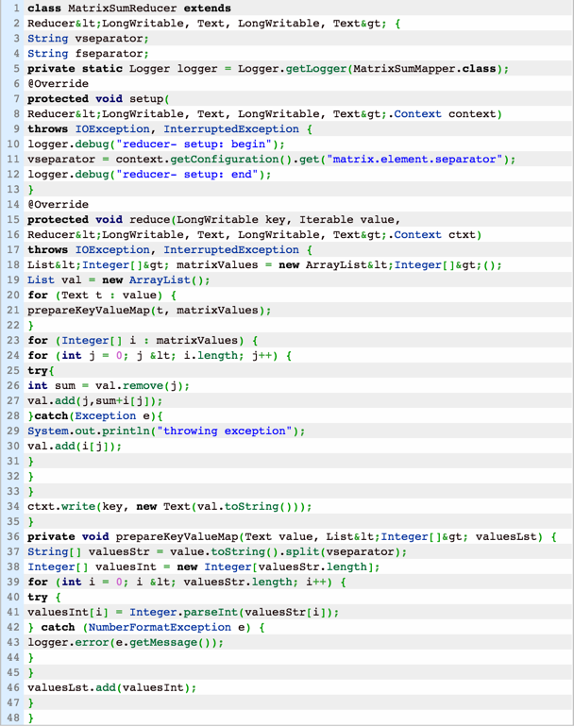

1. Driver Code

