**Question 1 :**Spark and Smartphone/Watch Application

Implement a smart application with big data analytics related to your project showing the collaboration between Spark and Smart Apps. Implement Twitter Streaming and perform word count on it and publish the results and showcase it in your Smart Phone/Watch Application.

**Description**: Here I implemented word count(hash count) on twitter streaming data and published the results on my smart phone. Here basically we have android client and spark server where data from spark is pushed on to android phone. The results on the android phone will be stopped only when we terminate spark process.The following are the screen shots

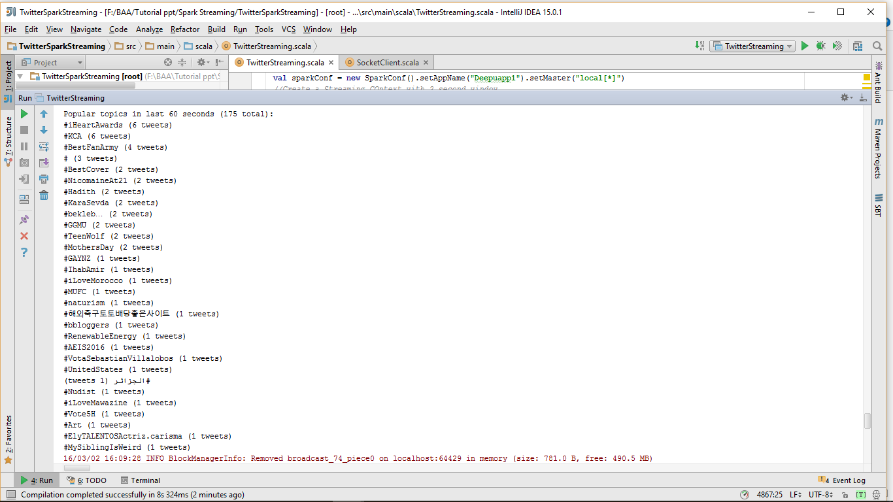

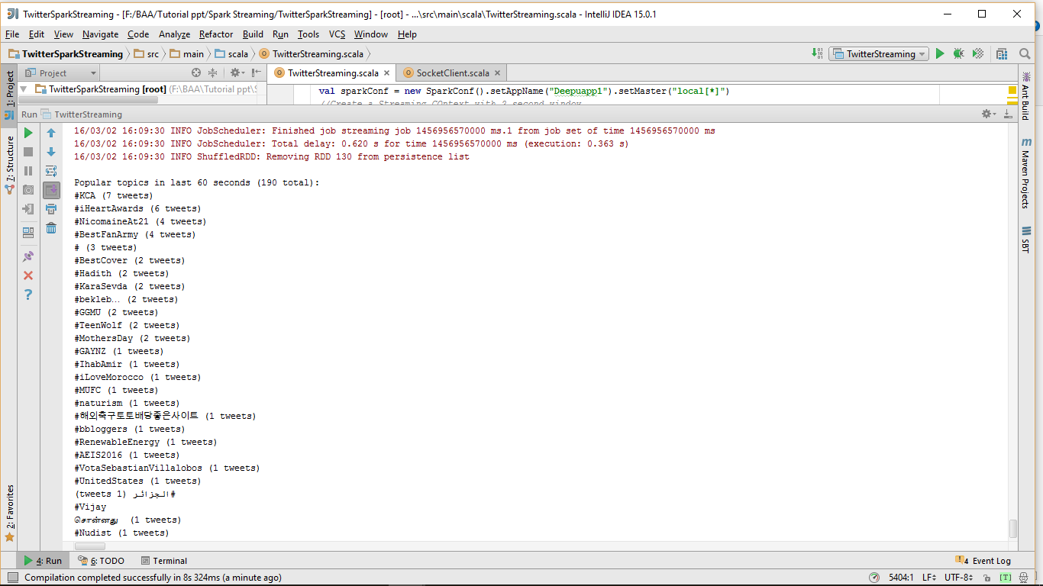

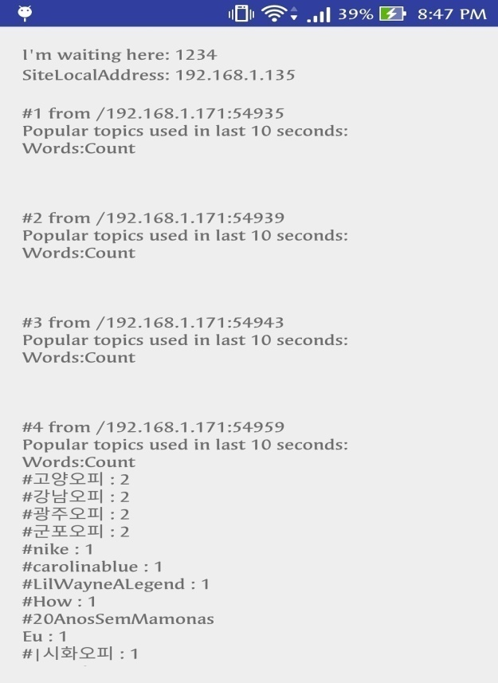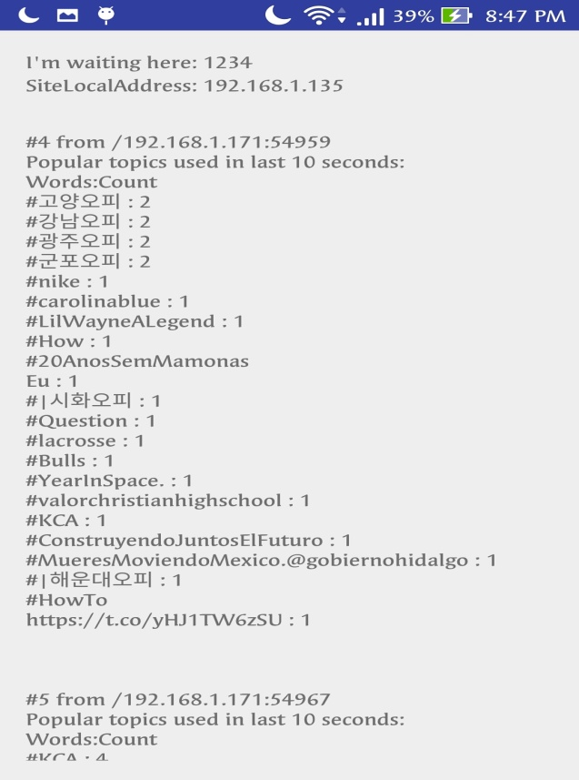

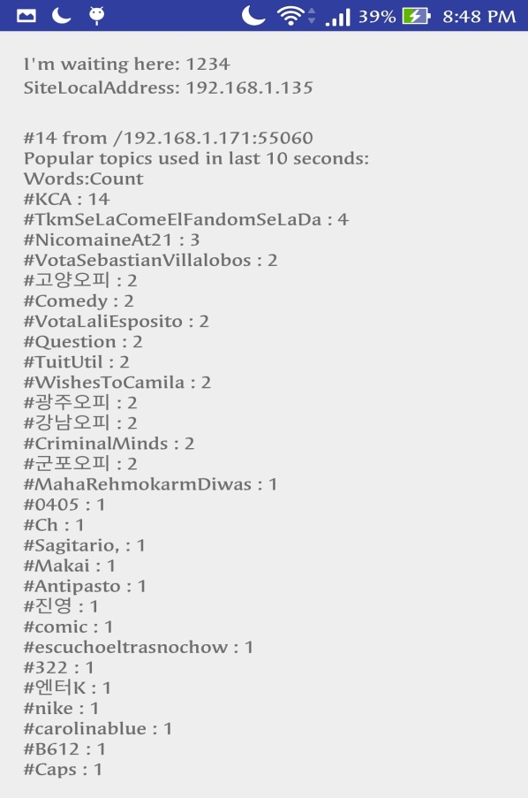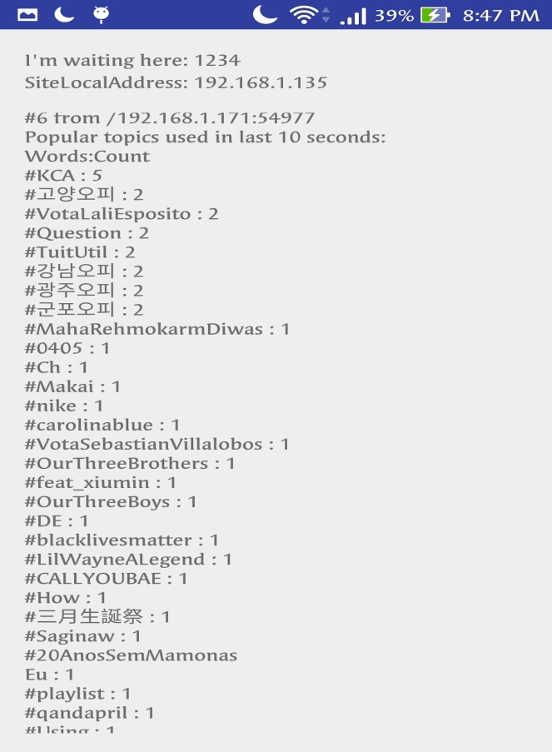

**Question 2:** Spark ML Lib Application

Perform a machine learning algorithm with the Twitter Streaming data to categorize each Tweet

1)Training datasets: Collect different categories of Tweets related to your project.(Categories can be based on HashTags /Subjects etc.)

2)Test data: The upcoming twitter stream

**Description**: we first classify the tweets based on hashtags like “Oscar”,”Trump”,”Music” etc into training folder. Now the upcoming stream is dumped into testing folder and prediction is made saying to which category hashtag it belongs to

**Screen Shots:**

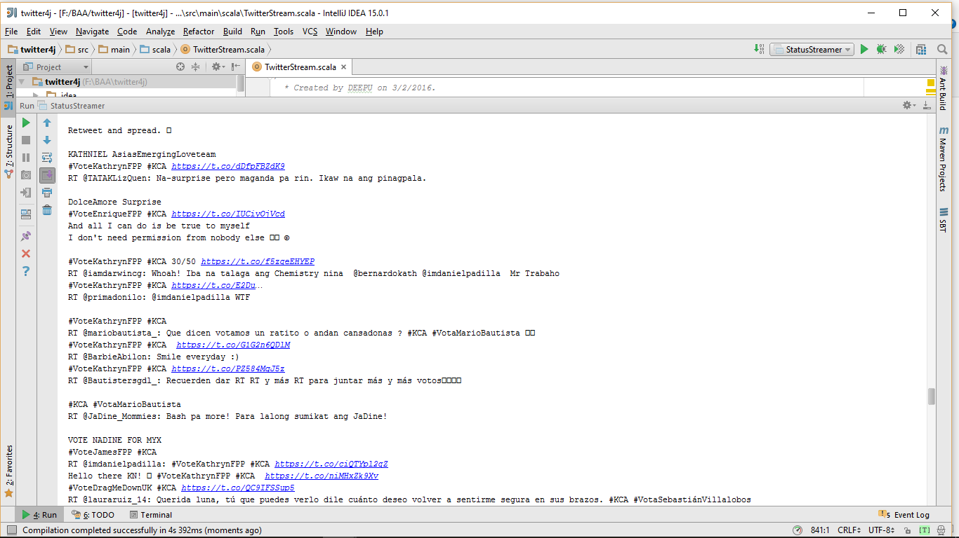

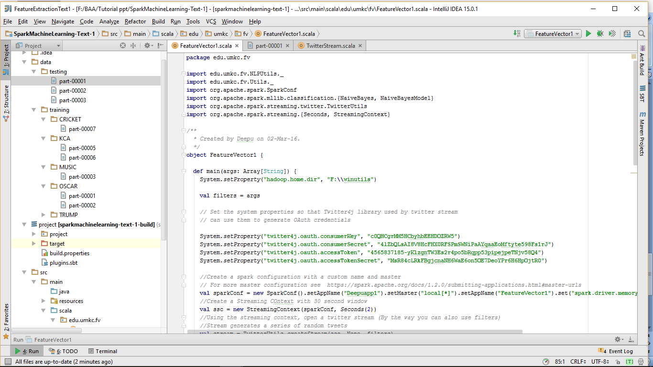

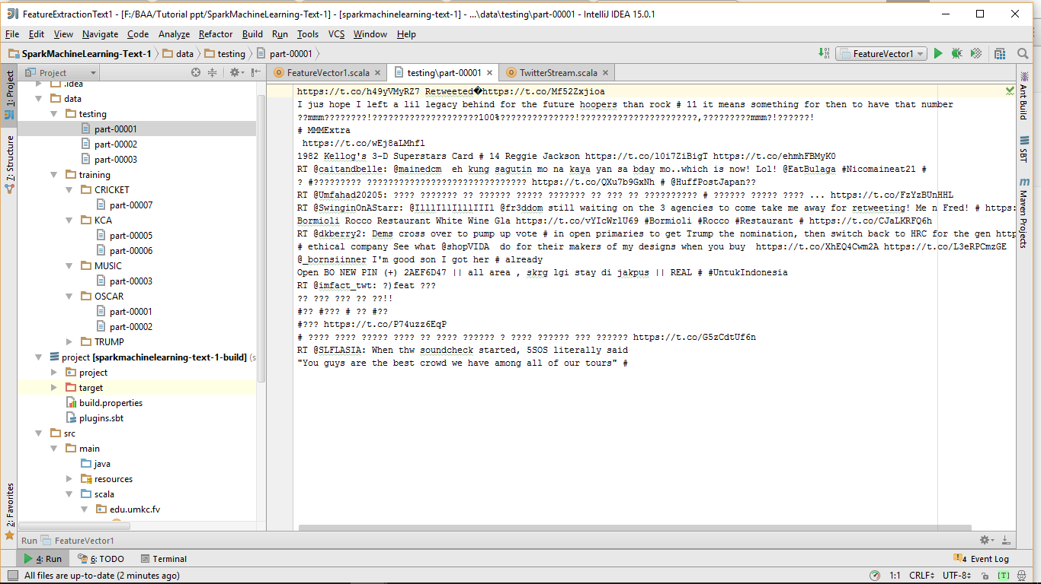

Processing data in test folder:stemming and lemmentation

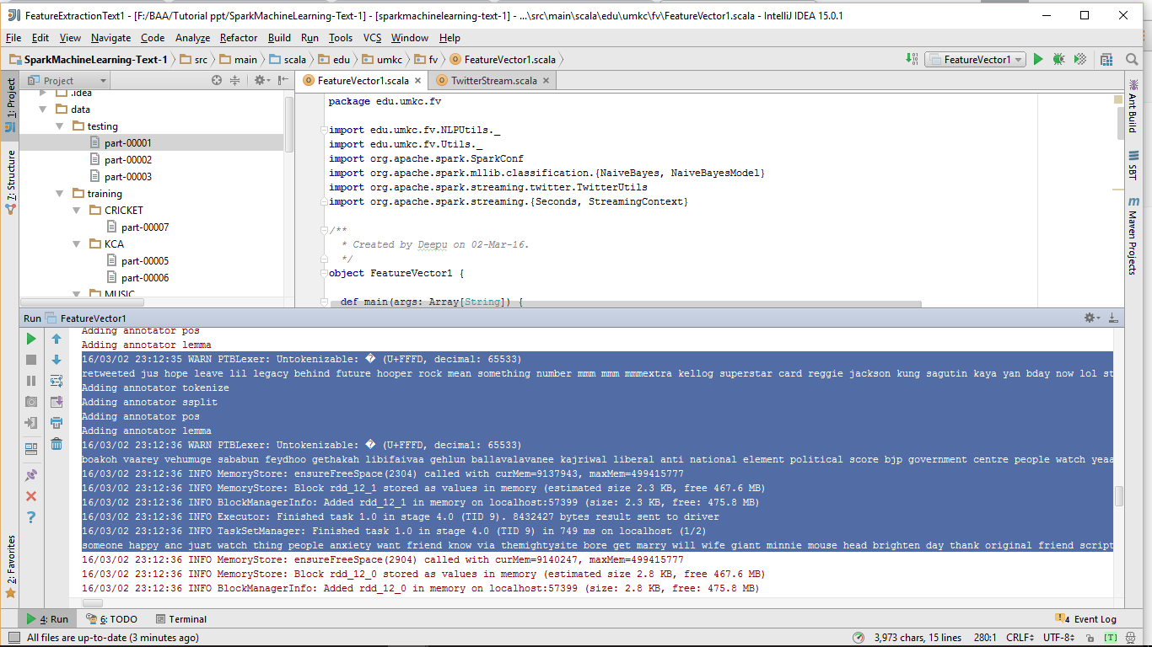

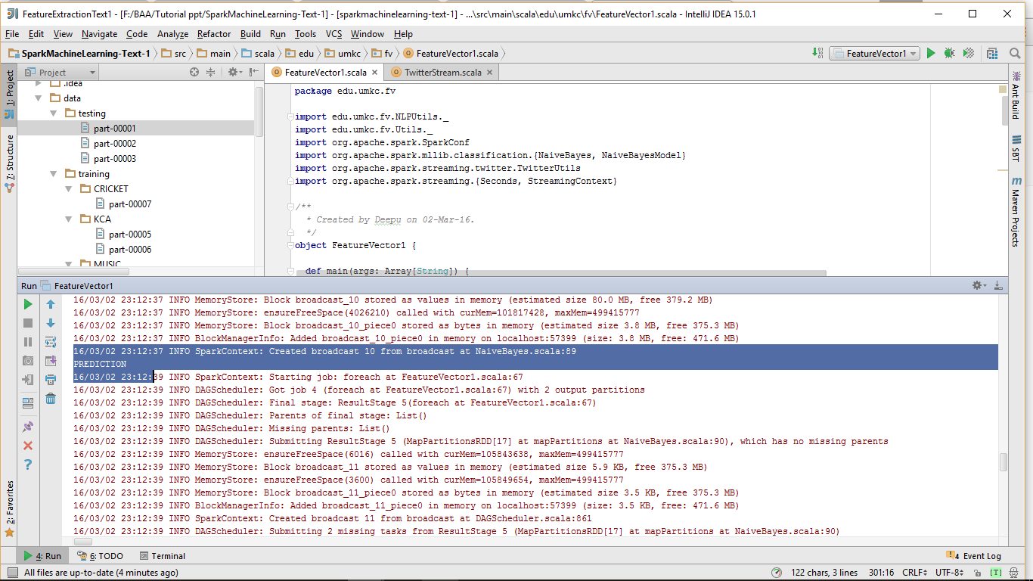

**Predicted results:**

