Lab Assignment 7

**Question 1-**

Sentimental analysis using twitter streaming

**Description**:

I added TwitterSentimentMain.scala to the existing project SentimentAnalysisCoreNLP given in tutorial 7. This will stream data from twitter and classify sentiment into either positive or negative.

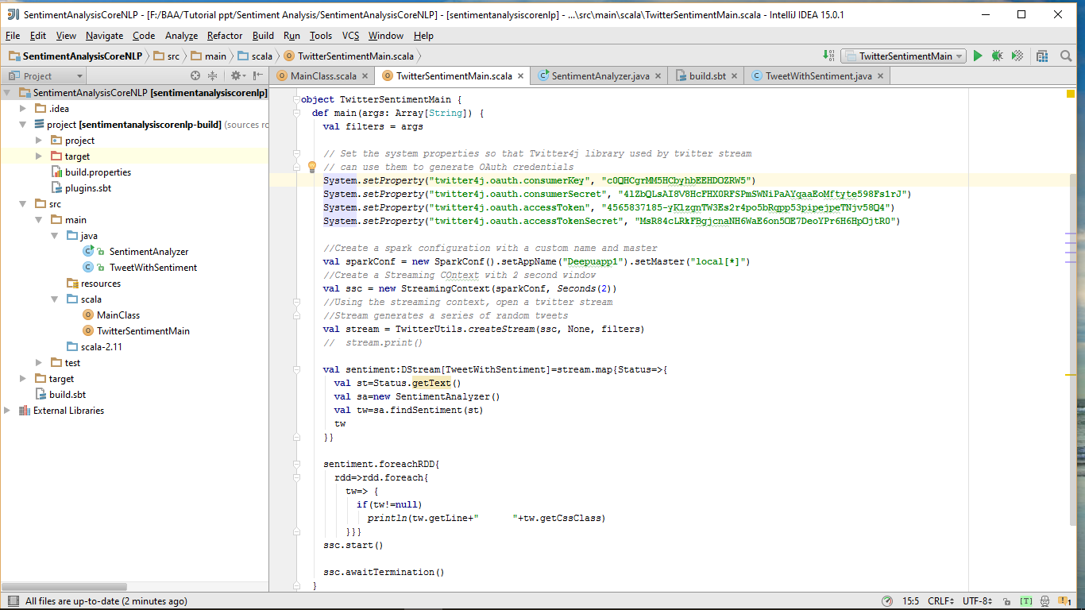

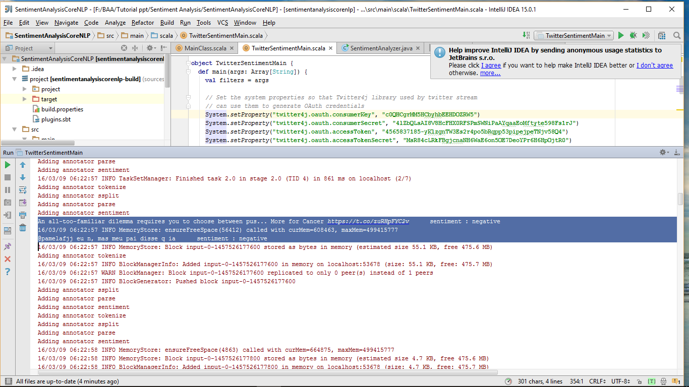

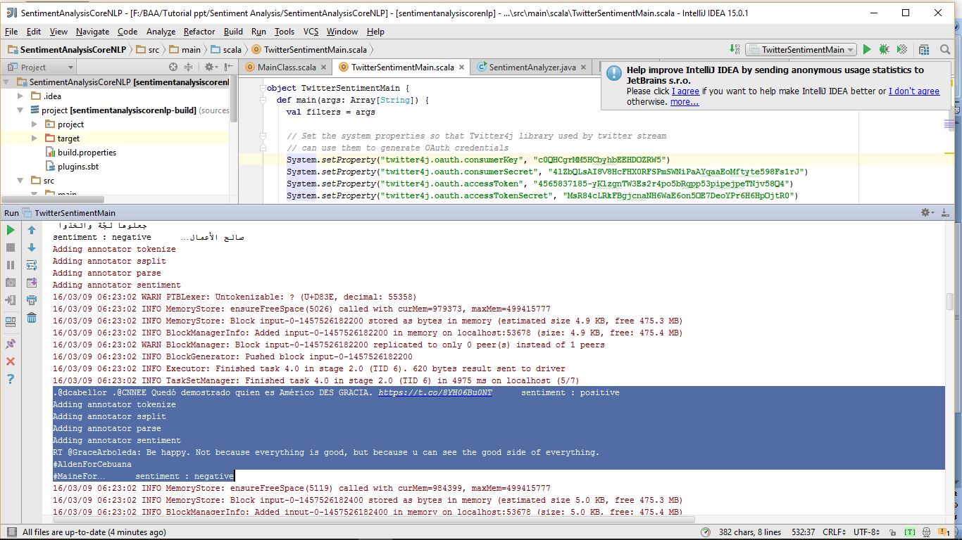

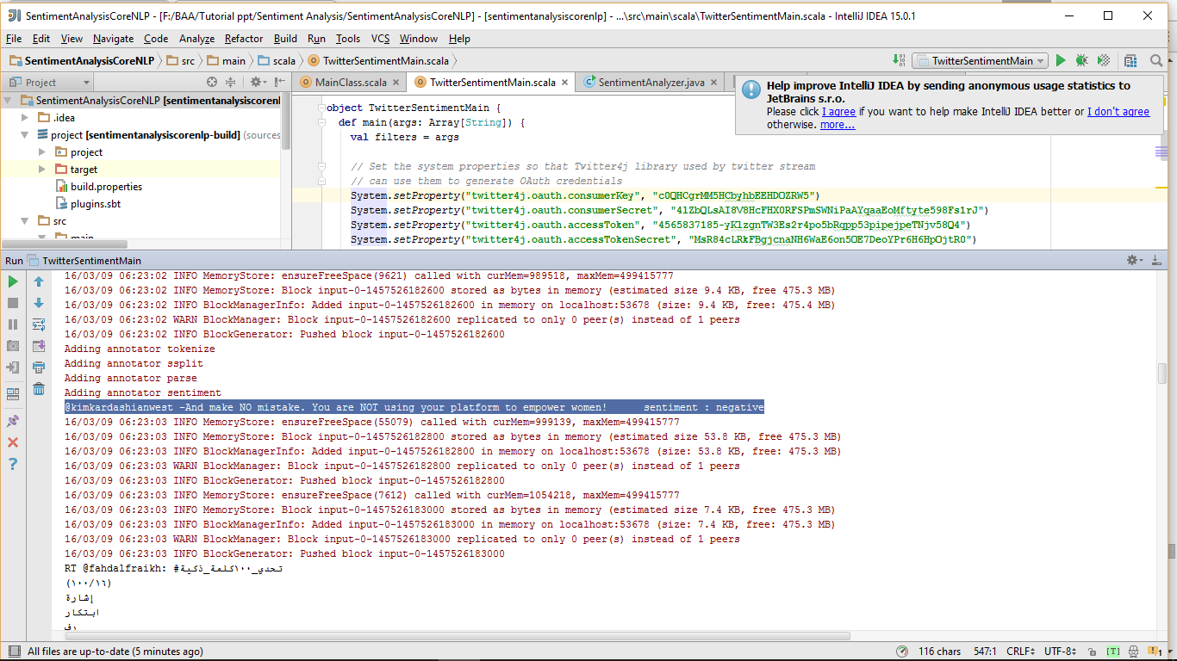

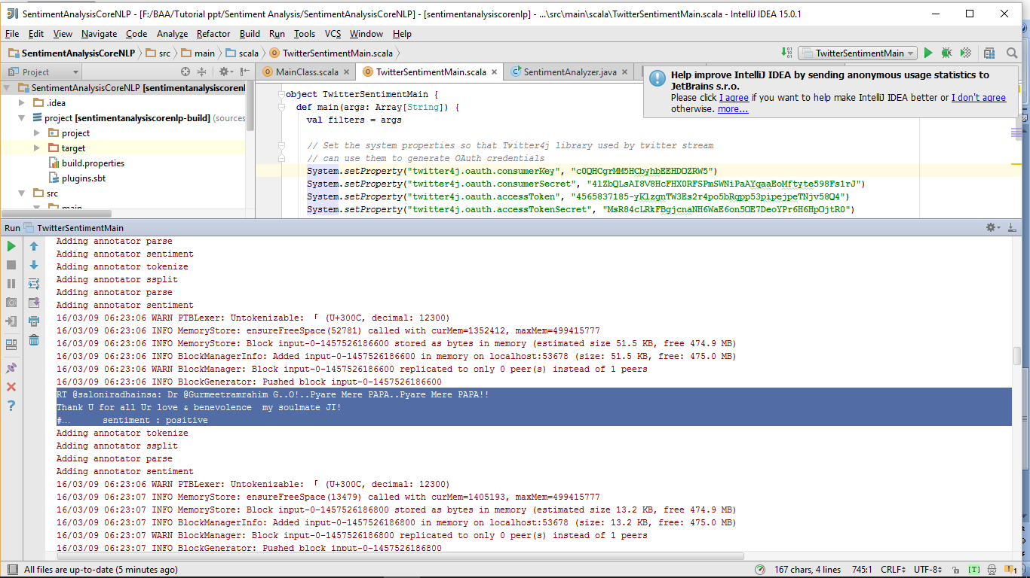

**Question-2**

**Make Recommendation(Related to your Project)**

**Description:**

In this section, I used the SparkMovieRecommendation.scala code to recommend the best places to buy his furniture(FurnitureMalls) to the user. Using 25 handpicked FurnitureMalls, the model recommends top 5 FurnitureMalls based on user preference.

This Screen shot shows the iterations of training:

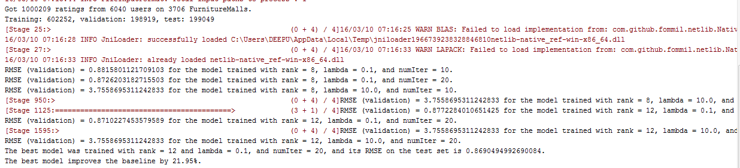

This Screenshot shows the FurnitureMalls recommended to you:

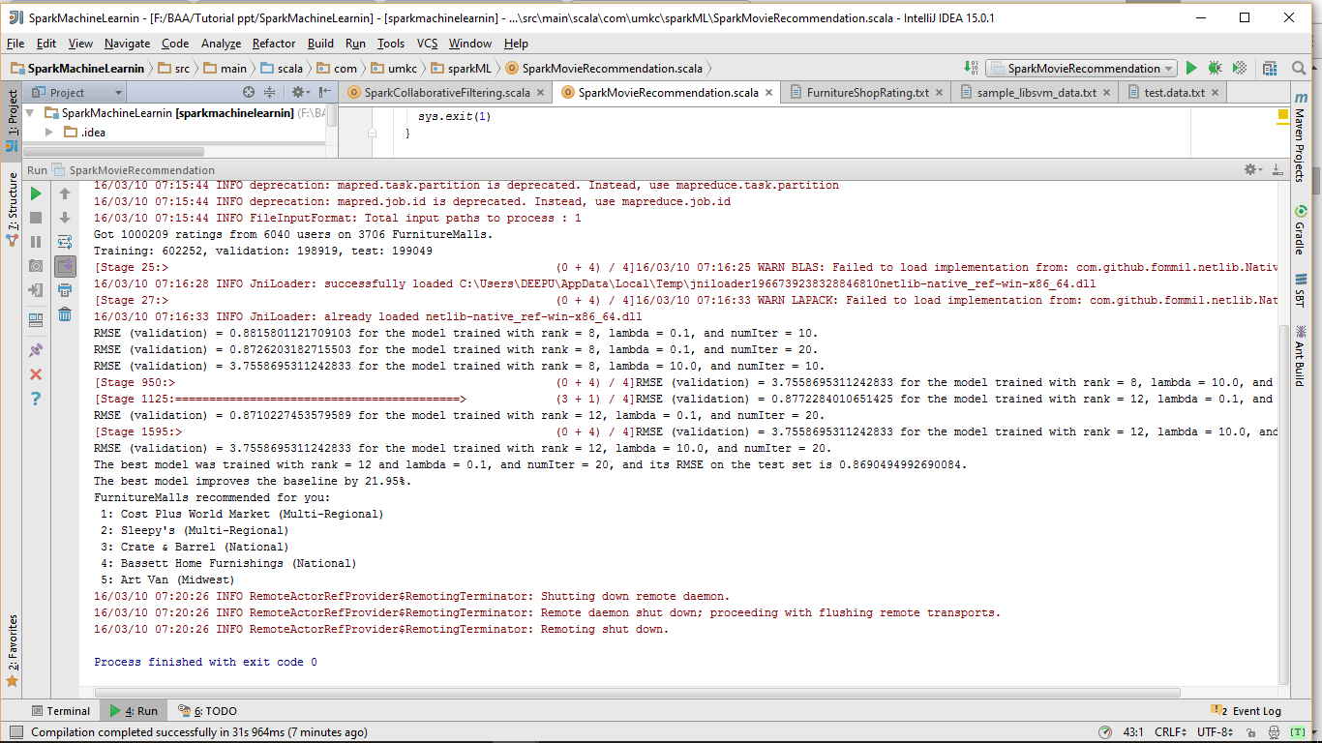

**Question 3**

**Recommendation through smartphone:**

**Description:**

Now the goal is to send the recommendations of the user to his smart phone. So I have taken this recommendation output above and sent it as a notification to smart phone.

Here is the Screenshot:

