Keywords for Google Trends Analytics

# COVID-19

In the United States, the most commonly searched topics related to COVID-19 were **transmission, clinical signs and symptoms, and activity modification** [[Reference](https://www.ncbi.nlm.nih.gov/pmc/articles/PMC7685696/)]

Pandemic -> Endemic

A [great visualization example](https://searchingcovid19.com) for covid-related search analytics.

## Clinical Symptoms

Cough/dry cough

Fever

Headache

Vomit/Puking/nausea

Giddiness

Diarrhoea

Chills

breathing difficulty/ shortness of breath

Fatigue

Muscle ache

Body ache

Loss of taste

Loss of smell

Sore throat

congestion/running nose/common cold

Chest pain

Nose irritation

Itching

Covid toe

Anxiety

infection

## Prevention

vaccine/vaccination

Pfizer

Johnson & johnson

Moderna

side effects

sanitation/sanitizer

Disinfectant wipes

Testing for covid

Home test/self-test at home

Rtpcr

Antigen testing

Face mask/N95

Face shield [[Spikes](https://trends.google.com/trends/story/US_cu_4Rjdh3ABAABMHM_en) in early March 2023]

Cloth face mask

PPE

Pandemic preparedness kit (close to +3200%)

## Transmission

Variants

Omicron

Delta

Sneeze

Quarantine

## Treatment

Tylenol

Cough suppressant

Antibiotics

Cough syrup

Pandemic relief fund

## Economy

Stimulus Check

Unemployment fund

National emergency

Stafford act

## How things changed?

1. Poor mental health
2. Increased misinformation reduced trust, especially in information from public health agenies and medical officials
3. Great resignation
4. Remote work, online education
5. Supply Chain affected
6. Inflation
7. Unemployment

**Symptoms**

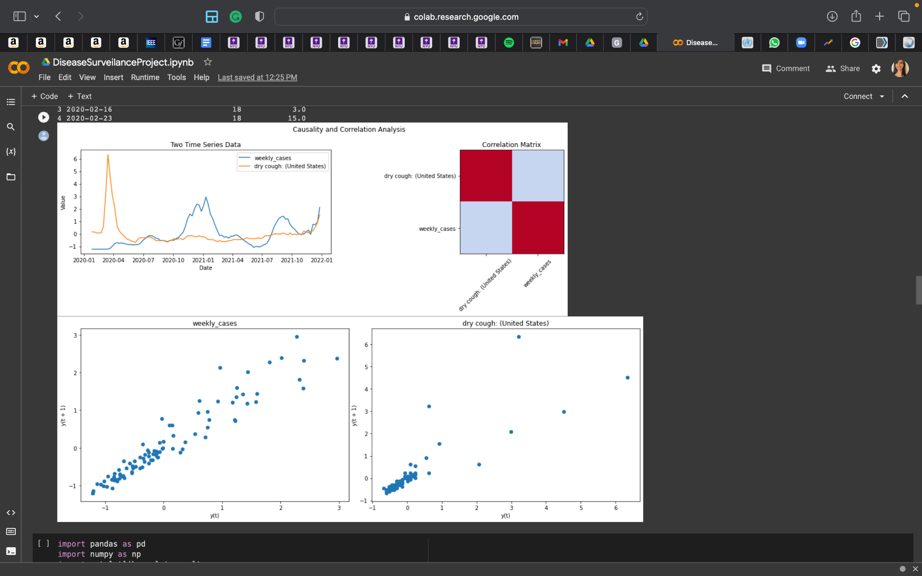

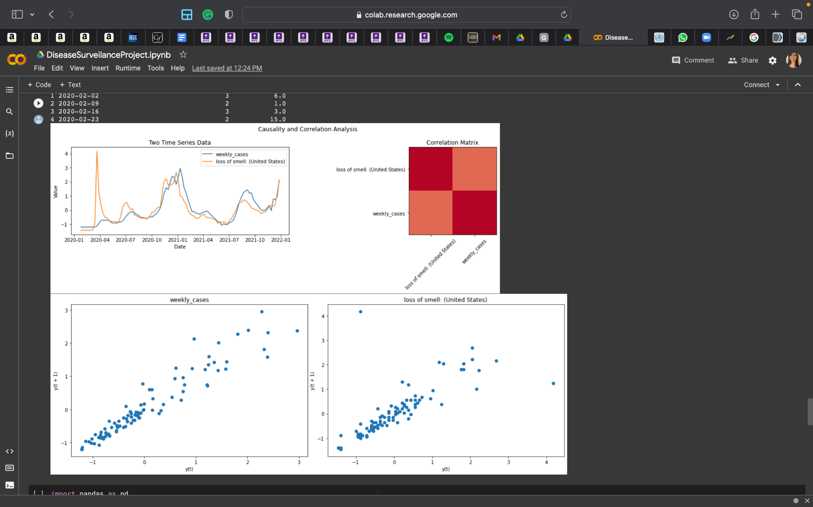

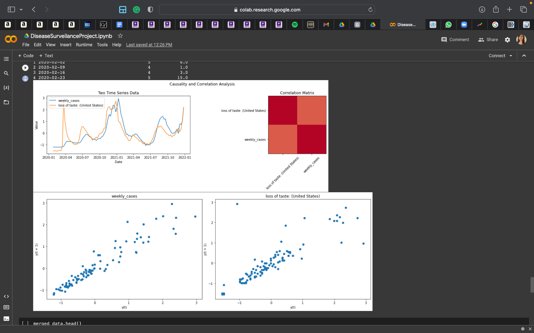

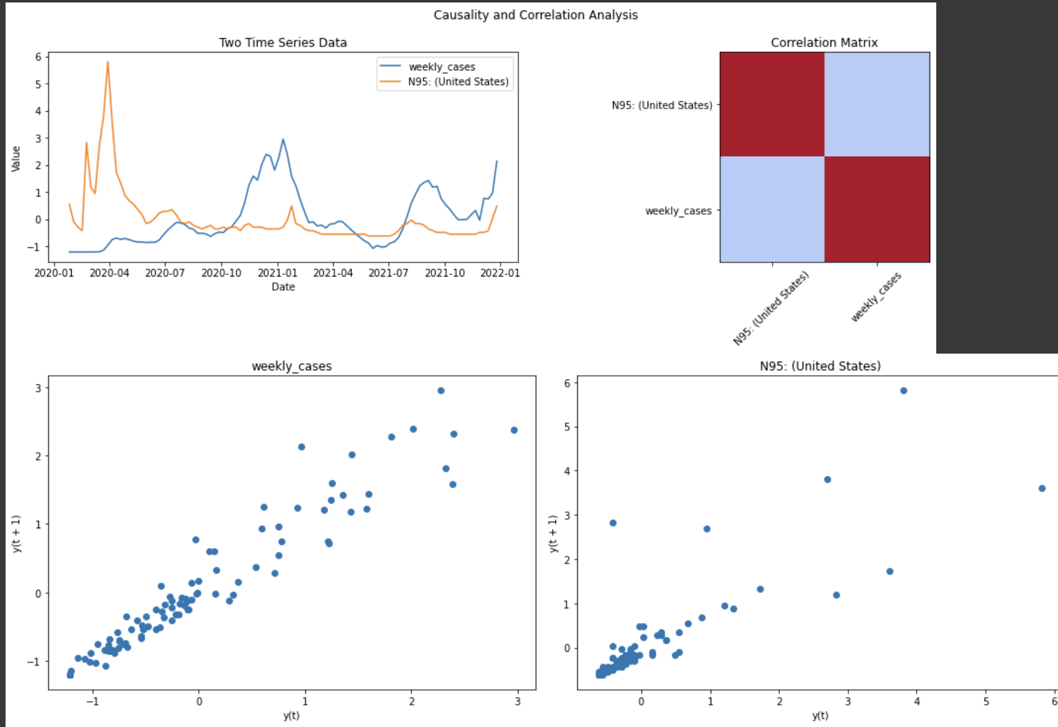

# Monkey Pox

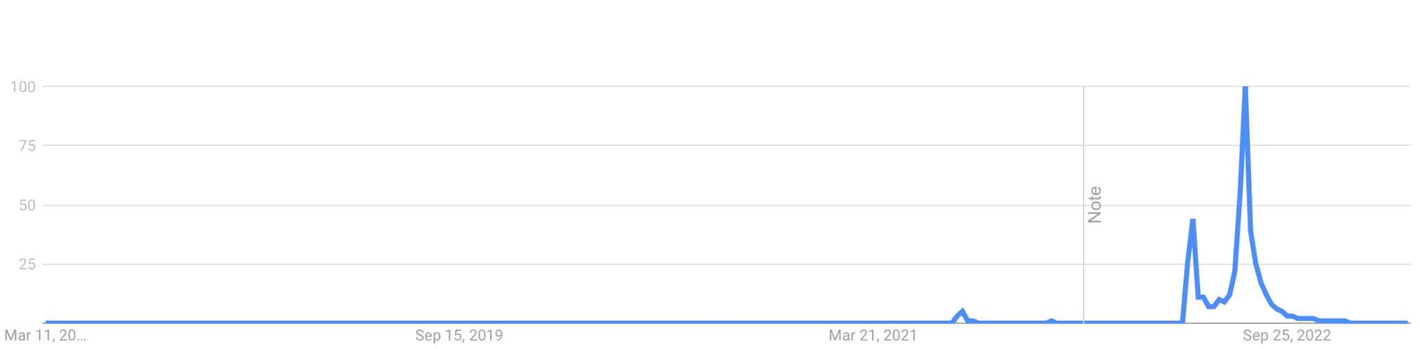

[[Reference](https://trends.google.com/trends/explore?date=today%205-y&geo=US&q=%2Fm%2F01k6yf)]

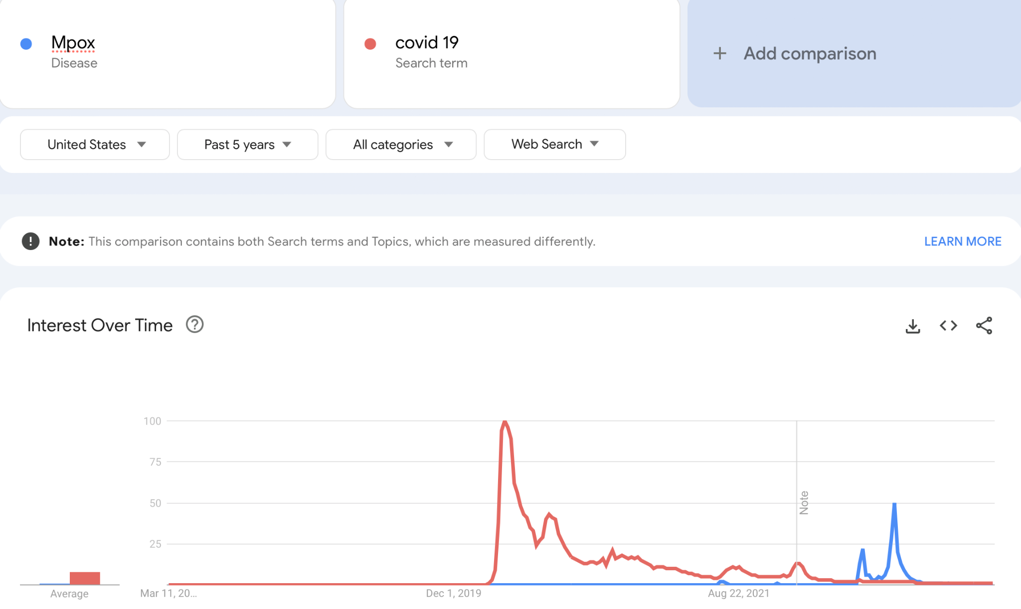

[[Reference](https://trends.google.com/trends/explore?date=today%205-y&geo=US&q=%2Fm%2F01k6yf,covid%2019)]

## Clinical Symptoms

Fever

Intense headache

*Swelling of lymph nodes* (distinctive for monkeypox)

Back pain

Muscle aches

Lack of energy

Skin eruption (within 1-3 days of appearance of fever)

Rash (on face and extremities)

## Prevention

Modified vaccinia Ankara

## Transmission

## Treatment

## Economy

## How things changed?

# Past: 2009 H1N1 Pandemic

# Zoonotic Diseases

<https://vis.csh.ac.at/sars-ani/>