Total Loan Application

select count(id) as Total_Loan_Applications from bank_loan_data



Month To Date(MTD)

select count(id) as Total_Loan_Applications from bank_loan_data

where Month(issue_date) = 12 AND year(issue_date) = 2021



Month over month(MOM)

select count(id) as PTotal_Loan_Applications from bank_loan_data

where Month(issue_date) = 11 AND year(issue_date) = 2021

(MTD-PMTD)/PMTD



Total Funded Amount

select sum(loan_amount) As Total_Funded_Amount From bank_loan_data



Month To Date(MTD)

select sum(loan_amount) As MTD_Total_Funded_Amount From bank_loan_data

where Month(issue_date) = 12 And Year(issue_date) = 2021



Month over month(MOM)

select sum(loan_amount) As PMTD_Total_Funded_Amount From bank_loan_data

where Month(issue_date) = 11 And Year(issue_date) = 2021



Total amount received

select sum(total_payment) As Total_Amount_received From bank_loan_data 

MTD Received

select sum(total_payment) As MTD_Total_Amount_received From bank_loan_data

where Month(issue_date) = 12 And Year(issue_date) = 2021



PMTD

select sum(total_payment) As PMTD_Total_Amount_received From bank_loan_data

where Month(issue_date) = 11 And Year(issue_date) = 2021



Avg Int Rate

select round(avg(int_rate), 4)*100 as Avgg_Interest_Rate From bank_loan_data



MTD

select round(avg(int_rate), 4)*100 as MTD_Avgg_Interest_Rate From bank_loan_data

where Month(issue_date) = 12 And Year(issue_date) = 2021



PMTD

select round(avg(int_rate), 4)*100 as PMTD_Avgg_Interest_Rate From bank_loan_data

where Month(issue_date) = 11 And Year(issue_date) = 2021



Avg DTI

select round(avg(dti), 4) *100 as Avg_DTI from bank_loan_data



MTD

select round(avg(dti), 4) *100 as MTD_Avg_DTI from bank_loan_data

where Month(issue_date) = 12 And Year(issue_date) = 2021



PMTD

select round(avg(dti), 4) *100 as PMTD_Avg_DTI from bank_loan_data

where Month(issue_date) = 11 And Year(issue_date) = 2021



Good Loan

select (Count(Case when loan_status = 'Fully Paid' Or loan_status = 'Current' Then id End) *100) / count(id) As Good_loan_percentage from bank_loan_data



Good loan Application

select count(id) as Good_Loan_Application From bank_loan_data where loan_status = 'Fully Paid' OR loan_status = 'Current'



Good_Loan_Funded_Amount

select sum(loan_amount) as Good_Loan_Funded_Amount From bank_loan_data where loan_status = 'Fully Paid' OR loan_status = 'Current'



Good_Loan_Received_Amount

select sum(total_payment) as Good_Loan_Received_Amount From bank_loan_data where loan_status = 'Fully Paid' OR loan_status = 'Current'



Bad Loan

select (Count(Case when loan_status = 'Charged Off' Then id End) *100) / count(id) As Bad_loan_percentage from bank_loan_data



Bad_Loan_Application

select count(id) as Bad_Loan_Application From bank_loan_data where loan_status = 'Charged Off'



Bad_Loan_Funded_Amount

select sum(loan_amount) as Bad_Loan_Funded_Amount From bank_loan_data where loan_status = 'Charged Off'



Bad_Loan_Received_Amount

select sum(total_payment) as Bad_Loan_Received_Amount From bank_loan_data where loan_status = 'Charged Off'



Loan Status

select loan_status,

count(id) as Total_Loan_applications,

sum(total_payment) as Total_Amount_Received,

sum(loan_amount) as Total_Funded_Amount,

avg(int_rate * 100) as Interest_Rate,

avg(dti*100) as DTI

From bank_loan_data

Group by loan_status



MTD Loan Status

SELECT

loan_status,

SUM(total_payment) AS MTD_Total_Amount_Received,

SUM(loan_amount) AS MTD_Total_Funded_Amount

FROM bank_loan_data

WHERE MONTH(issue_date) = 12

GROUP BY loan_status

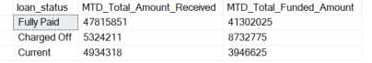

Monthly Total Application, Funded Amount, Received Amount

Select

Month(issue_date) As Month_Number,

DATENAME(MONTH, issue_date) AS Month_name,

count(id) as Total_Loan_Applications,

sum(loan_amount) As Total_Funded_Amount,

sum(total_payment) AS Total_Amount_Received

From bank_loan_data

Group by Month(issue_date), DATENAME(MONTH, issue_date)

Order by Month(issue_date) 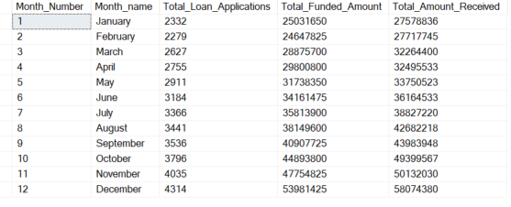

Regional Analysis

Select

address_state,

count(id) as Total_Loan_Applications,

sum(loan_amount) As Total_Funded_Amount,

sum(total_payment) AS Total_Amount_Received

From bank_loan_data

Group by address_state

Order by address_state

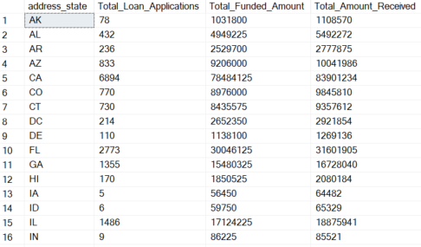

Term

Select

term,

count(id) as Total_Loan_Applications,

sum(loan_amount) As Total_Funded_Amount,

sum(total_payment) AS Total_Amount_Received

From bank_loan_data

Group by term

Order by term



Emp Duration

Select

emp_length,

count(id) as Total_Loan_Applications,

sum(loan_amount) As Total_Funded_Amount,

sum(total_payment) AS Total_Amount_Received

From bank_loan_data

Group by emp_length

Order by emp_length

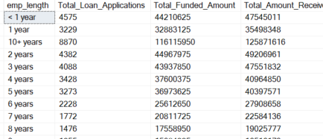

Purpose

Select

purpose,

count(id) as Total_Loan_Applications,

sum(loan_amount) As Total_Funded_Amount,

sum(total_payment) AS Total_Amount_Received

From bank_loan_data

Group by purpose

Order by purpose

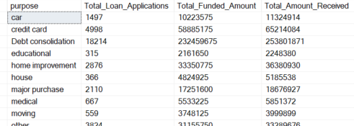

Home Ownership

Select

home_ownership,

count(id) as Total_Loan_Applications,

sum(loan_amount) As Total_Funded_Amount,

sum(total_payment) AS Total_Amount_Received

From bank_loan_data

Group by home_ownership

Order by home_ownership

