**GENERAL AWARENESS AND APTITUDE TEST**



**Questions: 40** **Marks: 160**



1. Verbal Reasoning
   1. Completing a series

|  |  |  |  |
| --- | --- | --- | --- |
|  | - | Number series | (2) |
|  | - | Letter series | (2) |
|  | - | Analog test | (2) |
|  | - | Coding and decoding | (1) |
|  | - | Arithmetical reasoning | (3) |
|  | - | Vocabulary test | (2) |
| ii) | a) | Facts about Nation | (3) |
|  | b) | Facts about Punjab | (3) |
|  | c) | Sports | (3) |
|  | d) | Health | (3) |
|  | e) | Environment | (3) |
|  | f) | Media and Entertainment | (3) |

1. Non-verbal reasoning

|  |  |  |
| --- | --- | --- |
| a) | Odd one out | (1) |
| b) | Completion of series | (2) |
| c) | Analog test | (1) |
| d) | Completing an incomplete pattern | (1) |
| e) | Spotting hidden pattern | (1) |
| f) | Identical and similar pattern | (2) |
| g) | Lateral inversion | (1) |
| h) | Folded and unfolded pattern | (1) |



1. ***General awareness and Aptitude test***
2. **COMPLETING A SERIES.**

**(a) Number Series.**

**Hints for answering the questions**

In these questions the series consists of numbers(digits). Number series are formed in many ways

* 1. Addition of figures given in row
  2. Subtraction of figures from one another
  3. Division of figures by one another
  4. Multiplication of figures
  5. Logical transportation of figures
  6. Increase/decrease of numbers in a specific pattern

**EXAMPLE:**

Write down the number which will complete the sequence and replace the ?

1. 6, 12, 18, 30, 48, ?
2. 3, 12, 48, 192, ?
3. 48, 24, 72, 36, 108, ?
4. 1, 4, 7, 10, 13, 16, 19, ?
5. 10, 15, 19, 22, 24, ?
6. 905, 576, 329, 247, ?
7. 1, 4, 9, 16, 25, ?
8. 1, 2, 8, 9, 15, 16, ?

**ANSWERS:**

1. 78,each term is obtained after adding two to the previous number
2. 768, multiply each term by 4 to get the next number
3. 54, divide by 2 and multiply by 3 alternatively.
4. 22, constant difference of 3 in each subsequent number.
5. 25, decreasing difference of 5,4,3,2,1 between subsequent numbers
6. 82, interval between each pair of numbers becomes the succeeding term in series
7. each term is square of natural number
8. 22, interval is alternatively 1 and 6

**Multiple Choice Questions**

Find the missing number in the following series out of four options.

|  |  |  |  |  |
| --- | --- | --- | --- | --- |
| 1. | 1, | 2, 5, 7, 11,______,17 | |  |
|  | a. | 12 | b. | 13 |
|  | c. | 14 | d. | 15 |
| 2. | 1, | 8, 27,____,125 |  |  |
|  | a. | 37 | b. | 47 |
|  | c. | 54 | d. | 64 |
| 3. | 6, | 12, 21, 33,____ |  |  |
|  | a. | 38 | b. | 40 |
|  | c. | 45 | d. | 48 |
| 4. | 2, 20,____,110, 182 | |  |  |
|  | a. | 56 | b. | 72 |
|  | c. | 90 | d. | 96 |
| 5. | 81, 9, 64,____,49, 7 | |  |  |
|  | a. | 8 | b. | 9 |
|  | c. | 10 | d. | 11 |
| 6. | 15, 20, 30,_____,65 | |  |  |
|  | a. | 35 | b. | 40 |
|  | c. | 45 | d. | 50 |
| 7. | 18, 30, 48, 72, 96,______ | | | |
|  | a. | 106 | b. | 115 |
|  | c. | 120 | d. | 96 |
| 8. | 12, 32, 72, 152,_______,632 | | | |
|  | a. | 515 | b. | 613 |
|  | c. | 815 | d. | 312 |
| 9. | 1, 2, 3, 5, 7,______,13 | | |  |
|  | a. | 8 | b. | 9 |
|  | c. | 10 | d. | 11 |
| 10. | 3, | 8, 22, 63, 185,_____ | |  |
|  | a. | 285 | b. | 295 |
|  | c. | 310 | d. | 500 |
| 11. | 4, 5, 7,_____, 19 | |  |  |
|  | a. | 56 | b. | 66 |
|  | c. | 11 | d. | 17 |

|  |  |  |  |  |  |  |  |  |  |  |  |
| --- | --- | --- | --- | --- | --- | --- | --- | --- | --- | --- | --- |
|  |  |  |  |  |  |  | ***General awareness and Aptitude test 3*** | | | |  |
| 12. | 27, 24, 30, 27, 33,______ | | | | 24. 8, 10, 14, 18,_______,34, 50, 66 | | | | |  |  |
|  | a. | 48 | b. | 27 |  | a. | 28 | b. | 27 |  |  |
|  | c. | 30 | d. | 24 |  | c. | 26 | d. | 25 |  |  |
| 13. | 4, 10, 22, 46,_______ | | |  | 25. 29, 36, 44, 53,_______ | | | |  |  |  |
|  | a. | 56 | b. | 66 |  | a. | 55 | b. | 63 |  |  |
|  | c. | 76 | d. | 94 |  | c. | 65 | d. | 69 |  |  |
| 14. | 4, | 1, -8,_______,-20, 29, -32, 43 | | | 26. 10, 22, 27,_______,44, 56, 61 | | | | |  |  |
|  | a. | 15 | b. | 16 |  | a. | 32 | b. | 39 |  |  |
|  | c. | 17 | d. | 18 |  | c. | 40 | d. | 42 |  |  |
| 15. | 2, | -2, 7, 3, 17,_______,32, 13 | | | 27. 2, 10, 60, 420, 3360,_________ | | | | |  |  |
|  | a. | 70 | b. | 10 |  | a. | 30240 | b. | 27840 |  |  |
|  | c. | 9 | d. | 8 |  | c. | 25140 | d. | 222240 |  |  |
| 16. | 9, 15, 23, 33,_______ | | |  | 28. 5, 8, 12, 17, 23,_______,38 | | | | |  |  |
|  | a. | 44 | b. | 36 |  | a. | 26 | b. | 28 |  |  |
|  | c. | 38 | d. | 45 |  | c. | 30 | d. | 29 |  |  |
| 17. | 12, 8, 14, 6,________,4 | | |  | 29. 4, 9, 20, 43, 90,______ | | | |  |  |  |
|  | a. | 5 | b. | 21 |  | a. | 180 | b. | 182 |  |  |
|  | c. | 24 | d. | 16 |  | c. | 179 | d. | 185 |  |  |
| 18. | 16, 12, 64, 16,_____,20, | | | 256 | 30. 5, 9, 16, 29, 54, 103,________ | | | | |  |  |
|  | a. | 18 | b. | 144 |  | a. | 102 | b. | 294 |  |  |
|  | c. | 20 | d. | 196 |  | c. | 203 | d. | 200 |  |  |
| 19. | 2, 6,_____,120, 720, 5040 | | | |  |  |  | **Key** |  |  |  |
|  | a. | 12 | b. | 18 |  |  |  |  |  |  |
|  | 1 | b | 11 | c | 21 | d |  |
|  | c. | 24 | d. | 60 |  |
|  | 2 | d | 12 | c | 22 | c |  |
| 20. | 9, 6, 16, 10, 30, 18,____,34 | | | | 3 | d | 13 | d | 23 | c |  |
| 4 | a | 14 | a | 24 | c |  |
|  | a. | 36 | b. | 60 |  |
|  | 5 | a | 15 | d | 25 | b |  |
|  | c. | 58 | d. | 60 |  |
|  | 6 | c | 16 | d | 26 | b |  |
|  |  |  |  |  |  |
| 21. | 10, 18, 34,_______,130, 258 | | | | 7 | d | 17 | d | 27 | a |  |
|  | a. | 32 | b. | 60 | 8 | d | 18 | b | 28 | c |  |
|  | 9 | c | 19 | d | 29 | d |  |
|  | c. | 68 | d. | 66 |  |
|  | 10 | d | 20 | c | 30 | d |  |
| 22. | 30, 23, 17, 12,________,5 | | | |  |
|  |  |  |  |  |  |  |
|  | a. | 6 | b. | 7 |  |  |  |  |  |  |  |
|  | c. | 8 | d. | 9 |  |  |  |  |  |  |  |
| 23. | 285, 253, 221, 189,_______ | | | |  |  |  |  |  |  |  |
|  | a. | 173 | b. | 167 |  |  |  |  |  |  |  |
|  | c. | 157 | d. | 146 |  |  |  |  |  |  |  |

1. ***General awareness and Aptitude test***

**LETTER SERIES**

Letter series contain only letters of the alphabet placed in a specific pattern . They may consist of terms with one , two , several letters. In such series the successive elements are obtained from the previous element according to a definite rule.

Example: U,B,I,P,________

Answer : If you study the pattern carefully you will find that every seventh letter is taken alphabetically. After U the letters VWXYZA are omitted and B is taken. After B , CDEFGH are omitted and I is taken. After I , JKLMNO are omitted and P is taken to follow the same pattern naturally. After P, QRSTUV should be omitted and W will be the next letter in the series.

Multiple Choice Questions

Each of the term in the questions belong to letter series. One of the term in questions belong to letter series. One of the terms of the series is missing. Find the missing term from amongst the four alternatives.

|  |  |  |  |  |
| --- | --- | --- | --- | --- |
| 1. | J,L,N,P,R,T,________ | | |  |
|  | a. | V | b. X | |
|  | c. | Y | d. | Z |
| 2. | C,F,I,L,O,R,_________ | | |  |
|  | a. | V | b. U | |
|  | c. | W | d. X | |
| 3. | B,F,J,N,R,V,_________ | | |  |
|  | a. | X | b. Y | |
|  | c. | Z | d. | C |
| 4. | E,J,O,T,Y,D,_________ | | | |
|  | a. | J | b. | K |
|  | c. | I | d. | F |

|  |  |  |  |  |  |  |  |
| --- | --- | --- | --- | --- | --- | --- | --- |
| 5. | AD, EH, IL, ____, QT, UX | | | | | |  |
|  | a. | MP | |  | b. MN | |  |
|  | c. | MO | |  | d. MQ | |  |
| 6. | B, I, P, W, D, K,_________ | | | | | |  |
|  | a. | Q |  |  | b. R | |  |
|  | c. | S |  |  | d. | T |  |
| 7. | AZ, BY, CX, D________ | | | | | |  |
|  | a. | E |  |  | b. W | |  |
|  | c. | R |  |  | d. V | |  |
| 8. | A, C, F, J, O,____________ | | | | | |  |
|  | a. | U |  |  | b. C | |  |
|  | c. | D |  |  | d. | F |  |
| 9. | C, J, P, U, Y,____________ | | | | | |  |
|  | a. | C |  |  | b. D | |  |
|  | c. | B |  |  | d. A | |  |
| 10. | AZ, BY, CX, DW, ______ | | | | | |  |
|  | a. | EX | |  | b. EU | |  |
|  | c. | EY | |  | d. EV | |  |
| 11. | aa | HI | cc, | cc JK | ee, ee LM gg, ____ | | |
|  | a. | ff | NO | ii | b. | gg NO | ii |
|  | c. | gg | ON | ee | d. ee ON | | ii |
| 12. | aBEf, bCFg, cDGh, _______ | | | | | |  |
|  | a. | dEGi | |  | b. | dHIg |  |
|  | c. | dEHi | |  | d. | dHEi |  |
| 13. | A, C, B, E, C, G, D,___ | | | | | ____ |  |
|  | a. | M,N | |  | b. | L,M |  |
|  | c. | I,E | |  | d. | G,H |  |
| 14. | CD, GH, KL, OP, ST, ________ | | | | | | |
|  | a. | RS | |  | b. QR | |  |
|  | c. | GH | |  | d. WX | |  |
| 15. | WZI, | | EHJ, | XAK, | _____, YBM, GJN | | |
|  | a. | ZCO | |  | b. IFL | |  |
|  | c. | FFL | |  | d. | FIL |  |

|  |  |  |  |  |  |  |  |
| --- | --- | --- | --- | --- | --- | --- | --- |
| 16. | BHL, DJN, FLP, | | | | ___________ | | |
|  | a. | HNR |  |  | b. HOS | | |
|  | c. | IOS |  |  | d. INR | | |
| 17. | B,E,I,N,T,___________ | | | | | |  |
|  | a. | R |  |  | b. U | |  |
|  | c. | S |  |  | d. | A |  |
| 18. | BC, FG, | | JK, _________, RS, VW | | | | |
|  | a. | LM |  |  | b. OP | | |
|  | c. | QR |  |  | d. NO | | |
| 19. | XD, WC, _________, YA | | | | | | |
|  | a. | XY |  |  | b. CD | | |
|  | c. | ZB |  |  | d. WV | | |
| 20. | AI, | BJ, | CK, | _________ | | | |
|  | a. | LM |  |  | b. DL | | |
|  | c. | GH |  |  | d. SE | | |
| 21. | AM, BN, EI, FJ, CO, DP, GK, ________ | | | | | | |
|  | a. | HL |  |  | b. PQ | | |
|  | c. | QR |  |  | d. HG | | |
| 22. | Z,W,S,P,L,I,E,___________ | | | | | | |
|  | a. | F |  |  | b. | G |  |
|  | c. | B |  |  | d. | K | |
| 23. | BD, EH, IM, NS, ______ | | | | | | |
|  | a. | UY |  |  | b. UZ | | |
|  | c. | TY |  |  | d. TZ | | |
| 24. | AC, | EG, | BD, | FH, | IK, | | _________ |
|  | a. | JL |  |  | b. OP | | |
|  | c. | IJ |  |  | d. | JK | |
| 25. | m | NN | o | PP |  | q | _________ |
|  | a. | rr |  |  | b. | RR | |
|  | c. | ss |  |  | d. QQ | | |
| 26. | CGKOS, | | AEIMQ, | | EIMQ___, | | |
|  | a. | W |  |  | b. X | |  |
|  | c. | V |  |  | d. U | |  |

***General awareness and Aptitude test 5***

1. AGMS, agms, _______________
   1. ABCD abcd
   2. abcdABCD
   3. BHNT bhnt
   4. bhntBHNT
2. aa, bbb, cccc, ______________

|  |  |  |  |  |  |  |  |
| --- | --- | --- | --- | --- | --- | --- | --- |
| a. | ddd |  |  | b. | ddddd | |  |
| c. | dddd | |  | d. DDDD | | |  |
| 29. ACF | | acf | G_______ | | |  |  |
| a. | IL gil | |  | b. | JL | gil |  |
| c. | IL | gjl |  | d. | LL | gli |  |
| 30. aB bB cD | | | | dD _________ | | |  |
| a. | ef |  |  | b. | gH |  |  |
| c. | fG |  |  | d. | eF |  |  |
|  |  |  |  | **Key** |  |  |  |
| 1 | a |  | 11 | b |  | 21 | a |
| 2 | b |  | 12 | c |  | 22 | b |
| 3 | c |  | 13 | c |  | 23 | d |
| 4 | c |  | 14 | d |  | 24 | a |
| 5 | a |  | 15 | d |  | 25 | b |
| 6 | b |  | 16 | a |  | 26 | d |
| 7 | b |  | 17 | d |  | 27 | c |
| 8 | a |  | 18 | d |  | 28 | b |
| 9 | c |  | 19 | c |  | 29 | a |
| 10 | d |  | 20 | b |  | 30 | d |

1. ***General awareness and Aptitude test***

**ANALOGY TEST**

Analogies Test your ability to see the relationship between types of relationships and recognize which relationship are similar.

Hints for Answering Questions:

1. Establish the relationship

Before you see the available answers try and establish what is the relationship between given pair.

Example:

Author : Book

1. Poem : poet
2. Ring : goldsmith
3. Carpenter : hammer
4. Composer : song

The relationship is that author creates a book. Take the keyword ***‘create’*** and try to fit this in all given choices

Poem ***‘create’*** poet wrong

Ring ***‘create’*** Goldsmith wrong

Carpenter ***‘create’*** hammer wrong

Composer ***‘create’*** song right

So ‘d’ is the correct answer.

2. Sequence of items is important

Like in above example person ie ‘Author’ comes first and the item ie ‘Book’ comes second. So in the answer also the person comes second. The only answer that satisfy this condition is (d).

Following types of relationship are possible.

1. Purpose relationship
2. Cause and effect relationship
3. Part and whole relationship
4. Part and part relationship
5. Action and object relationship
6. Synonym and antonym relationship
7. Place relationship
8. Degree relationship
9. Characteristic relationship
10. Sequence relationship
11. Numerical relationship
12. Association relationship

**Multiple Choice Questions**

In each of the questions below, a related pair of words(in capital letters) is given. Select the lettered pair out of four pair of words (in capital letters) is given. Select the lettered pair out of four pair of words that expresses the relationship that is most similar to that of the capitalized pair.

|  |  |  |  |  |
| --- | --- | --- | --- | --- |
| 1) | SCISSORS:CLOTH :: | | |  |
|  | a) | Axe:Wood | b) | Stone : Grinder |
|  | c) | Knife: Stone | d) | Gun: Hunt |
| 2) | FOOD:HUNGER :: | |  |  |
|  | a) | Axe:Wood | b) | Stone : Grinder |
|  | c) | Knife: Stone | d) | Gun: Hunt |

1. BIRD : NEST ::
   1. dog : doghouse
   2. squirrel : tree
   3. beaver : dam
   4. cat : litter box
   5. book : library
2. DALMATIAN : DOG ::
   1. Nightingale : bird
   2. horse : pony
   3. shark : great white

d) ant : insect e) stock : savings

1. DOCTOR : HOSPITAL ::
   1. sports fan : stadium
   2. cow : farm
   3. professor : college
   4. criminal : jail
   5. food : grocery store
2. CUB : BEAR ::
   1. piano : orchestra

b) puppy : dog c) cat : kitten

1. eagle : predator
2. fork : utensil

1. NOODLES : FLOUR ::
   1. snacks : breakfast
   2. Tomato : gravy
   3. beans : coffee
   4. thread : cotton
2. INK:PAPER ::
   1. Pen: pencil
   2. Paint: painting
   3. Chalk: blackboard
   4. Carbon paper: ballpoint
3. ROCKGARDEN:CHANDIGARH ::
   1. Delhi: RedFort
   2. Film Studio:Pune
   3. Chicago: USA
   4. India: Asia
4. LIGHT : CANDLE ::
   1. Exercise:Strength
   2. Heat:Coil
   3. Power:Battery
   4. Automobile:Engine
5. VOLCANO:LAVA ::
   1. Death:Sorrow
   2. Rock:Sand
   3. Delta:River
   4. Fault:Earthquake
6. SCALES : FISH ::
   1. Lady : Dress
   2. Skin : Man
   3. Tree: Leaves
   4. Bird: Feather
7. PETAL : FLOWER ::
   1. salt : pepper
   2. tire : bicycle
   3. base : ball
   4. sandals : shoes
   5. puppy : dog

***General awareness and Aptitude test 7***

14) BRISTLE : BRUSH

a) arm : leg b) stage : curtain

* 1. recline : chair d) key : piano
  2. art : sculpture

1. WOOL : WARMTH
   1. spring : elasticity
   2. marketing : advertising
   3. person : success
   4. radio : broadcast
2. ODOMETER : DISTANCE
   1. scale : weight
   2. length : width
   3. inch : foot
   4. mileage : speed
   5. area : size
3. WRITER : PEN
   1. pencil : eraser
   2. ball pen : notebook
   3. typewriter : paper
   4. blacksmith : hammer
   5. gun : hunter
4. PEDAL : BICYCLE
   1. inch : yardstick
   2. walk : skip
   3. tire : automobile
   4. buckle : belt
   5. oar : boat
5. RIBS : LUNGS
   1. ball : sphere
   2. hand : finger
   3. shell : nut
   4. coat : tie
6. BIRD : CAGE
   1. animal : zoo
   2. thief : prison
   3. antique : museum
   4. crime : punishment

1. ***General awareness and Aptitude test***

21) WAR : DESTRUCTION

a) fire : burn b) court : justice

* 1. water : drown d) food : hunger

1. YEN : CURRENCY
   1. brass : metal
   2. flower : fragrance
   3. paper : book
   4. karnataka : state
2. BINDING : BOOK
   1. criminal : gang
   2. display : museum
   3. artist : carpenter
   4. nail : hammer
   5. frame : picture
3. EXPLORE : DISCOVER
   1. read : skim
   2. research : learn
   3. write : print
   4. think : relate
   5. sleep : wake
4. COTTON : BALE
   1. butter : churn
   2. wine : ferment
   3. paper : ream
   4. curd : cheese
   5. beef : steak
5. STOOL : BENCH
   1. chair : table
   2. carpenter : chair
   3. foot rule : yardstick
   4. glass : cup
6. LAWN : GRASS
   1. wool : sheep
   2. skin : goat
   3. fur : animal skin
   4. rice : farm
7. WAITRESS : RESTAURANT
   1. doctor : diagnosis
   2. actor : role
   3. driver : truck
   4. teacher : school
   5. author : book
8. FINCH : BIRD
   1. frog : toad
   2. elephant : reptile
   3. Dalmatian : dog
   4. collie : marsupial
   5. ant : ladybug
9. RAIN : DRIZZLE

a) swim :dive b) hop : shuffle

* 1. juggle : bounce d) walk : run
  2. run : jog

1. EGG : OMELETTE
   1. dam : river
   2. student : classroom
   3. clay : pottery
   4. onion : salad
2. TAILOR : SUIT
   1. scheme : agent
   2. edit : manuscript
   3. revise : writer
   4. mention : opinion
   5. architect : building

**Key**

|  |  |  |  |  |  |
| --- | --- | --- | --- | --- | --- |
| 1 | a | 11 | d | 22 | d |
| 2 | a | 12 | b | 23 | e |
| 3 | b | 13 | b | 24 | b |
| 4 | a | 14 | d | 25 | c |
| 5 | c | 15 | a | 26 | c |
| 6 | b | 16 | a | 27 | c |
| 7 | d | 17 | d | 28 | d |
| 8 | c | 18 | e | 29 | c |
| 9 | b | 19 | c | 30 | e |
| 10 | c | 20 | b | 31 | c |
|  |  | 21 | a | 32 | e |

**CODING DECODING**

**What is Coding Decoding :**

A ‘Code’ is a system of conveying a message through signals. It is a method of sending a message between sender and the receiver in such a way that only the sender and the receiver can know its meaning. However ‘Coding’ is done according a certain pattern in the mind of the sender. Therefore, its meaning can be deciphered by a third person. Only if he carefully studies this pattern. This process is called ‘Decoding’. This capability is important in many fields of application.

The ‘Coding- Decoding’ test is set up to judge the candidate’s ability to decipher the pattern which goes behind a coded message or statement. There are many types of coding:

1. **LETTER CODING**

In such questions, code values are assigned

to a word in terms of the alphabets. There are following types of letter coding.

**Type 1 :** In this category, one word is coded according to a particular pattern and the candidate is asked to give the code letters for another word following the same pattern of coding.

**Ex. The word MAN is coded as NBO. Which of the following should be the code for SKY?**

**Sol.** The first letter of the code **N** comes after **M**. the first letter of the word in question. Similarly, the second letter **B** comes next to **A** of the question, and the third letter of code **O** comes after **N** of the main word. Following this pattern we can say that **TLZ** is coded as **SKY**.

**LETTER AND NUMERICAL CODING**

In these questions either numerical values are assigned to a word or alphabetical code values

***General awareness and Aptitude test 9***

are assigned to the numbers. The candidate is required to analyze the code according to the directions.

**Ex.** In a given code SISTER is coded as 535301. UNCLE as 84670 and BOY as 129. How is RUSTIC written in the code ?

|  |  |  |  |  |
| --- | --- | --- | --- | --- |
| (a) 633185 | | | (b) 185336 |  |
| (c) | 363815 | | (d) 581363 |  |
| (e) None | |  |  |  |
| **Sol.** | In this code the alphabets are coded as | | | |
| follows |  |  |  |  |
| SISTER UNC LE BOY | | | | |
| 5353 | | 0 1 | 84670 | 1 2 9 |

If we apply this method , the code comes out to be 185336

***Multiple Choice Questions***

1. In a certain coding system MOTHER is coded as PQWJHT, how will you code

SISTER?

a) VKUVHT b) VKVVHU

c) VKVVHT d) VKVVHS

2) In a certain coding system PRICE is coded as SVNIL, how will you code COST?

a) F SXY b) FSWY

c) FTWZ d) FSXZ

3) In a certain coding system FLOWER is written as SEXOMF, how will you code

GARDEN?

a) OEERBH b) OFESBH

c) OEESBG d) OEERBG

1. In a certain coding system TRAIN is written as GIZRM, how will you code FIGURE?

a) USTGKV b) VTYXTC

c) URTFIV d) VKGTSV

1. ***General awareness and Aptitude test***
2. If SINGLE can be given a code number of 66, what code number can be given to

|  |  |  |  |
| --- | --- | --- | --- |
| WINKLE? | |  |  |
| a) | 76 | b) | 66 |
| c) | 78 | d) | 74 |

6) If REASON is called as 5 and BELIEVED as 7, what is the code number for

|  |  |  |  |
| --- | --- | --- | --- |
| GOVERNMENT? | |  |  |
| a) | 10 | b) | 8 |
| c) | 9 | d) | 6 |

1. If PRATAP could be given a code number 1618120116, what code number can be given to NAVIN?

|  |  |  |  |
| --- | --- | --- | --- |
| a) | 73957614 | b) | 24639125 |
| c) | 14122914 | d) | 19274651 |

1. If CENTURION is coded as 325791465, and RANK as 18510, what will the figure 78510

represent?

|  |  |  |  |  |
| --- | --- | --- | --- | --- |
|  | a) | TANK | b) BANK | |
|  | c) | TAKE | d) SANK | |
| 9) | If WORK is coded as 4567 and MAN 328, | | | |
|  | then WOMAN is coded as | | | |
|  | a) | 45328 | b) | 43528 |
|  | c) | 32845 | d) | 35428 |
| 10) | If spider is written as PSDIRE, how would | | | |
|  | COMMON be written in that code | | | |
|  | a) | OCOMMO | b) OCMMNO | |

* 1. OCMOMNd) OCMMON

1. If (a) ‘gnr tag zog qmp’ stands for ‘Seoul Olympic organizing Committee’, (b) ‘hyto gnr emf’ stands for, ‘Summer Olympic Games, and (c) ‘esm sdr hyto’ stands for ‘Modern Games History’, What would ‘summer’ stands for?

a) gnr b) hyto

c) emf d) zog

1. In a certain language ‘526’ means ‘sky is blue’, ‘24’ means ‘blue colour’ and ‘436’

means ‘colour in fun’. Which digit in that language means ‘fun’?

|  |  |  |  |
| --- | --- | --- | --- |
| a) | 2 | b) | 3 |
| c) | 4 | d) | 6 |

1. If a rectangle is called a circle, a circle a point, a point a triangle, a triangle a square, then wheel is a:

a) rectangle b) circle

c) point d) triangle

1. If the letters is PRABA are coded as 27595 and THILAK are coded as 368451, how can

|  |  |  |  |
| --- | --- | --- | --- |
| BHARATHI be coded? | | |  |
| a) | 96575368 | b) | 57686535 |
| c) | 96855368 | d) | 37536689 |

1. If JAILAPPAS is coded as AIJAPLASP, ECONOMICS will be coded as:
   1. COEMONCSI
   2. COEOMNCSI
   3. OECMONSCI
   4. OECOMNCIS

***Key (Coding and Decoding)***

|  |  |  |  |
| --- | --- | --- | --- |
| 1. | c | 9. | a |
| 2. | d | 10. | b |
| 3. | d | 11. | c |
| 4. | c | 12. | b |
| 5. | d | 13. | c |
| 6. | c | 14. | a |
| 7. | c | 15. | b |

1. a

**ARITHMETICAL REASONING**

Hints for Answering Questions:

The section tests the basic calculation skills such as addition, subtraction, multiplication, division, calculation of percentages, average etc. The questions of ‘age’ and direction are also included in this test. The candidate must know the basics of geometry to solve the direction problems.

1. Rajesh walks 7 km to the north then turns left and walks 3 km. Then takes another left and continue walking this time another 7 km

forward. How much distance in km is he away from the starting point.

a) 10km b) 6km

c) 3km d) 2km

1. Balwant had 17 sheep. A storm in the village killed all but 7 sheep .How many was he left

with?

|  |  |  |  |
| --- | --- | --- | --- |
| a) | 10 | b) | 6 |
| c) | 7 | d) | 9 |

3) What is the smallest number of ducks that can swim in this formation- two ducks in front of a duck two ducks behind a duck and a duck between two ducks?

|  |  |  |  |
| --- | --- | --- | --- |
| a) | 3 | b) | 5 |
| c) | 7 | d) | 9 |

4) What is the product of all the numbers in the dial of a telephone?

a) 1,58,480 b) 1,59,450

* 1. 1,59,480d) None of those

1. A group of 1200 persons consisting of captains and soldiers is travelling in a train. For every 15 soldiers there is one captain. The number of captains in the group is

|  |  |  |  |
| --- | --- | --- | --- |
| a) | 85 | b) | 80 |
| c) | 75 | d) | 70 |

***General awareness and Aptitude test 11***

1. Aruna cut a cake into two halves and cuts one half into smaller pieces of equal size.

Each of the small pieces is twenty grams in weight. If she has seven pieces of the cake in all with her, how heavy was the original cake?

a) 120 grams b) 140 grams

c) 240 grams d) 280 grams

1. First bunch of bananas has ¼ again as many bananas as a second bunch. If the second bunch has 3 bananas less than the first bunch,

then the number of bananas in the first bunch is

|  |  |  |  |
| --- | --- | --- | --- |
| a) | 9 | b) | 10 |
| c) | 12 | d) | 15 |

1. At the end of a business conference the ten people present all shake hands with each other once. How many handshakes will there

be altogether?

|  |  |  |  |
| --- | --- | --- | --- |
| a) | 20 | b) | 45 |
| c) | 55 | d) | 90 |

9) A student got twice as many sums wrong as he got right. If he attempted 48 sums in all, how many did he solve correctly.

|  |  |  |  |
| --- | --- | --- | --- |
| a) | 12 | b) | 16 |
| c) | 18 | d) | 24 |

1. There were 28 people at last week’s board meeting. If the ratio of men to women was 4:3, how many women were at the meeting?

|  |  |  |  |
| --- | --- | --- | --- |
| a) | 16 | b) | 12 |
| c) | 7 | d) | 4 |

1. At a certain corporation, the ratio of clerical workers to executives is 7 to 2. If a combined total of 81 clerical workers and executive workers for that corporation, how many

clerical workers are there?

|  |  |  |  |
| --- | --- | --- | --- |
| a) | 9 | b) | 14 |
| c) | 18 | d) | 63 |

1. ***General awareness and Aptitude test***
2. Last Year, there were 720 crimes committed in the ninth precinct. These crimes involved

theft, rape, and drugs in the ration of 4:2:3, How many crimes involved drugs?

|  |  |  |  |
| --- | --- | --- | --- |
| a) | 80 | b) | 160 |
| c) | 240 | d) | 320 |

1. A unit price is a ratio that compares the price of an item to its unit of measurement. To determine which product is the better buy, calculate each one’s unit price. Which of these five boxes of Klean-O Detergent is the best buy?
   1. Travel-size: Rs. 100 for 5 Kg.
   2. Small: Rs. 200 for 11 KG.
   3. Regular: Rs. 400 for 22 Kg.
   4. Large: Rs. 700 for 40 Kg.
2. Rimmy pulse rate is 19 beats every 15 seconds. What is her rate in beats per minute?

|  |  |  |  |
| --- | --- | --- | --- |
| a) | 76 | b) | 60 |
| c) | 57 | d) | 45 |

1. If you write down all the numbers from 1 to 100, then how many times do you write 3?

|  |  |  |  |
| --- | --- | --- | --- |
| a) | 11 | b) | 18 |
| c) | 20 | d) | 21 |

1. The total number of digits used in numbering the pages of a book having 366 pages is

|  |  |  |  |
| --- | --- | --- | --- |
| a) | 732 | b) | 990 |
| c) | 1098 | d) | 1305 |

1. In a garden, there are 10 rows and 12 coloumns of mango trees. The distance

between two trees is 2 meters and a distance of one meter is left from all sides of the boundary of the garden. The length of the garden is

|  |  |  |  |
| --- | --- | --- | --- |
| a) | 20 m | b) | 22m |
| c) | 24m | d) | 26m |

1. A farmer built a fence around his square plot. He used 27 fence poles on each side of the

square. How many poles did he need altogether?

|  |  |  |  |
| --- | --- | --- | --- |
| a) | 100 | b) | 104 |
| c) | 108 | d) | None of these |

1. An enterprising businessman earns an income of Re.1 on the first day of his business. On every subsequent day, he earns on income which is just double of that made

on the previous day. One the 10th day of business, his income is

|  |  |  |  |
| --- | --- | --- | --- |
| a) | Rs. 29 | b) | Rs. 210 |
| c) | Rs. 10 | d) | Rs. 102 |

20) In a family, the father took **¼** of the cake and he had 3 times as much as each of the other members had. The total number of family members are

|  |  |  |  |
| --- | --- | --- | --- |
| a) | 3 | b) | 7 |
| c) | 10 | d) | 12 |

1. Three friends had dinner at a restaurant. When the bill was received, Amita Paid 2/3 as much as Veena paid and Veena paid 1/3 as much as Tanya paid. What fraction of the

bill did Veena pay?

|  |  |  |  |
| --- | --- | --- | --- |
| a) | 1/3 | b) | 3/11 |
| c) | 12/31 | d) | 5/8 |

22) Find the number which when added to itself

|  |  |  |  |
| --- | --- | --- | --- |
| 13 times, gives 112. | |  |  |
| a) | 7 | b) | 8 |
| c) | 9 | d) | 11 |

1. A monkey climbs 30 feet at the beginning of each hour and rests for a while when he slips back 20 feet before he again starts climbing

in the beginning of the next hour. If he begins his ascent at 8.00 a.m., at what time will he first touch a flag at 120 feet from the ground?

a) 4 p.m. b) 5 p.m.

c) 6 p.m. d) None of these

1. In a city, 40% of the adults are illiterate while 85% of the children are literate. If the ratio

of the adults to that of the children is 2:3, then what percent of the population is literate?

|  |  |  |  |
| --- | --- | --- | --- |
| a) | 20% | b) | 25% |
| c) | 50% | d) | 75% |

1. If every 2 out of 3 readymade shirts need alterations in the sleeves, and every 4 out of

5 need in the body, how many alterations will be required for 60 shirts?

|  |  |  |  |
| --- | --- | --- | --- |
| a) | 24 | b) | 123 |
| c) | 133 | d) | 143 |

1. If a clock takes seven seconds to strikes seven, how long will it take to strike ten?
   1. 7 seconds
   2. 9 seconds
   3. 10 seconds
   4. None of these

***Directions:*** Mr and Mrs. Sharma have two children Asha and Shahsi.Shashi married Radha, daughter of Mrs. Mahajan. Suresh, son of Mrs. Mahajan marries Rita. Sonu and Rocky are born to Suresh and Rita. Uma and Sudha are the daughters of Shashi and Radha.

|  |  |  |  |  |
| --- | --- | --- | --- | --- |
| 27) | What is the surname of Sonu? | | | |
|  | a) | Mahajan | b) | Sharma |
|  | c) | Shashi | d) | None of these |
| 28) | How is Suresh related to Sudha? | | | |
|  | a) | brother | b) | maternal uncle |
|  | c) | uncle | d) | cousin |
| 29) | What is Sudha’s relation to Asha? | | | |
|  | a) | sister | b) | niece |
|  | c) | aunt | d) | daughter |
| 30) | How is Sonu related to Mr. Mahajan? | | | |
|  | a) son-in-law | | b) | grandson |
|  | c) | son | d) | none of these |

***General awareness and Aptitude test 13***

1. Rita drives to the north of her place of stay at A and after traveling 25 km finds that she

has driven in the wrong directions. She then turns to her right and travels 2 km and then she again turns to the right and drives straight another 25 km. How much distance has she now to cover to go back to the starting point?

a) 25 km b) 2km

c) 4km d) 40 km

1. Rana travels 10 km to the north, turns left and travels 4 km and then again turns right

and covers another 5 km and then turns right and travels another 4 km. How far is he from the right starting point?

a) 15 km b) 4 km

c) 5 km d) 10 km

1. A taxi driver commenced his journey from a point and drove 10 km towards north and turned to his left and drove another 5 km. After waiting to meet a friend here, he turned to his right and continued to drive another 10

km. He has covered a distance of 25 km so far, but in which direction would he be now?

a) North b) East

c) South d) West

1. A tourist drives 10 km towards east and turns to the right hand and drives 3 km. Then he drives towards west (turning to his right) 3 km. He then turns to his left and drives 2 km. Finally he turns to his right and travels 7

km. How far is he from his starting point and in which direction would he be?

a) 10 km, East b) 9 km, North

c) 8 km, West d) 5 km, West

1. Of the 30 Officers on traffic duty, 20% didn’t work on Friday. How many officers worked

on Friday?

|  |  |  |  |
| --- | --- | --- | --- |
| a) | 6 | b) | 10 |
| c) | 12 | d) | 24 |

1. ***General awareness and Aptitude test***
2. After running 1½ miles on Wednesday, a runner had covered 75% of her planned

route. How many miles did she plan to run that day?

|  |  |  |  |
| --- | --- | --- | --- |
| a) | 2 | b) | 2¼ |
| c) | 2½ | d) | 2¾ |

1. Mr. Rakesh makes his special blends of coffee by mixing espresso beans with Colombian beans in the ratio of 4 to 5. How many K.g. of espresso beans does he need to make 18 K.g. of his special blend?

|  |  |  |  |
| --- | --- | --- | --- |
| a) | 4 | b) | 5 |
| c) | 8 | d) | 9 |

1. A recipe calls for 3 cups of sugar and 8 cups of flour. If only 6 cups of flour are used, how many cups of sugar should be used?

|  |  |  |  |
| --- | --- | --- | --- |
| a) | 1 | b) | 2 |
| c) | 2¼ | d) | 4 |

1. The average of eight different numbers is 5. If 1 is added to the largest number, what is

the resulting average of the eight numbers?

|  |  |  |  |
| --- | --- | --- | --- |
| a) | 5.1 | b) | 5.125 |
| c) | 5.25 | d) | 5.5 |

1. Lieutenant James made an average of 3 arrests per week for 4 weeks. How many arrests does she need to make in the fifth

week to raise her average to 4 arrests per week?

|  |  |  |  |
| --- | --- | --- | --- |
| a) | 4 | b) | 5 |
| c) | 8 | d) | 7 |

1. The average of 3 unique numbers is 50. If the lowest number is 30, what is the sum of the other two numbers?

|  |  |  |  |
| --- | --- | --- | --- |
| a) | 100 | b) | 110 |
| c) | 120 | d) | 150 |

1. A is 3 years younger than C but one year older than D. D is one year older than B but

4 years younger than C. C is 15 years old. What is the age of B in years?

|  |  |  |  |
| --- | --- | --- | --- |
| a) | 10 | b) | 11 |
| c) | 12 | d) | 13 |

1. Today is Varun’s birthday. One year from today he will be twice as old as he was 12

years ago. How old is Varun today?

a) 20 years b) 22 years

c) 25 years d) 27 years.

44) A is 3 years older to B and 3 years younger to C, while B and D are twins. How many

|  |  |  |  |
| --- | --- | --- | --- |
| years older is C to D? | | |  |
| a) | 2 | b) | 3 |
| c) | 6 | d) | 12 |

45) 12 year old Manick is three times as old as his brother Rahul. How old will Manick be when he is twice as old as Rahul?

a) 14 years b) 16 years

c) 18 years d) 20 years.

1. A woman says, “If you reverse my own age, the figures represent my husband’s age. He

is, of course, senior to me and the difference between our ages is one-eleventh of their sum.” The woman’s age is

a) 23 years b) 34 years

c) 45 years d) None of these.

1. In a town, 65% people watched the news on television, 40% read a newspaper and 25% read a newspaper and watched the news on television also. What percent of the people

neither watched the news on television nor read a newspaper?

|  |  |  |  |
| --- | --- | --- | --- |
| a) | 5 | b) | 10 |
| c) | 15 | d) | 20 |

1. Raj starts from his office facing west and walks 100 metres straight then takes a right turn and walks 100 metres. Further he takes

a left turn and walks 50 metres. In which direction is Raj now from the starting point?

a) North-East b) South-West

c) North d) North-West

1. Mohan starts from his house and walks 4 km. straight. He then turns towards his right

and walks 2 kms. He turns again to his right and walks 2 kms. If he is North West now, then in which direction did he start in the beginning?

a) North b) South

c) North-West d) West

1. A number consists of two digits. The digit at the ten’s place is two times the digit at the one’s place. The number, formed by reversing the digits is 27 less than the original

number. Then the original number is

|  |  |  |  |
| --- | --- | --- | --- |
| a) | 49 | b) | 94 |
| c) | 63 | d) | 36 |

1. A number consists of two digits of which the ten’s digit exceeds the one’s digit by 6. The number itself is equal to ten times the sum of

digits. Then the number is

|  |  |  |  |
| --- | --- | --- | --- |
| a) | 42 | b) | 60 |
| c) | 15 | d) | 51 |

1. A number consists of two digits. The digit at the ten’s place is two times the digit at the one’s place. The number formed by reversing the digits is 36 less than the original number.

Then the original number is

|  |  |  |  |
| --- | --- | --- | --- |
| a) | 84 | b) | 63 |
| c) | 48 | d) | 42 |

1. A boy is now one-third as old as his father Twelve years hence he will be half as old as his father. Then the present age of the boy is

a) 10 years b) 11 years

c) 12 years d) 13 years

***General awareness and Aptitude test 15***

1. 5 years ago, the age of a man was 7 times the age of his son. The age of the man will

be 3 times the age of his son in five years from now. How old is the man now?

a) 30 years b) 40 years

c) 50 years d) 60 years

1. A said to B,” I am 15 years older than you. After 5 years my age will be double of your age.” Then the present age of A is

a) 10 years b) 15 years

c) 20 years d) 25 years

1. The present age of Ram is 20 years and of his father is 40 years. How many years ago

the age of his father was three times of his age?

a) 10 years b) 8 years

c) 6 years d) 4 years

1. The age of Deepak and Vikas are in the ratio 7:5. Ten years hence, the ratio of their ages will be 9:7. Then the present age of Deepak

|  |  |  |  |  |  |  |  |
| --- | --- | --- | --- | --- | --- | --- | --- |
|  | is |  |  |  |  |  |  |
|  | a) | 20 years | | b) | 25 years | |  |
|  | c) | 30 years | | d) | 35 years. | |  |
|  |  |  |  | **Key** |  |  |  |
| 1 | c | 16 | b | 31 | b | 46 | c |
| 2 | c | 17 | b | 32 | a | 47 | d |
| 3 | a | 18 | b | 33 | a | 48 | d |
| 4 | d | 19 | a | 34 | d | 49 | d |
| 5 | c | 20 | c | 35 | d | 50 | c |
| 6 | c | 21 | b | 36 | a | 51 | b |
| 7 | d | 22 | b | 37 | c | 52 | a |
| 8 | b | 23 | c | 38 | c | 53 | c |
| 9 | b | 24 | d | 39 | b | 54 | b |
| 10 | b | 25 | c | 40 | c | 55 | d |
| 11 | d | 26 | d | 41 | c | 56 | a |
| 12 | c | 27 | a | 42 | a | 57 | d |
| 13 | d | 28 | b | 43 | c |  |  |
| 14 | a | 29 | b | 44 | c |  |  |
| 15 | c | 30 | b | 45 | b |  |  |

1. ***General awareness and Aptitude test***

**LOGICAL VENN DIAGRAMS**

This Section deals with questions which aim at analyzing a candidate’s ability to relate a certain given group of items and illustrate it diagrammatically. In these tests a relationship is to be established between two or more items represented by diagrams. The items represented by the diagrams may be individual, a particular group/class of people etc.

*Example:*

You are required to choose from the five diagrams the one that best illustrates the relationship among the three given classes in the questions that follow.



A B C

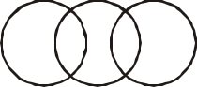

D E

*Questions*

1. Criminals, Pickpocketers, Terrorists
2. Dogs, Friendly Animals, Cats
3. Food, Curd, Spoons

*Answers*

1. E
2. D
3. C

*Explanation:*

1. Both Pickpocketers and Terrosist fall under the class of criminals. There is a possibility that some of pickpocketers can be terrorists and some of terrorists can be pickpocketers
2. Both dogs and cats can be wild as well as friendly animals, so we can infer that although both fall under separate classes some cats and some dogs may be friendly
3. Curd is covered under the class Food. However spoon is a separate class and has no relation with them.

**Hints for Answering Questions:**

To tackle questions on logical diagrams following hints will be helpful

1. These tests are based on the concept of class. A class is a group of items, all having something in common. Hence a class of MAMMALS will be all those members of animal kingdom who are MAMMALS and REPTILES will be not included in this class.
2. Classes can contain classes. A class may contain or be contained with another. Example: FATHERS will be contained in the larger group of MALES. But not all MALES will be FATHERS.
3. One class may be partially contained in another

*Example:* HUSBANDS and BROTHERS. All BROTHERS are not HUSBANDS and all HUSBANDS are not BROTHERS. The Partial relationship is as depicted in figure.

So a relationship can be of three basic types

1. Complete Exclusion
2. Complete Inclusion
3. Partial Inclusion

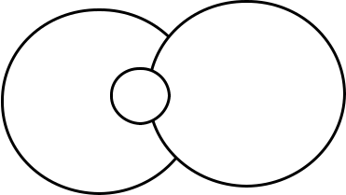

These three cases represent possible relationships between two classes if more classes are added it would result in more possible relationships. A class could be represented by any shape (circle, square, triangle etc ).

***Directions:*** Select the diagram that best represents the relation of terms given in question 1-10:

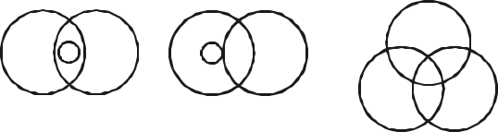

***General awareness and Aptitude test 17***

***Directions:*** Study the following diagram carefully and answer the questions the follow:

Government employees



Urban people



Graduates

Teachers

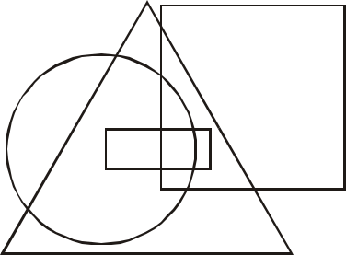

A B

C



D E

1. Animals, Cows, Dogs
2. Cousins, Males, Nephews
3. Women, Story teller, Liars
4. Doctors, Surgeons, Musicians
5. Students, Females, MBA entrance candidates
6. Bedroom, Sitting room, Dwelling
7. Civil Engineers, Boiler Engineers, Engineers
8. People, Doctors, Cows
9. Typewriter, Reading material, Magazines
10. Policemen, Magistrates, Human beings
11. Mule, Father Book
12. Family, Spouse, Husbands
13. Doctors, Human beings, Cows
14. Social workers, Alcoholics, Teatotallers
15. Females, Mothers, Nurses
16. Dogs, Rabbits, Rats
17. Females, Mothers, Sisters – a
18. Beef, Mutton, Eggs
19. Students, Married people, Human beings – a
20. Husbands, Brothers, Males – c
21. Which of the following statements is true?
    1. all urbans are graduates
    2. all graduates are urbans
    3. all the urban government employees are graduates
    4. all teachers are urban people
22. Choose the correct statement?
    1. there are some urban teachers who are government employees as well as graduates
    2. no teacher is a government employee
    3. all graduates are government employee
    4. all government employees are urban people
23. Mark the correct statement?
    1. all nonurban teachers are government employee
    2. all urban government employees are teachers
    3. there are some nonurban graduates who are neither teachers nor government employees
    4. all urban government employees are graduates

1. ***General awareness and Aptitude test***
2. Which of the following statement is not true?
   1. some government employees are rural
   2. all teachers are urban
   3. teachers who are government employees are that
   4. all govt. employees are urban people.

***Directions:*** In the following diagram there are three intersecting circles each representing certain sections of people. Different regions are marked a-g. Read the statements in question and choose the letter of the region which correctly represents the statements?

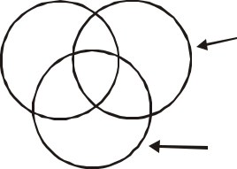

|  |  |  |  |  |  |  |
| --- | --- | --- | --- | --- | --- | --- |
| Russians | | | b |  | Artists |  |
|  |  | a | Af |  |
|  |  | d | c Ae |  |  |  |
|  |  |  | g |  | Singers |  |
|  |  |  |  |  |  |
| 25. | Russians who are artists but not singers. | | | | |  |
|  | a) | b | b) | c |  |  |
|  | c) | b | d) | g |  |  |
| 26. | Artists who are neither Russians nor singers. | | | | |  |
|  | a) | g | b) | c |  |  |
|  | c) | f | d) | b |  |  |
| 27. | Russians who are singers but not artists. | | | | |  |
|  | a) | a | b) | b |  |  |
|  | c) | c | d) | d |  |  |
| 28. | Russians who are artists as well as singers. | | | | |  |
|  | a) | a | b) | b |  |  |
|  | c) | c | d) | d |  |  |



 Rural people

Urban People



Post Graduates

Professors



1. Which one of the following statement is true?
   1. all urbans are post graduates
   2. all post graduates are urbans
   3. all professors are urban people
   4. all rural people are professors
2. Choose the correct statement?
   1. There are some professors who are rural people
   2. No professor is urban
   3. All post graduates are rural
   4. All post graduates are urban
3. Which of the following statement is true?
   1. all rural people are professors.
   2. There are some rural people who are post graduates and professors
   3. All rural people are post graduates
   4. All professors are rural but not post graduates
4. Mark the correct statement
   1. all urban people are post graduates
   2. all rural people are professors
   3. some professors are rural but not urban
   4. some urban people are not post graduates

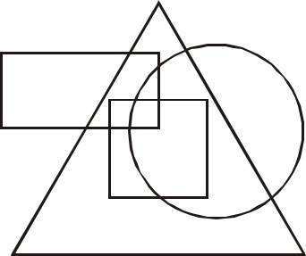

*Questions 33-36*

College students

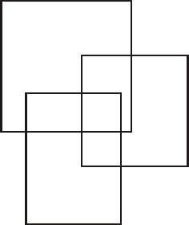

Aa

Ab

Ad Ac Af Artists

Ae

Ag

Singers

1. College students who are artists but not singers are represented by:

a) a b) b

c) f d) e

1. Artists who are neither college students nor singers are represented by?

a) b b) e

c) c d) f

1. College students who are singers but not artists are represented by?

a) a b) b

c) d d) c

1. College students who are artists as well as singers are represented by?

|  |  |  |  |  |  |  |  |
| --- | --- | --- | --- | --- | --- | --- | --- |
| a) | c |  |  |  | b) | f |  |
| c) | b |  |  |  | d) | a |  |
| *Questions 37-40* | | |  |  |  |  |  |
|  |  |  |  |  |  | Rural |  |
|  |  |  |  |  | 5 |  |  |
|  |  |  |  | 3 |  | Graduates |  |
|  |  |  |  | 2 |  | 6 |  |
|  |  |  | 4 | 1 |  |  |
| Hard |  |  |  |  |  |
|  |  | 11 | 9 |  | 7 |  |
| working | | 12 | 8 |  |
|  |  |  |  | Honest |  |
|  |  |  |  |  |  |  |
|  |  |  |  |  |  | 10 |  |

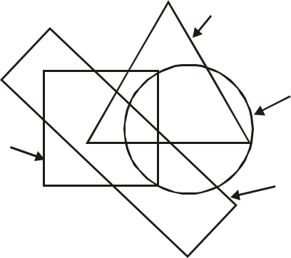

***General awareness and Aptitude test 19***

1. Graduates, hard working and honest rural people are indicated?

|  |  |  |  |
| --- | --- | --- | --- |
| a) | 1 | b) | 2 |
| c) | 3 | d) | 4 |

1. Rural people who are hard working and graduates but not honest are indicated by?

|  |  |  |  |
| --- | --- | --- | --- |
| a) | 1 | b) | 2 |
| c) | 3 | d) | 4 |

1. Urban graduates who are neither hard working nor honest are represented by?

|  |  |  |  |
| --- | --- | --- | --- |
| a) | 5 | b) | 7 |
| c) | 10 | d) | 11 |

1. Rural graduates who are neither honest nor hard working are indicated by

|  |  |  |  |
| --- | --- | --- | --- |
| a) | 2 | b) | 4 |
| c) | 6 | d) | 9 |

***Directions:*** There are four intersecting circles in the following diagram, each representing people who can read and write English, Hindi, Urdu and Punjabi.

A=40 C=2A

E=1/2A G=2E

English Hindi

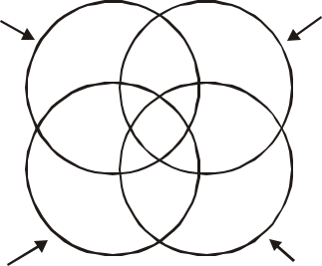

|  |  |  |  |
| --- | --- | --- | --- |
| A | B | C |  |
|  |  |
|  | I | J |  |
| H | M | D |  |
|  | L | K |  |
| G | F | E |  |

Punjabi Urdu

1. People who can read and write Hindi, Urdu, and Punjabi are represented by?

a) A b) D

c) K d) E

1. People who can read and write all the languages can be represented by?

a) L b) J

c) M d) K

1. ***General awareness and Aptitude test***
2. People who can read and write all the languages except Urdu are represented by?

a) K b) M

c) B d) I

1. People who cannot read and write English, Hindi and Punjabi are represented by?

a) L b) K

c) C d) E

1. People who cannot read and write Urdu and Punjabi, but are conversant with English and

Hindi both, are represented by?

a) M b) B

c) J d) K

1. People who do not know English and Hindi but are familiar with Urdu and Punjabi both

are represented by?

|  |  |  |  |  |
| --- | --- | --- | --- | --- |
|  | a) | F | b) | G |
|  | c) | E | d) | K |
| 47. | Which language is known by maximum | | | |
|  | number of people as per the above diagram? | | | |
|  | a) | Punjabi | b) | English |
|  | c) | Hindi | d) | Urdu |
| 48. | How many people know only Urdu? | | | |
|  | a) | 40 | b) | 10 |
|  | c) | 20 | d) | 60 |
| 49. | How many people know Urdu or Punjabi? | | | |
|  | a) | 40 | b) | 20 |
|  | c) | 80 | d) | 60 |

1. How many people can read and write any one language excepting Punjabi?

|  |  |  |  |
| --- | --- | --- | --- |
| a) | 120 | b) | 140 |
| c) | 100 | d) | 160 |

*Questions 51-55*

***Directions:*** Three circles representing GRADUATES, CLERKS and GOVERNMENT EMPLOYEES are intersecting one another. They intersecting one another. The intersections are marked A,B,C,e,f,g, and h. Which part best represents the statements in questions.

|  |  |  |  |  |  |
| --- | --- | --- | --- | --- | --- |
| Graduates | | e |  | Clerks |  |
|  | B |  |  |
|  |  | h |  | A |  |
|  |  | g |  |  |
|  |  | f |  |  |
|  |  | C |  | Govt. |  |
|  |  |  |  | Employees |  |
| 51. Some Clerks are graduates | | | | |  |
| a) | e |  | b) | h |  |
| c) | g |  | d) | f |  |

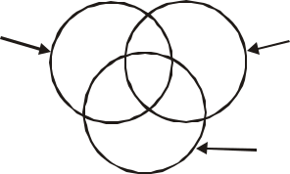

52. Some clerks are government employees

a) e b) h

c) g d) f

1. Some graduates are government employees but not as clerks

a) h b) g

c) f d) e

1. Clerks who are graduates as well as in government service.

a) e b) f

c) g d) h

1. Some graduates are clerks not working in government departments

|  |  |  |  |  |  |  |  |  |  |
| --- | --- | --- | --- | --- | --- | --- | --- | --- | --- |
|  | a) | f |  |  | b) | g |  |  |  |
|  | c) | h |  |  | d) | e |  |  |  |
|  |  |  |  |  | **KEY** |  |  |  |  |
| 1 | e |  | 15 | e | 29 | | c | 43 | d |
| 2 | b |  | 16 | d | 30 | | a | 44 | d |
| 3 | c |  | 17 | a | 31 | | b | 45 | b |
| 4 | d |  | 18 | b | 32 | | d | 46 | a |
| 5 | c |  | 19 | a | 33 | | b | 47 | c |
| 6 | e |  | 20 | c | 34 | | d | 48 | c |
| 7 | e |  | 21 | d | 35 | | c | 49 | d |
| 8 | d |  | 22 | a | 36 | | a | 50 | b |
| 9 | d |  | 23 | c | 37 | | a | 51 | a |
| 10 | e |  | 24 | d | 38 | | b | 52 | c |
| 11 | e |  | 25 | c | 39 | | b | 53 | c |
| 12 | d |  | 26 | c | 40 | | c | 54 | d |
| 13 | c |  | 27 | d | 41 | | c | 55 | d |
| 14 | e |  | 28 | c | 42 | | c |  |  |

**GENERAL FACTS ABOUT THE NATION**

This section contains general questions about India, the purpose of the section is to test the general knowledge of the candidate about his nation.

1. Navy Day is observed on

|  |  |  |  |  |
| --- | --- | --- | --- | --- |
| a) | Dec. | 4 | b) | Dec. 25 |
| c) | Dec. | 31 | d) | Jan. 1 |

1. National Song (Vande Mataram) was first sung on
   1. 1896 session of INC
   2. 1912 session of INC
   3. 1927 session of INC
   4. 1947 on eve of Independence
2. The shorter version of India’s National

Anthem has a playing time of

a) 12 seconds b) 15 seconds

c) 20 seconds d) 26 seconds

1. The inscription of India’s National Emblem, “Satya Meva Jayte” is a quotation from
   1. Gandhijis writings
   2. Nehru’s Speeches
   3. Mundak Upnishad
   4. None of these.
2. Tiger was adopted as National Animal in

|  |  |  |  |
| --- | --- | --- | --- |
| a) | Nov. 1970 | b) | Nov. 1972 |
| c) | Dec. 1974 | d) | Oct. 1980 |

1. There are how many languages and dialects used in India.
   1. < 100
   2. between 100 to 500
   3. between 500 to 1000
   4. > 1000
2. Post Office Day in India is celebrated observed on

***General awareness and Aptitude test 21***

a) 9th October b) 19th August

c) 5th April d) 28th February

1. BJP as a major party has won how many in general elections in Indian History.

|  |  |
| --- | --- |
| a) 1 | b) 2 |
| c) 3 | d) 4 |

1. Area wise the biggest Parliamentary Constituency in 2004 elections was
   1. Ladakh (J and K)
   2. Srinagar (J and K)
   3. Barmer (Rajasthan)
   4. Kutch (Gujrat)
2. The President of Jammu and Kashmir National Conference (JKNC)
   1. Farooq Abdullah
   2. Omar Abdullah
   3. Mohd. Ansari
   4. None of these
3. The first IPS Women Officer was

a) Kiran Badi b) Anna Chandi

c) Leila Seth d) P.K. Thresia

1. The National Emblem of India was adopted on
   1. Aug. 15, 1947
   2. Jan. 26, 1950
   3. Jan. 26, 1957
   4. Aug. 15, 1950
2. Who composed our National Anthem?
   1. Rabindranath Tagore
   2. Sri Aurobindo Ghosh
   3. Bankimchandra Chatterjee
   4. None of these
3. When the National Anthem of India first

song?

|  |  |  |  |
| --- | --- | --- | --- |
| a) | 1947 | b) | 1950 |
| c) | 1896 | d) | 1911 |

1. ***General awareness and Aptitude test***
2. The National Anthem was adopted by the Constituent Assembly on
   1. Dec. 27, 1950
   2. Aug. 15, 1947
   3. Jan 24, 1950
   4. Jan, 26, 1947
3. How many stanzas are there in our National Anthem?

a) Two b) Three

c) Four d) Five

1. What is the normal playing time of the full version of our National Anthem?

a) 2 minutes b) 1 minute

c) 52 seconds d) 50 seconds

18. What is the playing time of the shorter version of our National Anthem which is played on ceremonial occasions?

a) 1minute b) 50 seconds

c) 30 seconds d) 20 seconds

1. Which among the following is India’s National song?
   1. Vande Mataram
   2. Sare Jahan se Achcha
   3. Jana-gana-mana
   4. None of them
2. The largest and the oldest museum of India is located in the state/union territory of
   1. Andhra Pradesh
   2. Uttar Pradesh
   3. West Bengal
   4. New Delhi.
3. Ms Harita Kaur has the distinction of being the first Indian Woman
   1. to be inducted into the Indian Navy
   2. doctor to create a test tube baby
   3. pilot to fly an aircraft Solo
   4. Ambassador to a foreign country.
4. Who is the youngest player to score a century in test cricket?
   1. Haneef Mohammed
   2. Mohd. Azharuddin
   3. S. Gavaskar
   4. S. Tendulkar
5. The first English newspaper in India was started by
   1. Dadabhai Naroji
   2. J.A. Hickey
   3. Lord William Bentinck
   4. Rabindranath Tagore
6. The first nuclear reactor in India is

|  |  |  |  |
| --- | --- | --- | --- |
| a) | Dhruva | b) | Harsha |
| c) | Apsara | d) | Vipula |
| 25) The highest airfield in India is | | | |
| a) | Bhuntar | b) | Pantnagar |
| c) | Chushul | d) | Parapani |

26) The first “Financial Service Park” for industry is being set up at

|  |  |  |  |
| --- | --- | --- | --- |
| a) | Pune | b) | Surat |
| c) | Gurgaon | d) | Bangalore |
| 27) The first Field Marshal of India was | | | |
| a) | A. Vaidya | b) | K.M. Cariappa |

* 1. Sunder Ji
  2. S.H.F.J. Manekshaw

1. India’s first “Ladies Special” Suburban train was started by which of the following zones of Indian Railways?

a) Northern b) Southern

c) Western d) Eastern

1. Who was the first Indian to go into space?
   1. Satish Dhawan
   2. Ravi Malhotra
   3. Rakesh Sharma
   4. None of these

30) The largest dry dock in India is situated at

a) Marmugao b) Cochin

c) Kolkata d) Mumbai

1. Who composted the National Song of India?
   1. Rabindranath Tagore
   2. Bankim Chandra Chatterjee
   3. Sri Aurobindo
   4. Mahatma Gandhi
2. Who rendered the English translation of our National Song?
   1. Rabindranath Tagore
   2. Bankim Chandra Chatterjee
   3. Sri Aurobindo
   4. None of these
3. The National Song of India was adopted on
   1. Jan 26, 1947
   2. Jan 25, 1947
   3. Jan 24, 1950
   4. Jan 24, 1949
4. When was the National Calendar of India introduced for official purpose?
   1. April 1, 1957
   2. April 1, 1947
   3. March 22, 1950
   4. March 22, 1947
5. Which is the first month of our National Calender?

a) Bhadra b) Phalguna

c) Chaitra d) Kartika

1. The first date of our National Calendar corresponds to which date of the Gregorian Calendar?
   1. April 1, 1950
   2. March 22, 1950
   3. March 22, 1957
   4. March 31, 1957

***General awareness and Aptitude test 23***

1. Which is the last month of our National Calender?

a) Bhadra b) Phalguna

c) Chaitra d) Asadha

1. Which among the following is the correct pair of India’s National Animal and National Flower?
   1. Lion/Rose
   2. Cow/Lotus
   3. Tiger/Lotus
   4. Lion/Lotus
2. Which among the following is the Republic Day?
   1. August 15
   2. January 26
   3. January 30
   4. November 14
3. Which among the following is the Independence day?
   1. August 14
   2. August 15
   3. January 30
   4. November 11
4. Match the following:
   1. Teacher’s Day 1) 14th November
   2. Children’s Day 2) 5th September

|  |  |  |  |
| --- | --- | --- | --- |
| c) | Martyr’s Day | 3) | 26th January |
| d) | Republic Day | 4) | 30th January |

* 1. A-3, B-4, C-2, D-1
  2. A-2, B-1, C-4, D-3
  3. A-2, B-3, C-1, D-4
  4. A-3, B-4, C-1, D-2.

1. Who was the first President of India?
   1. Dr. S. Radhakrishnan
   2. Dr. Rajendra Prasad
   3. Dr. Zakir Hussain
   4. V.V. Giri

1. ***General awareness and Aptitude test***
2. Who was the first Vice-President of India?
   1. Dr. S. Radhakrishnan
   2. Dr. Rajendra Prasad
   3. Dr. Zakir Hussain
   4. G.S. Pathak
3. Who among the following had the longest tenure as the President of India?
   1. Dr. Zakir Hussain
   2. Dr. S. Radhakrishnan
   3. Dr. Rajendra Prasad
   4. V.V. Giri
4. Who became the first Acting Prime Minister of India?
   1. Lal Bahadur Shastri
   2. Gulzarilal Nanda
   3. Charan Singh
   4. None of them
5. Who was the first Prime Minister of India who did not face the Parliament during his tenure?
   1. Morarji Desai
   2. Gulzari Lal Nanda
   3. Charan Singh
   4. Lal Bahadur Shastri
6. Who was the first woman President of Indian National Congress?
   1. Mrs. Vijayalakshmi Pandit
   2. Mrs. Sarojini Naidu
   3. Dr. Annie Besant
   4. None of them
7. Who was the first woman judge of Supreme Court of India?
   1. Miss Leila Seth
   2. Miss M. Fathima Bibi
   3. Miss Anna Chandi
   4. Anna Georga Malhotra
8. Who was the first woman Chief Justice of High Court in India?
   1. Miss M. Fathima Beevi
   2. Miss Anna Chandi
   3. Anna Georga Malhotra
   4. Miss Leila Seth
9. Who was the first Prime Minister who had to step down as a result of defeat in election?
   1. Charan Singh
   2. Indira Gandhi
   3. Morarji Desai
   4. Gulzari Lal Nanda
10. Who was the first Prime Minister who had to resign from the office?
    1. Gulzarilal Nanda
    2. Charan Singh
    3. Morarji Desai
    4. V.P. Singh

|  |  |  |  |  |  |  |  |
| --- | --- | --- | --- | --- | --- | --- | --- |
|  |  |  |  | **KEY** |  |  |  |
| 1 | a | 14 | d | 27 | d | 40 | b |
| 2 | a | 15 | c | 28 | c | 41 | b |
| 3 | c | 16 | d | 29 | c | 42 | b |
| 4 | c | 17 | c | 30 | a | 43 | a |
| 5 | b | 18 | d | 31 | b | 44 | c |
| 6 | d | 19 | a | 32 | c | 45 | b |
| 7 | a | 20 | c | 33 | c | 46 | c |
| 8 | b | 21 | c | 34 | a | 47 | b |
| 9 | a | 22 | d | 35 | c | 48 | c |
| 10 | b | 23 | b | 36 | c | 49 | c |
| 11 | a | 24 | c | 37 | b | 50 | b |
| 12 | b | 25 | c | 38 | c | 51 | d |
| 13 | a | 26 | c | 39 | b |  |  |

**VOCABULARY TEST**

***Important Points***

In this test the candidates are required to form new words by suffixing or prefixing letters, the section also tests the basic knowledge of English language

In question 1 to 3 find the odd one out.

|  |  |  |  |  |
| --- | --- | --- | --- | --- |
| 1) | a) | Tiger | b) | Leopard |
|  | c) | Snail | d) | Fox |
| 2) | a) | Steamer | b) | yatch |
|  | c) | Sail | d) | Boat |
| 3) | a) | Ball | b) | Pingpang |
|  | c) | Rugby | d) | Bowling |
| 4) | Flex likes to _____ | |  |  |
|  | a) | Play Catch | b) | do catch |
|  | c) | does catch | d) | did catch |

1. John is _____
   1. Basket balling
   2. Doing Basketball
   3. Playing Basket Ball
   4. Sporting Basketball_____

Select the word out of the choices that is most appropriate the given meaning

|  |  |  |  |  |
| --- | --- | --- | --- | --- |
| 6) | Loud cry _____ | |  |  |
|  | a) | Scream | b) | Guilt |
|  | c) | Voice | d) | Ache |
| 7) | Look on face _____ | |  |  |
|  | a) | direction | b) | question |
|  | c) | expression | d) | concern |
| 8) | Weeping with short breaths _____ | | | |
|  | a) | squeezing | b) | staring |
|  | c) | twinkling | d) | sobbing |
| 9) | Told to be careful_____ | | |  |
|  | a) | managed | b) | warned |
|  | c) | noticed | d) | remembered |

|  |  |  |  |  |
| --- | --- | --- | --- | --- |
|  |  | ***General awareness and Aptitude test 25*** | | |
| 10) | Pardoned mistake_____ | | | |
|  | a) | Forgave | b) | Peered |
|  | c) | warned | d) | dejected |
| 11) | A baby bear is called_____ | | | |
|  | a) | cub | b) | fawn |
|  | c) | calf | d) | colt |
| 12) | A baby deer is called_____ | | | |
|  | a) | cub | b) | fawn |
|  | c) | calf | d) | colt |
| 13) | A baby cat is called a_____ | | | |
|  | a) | chick | b) | puppy |
|  | c) | kitten | d) | duckling |
| 14) | A baby fish is called a_____ | | | |
|  | a) | Fishlet | b) | fish |
|  | c) | fawn | d) | infant |
| 15) | A baby dog is called a _____ | | | |
|  | a) | duckling | b) | chick |
|  | c) | puppy | d) | kitten |
| 16) | Glasses are used for _____ | | | |
|  | a) | cleaning | b) | viewing |
|  | c) | cutting | d) | washing |
| 17) | Scissors are used for_____ | | | |
|  | a) | Bending | b) | plucking |
|  | c) | measuring | d) | clipping |
| 18) | Tweezers are used for_____ | | | |
|  | a) | Plucking | b) | clipping |
|  | c) | measuring | d) | chopping |

1. Sprinkler is used for_____
   1. Vaccuming Lawn
   2. Cutting Grass
   3. Watering lawn
   4. Washing floor
2. A Mop is used for
   1. Sweeping lawn
   2. Watering lawn
   3. Vaccuming floor
   4. drying floor

1. ***General awareness and Aptitude test***

Insert the word(s) that can be prefixed to the words given to form new meaning full words.

|  |  |  |  |  |  |
| --- | --- | --- | --- | --- | --- |
| 21) | __AGE | | __POSE | __PART | |
|  | a) | S |  | b) | R |
|  | c) | IM |  | d) | DE |
| 22) | __TIUE | | __ABLE | __TAIN | |
|  | a) | SAG |  | b) MOV | |
|  | c) | MAN |  | d) CAP | |
| 23) | __ROW | | __EATER | __AT | |
|  | a) | M |  | b) TH | |
|  | c) | WH |  | d) C | |
| 24) | __capable __consistent __tolerant | | | | |
|  | a) | UN |  | b) IM | |
|  | c) | IN |  | d) | AN |

*Tick mark the right meaning of the word*

|  |  |  |  |  |
| --- | --- | --- | --- | --- |
| 25) | Contempt | |  |  |
|  | a) | Love | b) | Beauty |
|  | c) | Call | d) | Hate |
| 26) | Fame | |  |  |
|  | a) | Publicity | b) | Hate |
|  | c) | Pleasure | d) | Renown |
| 27) | Notorious | |  |  |
|  | a) | immortal | b) | popular |
|  | c) | beautiful | d) | infamous |
| 28) | Excel | |  |  |
|  | a) | do well | b) | run |
|  | c) | please | d) | make well |
| 29) | Furtive | |  |  |
|  | a) | secretive | b) | good |
|  | c) | bad | d) | smoke |
| 30) | conflagration | |  |  |
|  | a) | popularity | b) | goy |
|  | c) | great man | d) | great fire |
| 31) | candid | |  |  |
|  | a) | clear | b) | secret |
|  | c) | open | d) | public |

|  |  |  |  |  |
| --- | --- | --- | --- | --- |
| 32) | Ambiguous | |  |  |
|  | a) | great | b) | bighearted |
|  | c) | uncertain | d) | clear |
| 33) | Festive | |  |  |
|  | a) | happy | b) | colourful |
|  | c) | bad | d) | good |
| 34) | Feeble | |  |  |
|  | a) | strong | b) | weak |
|  | c) | excellent | d) | good looking |
| 35) | Genuine | |  |  |
|  | a) | clear | b) | middy |
|  | c) | authentic | d) | less |
| 36) | Belittle | |  |  |
|  | a) | enlarge | b) | enfeeble |
|  | c) | please | d) | unimportant |
| 37) | Ignominy | |  |  |
|  | a) | popularity | b) | expensive |
|  | c) | disgrace | d) | wickedness |
| 38) | Ingenious | |  |  |
|  | a) | clever | b) | intelligent |
|  | c) | dull | d) | wickedness |
| 39) | Paramount | |  |  |
|  | a) | Miner | b) | Minor |
|  | c) | Important | d) | Supreme |
| 40) | Lenient | |  |  |
|  | a) | tall | b) | not strict |
|  | c) | foolish | d) | simple |

1. Which word does NOT belong with the others?

a) fair b) just

c) equitable d) favourable

42) Which word does NOT belong with the others?

a) defendant b) prosecutor

c) trial d) judge

1. Which word does NOT belong with the others?

a) area b) diameter

* 1. circumference d) quadrilateral

1. Which word does NOT belong with the others?

a) mayor b) lawyer

c) governor d) senator

1. Which word does NOT belong with the others?

a) acute b) right

c) obtuse d) parallel

46) Which word does NOT belong with the others?

a) wing b) fin

c) beak d) rudder

For questions 47 to 49, find the word that names a *necessary* part of the underlined word.

|  |  |  |  |  |  |  |  |
| --- | --- | --- | --- | --- | --- | --- | --- |
| 47) book | | |  |  |  |  |  |
|  | a) | fiction |  | b) | pages |  |  |
|  | c) | pictures |  | d) | learning |  |  |
| 48) guitar | | |  |  |  |  |  |
|  | a) | band |  | b) | teacher |  |  |
|  | c) | songs |  | d) | strings |  |  |
| 49) shoe | | |  |  |  |  |  |
|  | a) | sole |  | b) | leather |  |  |
|  | c) | laces |  | d) | walking |  |  |
|  |  |  |  | **KEY** |  |  |  |
| 1 | c | 13 | c | 25 | d | 37 | c |
| 2 | a | 14 | b | 26 | d | 38 | a |
| 3 | a | 15 | c | 27 | d | 39 | d |
| 4 | b | 16 | b | 28 | a | 40 | b |
| 5 | c | 17 | d | 29 | a | 41 | d |
| 6 | a | 18 | a | 30 | d | 42 | c |
| 7 | c | 19 | c | 31 | c | 43 | d |
| 8 | d | 20 | d | 32 | c | 44 | b |
| 9 | b | 21 | c | 33 | a | 45 | d |
| 10 | a | 22 | d | 34 | b | 46 | c |
| 11 | a | 23 | b | 35 | c | 48 | b |
| 12 | b | 24 | c | 36 | d | 49 | d |
|  |  |  |  |  |  | 50 | a |

***General awareness and Aptitude test 27***

**ENVIRONMENT**

1. Which natural disaster causes more deaths than any other?

a) Volcano b) Fire

c) Flooding d) Earthquakes

1. The natural process of the earths atmosphere heating through the traping of re-radiated infra-red radiation is known as
   1. Global warming
   2. Green house effect
   3. Solar heating
   4. Thermal inversion
2. Temperate forests are likely to have which

of the following species of trees?

a) Maple b) Spruce

c) Pine d) All

4. About what percentage of Earth people live in areas where water shortage are common.

|  |  |  |  |  |  |
| --- | --- | --- | --- | --- | --- |
| a) | 40 | percent | b) | 30 | percent |
| c) | 45 | percent | d) | 25 | percent |

1. Which of the following is not associated with industrial food production?
   1. The use of fossil fuels
   2. Chemical fertilizers
   3. Large amount of labour
   4. Machinery
2. With what bio-region is the team ‘steppe’ associated?
   1. Coniferous forest
   2. Tropical forests

c) Savanna d) Grass land

1. In which of the following areas do international environmental treaties exist?

a) Fisheries b) Whaling

* 1. Ocean pollution
  2. All

1. What percentage of earths water is fresh water?

1. ***General awareness and Aptitude test***

|  |  |  |  |  |
| --- | --- | --- | --- | --- |
| a) | 75 | percent | b) | 3 percent |
| c) | 27 | percent | d) | 10 percent |

1. Which country ratified the Kyoto protocol in late 2004 and thus caused it to become international law?

a) Russia b) USA

c) China d) India

1. The world’s growing appetite for what food product is a leading cause of tropical deforestation?

a) Lamb b) Sugar

c) Beef d) Pork

1. Between 1950 and 1980, an area of the size of Denmark has been decertified in which country.

a) China b) India

c) Bangladesh d) Iran

1. If current rates of deforestation continues in south-east Asia, then how many years would

it take for the region to become completely stripped of its forest?

|  |  |  |  |
| --- | --- | --- | --- |
| a) | 30 | b) | 40 |
| c) | 50 | d) | 60 |

1. In what type of bio-region is desertification most likely to occur?
   1. Temperate forest
   2. Savanna
   3. Tropical forests
   4. Grass lands
2. Why is cattle ranching not sustainable in areas that were formerly tropical forests?
   1. Cattle reaching quickly exhausts the nutrient-poor soil of tropical rainforests.
   2. Cattle waste is toxic to rainforest soils.
   3. Both (a) and (b)
   4. None
3. According tom United National estimate, about how much of the world’s range-lands are threatened by desertification?

|  |  |  |  |  |  |
| --- | --- | --- | --- | --- | --- |
| a) | 60 | percent | b) | 70 | percent |
| c) | 50 | percent | d) | 30 | percent |

1. Tropo pause is the boundary line between troposphere and ———
   1. Mesosphere
   2. Stratosphere

c) ionosphere d) Exosphere

1. Shrubs, thickest and stunted trees like kikar, jal and others are found in
   1. evergreen forests
   2. deciduous forests
   3. dry forests
   4. hill forests
2. The study of day-to-day variations in weather is called

a) Climatology b) Meteorology c) Cyclogensis d) None

1. The ionosphere includes
   1. Mesosphere
   2. Thermosphere
   3. Exosphere
   4. Both (b) and (c)
2. According to your text, what can “be thought of as the genetic library that keeps life going on earth”?
   1. Bio-diversity
   2. Human genes
   3. The human genome project
   4. None

|  |  |  |  |  |  |
| --- | --- | --- | --- | --- | --- |
|  |  |  | **Answer** |  |  |
| 1. | b | 2. | b | 3. | d |
| 4. | a | 5. | c | 6. | d |
| 7. | d | 8. | b | 9. | a |
| 10. | c | 11. | a | 12. | c |
| 13. | d | 14. | a | 15. | a |
| 16. | b | 17. | d | 18. | b |
| 19. | d | 20. | a |  |  |

**HEALTH**

1. Body temperature of a normal person:

|  |  |  |  |
| --- | --- | --- | --- |
| a) | 81.1°C | b) | 36.9°F |
| c) | 36.9°C | d) | 98.6°F |

1. A healthy person’s B.P. is
   1. 81/170 mm of mercury
   2. 80/120 mm of mercury
   3. 70/140 mm of mercury
   4. 120/180 mm of mercury
2. On kidney failure, blood is purified by

a) Dialysis b) Biopsy

* 1. Angiography d) Ultrasound

1. AIDS spreads through

|  |  |  |  |  |
| --- | --- | --- | --- | --- |
|  | a) | Bacteria | b) | Protozoa |
|  | c) | Virus | d) | Fungi |
| 5. | Heat beat of a normal person is | | | |
|  | a) | 50 per min | b) | 70 per min |
|  | c) | 80 per min | d) | 100 per min |
| 6. | Malaria is a disease which effects the | | | |
|  | a) | Heart | b) | Lungs |
|  | c) | Spleen | d) | Kidney |
| 7. | Which of the following pairs is incorrect? | | | |
|  | a) | Plague-rats | b) | Rabies-dogs |

* 1. Tapeworm – pig
  2. Poliomyelitis – monkeys

1. Typhoid and cholera are typical example of
   1. Infectious diseases
   2. Air-borne diseases
   3. Water borne diseases
   4. None
2. Myopia is a disease connected with

a) Eyes b) Brain

c) Liver d) Heart

1. Lock Jaw i.e. difficulty in opening the mouth is a symptom of

a) Diphtheria b) Tetanus

c) Cholera d) Plague

|  |  |  |  |  |
| --- | --- | --- | --- | --- |
|  |  | ***General awareness and Aptitude test 29*** | | |
| 11. | Volume of blood in a normal human body is | | | |
|  | a) | 3-4 litre | b) | 5-6 litre |
|  | c) | 8-10 litre | d) | 10-12 litre |
| 12. | Which of the following is hereditary disorder? | | | |
|  | a) | Scurvy | b) | Ricketus |

* 1. Colour blindness
  2. Night blindness

1. Main component of bones and teethes are
   1. Calcium carbonate
   2. Calcium phosphate
   3. Calcium sulphate
   4. Calcium nitrate
2. Diabetes is caused due to lack of

a) Sugar b) Insulin

c) Calcium d) Iron

15. Smallpox is a deadly and lightly contagious a) Viral disease b) Fungal disease

* 1. Both (a) and (b) d) None

1. Test tube baby means
   1. Ovum developed without fertilization in test tubes
   2. Ovum fertilized in test tube and developed in uterus
   3. Ovum fertilized and developed in test tube.
   4. Ovum fertilized in uterus and developed in test tubes.
2. A person of which of the following blood groups can receive blood of any group?

|  |  |  |  |  |
| --- | --- | --- | --- | --- |
|  | a) | A | b) AB | |
|  | c) | B | d) | O |
| 18. | ECG is used for the diagnosis of ailments of | | | |
|  | a) | Brain | b) | Heart |
|  | c) | Kidneys | d) | Lungs |
| 19. | Ricketts is a disease of | | |  |
|  | a) | Bones | b) | Tissue |
|  | c) | Muscles | d) | Blood |

1. ***General awareness and Aptitude test***
2. Which of the following vitamins promotes healthy functioning of eyes in human beings?

|  |  |  |  |  |  |
| --- | --- | --- | --- | --- | --- |
|  | a) | Vit B | b) | Vit C |  |
|  | c) | Vit A | d) | Vit D |  |
|  |  | **Answer** | |  |  |
| 1. | c | 2. | d | 3. | a |
| 4. | c | 5. | b | 6. | c |
| 7. | d | 8. | c | 9. | a |
| 10. | b | 11. b | | 12. | c |
| 13. | b | 14. b | | 15. | a |
| 16. | b | 17. b | | 18. | b |
| 19. | a | 20. c | |  |  |
|  |  | **SPORTS** | | |  |
| 1. | Olympic games 2012 were held at | | | |  |
|  | a) | England | b) | China |  |
|  | c) | Atlanta | d) | Tokyo |  |
| 2. | Commonwealth games 2010 held in | | | |  |
|  | a) | Manchester | b) | Victoria |  |
|  | c) | Delhi | d) | Perth |  |



1. Asian games 2010 held in
   1. Qatar
   2. China
   3. South Korea
   4. Thailand
2. Who scored double hundred first time in ODI cricket match?
   1. Saurav Ganguali
   2. M.S. Dhoni
   3. Rickey Ponting
   4. Sachin Tendulkar
3. The first athlete who won eight gold medals in individual events in one Olympic games is
   1. Micheal Phelps
   2. Milkha Singh
   3. Mike Powell
   4. P.T. Usha
4. Saina Nehwal is associated with which game.

a) Tennis b) Badminton

c) Lawn Tennis d) Athletic

7. Ranji Trophy is associated with which sport.

a) Hockey b) Football

c) Cricket d) Polo

1. Wimbledon Trophy is associated with which sport.

|  |  |  |  |  |
| --- | --- | --- | --- | --- |
|  | a) | Golf | b) | Tennis |
|  | c) | Badminton | d) | Cricket |
| 9. | Name the playing area of boxing | | | |
|  | a) | Rink | b) | Link |
|  | c) | Ring | d) | Court |
| 10. | Name the national sport of India | | | |
|  | a) | Cricket | b) | Hockey |
|  | c) | Judo | d) | Badminton |
| 11. | Indira Gandhi Indoor Stadium is located at | | | |
|  | a) | Mumbai | b) | Chennai |
|  | c) | New Delhi | d) | Kolkata |

1. The team dribble is associated with which sport

a) Basketball b) Badminton

c) Baseball d) Billiards

1. T-20 world cup cricket Tournament in 2012 was held in

a) South Africa b) Sri Lanka

c) England d) India

1. Third IPL 20-20 Championship was won by
   1. Mumbai Indians
   2. Royal Challengers
   3. Chennai Super Kings
   4. Kolkata Knight Riders
2. Hockey World cup 2010 was won by

a) Genmany b) Pakistan

c) Holland d) Australia

1. Who is second individual top scorer in test crickets after Brain Lara.
   1. Mathew Hayden
   2. Rahul Dravid
   3. Rickey Ponting
   4. Saurav Ganguli
2. Player who hit six sixes in an over in 20-20 world cup 2007
   1. Sahid Afridi
   2. Yuvraj Singh
   3. Yusuf Pathan
   4. Jacques Kellis
3. In 2011, Rajiv Gandhi Khel Ratan Award was given to
   1. Gagan Narang
   2. Abhivan Bindra
   3. Saina Nehwal
   4. Saniya Mirza
4. Who become the first Indian to win a Gold Medal at World Wrestling Championships?
   1. Susheel Kumar
   2. Vijender Singh
   3. Kuldeep Singh
   4. Rajeev Tomar
5. Tejaswina Sawant is Associated with which sport.
   1. Rifel Shooting
   2. Wrestling
   3. Boxing
   4. Badminton

|  |  |  |  |  |  |
| --- | --- | --- | --- | --- | --- |
|  |  | Answer | |  |  |
| 1. | a | 2. | c | 3. | b |
| 4. | d | 5. | a | 6. | b |
| 7. | c | 8. | b | 9. | c |
| 10. | b | 11. | c | 12. | a |
| 13. | b | 14. | d | 15. | d |
| 16. | a | 17. | b | 18. | a |
| 19. | a | 20. | a |  |  |

***General awareness and Aptitude test 31***

**MEDIA AND ENTERTAINMENT**

1. In Oscar award 2012, the best picture is
   1. No country for oldman
   2. The hurt locker
   3. Slumdog millionaire
   4. War Horse
2. In 59th national film awards, the best feature film is

a) Delhi 6 b) Deool

c) Putaani Parti d) Kutty srank

1. In 2012, 54th Grammy awards function was held in

a) Bangkok b) Philippines

c) Los angeles d) Thialand

1. Miss Universe 2012 is
   1. Olivia Culpo
   2. Dayana Mendoza
   3. Ksenia Sukhinova
   4. Stephenia Fernadiz
2. Nobel prize 2009 for peace was given to
   1. Ms Herta Meullar
   2. Barrack obama
   3. Willard S boyle
   4. Ada yonath
3. Best film in IIFA award 2012 was

|  |  |  |  |  |  |
| --- | --- | --- | --- | --- | --- |
|  | a. | Paa | b. Zindagi Na Milegi Dobara | | |
|  | c. | Delhi – 6 | | d. | All the best |
| 7. | Who has taken over mobile company Hutch | | | | |
|  | a. | Airtel |  | b. | Videocon |
|  | c. | Docomo | | d. Vodafone | |
| 8. | World’s tallest building is | | | | |
|  | a. | Eiffle tower | | b. | Qutab minar |

* 1. Burj khalifa
  2. World trade center

1. The film ‘Peepli live’ is produced by

a. Ajay Devgan b. Aamir khan

1. Saroj khan
2. David Dhawan

1. ***General awareness and Aptitude test***

10. Bhangra is the popular dance of

a. Bihar b. Punjab

* 1. Kerala
  2. Himachal Pradesh

1. Garba is the popular dance of

a. Gujarat b. West Bangal

c. Rajasthan d. Punjab

1. World’s highest radio station is
   1. All India radio, Leh
   2. All India ratio, Kashmir
   3. All India radio, Delhi
   4. None
2. ——— holds the world record for maximum number of song recordings
   1. Asha Bhonsle
   2. Lata Mangeshkar
   3. Kishor Kumar
   4. Mohd. Rafi.
3. Bihu is the popular dance of

a. Punjab b. Kerala

c. Assam d. H.P.

1. Nautanki is the popular dance of a. Uttar Pradesh b. Meghalaya

c. Karnataka d. Tamil Nadu

1. Best song written for Motion picture, television or other visual media is
   1. Jai Ho
   2. Jiyo Utho Bado Teeto
   3. Vende Matram
   4. None
2. In 57th national film awards, best actor award was won by
   1. Farook Sheikh
   2. Sharukh Khan
   3. Amitabh Bachchan
   4. Aamir Khan
3. In Oscar award 2010, best actor award was won by
   1. Mo’ Nique
   2. Jeff Bridges
   3. Michael Giacchins
   4. Christoph waltz
4. Life time achievement award was given by
   1. Pt. Bhimsen Joshi
   2. Lata Mangeshkar
   3. Asko Parpola
   4. Dev Anand
5. Phalke Ratan award 2009 was given to
   1. Amitabh Bachchan
   2. Anil Kappor
   3. Dev Anand
   4. Shammi Kapoor

|  |  |  |  |  |  |
| --- | --- | --- | --- | --- | --- |
|  |  | Answers | |  |  |
| 1. | d | 2. | b | 3. | c |
| 4. | a | 5. | b | 6. | b |
| 7. | d | 8. | c | 9. | b |
| 10. | b | 11. | a | 12. | a |
| 13. | b | 14. | c | 15. | a |
| 16. | a | 17. | c | 18. | b |
| 19. | a | 20. | c |  |  |



**FACTS ABOUT PUNJAB**

1. The area of Punjab is
   1. 40300 square Km
   2. 60302 square Km
   3. 50362 square Km
   4. 55000 square Km
2. Number of divisions of Punjab is

a) Six b) Four

c) Five d) Eight

3. Total no. of districts in Punjab is

|  |  |  |  |
| --- | --- | --- | --- |
| a) | 22 | b) | 17 |
| c) | 12 | d) | 13 |

|  |  |  |  |  |
| --- | --- | --- | --- | --- |
| 4. | Total no. of tehsils in Punjab is | | | |
|  | a) | 70 | b) | 81 |
|  | c) | 20 | d) | 80 |
| 5. | Total no. of blocks in Punjab is | | | |
|  | a) | 86 | b) | 120 |
|  | c) | 70 | d) | 72 |

1. Total number of Lok Sabha Seats in Punjab is

|  |  |  |  |
| --- | --- | --- | --- |
| a) | 17 | b) | 13 |
| c) | 20 | d) | 10 |

1. Number of Primary health centres in Punjab is

|  |  |  |  |
| --- | --- | --- | --- |
| a) | 219 | b) | 484 |
| c) | 445 | d) | 212 |

1. Density of population in 2011 in Punjab is
   1. 219 persons per square km.
   2. 550 persons per square km.
   3. 212 persons per square km.
   4. 480 persons per square km.
2. Literacy percentage in 2011 in Punjab is

|  |  |  |  |
| --- | --- | --- | --- |
| a) | 76.7% | b) | 72% |
| c) | 60% | d) | 63.2% |

10. The largest (areawise) district in Punjab is

a) Amritsar b) Jalandhar

c) Ferozepur d) Ludhiana

1. The smallest (areawise) district in Punjab is
   1. Fatehgarh Sahib
   2. Jalandhar
   3. Amritsar
   4. Ludhiana
2. Where is regional engineering college in Punjab

a) Amritsar b) Jalandhar

c) Patiala d) Chandigarh

13. The area between two rivers is called

a) Malwa b) Majha

c) Doaba d) Plain

***General awareness and Aptitude test 33***

1. The height of Bhakra dam is
   1. 765 feet
   2. 800 feet
   3. 700 feet
   4. 740 feet
2. Where is Science city Located in Punjab
   1. Ludhiana
   2. Amritsar
   3. Jalandhar
   4. Ferozepur
3. Where is Hosiery industry in Punjab
   1. Amritsar
   2. Ludhiana
   3. Jalandhar
   4. Ferozepur
4. In which direction of India, Punjab is located?

|  |  |  |  |  |
| --- | --- | --- | --- | --- |
|  | a) | North east | b) | East |
|  | c) | Northwest | d) | South |
| 18. | Length of Ravi river is | | |  |
|  | a) | 450 km | b) | 500 km |
|  | c) | 720 km | d) | 600 km |
| 19. | Longest river in Punjab is | | | |
|  | a) | Beas | b) | Ravi |
|  | c) | Satluj | d) | Chenab |

1. How many rivers are there in Punjab presently

|  |  |  |  |  |  |  |
| --- | --- | --- | --- | --- | --- | --- |
|  | a) | Four |  | b) | Three |  |
|  | c) | Five |  | d) | Two |  |
|  |  |  | **Answer** | |  |  |
| 1. | c |  | 2. | b | 3. | a |
| 4. | b |  | 5. | a | 6. | b |
| 7. | c |  | 8. | b | 9. | a |
| 10. | a |  | 11. | a | 12. | b |
| 13. | c |  | 14. | a | 15. | c |
| 16. | b |  | 17. | a | 18. | c |
| 19. | c |  | 20. | b |  |  |

1. ***General awareness and Aptitude test***

**B. NON-VERBAL REASONING**



**Important Points**

The purpose of non-verbal reasoning test is to find out how well a candidate understands ideas which are not presented in words or numbers, but in figures, diagrams, pictograms presented in terms of size or shape or position or quantity or other non-verbal, non-numerical forms. What is important in solving the problems of non-verbal reasoning tests is to follow a logical procedure. This latent logical procedure will help the candidate to find out the principle on which the problem figure is based.

1. **Odd One Out**

**Multiple Choice Questions**

Directions: In the given four figures, three of them are similar in some respect, while one is different. Out of the four figures select the figure which is different.



1.

a b c d



2.

a b c d



3.

a b c d



4.

a b c d



5.

6.



a b c d



7.

a b c d



 J  E  O  A 

8.



a b c d



9.

a b c d



10.

a b c d

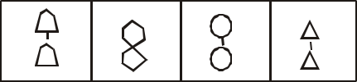

11.

a b c d

a b c d

***General awareness and Aptitude test 35***

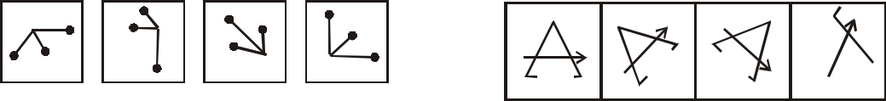

|  |  |  |  |  |
| --- | --- | --- | --- | --- |
| 12. |  |  | 20. |  |
| a | b | c |  |
| d |  |

a b c d

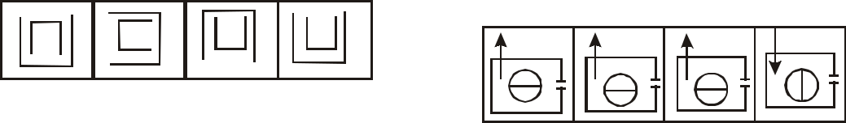

13.

a b c d 21.

14.



a b c d



15.

a b c d



16.

a b c d



17.

a b c d



18.

a b c d



a b c d

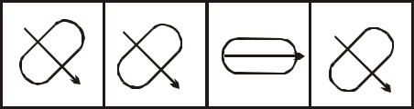

22.

a b c d

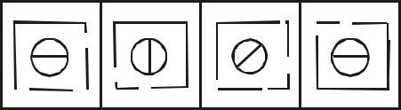

23.

a b c d

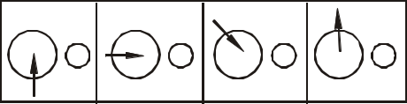

24.

a b c d



25.

a b c d

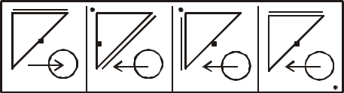

26.

|  |  |  |  |  |  |  |  |
| --- | --- | --- | --- | --- | --- | --- | --- |
| 19. |  |  | a | b | c | d |  |
| a | b | c |  |
| d |  |  |  |  |

1. ***General awareness and Aptitude test***

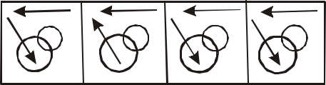

27.

a b c d

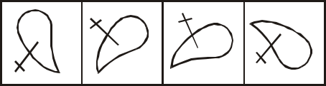

28.

a b c d

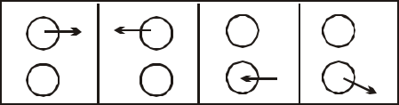

29.

a b c d

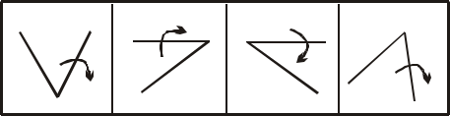

30.

|  |  |  |  |  |  |
| --- | --- | --- | --- | --- | --- |
|  | a |  | b | c | d |
|  |  |  | **Key** |  |  |
| 1. | a | 11. | b | 21. | d |
| 2. | d | 12. | d | 22. | c |
| 3. | c | 13. | d | 23. | c |
| 4. | b | 14. | c | 24. | d |
| 5. | d | 15. | d | 25. | d |
| 6. | a | 16. | a | 26. | a |
| 7. | b | 17. | b | 27. | b |
| 8. | a | 18. | c | 28. | d |
| 9. | b | 19. | b | 29. | d |
| 10. | b | 20. | d | 30. | c |

1. **Completion of Series Important Points**

In this test, a set of 3/4/5 figures is given. Each figure changes in design from the preceding one in a particular order. Candidates are required to choose the correct answer figure, which would best continue the series.

This test judges your pattern perception. You have to discern the pattern which may be quantitative, qualitative, rotative, multi-relational, or ratio-based. The series-may also be based on mixed operations, in which various elements change their directions/positions, increase or decrease in number as well as change qualitatively.

This test also includes questions on correct sequence of figures. Students are asked as to interchange of which two figures would make the series correct.

**Multiple Choice Questions**

**Directions:** There are two set of figures. One set is called problem figures and the other set is called answer figures. Problem set figures from some kind of series. Select one figure from the answer set figures which will continue the series in the problem set figures.

***General awareness and Aptitude test***

***37***

Problem Figures

Answer Figures

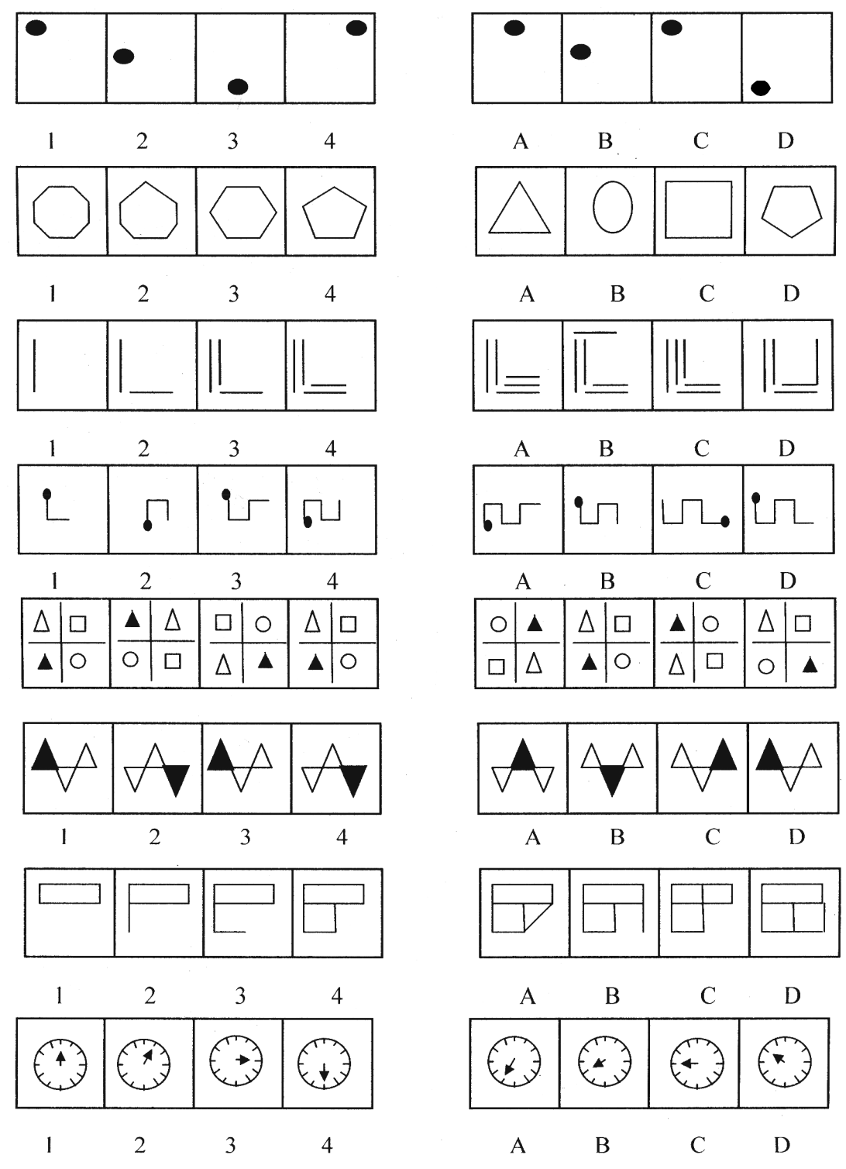

1.

2.

3.

4.

5.

6.

7.

8.

1. ***General awareness and Aptitude test***

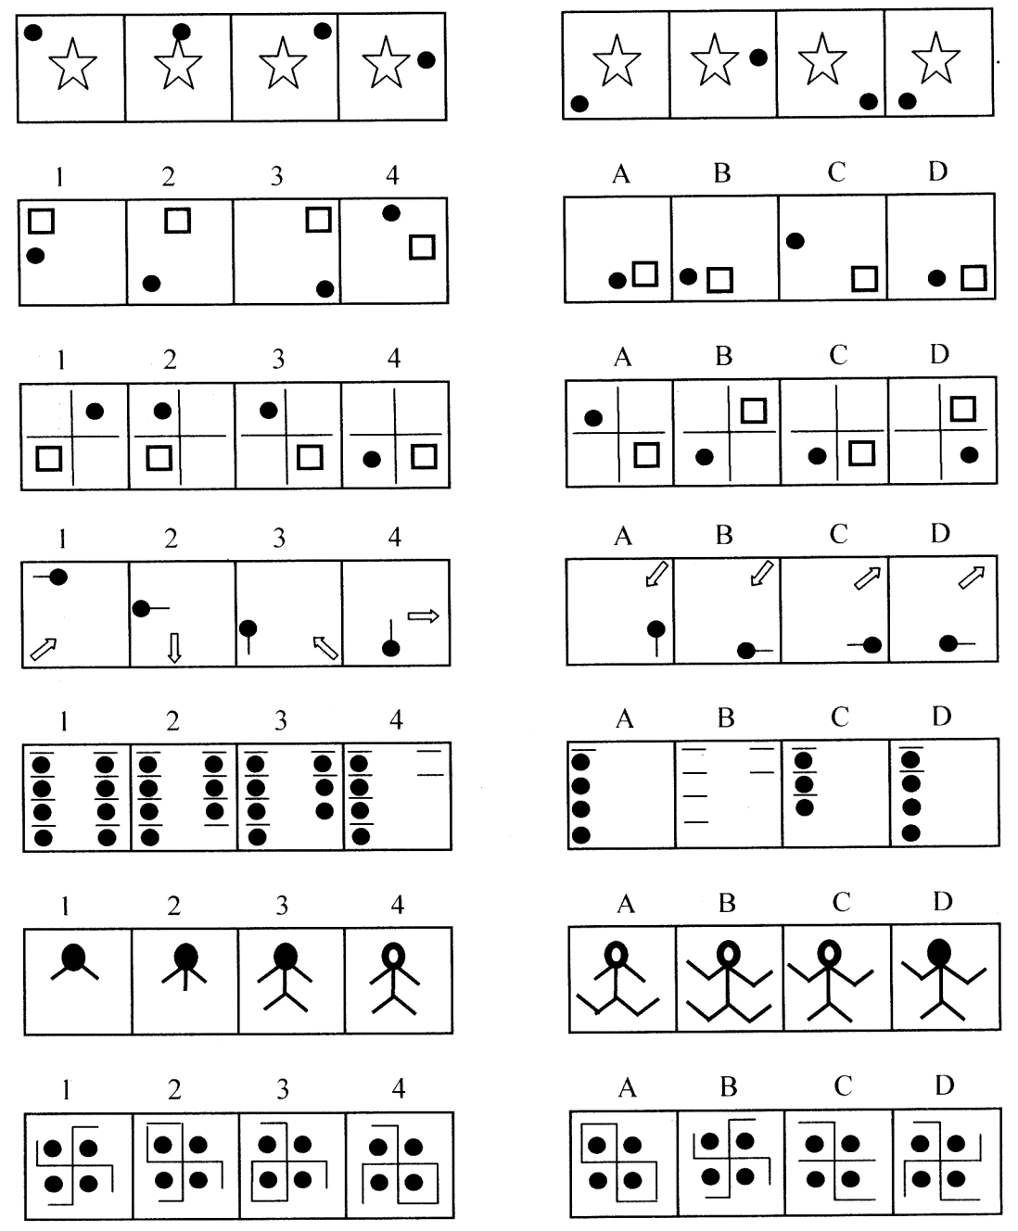

9.

10.

11.

12.

13.

14.

15.

|  |  |  |  |  |  |  |  |
| --- | --- | --- | --- | --- | --- | --- | --- |
|  |  |  |  | **Key** |  |  |  |
| 1 | d | 5 | a | 9 | c | 13 | d |
| 2 | c | 6 | d | 10 | d | 14 | c |
| 3 | c | 7 | c | 11 | b | 15 | d |
| 4 | d | 8 | d | 12 | b |  |  |

***General awareness and Aptitude test 39***

**iii) Analog Test**

'Analogy' implies corresponding. In the problems based on analogy, a pair of related figures is provided and a similar relationship is to be established between two other figures, by selecting one or both of them from a set of alternatives.

**Multiple Choice Questions**

Directions: Figures 1 & 2 in Problem figures are related in a particular manner. Establish the same relationship between figures 3 and 4 by choosing a figure from among the four alternative answer figures, which would replace the question mark in problem figures.

|  |  |  |  |  |  |  |  |  |
| --- | --- | --- | --- | --- | --- | --- | --- | --- |
| Problem Figures | |  |  |  | Answer Figures | |  |  |
| 1. |  |  |  |  |  |  |  |  |
| 1 | 2 | 3 | 4 | a | b | c | d |  |
| *c* | *c* |  |  |  |  |  |  |  |
| 2. |  |  |  |  |  |  |  |
| 1 | 2 | 3 | 4 | a | b | c | d |  |
| 3. |  |  | ? |  |  |  |  |  |
| 1 | 2 | 3 | 4 | a | b | c | d |  |
| 4. |  |  | ? |  |  |  |  |  |
| 1 | 2 | 3 | 4 | a | b | c | d |  |
| 5. |  |  | ? |  |  |  |  |  |
| 1 | 2 | 3 | 4 | a | b | c | d |  |
| 6. |  |  | ? |  |  |  |  |  |

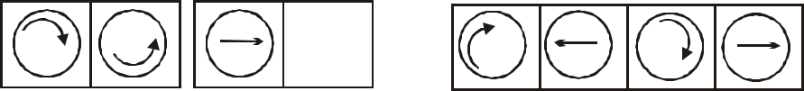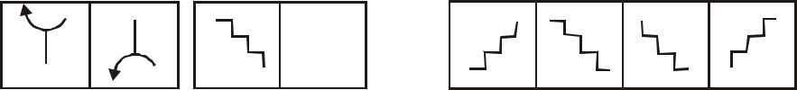

1 2 3 4 a b c d

1. ***General awareness and Aptitude test***



|  |  |  |  |  |  |  |  |  |
| --- | --- | --- | --- | --- | --- | --- | --- | --- |
| 7. |  | 3 | ? | a | b | c | d |  |
| 1 | 2 | 4 |  |
| 8. |  |  | ? |  |  |  |  |  |
|  |  |  |  |  |  |  |  |
| 1 | 2 | 3 | 4 | a | b | c | d |  |
| 9. |  |  | ? |  |  |  |  |  |
|  |  |  |  |  |  |  |  |
| 1 | 2 | 3 | 4 | a | b | c | d |  |
| 10. |  |  | ? |  |  |  |  |  |
| 1 | 2 | 3 | 4 | a | b | c | d |  |
| 11. |  |  | ? |  |  |  |  |  |
| 1 | 2 | 3 | 4 | a | b | c | d |  |
| 12. |  |  | ? |  |  |  |  |  |
| 1 | 2 | 3 | 4 | a | b | c | d |  |
| 13. |  |  | ? |  |  |  |  |  |
| 1 | 2 | 3 | 4 | a | b | c | d |  |



14.  ?

1 2 3 4 a b c d

***General awareness and Aptitude test 41***



|  |  |  |  |  |  |  |  |
| --- | --- | --- | --- | --- | --- | --- | --- |
| 15. |  |  | ? |  |  |  |  |
| 1 | 2 | 3 | 4 | a | b | c | d |
|  |  |  | Key (Analog Test) | |  |  |  |
|  | 1 | d | 6 | a |  |  | 11 b |
|  | 2 | d | 7 | a |  |  | 12 d |
|  | 3 | c | 8 | a |  |  | 13 a |
|  | 4 | d | 9 | c |  |  | 14 d |
|  | 5 | d | 10 | d |  |  | 15 d |

**iv) Completing an Incomplete Pattern**

These are based on the Raven Progressive Matrices Tests (1938-56). They were developed in England and used during World War II. They are non-verbal scales developed to judge your ability to comprehend correlations between geometric figures and diagrams, and to perceive the structure of the design in order to select the appropriate part from amongst a number of choices for completion of each pattern.

**Multiple Choice Questions**

Directions: A pattern/figure is given, a portion of which is left incomplete. A few choices- a,b,c and d in the answer figures are also given. You have to select the figure which fits into the blank space in the incomplete figure so that the original pattern is complete.

Incomplete Figures Answer Figures

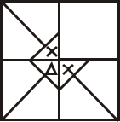

 ?



1.

A B C D

2.

3.

 ? 



A B C D

 ? 

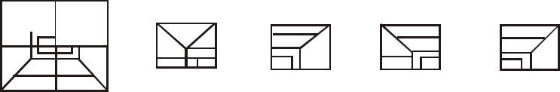

A B C D

1. ***General awareness and Aptitude test***

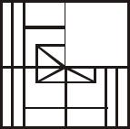

 ?



4.

A B C D

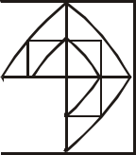

5.  ?



1.  ? 
2. ?
3.  ?
4.  ? 
5. ?

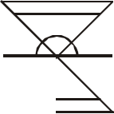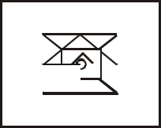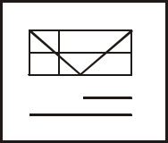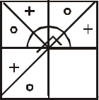

A B C D



A B C D



A B C D



A B C D

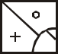

A B C D

***General awareness and Aptitude test 43***

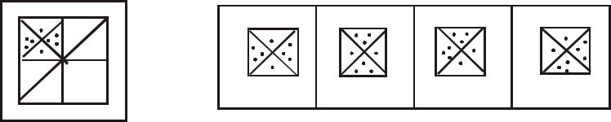

11. *?*

A B C D

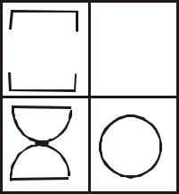

 ?



12.

A B

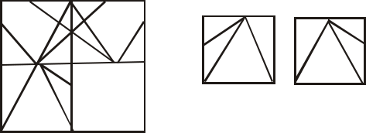

|  |  |  |  |  |
| --- | --- | --- | --- | --- |
| 13. | ? | A | B |  |
|  |  |
|  |  |  |

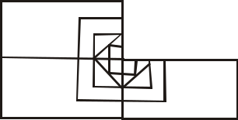

C D



C D

14.

15.

?



A

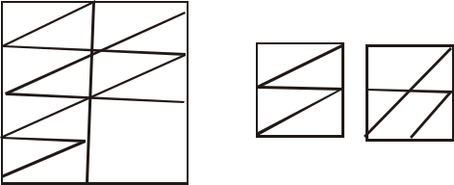

? A B

B C D



C D

Key (Completing an Incomplete Pattern)

|  |  |  |  |  |  |
| --- | --- | --- | --- | --- | --- |
| 1. | d | 6. | b | 11. | a |
| 2. | a | 7. | a | 12. | b |
| 3. | b | 8. | c | 13. | a |
| 4. | c | 9. | c | 14. | b |
| 5 | a | 10 | d | 15 | a |

1. ***General awareness and Aptitude test***
2. **Spotting Hidden Pattern**

**Important Points**

These non-verbal tests are designed to judge your sense of observation and analytical aptitude. In such questions, the PROBLEM FIGURE comprises just one figure. The ANSWER FIGURE contains four different blocks. The ANSWER FIGURE has a hidden figure of the PROBLEM FIGURE which is to be spotted out.

**Multiple Choice Questions**

***Direction:*** There is one block on left hand side marked (X) which has the basic design. The four blocks that follow, i.e. A,B,C and D have a group of more complex figures in one of which the main/basic figure given left hand column (X) is hidden/embedded in some position. You have to spot that particular figure from the choice of answers A,B,C and D.



1.

X A B C D

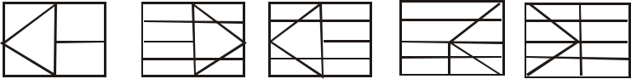

2.

X A B C D

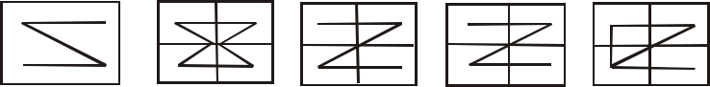

3.

X A B C D

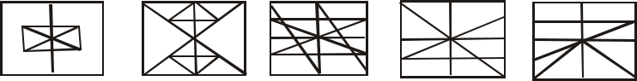

4.

X A B C D

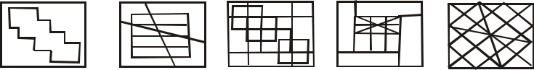

5.

X A B C D

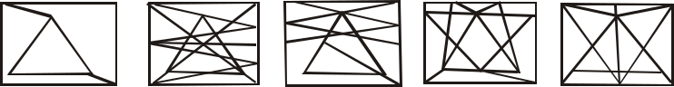

6.

X A B C D

***General awareness and Aptitude test 45***



7.

X A B C D

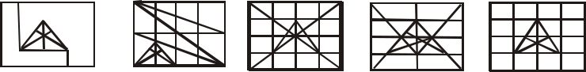

8.

x A B C D

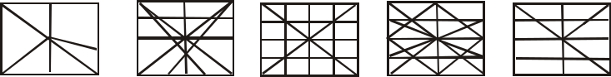

9.

x

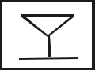

10.

x



A B C D

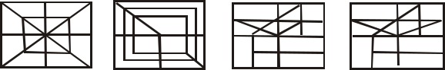

A B C D



11.

x

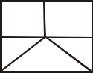

A B C D

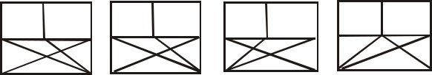

12.

x

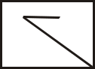

1. 

x

1. 

x



A B C D



A B C D



A B C D

Key (Spotting Hidden Pattern)

|  |  |  |  |  |  |  |  |  |  |
| --- | --- | --- | --- | --- | --- | --- | --- | --- | --- |
| 1 | b | 4 | b | 7 | b | 10 | a | 13 | d |
| 2 | b | 5 | b | 8 | b | 11 | b | 14 | a |
| 3 | a | 6 | a | 9 | c | 12 | d |  |  |

1. ***General awareness and Aptitude test***

**vi) Identical or Similar Pattern**

In these tests, the problem figure comprises only one figure. Below it are given four alternative figures. Of the four alternative figures, one figure is similar or identical to the problem figure. The candidates must study the problem figure and note its characteristic or peculiarities in detail. Then they should try to identify or locate the alternative figure which is identical to the problem figure. The answer figure should be identical to the problem figure, or should have the same characteristics as the problem figure, which is to be spotted out.

**Multiple Choice Questions**

***Directions:*** Select from the four alternative figures, the one with the same characteristics as in the given figure.

1. Given Figure: 3. Given Figure:



Alternate Figure:

Alternate Figure:

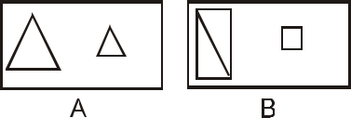

A B



C D

1. Given Figure:

4. Given Figure:

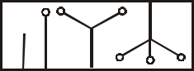

Alternate Figure:

Alternate Figure:

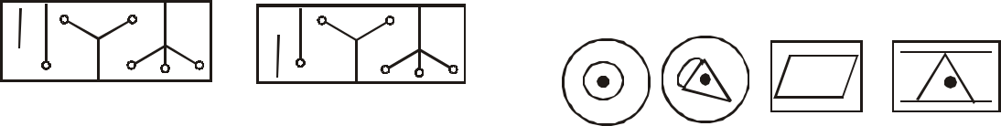

A B

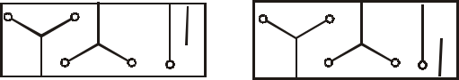

A B C D

C D

***General awareness and Aptitude test 47***

5. Given Figure: Alternate Figure:

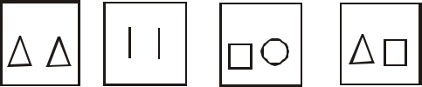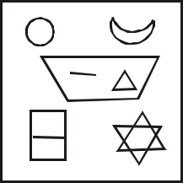

A B C D

8. Given Figure:

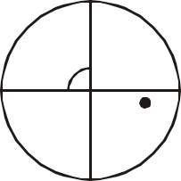

Alternate Figure:

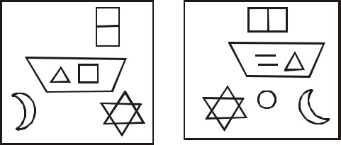

Alternate Figure:



A B

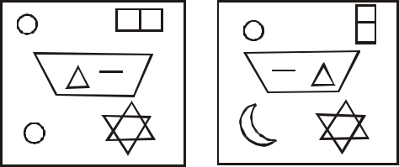

A B



C D

C D

1. Given Figure:

9. Given Figure:



Alternate Figure:

Alternate Figure:



A B C D

A B C D

7. Given Figure: 10. Given Figure:



1. ***General awareness and Aptitude test***

Alternate Figure: 13. Given Figure:

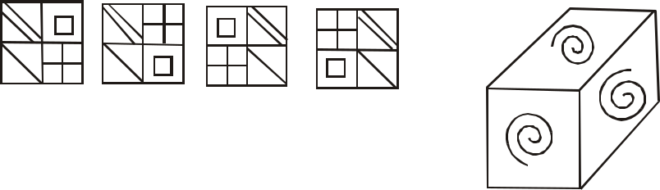

A B C D

11. Given Figure:

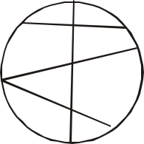

Alternate Figure:

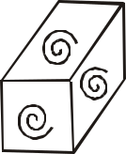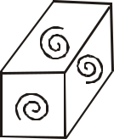

Alternate Figure:

A B

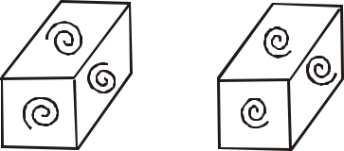

A B

C D



14. Given Figure:

C D

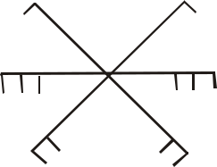

12. Given Figure:

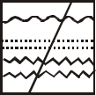

|  |  |  |
| --- | --- | --- |
| Alternate Figure: | Alternate Figure: |  |
|  |  |

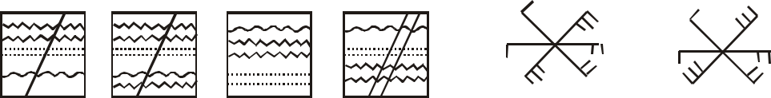

A B

A B C D

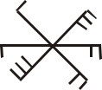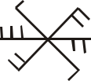

|  |  |  |  |  |  |  |  |  |
| --- | --- | --- | --- | --- | --- | --- | --- | --- |
| Key (Identical or Similar Pattern) | | | | |  |  |  |  |
| 1 | c | 6 | d | 11 | a |  |  |  |
| 2 | c | 7 | c | 12 | a | C | D |  |
| 3 | a | 8 | d | 13 | c |  |
|  |  |  |
| 4 | b | 9 | d | 14 | a |  |  |  |
| 5 | d | 10 | b |  |  |  |  |  |



**vii) Lateral Inversion**

**Important Points**

This test requires the candidate to observe carefully how a given figure will appear in the mirror, if the mirror is held at a particular position. For this test, you must remember that the left side of a pattern appears to be on the right side in the mirror and vice-versa.

***General awareness and Aptitude test 49***

1. Key Figure:

Answer Figure:



|  |  |  |  |  |
| --- | --- | --- | --- | --- |
| **Multiple Choice Questions** | a | b | c | d |
| ***Directions:*** In the following questions, a |  |  |  |  |
| figure is followed by four suggested mirror 4. | Key Figure: |  |  |  |
| reflections of it. Assuming that the mirror is placed |  |  |  |  |
| to the right of the figure (except in questions 7,11 |  |  |  |  |
| and 12), pick out the correct reflected figure. |  |  |  |  |
| 1. Key Figure: | Answer Figure: | |  |  |

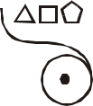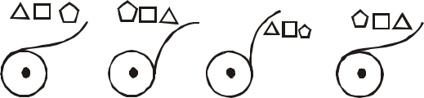

A B

Answer Figure:

5. Key Figure:



|  |  |  |  |  |  |  |
| --- | --- | --- | --- | --- | --- | --- |
|  |  |  |  | = | o |  |
|  |  |  |  | s |  |
| a | b | c | d |  |  |
| Answer Figure: | |  |
| 2. Key Figure: |  |  |  | s | = |  |
|  |  |  | o | o |  |
|  |  |  |  |  |
|  |  |  |  | = | s |  |
|  |  |  |  | A | B |  |
| Answer Figure: | |  | 6. | Key Figure: | |  |

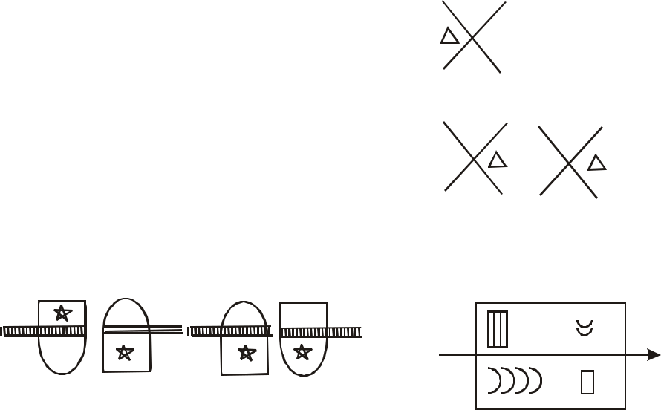

C D

* s



o  o

|  |  |  |
| --- | --- | --- |
| s | = |  |
| D |  |
| C |  |

a b c d

1. ***General awareness and Aptitude test***

Answer Figure: Answer Figure:

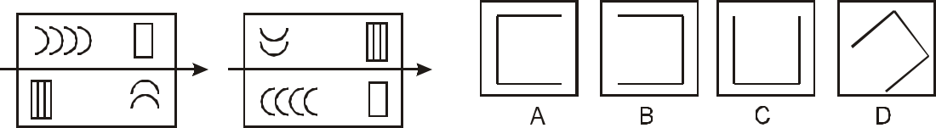

A B

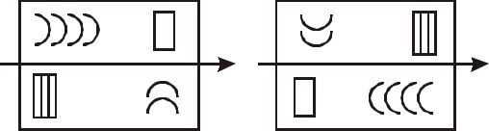

8. Key Figure:



C D

Answer Figure:

7. Key Figure:



A B C D

***Direction*** ((9-26): In each one of the following questions, choose the correct mirror image of the figure 'X' from amongst the form alternatives a,b,c,d given along with it.



9.

(X) A B C D

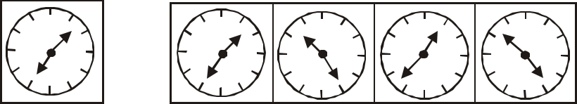

10.

(X) A B C D

11. (Mirror is placed at the Bottom)

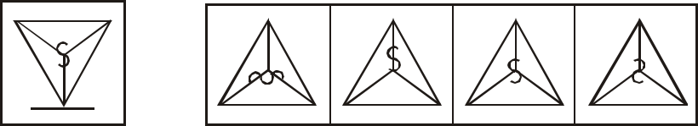

A B

(X) A B C D

***General awareness and Aptitude test 51***

12. (Mirror is placed at the Top)

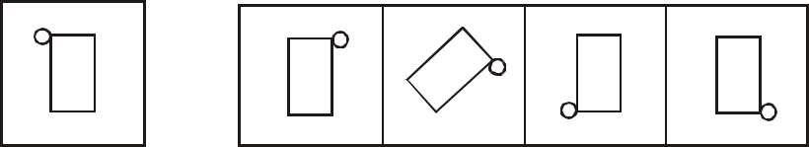

(X) A B C D



13.

(X) A B C D

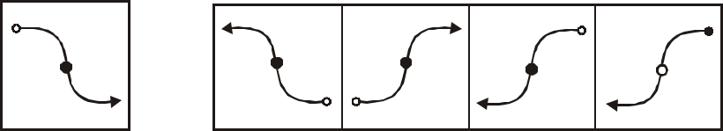

14.

(X) A B C D

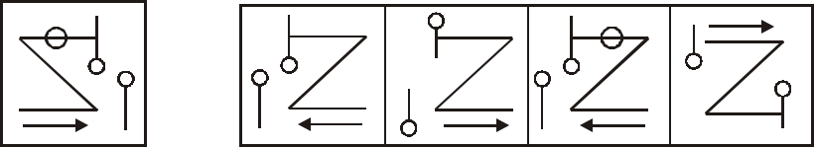

15.

(X) A B C D

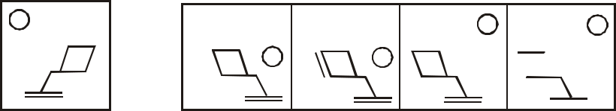

X

16.

X X

X X 

(X) A B C D

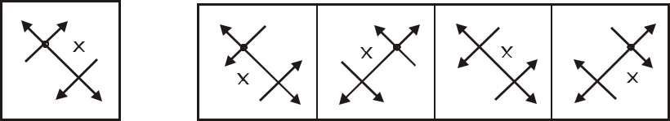

17.

(X) A B C D

1. ***General awareness and Aptitude test***

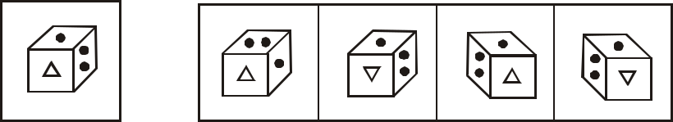

18.

(X) A B C D

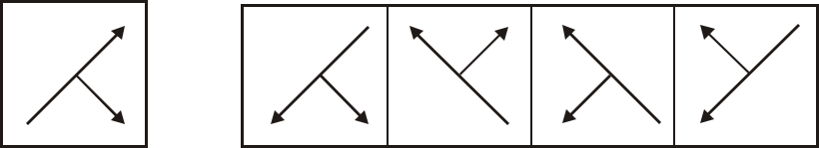

19.

(X) A B C D

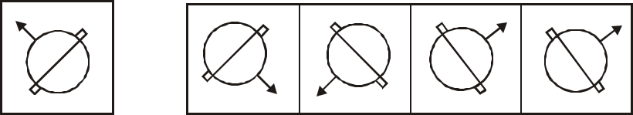

20.

(X) A B C D

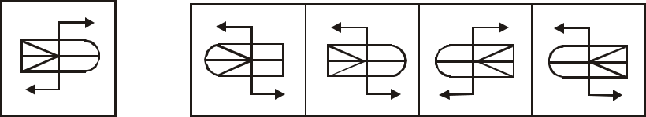

21.

(X) A B C D

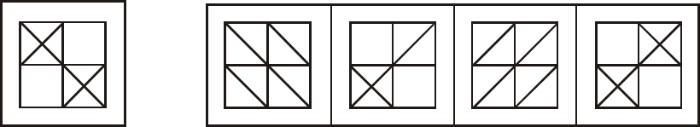

22.

(X) A B C D

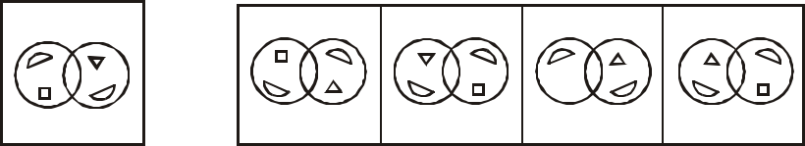

23.

(X) A B C D

***General awareness and Aptitude test 53***

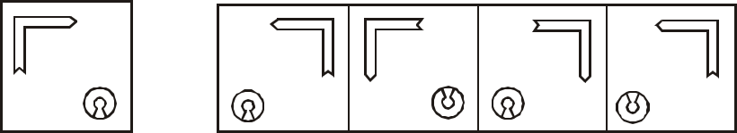

24.

(X) A B C D

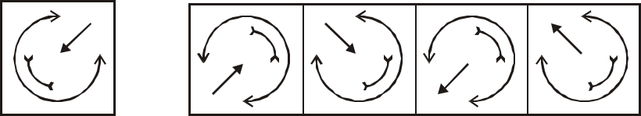

25.

(X) A B C D

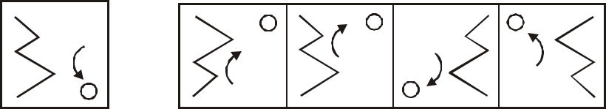

|  |  |  |  |  |  |  |  |
| --- | --- | --- | --- | --- | --- | --- | --- |
| 26. |  |  |  |  |  |  |  |
|  |  | (X) |  | A | B | C | D |
| Key (Later Inversion) | | |  |  |  |  |  |
| 1. | b | 10. | d | 19. | c |  |  |
| 2. | a | 11. | d | 20. | c |  |  |
| 3. | c | 12. | c | 21. | d |  |  |
| 4. | d | 13. | d | 22. | d |  |  |
| 5. | c | 14. | c | 23. | b |  |  |
| 6. | d | 15. | c | 24. | a |  |  |
| 7. | c | 16. | c | 25. | b |  |  |
| 8. | c | 17. | b | 26. | c |  |  |
| 9. | c | 18. | c |  |  |  |  |

**viii) Folded and Unfolded Pattern**

**Important Points**

In this test, the problem figures show how a piece of paper or cardboard is folded and cut or punched. From the answer figures, you are required to choose the correct shape of the paper or cardboard when it is unfolded.

**Multiple Choice Questions**

***Directions*** 1-15: In each one of the following questions, find from amongst the four response figures, the one which resembles the pattern formed when the transparent sheet, carrying a design is folded along the dotted line.

1. ***General awareness and Aptitude test***

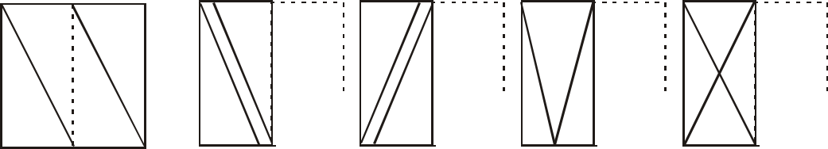

1.



A B C D

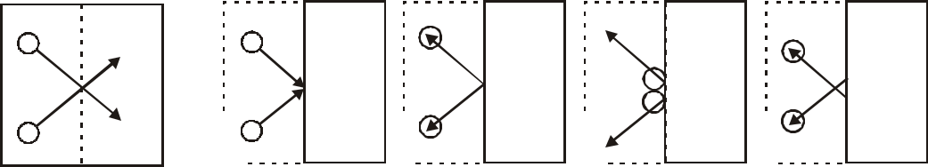

2.



A B C D

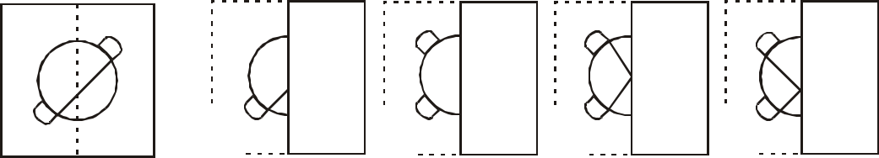

3.



A B C D

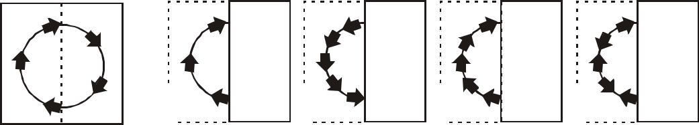

4.



A B C D

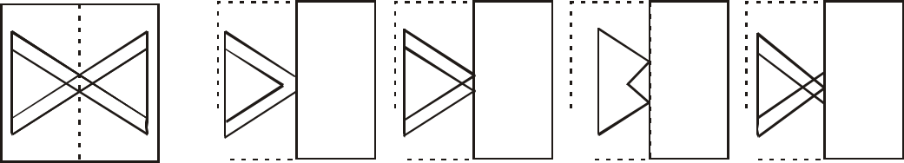

5.



A B C D

***General awareness and Aptitude test 55***

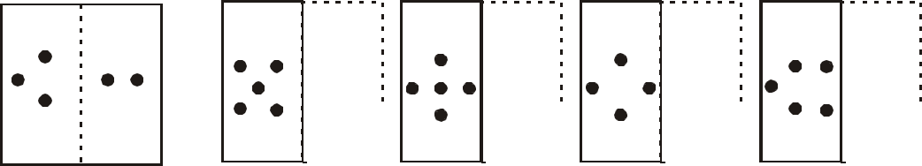

6.



A B C D

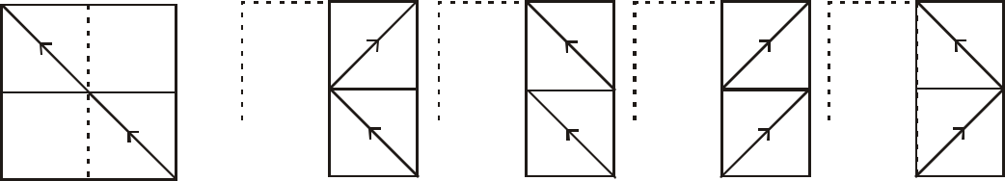

7.



A B C D

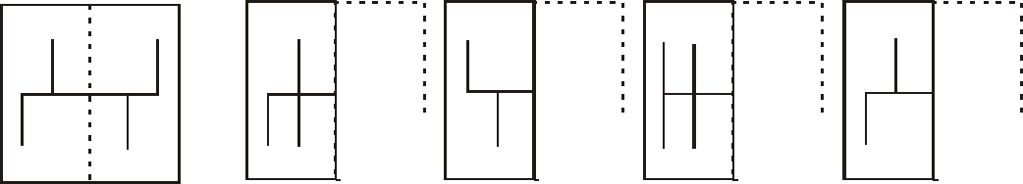

8.



A B C D

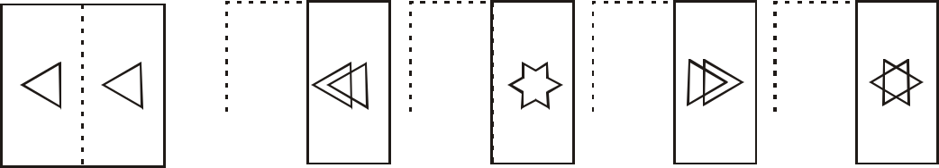

9.



A B C D

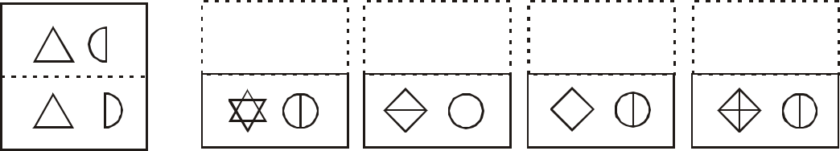

10.

A B C D

1. ***General awareness and Aptitude test***

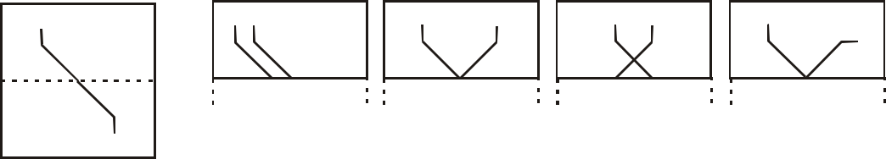

11.



A B C D

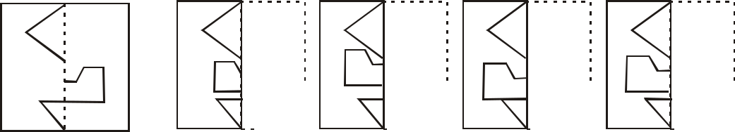

12.



A B C D

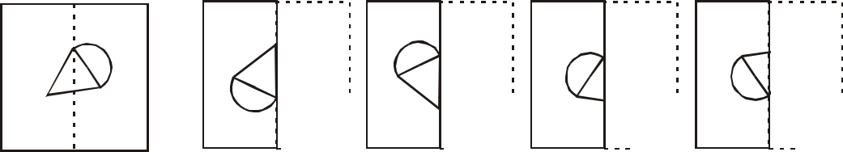

13.



A B C D

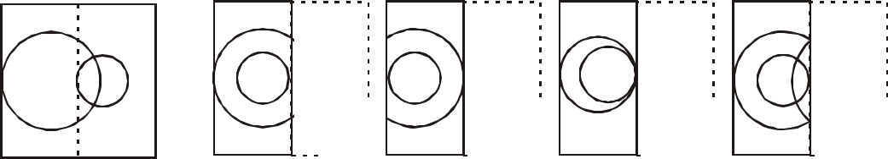

14.



A B C D

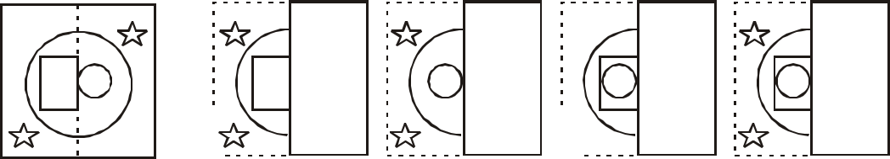

15.



A B C D

***General awareness and Aptitude test 57***

***Directions*** (16-20): A piece of square paper is folded as shown below and a cut is made as marked. How would the paper look like when unfolded?

16. Problem Figures:



Answer Figures:

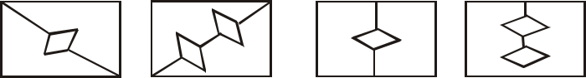

A B C D

17. Problem Figures:

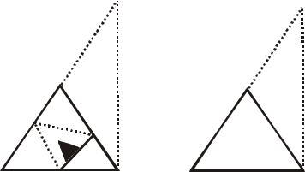

Answer Figures:

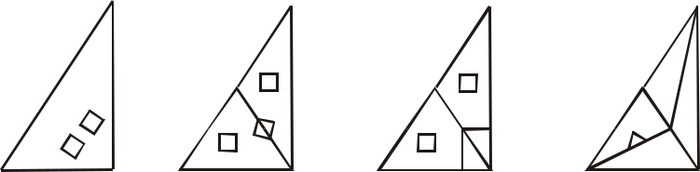

A B C D

18. Problem Figures:

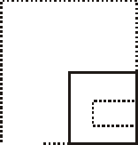

Answer Figures:

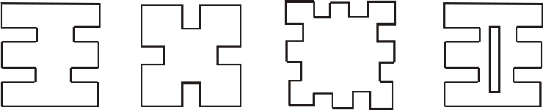

A B C D

1. ***General awareness and Aptitude test***
2. Problem Figures:

Answer Figures:

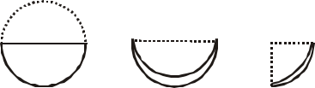

A B C D

1. Problem Figures:

Answer Figures:

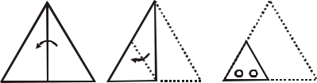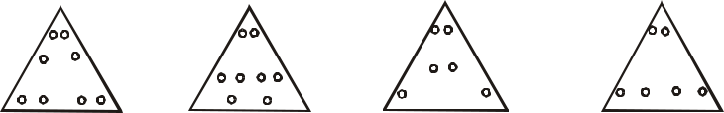

A B C D