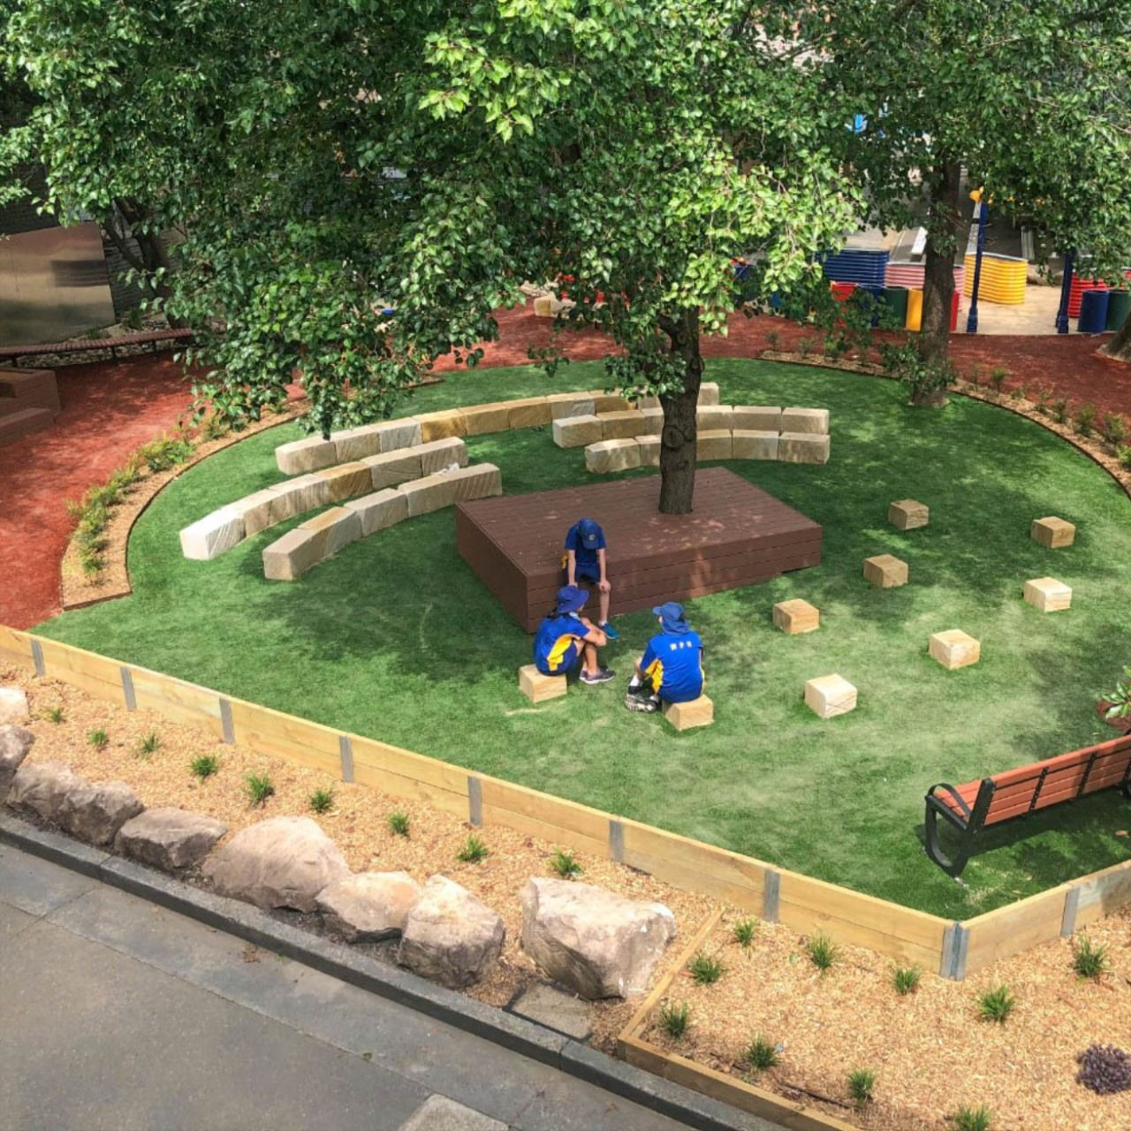  WORKING TOWARDS THE SUSTAINABLE TRANSFORMATION OF EDUCATION SYSTEMS LINKED WITH TECH-TRAD METHODS  (Education with Sustainable Development) | Abstract  This study specifies that individual departments and specific institutions in rural areas of the school to create a wonderful environment for enhancing learning have improved subject codes. Education for Sustainable Development means integrating key issues of sustainable development into teaching and learning through visionary new technologies in urban areas. Education for Sustainable Development means integrating key issues of sustainable development into teaching and learning through visionary new technologies in urban areas. Education for Sustainability develops the knowledge, skills, values and worldviews necessary for people to act in ways that contribute to more sustainable living patterns.  DEEPU KUMAR  ENVIRONMENTAL SCIENCE

2023
WORKING TOWARDS THE SUSTAINABLE TRANSFORMATION OF EDUCATION SYSTEMS LINKED WITH TECH-TRAD METHODS

A Dissertation submitted in partial fulfilment of the requirements
the degree of
Bachelors of Science (Hons.)
in
ENVIRONMENTAL SCIENCE
Submitted by
RAJAK DEEPU KUMAR
PRN – 2020033800061234
Under the Supervision of
Dr. SWAYAM SIDDHA



Department of Environmental Science
Faculty of Science
THE MAHARAJA SAYAJIRAO UNIVERSITY OF BARODA
2023

  Department of Environmental Science
  Sir CV Raman Building, Faculty of Science
  The Maharaja Sayajirao University of Baroda
  Vadodara, Gujarat, India – 390002
  Email: head-env@msubaroda.ac.in

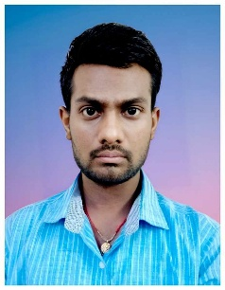
Date: 25.04.2023

Certificate
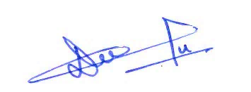 | 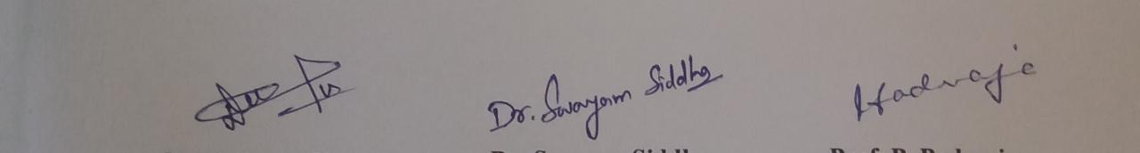 | 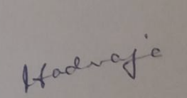
Rajak Deepu Kumar | Dr. Swayam Siddha | Prof. P. Padmaja
(Candidate) | (Supervisor) | (Offg. Head of Department)
This is to certify that the dissertation thesis entitled “Working Towards the Sustainable Transformation of Education Systems Linked with Tech-Trad Methods” submitted by RAJAK DEEPU KUMAR, Exam Seat No.614047, PRN: 2020033800061234 as part of the fulfilment of the requirements for the award of the degree of Bachelor of Science (Hons.) in Environmental Science. It embodies the work carried out in the Department of Environmental Studies, Faculty of Science, The Maharaja Sayajirao University of Baroda, Vadodara, Gujarat. The content presented in this Dissertation Thesis incorporates the original findings of independent research work carried out by the candidate himself. The content of this thesis has not been submitted elsewhere for the award of any degree.

Plagiarism Report










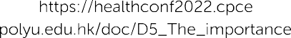

DECLARATION
I declare that this written submission represents my ideas in own words and where other’s ideas or words have been included in my thesis. I have adequately cited and referenced the original sources. I also declare that I have adhered to all principles of academic honesty and integrity and have not misrepresented or fabricated or falsified any idea/data/fact/source in my submission. I understand that any violation of the above will be cause for disciplinary action by the Institute and can also evoke penal action from the sources which have thus not been properly cited or from whom proper permission has not been taken when needed.

Place: Vadodara Name: Rajak Deepu Kumar
Date: 25 February 2023

ACKNOWLEDGEMENT

A project is an excellent opportunity for learning and self-development. I consider myself very lucky and honored to have many wonderful people who lead me through the completion of this academic work.
I, Deepu Kumar, express my sincere gratitude to my esteemed supervisor – Dr Swayam Siddha for his invaluable supervision, support, and tutelage during the course of my degree. My gratitude extends to the Faculty of Science for the funding opportunity to undertake my studies at the Department of Environmental Studies, The Maharaja Sayajirao University of Baroda. Additionally, I would like to express gratitude to additional faculty members to leading for their treasured support, which was influential in shaping my experiment methods and analyzing my results. I also thank my seniors for their mentorship regarding their experiences. I would like to thank my friends, classmates, colleagues, and research team for the cherished time spent together in the lab and settings. My appreciation also goes out to my family and friends for their encouragement and support throughout my studies.

Rajak Deepu Kumar
B.Sc. (Hons.) Environmental Science
Final Year (2020-2023)

RESEARCH THEME
“Education with Sustainable Development”

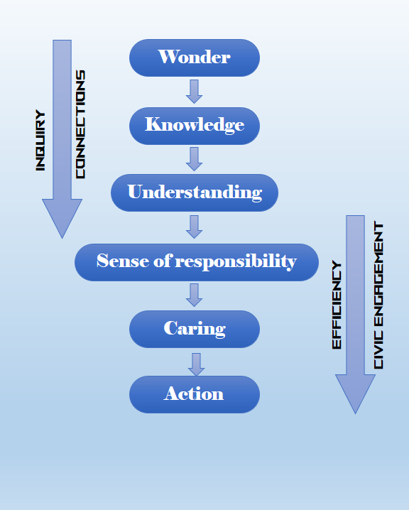

OBJECTIVES
- To study the background education and contributions applied to the life
- To analyze the system and background of education at the International level with comparison to periods
- To improve the burden and barrier level to develop an interest in professions.
- To optimize the alternative methods to enhance better qualities with the audience.

Table of Content

Acknowledgement v
Table of Content vii
List of Figures viii
Abstract ix
1 Introduction 1
1.1 Education System Performances during the Periods of the Ancient Era 3
1.2 Education System Performances during the Periods of the Medieval Era 4
1.3 Education System Performances during the Periods of the Modern Era 5
1.4 To understand the importance of an education perceived in the Modern Era. 6
1.5 Transformation of Education after Post Covid-19 to Whole Countries 7
1.6 The Comparison of Education Systems and factors affecting the World India 7
1.7 The comparison of the Indian education system with abroad education systems 8
2 Review of Literature 11
3 Methodology 17
3.1 Factors affect leading with Observation to research 18
3.1.1 Several factors of a high literacy rate in a country. 18
3.1.2 The factors show that Low literacy rates in low-lying countries 18
3.1.3 Elements of an effective sustainability education pattern: 19
3.1.4 Missions and Visions of jnvs toward sustainability 21
3.1.5 NCSC (National Children’s Science Congress) Model to promote advance 22
3.1.6 Gurukuls and Ashram’s methodology procedure in foreign countries. 22
3.1.7 Gurukuls system can be made relevant to the technological generation: 23
4 Results and Discussions 25
5 Conclusions 36
6 References 38

List of Figures

Figure 1 - No. of Gurukuls (Present*) 4
Figure 2 - No. of JNVs (Present*) 10
Figure 3 - Procedures for Researching opinions 17
Figure 4 - Classification of People 25
Figure 5 - Composition of Qualification (Present*) 26
Figure 6 - (a) Model of Institutions (b) Structure of Background 26
Figure 7 - Rating to Education System of India 27
Figure 8 - Educational Background Index 28
Figure 9 - Activities interaction with module 28
Figure 10 - Synchronize with new methods from Educators 29
Figure 11 - Qualities expected from Educator 30
Figure 12 - Learning techniques lead in curiosity 31
Figure 13 - Ideas for promoting Gurukuls (Present*) 31
Figure 14 - Individual Philosophy on Education 32
Figure 15 - Exam phobia barrier with Study 32
Figure 16 - New Experiment with System 33
Figure 17 - Response w.r.t Time Period 34
Figure 18 - Evaluation of syllabus with Period 35

ABSTRACT

Deepu Kumar, Dr. Swayam Siddha

This study specifies that individual departments and specific institutions in rural areas of the school to create a wonderful environment for enhancing learning have improved subject codes. Education for Sustainable Development means integrating key issues of sustainable development into teaching and learning through visionary new technologies in urban areas. Education for Sustainable Development means integrating key issues of sustainable development into teaching and learning through visionary new technologies in urban areas. Education for Sustainability develops the knowledge, skills, values and worldviews necessary for people to act in ways that contribute to more sustainable living patterns. The majority of reviews and need state-of-the-art coaches with personalized suggestions to improve their skills. They mainly advocate technical integration and sometimes experience development variations.
The classroom framework combines with digital and Environmental aspects, with only want leaning towards Gurukul-based methods in today`s modern era to promote Green interactive classes and mission to enhance growth of interest in students. Our data analysis shows a moderate rating are moderate, which is considered average in our education system. To improve the performance of the educator, he must be approachable and use a unique and humorous approach to explanations. Adding activities such as fieldwork and research-based assessments can improve their effectiveness. Reduce carbon footprint from digital courses by implementing Gurukul-based learning. Deploy the system for a better experience; Prioritize practical lessons. Students need important qualities and skills to excel in any field. The student's problem is a lack of success. We need to bring a system for a better experience. Prioritize hands-on instruction. Students need important qualities and skills to excel in any field. The problem with students is that they do not succeed.

___________________________________________________________________________
Key Words: Sustainability Manner, RTE, Tech-Trad, Traditional, Technology, JNVs, NCSC, Gurukuls.

Introduction
Education is not a preparation for life because it is life itself. Education is the only weapon we use to solve all problems in some usual cases. Education and sustainability are essential to save us today. The earth, due to global warming and its environmental impact are causing a crisis all over the world. We want to improve the solution to this problem through the sustainable use of education. The Gaps required to Conjugate Higher Students with University students. The level of thinking capacity became level up to similar but requires to such trying to develop in upgradation to open source of Mind and applicable to facing decision to solve the problem in any situational.
Different countries have infrastructures and systematic patterns of education that can be successful in applying in today's world. Education is the process of developing an individual's character and creativity so that they can contribute to the promotion of a healthy society. It is a process that influences individual skills, social environment, economic development, ethical environment, and most importantly cultural adaptability (Grohs et al., 2018). The requirement of expect to develop principles, methods, and guidelines for applying knowledge that may benefit society. The system enrollment to provide knowledge and skills to solve development challenges. It should also enable people and students to develop an understanding and perspective of their physical and social environment (Stefan, 2012).
The importance of education can be took from the answer to Aristotle's question. The question was, "How much better are educated men than uneducated men?" Aristotle's answer was as much as the abode of the dead. Therefore, education is an investment in human resources. In today's technological age, there is a growing awareness that education is necessary not only to become a better human and social being but also to be a creative and productive being. What our children wanted and bequeathed to our grandchildren may not get any better, as the environment has deteriorated because of political and economic choices made. Today, economic development is a matter of great concern those who benefit from this may aggravate future generations by excessively damaging or destroying natural resources and polluting the global environment (Boeren, 2019).
The motto of the G20 Earth Summit in India - 2023 (One Earth - One Family - One Future). Focused primarily on broad macroeconomic policies, the G20 is now expanding its scope to include trade, climate change, sustainable development, energy, the environment, anti-corruption, and more efficiencies (PIB Chennai, 2023). Each year G20 presidency charges control by the selected nation to control the conference to research and mitigate 17 sustainable Goals. One of the goals is “quality education”. The theme and logo reworking in the sense of action in every year with a new theme and slogan to promote the challenges to bring transformation inside us. Many of the institutions conducting the meeting to conventional pattern for education in the G20 presidency (Education et al., 2023). Education unleashes the intellect, unleashes the imagination, and is the foundation of self-esteem. It is a contribution to progressive people, to human society, and all. Goal by 2030; Ensure free, fair, and equitable access to quality education for all (Boeren, 2019). Affordable technology, equal access to experts, and more people with the skills needed to succeed in business. End all forms of discrimination in education, increase gender participation in education, education for sustainable development, global citizenship, create effective learning environments for all, and promote science in other countries.
The increase the supply of qualified teachers in different countries (Boeren, 2019). When education is sustainably connected, it applies system-wide, enabling more students to be educated. These students are interested in learning, they are interested in the institution, and they can spend more time on unnecessary activities (Sauve, 1996) (Mogren et al., 2019). A discussion of educational systems from antiquity to the development of modern technology. It would be better to get feedback that changes should be developed and implemented. This makes changes more comfortable for you and benefits the community.
Education is an essential element in building civilization. Civilizations and countries progress rapidly when the education system contributes greatly to human resource development. The rise of a nation is determined by the extent to which its educational institutions succeed in educating its people into good human beings and worthy citizens of the world (Mogren et al., 2019). The Hindu civilization dramatically emphasizes the importance of education. Education plays a large part in the history of Sanatana Dharma, along with the construction of the Gurukuls concept of teachers and students living together in an institution (Bhattacharya & Sachdev, 2021). Moreover, when the West was unable to find an established education system, India built the first university in the world with a highly developed education system; Taxila University is one of them those periods the better management pattern and so on. However, the progress of past civilizations was not always carry to the next era. Hindus, especially Hindus in Indonesia, are faced with a Hindu-based education that can meet global challenges (Seriadi, 2020). We seek the educational institutions necessary not only to develop excellent human resources but also to acquire skills as a global phenomenon Activities like yoga, meditation, singing etc. developed and equipped positivity and satisfaction. It was often obligatory to do regular chores on their own to communicate practical knowledge (Pareek, 2021). Hindu educational institutions are expected to be able to become modern Gurukuls and achieve excellence in human resources (Madhekar, 2020). In the constitution, the accessibility of the Right to Education from ages 6 to 12 should be free, the requirement of focus on this background. Because rural students are the best student as compared to facilitate students because they can able to create the full effort on any task.

Education System Performances during the Periods of the Ancient Era
The Ancient educational system was a combination of dwellings and institutions called ashrams or Gurukuls. Students leave their pre-adolescent parents for transformational education. The Ancients conceived of the concept of life in its role of education in providing students with the two kinds of knowledge necessary for their life goals. Life or spiritual knowledge related to becoming good people who participate in moksha to become social professionals (Pal, 2021). They learn hands-on from their hearts and brains, and students put their learning into practice. The focus that accompanies her inner sensory development is physical, mental, emotional, and spiritual. The purpose of making institutional in what way to practice and were experts in the sense of timing and self-introduction as a scientific part of life (Patel, 2021). A formal educational system, these Gurukuls educational systems were the great knowledge and wisdom of the Vedas, the intellectual, It played a major role in the theoretical, practical, secular, religious, or art of warfare, as well as character and personality formation. Transforming his students into useful citizens of society (Patel, 2021). Ancient Indian civilization is one of the most interesting and important civilizations in the world. For proper knowledge of this civilization, it is necessary to study its education system, which protected, propagated and amended this civilization for more than four thousand years. Ancient Indians highly valued education. The great need for education was always accepted for physical and spiritual upliftment and for the proper fulfillment of various responsibilities. Right from the Vedic era, it was considered as a source of light, which illuminates various areas of human life and gives it the right direction.

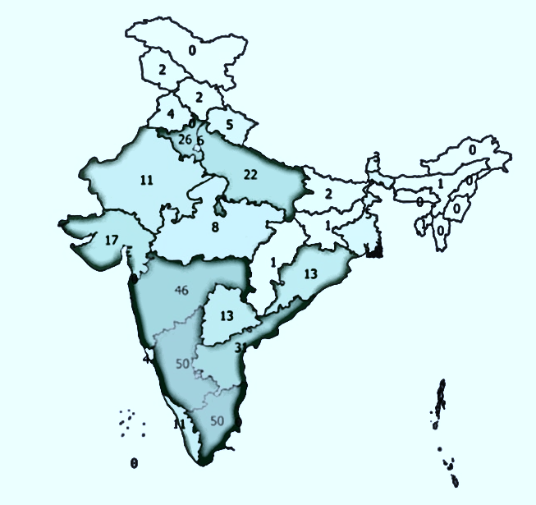
Figure 1 - No. of Gurukuls (Present*)

Education System Performances during the Periods of the Medieval Era
Educational enlightenment is slowly disappearing. Upanishads, Vedas, spirituality, and Buddhism contain the more distracting concepts that cause their minds to change after changing their educational behavior (Stefan, 2012). The advancement of a nation is determined by the extent of the educational institution which has succeeded in building its human being into a superior human being to be a dignified world citizens (Seriadi, 2020). Discipline and moral education were the focus of educational methodology to better advancement in person to gain accountability to prefers as the better sustainable to required less use of securities to development as snowball method to access to enable the dismissed of privacy. Traditional education appears deficient in its failure to recognize men’s relationship to an ecological system of which he is a part, and the need for adjustment of his behavior to rapidly changing conditions (Watson & Watson, 2017).
During this period, teachers enjoyed special respect and status in society. Gurus are sources of knowledge because of their dedication, quality of teaching, and spiritual attitude. Students acquired knowledge through processes such as listening to and understanding the teacher's words, reasoning, solving problems through teachers and friends, and orally imparting knowledge in Ancient India and spiritual guidance related to philosophy (Bhattacharya & Sachdev, 2021). The method of learning was to ask, direct and advise students. In addition, teachers used other techniques such as debate, discussion, oral reading, question answering, and storytelling. The Mughals wanted to educate the common people and spread education. They allowed both boys and girls to receive primary education. During the Vijaynagar kingdom, Temple, Agrahar, and Mathas were centers of learning. Islamic education came through Mastabas and mosques. They taught subjects such as architecture, astronomy, art, mathematics, medicine, painting, philosophy, religion, and theology (Pavi, 2011). Universities such as Taxila and Nalanda were the centers of education in India. People from different countries immigrate to India to study. At that time, Nalanda University and Taxila University were among the best educational systems, valuable and popular.

Education System Performances during the Periods of the Modern Era
Parenting training is the first initial investment in improving your baby. It is comparable to the development of the United States by governments and nations. The first price tier is with the training infrastructure of a university or college. The school grows in value. A knowledgeable person is useless if he has skills but no values (Seriadi, 2020). For example, many people are knowledgeable and skilled in many trades but use their skills and training to deceive and confuse society with their innovative fouls. Teachers, forums, and curriculum makers need to adapt their topics to specific ones. Students connect and pay attention to the coolest values and usefulness of their education for society and our development. Training should be available to everyone. Thanks to the innovators of fashionable technology and the Internet. Thanks to them, rural residents, bad people, and hut dwellers now have access to training via mobile phones. I was also able to watch and guide my children by being aware of the information I got from videos, search engines, and social media. After a while, you can enter online schools, colleges and universities (Abad-Segura et al., 2020). People with disabilities are unable to raise funds because of their traditional cost value. The education system developed in urban areas more than in rural areas. During this time, the creations of subjects such as art, science, philosophy, and literature. In modern times, British authority's school reports focus on higher education and less on primary education. During this time, school materials take into account the needs and requirements of the people. Individuals who received this education were able to manage their homes perfectly to maintain their schooling (Kioupi & Voulvoulis, 2019).
The ideology of Maharishi Aurobindo’s philosophy of Education background in India is Integral education based on Indian culture, beliefs (Dey et al., 2021), and norms to learn values as own way instead of copying the foreign background to a screening of the mind (Rani, 2017). The philosophy of Sonam Wangchuk is similar to business as sustainable methods, as education with practical inventions brings changes called applied science and Education towards a system that is cheaper and easily affordable and brings the capability to be independent. The transformation of Ladakh (UT) is present in India. The biopic movie gives courage from the movie of the real life of Sonam Wangchuk as Phunshuk Wangdu in the movie of 3 Idiots. It gives many inspirations that bring students capabilities and interest from inside for soul.

To understand the importance of an education perceived in the Modern Era.
- Nowadays the primary reason why a child is pushed into a school at the soft age of three is not always that the parents need him to gain knowledge; it is far due to the fact they may be afraid that their child may be "left-behind" different youngsters who are going via the identical senseless recurring. It is a vision of sight to look at small youngsters sporting truly heavy bags from side to side at school, which stunts their bodily development (Watson & Watson, 2017).
- The era final touch for a sure diploma to get a certain activity. In this manner, training has grown to be surprising and almost like a commercial enterprise today, with institutes charging very high charges for degrees that promise proper placements due to the fact with the organizations. Nevertheless, they are leaving their jobs after 3-4 months or most of them are not happy.
- Most college students are going into institutes with appropriate advertising and marketing approaches and make lofty guarantees to lure people at some stage in admission times. Therefore, humans are not prompt to the lecturers and the first-class coaching but by way of the commercials and promotional campaigns run with the aid of the institute.
- These days every knowledgeable man or woman knows the way to chat nicely with people from all over the international, but they have forgotten how to talk respectfully to elders of their own houses that include parents and others. The most effective training can assist our society to progress similarly and training is the most effective detail this is similarly considerable for all sects, ethnicity, and social companies because it has the energy to uplift each person.
- Everyone focuses on training as the routine for the term but nobody wants to make use of the value of school, and how they must obtain and implements it in his or her life. They do not take, as critically if the getting-to-know effects implemented in daily life everybody might be capable of startups mind of their primary degree to conclude the suitable use of training. The primary awareness to everyone prevents the activity looking for trying to do startup and development self-assets an entrepreneur (Mahaffy et al., 2019).

Transformation of Education after Post Covid-19 to Whole Countries
The NEP 2020 is a brilliant result of intellectual minds. They keep in mind that training has two objectives. One is to help the scholars emerge as appropriate people. Some other is to cause them to an expert in single or multiple fields for developing society.
Schools and Institutions were secure all over the world due to COVID-19. Globally, over 1.2 billion children are out of school. As a result, education has changed dramatically with the dramatic rise of e-learning taught remotely or on digital platforms. Research shows that online learning increases information retention and reduces turnaround time. This means that the changes brought about by the coronavirus may remain.
The effectiveness of online learning varies by age group. The consensus regarding children, especially younger children, is that children are easily distracted and need a structured environment. Replicating physical lessons lectures via video features but instead of comprehensiveness, personalization facilitating and intelligence (Stefan, 2012).

The Comparison of Education Systems and factors affecting the World India
Indian education is organic, growing, and evolving with time and the human spirit. This is the main reason why education differs in different countries of the world. Principles by which the education system is built uniquely. However, the goal is to make the human mind create. Every education system has its strengths and weaknesses. Strengths and weaknesses a developing country, the Indian education system has developed on the pillars of intensive theoretical knowledge. Students face the toughest competitive exams in various countries. Education systems in other developed countries are flexible. This allows students to pursue career opportunities beyond their usual choices. A developing country, India is the lack of skills and transformation philosophy, so all we need to do is raise funds to improve the educational system efficiently. A research-oriented education to achieve such as curriculum flexibility updates and global knowledge. The focus is to understand the differences between Indian and foreign education systems, especially for those eager to study abroad due to such beneficial human challenges (Badhwar, 2013). The countries also facing the cries of over strength due to filling up for limited vacant seats. Education is specified importance to them but the wars on the attraction competitions. They cannot be able to understand the importance of education for living and not compare competing with each other to respective values including moral values respective with the linking compatibility challenge to appreciate the compatibility to their philosophy (Stefan, 2012).

The comparison of the Indian education system with abroad education systems
Education in India focuses more on theory than on practice. In addition, the Indian education system does not recognize creativity. On the other hand, overseas. They tend to focus on hands-on learning. It also enables creativity in the education system. Education in India is formal and part of the routine. All Indians are required to have an engineering or medical degree. It does not focus on whether the student is learning or not like to give their contribute to making better precise developments (Stefan, 2012).
In foreign countries, education is an entire learning process (Badhwar, 2013). In addition, foreign education curricula typically include everything from arts to sports. The American curriculum primarily includes arts, sports, music, and drama. Australia focuses on sports, with cricket, hockey, and boxing included in the university curriculum. The Indian education system only emphasizes research. That is why our educational system has no place for extracurricular activities. Considering Dubai, primary and secondary education is free and required by law. In India, education becomes business and profit matters. From the privatization of education to tuition fees and coaching institutions, education is making big profits competition reasons are now branded competition enterprises to grow their incomes. Indian exceptions have no choice to choose their field of interest or talent; they mostly have to become engineers or doctors. Although sports and art are, consider futile. So if a student fails to enroll in the Science of Commerce stream and chooses Arts (Burbules et al., 2020). The philosophy of society became so mysterious take decisions, was not about self-acceptation but advice from them.
In India, students are acknowledge to streams with higher salary scales or relatively more jobs. Abroad students self-proclaimed according to their field of interest and talent. When it comes to India, students enroll to see and follow trends. So, in a given year, when the majority of students rush into engineering, students inevitably tend to accept an engineering degree. In India, students do not have the option to choose their field of study (Fuertes-Camacho et al., 2019).
In short, we go with the flow. International students wait until admission grants according to their field of interest and talent. In addition, Indian students generally have to memorize the facts and numbers, thousands of mathematical formulas, birth and death dates of freedom fighters, chemical reactions, and hundreds of other things. We focus primarily on theory. From an international perspective, it effectively influences students' knowledge through hands-on practice. When it comes to the Indian education system, teaches Ancient techniques. If education philosophy familiarized in the system, it acts as overall interests and the transformable first then quickly better upcoming event. Such as thought is “Invest your ideology as your best, profits earn as your value” (Chanda, 2017). Even after independence, the education system has not changed much but the revolution in the system adopted the British or others who ruled after the arrival of the Mughals (Sahoo et al., 2019). The Indian education system is very bad at incorporating the latest technology into the curriculum and incorporating new trends (Ceccherelli & Capaldi, 2020). Abroad, the curriculum is changing daily and the technology and industry needs are improving accordingly (Stefan, 2012). In summary, we believe in grades and certificates above all else. We believe in participating in IIT and IIM conferences on how to want to add our addictive skills to educational platforms (Education et al., 2023). Foreign countries primarily believe in competence and care less about educational institutions than about competence. The student has learned while in school is displayed from the world (Brian Fisher & McAdams, 2015).
The vision of JNVs is to provide good quality modern education-including a strong component of culture, inculcation of values, awareness of the environment, adventure activities and physical education- to talented children predominantly from rural areas without regard to their family's socio-economic conditions (Sabharwal, 2018). All the best qualities were similar to the Gurukuls and JNVs in India. The development of JNVs and Gurukuls is nowadays to understanding the linkage between Ancient and modern periods. At present, the number of JNVs and Gurukuls will being promote to future development with sustainability. The beneficial for providing qualities of education to every citizen of India.
Jawahar Navodaya Vidyalaya (JNV) is a system of central schools for talented students predominantly from rural areas in India, targeting gifted students who lack access to accelerated learning due to financial, social and rural disadvantages. The National Policy on Education-1986 envisaged setting up of residential schools, to be called Jawahar Navodaya Vidyalayas, which would bring out the best of rural talent. Its significance lies in the selection of talented rural children as the target group and the attempt to provide them quality education comparable to the best in a residential school system.
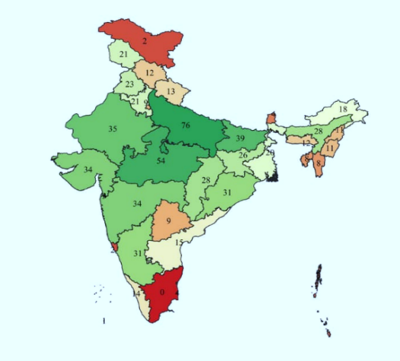
Figure 2 - No. of JNVs (Present*)

Nowadays, many education reformers want to change the system of education actually needs because the quality of education is unmounted. At present Khan Sir (GS), Divyakriti sir, Avadh Ojha sir, Alakh Sir (Physics Wallah) and Anand Kumar (Super 30). They will do such amends to change the pattern of education we need to take over revolution on education system linked with Ancient, Medieval and Modern or Smart technique content all in one. They are trying to make better, cheaper and qualitative education providing to all in India to minimize students who study abroad for education and access to RTE for every age group. The main target of these reformers to make better quality education at low cost. Which can be affordable by each citizen of our nation. Unlimited access of study material providing free on YouTube or source of Internet, if we utilizing there should no barrier of financial status instead to wasting of time in social media. Just to be utilize it is sufficient for us. New Education Policy 2020, according to my ideology similarities access with my research and my expectations. Government target to follow RTE, covering up five crore citizens of India age and above 15 to provide to education through volunteer teacher aspect. Delhi government want to transform all schools to government and substitute with qualities of education to the children. The Gaps required to Conjugate Higher Students with University students. The level of thinking capacity became level up to similar but requires to such trying to innovation in upgradation to open source of Mind.

Review of Literature

The teacher's corporations, surveyed peer faculties via trainer surveys to determine and investigate variations in guidance perceptions of college employers. It examines excellent ESD implementation techniques and precise approaches to organizing proposals for destined ESD implementation efforts, primarily based on a framework rooted in faculty development studies (Mogren et al., 2019). The introduction of ESD into university structures and exercises will transform education, making it more applicable to incoming students and improving their fitness thru social needs (Mogren et al., 2019). Outreach and transparency are seeking recommendations from diplomas where the reasons for the university's exercise are shared and understood in any respect factors within the college. the general motive of ESD is to provide an educational contribution to constructing a sustainable society and future (Fuertes-Camacho et al., 2019). Students have to have the possibility desires social exercise and make enhancements. We name this arms-on experience. Impact on training and destiny studies. Quality enrollment in the implementation of ESD goals (Grohs et al., 2018).
Academic strategies for enforcing sustainable improvements and their effect on college operations. Preference of Interdisciplinary community faculty. The jobs of each term in making it treasured for the following techniques are a stainable improvement, better education, innovation, era, environmental era, technological improvement, and environmental control. Global surveys have found boom developments, such as the best current years (Abad-Segura et al., 2020).
The main classes diagnosed in which extra papers have been social and environmental sciences. The connection between sustainability and the digital era is relevant to the interdisciplinary worldwide imagination and prescience of the human society of their conduct and environmental factors. This vicinity of research has crucial implications for the worldwide clinical network (Fuertes-Camacho et al., 2019).
The internal transformation of roots facilities Sustainable Development, whose outcomes need to change. A strategic first step is to check and empirically validate new strategies to get to know sustainability, offer better scientific underpinnings, and help destiny research and schooling relevant to building internal transformation to support (Wamsler, 2020).
It was developed to provide an organizational base for activities and inter-institutional cooperation. the first takes a look at examining whether there is a hyperlink between mindfulness, compassion, and sustainability, and is pondered in present-day sustainability studies, exercise, and schooling Mindfulness and compassion are not noted in each sustainability science and training (Grohs et al., 2018). They are often living in a foreign country for the first time and fearing their future and meaning during the transition between training and work. There was little room for deep learning and introspection, which ultimately increased my stress levels (Abad-Segura et al., 2020).
Environmental conduct and the applicable fostering of transformative aspects of sustainability, consisting of the human-nature relationship. A conscious, flexible, and adaptive reaction to sustainability-demanding situations such as effective influences, equity issues, social motion, and climate change. Growing and undertaking studies close to studies, the stress to be successful, mastering the terrible environmental effect we are having on the earth, and making human beings privacy to it unconsciously. Nature is constantly their dwelling state of affairs regularly residing out of the country for the first time and fearing their destiny and which means all through the transition between schooling and work (Mahaffy et al., 2019). There has been little room for deep getting-to-know and introspection, which in the end extended my pressure degrees. The Psychology of Education is deep from transforming inside to bringing outcomes outside forever until the constant of Ideas creative to continuing era. The field of educational psychology deals with the study of memory, conceptual processes, and individual differences in the conception of new strategies for human learning processes (Pal, 2021).
The Psychology of training is deep from transforming the interior to bringing consequences outside forever until the consistency of ideas innovative to persevering with technology. The sector of educational psychology offers the examination of reminiscence, conceptual strategies, and man or woman differences within the idea of the latest strategies for human mastering techniques. The adjustments essentially derived that the improvement of schooling patterns now and then adjustments via manners seeking to break out what was in reality needed to us for the Former training system Pre-Independence was not good until the overdue nineteenth century (Pal, 2021).
However, it has advanced the most for the reason that the twentieth century. Now the scenario is very similar as compared to others world education systems time modifications with infrastructures, fine, hobbies, morality, capabilities, and activities in the learner with the superior trends. The governments also promote the school to all gender from time to time with greater advancement in law and policy (Sahoo et al., 2019). We should reserve all around the United States. The chance of the research is to interrupt limitations in education to decorate most of the people to the institutional level. To introduce talent improvement works in the syllabus and impart teaching through the medium in their languages. The years of 2030 timetable truly displays the urgency to include the principles of schooling for Sustainable development (ESD) in all ranges of education. ESD is a critical part of excellent training (Grohs et al., 2018). All instructional establishments, from pre-primary to better training, informal and non-formal education, sell the improvement of sustainability capabilities. Capabilities in education for Sustainable development respond to this urgency and the paper presented affords his current traits in ESD skills (Grohs et al., 2018).
You focus on systematic literary research and curriculum improvement as a meta-evaluation of the interrelationships between sustainability content, capabilities evolved, and educational techniques used. Trying out and validating sustainability capabilities evaluation gear and procedures. Improvement of conceptual fashions focused on exclusive issue areas and stages of schooling (Values, Manners, Primary, Rural schools, Outside school aid offerings, Extra-curricular sports). Those contributions show how the sphere of his ESD competence inside the area of sustainability has gained prominence in the latest years (Grohs et al., 2018). Further studies efforts are had to operationalize sustainability talents and increase equipment to a degree and assess pupil and instructor growth. ESD should understand the concept of lifelong getting to know in all academic institutions from pre-number one to higher training (Badhwar, 2013).
Formal and non-formal training can and have to foster sustainable improvement competencies. ESD is a combination of getting to know content and outcomes, pedagogy, and getting to know the environment. It is supposed to be an interactive, learner-targeted coaching and getting-to-know set. We need movement-oriented and transformative training. It helps self-directed gaining knowledge of, participation and collaboration, trouble orientation, interdisciplinary and transdisciplinary, and relationships among formal and informal learning and crucial improvement. Sustainability abilities have grown over the previous few many years. The period of sustainability is the way the combination of skill drills, which are Cognitive skills, realistic competencies, moral Values, Attitudes, and Sustainability Content implies the whole approachable system (Badhwar, 2013).
Sustainable consistent with the trendy UNESCO files. Development is the ultimate goal of human surroundings therefore; the relationship has to be a complete educational system Redesigned for sustainable development. Such educational consequences are very essential (Giangrande et al., 2019). Statements argued with thoughts on surroundings, education, and sustainable development make the idea of environmental training sustainable. The environment is natural to be valued, reputable and guarded the surroundings are a useful resource to be controlled the surroundings. They are a trouble to be solved the surroundings are a 'location to stay' to learn, plan and nurture schooling for resettlement. Harmonious lifestyles in our place. The surroundings are the biosphere wherein we live collectively (Sauve, 1996). The future surroundings are a network undertaking that you may take part in to get better to become constructed. Humanizing the environment with training. The writer emphasizes the significance of integration. Affective size in environmental training packages. Many lots of nature schooling activities. Environmental value creation sports. Treaty on environmental training for sustainable societies and international obligation (Pavi, 2011). The private and collective war so that intervention companions can build a commonplace feel of favored trade. A vision of humanistic training. Subsequently, the idea of such environmental education in an extensive sense development of an accountable society. We can create many techniques toward solving through methods of field remark to develop the unconditional manner to substitute the gap (Brian Fisher & McAdams, 2015).
The remaining goal of self-actualization is several studying effects, consisting of college students feeling empowered college students feeling engaged, and involved in something that helps the college students able to individualization, college students, learn to take risks students gain knowledge of to take risks master to be complex, learn to appreciate and care for the scholar surroundings (Williams, 2010). In a way, educational institutions try to improve lifestyles slowly and regularly with higher-stage steps to avoid strain for youngsters and develop internally through their very own vision. The boom of acceptance as true among teachers and students is important for maintaining circulation ahead. This research uses one purpose Guiding, training, and contributing to environmental education and sustainable development teachers discover special approaches to do this. Without that form of training, students do not have the essential skills to cope with the environmental disasters we face. You knew the area of contrasts would feel like you are not their reference to nature so they are now not empowered to make the alternate. This research has bridged the distance between humans and the environment supporting the creation of a greater rich future (Brian Fisher & McAdams, 2015).
The learning technique consists of estimating the scholar's kind and their interplay with their mind. In this study, we develop a machine that creates and engages pupil interaction to sell studying growth and progresses in a method that higher blends students gaining knowledge of development. It seeks to get away from virtual education and supplement schooling based totally on the bodily presence (Ceccherelli & Capaldi, 2020). Implementation of an e-studying gadget for teaching and studying the art of designing traditional habitats include architectural layout and various complementary crafts implemented within the manufacture of furnishings, ceramics, and textiles. the focus is transferring from online virtual training as a shape of mixed learning to mediated 'virtual' and 'augmented' environments and their mixture with the actual world. Constructivism is gaining knowledge of ideas that incorporates herbal and social gaining knowledge of tactics. Constructivism has a couple of roots in psychology and philosophy, a perspective on cognitive and developmental interactions, and a cultural emphasis on the contextual nature of learning (Williams, 2010).
Instructors should either individually design and check their classes inside a present open environment, or interact within the tougher venture of designing their academic surroundings based totally on their capability to create 3-D areas and models. Instructors can contribute to the implementation of the material (Stefan, 2012). These studies have given the inspiration to change the heritage or another manner to test that the time of pursuing the practice cause getting into inside the different imaginative and prescient to make clear the device seeking to carry adjustments and result in them better advancement to getting effects. a measure of the construct about other dispositional measures that have received more attention in environmental psychology and by testing whether the mindset predicts behavior in a set of novel decision-making tasks (Grohs et al., 2018). The ideology is to make consolation to using SDGs with education to bring merchandising to steer guidelines and guidelines in line with them. The bringing down of the Activating talents via multiple Intelligences to growing the interior level to pursuing high facility to inspire college students with the usage of the abilities and assessment Framework to functions of training for Sustainable improvement (Aayog, 2015) (Abad-Segura et al., 2020).
Life and the system are cyclic in nature. Sri Aurobindo was an Indian philosopher, spiritual teacher, and revolutionary who lived from 1872 to 1950. He had a unique perspective on education, heavily influenced by Ancient Indian philosophy, especially the knowledge of the Vedas and Upanishads. Aurobindo believed that education should aim at the development of the human being as a whole, not just the intellect, and should be based on a spiritual vision of humans and the world. According to Aurobindo, the Ancient Indian educational system was based on this holistic view of man and aimed at fostering spiritual and moral values in addition to intellectual development (Chanda, 2017). This educational system was believed to be far more effective than the modern system, which focuses solely on intellectual development and often ignores spiritual and moral values. Aurobindo also believed that the Ancient Indian educational system was based on a deep understanding of human psychology and the natural rhythm of learning. Believed that students have opportunities to develop their unique strengths and talents compared to partitions in sexuality. In the field of education, there is always a need for someone who enriches the field of education for learning. Several Indian educators contributed. Sri Aurobindo has also done a lot to make a difference so that future generations can achieve better systems and ideas in education. In this post dealing with his involvement, it was mentioned that his philosophy of life and social psychology influence spiritual formation. He also addresses the pedagogical philosophical principles of the mind, knowledge, intellect and consciousness, which are very important parts of spiritual education (Dey et al., 2021).
Philosophy beyond Aurobindo on education in sustainability manners emphasizes the importance of ethical values and behavior in achieving sustainability. This philosophy recognizes that sustainability requires a shift in values and attitudes towards the environment, which can be achieved through education that promotes responsible and sustainable behaviors. It emphasizes the need to integrate environmental education into the curriculum and to provide opportunities for students to engage in sustainability practices, such as recycling and conservation. The philosophy emphasizes the need for education to empower students to become agents of change in their communities by promoting sustainable practices and advocating for environmental stewardship (Rani, 2017).
The Solutions we compared, Aurobindo's educational philosophy was deeply rooted in his understanding of Ancient Indian philosophy and spirituality. He believed that education should be holistic, individualized, and based on a deep understanding of people and the world.
The model to every bright youngster to performing index of Equity and Excellence: A Study of Jawahar Navodaya Vidyalaya. The philosophy and ideology of our ex-prime Minister of India Rajiv Gandhi. The contribution of their learning to find bright students to enhance and development of the theory of experiment that how to builds to integrate the candidates to enhance the skills to reform the unions of rural to how we can able to afford the sustainability to develop in nations to improve the constitutional remedies to Right to Education philosophy to each one from small villages (Sabharwal, 2018). JNVs are in such a way that the creation of rules splits it from headquarters to Regional offices, then to each JNV present in India. It is also known as the model of tech-trad methods applied all over the sustainability without any kind of distraction that is also known as such era implemented whole consists all of them (JNV, 2009).

Methodology

In this study, the methodology is followed by drafting Survey questions, to predict hypotheses and finding samples and data collection methods to get an easy explanation in short terms of titles. After the collection of data then the time to collaborate, the data in the manners in the proper way that easy to collect instants report need it. The ideas need to get research in this field for such unique scientific research in this case about the methods to collecting both primary and secondary data. The first step was to search for the individual specific title of the projects.
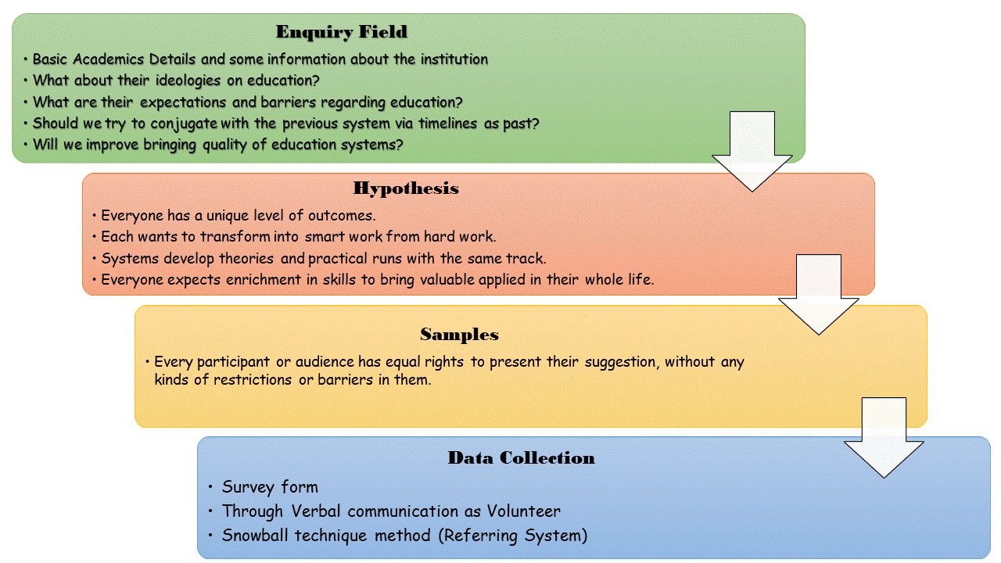
Figure 3 - Procedures for Researching opinions
The literacy rate in India improves better compare to previous data as survey was conduct. After the preliminary survey in Bihar, it showed that, the particular results of individual observation of the literary rates of Bihar and some other states are plenty of improvement in the result of the growth in data.
As for implementation is best society and the audience but according to politics, decisions are not on the base of local people. Education and sustainability are the roots of development in better future revolutions. The contributor`s ideals trend to small work on it to make the roots strong that the focus is how can we attract a candidate to be aware of the early synopsis of Education and sustainable development. The top ten countries have been chosen whose education system is better and also follow the better system and surrounding to create energetic, curiosity development that contributes to attached with the cation in future they will able to contribute to their own representing country. In addition to this collection of sources of data from the least or bottom countries have been conducted to examine the lack of interest in education, skills and passions as professionals.

Factors affect leading with Observation to research

Several factors of a high literacy rate in a country.
- Access to Education: These countries often have strong education systems that prioritize access to education for all citizens, including quality primary, secondary, vocational, and tertiary education.
- Government Support: Governments in these countries can invest significant resources in education, such as funding schools and teachers, and policies to promote literacy.
- Cultural Values: In some countries, the importance of education is cultural leading individuals and families to prioritize literacy and pursue educational opportunities.
- Economic Development: Countries with higher levels of economic development may have higher literacy rates due to better access to resources and educational opportunities.
The factors that contribute to increasing literacy in different countries and achieving high literacy are often complex interplay of social, cultural, economic, and political factors how that from UNDP shortlisted.
The data countries having highest in the world literacy rates (as of 2021) are Andorra - 100%, Finland - 100%, Georgia - 100%, Latvia - 100%, Liechtenstein - 100%, North Korea - 100%, Russia - 100%, Estonia - 99.8%, Belarus - 99.7% and Lithuania - 99.7%. (Report 2011)

The factors show that Low literacy rates in low-lying countries
- Limited Access to Education: Many of these countries have limited access to education, especially in rural areas, where they cannot learn to read and write.
- Poverty: Poverty can often be a significant barrier to education. Families may not be able to afford to send their children to school or provide the necessary materials and resources.
- Conflict and Instability: In countries affected by conflict and instability education systems can collapse, making it difficult for children and adults to obtain an education and learn to read and write that help to secure understanding skill development.
- Gender Inequality: In some countries, cultural norms discourage or prevent girls and women from getting an education, which can lead to lower female literacy rates.
- Language Barriers: In some cases, literacy acquisition can be difficult due to a lack of resources and support for non-native speakers of the country's official language.
- Limited Government Support: Some governments may not participate or allocate sufficient resources to support education systems and literacy programs. These issues and improving access to education and literacy programs will help increase literacy and promote social and economic development.
The data from UNDP shortlisted, the countries having lowest literacy rates in the world are follows South Sudan - 27%, Burkina Faso - 32%, Niger - 36%, Afghanistan - 38%, Chad - 38%, Mali - 41%, Central African Republic - 43%, Guinea - 44%, Benin - 48% and Ethiopia - 51%. (Report 2021). The country need to track in progress with everyone by the help of nations and union to lets to same track neither behind nor obstacles.
The purpose behind the analysis from the Form is that individuals are different and having own opinions, justifications, and ideas to present to us. Everyone having own experiences, struggles, successes, or failures to describe to them. Education is a union of different thoughts and ideologies of people. In this no one to copy or compare to self or another from their habits. Everyone’s mindset varied along the different levels to put our efforts together but not copy each other. In the survey form, the questions were drafted in a way to enhance and observe what the students want from the Education system. Sustainability is a crucial subject in today's world, and education plays a vital role in creating awareness and promoting sustainable practices. The best education pattern in sustainability is one that integrates sustainability into all aspects of learning, from curriculum design to teaching methodologies and assessment strategies (Burbules et al., 2020).

Elements of an effective sustainability education pattern:
- Inter-disciplinary Approach: Sustainability education should encompass multiple disciplines, including science, social sciences, humanities, and engineering, to provide a comprehensive understanding of sustainability issues.
- Experiential Learning: Hands-on learning experiences, such as field trips, sustainability projects, and community service, can help students apply sustainability concepts to real-world situations.
- Systems: Sustainability education should promote a holistic understanding of the interconnections between environmental, social, and economic systems.
- Critical Thinking: Students should be encouraged to think critically about sustainability issues and develop their solutions to complex problems.
- Ethical Considerations: Sustainability education should include discussions on ethical considerations, such as environmental justice and the responsibilities of individuals and organizations in promoting sustainability.
- Technology Integration: Technology can play a significant role in promoting sustainability, and sustainability education should incorporate the use of technology tools to promote sustainable practices.
- Collaboration and Communication: Sustainable solutions require collaboration and communication among diverse stakeholders, and sustainability education should promote these skills.
The Solutions we compared, the best education pattern in sustainability is integrated, experiential, and promotes critical thinking, ethics, technology, collaboration, and communication.
The best methods applied and implementations of this quality involved in the two institutions are Gurukuls and JNVs refer as (Jawahar Navodaya Vidyalaya) in India, which also contribute to the systems in this survey. JNVs are a system of co-educational, residential schools in India run by the Navodaya Vidyalaya Samiti, an autonomous organization under the Ministry of Education, Government of India. These schools were established to provide quality education to talented children from rural areas who may not have access to good educational facilities.
The JNVs provide education from class 6 to class 12 and follow the CBSE curriculum. The schools are fully residential, and the students are provided with free boarding, lodging, and textbooks. The medium of instruction is usually the mother tongue or regional language, but English is also taught as a subject. The schools also offer various co-curricular activities such as sports, music, dance, and art (Aayog, 2015).
Admission to JNVs is through a selection test held annually at the district level. The test is open to all students who are studying in class 5 in a government or government-aided school. The selection test is objective in nature and tests the student’s abilities such as Mathematics, General Science, and Mental Ability (Sabharwal, 2018).
JNVs have a unique system of student selection, where one-third of the seats are reserved for girls, and a minimum of 75% of the seats are reserved for students from rural areas. The schools also have a policy of not charging any fees from the students, except for a nominal amount for uniforms and other incidental expenses. The JNVs have been successful in providing quality education to talented children from rural areas and have produced many successful professionals in various fields. The schools have also contributed significantly to the overall development of rural areas by providing education and exposure to talented children who would otherwise not have had access to such opportunities (JNV, 2009).

Missions and Visions of JNVs toward sustainability
Jawahar Navodaya Vidyalayas (JNVs) are well suited to promote sustainability education in India. It was first established in 1986. The idea of Jawahar Navodaya Vidyalayas conceived by former Prime Minister of India Rajiv Gandhi to promote education to develop the advance of rural students. Currently 661 JNVs in India in every district of the states except Tamil Nadu, the reason for linguistic political issues. These schools are located in rural areas and cater to students from economically disadvantaged backgrounds. By providing quality education and exposure to sustainable practices, JNVs can contribute significantly to promoting sustainability in rural areas. It is under HRD (Human Resources Development) minister transformed into Education Ministers
- Curriculum Design: JNVs can incorporate sustainability concepts into the curriculum design to ensure that students need to sustainable practices from an early age. Concepts such as conservation, management, and renewable energy can be included in the curriculum.
- Experiential Learning: JNVs can provide hands-on learning experiences to students to promote sustainable practices such uncovering students to sustainable practices.
- Infrastructure: JNVs can incorporate sustainable infrastructure in the school campus, such as solar panels, rainwater harvesting systems, and composting pits. This will not only reduce the carbon footprint of the school but also provide practical examples of sustainable practices to students.
- Community Outcome: JNVs can work with the local community to promote sustainable practices. This can include organizing awareness campaigns, training workshops, and community service activities related to sustainability.
- Skill Development: JNVs can provide skill development training to students in areas such as organic farming, renewable energy, and waste management. This will not only promote sustainable practices but also equip students with skills that are in demand in the job market.
The Solutions we compared, JNVs have the potential to become important centers for promoting sustainability education in rural areas. By incorporating sustainability concepts into the curriculum, providing hands-on learning experiences, promoting sustainable infrastructure, working with the local community, and providing skill development training, JNVs can contribute significantly to the overall development of rural areas (Namita & Goswami, 2015).

NCSC (National Children’s Science Congress) Model to promote advance
NCSC is part of promoting sustainability festivals across the whole JNVs are among one them. It is the part to promote the Sustainable Festival. In spread to all over the JNVs.
The Indian government organizes it every year to stimulate the intellectual curiosity of rural children. We can improve the issue towards sustainability. The annual theme is sustainability and the integration of education to improve the country and economy and make it easy and affordable for nations and individuals. The program focuses on climate change, sustainability and green development to make our planet better and reduce our carbon footprint. The National Children's Science Congress presented research on ecosystems, health and wellness, and five sub-themes. It changes each year based on how issues related to terrestrial factors of address
Therefore, we decided to highlight themes, sub-themes and titles according to the aspects of the project based on sustainability. From this expectation as JNV, Gurukuls and NCSC promote sustainability and encourage Ashram students to follow a sustainable life path.

Gurukuls and Ashram’s methodology procedure in foreign countries.
Before British rule, India was one of the best leaders in open schools and the best educational system in the world. India known for the world leader at the time before British rule, but India also lost the title of the Golden Bird to British rule. To realize the big dream of India, known as THE GOLDEN BIRD, we are going to liberate it and grow into the second greatest leader in the world after India. Today, most foreign scholars want to incorporate Indian culture into their education, are interested in learning about sustainability, and are early aware of the crisis ahead. Gurukul is an Ancient educational concept and management essential to sustaining their lives. You will also learn about sustainable approaches to the environment compared to using less electricity and technical equipment. We are also learning to manage our lives without technology in this generation, but the advice that we can easily avoid distractions and mindsets are more appropriate.
All things are easy to learn considering you do not have any equipment in your Navodaya life. Modified Gurukuls training need modification to incorporate sustainability concepts. Technologies use for to enhance learning experiences and promote sustainability education. The concept of tech-trad manner is known as the linking of Institutional with both Technological and traditional manner to both make the stability to experience the period to enhance the opportunity (Rani, 2017).

Gurukuls system can be made relevant to the technological generation:
- Online Learning: The Gurukuls system can incorporate online learning platforms to provide access to quality education to students in remote areas. This will increase the reach of the system and reduce the education system's carbon footprint.
- Sustainable Technology: The Gurukuls system can incorporate sustainable technology, such as solar panels, AI-based energy management systems, and water harvesting systems, to promote sustainable practices.
- Virtual Reality: Virtual reality carrying out to provide experiential learning experiences to students. For example, students can experience a virtual farm to learn about sustainable farming practices.
- Internet of Things: The Internet of Things carrying out to monitor resource utilization in schools and promote sustainable practices. For example, smart lighting systems carrying out to reduce energy consumption.
- Coding and Robotics: Coding and robotics will incorporated into the curriculum to provide practical skills that are relevant to the technological generation. These skills carrying out to develop sustainable technology solutions.
The Solutions we need to compare with, the Gurukuls education system is modernized and relevant to the technological generation by incorporating sustainable technology, online learning, virtual reality, the Internet of Things, and coding and robotics to the job market.
Self-decision is the best example of satisfaction and leading learning progress in their life. Webinars and seminars are one of the best programs. The two are “150th Anniversary of Sir Aurobindo, Theme – Education Philosophy of Sir Aurobindo” We learned about the transformation of Education in our life, to bring the conventional to generation.
“Breaking barriers in science” program brings some insight into this study where getting solutions how we can able to make a better and professional career in each subject during current academic sessions. We tend to make systems conjugate with similar patterns to skills in the way of the unique creature of interest in us (Das, 2020).
The response from the public seen keen to attractive to part to change the system. They also want to modernize of education platform with both technological manners with the traditional culture it makes an attractive education platform which also leads to better contributing to the lead and formation of an Eco-Environmental system with a response with help to make free from carbon footprints.

Results and Discussions

Each person's responses and opinions can contribute to a large-scale evaluation of data for assessing the philosophy of the normal or ideal person to act, as the results lead to a glorious understanding of human dimensions. Each person's responses and opinions can contribute to a large-scale evaluation of data for assessing the philosophy of the normal or ideal person to act, as the results lead to a glorious understanding of human dimensions. The overall outcome of the research work is to maximize changes in educational patterns over this period. Categorization of results in the reference age section, platforms experienced in contributing to this research, and optional ignoring barriers. Participants will contribute by sharing their opinions and ideas, making some changes to the environment that will produce better results in the coming days.
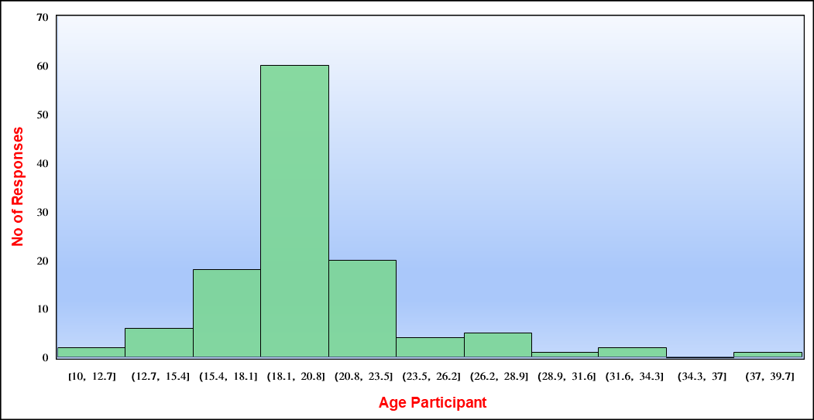
Figure 4 - Classification of People
The participants contribute by sharing opinions and ideas about to makes some changes to an environment that get better outcomes in the upcoming days. After the research, we It can be able to improve the better quality index in education. Figure 4 shows the response of the participant’s age where, it was mostly receive from the youths and adults at the age of 18 years to 20 years. The contributions among 50% from them. We need to activate the youth’s era to apply the skills and amination to process. The maximum numbers of participants need to the youth participants are the best options to draw the attentions with them. They have been the capabilities to need because that participants level of thinking would be the nature of ethics with moralities and follows by teens and young adults to suggest review for changes.

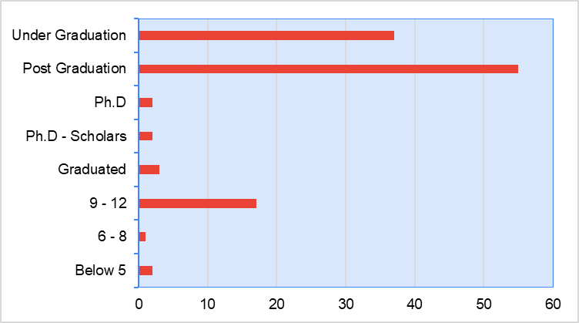
Figure 5 - Composition of Qualification (Present*)
From the interpretation of data maturity to human development the processing sector in our life, lead among themselves. According to the survey, it is shown in figure 5 that majority of the students participants are from post-graduation carrying 48% and then graduation graduated and pursuing Graduation attends, they are very excited to get better improvements in quality of the education level opinions are 25%. As for the high aspect need to thought from the candidates belong from higher secondary because that time the real advancement and begin of development of students respect to ideal mentality. The background of people who participates at the form institutional level and the quality of their individual varies in the attributes. It shows they can able to grow their skills of understanding the system which system, which can follow these days, able to compare the benefits and lack of impacts to vanish the obstacles in deeds. We needs to aware to seniors secondary students to develop their thoughts because this is the age of turning point to carrying out decisions.
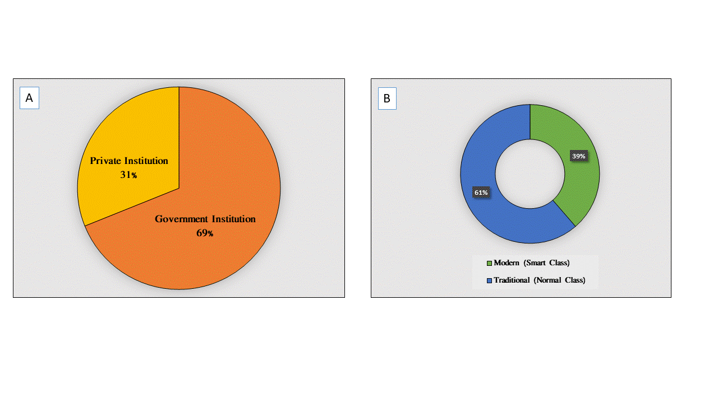
Figure 6 - (a) Model of Institutions (b) Structure of Background
The majority performing from the governments based in normal and they are capable to interesting in giving opinions. In my research majorities, in Figure 6 response from Government Institutions and many of them lead learning in sense of Smart classes. It means that the government support to us to better advancement from own side we need to also contribute from our sides.
Further development in sections, but can also be a requirement for development. Demonstrate that you can use the imagination and other skills of the student who valued filling in the gaps in the assignment to fill in the gaps. Because I made the emperor's rule not to be a slave to others. Decisions need to draft according to survivors, not experience. Development requires change from time to time, but we must to seen as environmental indicators of the balance between nature and the technological age. After examining, how they are treated as institutions, the rating system is categorized me. The index is showing that is normal but required to develop with growth in interests and fun also. The lack of gap found in the research we wish to fulfil with the responses and ideals of people. It means that the system is good but regulated as a system by their order applied to whole institutions. Listed as the points and tag of the level of the background of education are in the following ways, - Worse (Below 2), Bad (3-4), Moderate (5-6), Good (6-7), better (8-9) and Best (10) are categorized in my classifications of the education system. The rating per participant is maximum and the overall rating is moderate as compared to all. The system is neither worse nor best but the system runs and on. The institutions running, as on the slavery mode just like as continuous without any arguments.

Figure 7 - Rating to Education System of India
The different participant’s experiences in the platform and how they get suitable, adjust to grateful to share, and demands for their educational references. The maximum belonging from the traditional background of the study is (26%). They also want to change the background of the pattern that suitable for studying are learning in an Environmental Nature (34%), as follow Digital Classrooms (33%), Normal Classroom or Blank (26%), and Gurukuls or Ashrams (7%). The nature requires creating such background, which aligned to conjugate with interest of the human behavior. The need of transformation of classes with different method. As the results most want to green classroom and aware to about carbon free and sustainable expectation.
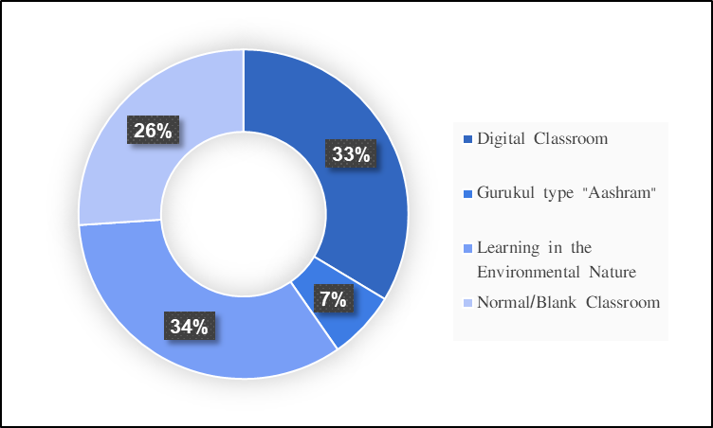
Figure 8 - Educational Background Index
The choice of a platform where they can study. The study background varies a place to place and education is common to allow everyone. They invest a lot and but we have access to equal education for all. In this preference, I would like to suggest including such activities relatable to Educational methodologies. In our country, theories can give importance to behavior. The absence of practical, skills and Imagination results give blank concepts provided by the institutions. Also, requires focusing on student’s strengths and weaknesses.
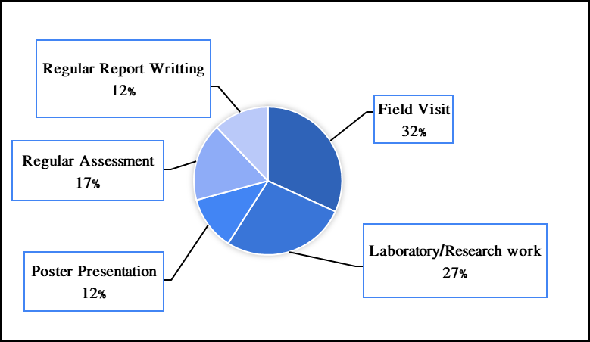
Figure 9 - Activities interaction with module
Therefore, we surely like to evolve a similar part of the syllabus with them Field visits (32%) Laboratory/Research work (27%), Poster presentations (12%), Regular assessments (17%) and Regular report writing (12%) these are some activities that can balance their proportions. The demand required not only single activities. They want to coordinate with multitasking activities with in to develop self in manners.
Another factor leading to responsible for their behaviors and attachment to interlinking between students and teachers. It has been also varying how we can make better integration with teachers-students to understand the concepts of each of them. Nowadays, Children annoying are beaten and anger from teachers, which distracts them avoid from education.
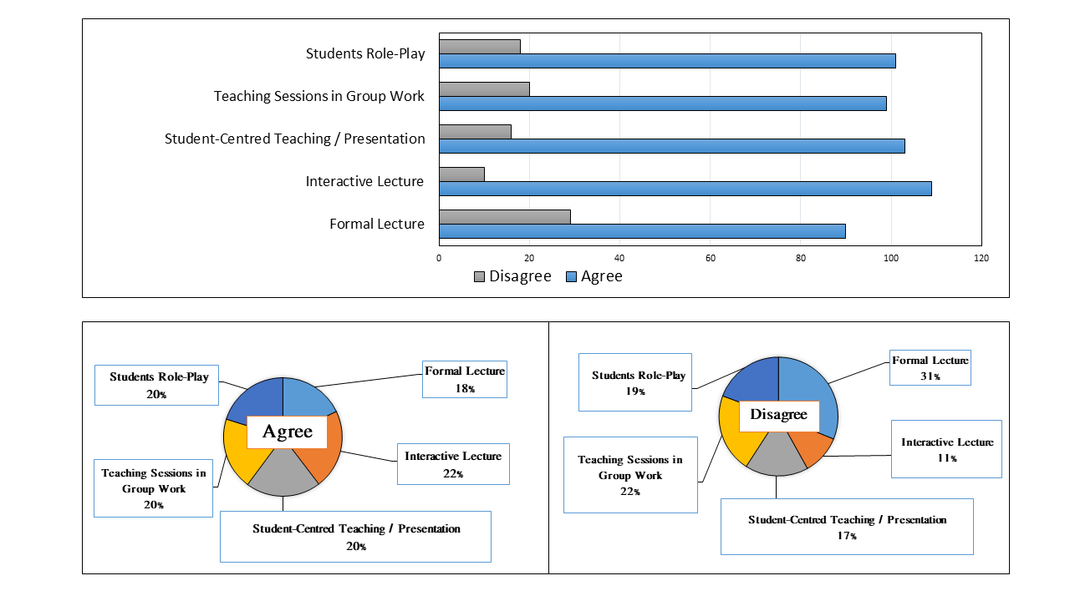
Figure 10 - Synchronize with new methods from Educators
The desire to students wants to approach the system with activities that perform as skills, activities and verbal in Figure 10. The inclusions of activities are Student role-play (20%), Interactive Lecture (22%), student-Centered Teaching and Presentation (20%), Teaching sessions in Groups (20%) and some formal lectures (18%) as professionals. The skills developed by teachers most students get attract toward education. However, also required for all. Every response is similar and equal proportions to accept challenges.
The desire to students wants to approach the system with activities that perform as skills, activities etc. Nevertheless, the disagreement with the statement. The system not aspect by some because the remaining sections lead to them having no interest in them. They attached and integrated with the section of curriculum. The exclusions of activities expectations are Student role-play (19%), Interactive Lecture (11%), student-Centered Teaching and Presentation (17%), Teaching sessions in Groups (22%) and some formal lectures (31%) as professionals. In this section avoidance of formal to make integrated courses.
The aspects through the communities, the pleasure to expect from the educators are in Figure 11 Approachable (24%) Fully focus on particular students, Organizations (17%) the methods for teachers how can practice giving time to students in learning opportunities, Humorous way teaching (28%) education in the way of entertainments to enhance interests in students, and Unique way to teaching style (31%) another level to express the methods in learning. In this section, the enormous response from the students is unique ways to learn and Knowledge presenting in Humorous ways. The qualities needed to bring out methods to implement in upcoming education policies to improve education factors to growth in literacy rates.
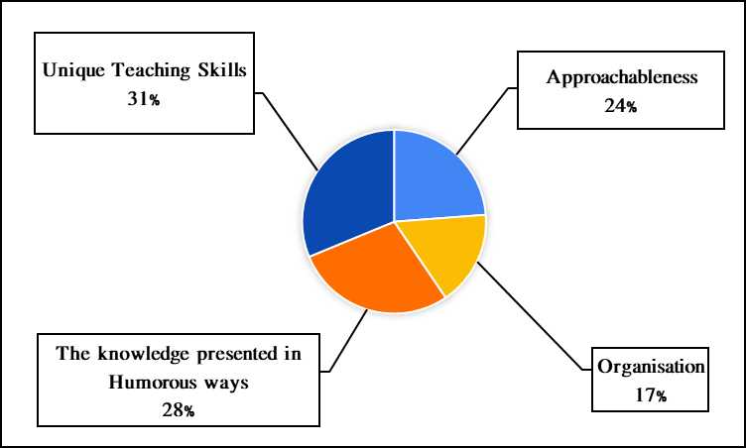
Figure 11 - Qualities expected from Educator
After knowing the visualizations of the interest interacting through the teacher and students to find self to activate. The students also want to improve the children’s philosophy because they cannot be able to discuss with teachers due to a lack of asking abilities get a decrease in students to manage personal behaviors. The responses are qualitative informatics to understand the pillar of strength. With the strength of support gets from teachers finally, students get the best options without any barriers in figure 12.
The essential elements for students reinforcing the explanation of information to provide alternative solutions for remembering (15%), providing motivation to encourage students (9%), and improving time management. Providing groups to support effective learning, and increasing group learning (28%). Collecting diverse knowledge for learning and interaction between students and teachers to improve knowledge interaction (25%) is the most important of the conclusions of problems and skills applied to effective learning. Discuss in and provide practical evidence for easy access to facilitate learning (23%).
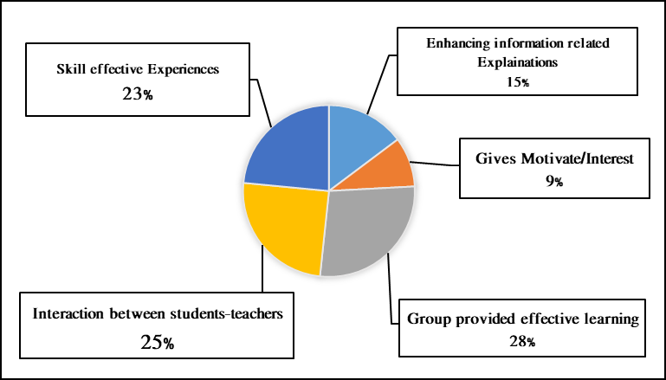
Figure 12 - Learning techniques lead in curiosity
The collapse between teachers and students also needs developments in the tech-trad system, and better efficiencies in the environment, due to carbon emissions alternative methods to decrease the index. Nowadays, technological advancements and required systems disturb the inequality index in our surroundings due to the radiation in this manner the contributions of students how they want to do changes and applied with Ancient manners like Vedas periods. They also want to promote the Gurukuls to learn in a sustainable manner, which also leads to increased inner concentration with advanced days. It also helps to balance with this period and the low effects of radiation in these periods. The enhancement of skills in shown interest to promote Gurukuls (94%) showing positive with the environment remaining (6%) adapted to this system they do not require they want to live as going on represent in figure 13.
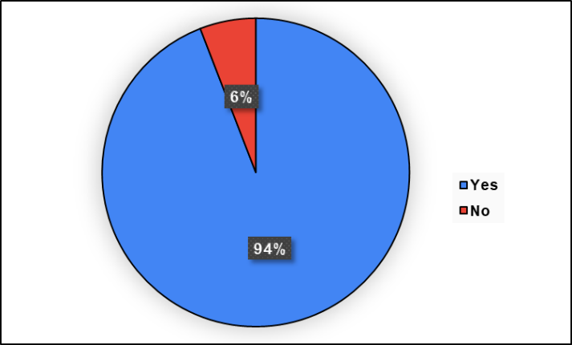
Figure 13 - Ideas for promoting Gurukuls (Present*)
It can also be safe for the environmental philosophy, the individual said that what they could understand from the reports today institutional prospects categorized in Attendance (1%) Explore and Learning (93%) and major in grade (6%), grade depends on how we can focus on the education, not education depends on the grade. Each thinking capabilities depend to perform in the system or vice-versa. The audience knowing the validity of life and the importance. If leave it never came back.
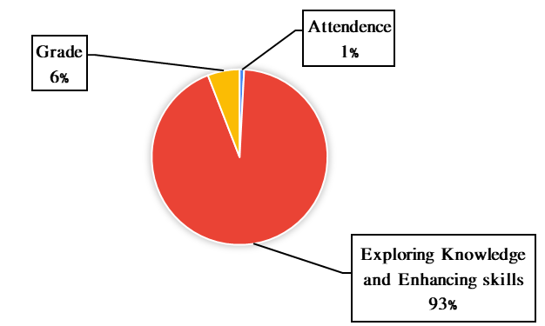
Figure 14 - Individual Philosophy on Education
In this research, I also observed that some bright students can do better, but sometimes they challenge with distractions from exams. The crisis of fear known exam fear. That diseases cause to kill learning ability, the focus depends on the grade. Under PM Sh. Narendra Modi, promotion of education advancement and many other schemes, which are beneficial for everyone, linked with sustainable development and the cabinet from different departments gets management success to fulfil the barrier or lack of substitutes. He also gives tips in his published book "Exam Warriors" to fight against the exams and only concentrate on studies. It is also helpful for us. He launched the program “Pariksha Pe Charcha” every year before the annual exam to encourage students to face and move forward.
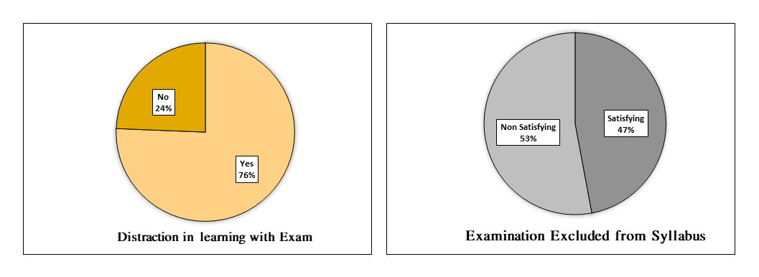
Figure 15 - Exam phobia barrier with Study
In figure 15, also encourage teachers, Parents, students and citizen to celebrate exam as festivals. He trying to help vanish Stress and burden. In addition, teach that the Exam is not a life but a part of life to face and move forward to accepting challenges. We found that 76% were distracted by exams and 24% were easy to face the challenges. In this report, 53% want to exclusion of exams from the academic prospect because they are distracted by the grade. Societies compared with a grade, not their skills and challenges, and 47% had no objection regarding exam exclusion they know the value to evaluate themselves with practice manners the importance.
In addition, also required to promote unique activities, which help to transform learning ways. It also enrichment skills in project work also. We can learn multiple things within the syllabus by another method. The other activities with create surrounding to feel such a desire to learn are in the following ways – learning practically (28%), normal method (15%), smart learning (19%), sustainable manners in nature (34%) and Tutor at Home (4%). The major response in sustainable manners follows smart class and practical learning. In short, according to results such want to back to the Vedas period to focus on inner strength and protection of the environment.
Nowadays, the inclusion of different contents in curriculum from Ancient times to the current era is the biggest issue that gets bored students. The need to revaluation of major part to make better evidence in syllabus. The majority want to change and remove the burden of the syllabus because of the lack of interest because of why we study what is beneficial to applied days.
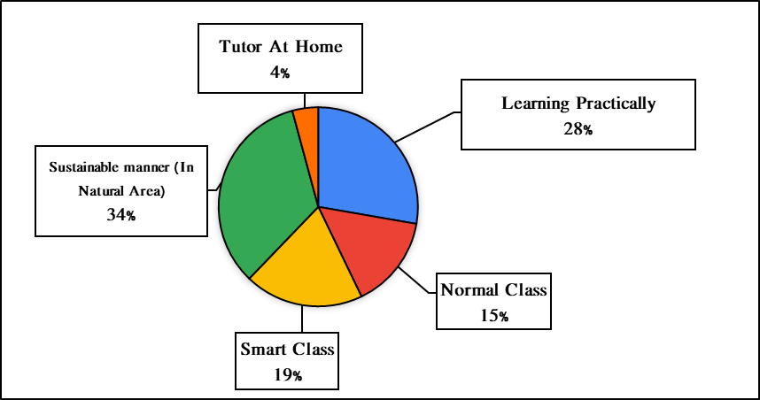
Figure 16 - New Experiment with System

We get some positive feedback as well as negative feedback. We need to analyze both factors. In this response, we found that students get the interaction of system changes with time and some contributions of the pattern are suitable for us. All periods are unequal distribution but most of them want to change with time. In addition, some want to go back to the past with Vedas culture because Indian culture and Spiritual are important to believing in all Yuga. They believe in the self is the greatest passion for inner development. Major want to include the section with the periods attached with the present to interlink to try new experiments with nature. There are four periods get section into four parts, in figure 17, which get help to enhance skills with fun and natural interaction with the system.

Figure 17 - Response w.r.t Time Period

We have been to conclude with the benefits of sustainability and economy for the prospect. The sections are mention in the following ways - Ancient Period or Vedas time (37%), medieval period (5%), Modern or Post Independence (10%) and Technical era (after the Covid pandemic) (48%).
Digital innovation mostly likes to follow the technical era and follow Vedas culture. Both compare Ancient cultures and want to add the current system to efficiency in Knowledge and Environment and bored sections are in syllabus following ways - Ancient Period or Vedas time (25%), Medieval period (5%), Modern or Post Independence (62%) and Technical era (after the Covid pandemic) (8%). All of them mention compare in Figure 18. They critically avoid without any reason but we want to change and only focus on the importance, not on the epic of theories. We need to focus on to remove unnecessary content from syllabus, which are useless. Making such as the system requires feeling better or comforting and attracting toward education.
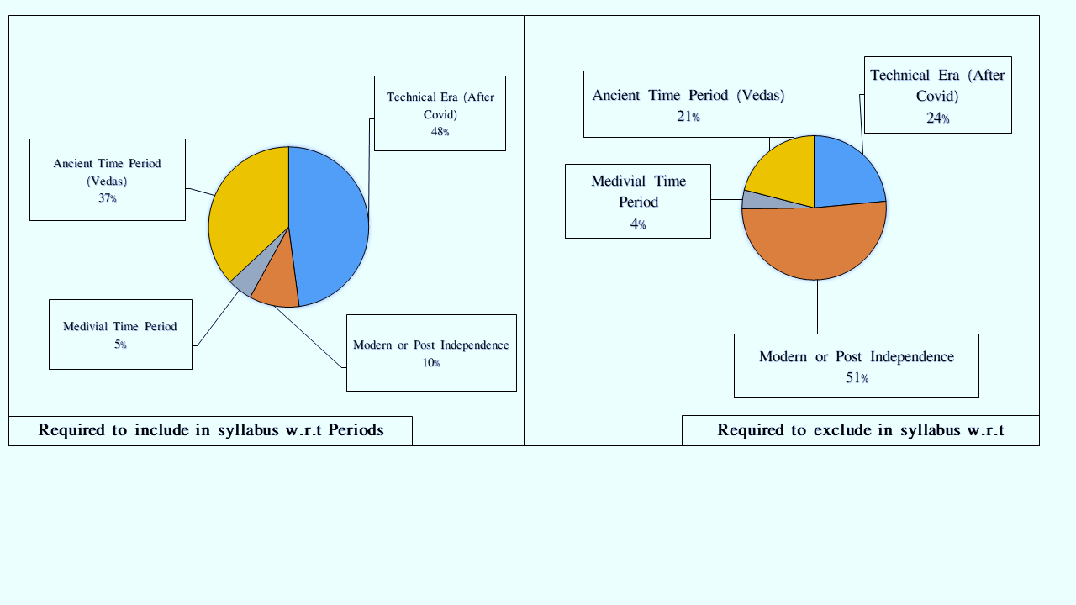
Figure 18 - Evaluation of syllabus with Period
The overall showing that requires of qualities in educations and they are challenging with barrier in them. If the conference held on the summits related to education should with respect to every countries better qualities applied in our system to make progress. We need to improve to make education skillful instead of ideal and philosophical learning. Requires of vocational and additional skilled course to enhancements in students. Performance attributes to give their best outcome that should be applicable in their life.

Conclusions

From this survey, it is found that most of the participants are from the age group the participants 50.4% of adults, 16.8% of Youth and 15.2% of teenagers, they are contributing reviews and they need modern, technically advanced trainers whose suggestions rather than a set curriculum to improve their student skills. The most active 46% participants are from postgraduate students and 31.4% graduate students and spatially teenagers 14.2% were the part of this researching. The surrounding help to estimate the experiences of background 69% of participants who take study from Governmental structure and mostly 61% take only traditional manners or normal classes. They only focus on that enough for them then time-to-time variation occurs in development for technicality that required to integrating with tech-trad methods. The classroom desired likely with digitally 33% and Environmental 34% and some aspect like Gurukul based 7% in modern era.
The analysis of data we have been getting the moderate level of rating 6.4 out of 10 is average based to our education system, it is enough to be able and we need to overall in favors for a progress in system and performers 14% and out of all everyone wanting interactive level of designing to encouragement and curiosity. The performance of the educator all qualities varying are approachable need to actions unique and humorous way to explaining to them. The alternative level to make more attractive, we need to add such activities including Fieldwork and Research based on assessment to enhance such as a new one. The emissions of carbon due to digital classes the solution get alternative with Gurukul based manners to reduce the consumption of pure environment 94% agree with to establishing the Ashrams with modern system that known tech-trad. Out of them 93%, know the value of education to learn new thing to exploring the possibility.
Nowadays exam is attribute to curriculum present students accepts, as it is important to us. If we learn well we can easily clear up exam but instead of learning, they focus on grade 6%. Out of them 76% feel as stress free, burden, and want to exclude from system in favors of 47% then they only progress on it and felt free from distraction. Remaining 53% not satisfying with them because they can able to evaluate the performance of strategy so wise decision make them sure it is the part of life. If we can make productive qualities children escape easily and attracting with the system. The audience 48% want to adopt smart learning methods and 37% want to attach Gurukul (Ashram) 37% to make better comfort zone in studies plan. The worse system and burden felt like post-Independence education system organized by British and the content of period between Medieval and modern or British India felt like crudely need to excludes the unwanted list from the side.
It is also worth noting that there is no guide for staying up to date when there are time changes. Bring the system into a real implementation to improve the experience. Developing a curriculum that includes a practical application is much more important. Avoid the negative effects of grade comparison, memorization, and curriculum design. It provides a platform for support, runs systems, develops new teaching techniques, and uses the insight language. Students lack the personality traits and skills, which are vital to become experts in any field. To study psychology of a student is more important. The study found that one of the student's problems was a lack of achievement. Different countries adjust their performance indicators differently to improve some of the best suggestions currently available. Try to learn in a way that to guided. How your heart and brain work. Make the value learning process permanent. A particularly advanced development of teachers is the method of learning. Know the importance of sustainability along with the value of education.

References

- Aayog, N. (2015). Evaluation Study on Navodaya Vidyalaya Samiti.
- Abad-Segura, E., González-Zamar, M. D., Infante-Moro, J. C., & García, G. R. (2020). Sustainable management of digital transformation in higher education: Global research trends. Sustainability (Switzerland), 12(5).
- Badhwar, M. (2013). Impact of the foreign education system in India. 3(4).
- Bhattacharya, S., & Sachdev, B. K. (2021). Gurukuls System versus Modern Education in India–A Need for Amalgamation of the Two Systems to Eliminate the Crisis of Illiteracy, Economy and Social Problems of the Society. International Journal of Recent Advances in Multidisciplinary Topics, 2(11), 102–104.
- Boren, E. (2019). Understanding Sustainable Development Goal ( SDG ) 4 on “ quality education ” from micro, meso and macro perspectives. International Review of Education, 0123456789.
- Brian Fisher, P., & McAdams, E. (2015). Gaps in sustainability education: The impact of higher education coursework on perceptions of sustainability. International Journal of Sustainability in Higher Education, 16(4), 407–423.
- Burbules, N. C., Fan, G., & Repp, P. (2020). Five trends of education and technology in a sustainable future. Geography and Sustainability, 1(2), 93–97.
- Ceccherelli, A., & Capaldi, D. (2020). What Do Students Expect From Learning? A Research on Skills As a Bridge Between School and University. EDULEARN20 Proceedings, 1(July), 1267–1276.
- Chanda. (2017). Education A study on the Educational thoughts’ s of Aurobindo Ghosh with relevance to the present educational context. Sambhu Assistant Professor College of Teacher Education Unakoti district of Tripura Department. 558–559.
- Das, P. K. (2020). Educational philosophy and contribution of shri aurobindo to the field of education. 8(7), 1697–1701.
- Dey, K., Student, E., & Bengal, W. (2021). A Study on Philosophy and Educational Thoughts of Sri Aurobindo Ghosh. 5(2), 864–865.
- Education, F., Group, W., Minister, P., & Modi, N. (2023). India ’ s G20 Presidency First Education Working Group ( EdWG ) Meeting. 3–7.
- Fuertes-Camacho, M. T., Graell-Martín, M., Fuentes-Loss, M., & Balaguer-Fàbregas, M. C. (2019). Integrating sustainability into higher education curricula through the project method, a global learning strategy. Sustainability (Switzerland), 11(3).
- Giangrande, N., White, R. M., East, M., Jackson, R., Clarke, T., Coste, M. S., & Penha-Lopes, G. (2019). A competency framework to assess and activate education for sustainable development: Addressing the UN sustainable development goals 4.7 challenge. Sustainability (Switzerland), 11(10), 1–16.
- Grohs, J. R., Kirk, G. R., Soledad, M. M., Knight, D. B., Gresch, H., Hasselhorn, M., Bögeholz, S., Pasch, N., Möller, A., Rieckmann, M. Mindt, L. and and Gardiner, S., Tilbury, D., Lezak, S. B., Thibodeau, P. H., York, S., Lavi, R., Dori, Y. J., Orgill, M. K., Bezeljak, P., Neurohr, A., … Boersma, K. T. (2018). Competencies in Education for Sustainable Development. Frontiers in Education, 3(3), 132. JNV, P. (2009). JNV Mandetory Pubic Disclosure.
- Kioupi, V., & Voulvoulis, N. (2019). Education for sustainable development: A systemic framework for connecting the SDGs to educational outcomes. Sustainability (Switzerland), 11(21).
- Madhear, M. (2020). Perception of Integration of Gurukuls System In Modern Indian Education: A Study Into Quality Education. International Journal of Research and Analytical Reviews, 7(3), 244–257.
- Mahaffy, P. G., Matlin, S. A., Holme, T. A., & MacKellar, J. (2019). Systems thinking for education about the molecular basis of sustainability. Nature Sustainability, 2(5),
- Mogren, A., Gericke, N., & Scherp, H. Å. (2019). Whole school approaches to education for sustainable development: a model that links to school improvement. Environmental Education Research, 25(4), 508–531.
- Namita, M., & Goswami, B. (2015). Teachers ’ Role in Jawahar Navodaya Vidyalayas : A Study. 46–49.
- Pal, P. K. (2021). Education Psychology in the Ancient Indian Gurukulsa System. 8(1), 141–146.
- Pareek, A. (2021). A Survey on Gurukuls Education System. Journal of Contemporary Issues in Business and Government, 27(3).
- Patel, L. S. (2021). Gurukuls education system of Ancient India and Indian education Policy Historical practice of 1947-2019 A . D . 03(02), 2–8.
- Pavi, S. (2011). A Comprehensive Study of Education. 73(22), 23–28.
- PIB Chennai. (2023). G20 Education.pdf (p. 4). PIB.
- Rani, C. (2017). A Study of Educational Vision of Aurobindo Ghosh. 5(1).
- Sabharwal, N. S. (2018). Equity and Excellence : A Study of Jawahar Navodaya Vidyalaya. July 2021.
- Sahoo, B., Pattnaik, S., & Patra, R. (2019). Education system in pre-independence and independence India concerning Odisha, 8(2), 7–12.
- Sauve, L. (1996). Environmental Education and Sustainable Development: A Further Appraisal. Canadian Journal of Environmental Education (CJEE), 1(Spring), 7–34.
- Seriadi, S. L. N. (2020). The Importance of EFL Teaching in Hindu Gurukulsa Modern System. Yavana Bhasha : Journal of English Language Education, 1(1), 12.
- Stefan, L. (2012). Immersive Collaborative Environments for Teaching and Learning Traditional Design. Procedia - Social and Behavioral Sciences, 51, 1056–1060.
- Wthe Seller, C. (2020). Education for sustainability: Fostering a more conscious society and transformation towards sustainability. International Journal of Sustainability in Higher Education, 21(1), 112–130.
- Watson, A., & Watson, A. (2017). TRACE : Tennessee Research and Creative Exchange Sustainability Education in Primary and Secondary Schools : Great Needs and Possible Solutions.
- Williams, A. (2010). Environmental Education and Education for Sustainability Projects: Inspiring and Facilitating Implementation. Online Submission, July, 1–66.

