package org.itc.com
import org.apache.spark.SparkConf
import org.apache.spark.sql.SparkSession
import org.apache.spark.sql.functions._
import org.apache.spark.sql.types._
import org.apache.spark.sql.expressions.Window
object JsonAssignment extends App{
val spark = SparkSession.builder()
.appName("Jsonreadfile").master("local[1]")
.getOrCreate()
import spark.implicits._
// Define schema for the JSON
val schema = StructType(Seq(
StructField("filename", StringType),
StructField("datasets", ArrayType(StructType(Seq(
StructField("orderId", StringType),
StructField("customerId", StringType),
StructField("orderDate", StringType),
StructField("shipmentDetails", StructType(Seq(
StructField("street", StringType),
StructField("city", StringType),
StructField("state", StringType),
StructField("postalCode", StringType),
StructField("country", StringType)
))),
StructField("orderDetails", ArrayType(StructType(Seq(
StructField("productId", StringType),
StructField("quantity", IntegerType),
StructField("sequence", IntegerType),
StructField("totalPrice", StructType(Seq(
StructField("gross", IntegerType),
StructField("net", IntegerType),
StructField("tax", IntegerType)
)))
))))
))))
))
// val df = spark.read.option("multiline", "true").json("D:\\spark_code\\sparkdemo\\input\\jsondf.json")
val df = spark.read.schema(schema)
.option("multiLine", true)
.option("mode", "PERMISSIVE").json("C:\\Files\\JsonAssignment.json")
df.show()
df.printSchema()
val flattenedDf = df.select(
$"filename",
explode($"datasets").as("ds"),
$"ds.orderId",
$"ds.customerId",
$"ds.orderDate",
$"ds.shipmentDetails.street",
$"ds.shipmentDetails.city",
$"ds.shipmentDetails.state",
$"ds.shipmentDetails.postalcode",
$"ds.shipmentDetails.country",
$"ds.orderDetails.productId",
$"ds.orderDetails.quantity",
$"ds.orderDetails.sequence",
$"ds.orderDetails.totalPrice.gross",
$"ds.orderDetails.totalPrice.net",
$"ds.orderDetails.totalPrice.tax"
)
//flattenedDf.filter($"ds.orderId" === "ord1001").show()
flattenedDf.show()
}

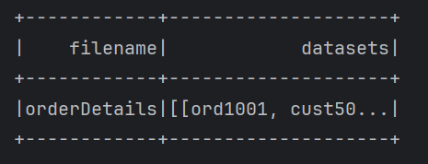
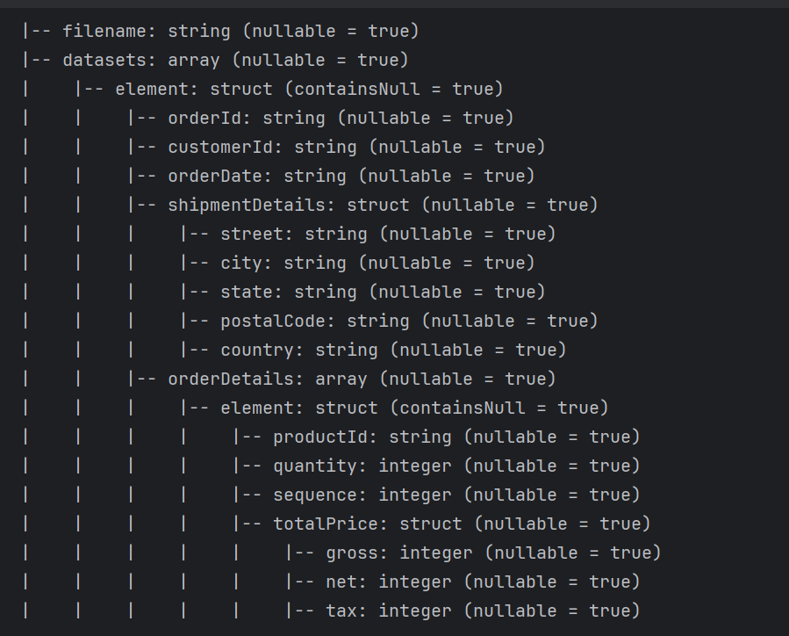

flattenedDf.filter($"ds.orderId" === "ord1001").show()

