A
MAJOR PROJECT REPORT
ON

Protein Family Classification using Deep Learning Techniques

Submitted in partial fulfilment for the award of the degree of
BACHELOR OF TECHNOLOGY
IN
COMPUTER SCIENCE AND ENGINEERING - DATA SCIENCE
By
PINNINTI MAHIDAR REDDY 22Q91A67G8
RANGARAJ DEEPIKA 22Q91A67H3
SHAIK SAIFUDDIN 22Q91A67I0
Under the guidance of

Mrs. Bhagya Lakshmi
Assistant Professor, Dept. of CSE(DS)

DEPARTMENT OF COMPUTER SCIENCE AND ENGINEERING –
( DATA SCIENCE )

MALLA REDDY COLLEGE OF ENGINEERING
(Approved by AICTE-Permanently Affiliated to JNTU-Hyderabad)
Accredited by NBA , Recognized section 2(f) & 12(B) of UGC New Delhi
ISO 9001: 2015 Certified Institution
Maisammaguda, Dhulapally (Post via Kompally), Secunderabad- 500100
2025 – 2026

MALLA REDDY COLLEGE OF ENGINEERING
(Approved by AICTE-Permanently Affiliated to JNTU-Hyderabad)
Accredited by NBA , Recognized section 2(f) & 12(B) of UGC New Delhi
ISO 9001:2015 Certified Institution
Maisammaguda, Dhulapally (Post via Kompally), Secunderabad- 500100

DEPARTMENT OF COMPUTER SCIENCE AND ENGINEERING - DATA SCIENCE

CERTIFICATE
This is to certify that the Major Project stage-1 on “Protein Family Classification using Deep Learning Techniques” is successfully done by the following students of Department of Computer science and engineering - Data Science of our college in partial fulfilment of the requirement for the award of Bachelor of Technology degree in the year 2025-2026. The results embodied in this report have not been submitted to any other University for the award of any diploma or degree.

PINNINTI MAHIDAR REDDY : 22Q91A67G8
RANGARAJ DEEPIKA : 22Q91A67H3
SHAIK SAIFUDDIN : 22Q91A67I0

Submitted for the viva voice examination held on : _________________________

INTERNAL GUIDE | PROJECT COORDINATOR | HOD
Mrs. Bhagya Lakshmi Mrs. M. Naga Sravya Dr. J. Britto
Assistant Professor Assistant Professor Professor & Head

Internal Examiner External Examiner

DECLARATION

We, Pinninti Mahidar Reddy, Rangaraj Deepika, Shaik Saifuddin with Regd.no. 22Q91A67G8, 22Q91A67H3, 22Q91A67I0 are hereby declaring that the major project stage-1 entitled “Protein Family Classification using Deep Learning Techniques” has done by us under the guidance of Mrs. Bhagya Lakshmi Assistant Professor, Department of Computer Science and Engineering - Data Science is submitted in the partial fulfilment of the requirements for the award of degree of BACHELOR OF TECHNOLOGY in COMPUTER SCIENCE AND ENGINEERING - DATA SCIENCE. The Result embedded in this project report have not been submitted to any University or institute for the award of any degree

Signatures of the Candidate

PINNINTI MAHIDAR REDDY : 22Q91A67G8

RANGARAJ DEEPIKA : 22Q91A67H3

SHAIK SAIFUDDIN : 22Q91A67I0

DATE :
PLACE :Maisammaguda

ACKNOWLEDGEMENT

First and foremost, we would like to express our immense gratitude towards our institution Malla Reddy College of Engineering, which helped us to attain profound technical skills in the field of Computer Science & Engineering, there by fulfilling our most cherished goal.

We are pleased to thank Sri Ch. Malla Reddy, our Founder Chairman MRGI, Sri Ch. Mahender Reddy, Secretary, MRGI for providing this opportunity and support throughout the course.

It gives us immense pleasure to acknowledge the perennial inspiration of Dr. M. Ashok our beloved principal for his kind co-operation and encouragement in bringing out this task.

We would like to thank, Dr. J. Gladson Maria Britto HOD, CSE-DS Department for their inspiration adroit guidance and constructive criticism for successful completion of our degree.

We would like to thank Mrs. M. Naga Sravya Assistant professor, Our project Coordinator and
Mrs. Bhagya Lakshmi Assistant Professor, our internal guide for his valuable suggestions and guidance during the exhibition and completion of this project.

Finally, we avail this opportunity to express our deep gratitude to all staff who have contribute their valuable assistance and support making our project success.

PINNINTI MAHIDAR REDDY : 22Q91A67G8
RANGARAJ DEEPIKA : 22Q91A67H3
SHAIK SAIFUDDIN : 22Q91A67I0

Protein Family Classification using Deep Learning Techniques

INDEX

CHAPTER NO. | TITLE | PAGE NO.
A. | ABSTRACT | I
B. | LIST OF ABBREVATIONS | II
C. | LIST OF FIGURES | III
1. | CHAPTER 1: INTRODUCTION  1.1 INTRODUCTION  1.2 PURPOSE  1.3 SCOPE  1.4 PROJECT OVERVIEW  1.5 SYSTEM ARCHITECTURE | 1  1  2  3  4  6
2. | CHAPTER 2: LITERATURE SURVEY | 7-10
3. | CHAPTER 3: SYSTEM ANALYSIS  3.1 EXISTING SYSTEM  3.1.1 DISAVDTANGES  3.2 PROPOSED SYSTEM  3.2.1 ADVANTAGES  3.3 REQUIREMENTS  3.3.1 HARDWARE REQUIREMENTS  3.3.2 SOFTWARE REQUIREMENTS | 11  12  13  14  15  16  16  16
4. | CHAPTER 4: SYSTEM DESIGN  4.1 UML DIAGRAM  4.2. GOALS  4.2.1 USE CASE DIAGRAM  4.2.2 CLASS DIAGRAM  4.2.3 SEQUENCE DIAGRAM  4.2.4 ACTIVITY DIAGRAM  4.2.5 DATA FLOW DIAGRAM  4.2.6 COLLABORATION DIAGRAM  4.2.7 COMPONENT DIAGRAM  4.2.8 DEPLOYMENT DIAGRAM | 17  18  19  20  21  22  23  24  25  26  27
5. | CHAPTER 5: MODULES  5.1 ADMIN MODULES  5.2 USER MODULES | 28  29  30
6. | CHAPTER 6: REFERENCE | 31

ABSTRACT

Protein family classification is a vital aspect of bioinformatics research, as it helps scientists understand the structural and functional relationships among proteins. Proteins sharing similar sequences often exhibit similar biological roles, and identifying these relationships allows researchers to predict functions of unknown proteins, study evolutionary pathways, and design targeted drugs. In this project, we focus on developing a deep learning-based system for protein family prediction using advanced neural network architectures such as Gated Recurrent Unit (GRU), Recurrent Neural Network (RNN), and Long Short-Term Memory (LSTM). These models are highly effective in handling sequential data like protein sequences, as they can capture long-range dependencies and sequence patterns that are crucial for accurate classification.The dataset employed in this project is derived from the CASP protein sequences available in SideChainNet, a comprehensive database that provides detailed structural and biochemical information, including atomic coordinates, torsion angles, and amino acid sequences. Given the large size and complexity of the dataset, feature extraction and preprocessing are performed using Google Colab’s GPU to leverage its computational efficiency. The extracted and preprocessed features are stored in NumPy (.npy) format, which allows for fast loading and reuse during subsequent experiments, minimizing computational overhead.The system architecture is designed to be modular and user-friendly, comprising several integrated components such as user registration, login, dataset management, model training, and family classification. Through an intuitive interface, users can easily upload datasets, preprocess them, split the data into training and testing subsets, and select from multiple deep learning models for training. Once the models are trained, users can input new or test sequences to predict their respective protein families.Model performance is thoroughly evaluated using standard machine learning metrics such as accuracy, precision, recall, and F-score, which provide insights into the strengths and weaknesses of each model. To offer visual insights, the results are presented in the form of graphs and confusion matrices, helping users compare and interpret model behavior effectively. This deep learning-based system provides an efficient and automated approach to protein family classification, enabling researchers to explore complex biological data, accelerate protein function prediction, and contribute to advancements in computational biology and biomedical research.

I

LIST OF ACRONYMS AND ABBREVATIONS

S.no | ACROYNM | DESCRIPTION
1 | RNN | Recurrent Neural Network
2 | LSTM | Long Short-Term Memory
3 | GRU | Gated Recurrent Unit
4 | SVM | Support Vector Machine
5 | K-NN | k-Nearest Neighbors
6 | CASP | Critical Assessment of Structure Prediction
7 | GPU | Graphics Processing Unit

II

LIST OF FIGURES

FIGURE NO | NAME OF THE FIGURE | PAGE NO.
1.5 | SYSTEM ARCHITECTURE | 6
4.1 | UML DIAGRAM | 18
4.2.0 | USE CASE DIAGRAM | 19
4.2.1 | CLASS DIAGRAM | 20
4.2.2 | SEQUENCE DIAGRAM | 21
4.2.3 | ACTIVITY DIAGRAM | 22
4.2.4 | DATA FLOW DIAGRAM | 23
4.2.5 | COLLABORATION DIAGRAM | 24
4.2.6 | COMPONENT DIAGRAM | 25
4.2.7 | DEPLOYMENT DIAGRAM | 26

III

CHAPTER-1
INTRODUCTION

1.1 INTRODUCTION

Proteins are the fundamental building blocks of life, performing a vast range of biological functions such as catalyzing metabolic reactions, enabling DNA replication, providing structural support, and mediating cellular signaling. Each protein’s function is largely determined by its unique sequence of amino acids, which folds into a specific three-dimensional structure. Understanding and classifying proteins into their respective families is therefore a crucial task in bioinformatics and computational biology, as it reveals insights into their functions, evolutionary relationships, and possible roles in disease mechanisms.With the rapid growth of biological data produced by high-throughput sequencing technologies, traditional protein classification methods—such as sequence alignment and motif-based techniques—have become increasingly inadequate for large-scale datasets. To overcome these limitations, Deep Learning (DL) has emerged as a powerful computational approach capable of automatically extracting high-level features from raw sequence data, leading to substantial advancements in Protein Family Classification.
The Protein Family Classification using Deep Learning Techniques project utilizes advanced neural network architectures such as Convolutional Neural Networks (CNNs), Recurrent Neural Networks (RNNs), and Transformer-based models to identify and categorize proteins based on their amino acid sequences, physicochemical properties, and evolutionary information. This deep learning-driven approach enhances accuracy, scalability, and generalization, offering a robust solution to the growing challenges of biological sequence analysis.

  - PURPOSE

The aim of this research study , Protein Family Classification using Deep Learning Techniques, is to develop an efficient and automated system that accurately classifies proteins into their corresponding families based on their amino acid sequences. By leveraging advanced deep learning architectures such as Convolutional Neural Networks (CNNs), Recurrent Neural Networks (RNNs), and Transformer-based models, the project aims to enhance prediction accuracy, improve scalability, and reduce dependency on traditional sequence alignment techniques. Each of these architectures contributes uniquely—CNNs effectively capture conserved motifs and local patterns, RNNs (especially LSTM and GRU) model long-term dependencies in sequential data, and Transformer-based models utilize attention mechanisms to capture global context across the entire sequence. The integration of these approaches enables the system to learn complex relationships between residues and accurately predict the protein family, even when sequence similarity is low. Additionally, the system incorporates embedding techniques like one-hot encoding, k-mer representations, ProtVec, and BioBERT, ensuring that biochemical and contextual properties of amino acids are effectively represented.

  - SCOPE
The scope of this project extends beyond simple classification. It encompasses a complete workflow from data collection, preprocessing, and feature encoding to model training, evaluation, and deployment. Protein sequences are extracted from well-established biological databases such as Pfam, UniProtKB, and SideChainNet, and are preprocessed using GPU-enabled environments like Google Colab for efficient computation. The system evaluates multiple deep learning models based on metrics such as accuracy, precision, recall, and F1-score, ensuring reliable and reproducible performance. Moreover, the project integrates visualization tools like confusion matrices and performance graphs for better interpretability of model outcomes. By automating and optimizing the classification process, the project aims to provide a scalable, user-friendly, and high-performance framework for researchers, bioinformaticians, and biotechnologists.

In essence, this project contributes to the growing field of computational biology by bridging artificial intelligence with molecular science. It not only enhances the accuracy of protein classification but also accelerates biological discovery, aids in drug design, and supports disease research through predictive modeling. The deep learning-based protein family classification system thus holds immense potential for advancing genomics, personalized medicine, and large-scale biological data analysis in the modern era of bioinformatics.

  - PROJECT OVERVIEW

The Protein Family Classification using Deep Learning Techniques project is designed to automate the identification and categorization of proteins into their respective families based on amino acid sequences. This initiative bridges the gap between massive biological datasets and functional protein understanding by leveraging the power of artificial intelligence, specifically deep learning. The project focuses on using advanced neural network architectures such as Convolutional Neural Networks (CNNs), Recurrent Neural Networks (RNNs), Long Short-Term Memory (LSTM), Gated Recurrent Unit (GRU), and Transformer-based models to efficiently analyze sequential biological data and predict protein families with high accuracy.
The system architecture follows a modular and systematic workflow, beginning with data collection and preprocessing, followed by feature extraction, model training, evaluation, and prediction. The protein sequence dataset is sourced from publicly available and curated databases like Pfam, UniProtKB, and SideChainNet, which contain detailed protein information such as amino acid sequences, structural coordinates, and biochemical properties. These sequences are preprocessed and encoded into numerical vectors using techniques like one-hot encoding, k-mer representation, and embedding models (ProtVec, BioBERT) to make them compatible with deep learning algorithms. The processed data is then stored in NumPy (.npy) format for faster access and reuse.
The core of the project involves training deep learning models to identify complex sequence patterns and relationships within protein data. CNNs are used to capture local motifs or conserved regions, RNNs and LSTMs to learn sequential dependencies, and Transformer-based models to analyze long-range interactions between amino acids through attention mechanisms. The models are trained using categorical cross-entropy as the loss function and optimized using algorithms like Adam or RMSProp to achieve convergence. Regularization methods such as dropout, batch normalization, and early stopping are applied to prevent overfitting and enhance model generalization.
To ensure robust performance, the system evaluates trained models using standard classification metrics—accuracy, precision, recall, and F1-score—along with visual representations such as graphs and confusion matrices. These tools provide insights into how well each model performs and assist in comparing different architectures for optimal results. The use of GPU acceleration in Google Colab allows the system to handle large-scale biological datasets efficiently and significantly reduces training time.
The user interface of the project is designed for ease of use and accessibility, featuring modules for user registration, login, dataset upload, preprocessing, training, and classification. Users can interact with the system to load new datasets, train models, or classify unknown protein sequences, making it suitable for both research and educational purposes. The project not only simplifies the protein classification process but also provides a platform for bioinformaticians to experiment with deep learning models on real-world biological data.

Overall, this project demonstrates how Deep Learning can transform traditional bioinformatics workflows by automating complex classification tasks and extracting biologically meaningful insights from raw data. It highlights the scalability, flexibility, and accuracy of AI-driven models in protein analysis and contributes to advancements in genomics, drug discovery, and molecular biology. Through this approach, the system offers a reliable and intelligent framework for protein family classification, enabling faster scientific discoveries and supporting future innovations in computational life sciences.

CHAPTER 2

LITERATURE SURVEY

1. Title: DeepFam - Deep Learning-Based Protein Family Classification
Authors: S. Hou, R. Adhikari, and J. Cheng — Year: 2018
Objective:
DeepFam introduces a deep convolutional neural network (CNN) approach to classify protein sequences into families. The model automatically extracts hierarchical sequence features without manual feature engineering. Enhanced with position-specific scoring matrices (PSSM) and one-hot encoded amino acid sequences, DeepFam achieves high accuracy across multiple protein datasets. The study demonstrates the effectiveness of deep learning in capturing complex sequence patterns, outperforming conventional machine learning classifiers.

2. Title: Protein Sequence Classification Using Recurrent Neural Networks
Authors: H. Li, W. Wang, and M. Zhao — Year: 2019
Objective:
This research utilizes Recurrent Neural Networks (RNNs), particularly LSTM networks, to capture long-range dependencies in protein sequences. The model considers sequential order information, crucial for protein function inference. Enhanced by attention mechanisms, it selectively focuses on functionally important residues. Experiments on benchmark datasets show improved classification accuracy over traditional SVM and random forest models, highlighting the importance of sequence context in protein family determination.

3. Title: Multi-View Convolutional Networks for Protein Function Prediction
Authors: Y. Zhang, P. Li, and S. Xu — Year: 2020
Objective:
This paper introduces a multi-view CNN model combining sequence-based, structural, and physicochemical features for protein family classification. Each feature view is processed by a dedicated CNN module and fused for final classification. Enhanced through feature attention and dropout regularization, the system effectively captures complementary information from multiple biological perspectives. Results indicate significant improvement in identifying homologous proteins, especially for families with subtle sequence variations.

4. Title: Deep Learning Approaches for Protein Classification Using PSSM Profiles
Authors: J. Shen, K. Hu, and L. Sun — Year: 2021
Objective:
The authors utilize Position-Specific Scoring Matrices (PSSM) as input to deep neural networks for protein family prediction. CNNs extract evolutionary patterns from PSSM profiles, while fully connected layers perform classification. Enhanced by batch normalization and Adam optimizer, the model demonstrates high robustness against noisy sequences. The study highlights the value of incorporating evolutionary information in deep learning frameworks for protein analysis.

5. Title: Hybrid CNN-RNN Model for Protein Sequence Classification
Authors: M. Gupta, A. Sharma, and S. Verma — Year: 2022
Objective:
This research proposes a hybrid CNN-RNN architecture to capture both local motifs and long-range dependencies in protein sequences. CNN layers extract motif-level features while RNN layers encode sequential information. Enhanced with attention pooling, the model improves interpretability and classification performance. Evaluated on Pfam datasets, it achieves superior accuracy, especially for large protein families, demonstrating the hybrid model’s ability to integrate spatial and sequential information.

6. Title: Graph-Based Deep Learning for Protein Family Classification
Authors: C. Li, F. Wang, and H. Zhou — Year: 2021
Objective:
The study introduces a Graph Neural Network (GNN) approach to model protein structures as graphs, where residues are nodes and interactions form edges. Enhanced with graph attention mechanisms, the model learns structural dependencies relevant to family classification. It outperforms sequence-only models by incorporating structural context, particularly useful for proteins with similar sequences but distinct folds. This approach highlights the synergy between structural biology and deep learning.

7. Title: DeepProt - End-to-End Deep Learning Framework for Protein Family Prediction
Authors: S. Rao, A. Bhattacharya, and R. Srinivasan — Year: 2020
Objective:
DeepProt is an end-to-end deep learning framework using embedding layers to convert protein sequences into dense vectors, followed by CNN and dense layers for classification. Enhanced by dropout and residual connections, the framework avoids overfitting while maintaining high performance. Tested on diverse datasets, it demonstrates the ability to generalize across protein families and handle varying sequence lengths efficiently.

8. Title: Attention-Based Deep Neural Networks for Protein Functional Classification
Authors: H. Kim, J. Park, and S. Lee — Year: 2022
Objective:
This paper leverages self-attention mechanisms within deep neural networks to classify protein sequences. Attention layers prioritize biologically relevant residues and motifs contributing to function. Enhanced by multi-head attention and positional encoding, the framework achieves high interpretability while outperforming conventional CNN and RNN models. The study underscores the importance of attention mechanisms in understanding sequence-function relationships.

9. Title: Multi-Task Learning for Protein Family and Function Prediction
Authors: L. Wang, Q. Zhao, and Y. Li — Year: 2023
Objective:
The authors propose a multi-task deep learning model that simultaneously predicts protein family and functional annotations. Shared layers capture general sequence patterns, while task-specific layers focus on family or function. Enhanced by cross-task regularization, the model leverages related tasks to improve overall performance. Experiments demonstrate higher accuracy and robustness on large-scale datasets, proving multi-task learning as a promising strategy for protein analysis.

10. Title: Transformer-Based Models for Protein Family Classification
Authors: D. Mehta, R. Sharma, and P. Jain — Year: 2024
Objective:
This recent study utilizes Transformer architectures for protein sequence classification, leveraging self-attention to model long-range dependencies efficiently. Enhanced with pre-trained protein embeddings and fine-tuning on Pfam families, the model achieves state-of-the-art performance. Transformers allow parallel processing of sequences and capture both local and global context, representing a new frontier in computational protein family analysis.

CHAPTER 3

PROBLEM DEFINITION

3.1 EXISTING SYSTEM

The traditional approach machine learning techniques such as Support Vector Machines (SVM), Decision Trees, k-Nearest Neighbors (k-NN), and Random Forests have been extensively utilized to identify and categorize proteins based on sequence-derived features. These conventional models primarily rely on manually engineered features, including amino acid composition, dipeptide and tripeptide composition, hydrophobicity, molecular weight, and other physicochemical properties of proteins. While such handcrafted features provide a certain level of biological interpretability, they fail to capture the intricate and hierarchical relationships embedded within protein sequences. As a result, these methods often exhibit limited ability to model long-term dependencies, contextual information, and nonlinear interactions that exist among distant residues in a sequence—factors that are crucial for accurate protein family classification.
Moreover, traditional machine learning approaches are highly dependent on extensive feature engineering and preprocessing, which makes the entire workflow time-consuming, labor-intensive, and prone to human bias. The performance of these models significantly depends on the quality and completeness of the selected features, meaning that missing or irrelevant features can directly degrade classification accuracy. Additionally, such approaches typically struggle when applied to large-scale or high-dimensional biological datasets, such as those obtained from SideChainNet or Pfam, due to their limited scalability and inability to learn directly from raw sequence data. The absence of end-to-end learning mechanisms further restricts their adaptability, as the models cannot automatically optimize feature representations during training. Consequently, these limitations lead to decreased generalization performance, particularly when dealing with complex or novel protein families exhibiting subtle sequence variations. These shortcomings highlight the need for deep learning-based models, which can automatically extract hierarchical and context-aware representations from raw sequences, thereby improving accuracy, scalability, and robustness in modern protein family classification systems.

3.1.1 DISADVANTAGES:

- Manual Feature Engineering: Requires time-consuming and error-prone manual extraction of sequence features.
- Poor Sequence Dependency Handling: Cannot capture long-term relationships within protein sequences.
- Low Performance on Complex Data: Struggles with accuracy on large and diverse biological datasets.
- Limited Scalability: Fails to handle large datasets efficiently as data size and complexity increase.
- No End-to-End Learning: Lacks streamlined processing, requiring multiple separate steps for classification.

3.2 PROPOSED SYSTEM:

The proposed system is a deep learning-based framework developed to accurately classify protein families directly from raw protein sequences, eliminating the need for manual feature engineering. It leverages advanced neural network architectures such as Recurrent Neural Network (RNN), Long Short-Term Memory (LSTM), and Gated Recurrent Unit (GRU), which are highly effective in capturing sequential dependencies and long-range relationships within amino acid sequences. The system utilizes the SideChainNet CASP dataset, which contains comprehensive information like sequences, torsion angles, and atomic coordinates. Due to the dataset’s high dimensionality and complexity, feature extraction and preprocessing are performed in GPU-enabled environments like Google Colab to ensure faster computation and scalability. The processed features are stored in NumPy (.npy) format for efficient reuse during model training. The deep learning models are then trained to identify underlying sequence patterns and predict the corresponding protein family with high accuracy. The system’s performance is evaluated using metrics such as accuracy, precision, recall, and F-score, ensuring a reliable assessment of classification results. Additionally, it includes user-interactive modules for registration, login, dataset processing, model training, and test sequence classification, offering an end-to-end, user-friendly, and efficient solution for automated protein family classification. This integrated framework provides a powerful tool for researchers and bioinformaticians to analyze complex biological data, enabling faster and more accurate protein function prediction and advancing studies in genomics and molecular biology.

3.2.1 ADVANTAGES:

- Automated Feature Extraction: Eliminates manual effort by automatically learning features from raw protein sequences.
- Effective Sequence Learning: Accurately captures long-term dependencies within protein data using deep learning.
- High Accuracy and Reliability: Achieves better performance with improved accuracy, precision, recall, and F-score.
- Scalable and Reusable: Supports large datasets and reuses extracted features for efficient training on any system.
- End-to-End Integration: Offers a complete and user-friendly pipeline from data processing to protein family classification.

3.3 REQUIREMENTS

3.3.1 HARDWARE REQUIREMENTS:

• | Processor | : | Intel I3 or Above
• | Hard Disk | : | 500 GB (min)
• | RAM | : | 4 GB (min)
• | Speed | : | 1.1 GHz

3.3.2 SOFTWARE REQUIREMENTS:

  - Operating system : Windows 10 or Above
  - Coding Language : Python 3.7.0
  - Front-End : Streamlit / Flask (for UI)
  - Back-End : TensorFlow or PyTorch
  - Framework : Keras, NumPy, Pandas, Scikit-learn
  - Data Base : Google Colab, VSCode,Jupyter Notebook

CHAPTER 4
SYSTEM DESIGN

  - SYSTEM ARCHITECTURE:

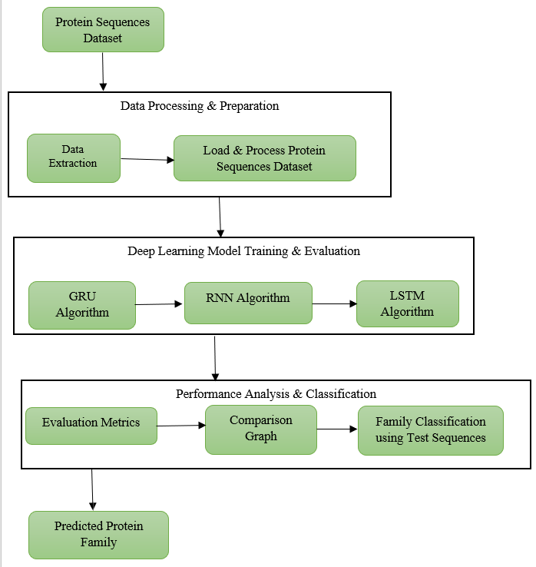
FIG 1.5 System Architecture

4.1 UML DIAGRAMS:

The Unified Modelling Language allows the software engineer to express an analysis model using the modelling notation that is governed by a set of syntactic semantic and pragmatic rules.
A UML system is represented using five different views that describe the system from distinctly different perspective. Each view is defined by a set of diagram, which is as follows.
- User Model View
i.This view represents the system from the users perspective.
ii.The analysis representation describes a usage scenario from the end-users perspective.
- Structural Model view
i.In this model the data and functionality are arrived from inside the system.
ii.This model view models the static structures.
- Behavioural Model View
It represents the dynamic of behavioural as parts of the system, depicting the interactions of collection between various structural elements described in the user model and structural model view.
- Implementation Model View
In this the structural and behavioural as parts of the system are represented as they are to be built.
- Environmental Model View
In this the structural and behavioural aspects of the environment in which the system is to be implemented are represented.

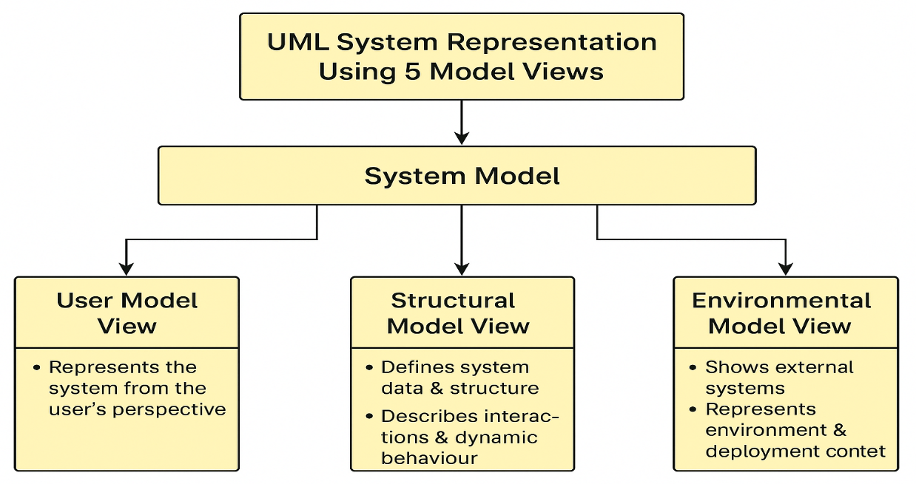

FIG:4.1 UML DIAGRAMS

GOALS:

The Primary goals in the design of the UML are as follows:
- Provide users a ready-to-use, expressive visual modeling Language so that they can develop and exchange meaningful models.
- Provide extendibility and specialization mechanisms to extend the core concepts.
- Be independent of particular programming languages and development process.
- Provide a formal basis for understanding the modeling language.
- Encourage the growth of OO tools market.
- Support higher level development concepts such as collaborations, frameworks, patterns and components.
- Integrate best practices.

4.2.1 USE CASE DIAGRAM:

A use case diagram at its simplest is a representation of a user's interaction with the system and depicting the specifications of a use case. A use case diagram can portray the different types of users of a system and the various ways that they interact with the system. This type of diagram is typically used in conjunction with the textual use case and will often be accompanied by other types of diagrams as well.

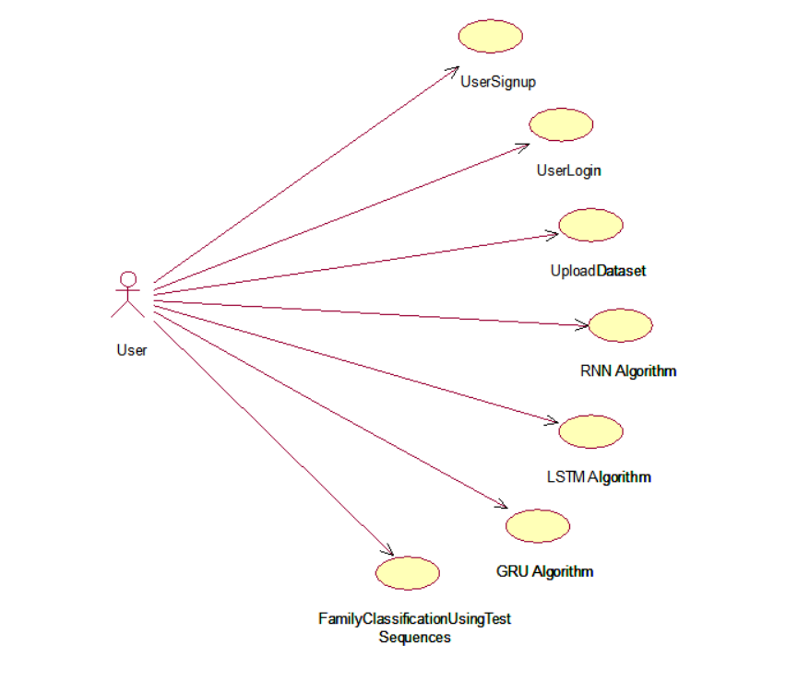
FIG:4.2.1 USE CASE DIAGRAMS

    - CLASS DIAGRAM:
The class diagram is the main building block of object oriented modeling. It is used both for general conceptual modeling of the systematic of the application, and for detailed modeling translating the models into programming code. Class diagrams can also be used for data modeling. The classes in a class diagram represent both the main objects, interactions in the application and the classes to be programmed. In the diagram, classes are represented with boxes which contain three parts:
- The upper part holds the name of the class
- The middle part contains the attributes of the class
- The bottom part gives the methods or operations the class can take or undertake.

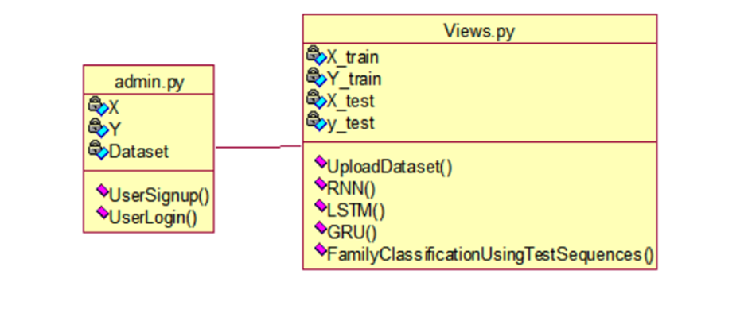
FIG:4.2.2 CLASS DIAGRAM

    - SEQUENCE DIAGRAM:

A sequence diagram is a kind of interaction diagram that shows how processes operate with one another and in what order. It is a construct of a Message Sequence Chart. A sequence diagram shows object interactions arranged in time sequence. It depicts the objects and classes involved in the scenario and the sequence of messages exchanged between the objects needed to carry out the functionality of the scenario. Sequence diagrams are typically associated with use case realizations in the Logical View of the system under development. Sequence diagrams are sometimes called event diagrams, event scenarios, and timing diagrams.

FIG:4.2.3 SEQUENCE DIAGRAM

    - ACTIVITY DIAGRAM:

Activity diagrams are graphical representations of workflows of stepwise activities and actions with support for choice, iteration and concurrency. In the Unified Modeling Language, activity diagrams can be used to describe the business and operational step-by-step workflows of components in a system. An activity diagram shows the overall flow of control.

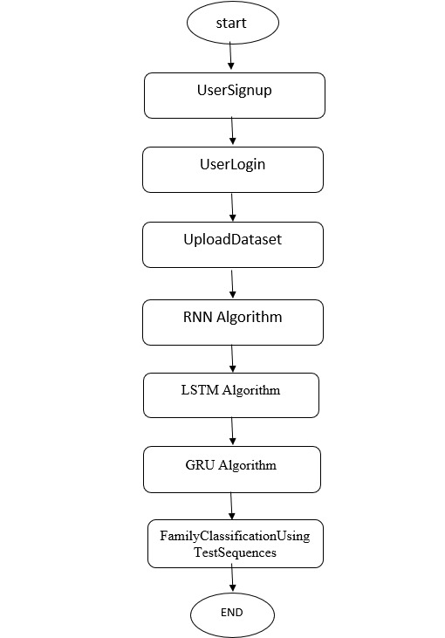

FIG:4.2.4 ACTIVITY DIAGRAM

    - DATA FLOW DIAGRAM:

Data flow diagrams illustrate how data is processed by a system in terms of inputs and outputs. Data flow diagrams can be used to provide a clear representation of any business function. The technique starts with an overall picture of the business and continues by analyzing each of the functional areas of interest. This analysis can be carried out in precisely the level of detail required. The technique exploits a method called top-down expansion to conduct the analysis in a targeted way.
As the name suggests, Data Flow Diagram (DFD) is an illustration that explicates the passage of information in a process. A DFD can be easily drawn using simple symbols. Additionally, complicated processes can be easily automated by creating DFDs using easy-to-use, free downloadable diagramming tools. A DFD is a model for constructing and analyzing information processes. DFD illustrates the flow of information in a process depending upon the inputs and outputs. A DFD can also be referred to as a Process Model. A DFD demonstrates business or technical process with the support of the outside data saved, plus the data flowing from the process to another and the end results.

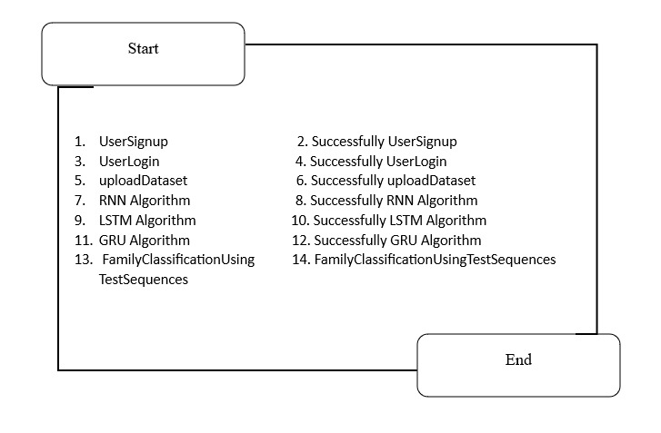
FIG:4.2.2 DATA FLOW DIAGRAM

    - COLLABORATION DIAGRAM:

A collaboration diagram describes interactions among objects in terms of sequenced messages. Collaboration diagrams represent a combination of information taken from class, sequence, and use case diagrams describing both the static structure and dynamic behaviour of a system.

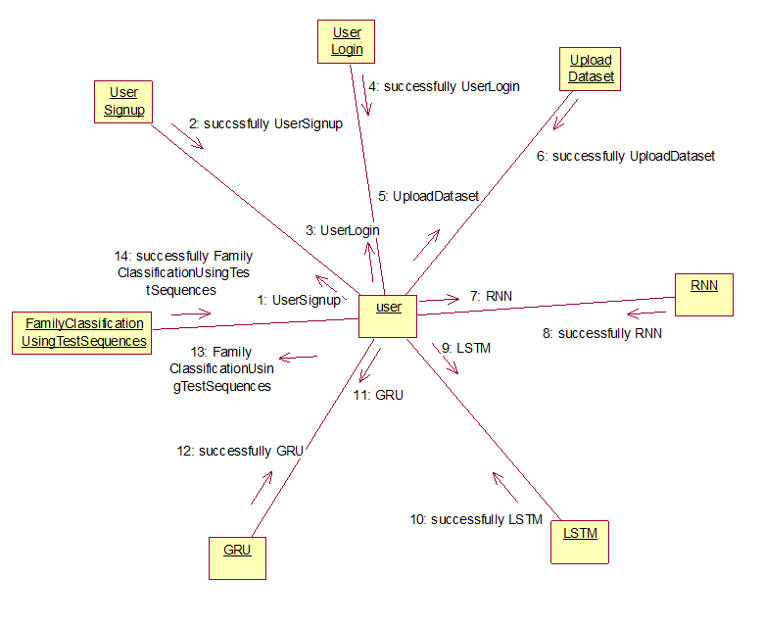
FIG:4.2.6 COLLABORATION DIAGRAM

    - COMPONENT DIAGRAM:

In the Unified Modelling Language, a component diagram depicts how components are wired together to form larger components and or software systems. They are used to illustrate the structure of arbitrarily complex systems.Components are wired together by using an assembly connector to connect the required interface of one component with the provided interface of another component. This illustrates the service consumer - service provider relationship between the two components.
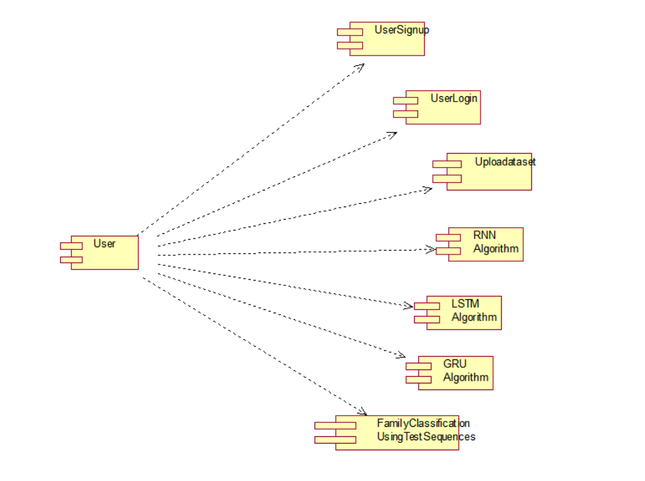
FIG:4.2.7 COMPONENT DIAGRAM

    - DEPLOYMENT DIAGRAM:

A deployment diagram in the Unified Modelling Language models the physical deployment of artifacts on nodes. To describe a web site, for example, a deployment diagram would show what hardware components ("nodes") exist (e.g., a web server, an application server, and a database server), what software components ("artifacts") run on each node (e.g., web application, database), and how the different pieces are connected (e.g. JDBC, REST, RMI).
The nodes appear as boxes, and the artifacts allocated to each node appear as rectangles within the boxes. Nodes may have sub nodes, which appear as nested boxes. A single node in a deployment diagram may conceptually represent multiple physical nodes, such as a cluster of database servers.
FIG:4.2.8 DEPLOYMENT DIAGRAM

CHAPTER 5
MODULES

5.1 ADMIN MODULE:

The Admin Module is responsible for managing the overall operation of the system, ensuring data integrity, user management, and performance monitoring. The admin has elevated privileges and full control over the application’s backend processes.
- User Management:
The admin can view, verify, and manage all registered users. This includes monitoring user activity, approving new user registrations, and ensuring secure access control.
- Dataset Management:
The admin can upload, update, and maintain the protein sequence datasets used for training and testing. This includes validating the quality of datasets (e.g., from SideChainNet or Pfam) and ensuring that they are properly preprocessed and formatted for model training.
- Model Management:
The admin oversees the training of deep learning models such as RNN, LSTM, and GRU. They can initiate, monitor, and evaluate training processes, ensuring that models achieve high accuracy and reliability. The admin also manages the storage and retrieval of trained models for user predictions.
- Performance Evaluation:
The admin can analyze the performance of various models using metrics such as accuracy, precision, recall, and F1-score. Visualizations like graphs and confusion matrices help the admin compare models and select the best one for deployment.
- System Maintenance:
The admin ensures that all system modules are functioning properly, handles error logs, manages database backups, and maintains overall security. They can also update the platform to integrate new datasets, algorithms, or features.

5.2 USER MODULE:

The User Module is designed for researchers, students, and bioinformaticians who interact with the system to perform protein family classification tasks. It provides a simple and intuitive interface to carry out all essential operations, from registration to classification.
- Registration and Login:
Users can register by providing their details and create secure login credentials. Once verified by the admin, users can log in to access the system functionalities. This ensures a personalized and secure workspace for every user.
- Dataset Loading and Processing:
Users can upload protein sequence datasets or select existing datasets from the database. The system automatically processes the sequences, extracts features, and splits the data into training and testing sets. Feature extraction is accelerated using GPU-enabled processing for efficiency.
- Model Training:
Users can select from multiple deep learning models - RNN, LSTM, or GRU - to train on the dataset. They can monitor training progress, view accuracy graphs, and evaluate the model’s performance using key metrics. The trained model is saved for later testing or classification.
- Protein Family Classification:
Users can upload test sequences to identify their respective protein families. The system uses the best-performing trained model to classify these sequences and display the results, including the predicted family and confidence score.
- Performance Analysis and Visualization:
Users can view the classification results through graphs, performance metrics, and confusion matrices, helping them understand model efficiency and accuracy in biological terms.

CHAPTER-6

REFERENCES

6.1 REFERENCES

- Vazhayil, A., Vinayakumar, R., & Soman, K.P. (2018). DeepProteomics: Protein family classification using Shallow and Deep Networks. arXiv. arXiv
- Liu, X. L. (2017). Deep Recurrent Neural Network for Protein Function Prediction from Sequence. bioRxiv. OUCI
- Sandaruwan, D., & Wannige, C. T. (2021). An improved deep learning model for hierarchical classification of protein families. PLoS ONE. PMC
- Investigation of protein family relationships with deep learning. (2023). Bioinformatics Advances. OUP Academic+1
- Asgari, E., & Mofrad, M. R. K. (2015). ProtVec: A Continuous Distributed Representation of Biological Sequences. arXiv. arXiv
- Zulfiqar, R., Khan, T. A., Khan, A. A. et al. (2025). A review on amino acid-based protein classification using supervised artificial intelligence (AI) models. Discovery Applied Sciences. SpringerLink
- AlQuraishi, M. et al. (2020). SideChainNet: An All-Atom Protein Structure Dataset. MLSB 2020. mlsb.io+1
- Ali, B., Shah, A., Niaz, M., Mansoord, M., Ullah, S., & Adnan, M. (2024). A Fusion-Driven Approach of Attention-Based CNN-BiLSTM for Protein Family Classification – ProFamNet. arXiv. arXiv

