Protein Family Classification using Deep Learning Techniques
In propose work we are employing deep learning algorithms such as GRU, RNN and LSTM to predict family from protein sequences. To train above models we have used Protein Sequences dataset from SideChainNet which can be downloaded and processes using below code
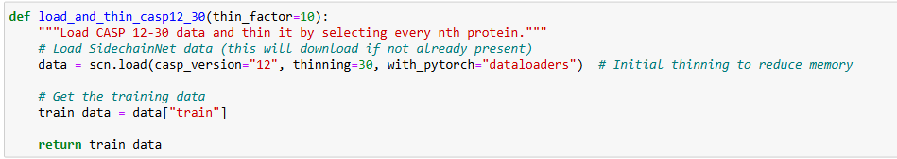
Above block of code will load CASP protein sequences dataset using 12 version
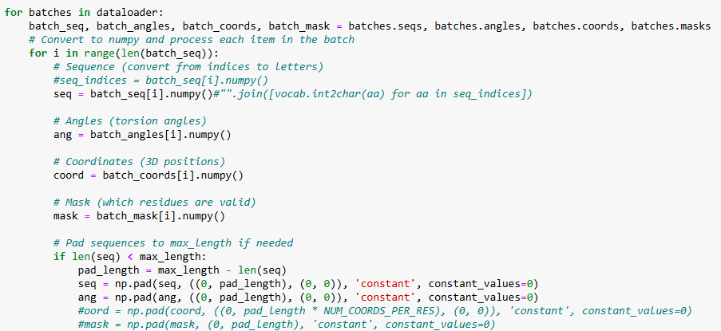Above block of code used to extract sequences, coordinates and angles from CASP sequences batch dataset. All extracted sequences can be input to DL algorithms to train a model and this trained model can be applied on test sequences to calculate prediction accuracy.
We have extracted all features and then saved those features in Dataset folder as NUMPY format. We cannot load and process above dataset in NORMAL CPU system so we need to load and extract features from Google COLAB GPU and then can save those features in NUMPY and reuse those features for training with DL algorithms in normal CPU.
Each DL algorithm performance is evaluated in terms of accuracy, precision, recall and FSCORE.
To implement this project we have designed following modules
- Registration Here: user can sign up with the application
- User Login: user can login to system
- Load & Process Protein Sequences Dataset: using this model will load and normalize all dataset sequences and then split into train and test where application using 80% sequences for training and 20% for testing
- Train DL Algorithms: 80% training sequences will be input to DL algorithms to trained a model and this model will be applied on 20% test sequences to calculate prediction accuracy
- Family Classification using Test Sequences: using this module user can upload test sequences and then best performing DL model will classify type of family.
SCREEN SHOTS
Install python 3.7.2 and then install all packages given in requirements.txt file and then install MYSQL database and then copy content from ‘database.txt file and then paste in MYSQL console to create database
To run project double click on ‘run.bat’ file to start python server and then will get below page
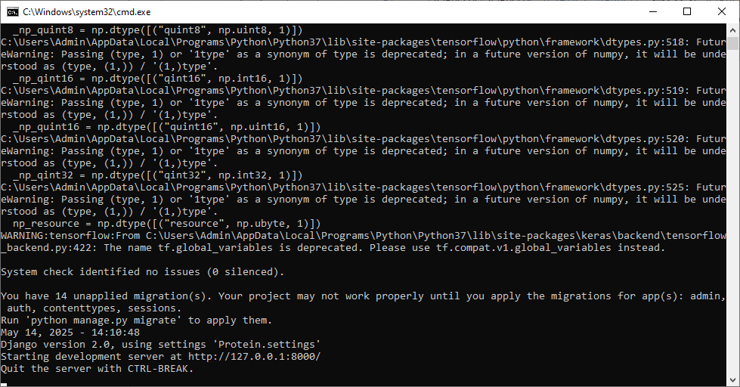
In above screen python server started and now open browser and enter URL as http://127.0.0.1:8000/index.html and then press enter key to get below page
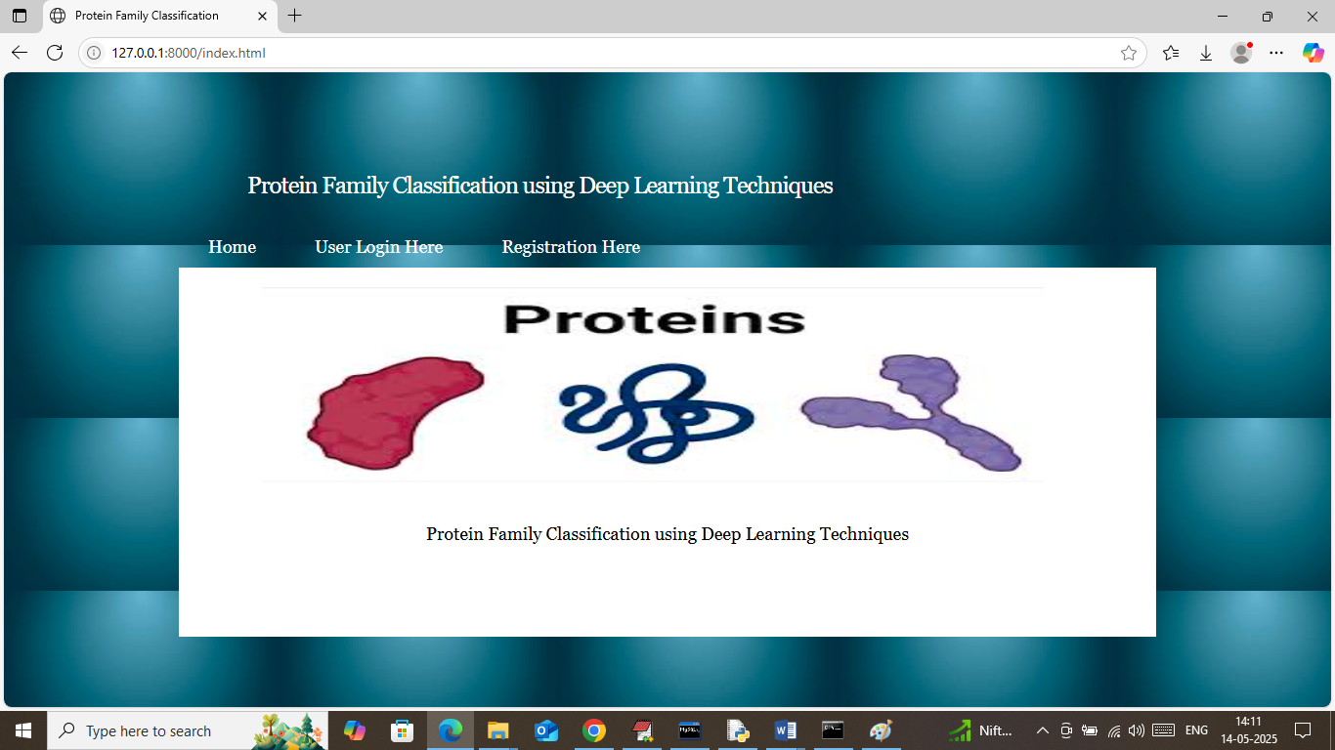
In above screen click on ‘Registration Here’ link to get below page
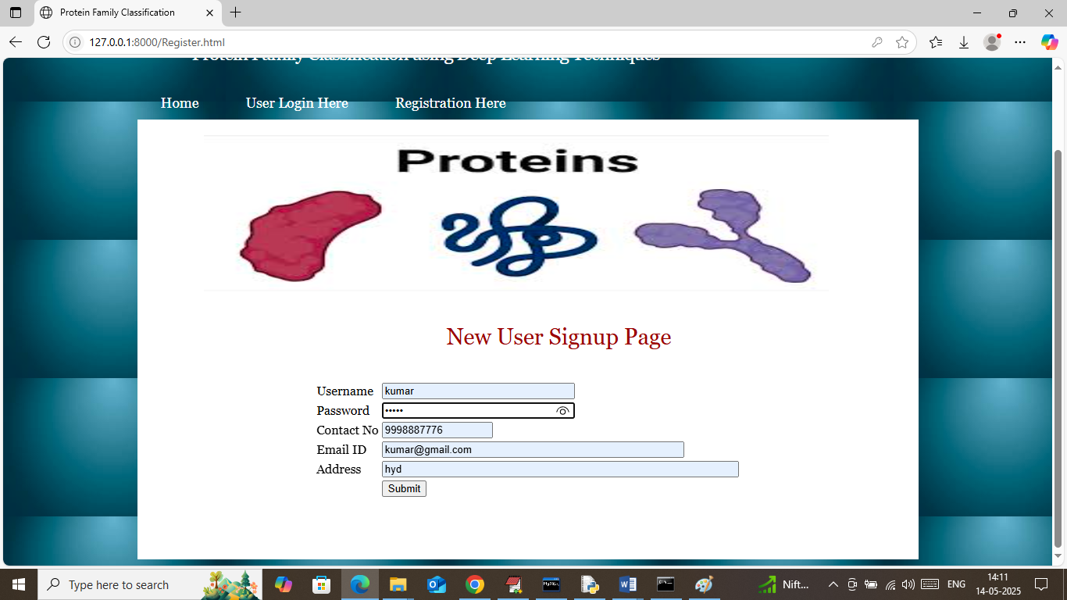
In above screen user is entering sign up details and then press button to get below page
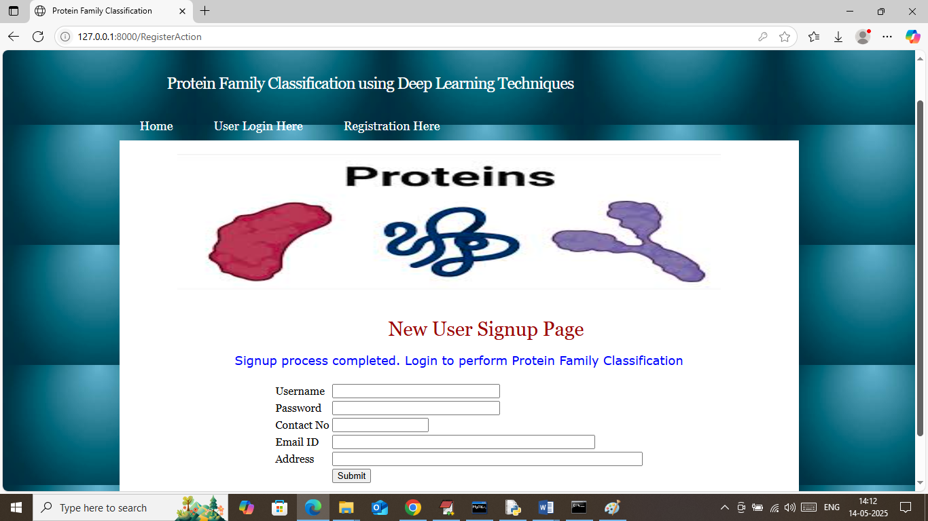
In above screen user sign up process completed and now click on ‘User Login Here’ link to get below page
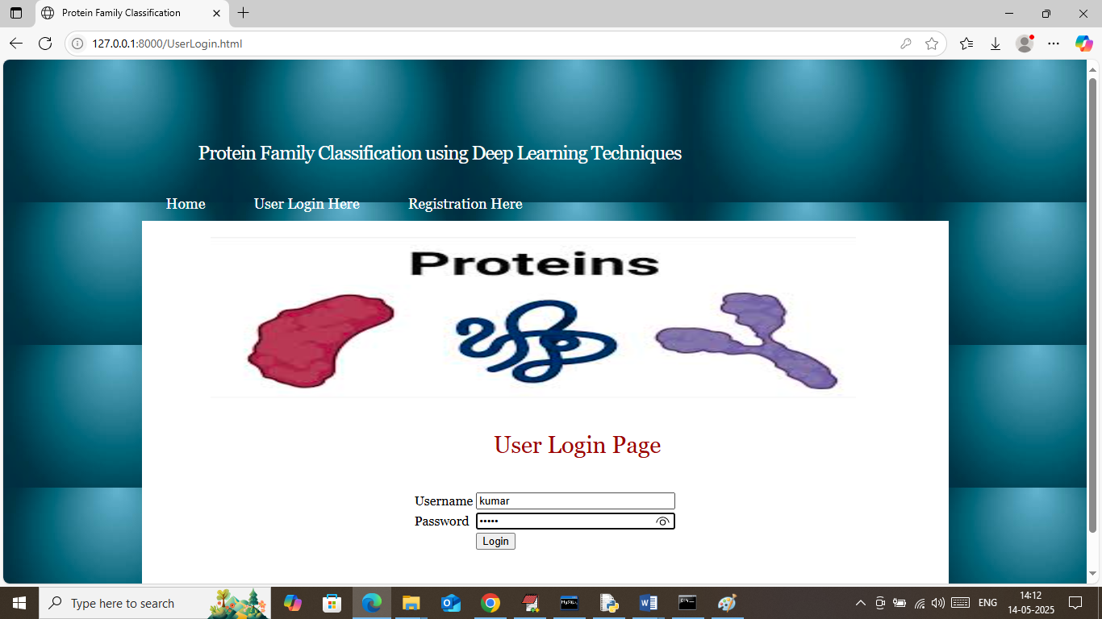
In above screen user is login and after login will get below page
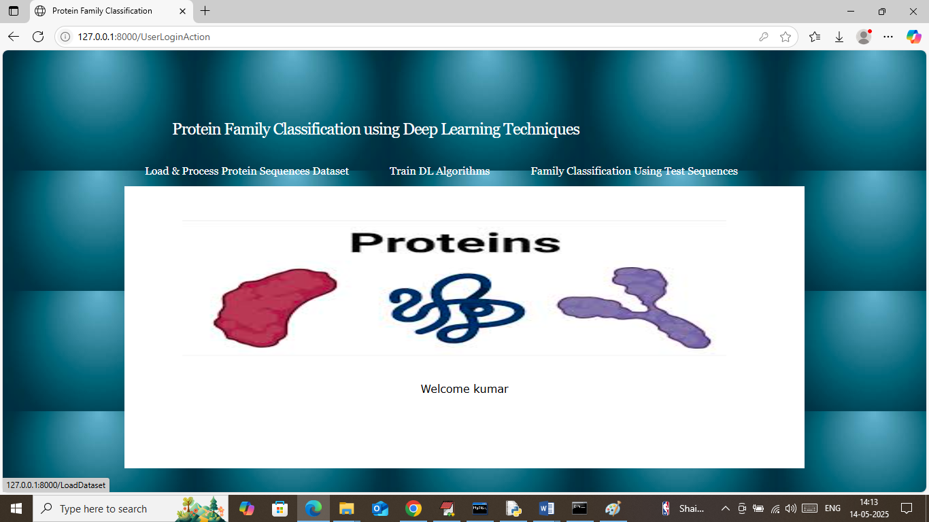
In above screen user can click on ‘Load & Process Protein Sequences Dataset’ link to load dataset and then will get below page
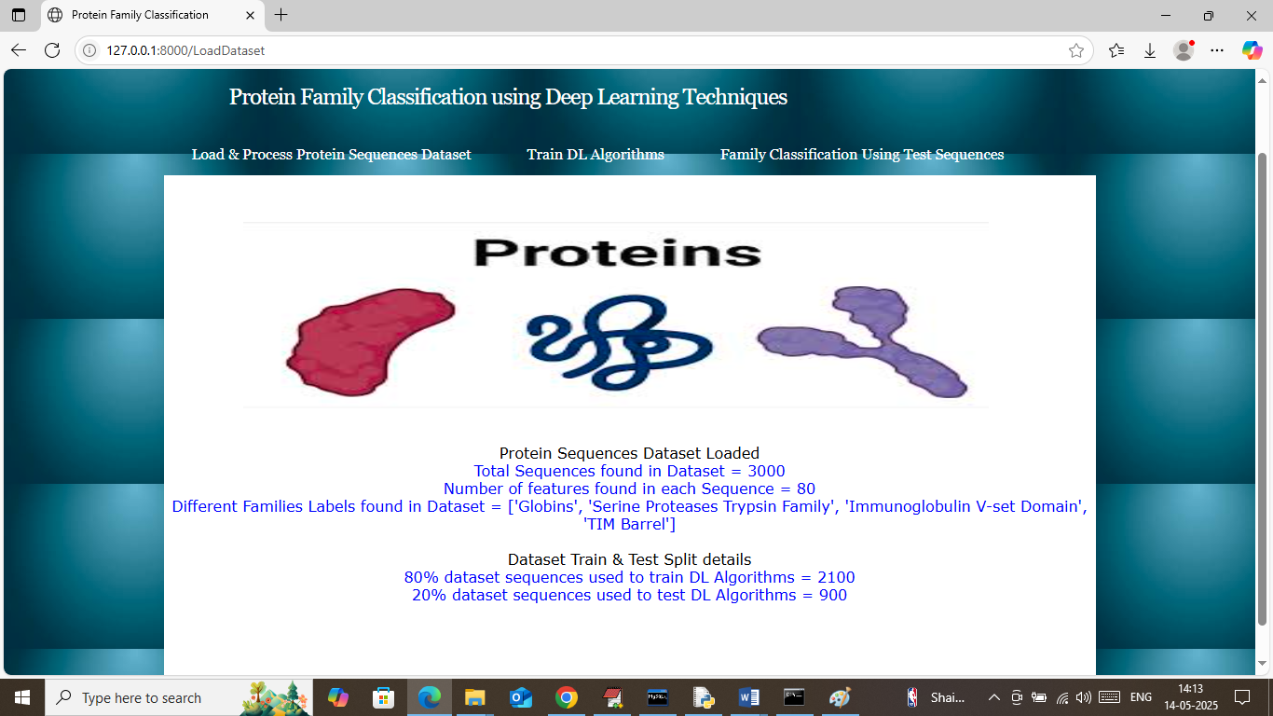
In above screen can see number of sequences loaded and processed from dataset and can see number of features available in each sequences and then can different families class labels found in dataset and then can see train and test size. Now click on ‘Train DL Algorithms’ link to train DL algorithms and then will get below page.
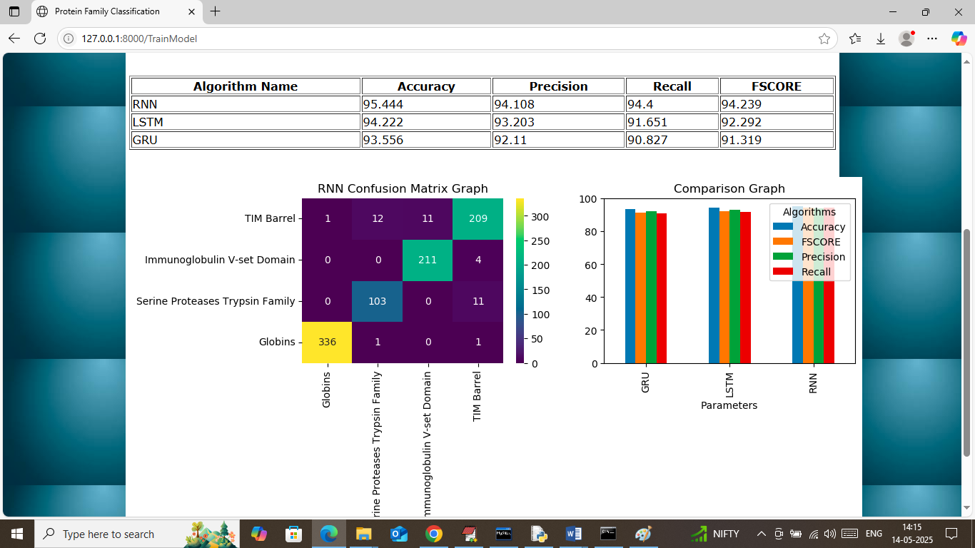
In above screen in table format can see LSTM, RNN and GRU algorithms performance where RNN got 95% accuracy and LSTM got 94% and GRU got 93% accuracy and can see other metrics like precision, recall and FSCORE. In confusion matrix graph x-axis represents ‘Predicted Family Labels’ and y-axis represents True labels and then different colour boxes in diagonal represents correct prediction count and remaining blue boxes represents incorrect prediction count which are very few. In second graph showing comparison graph between all algorithms where x-axis represents algorithm names and y-axis represents accuracy and other metrics in different colour bars. Now click on ‘Family Classification using Test Sequences’ link to get below page
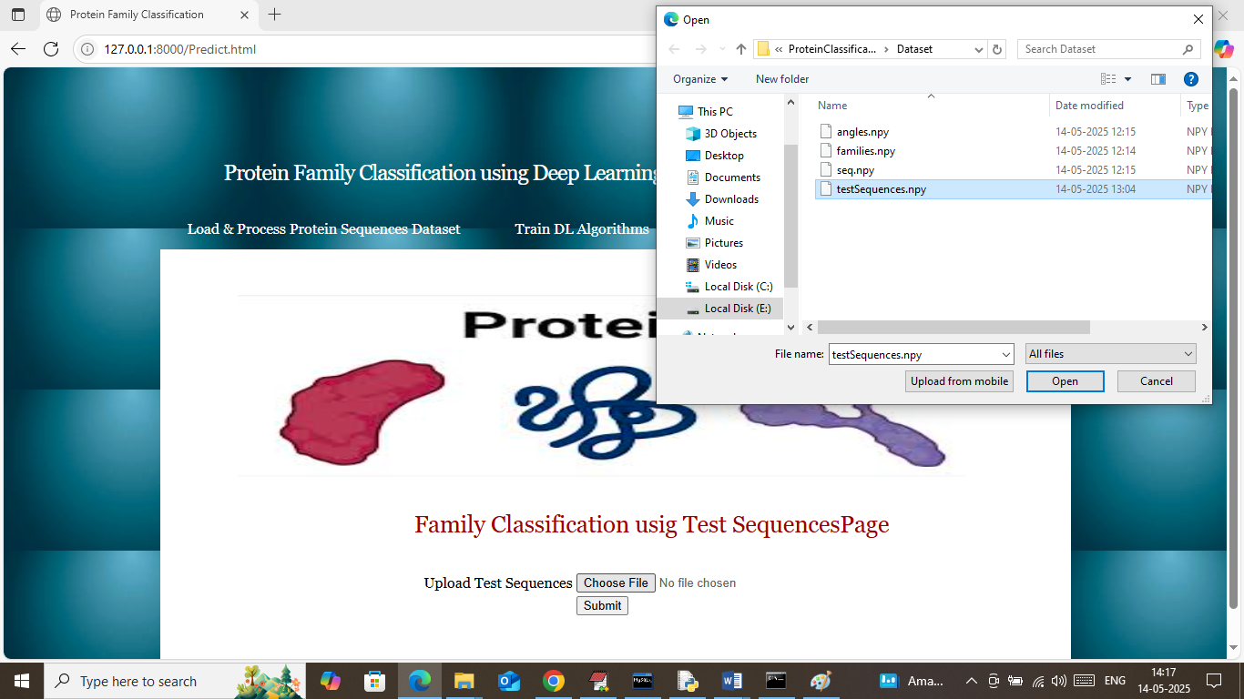
In above screen selecting and uploading test sequences file and then click on buttons to get below page
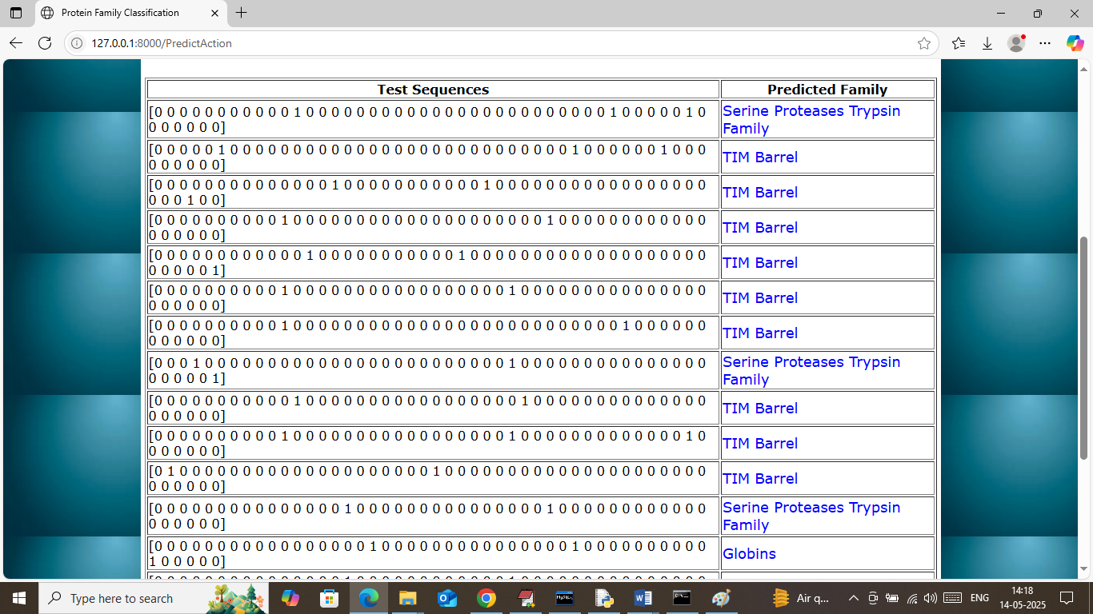
In above screen in first column showing few sequences from test data and in second column displaying classified family name
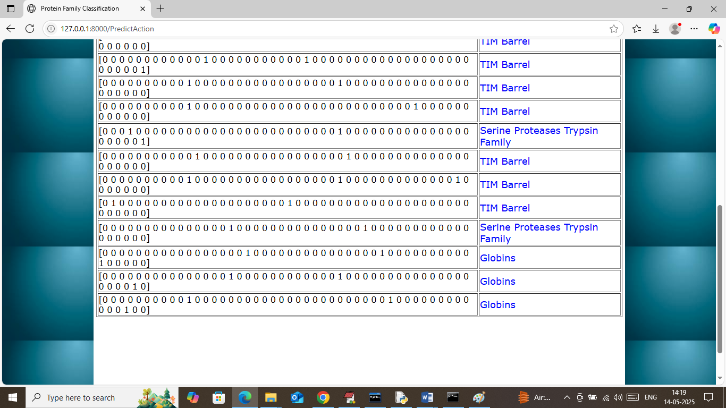
In above screen can see all predicted family output.

