# section 1

Enter the details of the loan as requested by the customer. The application received date, process date and the CBD date are auto generated. After you add all the details, click **Submit**. Enter the details of the loan as requested by the customer. Some of the fields are auto generated. After you add all the details, click **Submit** button.

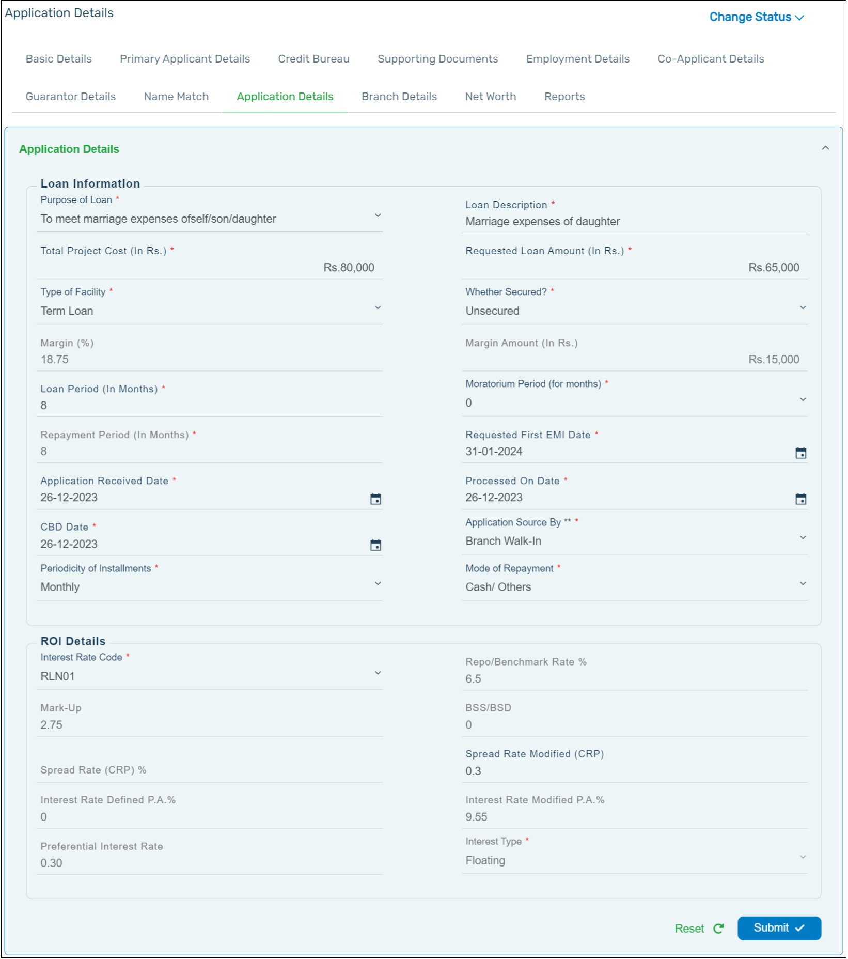

:::info

* The maximum Loan Period is **60 months**.

:::

# section 2

You can view the information related to the **Branch** where the application is being processed and the parking branch. Click the **Branch Details** tab to view the information.

The details of the branch where the application is being processed is shown as the Processing Branch. The details of the branch where the loan account would get opened is shown as the Parking Branch.

If you require to assign the application to a different Parking branch, click **Assign** button. Select the required branch in the list of dropdown that is available and Click the **Submit** button.

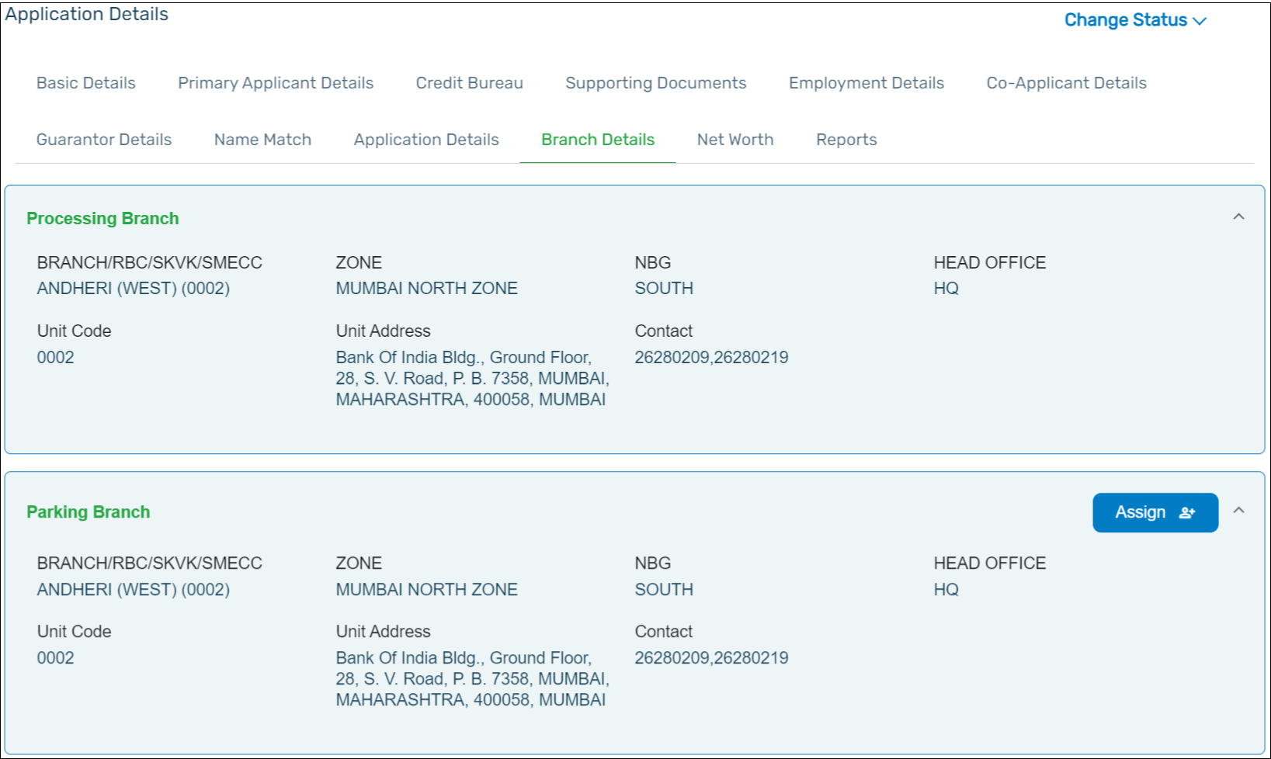

# section 3

Add the details of the **Co-applicant** to the loan application in this section. If there are no co-applicants, you can skip this section.

You can add the details of the co-applicant in the fields available. The system will match the details entered with the details available in CBS. If the details are available in CBS, the co-applicant details can be auto populated.

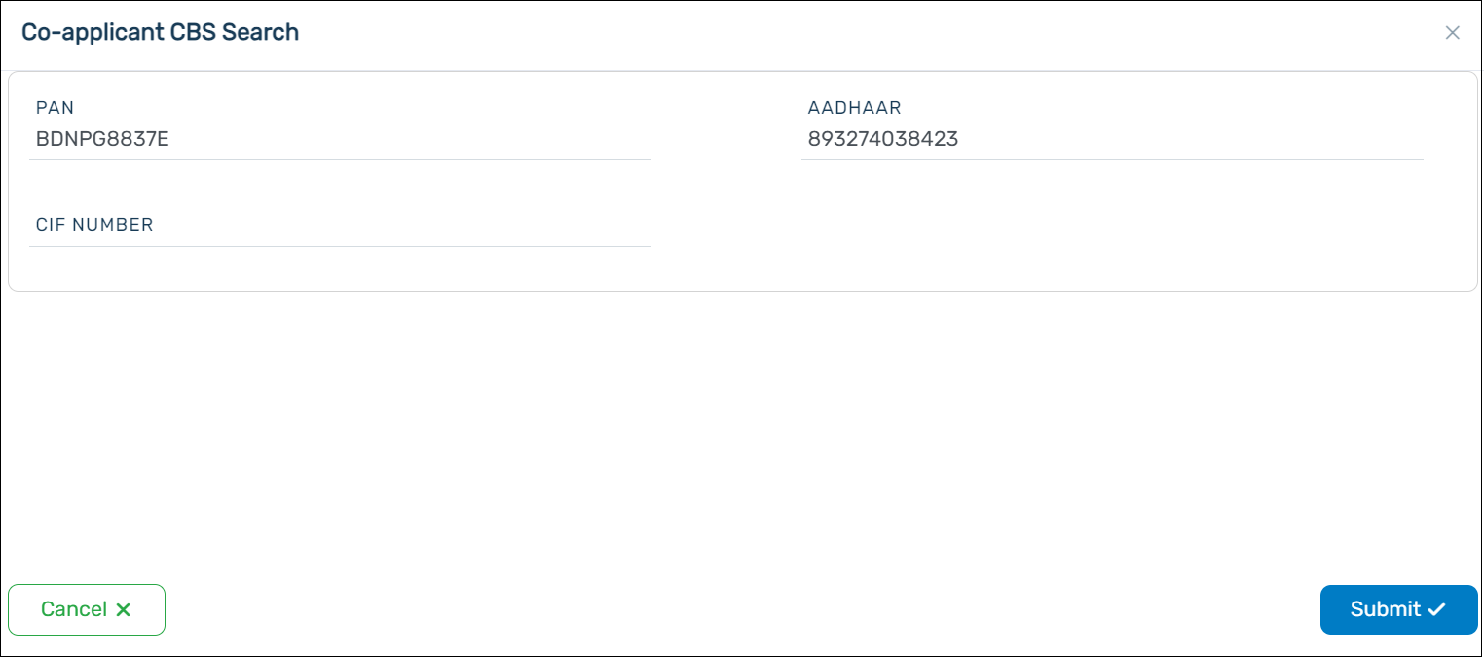

If the details are not available in CBS, you will get a pop-up as shown below. Click **Yes** to proceed.

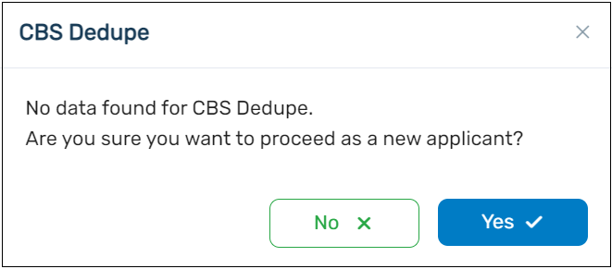

A pop-up will appear asking you to provide the details. You can add the personal details, address details and the family member details of the co-applicant.

:::info

* A maximum of **3 co-applicants** can be added to the pensioner loan application.
* The addition of a co-applicant to the pensioner loan application requires the information of the individual like the entries made for the primary applicant.
* The CIF Number is not mandatory for the Pensioner Loan product.

:::

[Image not found: D:\Documentation\work flow\pdf+docusaurus\datft36\image\fig32.png "figure 32"]

# section 4

In the Employment Details tab, you can fill in the **Employment** and the **Income** details of the applicant. Click **Submit** after all the fields are filled.

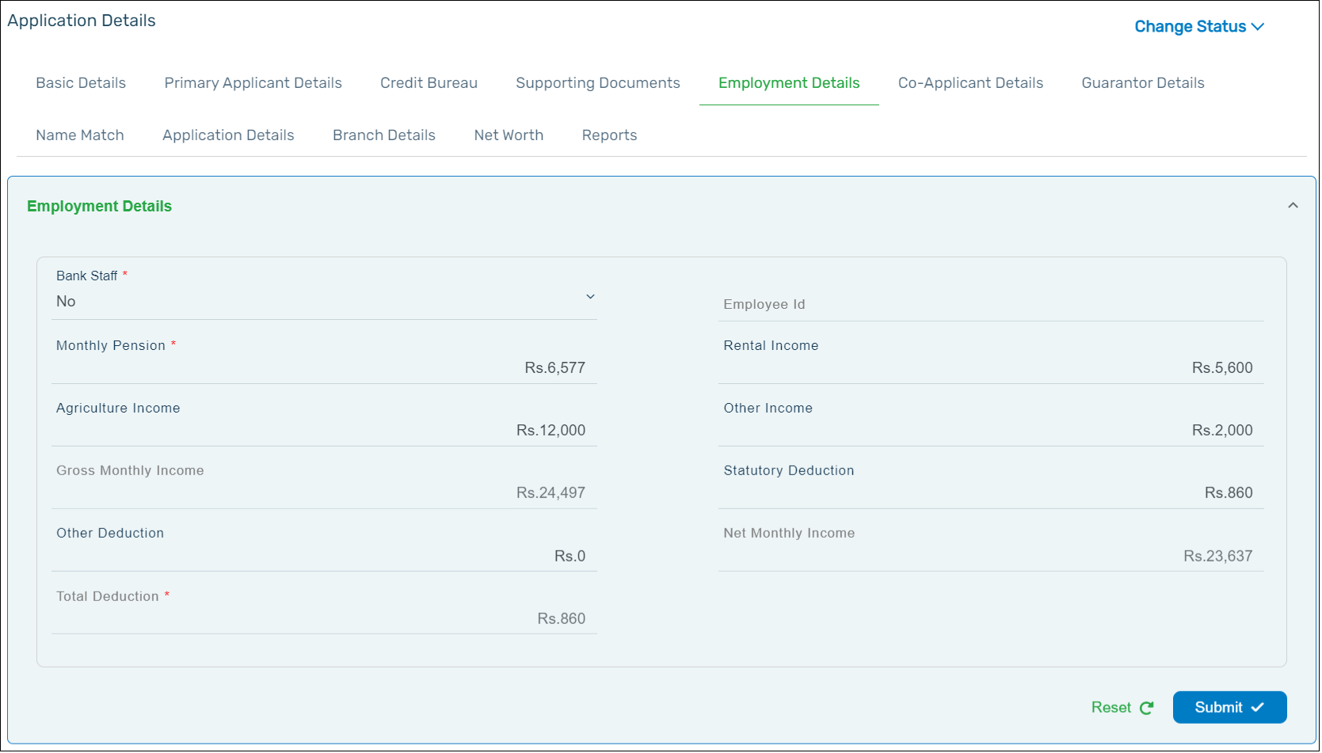

:::fig

* Make sure to fill all fields that are marked with a red asterisk (\*) as these are mandatory fields to process the application.
* The applicant can add additional income such as **Rental Income**, **Agricultural Income** and Other **Income**, if they are applicable.
* If the applicant is a bank employee, it is mandatory to add the Employee ID (PF ID).

:::

After you update the employment details, click **Submit** for it to get saved.

# section 5

Add the details of the **Guarantors** to the loan application in this section. If there are no guarantors, you can skip this section.

You can add the details of the guarantors in the fields available. The system will match the details entered with the details available in CBS. If the details are available in CBS, the guarantor details can be auto populated.

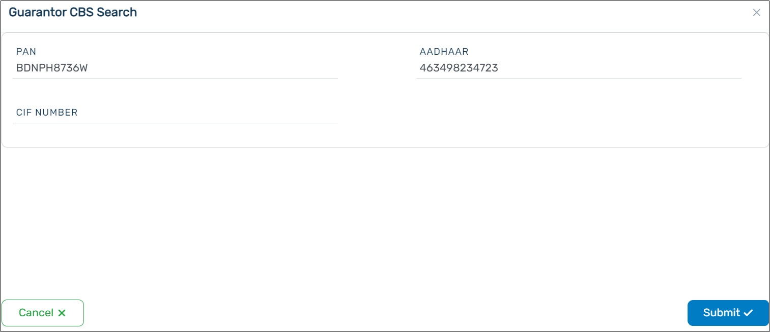

If the details are not available in CBS, you would get a pop-up as shown below. Click Yes to proceed.

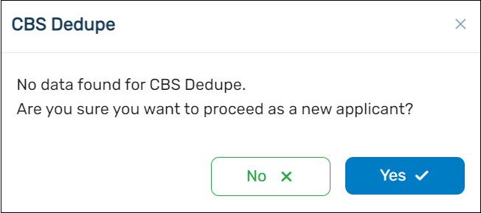

A pop-up will appear asking you to provide the details. You can add the personal details, address details and the family member details of the guarantor.

:::info

* A maximum of **3 co-applicants** can be added to the pensioner loan application.
* The addition of a guarantor to the pensionerloan application requires the information of the individual like the entries made for the primary applicant.
* The CIF Number is not mandatory for the Pensioner Loan product.

:::

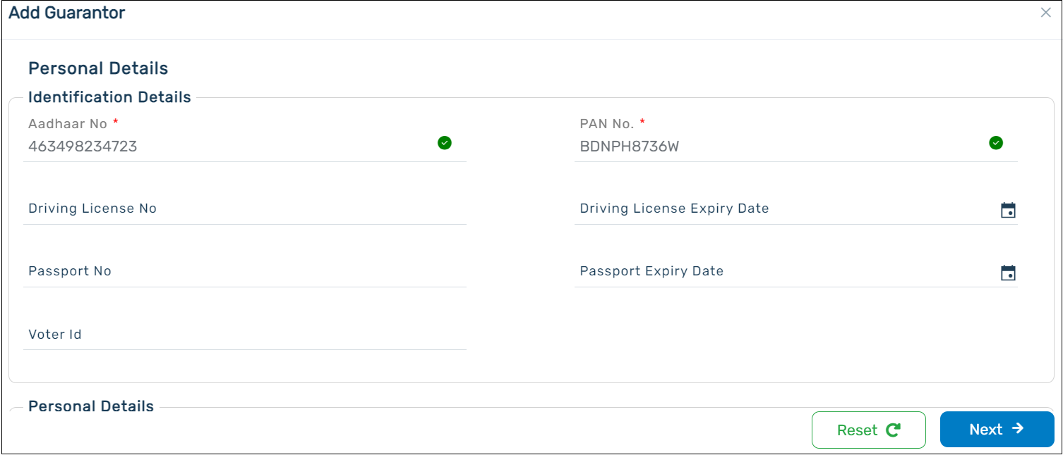

# section 6

The information available in this tab is auto generated. The system will perform the check of the name of the applicant along with the name present in the Aadhaar and PAN. If the names of the applicant match, **‘True’** will be displayed in the Is **Matched** column. The name match percentage is also displayed in the Match Percentage column.

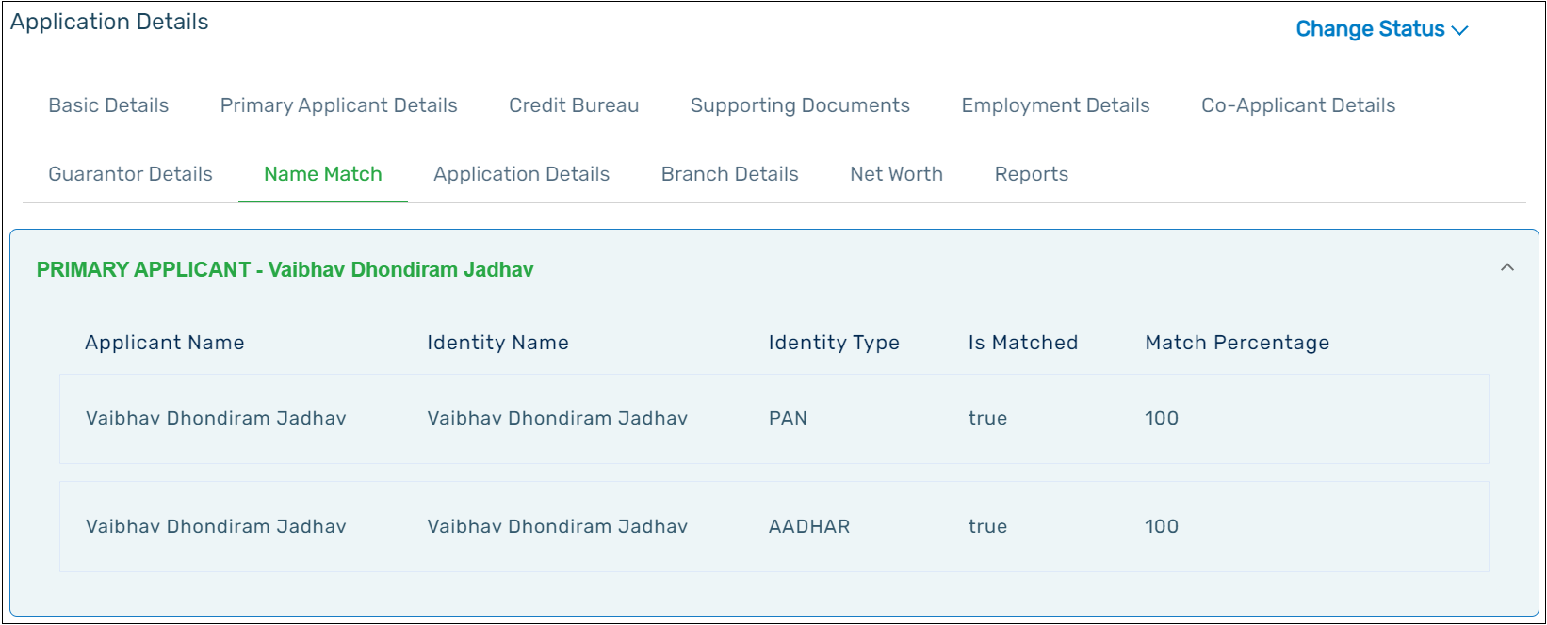

# section 7

Click the **Net Worth** tab. You can enter the details related to the customer’s liabilities and assets in the different tabs that are available. Click **Add icon** for the pop-up to appear and enter the necessary details. Once you complete adding the details, click on **Net Worth** tab to view the summarized net worth of the customer.

