Lab1:

Implement and demonstrate the FIND-S algorithm for finding the most specific hypothesis based on a given set of training data samples.

Program:

import pandas as pd

import numpy as np

data = pd.read_csv('lab1.csv')

concepts=np.array(data)[:,:-1]

target=np.array(data)[:,-1]

def search(con,tar):

for i,val in enumerate(tar):

if val=="yes":

specifichyp=con[i].copy()

break

for i,val in enumerate(con):

if tar[i]=="yes":

for x in range(len(specifichyp)):

if val[x]!=specifichyp[x]:

specifichyp[x]="?"

else:

pass

return specifichyp

print(search(concepts, target))

Output:

['sunny', 'warm', '?', 'strong', '?', '?']

Lab2:

For a given set of training data examples stored in a .CSV file, implement and demonstrate the Candidate-Elimination algorithm to output a description of the set of all hypotheses consistent with the training examples.

Program:

import numpy as np

import pandas as pd

data=pd.read_csv('data.csv')

concepts=np.array(data)[0:,:-1]

target=np.array(data)[0:,-1]

def candidate_elimination(con,tar):

s_hyp=con[0].copy()

g_hyp=[["?" for i in range(len(s_hyp))] for i in range(len(s_hyp))]

for i,val in enumerate(con):

if tar[i]=="yes":

for x in range(len(s_hyp)):

if val[x]!=s_hyp[x]:

s_hyp[x]="?"

g_hyp[x][x]="?"

if tar[i]=="no":

for x in range(len(s_hyp)):

if val[x]!=s_hyp[x]:

g_hyp[x][x]=s_hyp[x]

else:

g_hyp[x][x]="?"

indices=[i for i,val in enumerate(g_hyp) if val==["?","?","?","?","?","?"]]

for i in indices:

g_hyp.remove(["?","?","?","?","?","?"])

return s_hyp,g_hyp

s_final,g_final=candidate_elimination(concepts,target)

print(s_final)

print(g_final)

Output:

['sunny' 'warm' '?' 'strong' '?' '?']

[['sunny', '?', '?', '?', '?', '?'], ['?', 'warm', '?', '?', '?', '?']]

Lab3:

Write a program to demonstrate the working of the decision tree based ID3 algorithm. Use an appropriate data set for building the decision tree and apply this knowledge to classify a new sample.

Program:

import pandas as pd

import math

import numpy as np

data = pd.read_csv("3-dataset.csv")

features = [feat for feat in data]

features.remove("answer")

class Node:

def __init__(self):

self.children = []

self.value = ""

self.isLeaf = False

self.pred = ""

def entropy(examples):

pos = 0.0

neg = 0.0

for _, row in examples.iterrows():

if row["answer"] == "yes":

pos += 1

else:

neg += 1

if pos == 0.0 or neg == 0.0:

return 0.0

else:

p = pos / (pos + neg)

n = neg / (pos + neg)

return -(p * math.log(p, 2) + n * math.log(n, 2))

def info_gain(examples, attr):

uniq = np.unique(examples[attr])

#print ("\n",uniq)

gain = entropy(examples)

#print ("\n",gain)

for u in uniq:

subdata = examples[examples[attr] == u]

#print ("\n",subdata)

sub_e = entropy(subdata)

gain -= (float(len(subdata)) / float(len(examples))) * sub_e

#print ("\n",gain)

return gain

def ID3(examples, attrs):

root = Node()

max_gain = 0

max_feat = ""

for feature in attrs:

#print ("\n",examples)

gain = info_gain(examples, feature)

if gain > max_gain:

max_gain = gain

max_feat = feature

root.value = max_feat

#print ("\nMax feature attr",max_feat)

uniq = np.unique(examples[max_feat])

#print ("\n",uniq)

for u in uniq:

#print ("\n",u)

subdata = examples[examples[max_feat] == u]

#print ("\n",subdata)

if entropy(subdata) == 0.0:

newNode = Node()

newNode.isLeaf = True

newNode.value = u

newNode.pred = np.unique(subdata["answer"])

root.children.append(newNode)

else:

dummyNode = Node()

dummyNode.value = u

new_attrs = attrs.copy()

new_attrs.remove(max_feat)

child = ID3(subdata, new_attrs)

dummyNode.children.append(child)

root.children.append(dummyNode)

return root

def printTree(root: Node, depth=0):

for i in range(depth):

print("\t", end="")

print(root.value, end="")

if root.isLeaf:

print(" -> ", root.pred)

print()

for child in root.children:

printTree(child, depth + 1)

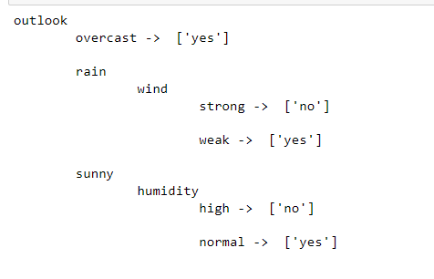

Lab4:

Implement the Linear Regression algorithm in order to fit data points. Select

appropriate data set for your experiment and draw graphs.

Program:

import numpy as np

import matplotlib.pyplot as plt

def estimate_coef(x, y):

# number of observations/points

n = np.size(x)

# mean of x and y vector

m_x = np.mean(x)

m_y = np.mean(y)

# calculating cross-deviation and deviation about x

SS_xy = np.sum(y*x) - n*m_y*m_x

SS_xx = np.sum(x*x) - n*m_x*m_x

# calculating regression coefficients

b_1 = SS_xy / SS_xx

b_0 = m_y - b_1*m_x

return (b_0, b_1)

def plot_regression_line(x, y, b):

# plotting the actual points as scatter plot

plt.scatter(x, y, color = "m",

marker = "o", s = 30)

# predicted response vector

y_pred = b[0] + b[1]*x

# plotting the regression line

plt.plot(x, y_pred, color = "g")

# putting labels

plt.xlabel('x')

plt.ylabel('y')

# function to show plot

plt.show()

def main():

# observations / data

x = np.array([0, 1, 2, 3, 4, 5, 6, 7, 8, 9,10,11,12])

y = np.array([1, 3, 2, 5, 7, 8, 8, 9, 10, 12,13,15,14])

# estimating coefficients

b = estimate_coef(x, y)

print("Estimated coefficients:\nb_0 = {} \

\nb_1 = {}".format(b[0], b[1]))

# plotting regression line

plot_regression_line(x, y, b)

if __name__ == "__main__":

main()

Output:

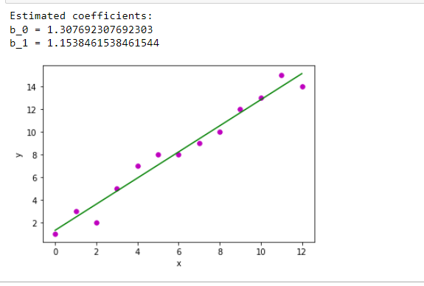

Lab5:

Write a program to implement the naïve Bayesian classifier for a sample training data set stored as a .CSV file. Compute the accuracy of the classifier, considering few test data sets

Program: