HOME:
<html>
<head>
<title>Shopping</title>
</head>
<body style="background-color:#FFF8DC;">
<center>
<img src="logo.png" width="30%" height="30%">
<h1><i>Pick Your Dress and Place Your Order<i></h1><center>
<p>Welcome to our online fashion store!Discover stylish, trendy, and affordable dresses for every occasion. From casual wear to party collections, we bring you the latest designs with quality you can trust.</p></i>
<h3>Before placing your order, please log in or register.</h3>
<a href="login.html">LOGIN</a><br>
<a href="register.html">REGISTER</a><br>
<h1></h1>
<video width="100%" height="80%" controls>
<source src="video1.mp4" type="video/mp4">
Your browser does not support the video tag.
</video>
</body>
</html>
LOGIN:
<html>
<head><title>Log in</title></head>
<body style="background-color:#FFFAF0;">
<center>
<h2>Log in</h2>
<img src="logo.png" width="30%" height="30%"><h1></h1>
<table border="1" width="350" height="300" bgcolor="white">
<tr><td><center>
<form action ="category.html" style="background-color:white;" width="300" height="50"><p>
<label>user name</label><br>
<input type="text" name="user name" placeholder="Enter user name" required></p>
<p>
<label>Email</label><br>
<input type="email" name="customer_email" placeholder="Enter email"required></p>
<p>
<label>Password</label><br>
<input type="Password" name "password" placeholder="Enter password"required></p>
<button type="submit" onclick="alert ('Logged in successfully')">Login</button></form>
<p></center>
</td></tr></table>
Don't have an account?
<a href="register.html">Register</a>
</p>
</center>
</body>
</html>
REGISTER:
<html>
<head><title>register</title></head>
<body style="background-color:#FDF5E6;">
<center>
<h2>Register</h2>
<img src="logo.png" width="30%" height="30%"><h1></h1>
<table border="1" width="350" height="300" bgcolor="white">
<tr><td><center>
<form action = "category.html" style="background-color:white;">
<p>
<label>user name</label><br>
<input type="text" name="user name" placeholder="Enter user name" required></p>
<p>
<label>Email</label><br>
<input type="email" name="customer_email" placeholder="Enter email" required></p>
<p>
<label>Password</label><br>
<input type="password" name="password" placeholder="Enter password" required></p>
<p>
<input type="radio" name="gender">male
<input type="radio" name="gender">female
</p>
<p>
<input type="checkbox" required>I agree to the terms and conditions
</p>
<button type="submit" onclick="alert ('Registerd in successfully')">Register</button>
</form>
<p></center>
</td></tr></table>
Already have an account?
<a href="login.html">Login</a>
</p>
</center>
</body>
</html>
CATEGORY:
<html>
<head><title>category</title></head>
<body style="background-color:#F5FFFA;">
<center>
<h2>Choose a Category!!</h2>
<p>Select your preferred category and start exploring our latest collections.</p><br>
<img src="logo.png" width="20%" height="20%">
<table width="60%" height="300">
<tr>
<th></th>
<th></th>
</tr>
<tr>
<td><center><a href="female.html"><img src="female.jpg" width="270" height="250"></a></center></td>
<td><center><a href="male.html"><img src="male.png" width="270" height="250"></a></center></td>
</tr>
<tr>
<td><center><h2>Female</h2></center></td>
<td><center><h2>Male</h2></center></td>
</tr>
</table>
</center>
</body>
</html>
FEMALE:
<html>
<head><title>Female Collection</title></head>
<body style="background-color:#FFF0F5;">
<center>
<h2>Women's Collection</h2>
<p>Explore our latest dresses and choose your favorite style.</p><br>
<img src="logo.png" width="20%" height="20%">
<table border="1" width="70%" height="350">
<tr>
<th>Dress 1</th>
<th>Dress 2</th>
</tr>
<tr>
<td><center><img src="dress1.jpeg" width="180" height="220"></center></td>
<td><center><img src="dress2.jpeg" width="180" height="220"></center></td>
</tr>
<tr>
<td><center>
Floral Maxi Dress<br>
Price : ₹999<br><br>
<button>Buy Now</button></center>
</td>
<td><center>
Party Wear Gown<br>
Price : ₹1499<br><br>
<button>Buy Now</button></center>
</td>
</tr>
</table>
<br>
<a href="category.html">Back to Category</a><br><br>
<a href="shopping.html">Back to Home</a>
</center>
</body>
</html>
MALE:
<html>
<head><title>Male Collection</title></head>
<body style="background-color:#F5FFFA;">
<center>
<h2>Men's Collection</h2>
<p>Explore our latest outfits and choose your favorite style.</p><br>
<img src="logo.png" width="20%" height="20%">
<table border="1" width="70%" height="350">
<tr>
<th>Dress 1</th>
<th>Dress 2</th>
</tr>
<tr>
<td><center><img src="shirt1.jpeg" width="180" height="220"></center></td>
<td><center><img src="shirt2.jpeg" width="180" height="220"></center></td>
</tr>
<tr>
<td><center>
Casual Shirt<br>
Price : ₹899<br><br>
<button>Buy Now</button></center>
</td>
<td><center>
Denim Jacket<br>
Price : ₹1799<br><br>
<button>Buy Now</button></center>
</td>
</tr>
</table>
<br>
<a href="category.html">Back to Category</a><br><br>
<a href="home.html">Back to Home</a>
</center>
</body>
</html>

HOME:

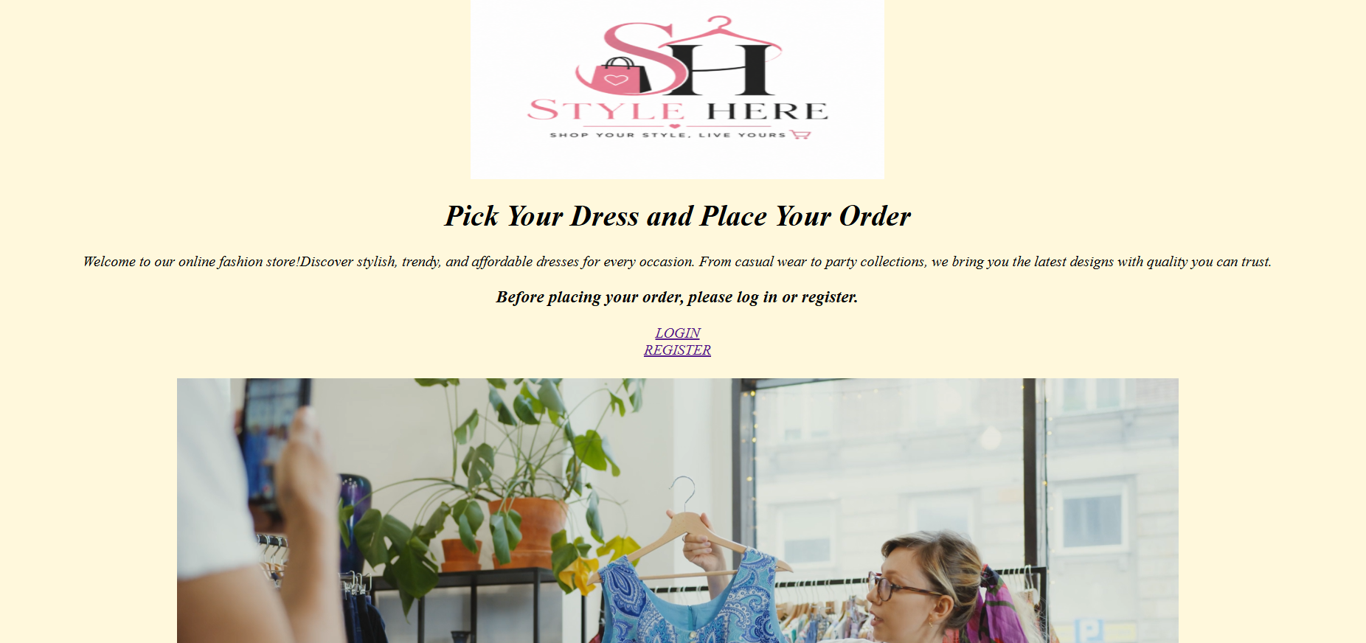

LOGIN:

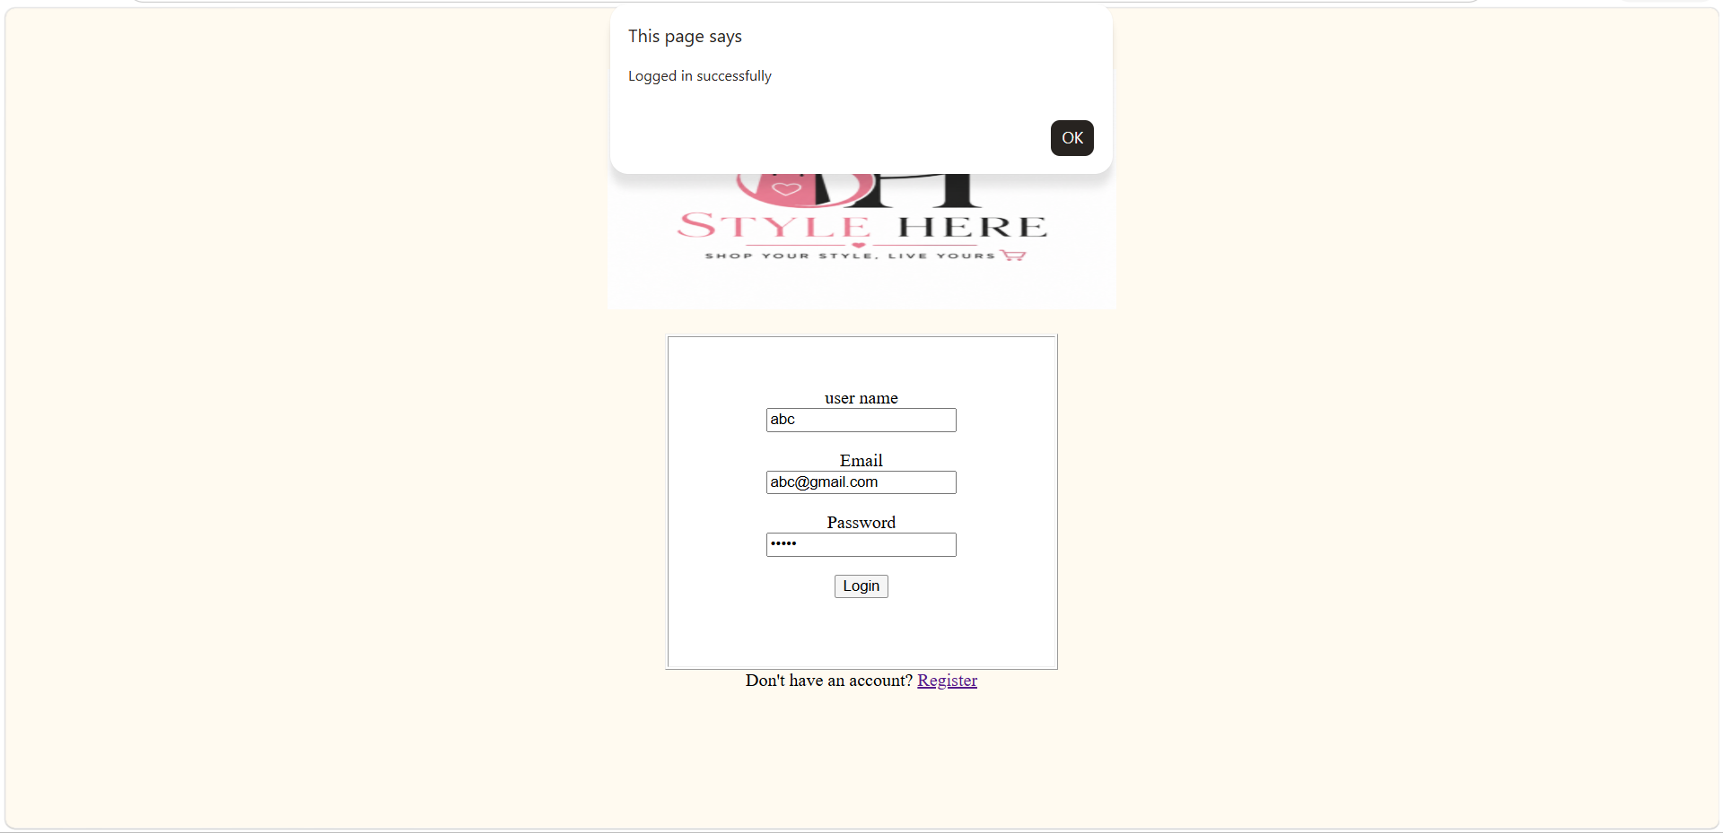

REGISTER:

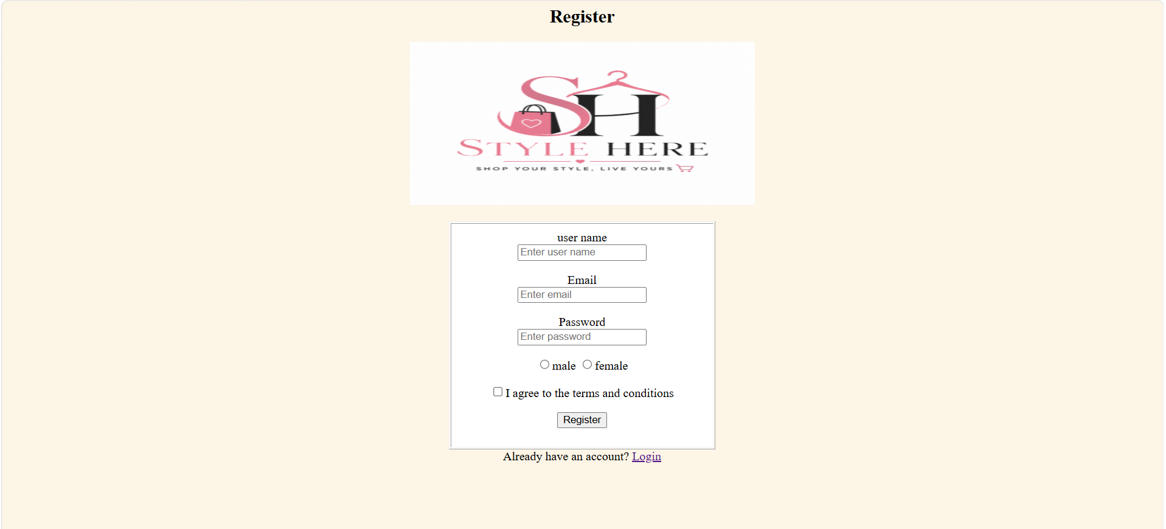

CATEGORY:

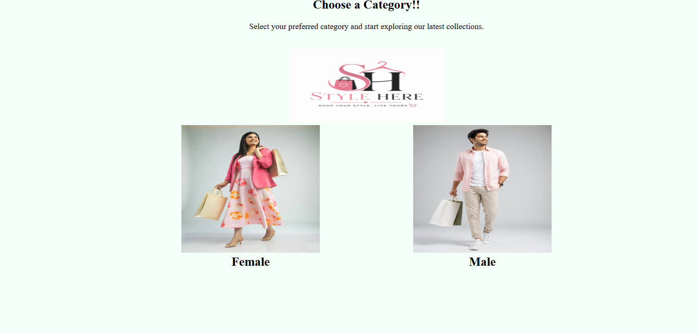

FEMALE:

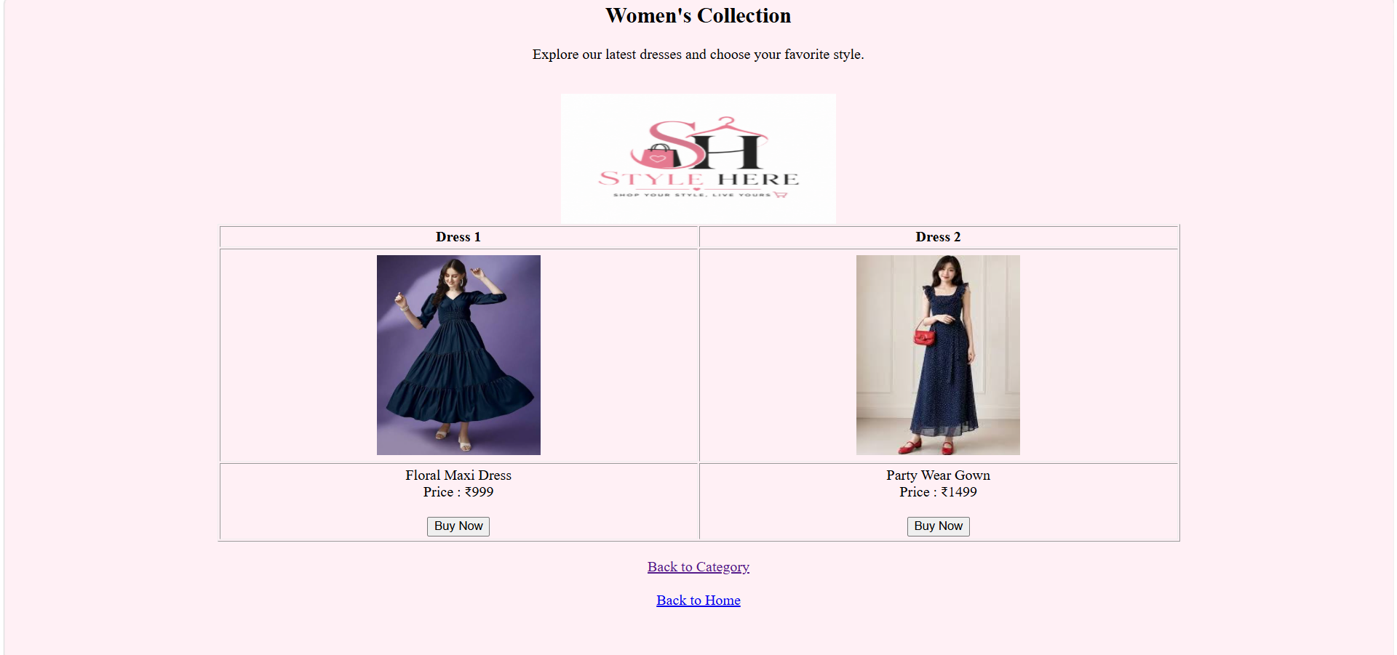

MALE:

