Homework 2

彭子帆 3170105860

Date: 2020/3/29

**Question 3:**

**Security: 7.5% Coca-Cola maturing 15 December 2005**

**Type: Eurobond, annual, 30E/360**

**Settlement date: 12 August 2004**

**Amount dealt: USD 10 million**

**Yield: 6.75%**

1. **What is total accrued interest payable on this trade?**

493,750

After I search the statics on the internet, I find the meaning of “30E/360”:

**30E/360**

Other names: Bond Basis, 30-360 U.S. Municipal 30/360 Eurobond, 30/360 ISMA, 30/360 European, 30S/360 Special German, Eurobond Basis  
  
Start date: M1/D1/Y1  
End date: M2/D2/Y2  
  
Day count = (Y2-Y1) *360+(M2-M1) *30+(D2-D1)  
  
Convention:  
• if D1=31, then D1=30  
• if D2=31, then D2=30

So, the number of days is 2003-12-15 - 2004-08-12 = 30*7+11 = 237 days.

Fractional coupon period = 237/360 = 0.65833333333…

Accrued interest = 0.65833333…*7.5 = 4.9375 or 4.9375‬%

Total accrued interest payable in this trade = 10,000,000 * 4.9375‬% = 493,750

1. **What is the bond’s dirty price, rounded to the nearest 2 decimal places?**

Dirty price = clean price + accrued interest

2004-12-15 – 2004-08-12 = 123 days

a is the fraction of the coupon period to the next coupon payment

a is 123/360 =0.341666…

Dirty price = 7.5/ ((1+6.75%) ^a) + (100+7.5)/ ((1+6.75%) ^(a+1)) = 105.8145137135749

1. **What is the clean price on this bond, rounded to the nearest 1/8%? (Write in decimal).**

Clean price = Dirty price = 105.8145137135749 - 4.9375 = 100.8770137

1. **Assuming you bought the bond at the price calculated in (c), what is the total settlement amount of the transaction?**

Total settlement amount = dirty price * amount dealt = 10,581,451

1. **Would you need to pay more or less for this bond if you required a yield of 7%?**

**Pay less**, because the dirty price will be lower and in the meanwhile dirty price will be lower, so the multiply result between the dirty price and amount dealt will be less.

**Question 4:**

**This exercise is too complex to perform with a simple calculator. You should use a financial calculator such as the HP 17 (or later model) or the bond pricing model, which should have been provided for you to go with this exercise.**

**Security: 7.5% US Treasury bond maturing 21 October 2009**

**Type: semi-annual, actual/actual**

**Settlement date: 20 April 2004**

**Yield: 7.00%**

1. **What is the bond’s clean price, rounded to the nearest 1/32%? (Enter in decimal)**

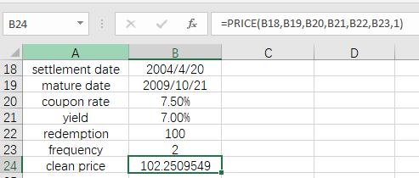

If rounded to the nearest 1/32%, then the answer is 102.2510

1. **What is its dirty price, rounded to 2 decimal places?**

The dirty price is the clean price plus the accrued interest.

Number of days since last coupon 182 days

Fractional coupon period = 182/182.5 = 0.9972602739726028

Accrued interest = 0.99726027397260 * 7.5 = 7.47945205479452

Dirty price = 7.479452054 + 102.2509549 = 109.7304069548

So, the answer is 109.73

1. **Given the same yield, what would be the bond’s clean price for value 22 April 2004, rounded to the nearest 1/32%? Enter the result in decimal, to 2 decimal places.**

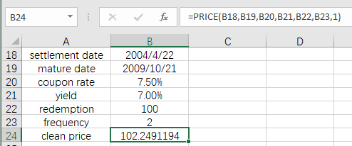

So, the answer is 102.2491

1. **What would be its dirty price, rounded to 2 decimal places?**

Dirty price will be clean price plus accrued interest:

Number of days since last coupon 1 days

Fractional coupon period = 1/182.5 = 0.00547945205

Accrued interest = 0.00547945205 * 7.5 = 0.0410958904

Dirty price = 0.0410958904 + 102.2491194 = 102.29021529

So, the answer is 102.29

1. **Explain the differences between (b) and (d), above.**

**A coupon was paid on 21 April.**

In (b), the bond was been traded just one day before the next coupon day, in the meanwhile, in (d), the bond was been traded just one day after the last coupon day. So the incurred interest is not the same, so the dirty price will be different.