**HW1**

彭子帆 3170105860

**1-14**

An interrupt is a hardware-generated change of flow within the system. An interrupt

handler is summoned to deal with the cause of the interrupt; control is then returned

to the interrupted context and instruction. A trap is a software-generated interrupt.

An interrupt can be used to signal the completion of an I/O to obviate the need for

device polling. A trap can be used to call operating system routines or to catch

arithmetic errors.

**1-17**

An operating system for a machine of this type would need to remain in control (or monitor mode) at all times. This could be accomplished by two methods:

a. Software interpretation of all user programs (like some BASIC, Java, and LISP systems, for example). The software interpreter would provide, in software, what the hardware does not provide.

b. Require that all programs be written in high-level languages so that all object code is compilerproduced. The compiler would generate (either in-line or by function calls) the protection checks that the hardware is missing.

**1-19**

Slowest f c a e d g b fastest

**1-22**

The processor could keep track of what locations are associated with each process and limit access to locations that are outside of a program’s extent. Information regarding the extent of a program’s memory could be maintained by using base and limits registers and by performing a check for every memory access.

截图如下：

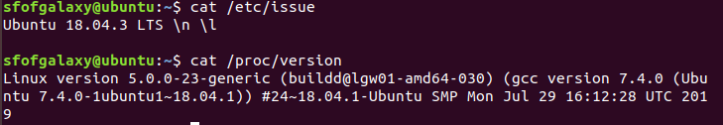

1. 截图：

Cpu:

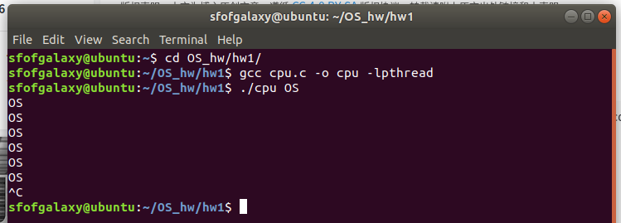

Memory：

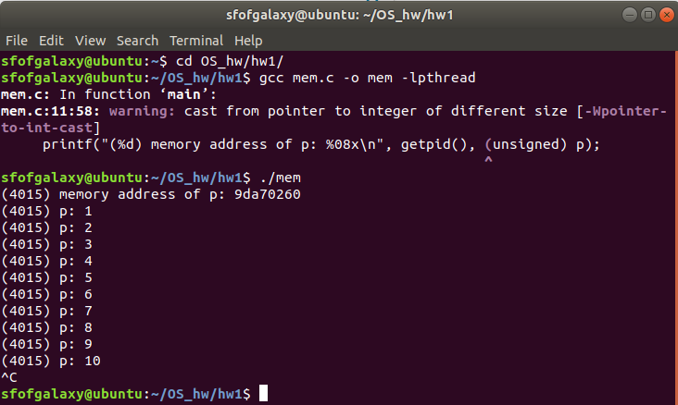

Threads:

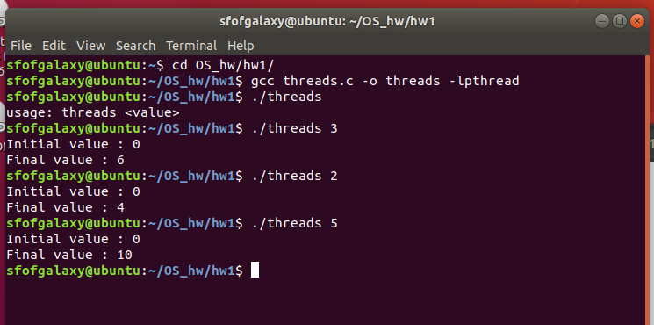

1. 学会了什么
2. 通过这些文件，学会了如何组织这些文件，可以并且如何进行编译、运行，并且链接不是标准库中的库。
3. 通过cpu.c学会了main函数中的参数的含义，运行时所需参数。
4. 通过Common.h中对于Spin函数的定义明白了该间隔时间的函数如何编写。
5. 通过mem.c分配内存以及进程分配内存的ID
6. 通过treads.c明白一个处理器可以创建多个线程
7. 和书上一致. 程序运行和书中的对比获得的地址值不同，ASLR把堆、栈、共享库映射等线性区布局随机化，所以每次运行程序所获得的地址值会是不同的，是一种针对缓冲区溢出的安全保护技术。