**HW 2**

彭子帆 3170105860

**2-9**

One class of services provided by an operating system is to enforce protection between different processes running concurrently in the system. Processes are allowed to access only those memory locations that are associated with their address spaces. Also, processes are not allowed to corrupt files associated with other users. A process is also not allowed to access devices directly without operating system intervention.

The second class of services provided by an operating system is to provide new functionality that is not supported directly by the underlying hardware. Virtual memory and file systems are two such examples of new services provided by an operating system.

**2-10**

1. In the registers.
2. Registers pass starting addresses of blocks of parameters.
3. Parameters can be placed or pushed, on to the stack by program and popped ty operating system in like wise.

**2-12**

Each device can be accessed as though it was a file in the file system. Since most of the kernel deals with devices through this file interface, it is relatively easy to add a new device driver by implementing the hardware-specific code to support this abstract file interface. Therefore, this benefits the development of both user program code, which can be written to access devices and files in the same manner, and device driver code, which can be written to support a well-defined API.

The disadvantage with using the same interface is that it might be difficult to capture the functionality of certain devices within the context of the file access API, thereby resulting in either a loss of functionality or a loss of performance.

**2-17**

Mechanism and policy must be separate to ensure that systems are easy to modify. No two system installations are the same, so each installation may want to tune the operating system to suit its needs. With mechanism and policy separate, the policy may be changed at will while the mechanism stays unchanged. This arrangement provides a more flexible system.

1. 运行与截图

编译：

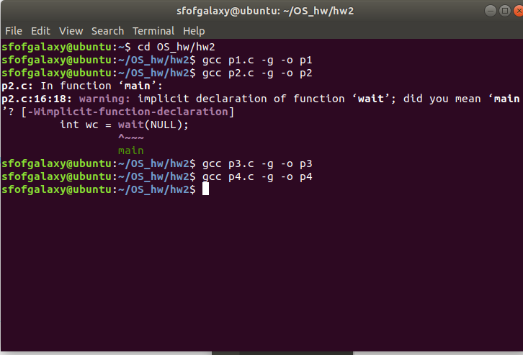

P1运行：

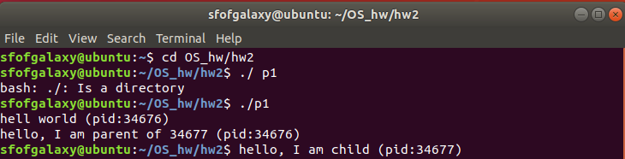

P2运行：

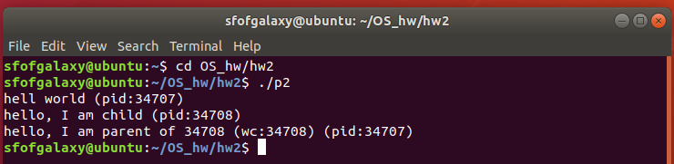

P3运行：

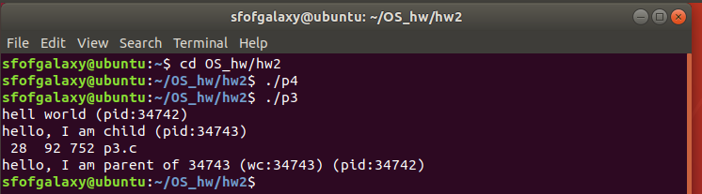

P4运行：

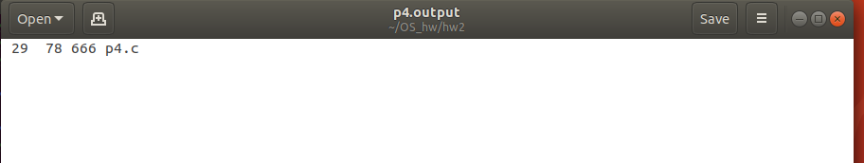

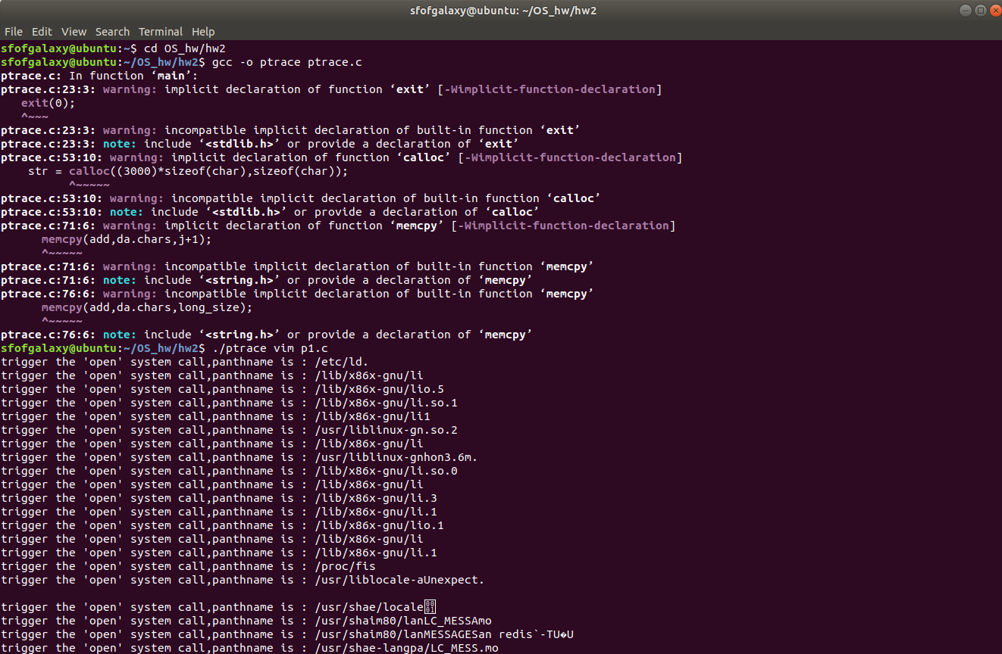PPTRACE：