Long-Context Factual Reliability in Llama 3.2 3B Instruct
Experiment C: Total Inaccuracy Report
Model: meta-llama/Llama-3.2-3B-Instruct
Dataset: 100 question families, 500 repeated observations
Report date: 2026-08-10

Table of Contents
- 1. Executive Summary / Abstract
- 2. Research Question and Motivation
- 3. Dataset and Source Domains
- 4. Question Dataset
- 5. Experimental Configuration
- 6. Grading Method
- 7. Overall Results
- 8. Statistical Analysis of Overall Inaccuracy
- 9. Paired Context Comparisons
- 10. Question-Type Results
- 11. Domain Results
- 12. Inference-Time Analysis
- 13. Interpretation, Limitations, and Conclusion
- 14. Methodological Provenance
- Appendix A. Detailed Tables

1. Executive Summary / Abstract
This report summarizes Experiment C, a completed local inference experiment evaluating factual reliability for meta-llama/Llama-3.2-3B-Instruct. The benchmark uses primary-source records from SEC filings, Drugs@FDA, ClinicalTrials.gov, and FRED to create 100 repeated question families evaluated at 4K, 8K, 16K, 32K, and 64K context lengths, for 500 total observations.
The main result is a strong increase in total inaccuracy as context length increases. Inaccuracy rose from 43% at 4K to 73% at 64K. In a GEE logistic model clustered by question family, each doubling of context length was associated with 1.35x the odds of an inaccurate answer (95% CI [1.20, 1.52], p = 4.06e-07). Mean inference latency increased from 0.317 s to 7.824 s.

2. Research Question and Motivation
The primary research question is how increasing context length affects factual reliability when a model is given legitimate but competing same-domain records. The report uses total inaccuracy as the main reliability metric: a response is either Correct or Inaccurate.

3. Dataset and Source Domains
The benchmark converts authoritative primary-source records into controlled factual questions. Each question family has a deterministic gold answer, target evidence, structured target conditions, and same-domain distractors. Contexts grow by adding plausible competing information while preserving the same question, gold answer, and target evidence.

Table 1. Source domains.
Domain | Role
SEC | Company financial facts and filings.
FDA / Drugs@FDA | Drug applications, submissions, products, strengths, dosage forms, and routes.
ClinicalTrials.gov | Trial metadata, dates, enrollment, arms, status, and unavailable fields.
FRED | Economic time series with unit, frequency, and series attributes.

4. Question Dataset
The final dataset contains 100 unique question families: 80 answerable and 20 unanswerable. Each family was evaluated at five context lengths, yielding 100 x 5 = 500 repeated observations. Because the same families appear at all context lengths, statistical tests treat observations as clustered by family.

Table 2. Question-type distribution.
Question type | Families | Purpose
DIRECT_RETRIEVAL | 20 | Single-record factual retrieval.
RETRIEVAL_CALCULATION | 30 | Retrieve values and compute a deterministic answer.
TEMPORAL_VERSION | 11 | Identify the requested period, version, or submission.
ENTITY_UNIT_BINDING | 19 | Bind entity, unit, product, route, dosage form, or series attributes.
UNANSWERABLE | 20 | Return the insufficient-evidence answer when target evidence is absent.

5. Experimental Configuration

Table 3. Inference configuration.
Setting | Value
Model | meta-llama/Llama-3.2-3B-Instruct
Model revision | 0cb88a4f764b7a12671c53f0838cd831a0843b95
Hardware | NVIDIA GeForce RTX 4090
Precision/cache | BF16, standard DynamicCache
Decoding | deterministic greedy; do_sample=False; num_beams=1; max_new_tokens=128
Quantization/offloading | none
Prompt version/hash | llama_chat_v4 / 5d2869822989e19b
Output contract | ANSWER: <answer>

Experiment C achieved 500/500 successful inference instances, zero format failures, and zero outputs hitting the 128-token cap.

6. Grading Method
Responses were graded by a frozen deterministic grader (SHA-256 d9282a0ccc50daba3bfd232c058dfbab63a5c19a7323d585a7c2236b3a6c4ba8). Of 500 responses, 499 were resolved by the deterministic grader and one was resolved by documented human manual adjudication. The report presents total inaccuracy as the reliability outcome: an answer is Correct if it matches the deterministic gold answer after normalization, otherwise it is Inaccurate.

7. Overall Results

Table 4. Central factual-reliability results.
Context | N | Correct | Inaccurate | Inaccuracy 95% CI | Mean inference latency
4K | 100 | 57% | 43% | [33%, 53%] | 0.317 s
8K | 100 | 50% | 50% | [40%, 60%] | 0.601 s
16K | 100 | 43% | 57% | [47%, 67%] | 1.212 s
32K | 100 | 38% | 62% | [52%, 71%] | 2.842 s
64K | 100 | 27% | 73% | [64%, 81%] | 7.824 s

Figure 1. Factual reliability vs context length.
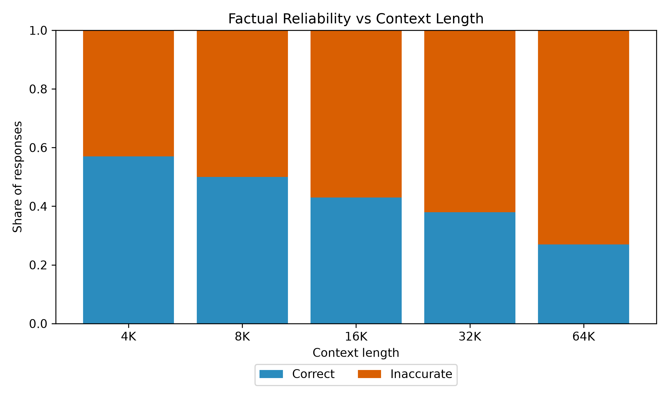
Correct and inaccurate responses sum to 100% at each context length.
Figure 2. Inaccuracy vs context length.
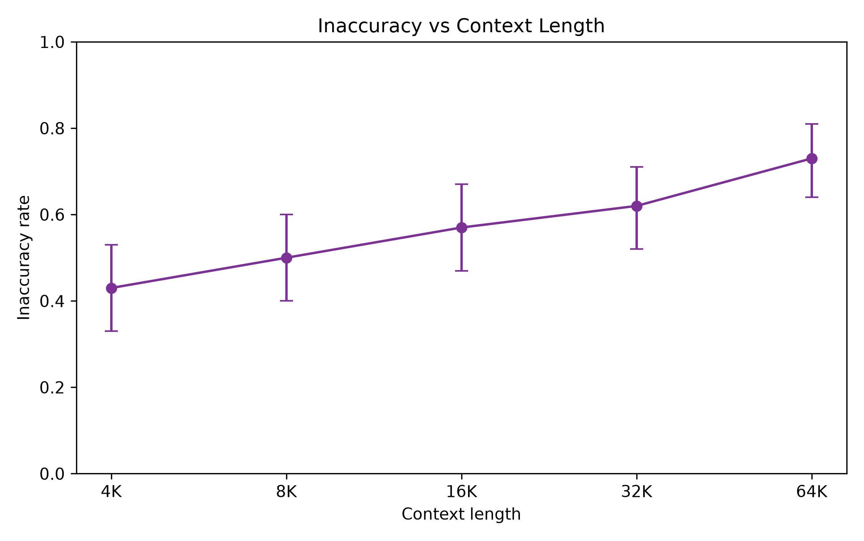
GEE OR per context doubling = 1.352, 95% CI [1.203, 1.519], p = 4.06e-07.

8. Statistical Analysis of Overall Inaccuracy
The repeated-measures model was fit as a GEE logistic regression clustered by question_family_id with context_log2 coded as 4K = 0, 8K = 1, 16K = 2, 32K = 3, and 64K = 4.
Accuracy OR per context doubling was 0.740 (95% CI [0.659, 0.831], p = 4.06e-07). Equivalently, inaccuracy OR per context doubling was 1.352 (95% CI [1.203, 1.519], p = 4.06e-07). This is an odds increase, not a percentage-point increase.

9. Paired Context Comparisons
Paired McNemar tests compared each longer context to 4K within the same question families. Holm correction was applied across the four comparisons.

Table 5. Paired inaccuracy comparisons.
Comparison | Inaccuracy difference | Discordant pairs | Raw p-value | Holm-adjusted p-value | Result
4K vs 8K | 7.0% | 3/10 | 0.0923 | 0.0923 | not significant after Holm
4K vs 16K | 14.0% | 3/17 | 0.0026 | 0.0052 | p < 0.05 after Holm
4K vs 32K | 19.0% | 5/24 | 5.46e-04 | 0.0016 | p < 0.05 after Holm
4K vs 64K | 30.0% | 5/35 | 1.38e-06 | 5.53e-06 | p < 0.05 after Holm

10. Question-Type Results
Question-type analyses are exploratory because subgroup cell sizes are smaller than the primary repeated-measures analysis.
Inaccuracy by Question Type & Context.
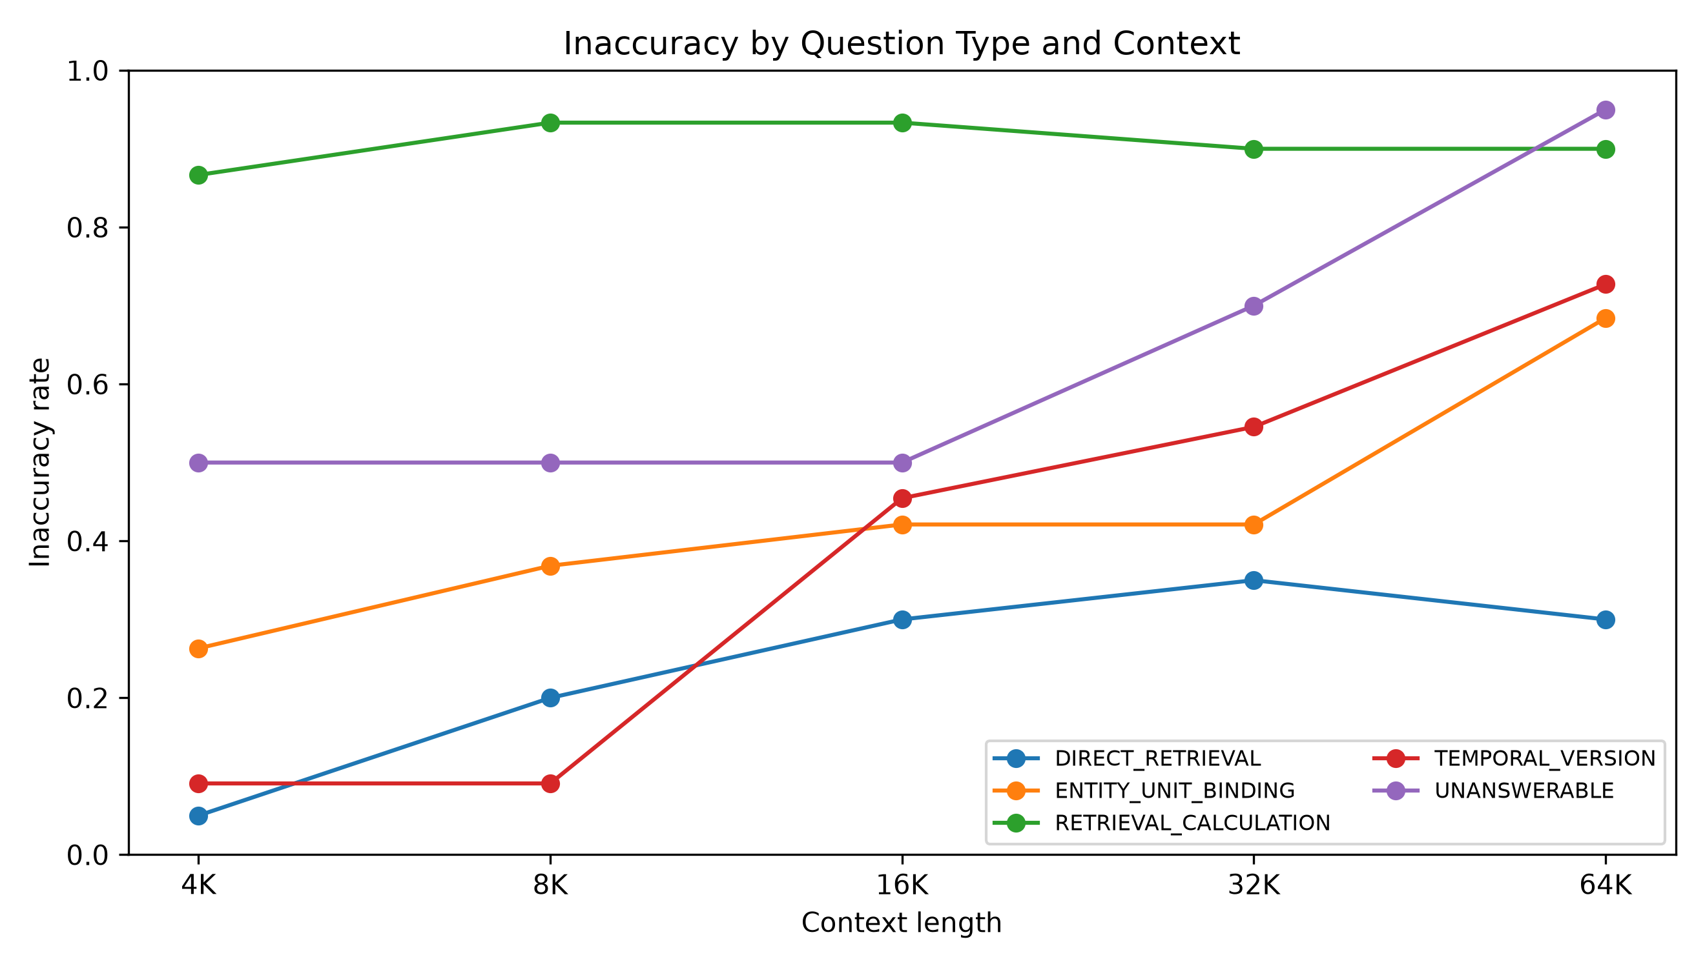
Subgroup results are exploratory because cells are smaller than the primary repeated-measures analysis.

Table 6. Inaccuracy by question type and context.
Group | Context | N | Correct | Inaccurate
DIRECT_RETRIEVAL | 16K | 20 | 70.0% | 30.0%
DIRECT_RETRIEVAL | 32K | 20 | 65.0% | 35.0%
DIRECT_RETRIEVAL | 4K | 20 | 95.0% | 5.0%
DIRECT_RETRIEVAL | 64K | 20 | 70.0% | 30.0%
DIRECT_RETRIEVAL | 8K | 20 | 80.0% | 20.0%
ENTITY_UNIT_BINDING | 16K | 19 | 57.9% | 42.1%
ENTITY_UNIT_BINDING | 32K | 19 | 57.9% | 42.1%
ENTITY_UNIT_BINDING | 4K | 19 | 73.7% | 26.3%
ENTITY_UNIT_BINDING | 64K | 19 | 31.6% | 68.4%
ENTITY_UNIT_BINDING | 8K | 19 | 63.2% | 36.8%
RETRIEVAL_CALCULATION | 16K | 30 | 6.7% | 93.3%
RETRIEVAL_CALCULATION | 32K | 30 | 10.0% | 90.0%
RETRIEVAL_CALCULATION | 4K | 30 | 13.3% | 86.7%
RETRIEVAL_CALCULATION | 64K | 30 | 10.0% | 90.0%
RETRIEVAL_CALCULATION | 8K | 30 | 6.7% | 93.3%
TEMPORAL_VERSION | 16K | 11 | 54.5% | 45.5%
TEMPORAL_VERSION | 32K | 11 | 45.5% | 54.5%
TEMPORAL_VERSION | 4K | 11 | 90.9% | 9.1%
TEMPORAL_VERSION | 64K | 11 | 27.3% | 72.7%
TEMPORAL_VERSION | 8K | 11 | 90.9% | 9.1%
UNANSWERABLE | 16K | 20 | 50.0% | 50.0%
UNANSWERABLE | 32K | 20 | 30.0% | 70.0%
UNANSWERABLE | 4K | 20 | 50.0% | 50.0%
UNANSWERABLE | 64K | 20 | 5.0% | 95.0%
UNANSWERABLE | 8K | 20 | 50.0% | 50.0%

11. Domain Results
Domain analyses are exploratory because each domain contributes 25 families.
Inaccuracy by Domain & Context.
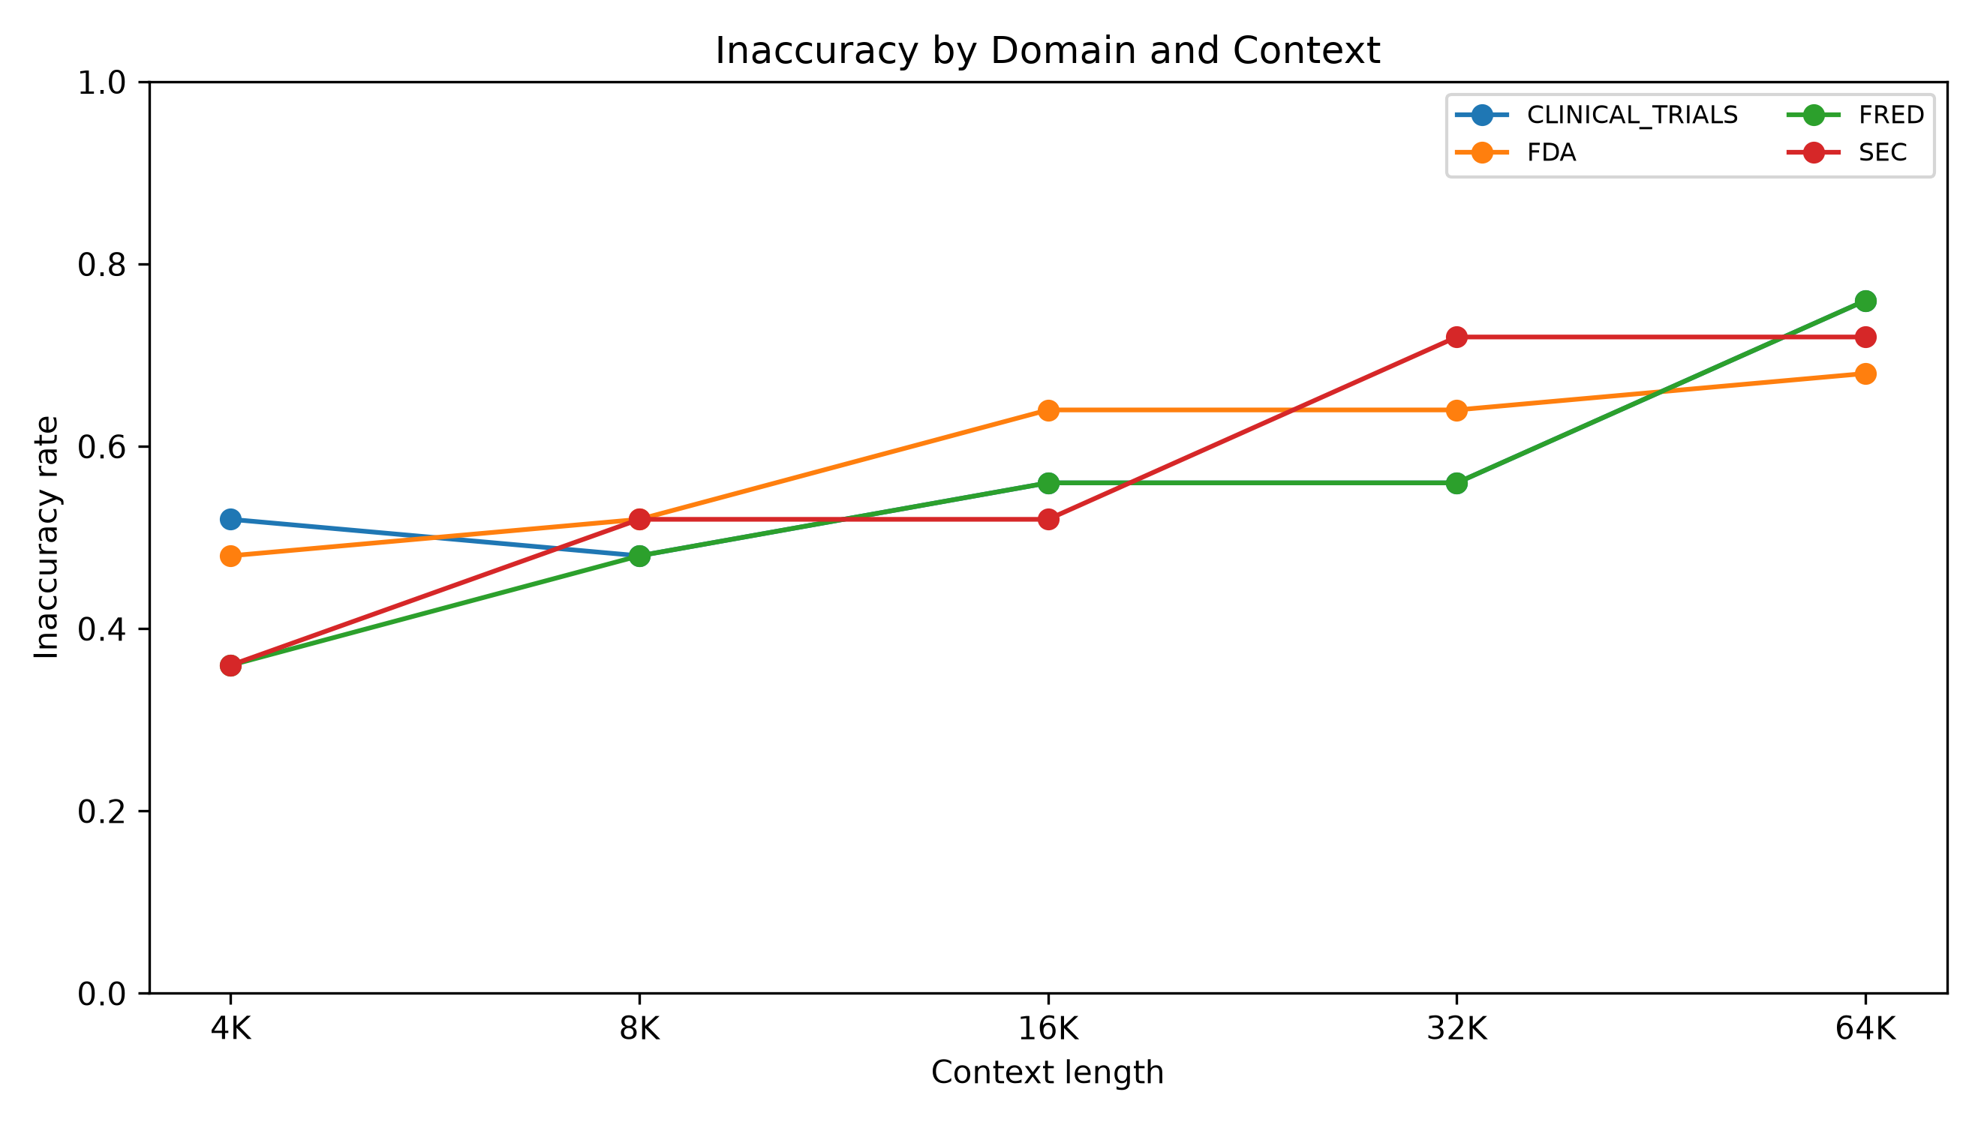
Subgroup results are exploratory because cells are smaller than the primary repeated-measures analysis.

Table 7. Inaccuracy by domain and context.
Group | Context | N | Correct | Inaccurate
CLINICAL_TRIALS | 16K | 25 | 44.0% | 56.0%
CLINICAL_TRIALS | 32K | 25 | 44.0% | 56.0%
CLINICAL_TRIALS | 4K | 25 | 48.0% | 52.0%
CLINICAL_TRIALS | 64K | 25 | 24.0% | 76.0%
CLINICAL_TRIALS | 8K | 25 | 52.0% | 48.0%
FDA | 16K | 25 | 36.0% | 64.0%
FDA | 32K | 25 | 36.0% | 64.0%
FDA | 4K | 25 | 52.0% | 48.0%
FDA | 64K | 25 | 32.0% | 68.0%
FDA | 8K | 25 | 48.0% | 52.0%
FRED | 16K | 25 | 44.0% | 56.0%
FRED | 32K | 25 | 44.0% | 56.0%
FRED | 4K | 25 | 64.0% | 36.0%
FRED | 64K | 25 | 24.0% | 76.0%
FRED | 8K | 25 | 52.0% | 48.0%
SEC | 16K | 25 | 48.0% | 52.0%
SEC | 32K | 25 | 28.0% | 72.0%
SEC | 4K | 25 | 64.0% | 36.0%
SEC | 64K | 25 | 28.0% | 72.0%
SEC | 8K | 25 | 48.0% | 52.0%

12. Inference-Time Analysis
Figure 3. Inference latency vs context length.
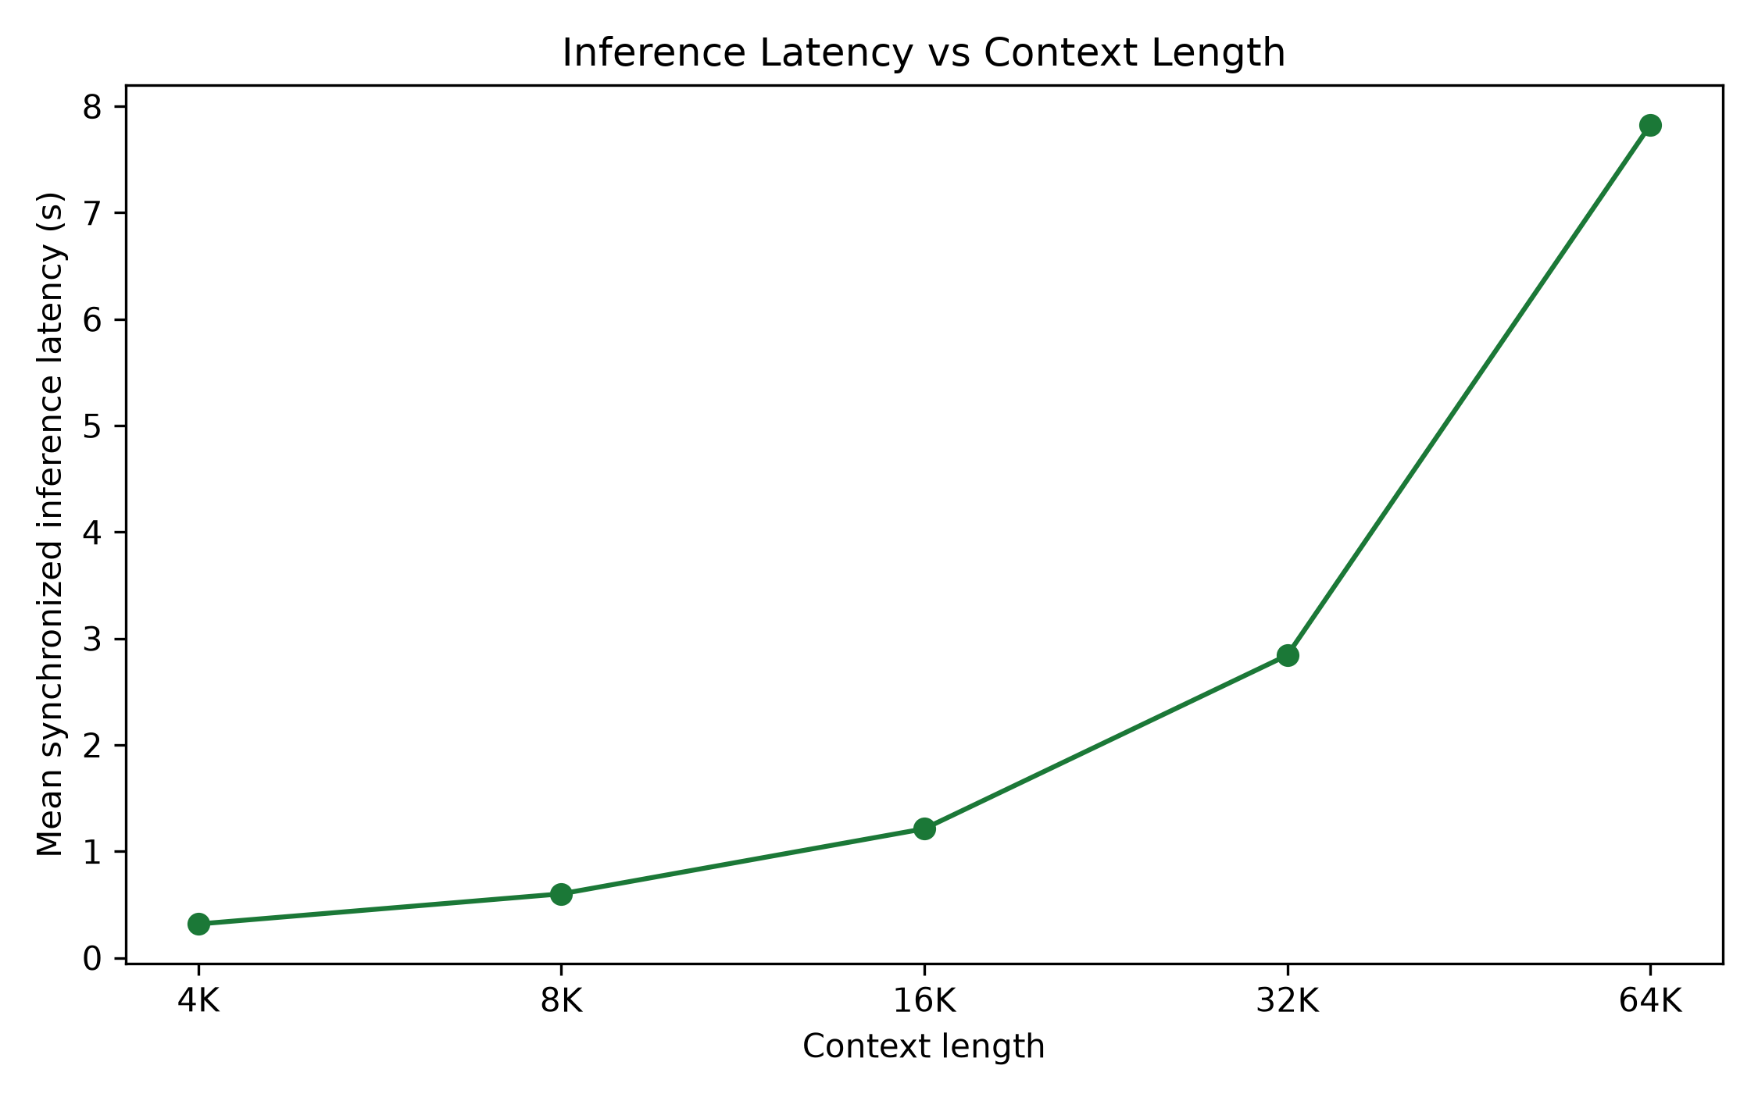
Mean synchronized generation latency rises as input length increases.

Table 8. Inference latency summary.
Context | Mean latency (s) | Median latency (s) | P95 latency (s) | Total latency (s) | Mean input tokens | Mean output tokens
4K | 0.3173239503800868 | 0.3150759311392903 | 0.3498486455995589 | 31.73239503800869 | 4265.73 | 8.47
8K | 0.6007813499122858 | 0.5982510871253908 | 0.6359666367061436 | 60.07813499122858 | 8329.19 | 8.42
16K | 1.2121606383286416 | 1.2097398359328508 | 1.2600192060228437 | 121.21606383286417 | 16440.02 | 8.31
32K | 2.8423769909795373 | 2.8350786096416414 | 2.9353641430847346 | 284.23769909795374 | 32671.02 | 8.37
64K | 7.823902476206422 | 7.810557162389159 | 7.952514025289565 | 782.3902476206422 | 65120.48 | 8.3

Latency grows sharply with context length. This analysis is descriptive and should not be interpreted as causal evidence about reliability.

13. Interpretation, Limitations, and Conclusion
Longer contexts substantially reduce factual reliability in Llama 3.2 3B under this benchmark. Overall inaccuracy increased from 43% at 4K to 73% at 64K, and the odds of an inaccurate answer increased by approximately 35% per context doubling.
- The experiment includes 100 question families and 500 observations.
- Only one model was evaluated: Llama 3.2 3B Instruct.
- Experiment C covers contexts through 64K.
- The benchmark uses four factual/structured data domains and intentionally strong same-domain distractors.
- Experiment C uses an answer-only format and therefore has no evidence-selection metric.
- Grading is deterministic with one documented manual adjudication.
- Subgroup analyses have smaller samples and are exploratory.
- GEE was used instead of mixed-effects logistic regression for reliable repeated-measures fitting.
- Results may not generalize to larger, proprietary, or differently prompted models.

14. Methodological Provenance

Table 9. Provenance.
Item | Value
Final scored dataset hash | 6fdfaa035b5da2211e813353916902c871e783ecfa993615db672f62bcb8e327
Frozen grader hash | d9282a0ccc50daba3bfd232c058dfbab63a5c19a7323d585a7c2236b3a6c4ba8
Analysis directory | data/analysis_experiment_c_final_v1
Statistical method | GEE logistic regression clustered by question_family_id; paired McNemar tests
Bootstrap CIs | Family-clustered bootstrap; seed 20260810; 5000 replicates
No reruns | Inference and grading were not rerun for this report.

Appendix A. Detailed Tables

Appendix Table A1. Full question-type results.
Group | Context | N | Correct | Inaccurate
DIRECT_RETRIEVAL | 16K | 20 | 70.0% | 30.0%
DIRECT_RETRIEVAL | 32K | 20 | 65.0% | 35.0%
DIRECT_RETRIEVAL | 4K | 20 | 95.0% | 5.0%
DIRECT_RETRIEVAL | 64K | 20 | 70.0% | 30.0%
DIRECT_RETRIEVAL | 8K | 20 | 80.0% | 20.0%
ENTITY_UNIT_BINDING | 16K | 19 | 57.9% | 42.1%
ENTITY_UNIT_BINDING | 32K | 19 | 57.9% | 42.1%
ENTITY_UNIT_BINDING | 4K | 19 | 73.7% | 26.3%
ENTITY_UNIT_BINDING | 64K | 19 | 31.6% | 68.4%
ENTITY_UNIT_BINDING | 8K | 19 | 63.2% | 36.8%
RETRIEVAL_CALCULATION | 16K | 30 | 6.7% | 93.3%
RETRIEVAL_CALCULATION | 32K | 30 | 10.0% | 90.0%
RETRIEVAL_CALCULATION | 4K | 30 | 13.3% | 86.7%
RETRIEVAL_CALCULATION | 64K | 30 | 10.0% | 90.0%
RETRIEVAL_CALCULATION | 8K | 30 | 6.7% | 93.3%
TEMPORAL_VERSION | 16K | 11 | 54.5% | 45.5%
TEMPORAL_VERSION | 32K | 11 | 45.5% | 54.5%
TEMPORAL_VERSION | 4K | 11 | 90.9% | 9.1%
TEMPORAL_VERSION | 64K | 11 | 27.3% | 72.7%
TEMPORAL_VERSION | 8K | 11 | 90.9% | 9.1%
UNANSWERABLE | 16K | 20 | 50.0% | 50.0%
UNANSWERABLE | 32K | 20 | 30.0% | 70.0%
UNANSWERABLE | 4K | 20 | 50.0% | 50.0%
UNANSWERABLE | 64K | 20 | 5.0% | 95.0%
UNANSWERABLE | 8K | 20 | 50.0% | 50.0%

Appendix Table A2. Full domain results.
Group | Context | N | Correct | Inaccurate
CLINICAL_TRIALS | 16K | 25 | 44.0% | 56.0%
CLINICAL_TRIALS | 32K | 25 | 44.0% | 56.0%
CLINICAL_TRIALS | 4K | 25 | 48.0% | 52.0%
CLINICAL_TRIALS | 64K | 25 | 24.0% | 76.0%
CLINICAL_TRIALS | 8K | 25 | 52.0% | 48.0%
FDA | 16K | 25 | 36.0% | 64.0%
FDA | 32K | 25 | 36.0% | 64.0%
FDA | 4K | 25 | 52.0% | 48.0%
FDA | 64K | 25 | 32.0% | 68.0%
FDA | 8K | 25 | 48.0% | 52.0%
FRED | 16K | 25 | 44.0% | 56.0%
FRED | 32K | 25 | 44.0% | 56.0%
FRED | 4K | 25 | 64.0% | 36.0%
FRED | 64K | 25 | 24.0% | 76.0%
FRED | 8K | 25 | 52.0% | 48.0%
SEC | 16K | 25 | 48.0% | 52.0%
SEC | 32K | 25 | 28.0% | 72.0%
SEC | 4K | 25 | 64.0% | 36.0%
SEC | 64K | 25 | 28.0% | 72.0%
SEC | 8K | 25 | 48.0% | 52.0%

