Longer Contexts Reduce Factual Reliability
Separating Hallucinatory and Grounded Errors in Llama 3.2 3B
Experiment D Final Report
Generated: 2026-08-11
Model: meta-llama/Llama-3.2-3B-Instruct
Benchmark: 500 question families, six context lengths

Table of Contents
Executive Summary
1. Introduction and Motivation
2. Data Sources
3. Question-Family Design
4. Context-Length Design
5. Experiment Size and Runtime Outcome
6. Model and Inference Configuration
7. Grading
8. Primary Factual-Reliability Results
9. Primary Statistical Model
10. Hallucinatory Inaccuracy
11. Grounded Inaccuracy
12. Sensitivity Analyses
13. Paired McNemar Tests
14. Question-Type Analysis
15. Domain Analysis
16. Error-Type Evolution
17. Latency
18. Family-Level Transitions
19. Discussion
20. Limitations
21. Conclusion
Appendix A. Reproducibility and Provenance
Executive Summary
This study asks how increasing long-context length affects factual reliability when an LLM must answer factual questions from authentic but competing primary-source records. The benchmark used 500 question families across SEC, FDA/Drugs@FDA, ClinicalTrials.gov, and FRED/ALFRED. Each family was evaluated at 4K, 8K, 16K, 32K, 64K, and an empirically hardware-bounded 82K condition.
Overall inaccuracy increased from 49.6% at 4K to 70.7% at 82K. GEE OR per 2x rendered context = 1.232, 95% CI [1.178, 1.288], p = 8.66 x 10^-20. Grounded Inaccuracy increased strongly. Hallucinatory Inaccuracy increased in the full dataset, but after excluding UNANSWERABLE tasks it decreased, indicating the full-dataset hallucination trend is driven primarily by failed abstention.
1. Introduction and Motivation
The central research question is how increasing context length affects factual reliability when an LLM must retrieve and reason over authentic but competing contextual records. A single hallucination rate is insufficient because long-context failures may come from unsupported fabrication, selection of the wrong legitimate contextual fact, wrong entity/temporal/version binding, calculation mistakes, or failure to abstain.
Every successful response is classified as Correct, Hallucinatory Inaccuracy, or Grounded Inaccuracy. Inaccuracy is the sum of Hallucinatory Inaccuracy and Grounded Inaccuracy. Runtime failures are separate and are not factual inaccuracies.
2. Data Sources
The benchmark uses four authoritative primary-source domains. Authentic records were used to construct target evidence, deterministic gold answers, same-domain distractors, temporal competitors, version competitors, entity competitors, series/unit competitors, and unanswerable cases.
Table 1. Authoritative source domains.
Domain | Families | Role
SEC | 125 | Company financial filings, concepts, periods, units, versions
FDA / Drugs@FDA | 125 | Drug application/product records, strengths, dosage forms, routes
ClinicalTrials.gov | 125 | Trial identifiers, statuses, dates, arms, posted results
FRED / ALFRED | 125 | Economic time series, vintages, units, seasonal/series variants
3. Question-Family Design
The benchmark contains 400 answerable families and 100 unanswerable families. The same question, gold answer, evidence policy, and answerability are preserved across all context lengths within a family.
Table 2. Question-type distribution.
Question Type | Families | Purpose
DIRECT_RETRIEVAL | 100 | Retrieve one explicitly requested fact from competing records
RETRIEVAL_CALCULATION | 150 | Retrieve multiple operands and compute a deterministic result
TEMPORAL_VERSION | 55 | Select the correct date, period, or version among competitors
ENTITY_UNIT_BINDING | 95 | Bind a requested value to the correct entity, unit, or series
UNANSWERABLE | 100 | Return INSUFFICIENT_EVIDENCE when required evidence is absent
Total | 500
4. Context-Length Design
The context ladder is 4K, 8K, 16K, 32K, 64K, and 82K. The 82K condition is not a doubling of 64K; models therefore used actual log2 rendered input tokens.
Table 3. Mean rendered input tokens by context condition.
Context | Mean Rendered Input Tokens
4K | 4,273.3
8K | 8,330.6
16K | 16,442.3
32K | 32,671.4
64K | 65,126.1
82K | 81,745.1
5. Experiment Size and Runtime Outcome
The frozen benchmark has 3,000 attempted inference instances. There were 2,998 successful generations and two CUDA OOM runtime failures, both at 82K. The OOM cases were excluded from factual-outcome denominators.
6. Model and Inference Configuration
The model was meta-llama/Llama-3.2-3B-Instruct, revision 0cb88a4f764b7a12671c53f0838cd831a0843b95, run on an NVIDIA GeForce RTX 4090 with BF16, batch size 1, standard Hugging Face DynamicCache, greedy decoding, do_sample=False, num_beams=1, max_new_tokens=128, no quantization, no cache offloading, and no model offloading. The prompt was llama_chat_v4, prompt hash 5d2869822989e19b, with frozen date 09 Aug 2026. Successful outputs had zero malformed outputs, zero 128-token cap hits, and zero repetitive/degenerate outputs.
7. Grading
Grading was deterministic. The frozen grader hash was d9282a0ccc50daba3bfd232c058dfbab63a5c19a7323d585a7c2236b3a6c4ba8. Nineteen cases were manually adjudicated under the frozen rules: seven correct grader edge cases and twelve grounded WRONG_ENTITY cases. No manual case was converted to hallucination.
Table 4. Final factual-outcome totals.
Outcome | Count
Correct | 1176
Inaccurate | 1822
Hallucinatory Inaccuracy | 1132
Grounded Inaccuracy | 690
Runtime Failures | 2
Ambiguous | 0
8. Primary Factual-Reliability Results
Table 5. Primary factual-reliability results by context.
Context | Gradable N | Correct | Inaccurate | Inaccuracy 95% CI | Hallucinatory Inaccuracy | Grounded Inaccuracy | Runtime Failures | Mean Latency
4K | 500 | 50.4% | 49.6% | 45.2%-54.0% | 34.2% | 15.4% | 0 | 0.316 s
8K | 500 | 45.6% | 54.4% | 50.0%-58.8% | 37.2% | 17.2% | 0 | 0.598 s
16K | 500 | 41.2% | 58.8% | 54.4%-63.2% | 34.8% | 24.0% | 0 | 1.212 s
32K | 500 | 38.4% | 61.6% | 57.4%-65.8% | 38.2% | 23.4% | 0 | 2.842 s
64K | 500 | 30.4% | 69.6% | 65.6%-73.6% | 41.8% | 27.8% | 0 | 7.827 s
82K | 498 | 29.3% | 70.7% | 66.6%-74.7% | 40.4% | 30.3% | 2 | 11.260 s
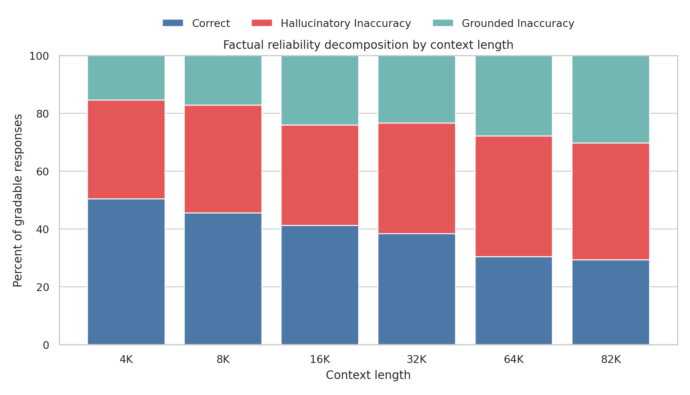
Figure 1. Factual Reliability Decomposition. Correct, Hallucinatory Inaccuracy, and Grounded Inaccuracy sum to 100% of gradable responses at each context length.
9. Primary Statistical Model
The primary model was GEE logistic regression with outcome inaccurate, predictor log2(rendered_input_tokens), and clustering by question_family_id. Each +1 increase corresponds to a doubling of rendered context. OR = 1.232, 95% CI [1.178, 1.288], p = 8.66 x 10^-20. This is an odds increase, not a percentage-point increase.
Table 6. GEE trend models.
Outcome | OR per 2x Context | 95% CI | p-value | Interpretation
Overall Inaccuracy | 1.232 | [1.178, 1.288] | 8.66e-20 | Odds ratio per doubling of rendered input tokens
Hallucinatory Inaccuracy | 1.070 | [1.027, 1.115] | 0.00133 | Odds ratio per doubling of rendered input tokens
Grounded Inaccuracy | 1.215 | [1.153, 1.280] | 3.34e-13 | Odds ratio per doubling of rendered input tokens
Hallucinatory vs Grounded Among Inaccuracies | 0.936 | [0.897, 0.977] | 0.00249 | Odds ratio per doubling of rendered input tokens
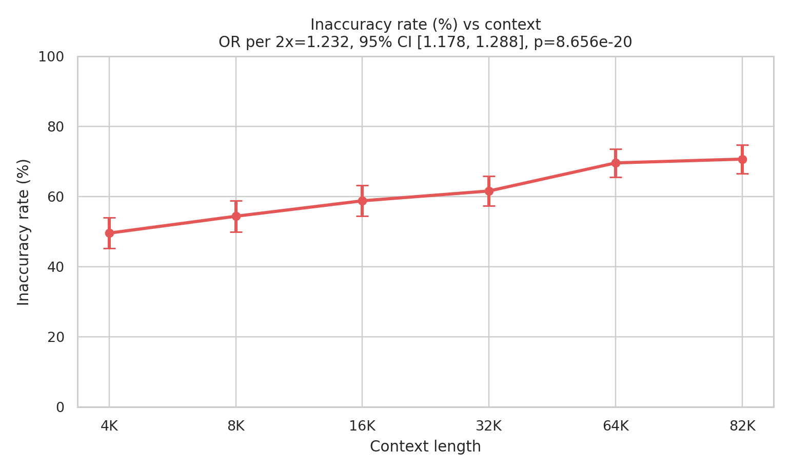
Figure 2. Overall Inaccuracy vs Context. GEE OR = 1.232 per 2x rendered context, 95% CI [1.178, 1.288], p = 8.66 x 10^-20.
10. Hallucinatory Inaccuracy
Hallucinatory Inaccuracy increased in the full benchmark from 34.2% at 4K to 40.4% at 82K. GEE OR = 1.070, 95% CI [1.027, 1.115], p = 0.00133. This full-dataset result must be interpreted with the UNANSWERABLE sensitivity analysis.
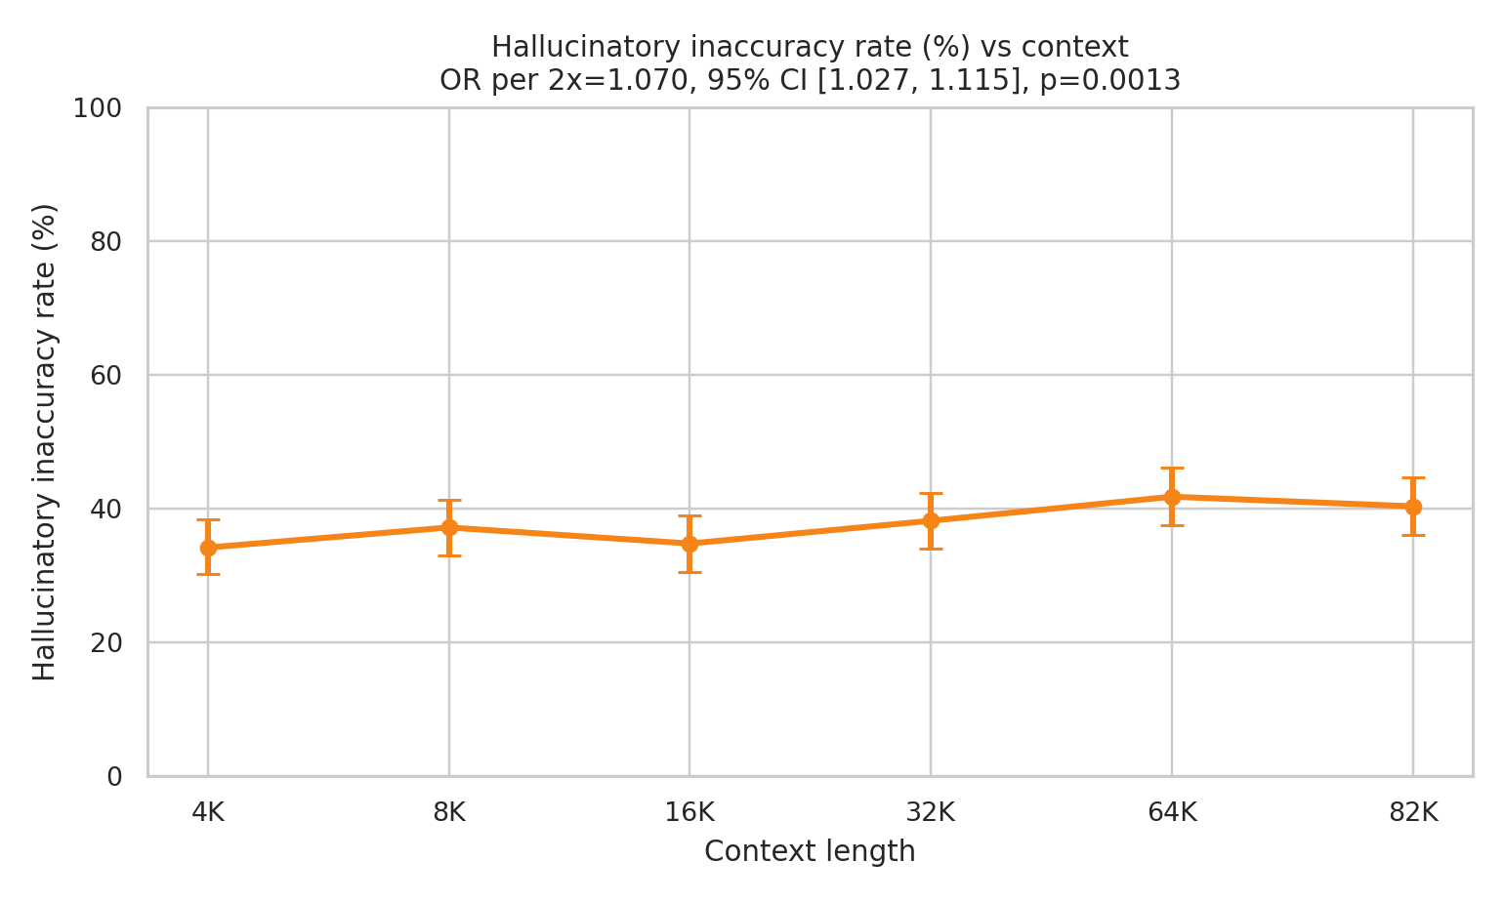
Figure 3. Hallucinatory Inaccuracy vs Context. GEE OR = 1.070, 95% CI [1.027, 1.115], p = 0.00133.
11. Grounded Inaccuracy
Grounded Inaccuracy increased from 15.4% at 4K to 30.3% at 82K. GEE OR = 1.215, 95% CI [1.153, 1.280], p = 3.34 x 10^-13. These are legitimate contextual values bound or reasoned over incorrectly.
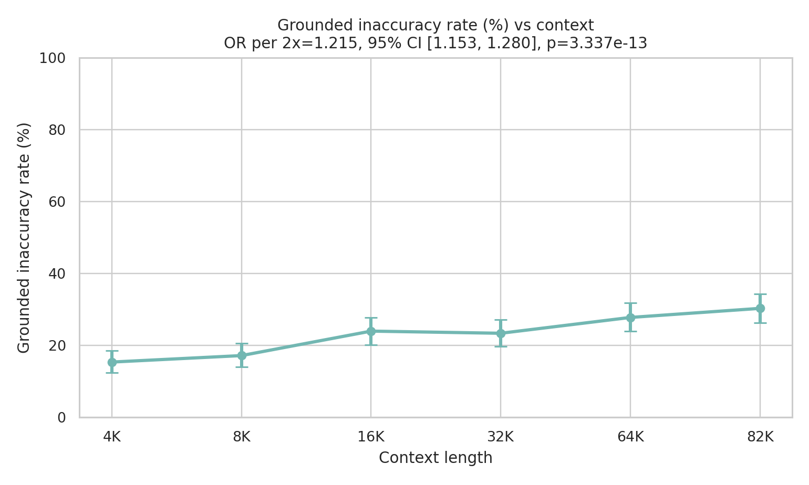
Figure 4. Grounded Inaccuracy vs Context. GEE OR = 1.215, 95% CI [1.153, 1.280], p = 3.34 x 10^-13.
12. Sensitivity Analyses
12.1 Excluding UNANSWERABLE Questions
Table 7. Trend models after excluding UNANSWERABLE families.
Outcome | OR | 95% CI | p-value
inaccurate | 1.129 | [1.081, 1.180] | 5.30e-08
hallucinatory_inaccuracy | 0.942 | [0.906, 0.980] | 0.00275
grounded_inaccuracy | 1.234 | [1.166, 1.306] | 2.66e-13
After excluding UNANSWERABLE families, overall inaccuracy and grounded inaccuracy still increased, while Hallucinatory Inaccuracy decreased. The full-dataset increase in Hallucinatory Inaccuracy is therefore driven primarily by failed abstention on unanswerable tasks.
12.2 Complete-Case Sensitivity
Table 8. Complete-case trend models using 498 families and 2,988 observations.
Outcome | OR | 95% CI | p-value
inaccurate | 1.232 | [1.178, 1.289] | 8.14e-20
hallucinatory_inaccuracy | 1.072 | [1.028, 1.117] | 0.00105
grounded_inaccuracy | 1.213 | [1.151, 1.278] | 4.69e-13
Conclusions were unchanged.
13. Paired McNemar Tests
All higher contexts were significant versus 4K for overall inaccuracy after Holm correction. Hallucinatory Inaccuracy was significant for 4K vs 8K, 64K, and 82K. Grounded Inaccuracy was significant for 4K vs 16K, 32K, 64K, and 82K.
Table 9. Paired McNemar comparisons against 4K.
Outcome | Comparison | Paired N | Rate Difference (pp) | 4K=0, Higher=1 | 4K=1, Higher=0 | Raw p | Holm p | Holm Significant
inaccurate | 4K_vs_8K | 500 | 4.8 | 41 | 17 | 0.00223 | 0.00223 | True
inaccurate | 4K_vs_16K | 500 | 9.2 | 66 | 20 | 6.67e-07 | 1.33e-06 | True
inaccurate | 4K_vs_32K | 500 | 12.0 | 88 | 28 | 2.09e-08 | 6.27e-08 | True
inaccurate | 4K_vs_64K | 500 | 20.0 | 124 | 24 | 1.89e-17 | 7.57e-17 | True
inaccurate | 4K_vs_82K | 498 | 21.3 | 129 | 23 | 4.33e-19 | 2.17e-18 | True
hallucinatory_inaccuracy | 4K_vs_8K | 500 | 3.0 | 24 | 9 | 0.01353 | 0.04059 | True
hallucinatory_inaccuracy | 4K_vs_16K | 500 | 0.6 | 35 | 32 | 0.80719 | 0.80719 | False
hallucinatory_inaccuracy | 4K_vs_32K | 500 | 4.0 | 51 | 31 | 0.03524 | 0.07048 | False
hallucinatory_inaccuracy | 4K_vs_64K | 500 | 7.6 | 75 | 37 | 0.00042 | 0.0021 | True
hallucinatory_inaccuracy | 4K_vs_82K | 498 | 6.4 | 69 | 37 | 0.00244 | 0.00976 | True
grounded_inaccuracy | 4K_vs_8K | 500 | 1.8 | 39 | 30 | 0.33556 | 0.33556 | False
grounded_inaccuracy | 4K_vs_16K | 500 | 8.6 | 68 | 25 | 9.38e-06 | 2.81e-05 | True
grounded_inaccuracy | 4K_vs_32K | 500 | 8.0 | 70 | 30 | 7.85e-05 | 0.00016 | True
grounded_inaccuracy | 4K_vs_64K | 500 | 12.4 | 90 | 28 | 8.91e-09 | 3.57e-08 | True
grounded_inaccuracy | 4K_vs_82K | 498 | 14.9 | 96 | 22 | 3.26e-12 | 1.63e-11 | True
14. Question-Type Analysis
Table 10. Question-type outcome rates at 4K and 82K.
Question Type | 4K Inaccuracy | 82K Inaccuracy | 4K Hallucinatory | 82K Hallucinatory | 4K Grounded | 82K Grounded
DIRECT_RETRIEVAL | 24.0% | 37.0% | 0.0% | 1.0% | 24.0% | 36.0%
ENTITY_UNIT_BINDING | 25.3% | 50.5% | 4.2% | 2.1% | 21.1% | 48.4%
RETRIEVAL_CALCULATION | 94.0% | 89.9% | 78.0% | 64.9% | 16.0% | 25.0%
TEMPORAL_VERSION | 18.2% | 67.3% | 1.8% | 9.1% | 16.4% | 58.2%
UNANSWERABLE | 49.0% | 97.0% | 49.0% | 97.0% | 0.0% | 0.0%
UNANSWERABLE failures rose from approximately 49.0% to 97.0%, explaining much of the full-dataset Hallucinatory Inaccuracy increase. TEMPORAL_VERSION inaccuracy rose from approximately 18.2% to 67.3%, indicating temporal/version confusion. These subgroup results are exploratory.
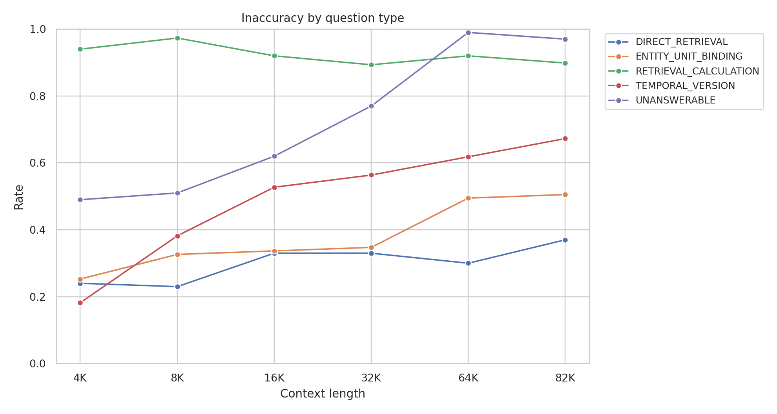
Figure 6. Inaccuracy by question type and context length.
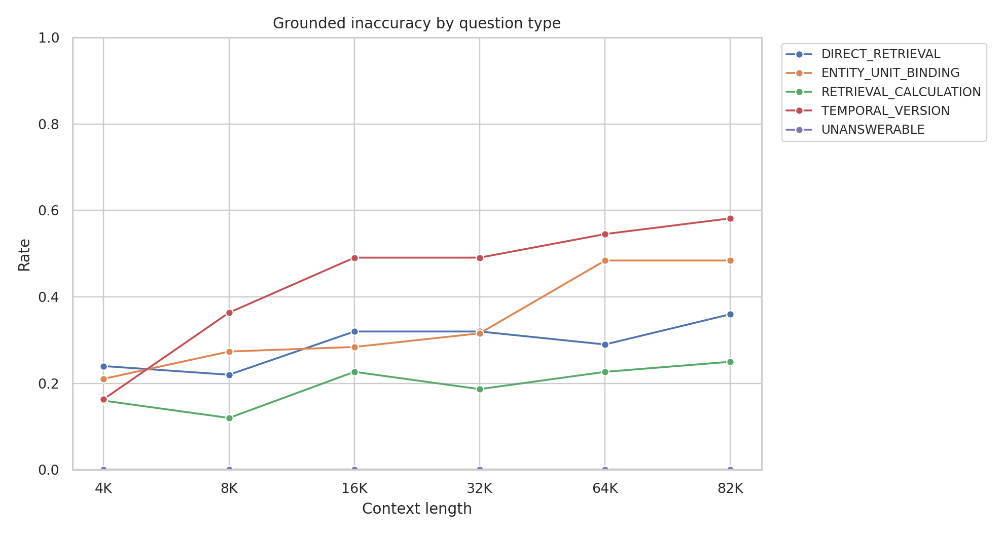
Figure 7. Grounded Inaccuracy by question type and context length.
15. Domain Analysis
Table 11. Domain outcome rates at 4K and 82K.
Domain | 4K Inaccuracy | 82K Inaccuracy | 4K Hallucinatory | 82K Hallucinatory | 4K Grounded | 82K Grounded
CLINICAL_TRIALS | 44.0% | 59.2% | 40.8% | 36.8% | 3.2% | 22.4%
FDA | 58.4% | 62.4% | 53.6% | 44.8% | 4.8% | 17.6%
FRED | 43.2% | 79.0% | 20.8% | 36.3% | 22.4% | 42.7%
SEC | 52.8% | 82.3% | 21.6% | 43.5% | 31.2% | 38.7%
SEC and FRED showed the largest overall inaccuracy increases. FDA was comparatively flatter. ClinicalTrials increased mainly through grounded errors. Domain-level results are exploratory.
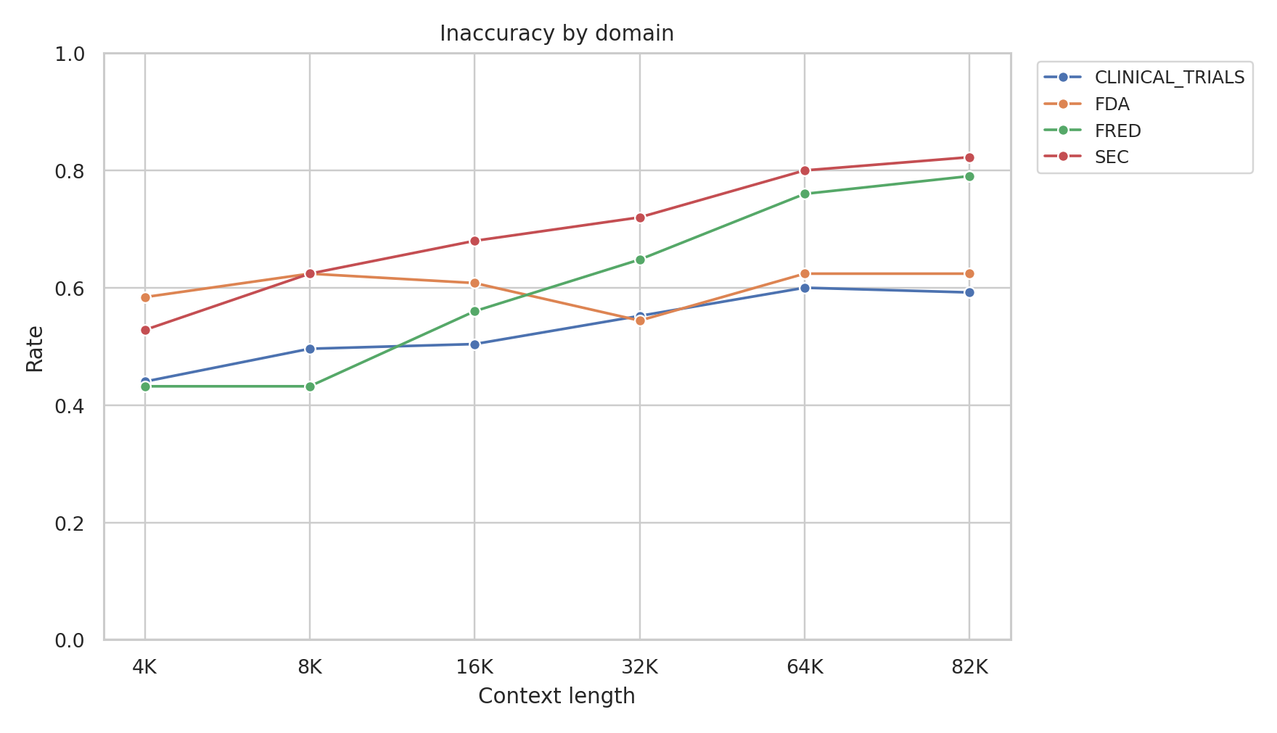
Figure 8. Inaccuracy by domain and context length.
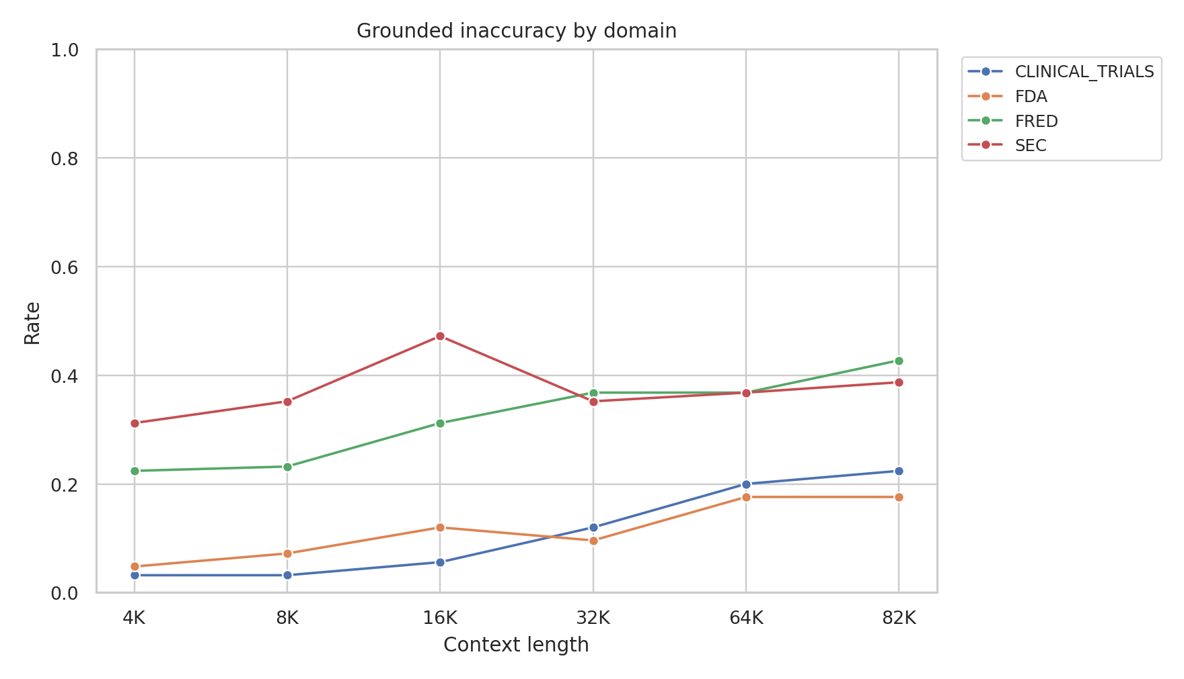
Figure 9. Grounded Inaccuracy by domain and context length.
16. Error-Type Evolution
Table 12. Detailed error-type counts by context.
Error Type | 4K | 8K | 16K | 32K | 64K | 82K | 82K - 4K
CALCULATION_ERROR | 12 | 9 | 8 | 12 | 14 | 13 | 1
FAILED_TO_ABSTAIN | 49 | 51 | 62 | 77 | 99 | 97 | 48
UNNECESSARY_ABSTENTION | 11 | 5 | 20 | 8 | 12 | 10 | -1
UNSUPPORTED_VALUE | 122 | 135 | 112 | 114 | 110 | 104 | -18
WRONG_ENTITY | 32 | 45 | 44 | 42 | 43 | 47 | 15
WRONG_FIELD | 1 | 1 | 4 | 6 | 12 | 15 | 14
WRONG_PERIOD | 6 | 10 | 19 | 19 | 35 | 45 | 39
WRONG_SERIES_VARIANT | 2 | 3 | 2 | 3 | 1 | 2 | 0
WRONG_UNIT | 3 | 2 | 0 | 2 | 0 | 1 | -2
WRONG_VERSION | 10 | 11 | 23 | 25 | 22 | 18 | 8
The largest 4K-to-82K increases were FAILED_TO_ABSTAIN (+48), WRONG_PERIOD (+39), WRONG_ENTITY (+15), and WRONG_FIELD (+14). UNSUPPORTED_VALUE decreased by 18. The growth in total inaccuracy is therefore substantially driven by abstention failure and contextual misbinding.
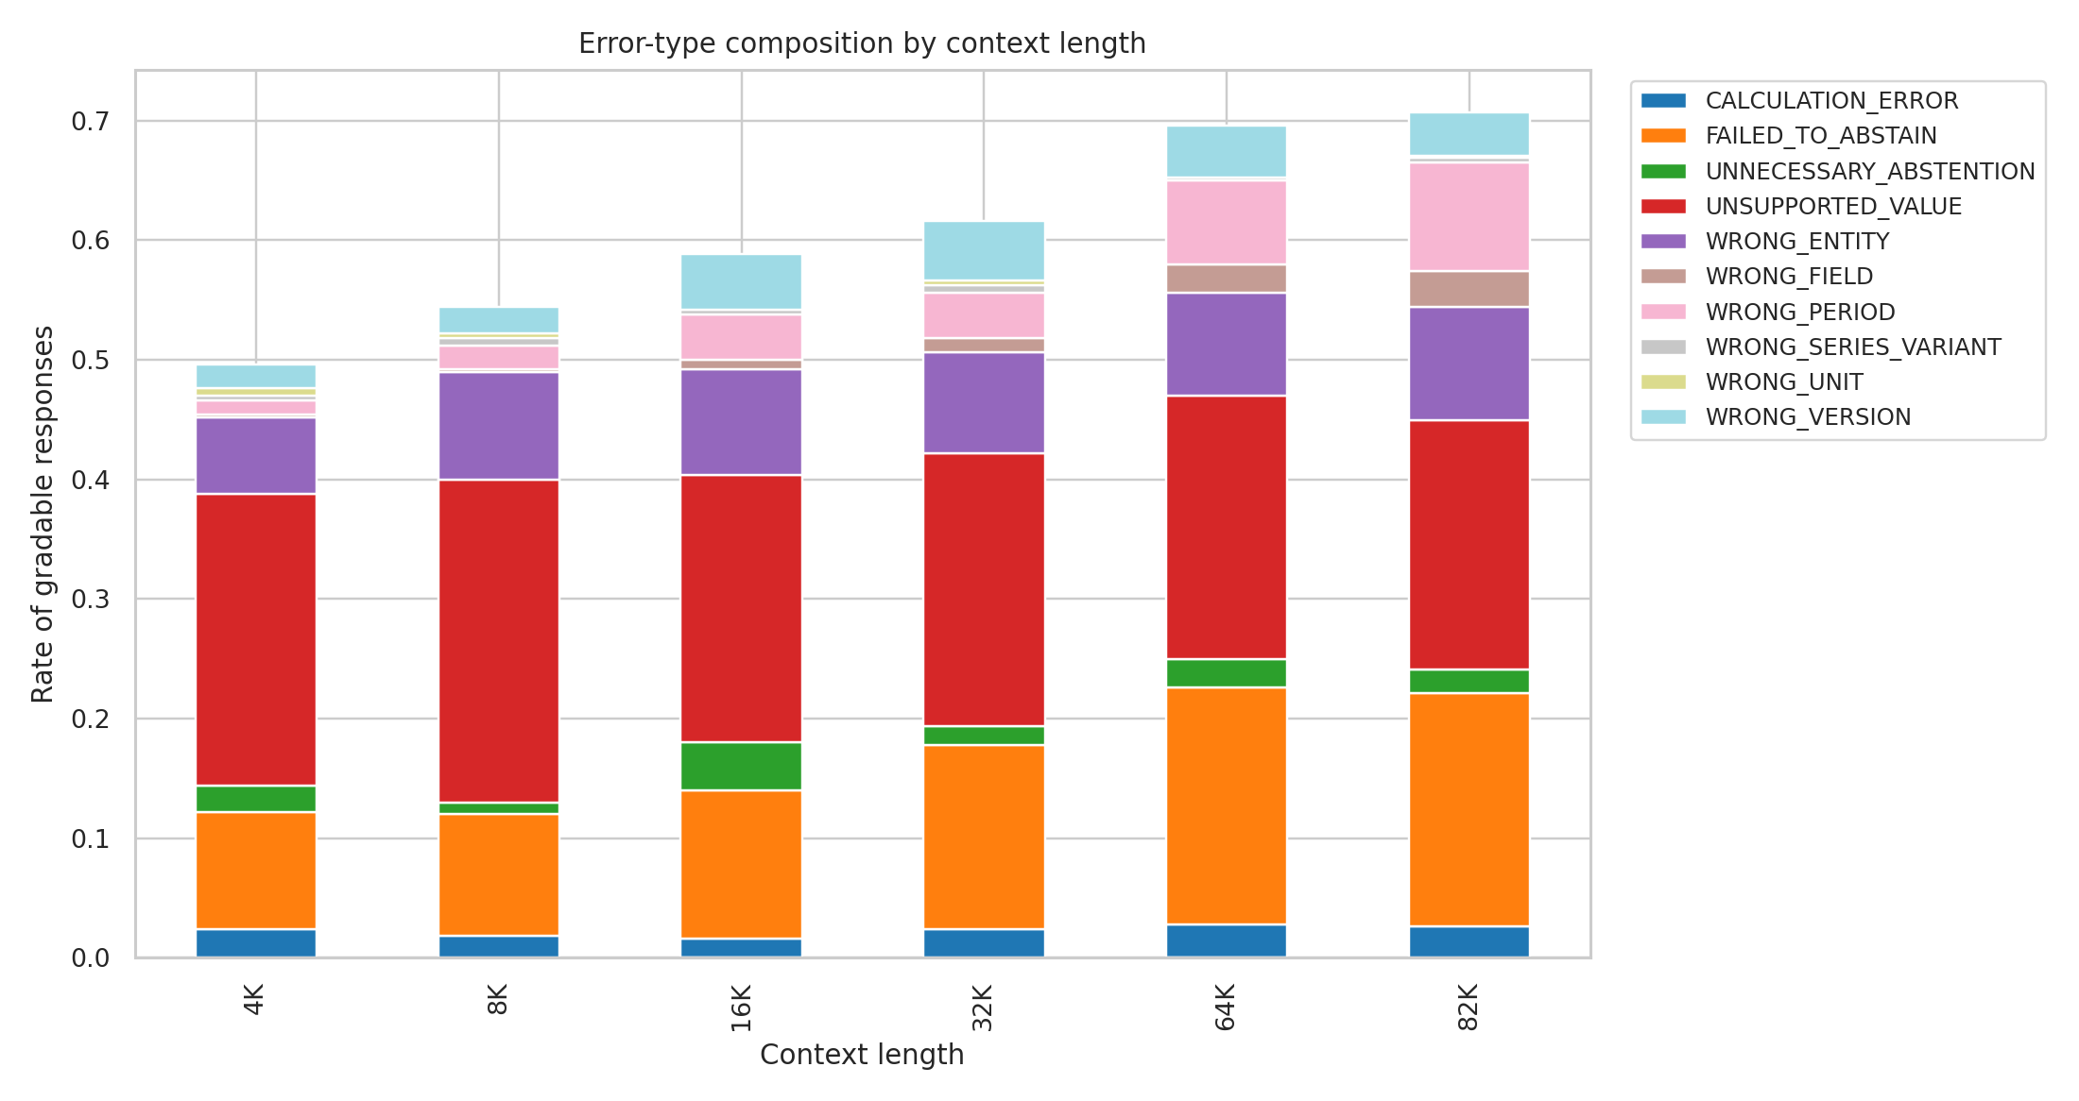
Figure 5. Error-type composition by context length.
17. Latency
Table 13. Inference latency by context.
Context | N | Mean | Median | P95 | P99 | Mean Input Tokens | Mean Output Tokens
4K | 500 | 0.316 s | 0.315 s | 0.350 s | 0.355 s | 4,273.3 | 8.4
8K | 500 | 0.598 s | 0.597 s | 0.635 s | 0.641 s | 8,330.5 | 8.3
16K | 500 | 1.212 s | 1.211 s | 1.260 s | 1.268 s | 16,442.3 | 8.3
32K | 500 | 2.842 s | 2.832 s | 2.938 s | 2.944 s | 32,671.4 | 8.3
64K | 500 | 7.827 s | 7.804 s | 7.959 s | 7.968 s | 65,126.1 | 8.2
82K | 498 | 11.260 s | 11.251 s | 11.385 s | 11.409 s | 81,745.1 | 8.3
Inference latency increased sharply with context length. This report does not claim latency causes factual errors.
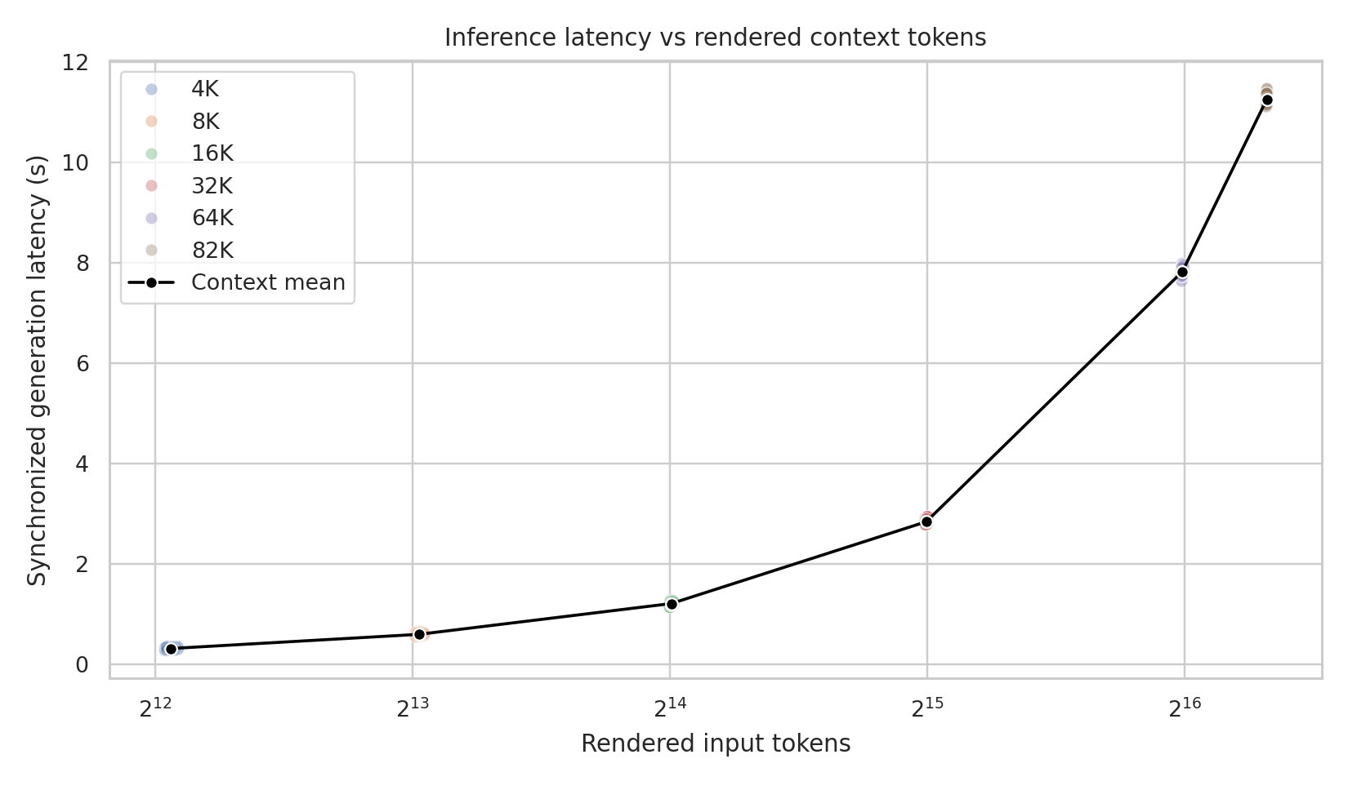
Figure 10. Inference latency vs rendered context tokens.
18. Family-Level Transitions
Family-level trajectories were heterogeneous, including always-correct, always-inaccurate, first-failure-at-longer-context, and non-monotonic patterns.
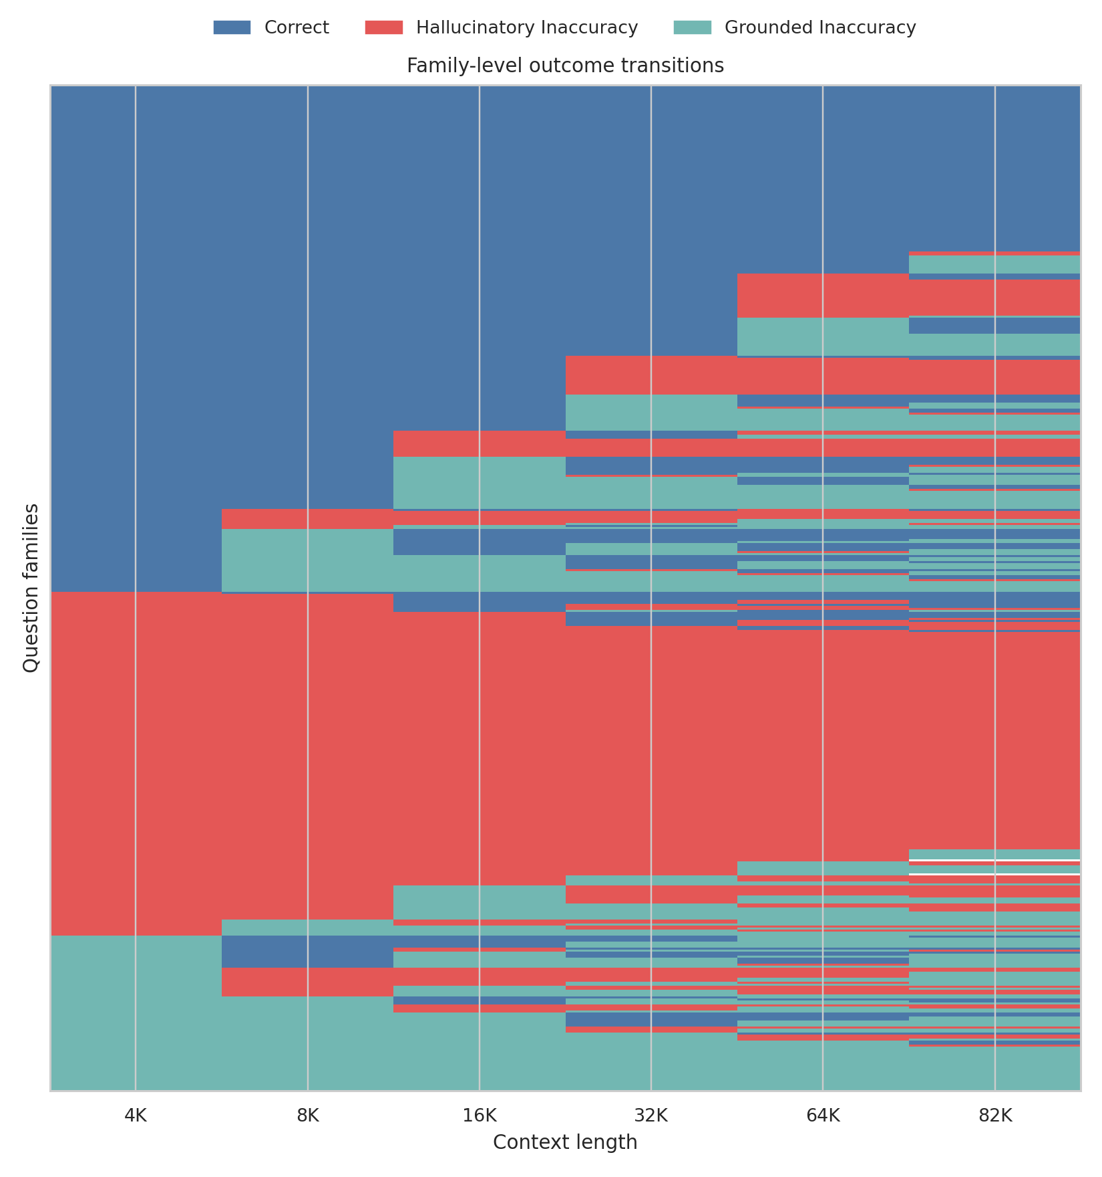
Figure 11. Family-level transition visualization across context lengths.
19. Discussion
Increasing context length substantially reduces factual reliability. The degradation is not captured adequately by a single hallucination metric. More context introduces more authentic competing information, and the model increasingly selects, binds, or reasons over legitimate but incorrect contextual records. This grounded contextual-confusion mechanism is distinct from classical unsupported hallucination.
The full dataset shows increasing Hallucinatory Inaccuracy, but the sensitivity analysis demonstrates that this is driven primarily by failed abstention on unanswerable questions. On answerable factual tasks, Hallucinatory Inaccuracy decreases while Grounded Inaccuracy increases.
20. Limitations
Limitations include one model, one hardware/inference configuration, 500 question families across four structured factual domains, context tested through approximately 82K rendered input tokens, two 82K CUDA OOM runtime failures, answer-only output with no evidence-selection metric, deterministic grading plus 19 manually adjudicated edge cases, high-quality competing distractors by design, exploratory subgroup analyses, GEE rather than a full GLMM, and uncertain generalization to larger or proprietary LLMs.
21. Conclusion
Inaccuracy increased from 49.6% at 4K to 70.7% at 82K. The primary GEE model estimated an inaccuracy OR of 1.232 per context doubling, p = 8.66 x 10^-20. Grounded Inaccuracy increased from 15.4% to 30.3%, OR 1.215, p = 3.34 x 10^-13. Hallucinatory Inaccuracy increased from 34.2% to 40.4% in the full dataset, OR 1.070, p = 0.00133, but excluding unanswerable tasks reversed that trend, OR 0.942, p = 0.00275.
Increasing context length substantially reduces factual reliability. The most robust mechanism on answerable factual tasks is an increase in grounded contextual confusion rather than an increase in unsupported fabrication.
Appendix A. Reproducibility and Provenance
Final JSONL hash: 8fa4fd3b990adf54b6f7790ed6defa9c5d89aa6dd8365e0a7519beeb44d985e8
Final CSV hash: 155f80ec3bf284a7928ede0d24b491a972540b77dfe01d98eb622825c9c06a78
Benchmark hash: dc2c4194dedb090198e6883735257908ce274bebc8611b40d958dbd026aa1fe6
Grader hash: d9282a0ccc50daba3bfd232c058dfbab63a5c19a7323d585a7c2236b3a6c4ba8
Prompt hash: 5d2869822989e19b
Model revision: 0cb88a4f764b7a12671c53f0838cd831a0843b95

