SCALA PROGRAMMING

NAME: DURGAM NAGA DEERAJ REDDY

USN: 22BTRAD013

Q. Write a Scala program to create a set and find the common elements between two sets.

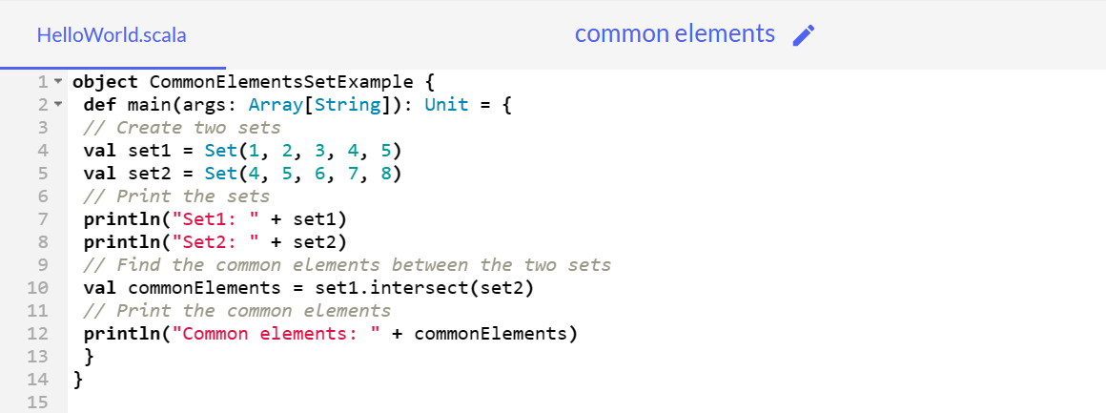

**CODE:**

object CommonElementsSetExample {

def main(args: Array[String]): Unit = {

// Create two sets

val set1 = Set(1, 2, 3, 4, 5)

val set2 = Set(4, 5, 6, 7, 8)

// Print the sets

println("Set1: " + set1)

println("Set2: " + set2)

// Find the common elements between the two sets

val commonElements = set1.intersect(set2)

// Print the common elements

println("Common elements: " + commonElements)

}

}

**EXPECTED OUTPUT:**

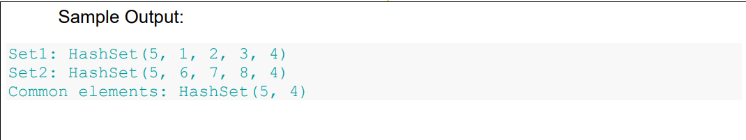

**OUTPUT:**

