SCALA PROGRAMMING

NAME: DURGAM NAGA DEERAJ REDDY

USN: 22BRAD013

**Problem Statement 16:**

Write a Scala program that creates a class ContactInfo with properties name, email, and address. Create a class Customer that includes a ContactInfo object.

**Background & Use case:**

* The "ContactInfo" class is defined with the properties name, email, and address. It has a primary constructor that takes these properties as parameters.
* The "Customer" class is defined by the property contactInfo of type ContactInfo. It represents a customer and includes contact information.
* The CustomerApp object contains the main method to test functionality. It creates an instance of the ContactInfo class with sample information and then creates a customer object using the ContactInfo instance.
* Finally, the program prints the customer's name, email, and address using string interpolation.

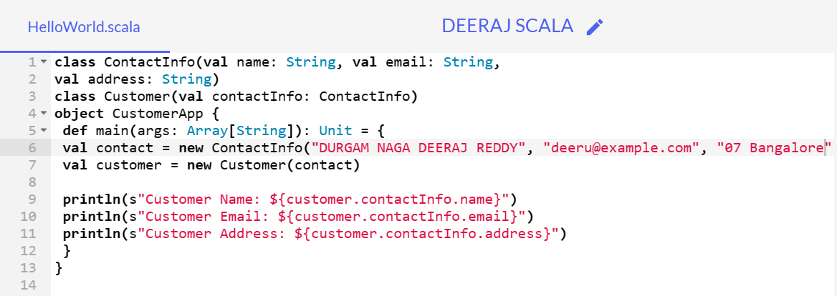

**CODE:**

class ContactInfo(val name: String, val email: String,

val address: String)

class Customer(val contactInfo: ContactInfo)

object CustomerApp {

def main(args: Array[String]): Unit = {

val contact = new ContactInfo("DURGAM NAGA DEERAJ REDDY", "deeru@example.com", "07 Bangalore")

val customer = new Customer(contact)

println(s"Customer Name: ${customer.contactInfo.name}")

println(s"Customer Email: ${customer.contactInfo.email}")

println(s"Customer Address: ${customer.contactInfo.address}")

}

}

OUTPUT:

