SCALA PROGRAMMING

NAME: DURGAM NAGA DEERAJ REDDY

USN: 22BTRAD013

Q. Write a Scala program to remove the character in a given position of a given string. The given position will be in the range 0...string length -1 inclusive

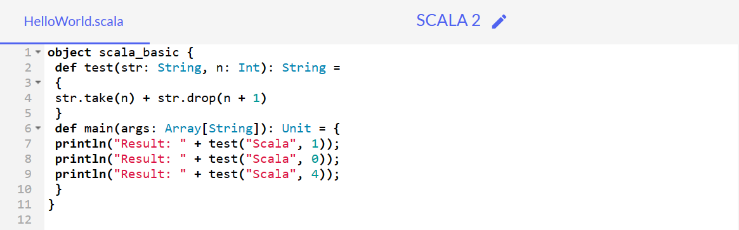

**CODE:**

object scala_basic {

def test(str: String, n: Int): String =

{

str.take(n) + str.drop(n + 1)

}

def main(args: Array[String]): Unit = {

println("Result: " + test("Scala", 1));

println("Result: " + test("Scala", 0));

println("Result: " + test("Scala", 4));

}

}

**OUTPUT:**

