SCALA PROGRAMMING

CODE:

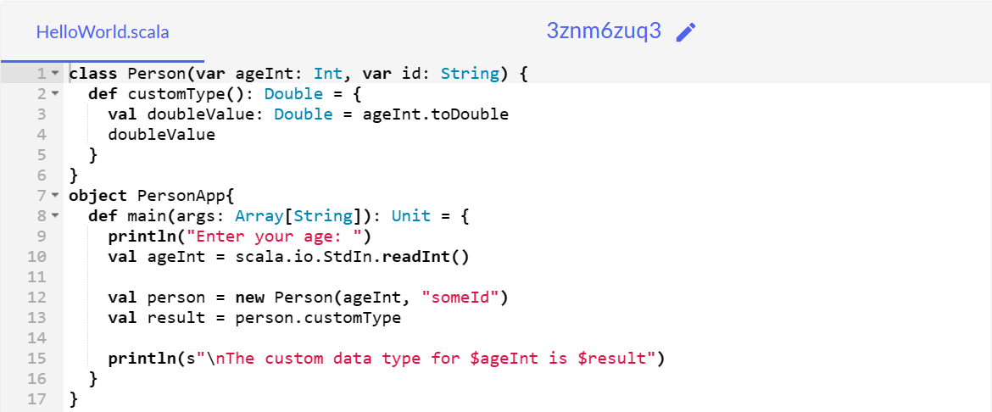

OUTPUT:

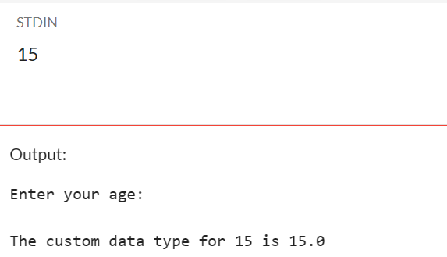

**BY**:

DURGAM NAGA DEERAJ REDDY

22BTRAD013

**GITHUB LINK**:

https://github.com/DeeruReddy/Scala_programming